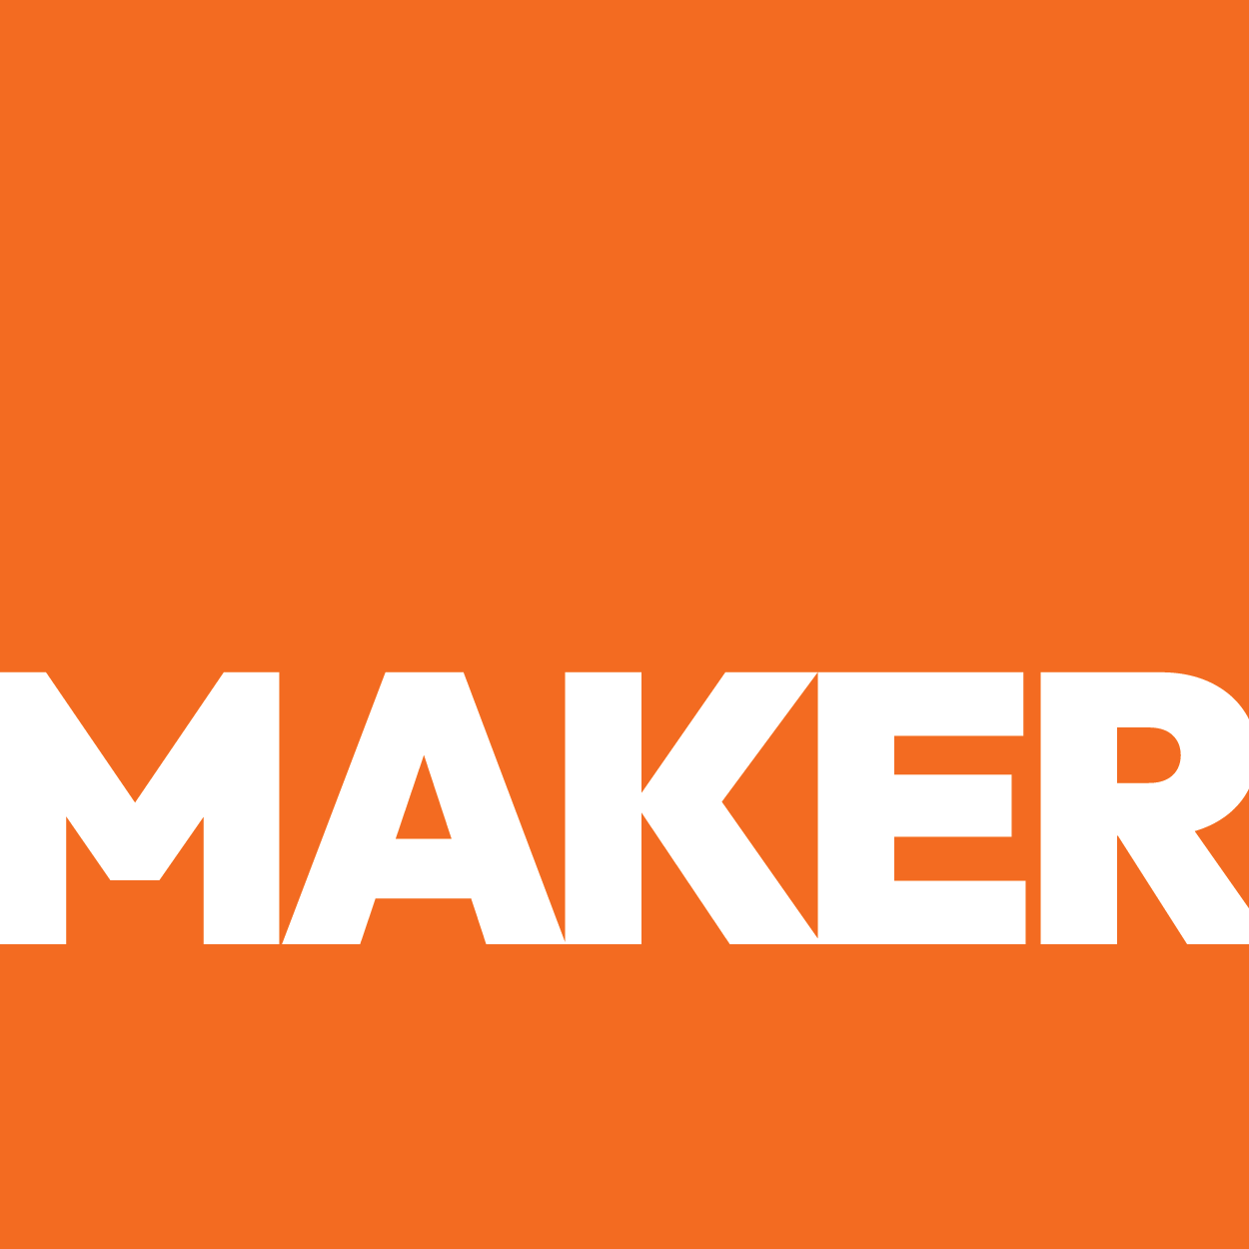

REVENUE GROWTH PLAYBOOK
REVENUE GROWTH
PLAYBOOK

Strategic Offer Architecture for Maximum Revenue Impact
● Prepared by Maker Web Studios ● March 2026 ●
CONFIDENTIAL — PREPARED EXCLUSIVELY FOR Empiria Labs
OVERVIEW
The Problem — Right Now
Empiria Labs currently presents itself with the generic positioning: "analytical testing services for the fruits and vegetables industry." This language is interchangeable with any of the 500+ testing labs in the United States. It says nothing about dual accreditation, nothing about local turnaround advantage, nothing about the specific instrumentation or methodologies that separate Empiria from a basic testing outfit. The website itself reinforces this commodity positioning by showing nothing at all -- literally an empty page. A buyer scanning for a testing partner cannot differentiate Empiria from any other lab, because the website gives them nothing to differentiate with.
What Empiria Labs Actually Is

"Empiria Labs is the only dual A2LA-accredited food safety testing laboratory in South Texas, offering same-day sample acceptance and 2-3 day turnaround for produce growers who currently lose a week shipping samples to Houston."
— Maker Web Studios Audit Finding

$[X]K+  BONUS VALUE | [X]+  A2LA Accreditation Certificates (Chemistry + Biology) | [X]K  Pesticide Compounds Screened Per Sample | ISO/IEC 17025:2017 International Standard  ISO 17025
SECTION STEP 1
Pick the Niche
Three Core Services:
- Pesticide Residue Analysis (LC/MS-MS, GC/MS-MS)
- Microbiological Testing (E. coli, Salmonella, Listeria)
- Heavy Metals & Mycotoxin Analysis (ICP/OES)
Avatar: QA Manager or Food Safety Director at a mid-size produce company ($5M-$50M revenue) in the Rio Grande Valley or South Texas border region. Responsible for FSMA compliance, retailer audit documentation, and managing third-party testing relationships. Currently shipping samples to Houston or San Antonio and losing 3-5 days per testing cycle. Under pressure from retail buyers (HEB, Walmart, Kroger) to provide accredited test results with faster turnaround. Bilingual (English/Spanish) and connected to the cross-border produce supply chain.
Geography: Rio Grande Valley produce corridor (Edinburg, McAllen, Mission, Pharr, Weslaco), South Texas agricultural exporters, cross-border produce importers using the McAllen-Hidalgo and Pharr International Bridges, and oil & gas exploration companies operating in the Eagle Ford Shale region.

SECTION STEP 2
The Dream Outcome
The Quality Assurance Manager or Owner at a mid-size produce company in South Texas needing fast, local, accredited pesticide and micro testing does not want a . They want:
- Produce companies in the RGV find Empiria Labs on Google before shipping samples to Houston or San Antonio -- eliminating 3-5 days of transit time and reducing cost per test cycle.
- A2LA dual accreditation is the first thing every visitor sees -- instant credibility that shortens the buyer's due diligence process from weeks to minutes.
- An online sample submission system eliminates phone tag and lets growers initiate testing 24/7, even during harvest season when office hours do not align with field schedules.
- The website positions Empiria as THE food safety testing authority in South Texas -- the lab that procurement managers recommend to each other.
- Empiria's scientific leadership and conference presence build a brand that attracts not just testing contracts, but partnership opportunities with produce associations, research institutions, and government agencies.

SECTION STEP 3
Four Market Indicators
INDICATOR | Empiria Labs CHECK
Massive Pain | Produce growers face mounting FSMA enforcement, retailer audit requirements, and export certification demands. Testing is not optional -- it is a cost of doing business. Growers who cannot get fast, accredited results risk shipment delays, rejected loads, and regulatory action.
Purchasing Power | Produce companies spend $2,000-$10,000+ per month on testing services. A mid-size grower with multiple crops and shipping cycles may spend $50,000-$100,000+ annually on laboratory testing. These are established budget line items, not discretionary spending.
Easy to Target | Produce companies in the RGV are concentrated, identifiable, and reachable. They attend Viva Fresh, they are listed in USDA directories, they advertise at border crossings, and they are searchable through produce association memberships. Empiria already has relationships in this community.
Growing Market | Food safety testing is growing at 7.2% CAGR driven by FSMA enforcement, consumer demand for transparency, retailer requirements, and cross-border trade growth. The RGV corridor specifically is expanding as nearshoring drives more produce through South Texas.

SECTION STEP 4
Rename the Offer (MAGIC Formula)
Old: Old: "Analytical testing services for fruits and vegetables"
New: "The 90-Day Lab Visibility System for South Texas Testing Laboratories"
MAGIC Formula:
M (Magnet): "90-Day" -- specific, time-bound
A (Avatar): "South Texas Testing Laboratories" -- geographic and industry specific
G (Goal): "Visibility" -- what they actually need (being found)
I (Interval): 90 days -- fast enough to feel urgent, long enough to deliver results
C (Container): "System" -- implies a process, not just a website
New: -Day First Inbound Sample Submission Launchpad for Quality Assurance Manager or Owner at a mid-size produce company in South Texas needing fast, local, accredited pesticide and micro testing]
M (Magnet): The fastest path to First Inbound Sample Submission
A (Avatar):
G (Goal):
I (Interval): [X] days from first call to first
C (Container): Launchpad / Accelerator / Program

SECTION STEP 5
Value Stack
Core Offer — The 90-Day Lab Visibility System for South Texas Testing Laboratories
- Revenue Engine Website Build -- a custom, mobile-ready, Cloudflare-powered website built specifically for analytical testing laboratories. Includes homepage, 4 service pages, capabilities page, certifications page, team page, contact page, and online sample submission system. A2LA accreditation badges deployed across the entire site. Google Analytics 4 and Search Console connected. Google Business Profile fully optimized.

Anchored value: $ annually
Bonus 1 — "South Texas Lab Authority SEO Blueprint"

Anchored value: $ — FREE
Bonus 2 — "South Texas Lab Authority SEO Blueprint"

Anchored value: $ — FREE
Bonus 3 — "South Texas Lab Authority SEO Blueprint"

Anchored value: $ — FREE

SECTION STEP 6
Guarantee
Layer 1 — Unconditional (30 days):
30-Day Satisfaction Guarantee: If the completed website does not match the approved design and scope, we will redesign any page at no additional charge. You own the code, the content, and the domain from day one. No lock-in, no proprietary builders, no hostage situations.
Layer 2 — Conditional (90 days):
90-Day Inbound Inquiry Guarantee: If Empiria Labs does not receive at least one qualified inbound inquiry through the website within 90 days of launch, we will continue optimizing, publishing content, and refining the site at no additional cost until you do.
Why this works:

SECTION STEP 7
Scarcity
Maker Web Studios takes on a maximum of 4 active website builds at any time to ensure quality and attention. As a specialized shop focused on manufacturers and laboratories in the RGV, capacity is genuinely limited -- not artificially constrained.
SECTION STEP 8
Urgency
Every week without a functioning website, produce companies in the RGV are choosing competitors by default. Bureau Veritas and Eurofins are both expanding their Texas operations. The competitive window for establishing Empiria as the dominant local lab brand is open now, but national players are actively working to close it. Additionally, FSMA enforcement actions increased 40% year-over-year -- more growers need testing, and they are searching for labs online right now.

SECTION STEP 9
Website Changes
SECTION | CURRENT | RECOMMENDED VERSION
Hero | "About Us" heading with no content. | "The Only Dual-Accredited Food Safety Lab in South Texas. Pesticide, Micro, Heavy Metal Testing -- Results You Can Defend." A2LA badges flanking the headline. "Submit a Sample" CTA button.
Sub-hero | Nothing. | "ISO/IEC 17025:2017 accredited for both Chemistry and Biological Testing. Same-day sample acceptance for RGV growers. Results that hold up under FDA, USDA, and retailer audits."
CTA | None. | "Submit a Sample" (primary, orange) and "Request a Call" (secondary, dark). Both above the fold, both on every page.
Trust badges | None. | A2LA Chemistry badge, A2LA Biological Testing badge, ISO 17025 seal, and client count ("100+ produce companies trust Empiria" or similar when available).
Services | Not listed. | 4-card grid showing Pesticide Residue Analysis, Microbiological Testing, Heavy Metals, and Mycotoxins. Each card links to a detailed service page with methods, turnaround times, and a CTA.
Case studies | None. | "How RGV Growers Save 3-5 Days by Testing Locally" case example with before/after turnaround comparison.
Guarantee | None. | "Your results are A2LA-accredited and defensible under regulatory audit -- guaranteed. If we cannot meet your turnaround commitment, we expedite at no charge."
Lead capture | None. | Online sample submission form with company info, sample type, testing required, urgency, and preferred turnaround. Also available as downloadable PDF chain-of-custody form.
Phone | Not displayed. | Click-to-call phone number in header and footer, with "Call for Same-Day Sample Drop-Off" messaging.
Bottom CTA | None. | Full-width section: "Stop Shipping Samples to Houston. Accredited Testing is Right Here in the Valley." with Submit a Sample and Call Now buttons.

SECTION STEP 10
The Pitch in One Paragraph
"Most produce companies in South Texas are shipping samples to Houston and waiting a week for results they need in days -- paying for overnight shipping, absorbing turnaround delays, and losing money on held inventory. Empiria Labs has already solved this problem: dual A2LA accreditation for both chemistry and biological testing, LC/MS-MS and GC/MS-MS instrumentation matching national lab capability, and same-day sample acceptance right here in Edinburg. For $4,500, we build the digital front door that puts these credentials in front of every QA manager searching for testing in the RGV. Backed by a 90-day inbound inquiry guarantee. Only 4 build slots available at any time."
— The The 90-Day Lab Visibility System for South Texas Testing Laboratories — One-Paragraph Pitch

SECTION STEP 11
What the Client Is Sitting On
1. First: Dual A2LA accreditation (Chemistry + Biological Testing) that no other lab in South Texas holds. This is a credential that took years to earn and cannot be replicated quickly by competitors.
Second: Advanced instrumentation (LC/MS-MS, GC/MS-MS, ICP/OES) with extraction capabilities (ASE-350, QuEChERS, SPE) that match the analytical power of the national labs -- at local convenience.
Third: A PhD-led scientific team with petroleum geochemistry depth that opens a second revenue stream entirely separate from food safety testing.
Fourth: Physical location in the nation's busiest produce import corridor, where every day of shipping delay to a distant lab costs growers money and risk.

2. First: Dual A2LA accreditation (Chemistry + Biological Testing) that no other lab in South Texas holds. This is a credential that took years to earn and cannot be replicated quickly by competitors.
Second: Advanced instrumentation (LC/MS-MS, GC/MS-MS, ICP/OES) with extraction capabilities (ASE-350, QuEChERS, SPE) that match the analytical power of the national labs -- at local convenience.
Third: A PhD-led scientific team with petroleum geochemistry depth that opens a second revenue stream entirely separate from food safety testing.
Fourth: Physical location in the nation's busiest produce import corridor, where every day of shipping delay to a distant lab costs growers money and risk.

3. First: Dual A2LA accreditation (Chemistry + Biological Testing) that no other lab in South Texas holds. This is a credential that took years to earn and cannot be replicated quickly by competitors.
Second: Advanced instrumentation (LC/MS-MS, GC/MS-MS, ICP/OES) with extraction capabilities (ASE-350, QuEChERS, SPE) that match the analytical power of the national labs -- at local convenience.
Third: A PhD-led scientific team with petroleum geochemistry depth that opens a second revenue stream entirely separate from food safety testing.
Fourth: Physical location in the nation's busiest produce import corridor, where every day of shipping delay to a distant lab costs growers money and risk.

4. First: Dual A2LA accreditation (Chemistry + Biological Testing) that no other lab in South Texas holds. This is a credential that took years to earn and cannot be replicated quickly by competitors.
Second: Advanced instrumentation (LC/MS-MS, GC/MS-MS, ICP/OES) with extraction capabilities (ASE-350, QuEChERS, SPE) that match the analytical power of the national labs -- at local convenience.
Third: A PhD-led scientific team with petroleum geochemistry depth that opens a second revenue stream entirely separate from food safety testing.
Fourth: Physical location in the nation's busiest produce import corridor, where every day of shipping delay to a distant lab costs growers money and risk.

SECTION STEP 12
The Real Competitive Moat
Empiria Labs' moat is the intersection of three things that cannot be easily replicated: dual A2LA accreditation (takes years to achieve), physical location in the RGV produce corridor (cannot be moved), and bilingual scientific leadership with cross-border regulatory expertise (requires deep domain knowledge). A national lab can open a Texas office, but it will take years to build the accreditation scope, local relationships, and cultural fluency that Empiria already has.

"The only lab in South Texas with dual A2LA accreditation for both chemistry and biological testing -- same-day sample drop-off, results in days instead of weeks."
— Maker Web Studios Audit Finding
BOTTOM LINE
For $4,500, we build Empiria Labs a website that puts your dual A2LA accreditation in front of every produce company searching for testing in South Texas. Online sample submission, service pages that rank on Google, and a digital presence that matches the laboratory you have already built. Delivered in 30 days. If you do not get at least one qualified inbound inquiry within 90 days of launch, we keep working at no additional cost until you do.

