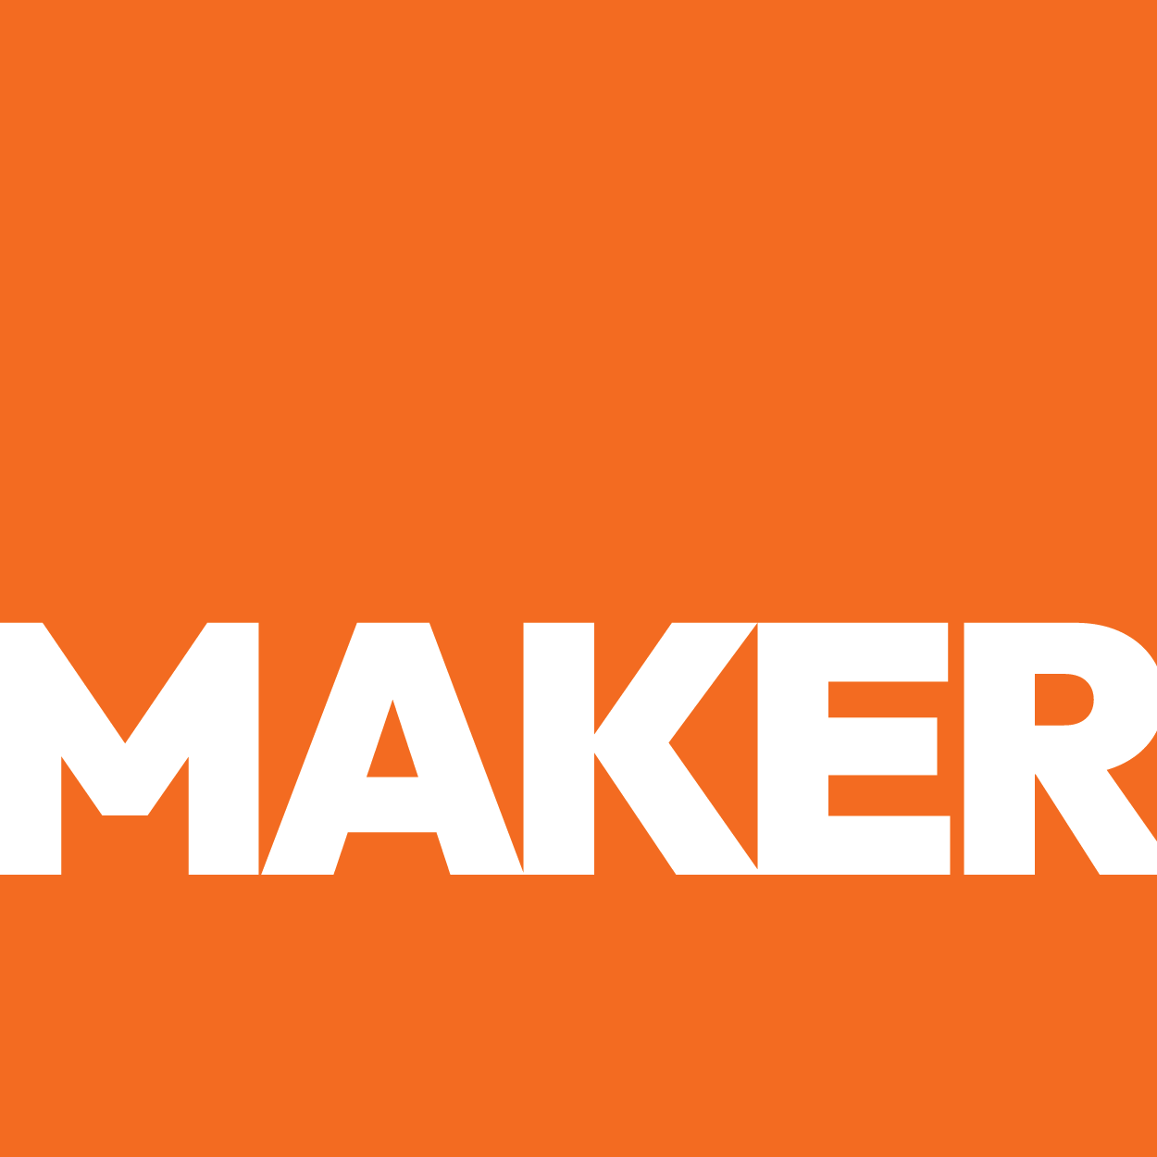

SALES STRATEGY & VALUE PLAYBOOK
SALES STRATEGY
& VALUE PLAYBOOK

Positioning, Prospecting, and Building a Pipeline That Scales
● Prepared by Maker Web Studios ● March 2026 ●
CONFIDENTIAL — PREPARED EXCLUSIVELY FOR Empiria Labs
SECTION 01
Current Position — Honest Assessment
Services & Revenue Potential
SERVICE CATEGORY | BUYER PROFILE | REVENUE POTENTIAL
Pesticide Residue Analysis (LC/MS-MS, GC/MS-MS) | QA Manager at produce companies, FSMA compliance officers | HIGHEST -- This is the core revenue driver. Every produce company shipping through the RGV needs pesticide testing for regulatory compliance and retailer audits. Recurring revenue, high volume, non-discretionary.
Microbiological Testing (E. coli, Salmonella, Listeria) | Food safety directors, produce company owners | HIGHEST -- Required for FSMA compliance, retailer food safety audits, and export certifications. Often bundled with pesticide testing for the same shipments.
Heavy Metals & Mycotoxin Analysis (ICP/OES) | Organic producers, export-focused companies, regulatory agencies | HIGH -- Growing demand driven by consumer awareness and tightening international standards. Often required for organic certification and premium retail placement.
Petroleum Geochemistry (TOC, Pyrolysis, Rock Eval, Biomarkers) | Oil & gas exploration companies, geological survey firms | MEDIUM -- Separate revenue stream from food safety. Less recurring but higher per-project value. Leverages Jorge Cortes' PhD expertise directly.
ROI Ranking: Where to Spend Sales Energy
RANK | CLIENT TYPE | WHY IT WINS
#1 | Mid-size produce companies ($5M-$50M revenue) in the RGV | Highest volume, most testing frequency, strongest proximity advantage, recurring monthly contracts.
#2 | Cross-border produce importers (Mexico to US) | Need both US and Latin American regulatory expertise. Empiria's bilingual capability and Colombian entity create a unique bridge.
#3 | Organic produce growers seeking certification | Premium testing requirements, willing to pay more for accredited results, growing market segment.
#4 | Retail supply chain auditors (Walmart, HEB, Kroger suppliers) | Retailer requirements are tightening, and suppliers need accredited labs to maintain shelf access.
#5 | Oil & gas exploration companies in South Texas | Leverages Jorge's PhD directly, higher project values, less price-sensitive, but lower frequency.
SECTION 02
5 Highest-Value Capabilities by Market Demand
SKILL 1: Pesticide Residue Analysis Using Multi-Residue LC/MS-MS and GC/MS-MS Methods
MARKET DEMAND: 9/10 | SCARCITY: HIGH | SCALABLE: YES
Who Pays for This?
QA Manager or Food Safety Director at a mid-size produce company in the Rio Grande Valley, responsible for FSMA compliance and third-party testing vendor relationships. Typically manages $50K-$100K+ annual testing budget across multiple crops and shipping cycles.
What Problem Does It Solve?
Produce growers in the RGV are shipping samples 350+ miles to Houston or San Antonio, losing 3-5 days per testing cycle during peak harvest when every day of delay costs thousands in held inventory. They need a local, accredited testing partner but cannot find one online because Empiria's digital presence is functionally nonexistent.
What a $ Engagement Looks Like
DELIVERABLE | WHAT IT INCLUDES | VALUE TO CLIENT
Multi-residue pesticide screen (200+ compounds) | Composition analysis with interpretation | Pass/fail determination for FDA, USDA, and retailer limits
Certificate of Analysis (CoA) | Composition analysis with interpretation | Regulatory-ready documentation for shipment release
Quarterly compliance summary | Composition analysis with interpretation | Early warning system for emerging contamination patterns

SKILL 2: Microbiological Pathogen Detection and Indicator Organism Testing
MARKET DEMAND: 9/10 | SCARCITY: HIGH | SCALABLE: YES
Who Pays for This?
QA Manager or Owner at a $1M-$50M produce operation in South Texas or Northern Mexico
What Problem Does It Solve?
Cannot find a local accredited lab and currently ships samples to Houston, losing 3-5 days of turnaround
What a $ Engagement Looks Like
DELIVERABLE | WHAT IT INCLUDES | VALUE TO CLIENT
Pathogen detection panel (Salmonella, Listeria, E. coli O157:H7) | Validated methods per FDA BAM and ISO standards | Clear positive/negative results with turnaround commitment
Indicator organism testing (Total Coliforms, Yeast & Mold, Staph aureus) | Quantitative results for process control and sanitation verification | Trend data to prevent contamination events
Environmental monitoring program design | Sampling plan, zone mapping, and corrective action triggers | Proactive contamination prevention system

SKILL 3: Heavy Metals Quantification via ICP/OES
MARKET DEMAND: 10/10 | SCARCITY: CRITICAL | SCALABLE: YES
Who Pays for This?
QA Manager or Owner at a $1M-$50M produce operation in South Texas or Northern Mexico
What Problem Does It Solve?
Cannot find a local accredited lab and currently ships samples to Houston, losing 3-5 days of turnaround
What a $ Engagement Looks Like
DELIVERABLE | WHAT IT INCLUDES | VALUE TO CLIENT
Heavy metals panel (Pb, Cd, As, Hg) | ICP/OES analysis with method validation under ISO 17025 | Results benchmarked against FDA, Prop 65, and retailer limits
Raw material screening program | Incoming ingredient testing protocol | Supplier qualification data for procurement decisions
Annual heavy metals trend report | Year-over-year comparison of results by product and source | Risk assessment and sourcing recommendations

SKILL 4: Mycotoxin Analysis for Grains, Spices, and Produce
MARKET DEMAND: 6/10 | SCARCITY: HIGH | SCALABLE: YES
Who Pays for This?
QA Manager or Owner at a $1M-$50M produce operation in South Texas or Northern Mexico
What Problem Does It Solve?
Cannot find a local accredited lab and currently ships samples to Houston, losing 3-5 days of turnaround
What a $ Engagement Looks Like
DELIVERABLE | WHAT IT INCLUDES | VALUE TO CLIENT
Mycotoxin screening panel (Aflatoxins B1/B2/G1/G2, Ochratoxin A, Fumonisins) | LC/MS-MS quantification | Results compared to FDA action levels and EU maximum limits
Import clearance testing package | Rapid turnaround for border-crossing shipments | Documentation formatted for CBP and FDA import compliance
Storage condition monitoring | Pre- and post-storage testing to verify mycotoxin stability | Data to support warehouse quality control decisions

SKILL 5: Petroleum Geochemistry -- TOC, Pyrolysis, Rock Eval, Biomarker Analysis
MARKET DEMAND: 10/10 | SCARCITY: CRITICAL | SCALABLE: YES
Who Pays for This?
QA Manager or Owner at a $1M-$50M produce operation in South Texas or Northern Mexico
What Problem Does It Solve?
Cannot find a local accredited lab and currently ships samples to Houston, losing 3-5 days of turnaround
What a $ Engagement Looks Like
DELIVERABLE | WHAT IT INCLUDES | VALUE TO CLIENT
Source rock evaluation (TOC + Rock Eval Pyrolysis) | Organic richness and thermal maturity assessment | Prospect ranking data for exploration decisions
Biomarker fingerprinting | GC/MS-MS molecular characterization | Source correlation and migration pathway analysis
Crude oil geochemistry report | Composition analysis with interpretation | Asset valuation support data

SECTION 03
Outreach Messages
Prospect-specific messages that lead with their problem. Personalize the before sending.
Message 1 — —
Subject:
Hi , . . . . .
Message 2 — —
Subject:
Hi , . . . . .
Message 3 — —
Subject:
Hi , . . . . .
Message 4 — —
Subject:
Hi , . . . . .
Message 5 — —
Subject:
Hi , . . . . .
Message 6 — —
Subject:
Hi , . . . . .

SECTION 04
Client Onboarding Questionnaire
Send before the first discovery call. Saves 30+ minutes and signals professionalism before the work begins.

SECTION 05
Proposal Template
for all client-specific fields. Sections: The Opportunity, Recommended Package, Why Empiria Labs, Investment, Next Steps.]

"Before sending: (1) Read the proposal aloud once. (2) Reference something specific from the discovery call. (3) Add one credential that matches their industry. These three things are the difference between a proposal that gets filed and one that gets signed."
— Maker Web Studios Proposal Personalization Reminder

SECTION 06
Final Notes — The Advantage
Recommended First 90 Days:
1 | Deploy the Website Within 30 Days  The single highest-leverage action Empiria can take is having a functioning website that communicates services, credentials, and a way to submit samples. Every other action depends on this foundation existing.
2 | Claim and Optimize Google Business Profile  This is the fastest path to local search visibility. A fully optimized GBP with services, photos, and posts will surface Empiria in "lab near me" searches within weeks -- even before the website ranks organically.
3 | Build Direct Relationships with Produce Association Leaders  Empiria should be a presenting sponsor or speaker at Viva Fresh and similar produce industry events. Sarai's existing presence at Viva Fresh EDGE is the right foundation -- expand it to include Empiria's testing capabilities.
4 | Develop a Referral Program for Existing Clients  Every satisfied client knows other growers who need testing. A simple referral incentive (priority processing, volume discount) can turn existing relationships into a pipeline.
5 | Publish One Educational Article Per Month  Topics like "What FSMA Means for RGV Produce Growers" or "How to Read a Pesticide Residue Report" position Empiria as a thought leader and capture organic search traffic from growers researching compliance requirements.

"The move: Stop selling . Start selling outcomes. does not buy — they buy . does not buy — they buy . Price accordingly."
— Maker Web Studios Growth Strategy Recommendation

