SIMPLE SOLARIUM CONTROL

This device controls the Solarium by commands from a PC or other IoT device:

* Commands are transmitted via RS485 as texts
* Command Execution - System-on-Module LPC824 Lite
* LPC824 Lite installed in I2C 2RO + 2DI Pro module
* More details on GitHub: <https://github.com/makethingshappy/I2C_2RO-2DI_Pro>
* Algorithm of the command executor - in the Adapter Firmware file
* Connection diagram - in the file Debug_Connection-2DI2DO
* Diagnostic description - in the Diagnostic file

Debug stand in the following photo:

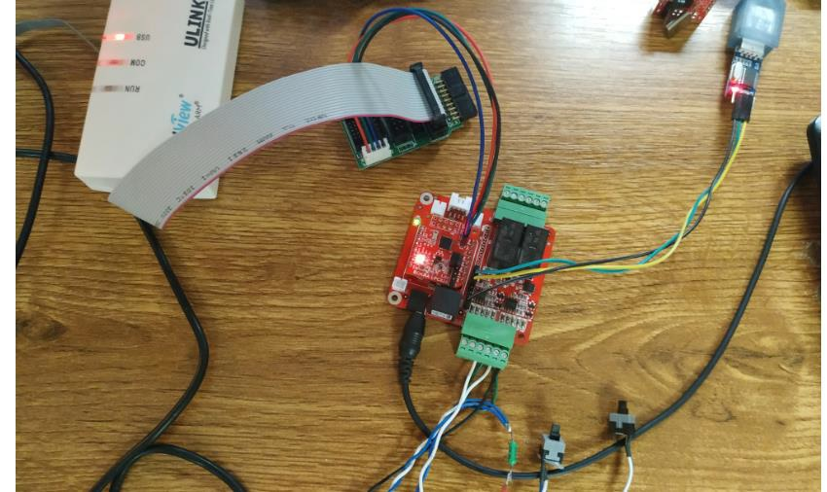

The firmware for this example was developed by Peter Janis for BOKRA.