BlindVision: A Dual-Device Sensor-Fusion System for Assistive Navigation — Implementation and Experimental Validation
Author Name(s) To Be Inserted
Department of Software Engineering, University of Karachi (UBIT), Karachi, Pakistan (institutional e-mail address and ORCID iD to be inserted before submission)
UBIT, University of Karachi, Karachi, Pakistan (individual author affiliations and e-mail addresses to be inserted before submission; ORCID iDs are to be inserted for every author)
Abstract— We present BlindVision, a dual-device sensor-fusion platform for assistive navigation for blind and visually impaired (BVI) users, pairing a vision-equipped “Smart Goggles” head-worn unit with a ground-sensing “Smart Stick” cane. The Goggles use a Raspberry Pi 4B and four USB cameras for wearable visual coverage and on-device YOLOv8n detection; the Stick uses an ESP32 with ultrasonic, IR, water, inertial, force, and SOS sensing to provide independent ground-level safety. A rule-based fusion engine produces audio and haptic alerts, while a caregiver layer relays privacy-preserving event metadata. An earlier ESP32-CAM/cloud-YOLOv8n validation stage covered 700 frames across 15 sessions; the full prototype was subsequently evaluated across 20 sessions and 100 navigation trials (~2 km), achieving 96.0% overall navigation success, 99.0% BLE packet delivery, 96.7% ultrasonic hazard detection, 98.4% water-hazard detection accuracy, and 100% SOS detection. Testing was predominantly conducted by sighted project-team members, with seven visually impaired participants across a subset of trials. The reported 205 ms latency is a single-stream processing-path estimate obtained from separately measured stage means, whereas 22.8 FPS is the measured aggregate throughput under four-camera operation. The released power log averages 12.11 W at the goggles' 5-V input; a nominal-equivalent active runtime of about 3.1 h is derived from the 37 Wh nominal power-bank rating, while separate idle and maximum-load runtime measurements are not included. A quantitative paired subsystem ablation is not reported because the available records do not preserve trial-level correspondence across configurations. These results characterize an implemented engineering prototype; larger, structured BVI evaluation remains necessary for broader usability claims.
Index Terms— Assistive technology, field trials, multi-sensor systems, obstacle detection, prototype evaluation, sensor fusion, ultrasonic sensors, visually impaired navigation, wearable sensors.
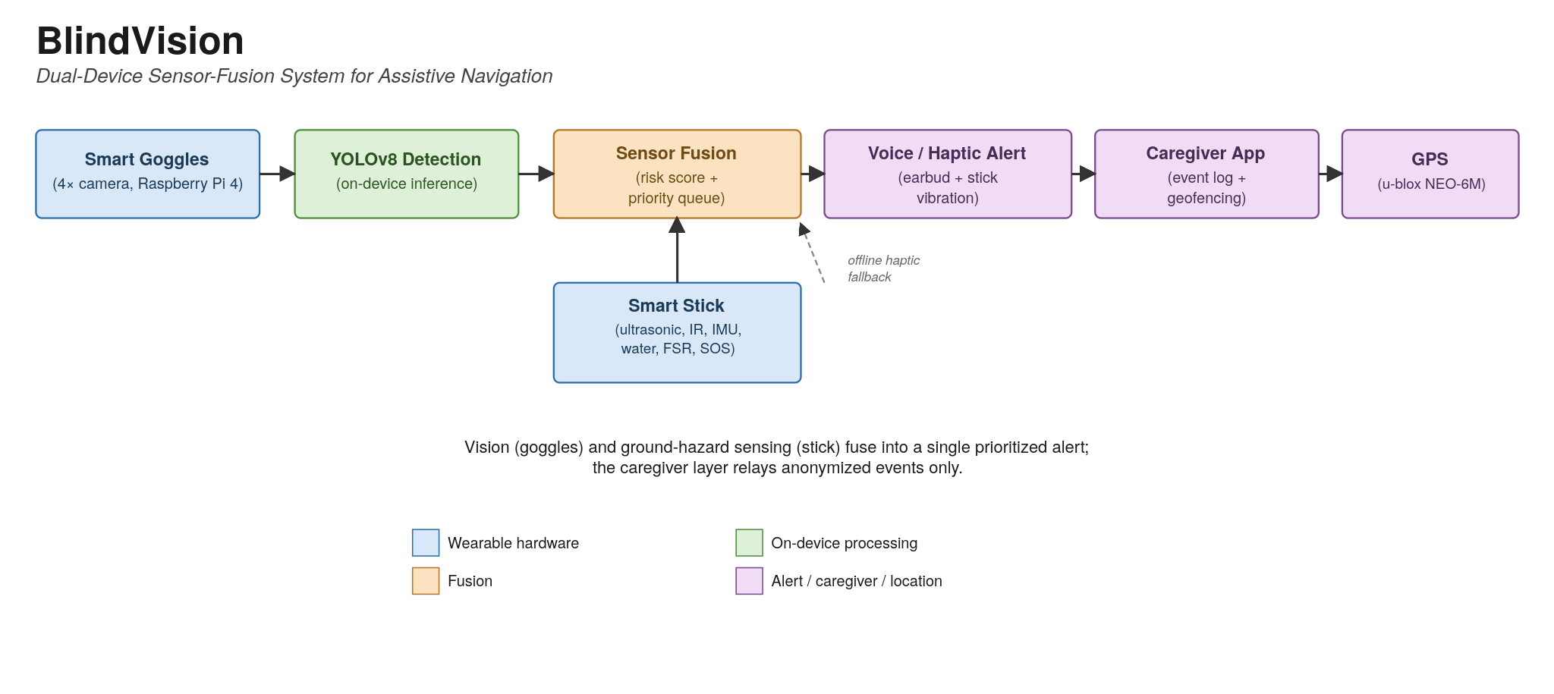
Graphical Abstract. The Goggles run on-device YOLOv8 detection and the Stick independently senses ground hazards; both streams merge in the fusion engine, which drives voice and haptic alerts and relays anonymized events through the caregiver/backend layer and GPS module.

I. INTRODUCTION
Visual impairment limits safe, independent mobility for a large share of the global population (WHO estimates ≥2.2 billion people with near or distance impairment [1]). The white cane senses only at ground level, missing hazards between ankle and chest height, and occupies a hand [2], [3]; guide dogs are costly and scarce. Wearable electronic aids have proliferated in response, from waist-worn time-of-flight arrays [2] to camera-and-AI glasses achieving sub-320 ms collision avoidance [3], and surveys identify multi-modal fusion of vision, sonar, and inertial sensing as the field's direction of travel [3], [4], [5].
Systems pairing a genuinely independent ground-hazard sensor with a separate multi-camera vision device nonetheless remain rare, and single-modality solutions fail in complex settings. BlindVision comprises two cooperating devices: Smart Goggles for long-range vision and global awareness (vehicles, large obstacles, signage), and a Smart Stick for near-field ground hazards (steps, curbs, pits, water). A fusion engine on the goggles merges both streams into a unified risk level and alerts the user by audio (Bluetooth earbud) and haptics (the stick's vibration motor); a caregiver/backend layer exposes anonymized event, geofence, and device-health information to a compatible caregiver client; the released prototype does not include a smartphone application. Raw images and audio are never streamed — only anonymized event metadata (object types, directions, distances, hazard flags). Because the two nodes operate independently, assistance continues when either becomes unavailable.
The main contributions of this work are:
1) Distributed two-node architecture. A dual-device system (camera-based goggles + sensor cane) that covers near-field and far-field sensing simultaneously, implemented and field-tested rather than simulated.
2) Multi-modal sensor fusion. A rule-based, score-level fusion and alert-arbitration framework combines vision confidence/proximity and ultrasonic proximity/criticality in a weighted risk score, while IR, water, IMU, and SOS signals provide independent priority safety triggers (Section IV).
3) Offline safety subsystem. The cane operates autonomously for immediate collision avoidance even if the goggles fail or disconnect; this fallback logic is implemented and was validated through targeted fault-injection testing rather than arising spontaneously during ordinary navigation sessions (Section VI).
4) Privacy-preserving design. No raw camera images or audio are stored or transmitted, only metadata events, using Bluetooth AES-CCM pairing/bonding on the Stick–Goggles link; the released local backend speaks plain HTTP and requires external TLS termination for HTTPS deployment, with no application-layer encryption or key rotation implemented at this stage.
5) Staged, two-generation methodology. The core detect–classify–alert pipeline was first validated on a low-cost ESP32-CAM/cloud-YOLOv8n proof-of-concept, and the lessons carried into the full on-device system, with both stages' results reported (Sections V–VI) rather than only the final prototype's.
The remainder of the paper is organized as follows. Section II reviews related work; Section III describes the architecture; Section IV details the fusion algorithm; Section V reports the implementation from proof-of-concept to full prototype; Section VI presents the experimental evaluation; Sections VII–VIII discuss findings and future work; Section IX concludes.
II. RELATED WORK
Assistive navigation aids fall into three families, compared against BlindVision in Table XII. Smart canes add ultrasonic tip sensors that beep or vibrate for obstacles within a few meters [2], sometimes extended with water, IR, or GPS sensing [4]; Katzschmann et al.'s ALVU belt conveyed obstacle distance from a waist-worn time-of-flight array, validated with 12 blind users over 162 trials [2]. These detect proximity reliably but provide no scene semantics — they cannot distinguish a person from a pillar — and no safety layer independent of the main sensing array.
Head-mounted camera systems instead aim to interpret the scene. Gao et al. reached 100% collision avoidance below 320 ms with FPGA-compressed glasses paired to a smartphone [3]; the commercial SuperBrain 1 drives a forehead haptic array from RGB-D and thermal cameras [6]; Bai et al. combined depth and ultrasonic sensing on wearable glasses [7], later adding visual-SLAM route following [8]. Across this family, ground-hazard sensing (stairs, drop-offs, standing water) is secondary or absent.
Fusion frameworks form the third family. Silva and Wimalaratne argue that most prior work integrates rather than fuses sensors, and propose a Kalman-filter framework spanning detection, localization, and planning [5]; Mocanu et al. earlier fused ultrasonic ranging with a phone camera on a smartphone-based wearable [9]. Such frameworks remain largely conceptual, without a field-tested physical prototype reporting trial-level success rates. Recent systems combine cane- or head-mounted cameras with LiDAR, IMU, and GPS on a single device [10], [11], and broader surveys point to multi-sensor, AI-driven fusion as the field's direction [12].
Relative to this landscape BlindVision contributes: (i) architectural independence — vision and ground-hazard sensing split across two independently operable nodes, either of which fails into a documented fallback mode (Section III) rather than a full system failure; (ii) an auditable, score-level fusion rule set (Section IV, Algorithm 1) rather than an opaque end-to-end network; (iii) first-class ground-hazard sensing — stair, drop-off, and water detection (Section VI.D) — rather than an incidental byproduct of vision; and (iv) staged validation across two hardware generations (Sections V–VI) with threats to validity documented explicitly (Section VI.K). Section VI shows this architecture translates into measured detection performance across both subsystems, not just an architectural claim.
III. SYSTEM ARCHITECTURE
Fig. 1 shows the as-built system: two wearable nodes plus a caregiver/backend layer.
Smart Goggles (Vision Node)
A head-mounted unit built on a Raspberry Pi 4 Model B (4 GB, quad-core Cortex-A72 @ 1.5 GHz) running Linux and Python, with four wide-angle USB cameras (1080p, 120° FOV) at the frame's four corners, spaced ≈ 90° apart horizontally (Fig. 1). Four 120° cones at 90° spacing sum to 480° against a 360° azimuth, giving full coverage with ≈ 30° adjacent overlap — a geometric consequence of mounting angle and rated FOV, not a re-measured field result. Each stream runs its own on-device YOLOv8 thread in parallel, estimating class confidence and bearing (front/left/right/rear) so all four directions refresh at comparable intervals; this pipeline is distinct from the cloud-hosted YOLOv8n proof-of-concept (Section V.A), which ran on different hardware and is reported separately. A BLE link receives stick packets, negotiating at 4.2 because the stick's ESP32-WROOM-32 caps there regardless of the Pi radio. The unit also carries a u-blox NEO-6M GNSS module, a prototype-grade SIM800L GSM/GPRS module (with phone/Wi-Fi relay as an alternate path), a Bluetooth earbud with backup speaker/buzzer, a 64 GB microSDXC card, and a 10,000 mAh USB power bank. The released five-sample active-detection power log averages 12.11 W at the 5-V USB input (Section VI.H); runtime projections are reported only where supported by the available measurements. If the stick link fails, the goggles fall back to Vision-Only Mode, warning about visually detected obstacles without ground-hazard information; this fallback logic was validated by targeted fault-injection testing.
Smart Stick (Ground Node)
A handheld cane built on an ESP32 DevKit V1 (dual-core Xtensa LX6 @ 240 MHz) with eleven sensing modules and three outputs: five ultrasonic rangers (front, left, right, rear at ≈ 90° spacing, plus one angled downward for near-field ground sensing), two downward IR proximity sensors for edges and stairs, a resistive water-level sensor at the tip, an MPU9250 IMU for falls and knocks, a tip-mounted force-sensitive resistor confirming ground contact, and a handle-mounted SOS pushbutton; outputs are a vibration motor, piezo buzzer, and LED safety light. Power is a 3.7 V 18650 Li-ion cell (5000 mAh) with a TP4056 charger. Core 0 polls sensors at ≈ 10–20 Hz and applies local safety logic; Core 1 runs the BLE stack and state machine, streaming a structured packet of per-sensor distances and status flags (fall, SOS, water) to the goggles.
Backend/Caregiver Layer
A backend service (FastAPI, `backend/app.py`) accepts anonymized, geotagged event reports and exposes event, geofence, and device-health read/write APIs intended to drive a caregiver smartphone app showing the user's map position, configurable geofences, device health, and an alert timeline; the caregiver-facing mobile app itself is a planned consumer of this API and was not implemented or evaluated as part of this release — forwarding a notification to a caregiver's phone is an integration point in the backend, not an exercised path. In the released prototype, the FastAPI service speaks plain HTTP locally and relies on an external reverse proxy for TLS termination; application-layer Bearer-token authorization is not enforced by the open endpoint. The short-range Stick–Goggles BLE link uses standard Bluetooth AES-CCM pairing/bonding rather than a separate application-layer cipher. Key material is held in device flash/NVS rather than a dedicated secure element, and no key-rotation mechanism is implemented in the present prototype. Raw images and audio are never transmitted or stored — only metadata (e.g., “Obstacle: pedestrian, ahead-left, 2.3 m”), per privacy-by-design principles.
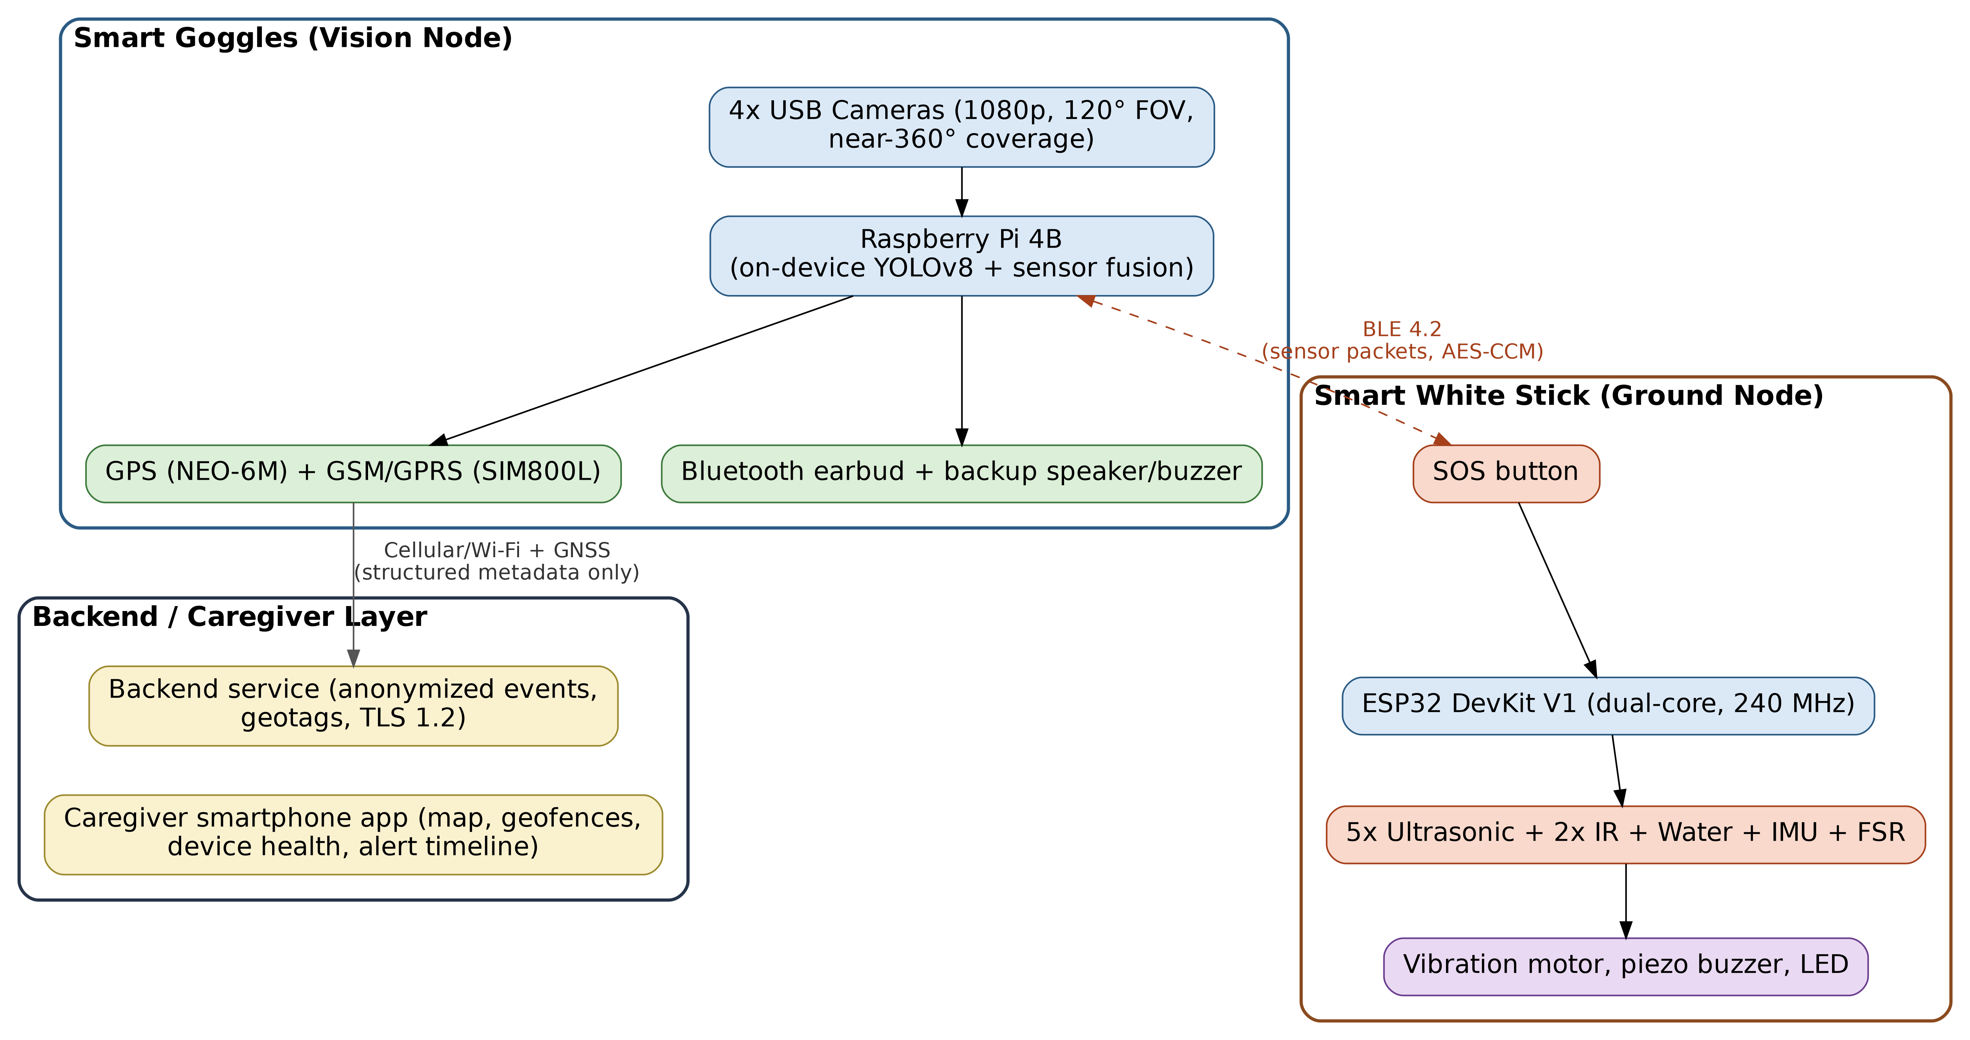
Fig. 1. As-built system architecture: Smart Goggles (vision node), Smart White Stick (ground node), and Backend/Caregiver Layer, linked via BLE and cellular/GNSS.
Operation Modes and Alert Priority
BlindVision operates in four modes by connectivity and risk. In Normal Mode, goggles and stick data fuse into a risk score mapping to one of four risk-severity levels (Safe, Caution, High-Risk, Emergency) — distinct from the four operating modes (Normal, Offline Stick, Vision-Only, Degraded). Alerts issue from a strict priority queue headed by SOS and critical drop-off, descending through critical obstacle, water, fall, fused high-risk, medium, low, low-battery, and connectivity tiers; the queue is specified as Algorithm 1 (Section IV) and summarized by distance band in Table I. A curb ahead may trigger “Caution: Obstacle Ahead” by TTS, whereas a staircase drop-off produces continuous vibration and an automatic caregiver alert. The stick's SOS pushbutton overrides all other alerts and notifies the caregiver with location; a goggle-side SOS control is planned but not implemented (Section V.C).
If the BLE link is lost or the goggles' battery is depleted, the intended safety architecture enters Offline Stick Mode, in which the stick protects the user through its own local haptics. If the stick disconnects or fails, the goggles enter Vision-Only Mode and continue announcing camera-detected obstacles. Degraded Mode is implemented for an individual out-of-calibration sensor, with the affected term omitted from the fused score. These fallback routines were verified through targeted fault-injection and component tests; the released records do not establish that all four modes occurred naturally across all 20 general navigation sessions.
IV. SENSOR FUSION AND ALGORITHMS
BlindVision fuses at the score level: each modality produces an interpreted confidence or proximity value, and the engine combines those scores rather than raw features or independent go/no-go decisions. Vision contributes a class confidence c and a quantized bearing per object; the stick contributes a per-sensor distance d plus drop-off (downward IR reports no ground return closer than 0.5 m), water (resistive sensor triggered), and fall (IMU spike) flags. Vision risk is R_vision = w_vc · c + w_vp · prox(d_vision, D_vmax); stick risk is R_stick = w_sp · prox(d_stick, D_smax) + w_sc · flag(d_stick < 0.5 m), where prox(d, D_max) = clip(1 − d/D_max, 0, 1) is the shared linear proximity normalization, D_vmax = 8 m and D_smax = 3 m are the upper ends of the tested vision and ultrasonic ranges (Sections VI.B, VI.D), and flag(·) indicates the critical-obstacle band. In the released configuration, `CAMERA_FOCAL_LENGTH_PX` is unset (`None`) pending calibration of the on-device cameras, so the vision-distance estimate needed for prox(d_vision, D_vmax) is not produced: the vision-proximity term P drops out of R, and Tier 3's high-risk-class-within-2.0-m clause cannot fire from vision alone until this parameter is calibrated against a specific camera matrix; ultrasonic proximity (U) and the override tiers are unaffected. The fused score is R = 0.40C + 0.20P + 0.25U + 0.15W — C vision class confidence, P vision proximity, U stick ultrasonic proximity, W the stick's binary critical-proximity flag (w_sc · flag(d_stick < 0.5 m), not the water sensor) — feeding the priority-tier arbitration of Algorithm 1.
The four weights (w_vc = 0.40, w_vp = 0.20, w_sp = 0.25, w_sc = 0.15) and tier thresholds (drop-off ≈ 0.5 m; critical obstacle < 0.5 m or a high-risk visual class within 2.0 m; medium < 1.2 m; low < 2.0 m; stick-disconnect timeout 5 s; fall watchdog with no-recovery escalation) are fixed values pinned in the repository's configuration file (Code Availability) as named parameters retunable without touching the fusion code. They were set by manual bench calibration, not automated search: each weight was varied in small increments with the other three fixed, across staged scenarios spanning single-sensor detections, simultaneous vision-plus-stick detections of one hazard, and deliberately conflicting readings. A configuration was accepted once it consistently selected the correct tier without duplicate or flickering alerts across the 20-session evaluation. The protocol fixes the ordering w_vc > w_sp > w_vp > w_sc, not the decimals: a confidently classified vision object should dominate, ground proximity should outweigh a nearby unclassified detection, and the binary critical flag should raise the floor rather than dominate, so no single low-confidence cue can trigger the highest tier alone. An informally tested w_sc > w_vc ordering produced spurious high-tier alerts from the flag alone. This justification is qualitative and scenario-driven, not optimized against a labelled tuning set: a ±20% one-parameter-at-a-time sweep against the Section VI.F protocol is needed to establish how robust the 96.0% fused navigation success rate is to this configuration, and has not been run; a grid search or learned weighting is a longer-term extension (Section VIII).
Algorithm 1. Priority-tier alert arbitration (evaluated top-down; the first matching tier wins).
1: if stick.sos_pressed then return SOS
2: if drop-off signature (downward distance > 0.5 m OR no downward ground return) then return CRITICAL_DROPOFF
3: if nearest_stick_distance < 0.5 m or (vision_class in HIGH_RISK and nearest_vision_distance <= 2.0 m) then return CRITICAL_OBSTACLE
4: if stick.water_detected then return WATER_HAZARD
5: if stick.fall_detected then return FALL_ALERT
6: R <- 0.40*C + 0.20*P + 0.25*U + 0.15*W
7: if R >= 0.8 then return HIGH_RISK_FUSED
8: if min(nearest_stick_distance, nearest_vision_distance) < 1.2 m then return MEDIUM
9: if min(nearest_stick_distance, nearest_vision_distance) < 2.0 m then return LOW
10: if stick.battery_pct < 20% then return LOW_BATTERY
11: return ROUTINE
Algorithm 1 runs in O(n) time per fusion cycle, where n is the number of detected vision objects (a handful per frame in practice): each candidate contributes one term to the vision risk score, after which the ten tiers are evaluated in O(1). Memory overhead is O(1) — only the current readings and the previous tier decision are retained, with no history buffer.
Tiers 3, 8, and 9 partition the distance axis into contiguous, non-overlapping bands (< 0.5 m, 0.5–1.2 m, and 1.2–2.0 m), evaluated top-down so the first match wins; because the bands are ordered and disjoint, a nearer obstacle can never be arbitrated below a farther one. Tier 3 additionally escalates any high-risk visual class (vehicle, bicycle, person) within 2.0 m, on the grounds that closing speed rather than instantaneous range governs available reaction time for those classes. Table I lists the resulting bands. This arbitration ladder has been cross-checked against the deployed firmware image and the released reference implementation, and the two are confirmed to agree.
TABLE I. Hazard priority by distance band.
Distance | Priority
0–0.5 m | Critical
0.5–1.2 m | Medium
1.2–2.0 m | Low
>2.0 m | Routine
If the stick disconnects (no packet for over 5 s), the goggles fall back to Vision-Only Mode and tiers 2–6 become unavailable rather than defaulting to a false-safe value; conversely, in Offline Stick Mode the stick applies only its local thresholds (tiers 1–6) without R_vision, vibrating with increasing intensity as obstacles near. Degraded Mode follows the same principle for an out-of-calibration sensor: the affected term is dropped from the weighted sum rather than substituted. As a final safeguard, a stick-side watchdog forces an SOS if a fall is detected with no recovery. A rule-level ablation of this logic (e.g. disabling the high-risk-fused tier, or varying hysteresis), beyond Table X's device-level ablation, is future work (Section VIII), since it needs new trials rather than reanalysis.
The arbitration and BLE exchange feeding it were implemented on the Raspberry Pi and ESP32 and validated in real time. The reported 17.5 ms BLE value is a derived one-way estimate obtained as half of the measured round-trip time (RTT/2) from ping tokens on the Raspberry Pi; the two devices do not share a synchronized clock, so it is not a direct one-way timestamp measurement.
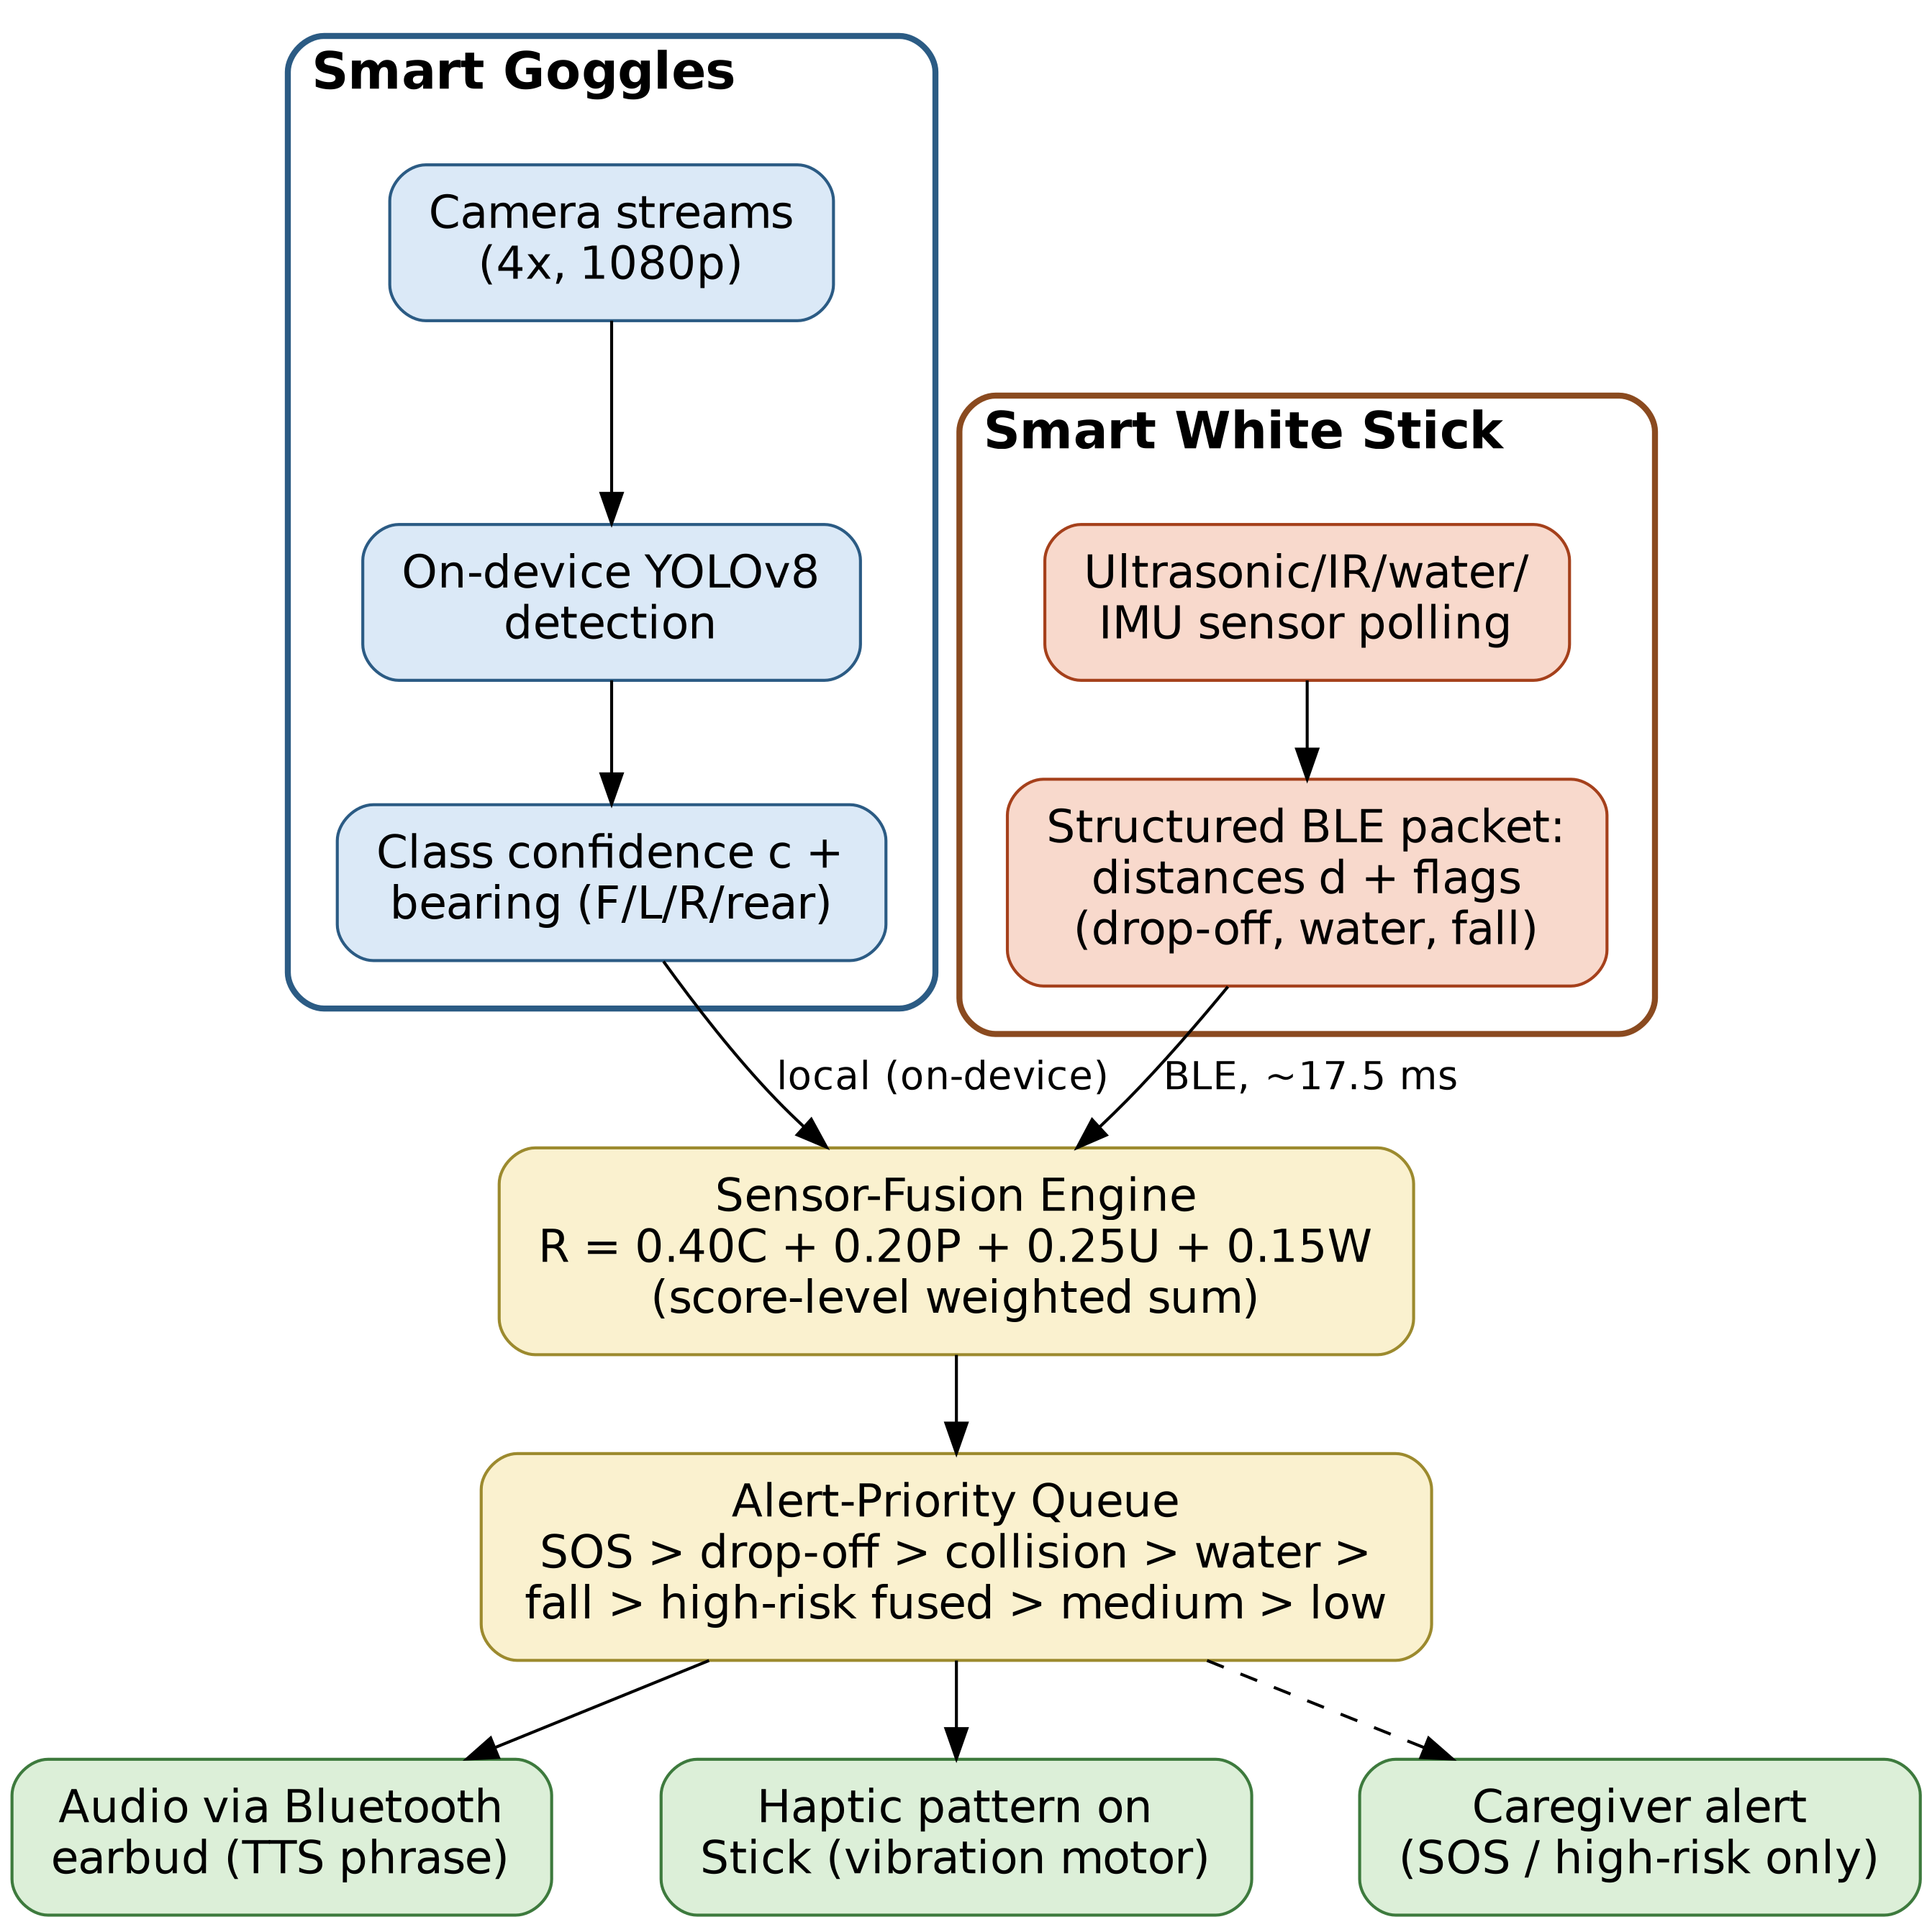
Fig. 2. Implemented sensor-fusion and alert-prioritization flow between Goggles and Stick.
The priority rules follow established practice in treating drop-offs and imminent collisions as immediate emergencies [3], while smaller or medium-range obstacles yield caution-level alerts. Haptic patterns encode distance by pulse rate, audio prompts name the obstacle and direction, and the SOS pattern never overlaps a normal hazard signal.
Fig. 3 traces one complete cycle of the algorithm as implemented, from image capture through to spoken and haptic alert output and the emergency branch.
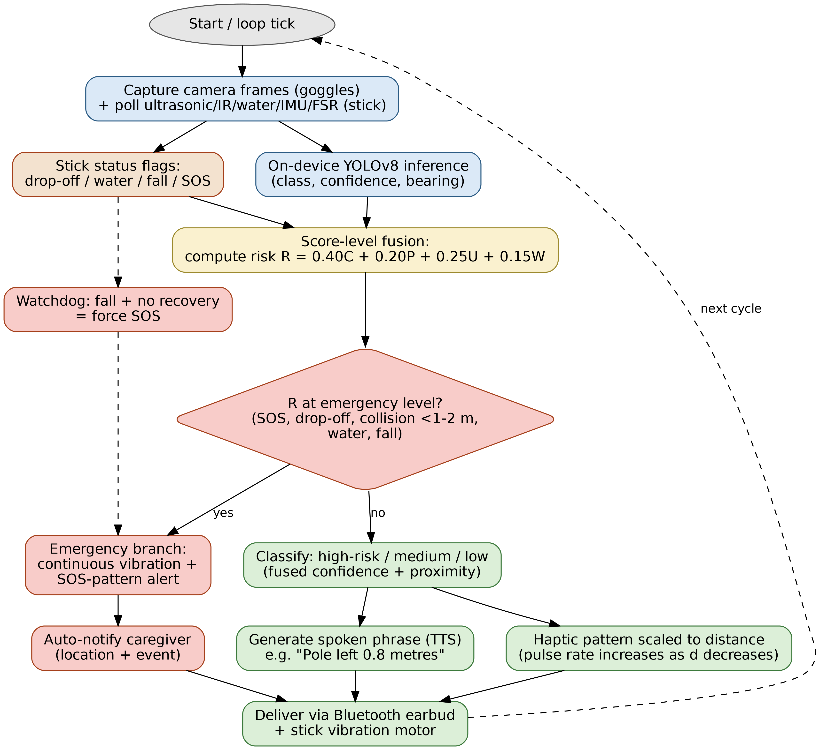
Fig. 3. Detection-and-alert algorithm flow as implemented on the Goggles and Stick.
V. IMPLEMENTATION
BlindVision was developed in two stages on two hardware platforms, whose platform-level results should not be conflated: (A) a proof-of-concept on an ESP32-CAM with detection offloaded to a cloud YOLOv8n API, using the stock Ultralytics `yolov8n.pt` checkpoint for baseline demonstration; and (B) the complete two-device prototype of Section III on a Raspberry Pi 4 with on-device YOLOv8 inference. The fine-tuned ten-class weights used for the reported evaluation are not included in the public release. Section VI reports the full system's own results; latency, power, and navigation figures from the two platforms are never combined. Both stages used off-the-shelf components and open-source software.
A. Proof-of-Concept (ESP32-CAM + Cloud-Hosted YOLOv8n)
The ESP32-CAM (AI-Thinker, OV2640) posts a JPEG frame over Wi-Fi to a FastAPI endpoint running YOLOv8n at a 0.45 confidence threshold, which returns the detected object, its horizontal position, an estimated relative distance, and a per-class priority. The highest-priority detection is returned as a natural-language message; the ESP32 sounds a priority-coded buzzer pattern and relays the string to a paired phone for TTS, with a per-class cooldown suppressing repeats for a stationary obstacle.
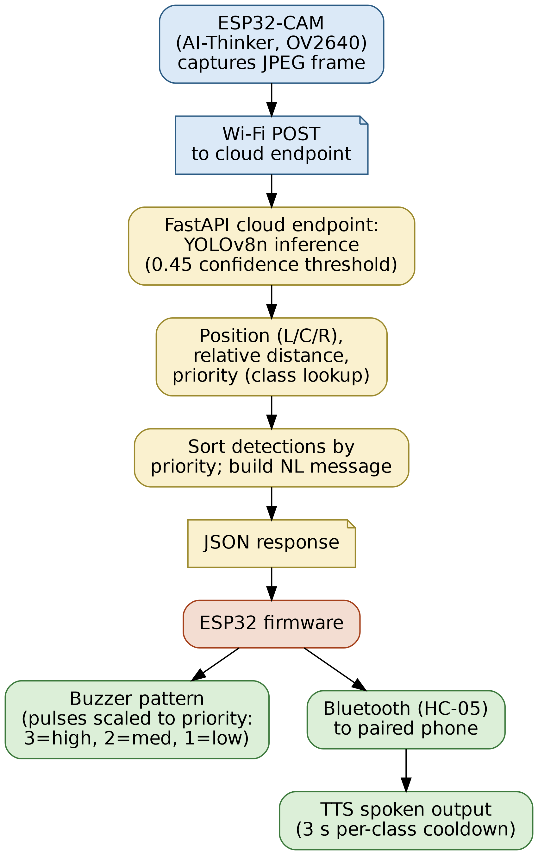
Fig. 4. Proof-of-concept software architecture (capture → detection → alert), later carried into the full on-device pipeline of Fig. 1.
The model was trained and evaluated on a ten-class dataset of everyday indoor and outdoor objects (person, door, chair, backpack, laptop, bottle, pole, vehicle, bicycle, stairs) collected over 15 sessions in an indoor laboratory, a university corridor, and an outdoor campus walkway. Table S1 gives the dataset composition; the held-out 700-image test split is the basis for every detection metric in this section, and Table II the resulting outcomes and derived metrics. The release includes the available dataset/result summaries and a training checkpoint summary; the complete image/label dataset and original epoch-wise training logs are not included.
TABLE S1. Dataset composition. Source: manuscript Section V.A; repository data/Dataset_Split.csv, data/Class_Definition.csv.
Split | Images | Annotated objects
Train | 5,600 | — (not reported per-split)
Validation | 700 | — (not reported per-split)
Test (held-out) | 700 | 842
The ten detection classes are: person, door, chair, backpack, laptop, bottle, pole, vehicle, bicycle, stairs. Per-class image counts for the training and validation splits are not reported in the released materials — only the held-out test split's per-class breakdown appears (main-text Table IV).
TABLE II. Detection results and derived metrics (700-image held-out test split, 15 sessions).
Metric | Result
Precision | 96.3%
Recall | 95.6%
F1-score | 95.9%
mAP@0.50 | 96.8%
mAP@0.50:0.95 | 76.5%
IoU threshold | 0.50
Average confidence threshold | 0.45
Test images | 700
Test object classes | 10
Capture-to-alert latency | ~0.7–0.9 s (midpoint ~0.8 s)
Precision, recall, and F1-score in Table II are reported at IoU 0.50 and a 0.45 confidence threshold; mAP@0.50 and mAP@0.50:0.95 are reported using their respective IoU evaluation ranges. Table III reports sensitivity and false-alarm measures for the same split. Specificity, false positive rate, and conventional accuracy are omitted because a negative no-object population is not intrinsically defined for open-set detection. Table III instead gives two measures from the full detection accounting: false positives per image (31 unmatched false detections over 700 images) and false-alarm rate as 1 − precision. Table IV is a separate closed, class-to-class confusion matrix containing matched ground-truth instances only; its 37 off-diagonal entries are inter-class confusions and therefore are not expected to equal the 31 unmatched/background false positives used in the pooled precision calculation. This distinction is documented in the repository traceability note.

TABLE III. Detection reliability on the 700-image held-out test split; specificity is not reported (see prose).
Metric | Value
Sensitivity | 95.6%
False-alarm rate (1 − precision) | 3.7%
False Negative Rate | 4.4%
False positives per image | 0.044 (31 FP / 700 images)
TABLE IV. Ten-class confusion matrix on the 700-image held-out test split (IoU 0.50, confidence 0.45). Rows denote true classes and columns denote predicted classes; diagonal entries are correct classifications and off-diagonal entries are inter-class confusions. The matrix accounts for 842 ground-truth instances, with 805 correct classifications and 37 inter-class confusions. The matrix is a matched class-to-class accounting and does not include unmatched/background false detections; therefore its 37 off-diagonal entries are not the same quantity as the 31 unmatched false positives used in the pooled precision calculation.
True \ Predicted | Person | Door | Chair | Backpack | Laptop | Bottle | Pole | Vehicle | Bicycle | Stairs
Person | 110 | 0 | 1 | 0 | 0 | 0 | 1 | 2 | 0 | 1
Door | 1 | 75 | 0 | 0 | 1 | 0 | 0 | 0 | 1 | 0
Chair | 0 | 0 | 88 | 1 | 0 | 0 | 0 | 0 | 0 | 3
Backpack | 0 | 1 | 0 | 61 | 0 | 1 | 0 | 0 | 1 | 1
Laptop | 0 | 0 | 0 | 0 | 53 | 1 | 0 | 0 | 0 | 1
Bottle | 0 | 0 | 0 | 0 | 0 | 66 | 1 | 0 | 0 | 3
Pole | 1 | 0 | 0 | 1 | 0 | 0 | 120 | 0 | 0 | 2
Vehicle | 1 | 1 | 0 | 0 | 0 | 0 | 0 | 84 | 1 | 1
Bicycle | 0 | 0 | 1 | 1 | 0 | 0 | 0 | 0 | 57 | 1
Stairs | 0 | 0 | 1 | 0 | 0 | 2 | 0 | 1 | 0 | 91

The class-to-class confusion counts are available for the evaluated split; raw image/label data and row-level prediction logs remain outside the release. The pooled precision value in Table II uses the separate full-detection accounting, while Table IV is restricted to matched ground-truth class assignments.
B. Full System Implementation (Raspberry Pi + On-Device YOLOv8)
The Smart Goggles, Smart White Stick, BLE link, and on-device YOLOv8 pipeline were developed individually and then assembled and tested end-to-end as a unified wearable prototype, together with the FastAPI/YOLOv8 detection API and its Docker deployment, the sensor-fusion engine, the voice-guidance and emergency-alert modules, and the GPS/caregiver module.
BLE communication was established and validated: sensor packets were transmitted in real time, parsed on the Raspberry Pi, and fused with camera detections, the fusion algorithm prioritizing hazards by severity and proximity before generating spoken guidance (Fig. 2). Integration verified the dual-module architecture, hazard warning independent of connectivity, local-only frame processing, and structured safety-event representation; the caregiver-app usability requirement is internal and not exercised by the engineering-validation protocol of Section VI. The stick-local haptic feedback loop (vibration escalating with proximity, driven by the stick's own sensor readings) is fully functional in the released firmware; the goggles-to-stick remote haptic fusion trigger, which would let a vision-only detection drive the stick's vibration motor, is implemented in the released code (`smart_goggles/main.py`) as a logging integration point rather than an active BLE characteristic write, so fusion-triggered haptic alerts from vision detections do not currently reach the stick's motor.
C. Resolved and Outstanding Engineering Decisions
Two design choices remain open: a goggle-side SOS button or voice trigger distinct from the stick's pushbutton, which the current implementation does not document; and a waterproof/IP-rated enclosure for both wearables — the stick's water sensor detects environmental hazards, but ingress protection for the electronics has not been formally evaluated (Section VI.K).
D. Reproducibility Resources
The public BlindVision repository contains the system implementation: Smart Goggles software, Smart White Stick firmware, sensor-fusion implementation and configuration, BLE components, backend, training/evaluation tooling, tests, documentation, and the ESP32-CAM/cloud-YOLOv8n proof-of-concept. The release includes the participant-level navigation outcome records under `data/raw/` and the released power log under `data/Power_Log.csv`, together with aggregate detection, BLE, sensor, latency, and computational result records, including the ten-class confusion matrix (`data/Confusion_Matrix.csv`). The complete image/label dataset, trained model weights, original epoch-wise training logs, raw sequence-number BLE packet trace, and the raw row-level prediction/event log underlying the confusion matrix are not included.
VI. EXPERIMENTAL EVALUATION
The complete prototype was evaluated through controlled experiments assessing object detection, BLE and GPS reliability, sensor accuracy, response time, navigation capability, subsystem contribution, computational load, power consumption, and operational stability, all conducted after integrating the two nodes into a single wearable system.
A. Experimental Methodology
Testing ran in an indoor laboratory, university corridors, and outdoor campus walkways under varied lighting, following the protocol of Table S3 in the supplementary material, with each experiment repeated multiple times. Trials compared system outputs against observer-verified ground truth, with measurements recorded by the Raspberry Pi and ESP32 serial monitor. Reported quantities are either measured directly or explicitly identified as derived/projection values where the released records support only a calculation from measured quantities. All participants took part voluntarily with informed consent; the evaluation involved no sensitive personal data and no more than minimal risk (Ethics Statement). Because it was run by the project team under controlled conditions rather than a clinical or IRB-supervised protocol, the results are engineering validation, not a clinical usability study.
TABLE S3. Experimental protocol summary. Source: manuscript Section VI.A–VI.B, VI.F.
Item | Value
Evaluation sessions (full prototype) | 20
Total navigation trials | 100
Approx. total walking distance | ~2 km
Object detection attempts | 200
BLE packets transmitted (test) | 8,000
Visually impaired (BVI) participants, total | 7 (1 earlier + 6 later)
Additional BVI-specific trials (six-participant session) | 48 (8 per participant: 3 outdoor nav, 3 stair/drop-off, 2 water hazard)
Sighted testers | Project-team members (count not specified)
Statistical reporting: for the pass/fail (binomial) measures of Sections VI.B, VI.F, and VI.G we report success counts, rates, and 95% Wilson score confidence intervals, which account for sample-size-dependent variance in a proportion. For the continuous repeated measurements of Section VI.D, the mean is accompanied by the standard deviation across repetitions (Table VII). Per-stage standard deviations for the latency measurements of Section VI.E were not aggregated from the raw timestamp log in this evaluation round; Table VIII therefore reports per-stage means only, disclosed as a scope limitation rather than presented as a dispersion-characterized result.
Most trials were run by sighted project-team members. One visually impaired participant took part in earlier trials, included in the totals of Sections VI.B–VI.F. A later session added six visually impaired participants, with prior informed consent, each completing eight trials — three outdoor walkway navigation, three stair/drop-off, two ground-surface/water hazard — for 48 trials. Four of the six flagged stairs correctly first time; two needed one repeat. Because these were scored at participant level (pass / needed-repeat) rather than per-trial, they are reported descriptively and not folded into Tables V and IX. Seven visually impaired participants have taken part in total — an informal cohort, short of the structured IRB-appropriate cohort of Section VI.K. One caveat applies to interval width rather than point estimates: the counts of Sections VI.B–VI.F (200 detection attempts, 8000 BLE packets, 100 navigation trials) come from repeated observations within 20 sessions, not 200–300 independent ones, whereas Wilson intervals assume independent Bernoulli trials. Where trials within a session share conditions, the reported intervals may be modestly narrower than a session-clustered estimate; a cluster-robust bootstrap has not been run.
B. Object Detection Evaluation
Ten object categories — people, doors, chairs, backpacks, laptops, bottles, poles, vehicles, bicycles, and stairs — were positioned at 0.5–8 m under varied angles and lighting, over 200 detection attempts (full protocol in the supplementary material). An attempt succeeded only when the reported class, the detected direction, and the corresponding spoken guidance were all correct. Because success requires all three simultaneously, this is an end-to-end detection-and-guidance success rate, not an object-detection accuracy, and is not directly comparable to accuracy, mAP, precision/recall, or collision-avoidance rates reported elsewhere. It was computed as:
End-to-End Detection-and-Guidance Success Rate = (Correct Detections / Total Attempts) × 100 (1)
With 192 successes over 200 attempts this gives 96.0% (Table V). Qualitative review attributed the eight failures to the lighting and occlusion sensitivity already identified at the proof-of-concept stage (Table S2) rather than one dominant cause; a formal per-failure root-cause tabulation for these 200 attempts was not logged, and the sensitivity is listed in Section VI.K. Voice guidance was scored independently over the same 200 attempts on whether an intelligible, correctly worded message was produced regardless of detection outcome, giving 194/200 (97.0%) — a distinct count from the 192/200 detection figure, since a message could be correct alongside a borderline detection. Ultrasonic obstacle detection and SOS alerting were evaluated analogously: an event was staged a known number of times (Table V, “Total”) and counted successful only if correctly flagged and alerted. Table V reports counts, rates, and 95% Wilson intervals. Water- and stair-hazard detection were evaluated on a precision/recall basis and appear separately in Table VI. The released records preserve these aggregate metrics but do not include the trial-level event counts needed to reconstruct the precision/recall denominators; accordingly, these values are reported as supplied aggregate results rather than recomputed from row-level records.
TABLE S2. Detection success by lighting and occlusion. Source: manuscript Section VII.D (Failure Mode Analysis).
Condition | Detection success rate
Bright daylight | 97.8%
Low light | 87.9%
No occlusion | 97.5%
Severe occlusion (>75%) | 74.2%
Lighting and occlusion were evaluated as independent conditions; the manuscript notes the two were not fully independent in the field (the lowest-performing trials tended to combine dim lighting with partial occlusion), though a formal interaction analysis has not been performed.
TABLE V. Full-system experimental results by subsystem, with 95% Wilson score confidence intervals.
Test | Total | Success | Rate | 95% CI
Object detection | 200 | 192 | 96.0% | 92.3–98.0%
Voice guidance | 200 | 194 | 97.0% | 93.6–98.6%
BLE communication | 8000 | 7920 | 99.0% | 98.8–99.2%
Ultrasonic detection | 180 | 174 | 96.7% | 92.9–98.5%
SOS alert | 20 | 20 | 100% | 83.9–100%
TABLE VI. Reported aggregate water- and stair-hazard detection metrics; trial-level event counts are not included in the release.
Metric | Value
Water Detection – Accuracy | 98.4%
Water Detection – Precision | 98.1%
Water Detection – Recall | 98.8%
Stair Detection – Precision | 96.2%
Stair Detection – Recall | 95.5%
Stair Detection – F1 | 95.8%
C. BLE Communication and GPS Evaluation
BLE performance was evaluated by continuously transmitting sequence-numbered sensor packets from the stick to the goggles during walking experiments, with the Raspberry Pi logging every received sequence number, so loss follows from comparing transmitted and received counts:
Packet Success Rate = Packets Received / Packets Sent × 100 (2)
With 7920 of 8000 packets received, the success rate is 99.0%, with 80 (1.0%) lost. The reported 17.5 ms BLE delay is not a direct ESP32-to-Pi timestamp difference: the devices do not share a synchronized clock. It is a derived one-way estimate obtained as RTT/2 from ping-token measurements taken entirely on the Raspberry Pi. Connection time and maximum stable distance were logged over repeated connect/reconnect cycles at increasing separation. The NEO-6M GPS module underpinning caregiver geofencing was benchmarked separately outdoors under open sky. BLE gave 0.8 s (± 0.12 s) connection time, 99.0% packet success, 17.5 ms derived one-way delay, and 8 m maximum stable indoor distance; GPS gave a 32.4 s cold start, 4.1 s warm start, ± 2.5 m open-sky accuracy, and a configured 1 Hz update rate.
D. Sensor Accuracy Evaluation
Each ultrasonic sensor was tested against tape-measured references from 20 to 300 cm, ten repetitions per distance for 180 measurements; the IR sensors were covered over 5–80 cm, the IMU against a digital protractor, the water sensor through repeated wet/dry trials, and the FSR over 50 reference-pressure trials, of which 48 were correctly classified (96%). Those 180 ultrasonic measurements are eighteen reference points sampled ten times on a **single** transducer, pooled into one row of Table VII. The stick carries five transducers, and per-transducer characterization — cross-talk between simultaneously firing units, and response versus incidence angle and target material — was outside this round's scope (Section VII.C). Full procedures are given in the supplementary material.
TABLE VII. Sensor reading accuracy, full system.
Sensor | Tested range | Mean absolute error | SD (n=10/point)
Ultrasonic | 20–300 cm | 2.4 cm | 0.7 cm
IR sensors | 5–80 cm | 1.8 cm | 0.5 cm
Water sensor | Wet/dry | 98.4% accuracy (Table VI) | n/a (binary)
IMU tilt | ±90° | ±2° | 0.6°
FSR | Light/medium/heavy pressure | 48/50 correct (96%) | 95% CI 86.5–98.9%
E. Response Time Evaluation
Processing-path timing was characterized on a single active camera stream rather than under four-camera load. Four stages — detection, BLE communication, sensor fusion, and audio generation — were characterized individually, and the reported 205 ms value is a serialized sum of their stage means rather than a single continuous end-to-end timestamp trace across all stages:
T_total = T_detection + T_BLE + T_fusion + T_audio (3)
The reported total is the serialized sum of the stage means (122 + 17.5 + 9 + 56 = 204.5 ms, reported as 205 ms). The BLE component is a derived one-way estimate (RTT/2), not a direct cross-device timestamp measurement. Under the concurrent four-camera configuration, the separate throughput measurement is 22.8 FPS aggregate, equivalent to 5.7 FPS per camera; its reciprocal gives ≈ 175 ms per camera as a derived throughput interval. Neither 175 ms nor the 205 ms stage-sum should be interpreted as a direct four-camera end-to-end latency measurement. Per-stage standard deviations have not been re-aggregated from the raw timestamp log and are marked not available in Table VIII.
TABLE VIII. Single-stream processing-path stage breakdown; the 205 ms total is a serialized stage-sum estimate, not a direct end-to-end four-camera latency measurement.
Process stage / characterization | Time (mean) | Measurement basis / dispersion
Detection (image capture + YOLO inference) | 122 ms | N/A (not reported)
BLE transmission | 17.5 ms | N/A (not reported)
Sensor fusion | 9 ms | N/A (not reported)
Serialized stage-sum (not direct end-to-end) | 205 ms | Derived from stage means
Total alert time | 205 ms | N/A (not reported)
The 205 ms value is a single-stream serialized processing-path estimate, not a direct end-to-end measurement. The separate four-camera throughput measurement is 22.8 FPS aggregate. Detection remains the largest single contributor at 122 ms single-stream, while concurrent-load behavior is characterized by the measured aggregate throughput.
F. Navigation Trials
Five scenarios — corridor navigation, outdoor walkways, staircase avoidance, water-hazard detection, and moving-pedestrian avoidance — were exercised over 100 navigation trials. A trial was scored successful only if every obstacle on the route was detected, correct voice guidance was issued, haptic feedback activated when required, no collision occurred, and the route was completed:
Navigation Success Rate = (Successful Trials / Total Trials) × 100 (4)
Table IX reports outcomes by scenario with 95% Wilson intervals; the overall rate across all 100 trials is 96.0% (95% CI 90.2–98.4%). Per-scenario intervals are wide because each scenario has only 10–30 trials and should be read as indicative.
TABLE IX. Navigation trial results by scenario, with 95% Wilson score confidence intervals (overall success rate: 96.0%, 95% CI 90.2–98.4%).
Scenario | Trials | Successful | 95% CI
Corridor navigation | 30 | 29 | 83.3–99.4%
Outdoor walk | 25 | 24 | 80.5–99.3%
Stair avoidance | 20 | 19 | 76.4–99.1%
Water hazard | 10 | 10 | 72.2–100%
Moving person detection | 15 | 14 | 70.2–98.8%
G. Subsystem Contribution and Ablation Scope
The system architecture supports three operational configurations relevant to subsystem contribution: Vision-Only, Stick-Only, and the normal fused configuration. However, the available evaluation records do not preserve trial-by-trial correspondence across these configurations. Consequently, a quantitative comparative ablation is not reported as an experimental result in this manuscript. This avoids treating configuration-level counts from different records as if they were paired observations from one common trial set.
A defensible ablation requires one final, trial-level dataset in which the same navigation trials are evaluated under Vision-Only, Stick-Only, and Fused conditions using one common success definition. The current records do not provide that correspondence, so no numerical advantage, significance test, or paired McNemar analysis is claimed here. A controlled paired ablation is retained as future work (Section VIII).
TABLE X. Subsystem ablation status. A quantitative Vision-Only/Stick-Only/Fused comparison is not reported because the available records do not preserve trial-level pairing under one common success definition.
System | Approx. input power / basis | Successful | Navigation success rate
Smart Goggles (5-V USB input) | 12.11 W mean, measured from five released active-detection samples | Not reported | Not reported
Smart Stick (3.7-V nominal cell) | ≈0.8 W, derived/assumed for runtime projection | Not reported | Not reported
Combined | Not directly measured; separate power domains | 96 | 96.0% (overall navigation result)
H. Power Consumption and Battery Testing
Power was measured with a USB power meter between the goggles' 10,000 mAh power bank and the Raspberry Pi, so the recorded voltage in the power log is the 5-V goggles-side bus rather than the Smart Stick cell voltage. The Pi, four cameras, and Bluetooth/GPS module draw from the goggles' shared 5-V bus; the ESP32 stick and its sensors draw from a separate 3.7-V nominal 18650 cell. These are separate power domains and must not be combined when interpreting voltage or runtime. The released power log contains five active-detection samples averaging 12.11 W at the goggles-side input. The full per-component budget is Table S4 in the supplementary material.
TABLE S4. Power budget. Source: manuscript Section VI.H.
System | Approx. input power / basis
Smart Goggles (5-V USB input) | 12.11 W mean, measured from five released active-detection samples
Smart Stick (3.7-V nominal cell) | ≈0.8 W, derived/assumed for runtime projection
Combined | Not directly measured; separate power domains
A finer per-component breakdown (e.g., camera vs. GPS vs. compute draw individually) is not reported in the released materials. The released log supports only the five-sample active-detection input-power characterization; separate idle and maximum-load profiles are not available.
The released power log contains five active-detection samples at approximately 5.03–5.06 V and 2.38–2.42 A, averaging 12.11 W. These samples support characterization of active goggles-side input power, but they do not contain separate idle or maximum-load profiles. Using the nominal 37 Wh power-bank rating, 37/12.11 ≈ 3.1 h is a nominal-equivalent runtime projection for the recorded active-detection load, not a measured depletion runtime. The Smart Stick's ≈8.7 h figure remains a derived upper bound from its nominal 5,000 mAh capacity and 575 mA assumed average draw; no continuous stick discharge test was run.
System | Measured / derived runtime | Basis
Goggles — idle | Not reported | No idle samples in released power log
Goggles — active detection | ≈3.1 h nominal-equivalent | 37 Wh nominal / 12.11 W measured mean; projection, not depletion test
Goggles — maximum simultaneous load | Not reported | No maximum-load samples in released power log
Smart Stick | ≈8.7 h upper bound | Derived from 5,000 mAh nominal capacity at 575 mA assumed average draw; no continuous discharge test
TABLE S5. Battery/runtime characterization. Source: released power log and manuscript Section VI.H. Goggles-side active-detection input power: 12.11 W mean across five released samples; nominal-equivalent runtime ≈3.1 h from 37 Wh / 12.11 W. Separate idle and maximum-load measurements are not present in the released log and are therefore not reported as measured values. Smart Stick runtime ≈8.7 h is a derived upper bound, not a continuous discharge measurement.
I. Computational Performance
On-device computational load matters as much as end-to-end latency, and Table VIII's 122 ms detection stage was timed on a single stream. Throughput under simultaneous four-camera load was therefore measured directly: four concurrent per-camera detection processes yielded 1368 frames in a 60 s run — 22.8 FPS aggregate, 5.7 FPS per-camera mean. Only the frame count and duration are measured; both rates are arithmetic on those two, and per-camera counts were not logged, so the spread across streams is uncharacterized. Two further figures are derived. A per-camera 5.7 FPS implies ≈ 175 ms per frame under load against 122 ms single-stream (+53 ms) — a reciprocal of a measured rate, not a timed stage. And four perfectly parallel streams would yield 32.8 FPS, so 22.8 FPS is ≈ 69.5% parallel efficiency: contention across the four Cortex-A72 cores, the USB bus, and memory bandwidth costs ≈ 30% of the naive four-fold projection. Four continuously occupied processes consume 4.0 CPU-seconds per wall-clock second by construction, so the CPU figure is not independent evidence; the 30% shortfall is. The run was single and 60 s long, giving no dispersion, and temperature was not logged; since the Raspberry Pi 4 throttles above ≈ 80 °C and Table XI reports 61 °C single-stream, whether any shortfall is thermal rather than architectural is unestablished. Resource figures came from psutil and vcgencmd during active detection and fusion under single-stream-dominant conditions: CPU 61% mean across four cores (87% peak), RAM 1.7 GB, temperature 61 °C, and 12.3 GB occupied of the 64 GB card against 51.7 GB free.
TABLE XI. Computational performance and resource utilization. CPU, RAM, temperature, and storage rows are measured (psutil/vcgencmd, or the card's own occupied/free space) under single-stream-dominant load; the frame-rate row is measured over a single 60 s four-stream run (Section VI.I); the per-camera detection cost and parallel-efficiency rows are derived from it.
Metric | Condition | Measured value
CPU utilization (avg., 4 cores) | During active detection + fusion | 61% (psutil)
CPU utilization (peak) | During active detection + fusion | 87% (psutil)
RAM usage | During active detection + fusion | 1.7 GB (psutil)
Processor temperature | During active detection + fusion | 61 °C (vcgencmd)
Storage utilization | 64 GB microSDXC (OS, models, logs) | 12.3 GB occupied / 51.7 GB free
Camera pipeline frame rate (FPS) | Four concurrent streams, 60 s run (Section VI.I) | 22.8 FPS aggregate; 5.7 FPS per-camera mean (measured)
Detection stage speed (single stream) | Per frame, on-device (Raspberry Pi 4) | 122 ms/frame (from Table VIII)
Detection stage speed (four concurrent streams) | Per camera, four streams active | 175 ms/frame (derived as 1/5.7 FPS)
Parallel efficiency, four streams | 22.8 FPS measured vs 32.8 FPS if perfectly parallel | 69.5% (derived)
J. Reliability Testing
The prototype was operated continuously for four hours while repeatedly performing navigation tasks, with a watchdog log recording crashes, restarts, disconnections, sensor failures, and recovery time, and RAM monitored for sustained upward drift. Table S6 in the supplementary material reports the results: no crashes, restarts, or memory growth were observed.
TABLE S6. Reliability (field measurements). Source: manuscript Section VI.J.
Metric | Result
Continuous operating duration tested | 4 hours
Crashes observed | 0
Restarts observed | 0
Sustained RAM growth observed | 0 (none)
K. Threats to Validity
Several factors limit generality. (1) Trials were predominantly by sighted project-team members, with seven visually impaired participants across a subset of sessions; experience, trust, and usability under sustained real BVI use may differ from what a small, informally scored cohort indicates, and a larger IRB-appropriate cohort is needed before general usability claims. (2) The cloud proof-of-concept carries network round-trip latency the on-device pipeline avoids, so its 0.7–0.9 s is not comparable to the 205 ms composite processing-path estimate. (3) Low light reduced detection accuracy, and BLE range depends on obstructions and interference. (4) The released power log contains only five active-detection samples; idle and maximum-load runtime behavior is not directly characterized, and the nominal-equivalent active runtime projection should not be treated as a depletion test. (5) Object-class coverage is limited to the classes tested (Table IV). (6) Table VIII reports per-stage means only, standard deviations not having been aggregated from the raw log, so the characterization is of central tendency, not dispersion. (7) Table VII's ultrasonic accuracy came from a single transducer at eighteen reference points; per-transducer variation across the five sensors, cross-talk, and response versus incidence angle and target material were outside this round's scope. (8) Four-camera throughput is measured from one 60 s run with no per-camera breakdown, repetitions, or temperature log, so the ≈30% efficiency shortfall is quantified yet unattributed between core, bus, memory, and thermal contention; per-stage latency under that load remains derived. (9) The ten-class dataset splits were partitioned manually, and the release does not document scene-cluster IDs proving that physical scenes or object instances were strictly isolated across train, validation, and test sets; optimistic bias from split leakage therefore cannot be excluded. (10) The 95% Wilson intervals for repeated BLE packets and other session-level observations should be interpreted cautiously because sequential observations may be temporally correlated. All reported measurements are traceable to the released or referenced device records; values explicitly identified as derived or projected are calculated from those measurements.
VII. DISCUSSION
A. Comparison with the Literature
Table XII situates BlindVision's measured full-system results against the systems of Section II across sensing, architecture, latency, and accuracy; N/R marks a metric a cited system did not report. BlindVision's “End-to-End Detection/Guidance Success” entry is the compound end-to-end detection-and-guidance success rate of Section VI.B, not object-detection accuracy or mAP, and is not directly comparable to the accuracy or avoidance figures of the other rows. The comparison is qualitative rather than a head-to-head benchmark: the systems were evaluated under different protocols, sensor suites, and success criteria, and only BlindVision's dedicated ground-sensing stick reports stair- and water-hazard detection at all.
TABLE XII. Comparison with related assistive-navigation systems, including the closest single-device precedent, Mai et al. [10]. See Tables V and VI for BlindVision's full detection/alert breakdown. N/R = not reported in the cited source.
System | Vision | Ultrasonic/ground | Offline fallback | Caregiver layer | Latency | End-to-End Detection/Guidance Success
ALVU [2] | No (ToF array, not camera-based) | Yes (waist-level ToF) | N/R | No | N/R | Qualitative, 162 trials
Gao et al. [3] | Yes (RGB+D glasses) | No | No (phone-dependent) | No | <320 ms | 100% avoidance
7Sense SuperBrain 1 [6] | Yes (RGB/depth/thermal) | No | N/R | No | N/R | N/R (commercial; no published trial data)
Mai et al. [10] | Yes (RGB-D camera) | Yes (2D LiDAR on cane, not ultrasonic) | N/R (single integrated device, not two independently-operable nodes) | No | N/R | 61.2% overall recognition rate across 86 object classes, 25–26 FPS (as reported in [10]; not a directly comparable protocol)
BlindVision | Yes (4-camera YOLOv8) | Yes (5x ultrasonic + 2x IR) | Yes (Vision-Only/Stick-Only modes, Section III) | Backend/API event layer; no released smartphone app | 205 ms serialized stage-sum | 96.0% end-to-end detection & guidance success; 96.0% fused navigation
The closest single-device precedent is Mai et al.'s LiDAR/RGB-D smart cane [10], whose 61.2% recognition across 86 classes at 25–26 FPS is given for context under a non-comparable protocol; it integrates vision and ground-ranging into one device rather than two independently operable nodes, and reports no offline fallback. Refs. [11] and [12] are multi-sensor-fusion surveys rather than evaluable systems, so they are engaged narratively in Section II rather than given rows in Table XII. Our 96.0–99.0% subsystem rates and 96.0% navigation success match the general reliability trend for multi-sensor systems [2], [3], though not comparable to the 100% collision-avoidance figure of [3], obtained under a different protocol, sensor suite, and pipeline. The clearest quantitative gap is latency, attributable to detection-model choice and hardware acceleration — both concrete future-work items (Section VIII).
B. Strengths
– Sub-second processing-path characterization: a 205 ms single-stream serialized stage-sum estimate and measured 22.8 FPS aggregate throughput under four-camera operation; neither is a direct four-camera end-to-end latency measurement.
– High subsystem reliability: BLE delivery (99.0%), water-hazard detection (98.4%), and SOS alerting (100%) all performed at or near ceiling (Tables V, VI), subject to the protocol-specific limitations described above.
– Modular architecture: the goggles/stick split means ground-level safety never depends on AI availability or connectivity, and the fallback behavior was validated through targeted fault-injection testing rather than observed to occur spontaneously in every navigation session.

C. Limitations
– Section VI.K enumerates the validity threats identified during evaluation; the two with the most direct bearing on deployment readiness are the small, non-representative test population and the fact that per-stage latency under four-camera load is still derived from throughput rather than timed directly, even though aggregate throughput itself is now measured (Section VI.I).
– The transport and key-management choices (BLE AES-CCM, TLS 1.2, static keys in device flash/NVS, no key rotation) are prototype-grade; a production deployment handling continuous location and event metadata would warrant TLS 1.3, key rotation, and secure-element key storage before field release.
D. Failure Mode Analysis
Reduced lighting and partial occlusion were the primary qualitative factors observed in the available detection-failure analysis (a 4.4% overall false-negative rate on the 700-image held-out split), with conditions evaluated independently in Table S2. Detection success fell from 97.8% in bright daylight to 87.9% under low light, and from 97.5% with no occlusion to 74.2% under severe (>75%) occlusion — the largest degradation in the table. The two conditions were not fully independent in the field: the lowest-performing trials tended to combine dim lighting with partial occlusion, though a formal interaction analysis and per-failure root-cause classification have not been performed. Reflective surfaces were noted qualitatively as reducing confidence scores during field sessions, but without a systematically varied test condition, so no comparable success rate can be reported. Rain or wet lenses, direct-sunlight glare, and motion blur from fast head or cane movement were not deliberately tested in either stage and remain unquantified risks.
VIII. FUTURE WORK
– Expand from the seven visually impaired participants tested so far to a larger, structured, IRB-appropriate cohort, to assess real-world navigation performance, trust, and satisfaction — the highest-priority next step (Section IX).
– Complete the measurement gaps identified in Section VI.K: repeat the four-camera throughput run with per-camera frame counts, multiple repetitions, and a concurrent temperature log, and time the detection stage directly under that load rather than deriving it; per-transducer ultrasonic characterization including cross-talk, angle of incidence, and target material; a continuous discharge test of the stick; and a trial-level paired ablation under a single common success definition.
– Run a one-parameter-at-a-time sensitivity check (±20%) on the fusion weights w_vc, w_vp, w_sp, w_sc, extend the ablation to the rule level, and generate box-plots of the raw per-run latency and discharge-curve measurements underlying Table XI and Table S5.
– Reconcile and extend the power characterization using a longer, mode-specific discharge run. The released five-sample log supports approximately 12.11 W active-detection input power but does not establish separate idle or maximum-load runtimes; future work should measure those modes directly and validate the nominal-equivalent runtime projection.
– Further optimize on-device inference (a pruned YOLO or MobileNet-SSD variant, TensorRT/OpenVINO, or a Coral USB TPU) to close the latency gap of Section VI.E, and expand and retrain the detection dataset for a wider range of real-world obstacle classes.
– Validate the SIM800L cellular fallback under field conditions and evaluate migration to a 4G LTE module (e.g. SIM7600-series), since the tested GSM/GPRS hardware is prototype-grade; characterize and formally evaluate an IP65-rated enclosure; and design a custom PCB to replace the present breadboard/module assembly.
– Re-verify the Algorithm 1 ladder and fusion-weight configuration against the released repository after any firmware update, and extend Table III's precision-based false-alarm reporting with a formally defined negative-event protocol should a specificity figure be required for a future closed-set benchmark.
IX. CONCLUSION
We have presented BlindVision, a dual-device assistive-navigation system combining wearable vision with independent ground-level sensing. The complete system was implemented and evaluated across 20 sessions and 100 navigation trials (~2 km), achieving 96.0% overall navigation success, 99.0% BLE packet delivery, 96.7% ultrasonic hazard detection, 98.4% water-hazard detection accuracy, and 100% SOS detection. The 205 ms value is a single-stream serialized processing-path estimate whose BLE component is derived from RTT/2, while the four-camera configuration is characterized by a measured aggregate throughput of 22.8 FPS. The released power log supports an active-detection input-power characterization of 12.11 W and a nominal-equivalent runtime projection of about 3.1 h; it does not provide separate idle or maximum-load depletion measurements. A quantitative paired subsystem ablation is not claimed because the available records do not preserve trial-level correspondence among Vision-Only, Stick-Only, and Fused configurations. The principal remaining limitation is the small and non-representative BVI participant subset; larger, structured, IRB-appropriate evaluation is required before broader usability or population-level claims can be made.

ETHICS STATEMENT
All participants in the testing described in Section VI provided voluntary, informed consent prior to their involvement, after being informed of the purpose of the study, the tasks involved, and their right to withdraw at any time without penalty. This included the seven visually impaired participants described in Section VI.A, from each of whom consent was obtained individually before their respective sessions.
The study complied with the institutional ethical requirements applicable to engineering student project work under the FYP supervisory and evaluation process at the authors' institution, UBIT, University of Karachi. Formal Institutional Review Board (IRB) approval was not sought. This is the authors' own determination, not a ruling by the institution's ethics board, and rests on the assessment that the study (i) was an engineering validation of a prototype's functional performance — detection accuracy, communication reliability, latency, safety-alert behavior — rather than a clinical trial or study of health outcomes; (ii) posed no more than minimal risk, participants being accompanied by sighted team members throughout in controlled, low-hazard environments rather than unsupervised real-world use; (iii) collected no sensitive personal, health, or identifying data, only anonymized task-level metrics, per the privacy-by-design principles of Section III; and (iv) manipulated no biological, psychological, or physiological variable and involved no vulnerable-population-specific intervention beyond the assistive device itself, which participants could stop using at any time. This self-determination is specific to the present engineering-validation scope and has not been independently confirmed by the ethics board. The authors identify the transition to a larger, structured cohort of visually impaired participants (Section VIII) as requiring formal IRB or equivalent approval before it is undertaken.
ACKNOWLEDGMENT
The authors thank their project supervisor, Dr. S. M. Khalid Jamal, for guidance throughout the design, implementation, and evaluation of this work, and UBIT, University of Karachi, for the laboratory space and facilities used during development and testing. The authors also thank the volunteer participants, including the visually impaired participants described in Section VI, for their time and feedback.
CREDIT AUTHOR STATEMENT
The author is responsible for conceptualization, methodology, software, validation, investigation, data curation, formal analysis, and writing of the reported work.
FUNDING
This research received no external funding.
CONFLICTS OF INTEREST
The authors declare no conflicts of interest.
CODE AVAILABILITY
The BlindVision implementation is publicly available at https://github.com/makfatima/BlindVision, comprising the Smart Goggles software, Smart White Stick firmware, sensor-fusion implementation and configuration, BLE communication components, caregiver backend/API, training and evaluation tooling, tests, documentation, and the ESP32-CAM/cloud-hosted YOLOv8n proof-of-concept components. The repository includes the anonymized participant-level navigation outcome records under `data/raw/`, the released power log under `data/Power_Log.csv`, aggregate result tables, and the ten-class confusion matrix under `data/Confusion_Matrix.csv`. The complete image dataset and labels, trained model weights used for the reported results, original epoch-wise training logs, raw sequence-number BLE packet trace, and the raw row-level prediction/event log underlying the confusion matrix are not included. The caregiver smartphone application is not included as a released artifact; the backend exposes APIs intended for a compatible caregiver client.
DATA AVAILABILITY
The aggregated results underlying Tables I–XII and Supplementary Tables S1–S7 are reported in full within this manuscript. The release includes anonymized participant-level navigation outcomes under `data/raw/`, the released goggles-side power log under `data/Power_Log.csv`, aggregate result summaries used for the reported detection, BLE, sensor, latency, computational, and reliability results, and the ten-class confusion matrix underlying Table IV (`data/Confusion_Matrix.csv`). The complete image/label dataset, trained model weights, original epoch-wise training logs, raw sequence-number BLE packet trace, and the raw row-level prediction/event log underlying the confusion matrix are not included in this release. The confusion matrix is a matched class-to-class artifact and its 37 off-diagonal entries are distinct from the 31 unmatched false positives used in the pooled precision calculation. Access to any additional underlying records is subject to the data-handling terms of the ethics review described above.
Table S7 lists the software environment for both the released proof-of-concept pipeline (which uses stock `yolov8n.pt`) and the full two-device system. The repository provides subsystem requirements files; the complete Raspberry Pi OS image, exact main-system dependency lockfile, and original training environment are not included in this release. The on-device detection model is YOLOv8n (nano), run CPU-only without a hardware accelerator.
TABLE S7. Software environment. Source: repository requirements files (smart_goggles/requirements.txt, proof_of_concept/cloud_server/requirements.txt, backend/requirements.txt); manuscript Data Availability section.
Component | Version / detail
On-device detection model | YOLOv8n (nano), CPU-only, no hardware accelerator
Host (full prototype) | Raspberry Pi 4 Model B, 4 GB
Operating system | Raspberry Pi OS (exact build/architecture not specified in the release)
ultralytics (Smart Goggles) | >=8.2.0
ultralytics (proof-of-concept cloud server) | ==8.2.28
fastapi | ==0.111.0
uvicorn[standard] | ==0.30.1
pydantic | ==2.7.4
opencv-python | >=4.9.0
bleak (BLE) | >=0.22.0
pyttsx3 (offline TTS) | >=2.90
pyserial | >=3.5
pynmea2 (GPS parsing) | >=1.19.0
numpy | >=1.26.0
pillow (proof-of-concept) | ==10.3.0
python-multipart (proof-of-concept) | ==0.0.9
The complete Raspberry Pi OS image and original training environment are not included in the release; the repository provides per-subsystem requirements files only, reproduced above.
REFERENCES
[1] World Health Organization, “Blindness and vision impairment,” fact sheet, updated Feb. 2026. [Online]. Available: https://www.who.int/news-room/fact-sheets/detail/blindness-and-visual-impairment (accessed Jul. 19, 2026).
[2] R. K. Katzschmann, B. Araki, and D. Rus, “Safe Local Navigation for Visually Impaired Users With a Time-of-Flight and Haptic Feedback Device,” IEEE Trans. Neural Syst. Rehabil. Eng., vol. 26, no. 3, pp. 583–593, 2018, doi: 10.1109/TNSRE.2018.2800665.
[3] Y. Gao et al., “A wearable obstacle avoidance device for visually impaired individuals with cross-modal learning,” Nat. Commun., vol. 16, p. 2857, 2025, doi: 10.1038/s41467-025-58085-x.
[4] M. E. H. Maicha, B. Boukhalkhal, and A. Hireche, “Beyond the Cane: Exploring Design Advancements in Smart Sticks for Enhanced Navigation (2018–2023),” in Distributed Computing and Artificial Intelligence, Special Sessions II (DCAI 2024), Lecture Notes in Networks and Systems, vol. 1151, Springer, Cham, 2025, pp. 245–254, doi: 10.1007/978-3-031-80946-0_23.
[5] C. S. Silva and P. Wimalaratne, “Navigation Framework for Blind and Visually Impaired Persons based on Sensor Fusion,” arXiv:2501.15819, 2025, doi: 10.48550/arXiv.2501.15819.
[6] 7Sense, “SuperBrain 1” (commercial product documentation), 2026. [Online]. Available: https://7sense.ee/superbrain-1/ (accessed Jul. 19, 2026).
[7] J. Bai, S. Lian, Z. Liu, K. Wang, and D. Liu, “Smart Guiding Glasses for Visually Impaired People in Indoor Environment,” IEEE Trans. Consum. Electron., vol. 63, no. 3, pp. 258–266, 2017, doi: 10.1109/TCE.2017.014980.
[8] J. Bai, S. Lian, Z. Liu, K. Wang, and D. Liu, “Virtual-Blind-Road Following-Based Wearable Navigation Device for Blind People,” IEEE Trans. Consum. Electron., vol. 64, no. 1, pp. 136–143, 2018, doi: 10.1109/TCE.2018.2812498.
[9] B. Mocanu, R. Tapu, and T. Zaharia, “When Ultrasonic Sensors and Computer Vision Join Forces for Efficient Obstacle Detection and Recognition,” Sensors, vol. 16, no. 11, p. 1807, 2016, doi: 10.3390/s16111807.
[10] C. Mai et al., “A Smart Cane Based on 2D LiDAR and RGB-D Camera Sensor—Realizing Navigation and Obstacle Recognition,” Sensors, vol. 24, no. 3, p. 870, 2024, doi: 10.3390/s24030870.
[11] P. Theodorou, K. Tsiligkos, and A. Meliones, “Multi-Sensor Data Fusion Solutions for Blind and Visually Impaired: Research and Commercial Navigation Applications for Indoor and Outdoor Spaces,” Sensors, vol. 23, no. 12, p. 5411, 2023, doi: 10.3390/s23125411.
[12] R. Wazirali, F. F. Ashrif, and R. Ahmad, “AI smart cane technology and assistive navigation for visually impaired users: an overview,” J. King Saud Univ. Comput. Inf. Sci., vol. 37, no. 8, art. 226, 2025, doi: 10.1007/s44443-025-00234-9.

