<https://www-europe.datsun-cdn.net/content/dam/Datsun/ZA/brochures/DatsunGO-2019.pdf>

SPECIFICATIONS

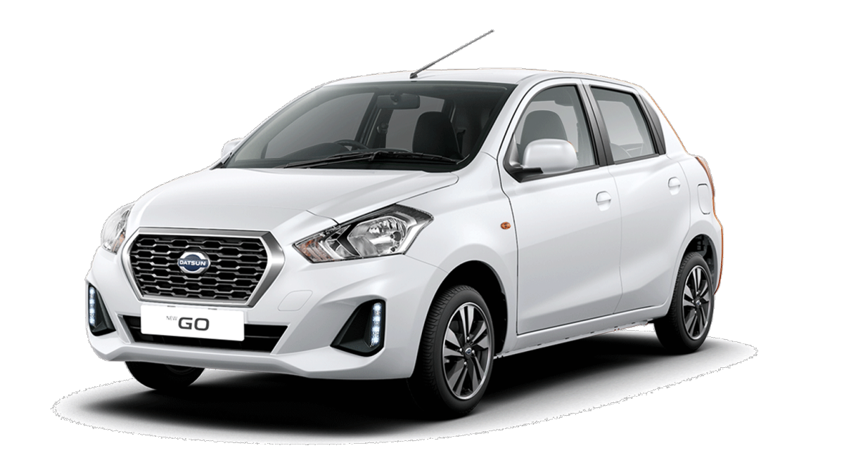

DATSUN GO MID

* STARTING PRICE

R179,000

EQUIPMENT INCLUDES

* Android Auto & Apple Car Play
* Google Maps, App Support & Voice Recognition
* Dual Airbags (Driver and Passenger) & ABS

DETAILS

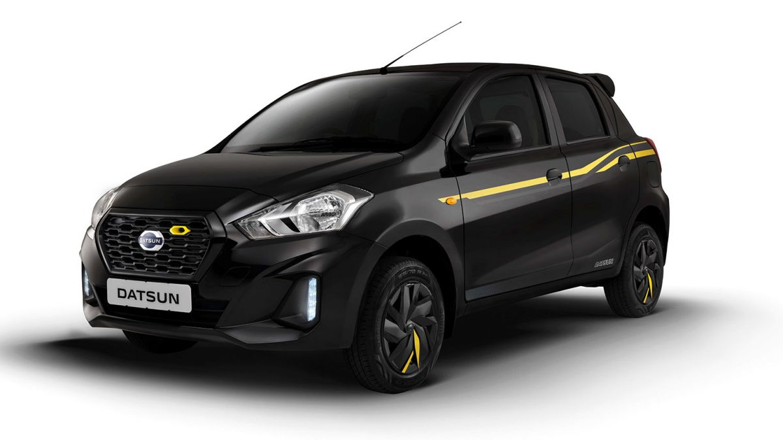

DATSUN GO MID SPECIAL VERSION

* STARTING PRICE

R183,700

EQUIPMENT INCLUDES

* Android Auto & Apple Car Play
* Google Maps, App Support & Voice Recognition
* Dual Airbags (Driver and Passenger) & ABS
* Rear spoiler, Grill insert and body graphics
* Yellow seat belt, seat cover and wheel covers with yellow accents.

DETAILS

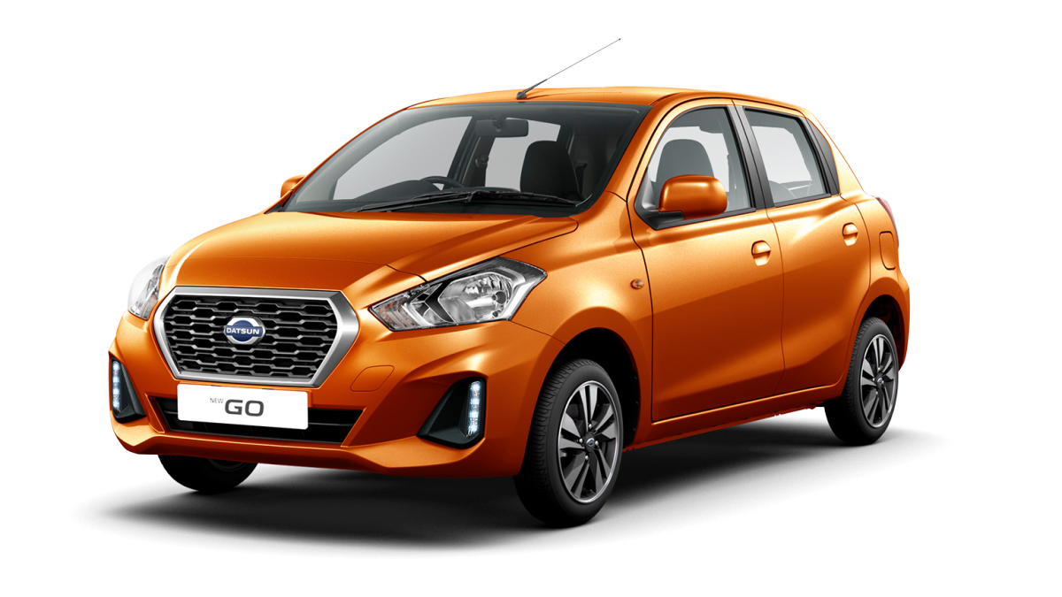

DATSUN GO LUX

* STARTING PRICE

R191,000

EQUIPMENT INCLUDES

* Day Time Running Lights (LEDs)
* Android Auto & Apple Car Play
* Google Maps, App Support & Voice Recognition
* Dual Airbags
* ABS

DETAILS

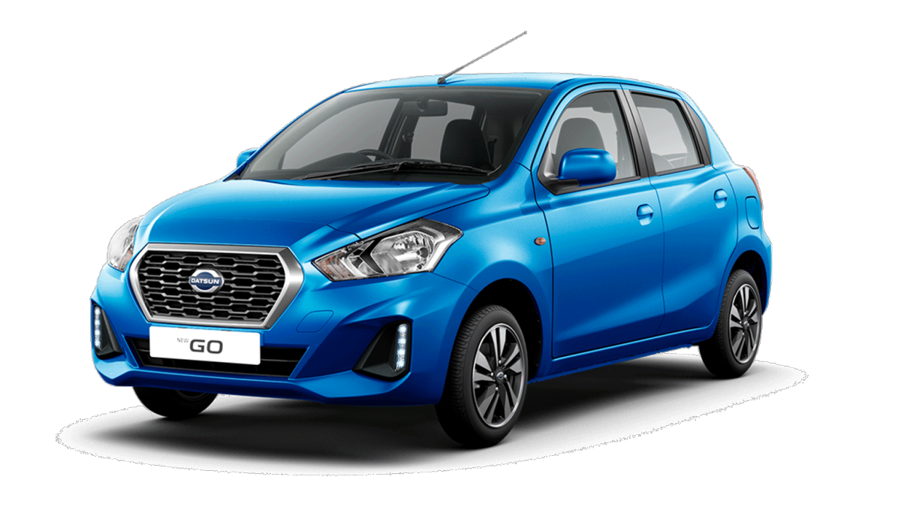

DATSUN GO LUX CVT

* STARTING PRICE

R207,300

EQUIPMENT INCLUDES

* 5-speed automatic CVT transmission
* Android Auto & Apple Car Play
* Google Maps, App Support & Voice Recognition
* Dual Airbags
* Vehicle Dynamics Control
* ABS

DETAILS

#### **PETROL*1.2L FRONT-WHEEL DRIVE (FWD)***

#### **EQUIPMENT INCLUDES**

* Warranty: 6 year/150 000km
* 50

KW

* 5.5

L/100KM

* 104

NM