<https://live-media.toy-backend.co.za/pdfs/spec-sheets/Aygo_spec-sheet.pdf>

## AYGO

### x-clusiv 5-door 182 000

[Change vehicle](https://www.toyota-europe.com/new-cars/aygo/build?path=model/813b0db9-bca0-4893-9167-cc0c4f69cfc2&c=2158c3e3-dd75-446b-a763-4ec4c0ffdeeb&financeOption=cash)

##### Standard equipment

* 15" black machined-face alloy wheels (10-double-spoke)
* Smart Entry & Start System
* Pre-Collision System
* Lane Departure Alert

Show standard equipment

## CHOOSE YOUR ENGINE

***PETROL***

## [**1.0 l VVT-i**](https://www.toyota-europe.com/new-cars/aygo/build?path=engine/813b0db9-bca0-4893-9167-cc0c4f69cfc2/7b77d85b-8f26-4645-82ac-22154a7d6293/26d5e081-9e9e-4fba-93c7-07ff3a77077a&c=2158c3e3-dd75-446b-a763-4ec4c0ffdeeb#engine-d5ee3090-b417-479e-a988-e1f057543509)

### 5-speed manual transmission (2WD)

* Combined driving (litres/100 km): 4.1 l/100 km
* Fuel consumption combined (l/100km): 4.1 l/100 km
* Fuel consumption, combined speeds (l/100km): 5 l/100 km
* CO2 combined driving (g/km): 93 g/km
* CO2 emissions, combined speeds (g/km): 114 g/km

[Choose this engine](https://www.toyota-europe.com/new-cars/aygo/build?path=customize/813b0db9-bca0-4893-9167-cc0c4f69cfc2/511e5790-4d7a-4754-9e00-88b6d75a6799&c=2158c3e3-dd75-446b-a763-4ec4c0ffdeeb&financeOption=cash)

Engine details

**1.0 l VVT-i**

5-speed manual transmission

* Combined driving (litres/100 km): 4.1 l/100 km
* Fuel consumption combined (l/100km): 4.1 l/100 km
* Fuel consumption, combined speeds (l/100km): 5 l/100 km
* CO2 combined driving (g/km): 93 g/km
* CO2 emissions, combined speeds (g/km): 114 g/km

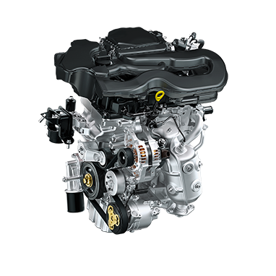

|  |  |
| --- | --- |
| Fuel consumption, combined speeds (l/100km) | 5 |
| Fuel tank capacity (litres) | 35 |
| CO2 emissions, combined speeds (g/km) | 112 - 114 |
| Euro class | EURO 6 AD - EURO 6 DG |
| Number of cylinders | 3 CYLINDER, IN LINE |
| Fuel system | Electronic injection system |
| Displacement (cc) | 998 |
| Maximum power output (DIN hp) | 72 |
| Maximum power output (kW/rpm) | 53/6000 |
| Maximum torque (Nm/rpm) | 93/-4400 |
| Maximum speed (km/h) | 160 |
| 0–100 km/h (secs) | 13.8 |

## AYGO

### x-play 5-door R185 000

[Change vehicle](https://www.toyota-europe.com/new-cars/aygo/build?path=model/813b0db9-bca0-4893-9167-cc0c4f69cfc2&c=95fc8f22-feaf-498e-9f09-cffeb14f0e76&financeOption=cash)

##### Standard equipment

* 15" steel wheels with wheel caps (8-double-spoke)
* Piano black front bumper liner
* Rear-view camera
* Smartphone Integration powered by Pioneer

## AYGO

### JBL Edition 5-door R250 000

[Change vehicle](https://www.toyota-europe.com/new-cars/aygo/build?path=model/813b0db9-bca0-4893-9167-cc0c4f69cfc2&c=800e7ea2-1445-4bf9-9065-aa7f0daa9a70&financeOption=cash)

##### Standard equipment

* JBL premium sound system
* 15" glossy black alloy wheels (10-spoke)
* Pure Orange front bumper liner
* Pure Orange insert on lower side doors
* Pure Orange roof