[[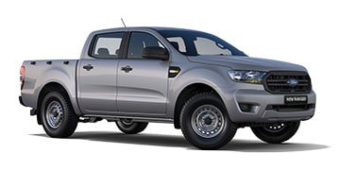](https://www.ford.co.za/commercial/ranger-019/models/new-ranger-2-2-tdci-double-cab-xl-6mt-4x2-hr-FAF/?intcmp=vhp-return-model)](https://www.ford.co.za/commercial/ranger-019/models/new-ranger-2-2-tdci-double-cab-xl-6mt-4x2-hr-FAF/?intcmp=vhp-return-model)

[2.2 TDCi Double Cab XL 6MT 4x2 HR](https://www.ford.co.za/commercial/ranger-019/models/new-ranger-2-2-tdci-double-cab-xl-6mt-4x2-hr-FAF/?intcmp=vhp-return-model)

From R462,900

[[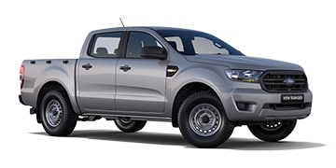](https://www.ford.co.za/commercial/ranger-019/models/new-ranger-2-2-tdci-double-cab-xl-6at-4x2-hr-FAF/?intcmp=vhp-return-model)](https://www.ford.co.za/commercial/ranger-019/models/new-ranger-2-2-tdci-double-cab-xl-6at-4x2-hr-FAF/?intcmp=vhp-return-model)

[2.2 TDCI DOUBLE CAB XL 6AT 4X2](https://www.ford.co.za/commercial/ranger-019/models/new-ranger-2-2-tdci-double-cab-xl-6at-4x2-hr-FAF/?intcmp=vhp-return-model)

From R485,900

[[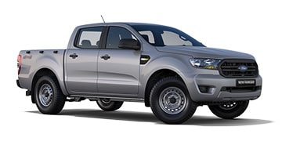](https://www.ford.co.za/commercial/ranger-019/models/new-ranger-2-2-tdci-double-cab-xl-6mt-4x4-hr-FAF/?intcmp=vhp-return-model)](https://www.ford.co.za/commercial/ranger-019/models/new-ranger-2-2-tdci-double-cab-xl-6mt-4x4-hr-FAF/?intcmp=vhp-return-model)

[2.2 TDCi Double Cab XL 6MT 4x4 HR](https://www.ford.co.za/commercial/ranger-019/models/new-ranger-2-2-tdci-double-cab-xl-6mt-4x4-hr-FAF/?intcmp=vhp-return-model)

From R520,900

[[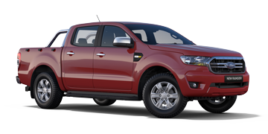](https://www.ford.co.za/commercial/ranger-019/models/new-ranger-2-2-tdci-double-cab-xls-6mt-4x2-hr-FAF/?intcmp=vhp-return-model)](https://www.ford.co.za/commercial/ranger-019/models/new-ranger-2-2-tdci-double-cab-xls-6mt-4x2-hr-FAF/?intcmp=vhp-return-model)

[2.2 TDCi Double Cab XLS 6MT 4x2 HR](https://www.ford.co.za/commercial/ranger-019/models/new-ranger-2-2-tdci-double-cab-xls-6mt-4x2-hr-FAF/?intcmp=vhp-return-model)

From R517,900

[[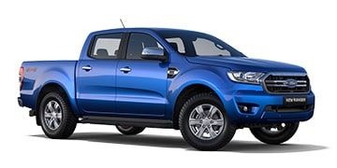](https://www.ford.co.za/commercial/ranger-019/models/new-ranger-2-0-sit-double-cab-xlt-10at-4x4-hr-FAF/?intcmp=vhp-return-model)](https://www.ford.co.za/commercial/ranger-019/models/new-ranger-2-0-sit-double-cab-xlt-10at-4x4-hr-FAF/?intcmp=vhp-return-model)

[2.0 Single Turbo Double Cab XLT 10AT 4x4 HR](https://www.ford.co.za/commercial/ranger-019/models/new-ranger-2-0-sit-double-cab-xlt-10at-4x4-hr-FAF/?intcmp=vhp-return-model)

From R657,900

[[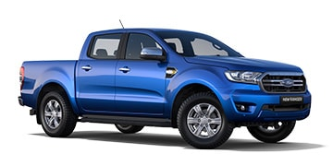](https://www.ford.co.za/commercial/ranger-019/models/new-ranger-3-2-tdci-double-cab-xlt-6at-4x2-hr-FAF/?intcmp=vhp-return-model)](https://www.ford.co.za/commercial/ranger-019/models/new-ranger-3-2-tdci-double-cab-xlt-6at-4x2-hr-FAF/?intcmp=vhp-return-model)

[3.2 TDCi Double Cab XLT 6AT 4x2 HR](https://www.ford.co.za/commercial/ranger-019/models/new-ranger-3-2-tdci-double-cab-xlt-6at-4x2-hr-FAF/?intcmp=vhp-return-model)

From R654,900

[[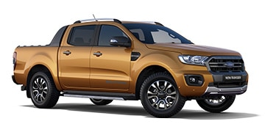](https://www.ford.co.za/commercial/ranger-019/models/new-ranger-2-0-bit-double-cab-wildtrak-10at-4x2-hr-FAF/?intcmp=vhp-return-model)](https://www.ford.co.za/commercial/ranger-019/models/new-ranger-2-0-bit-double-cab-wildtrak-10at-4x2-hr-FAF/?intcmp=vhp-return-model)

[2.0 Bi Turbo Double Cab Wildtrak 10AT 4x2 HR](https://www.ford.co.za/commercial/ranger-019/models/new-ranger-2-0-bit-double-cab-wildtrak-10at-4x2-hr-FAF/?intcmp=vhp-return-model)

From R723,900

[[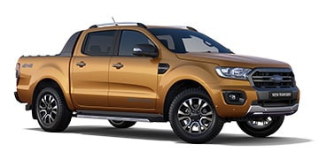](https://www.ford.co.za/commercial/ranger-019/models/new-ranger-2-0-bit-double-cab-wildtrak-10at-4x4-hr-FAF/?intcmp=vhp-return-model)](https://www.ford.co.za/commercial/ranger-019/models/new-ranger-2-0-bit-double-cab-wildtrak-10at-4x4-hr-FAF/?intcmp=vhp-return-model)

[2.0 Bi Turbo Double Cab Wildtrak 10AT 4x4 HR](https://www.ford.co.za/commercial/ranger-019/models/new-ranger-2-0-bit-double-cab-wildtrak-10at-4x4-hr-FAF/?intcmp=vhp-return-model)

From R778,40

[[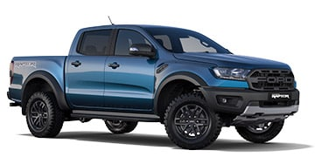](https://www.ford.co.za/commercial/ranger-019/models/new-ranger-2-0-bit-double-cab-raptor-10at-4x4-hr-FAF/?intcmp=vhp-return-model)](https://www.ford.co.za/commercial/ranger-019/models/new-ranger-2-0-bit-double-cab-raptor-10at-4x4-hr-FAF/?intcmp=vhp-return-model)

[2.0 Bi Turbo Double Cab Ranger Raptor 10AT 4x4 HR](https://www.ford.co.za/commercial/ranger-019/models/new-ranger-2-0-bit-double-cab-raptor-10at-4x4-hr-FAF/?intcmp=vhp-return-model)

From R888,900

[[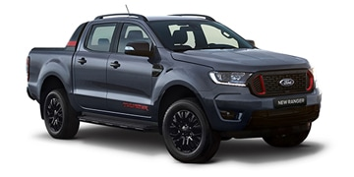](https://www.ford.co.za/commercial/ranger-019/models/new-ranger-3-2-tdci-double-cab-thunder-6at-4x2-hr-FAF/?intcmp=vhp-return-model)](https://www.ford.co.za/commercial/ranger-019/models/new-ranger-3-2-tdci-double-cab-thunder-6at-4x2-hr-FAF/?intcmp=vhp-return-model)

[3.2 TDCi Double Cab Thunder 6AT 4x2 HR](https://www.ford.co.za/commercial/ranger-019/models/new-ranger-3-2-tdci-double-cab-thunder-6at-4x2-hr-FAF/?intcmp=vhp-return-model)

From R733,500

[[](https://www.ford.co.za/commercial/ranger-019/models/new-ranger-2-0-bit-double-cab-thunder-10at-4x2-hr-FAF/?intcmp=vhp-return-model)](https://www.ford.co.za/commercial/ranger-019/models/new-ranger-2-0-bit-double-cab-thunder-10at-4x2-hr-FAF/?intcmp=vhp-return-model)

[2.0 Bi Turbo Double Cab Thunder 10AT 4x2 HR](https://www.ford.co.za/commercial/ranger-019/models/new-ranger-2-0-bit-double-cab-thunder-10at-4x2-hr-FAF/?intcmp=vhp-return-model)

From R757,300

[[](https://www.ford.co.za/commercial/ranger-019/models/new-ranger-2-0-bit-double-cab-thunder-10at-4x4-hr-FAF/?intcmp=vhp-return-model)](https://www.ford.co.za/commercial/ranger-019/models/new-ranger-2-0-bit-double-cab-thunder-10at-4x4-hr-FAF/?intcmp=vhp-return-model)

[2.0 Bi Turbo Double Cab Thunder 10AT 4x4 HR](https://www.ford.co.za/commercial/ranger-019/models/new-ranger-2-0-bit-double-cab-thunder-10at-4x4-hr-FAF/?intcmp=vhp-return-model)

From R811,800