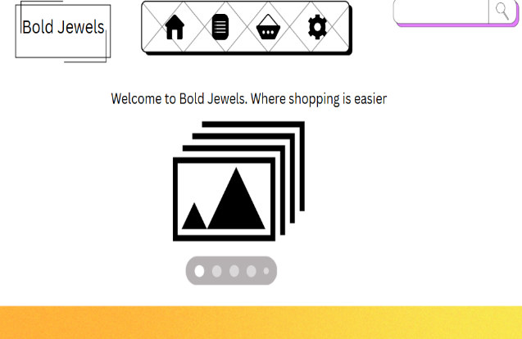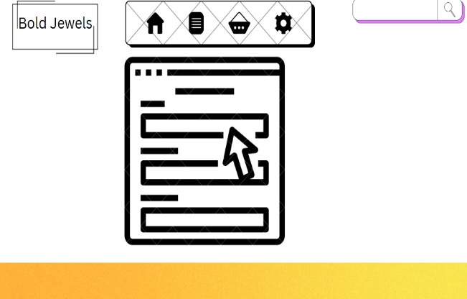
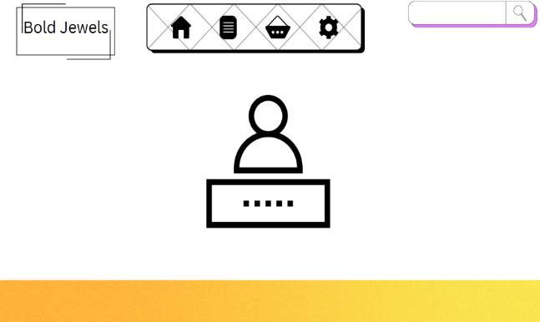
Index.html (home page)
<!DOCTYPE html>
<html lang="en">
<head>
<meta charset="UTF-8">
<meta name="viewport" content="width=device-width, initial-scale=1.0">
<title>Bold Jewels - Homepage</title>
<link rel="stylesheet" href="style.css">
</head>
<body>
<header>
<nav class="navbar">
<a href="index.html" class="logo">Bold Jewels</a>
<ul class="nav-links">
<li><a href="index.html">Home</a></li>
<li><a href="about.html">About Us</a></li>
<li><a href="contact.html">Contact Us</a></li>
<li><a href="register.html">Register</a></li>
<li><a href="login.html">Login</a></li>
<li><a href="shop.html">Shop</a></li>
<li><a href="services.html">Services</a></li>
</ul>
<div class="search-container">
<form action="search.html">
<input type="text" placeholder="Search..." name="search">
<button type="submit">🔍</button>
</form>
</div>
</nav>
</header>

<main class="content">
<h1>Welcome to Bold Jewels. Where shopping is made easier</h2>
<div class="slideshow-container">
<div class="mySlides fade">
<img src="c:\Users\makgo\OneDrive\Documents\MM LEVEL 4\my website\images\specials.jpg" alt="specials" style="width:50%">
</div>
<div class="mySlides fade">
<img src="c:\Users\makgo\OneDrive\Documents\MM LEVEL 4\my website\images\variety.webp" alt="variety" style="width:50%">
</div>
<div class="mySlides fade">
<img src="c:\Users\makgo\OneDrive\Documents\MM LEVEL 4\my website\images\promotions.jpg" alt="promotions" style="width:50%">
</div>
<div class="mySlides fade">
<img src="c:\Users\makgo\OneDrive\Documents\MM LEVEL 4\my website\images\sales.webp" alt="sales" style="width:50%">
</div>
<div class="mySlides fade">
<img src="c:\Users\makgo\OneDrive\Documents\MM LEVEL 4\my website\images\home run.jpg" alt="home run" style="width:50%">
</div>
</div>
</main>
<footer>
<p>&copy; 2025 Bold Jewels. All rights reserved. contact us on facebook and instargran. Or visit our local shops</p>
</footer>
<script src="script.js"></script>
</body>
</html>

Register.html (register page)
<!DOCTYPE html>
<html lang="en">
<head>
<meta charset="UTF-8">
<meta name="viewport" content="width=device-width, initial-scale=1.0">
<title>Bold Jewels - Register</title>
<link rel="stylesheet" href="style.css">
</head>
<body>
<header>
<nav class="navbar">
<a href="index.html" class="logo">Bold Jewels</a>
<ul class="nav-links">
<li><a href="index.html">Home</a></li>
<li><a href="about.html">About Us</a></li>
<li><a href="contact.html">Contact Us</a></li>
<li><a href="register.html">Register</a></li>
<li><a href="login.html">Login</a></li>
<li><a href="shop.html">Shop</a></li>
<li><a href="services.html">Services</a></li>
</ul>
<div class="search-container">
<form action="search.html">
<input type="text" placeholder="Search..." name="search">
<button type="submit"></button>
</form>
</div>
</nav>
</header>

<main class="form-container">
<h2>Create an Account</h2>
<form id="register-form">
<div class="form-group">
<label for="email">Email</label>
<input type="email" id="email" name="email">
</div>
<div class="form-group">
<label for="phone">Phone Number</label>
<input type="tel" id="phone" name="phone">
</div>
<div class="form-group">
<label for="password">Password</label>
<input type="password" id="password" name="password">
</div>
<button type="submit" class="btn">Register</button>
</form>
</main>
<footer>
<p>&copy; 2025 Bold Jewels. All rights reserved.</p>
</footer>
<script src="script.js"></script>
</body>
</html>

Search.html (search page)
<!DOCTYPE html>
<html lang="en">
<head>
<meta charset="UTF-8">
<meta name="viewport" content="width=device-width, initial-scale=1.0">
<title>Bold Jewels - Search</title>
<link rel="stylesheet" href="style.css">
</head>
<body>
<header>
<nav class="navbar">
<a href="index.html" class="logo">Bold Jewels</a>
<ul class="nav-links">
<li><a href="index.html">Home</a></li>
<li><a href="about.html">About Us</a></li>
<li><a href="contact.html">Contact Us</a></li>
<li><a href="register.html">Register</a></li>
<li><a href="login.html">Login</a></li>
<li><a href="shop.html">Shop</a></li>
<li><a href="services.html">Services</a></li>
</ul>
<div class="search-container">
<form action="search.html">
<input type="text" placeholder="Search..." name="search">
<button type="submit">🔍</button>
</form>
</div>
</nav>
</header>
<main class="form-container">
<h2>Search for a Product</h2>
<form id="search-form">
<div class="form-group">
<label for="name">Your Name</label>
<input type="text" id="name" name="name" required>
</div>
<div class="form-group">
<label for="email">Your Email</label>
<input type="email" id="email" name="email" required>
</div>
<div class="form-group">
<label for="query">What are you searching for?</label>
<textarea id="query" name="query" required></textarea>
</div>
<button type="submit" class="btn">Submit Search</button>
</form>
</main>
<footer>
<p>&copy; 2025 Bold Jewels. All rights reserved.</p>
</footer>
<script src="script.js"></script>
</body>
</html>

Login.html (login page)
<!DOCTYPE html>
<html lang="en">
<head>
<meta charset="UTF-8">
<meta name="viewport" content="width=device-width, initial-scale=1.0">
<title>Bold Jewels - Login</title>
<link rel="stylesheet" href="style.css">
</head>
<body>
<header>
<nav class="navbar">
<a href="index.html" class="logo">Bold Jewels</a>
<ul class="nav-links">
<li><a href="index.html">Home</a></li>
<li><a href="about.html">About Us</a></li>
<li><a href="contact.html">Contact Us</a></li>
<li><a href="register.html">Register</a></li>
<li><a href="login.html">Login</a></li>
<li><a href="shop.html">Shop</a></li>
<li><a href="services.html">Services</a></li>
</ul>
<div class="search-container">
<form action="search.html">
<input type="text" placeholder="Search..." name="search">
<button type="submit">🔍</button>
</form>
</div>
</nav>
</header>
<main class="form-container">
<h2>Login to Your Account</h2>
<form id="login-form">
<div class="form-group">
<label for="email-login">Email</label>
<input type="email" id="email-login" name="email">
</div>
<div class="form-group">
<label for="password-login">Password</label>
<input type="password" id="password-login" name="password">
</div>
<button type="submit" class="btn">Login</button>
</form>
</main>
<footer>
<p>&copy; 2025 Bold Jewels. All rights reserved.</p>
</footer>
<script src="script.js"></script>
</body>
</html>

CSS styling
body {
font-family: 'Arial', serif;
margin: 0;
padding: 0;
background-image: url(images/logo.png) ;
color: goldenrod;
}
.navbar {
display: flex;
justify-content: space-between;
align-items: center;
background-color: lightgoldenrodyellow ;
padding: 1rem 2rem;
box-shadow: 0 2px 4px rgba(0,0,0,0.1);
}
.logo {
font-size: 1.5rem;
font-weight: bold;
color: #a87932;
text-decoration: serif;
}
.nav-links {
list-style: none;
display: flex;
gap: 1.5rem;
margin: 0;
padding: 0;
}
.nav-links a {
text-decoration: serif;
color: #555;
font-weight: bold;
transition: color 0.3s;
}
.nav-links a:hover {
color: #a87932;
}
.search-container input[type=text] {
padding: 6px;
border: 1px solid #ccc;
border-radius: 4px;
}
.search-container button {
padding: 6px 10px;
background: #a87932;
color: white;
border: none;
border-radius: 4px;
cursor: pointer;
}
.content, .form-container {
max-width: 600px;
margin: 1rem auto;
padding: 1rem;
background-color: lightgoldenrodyellow ;
box-shadow: 0 0 5px rgba(0,0,0,0.1);
text-align: center;
}
.slideshow-container {
max-width: 600px;
position: relative;
margin: auto;
background: transparent;
}
.mySlides {
display: none;
background: transparent;
}
.fade {
animation-name: fade;
animation-duration: 2s;
}
@keyframes fade {
from {opacity: .4}
to {opacity: 1}
}
.form-container {
max-width: 500px;
}
.form-group {
margin-bottom: 1rem;
text-align: left;
}
.form-group label {
display: block;
margin-bottom: 0.5rem;
}
.form-group input, .form-group textarea {
width: 100%;
padding: 0.8rem;
border: 1px solid #ccc;
border-radius: 5px;
}
.btn {
background-color: #a87932;
color: white;
padding: 1rem 1.5rem;
border: none;
border-radius: 5px;
cursor: pointer;
font-size: 1rem;
width: 100%;
}
.btn:hover {
background-color: #8c642b;
}
footer {
text-align: center;
padding: 1rem;
background-color: black;
color: #777;
position: fixed;
width: 100%;
bottom: 0;
box-shadow: 0 -2px 4px rgba(0,0,0,0.1);
}
Java script
let slideIndex = 0;
showSlides();
function showSlides() {
let i;
let slides = document.getElementsByClassName("mySlides");
for (i = 0; i < slides.length; i++) {
slides[i].style.display = "none";
}
slideIndex++;
if (slideIndex > slides.length) {
slideIndex = 1;
}
if (slides[slideIndex-1]) {
slides[slideIndex-1].style.display = "block";
}
setTimeout(showSlides, 3000);
}
document.addEventListener('DOMContentLoaded', () => {
const registerForm = document.getElementById('register-form');
const loginForm = document.getElementById('login-form');

if (registerForm) {
registerForm.addEventListener('submit', (event) => {
if (!validateRegistrationForm()) {
event.preventDefault();
}
});
}
if (loginForm) {
loginForm.addEventListener('submit', (event) => {
if (!validateLoginForm()) {
event.preventDefault();
}
});
}
});
function validateRegistrationForm() {
const email = document.getElementById('email').value;
const phone = document.getElementById('phone').value;
const password = document.getElementById('password').value;

if (isEmpty(email) || isEmpty(phone) || isEmpty(password)) {
alert("Please fill in all empty fields.");
return false;
}
if (!validateEmail(email)) {
alert("Please enter a valid email address.");
return false;
}
if (!validatePhoneNumber(phone)) {
alert("Please enter a valid phone number.");
return false;
}
if (password.length < 6) {
alert("Password must be at least 6 characters long.");
return false;
}
return true;
}
function validateLoginForm() {
const email = document.getElementById('email-login').value;
const password = document.getElementById('password-login').value;

if (isEmpty(email) || isEmpty(password)) {
alert("Please fill in all empty fields.");
return false;
}
return true;
}
function isEmpty(str) {
return str.trim() === '';
}
function validateEmail(email) {
const re = /^(([^<>()\[\]\\.,;:\s@"]+(\.[^<>()\[\]\\.,;:\s@"]+)*)|(".+"))@((\[[0-9]{1,3}\.[0-9]{1,3}\.[0-9]{1,3}\.[0-9]{1,3}])|(([a-zA-Z\-0-9]+\.)+[a-zA-Z]{2,}))$/;
return re.test(String(email).toLowerCase());
}
function validatePhoneNumber(phone) {
const re = /^\+?[0-9]{10,14}$/;
return re.test(String(phone));
}
