**Evaluation Only. Created with Aspose.Words. Copyright 2003-2015 Aspose Pty Ltd.**

Converting a Word Document (DOCX) to a Web Page using a built-in MOSS document converter.

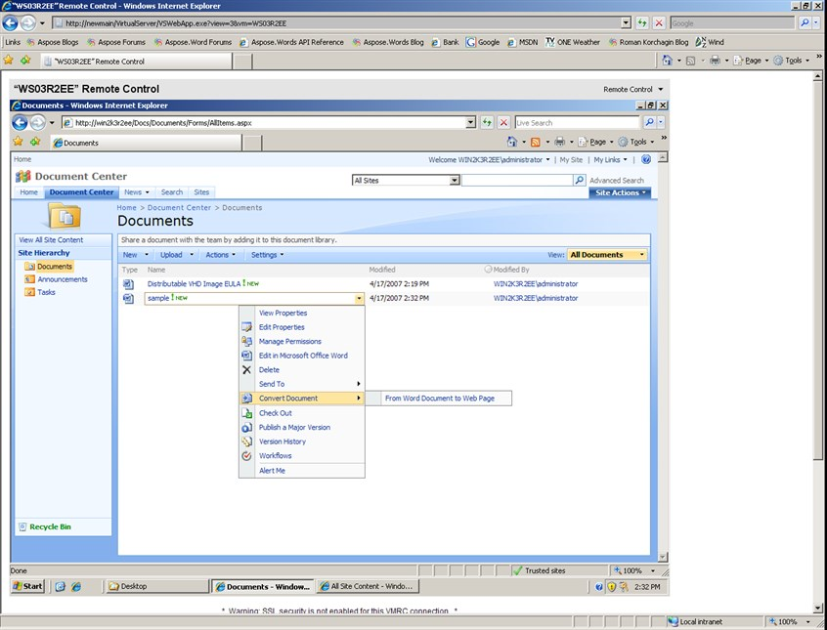

Add a reference to C:\Program Files\Aspose\Aspose.Words\Bin\net2.0\Aspose.Words.DLL.

