Appendix A.
3D graphical overview of models performance for system no 11 (owning largest data points) is presented here. Each figure has three section; Top view placed in left side, 3D solubility data and model mesh surface on top right side, and residual for each data point in bottom right.

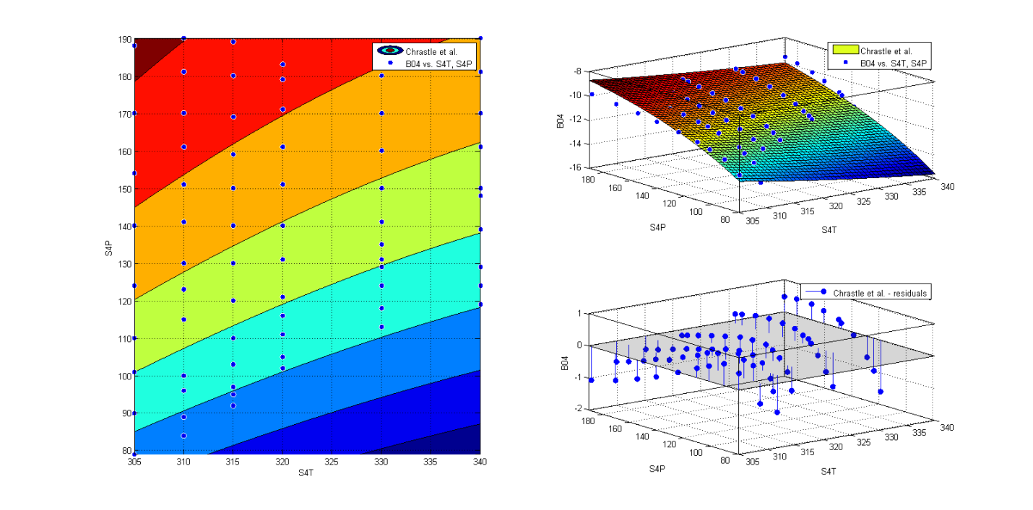Figure 1. Chrastil Model.

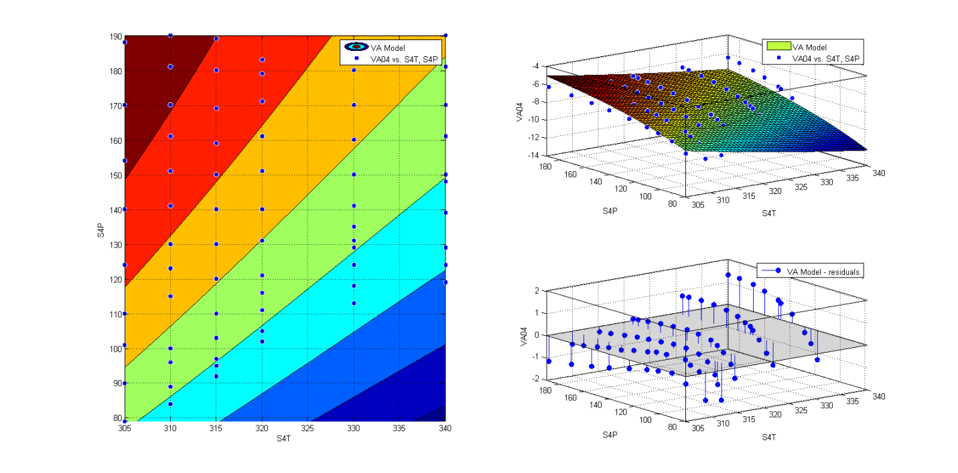
Figure 2. VA Model.
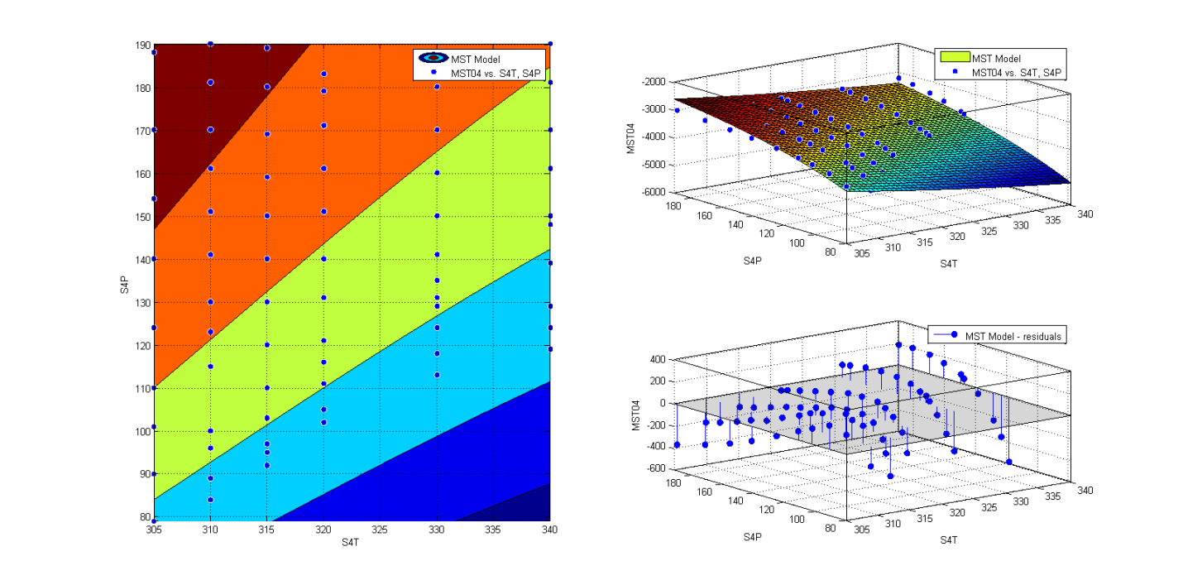
Figure 3. MST Model.

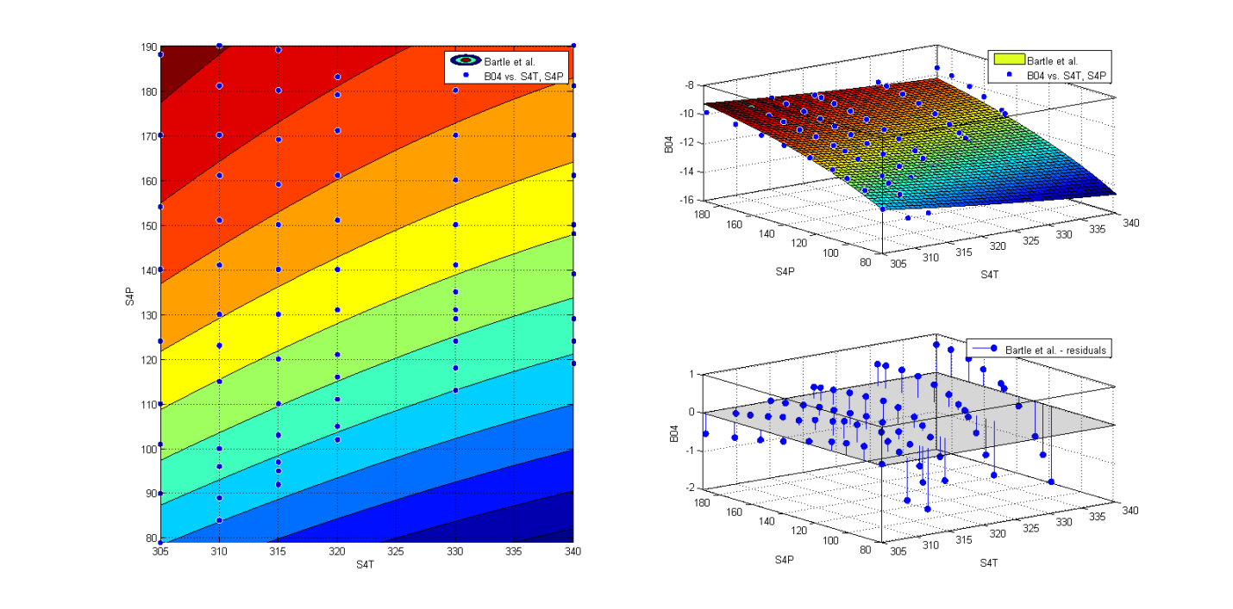
Figure 4. Bartle et al. Model.
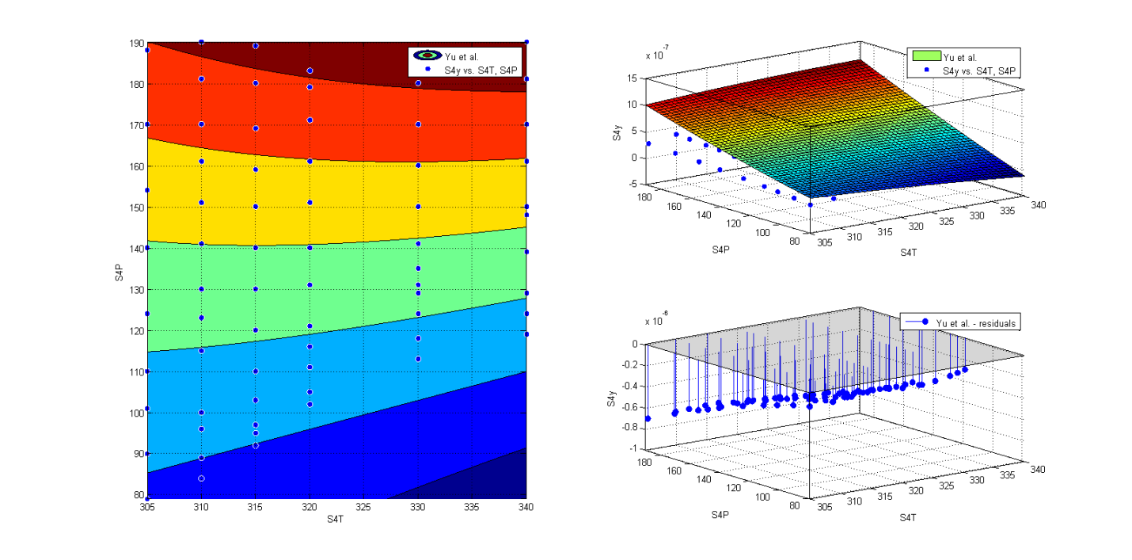
Figure 5. Yu et al. Model.
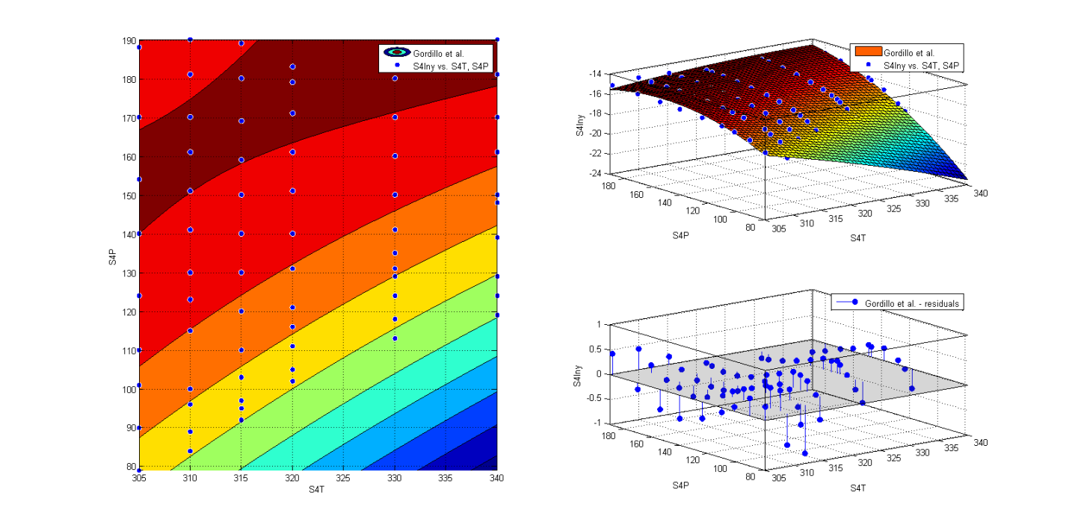
Figure 6. Gordillo et al. Model.
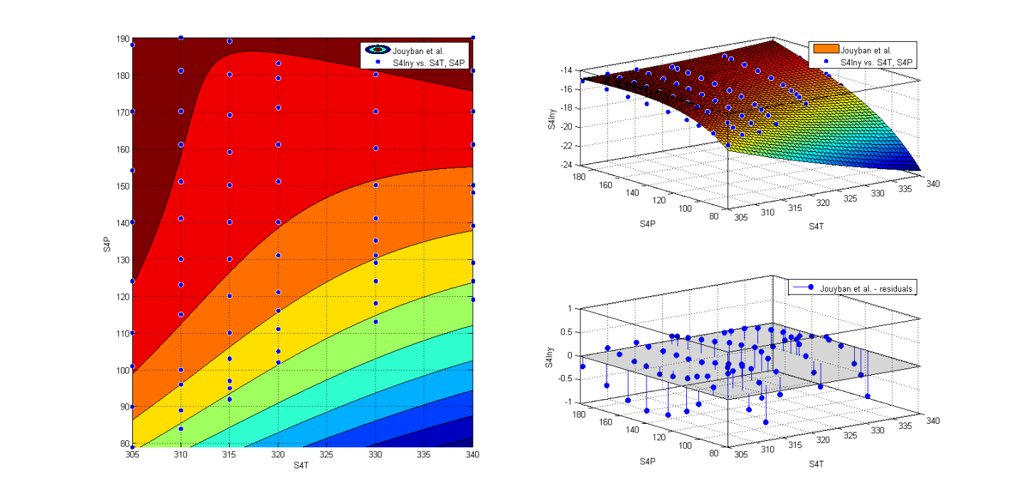
Figure 7. Jouyban et al. Model.
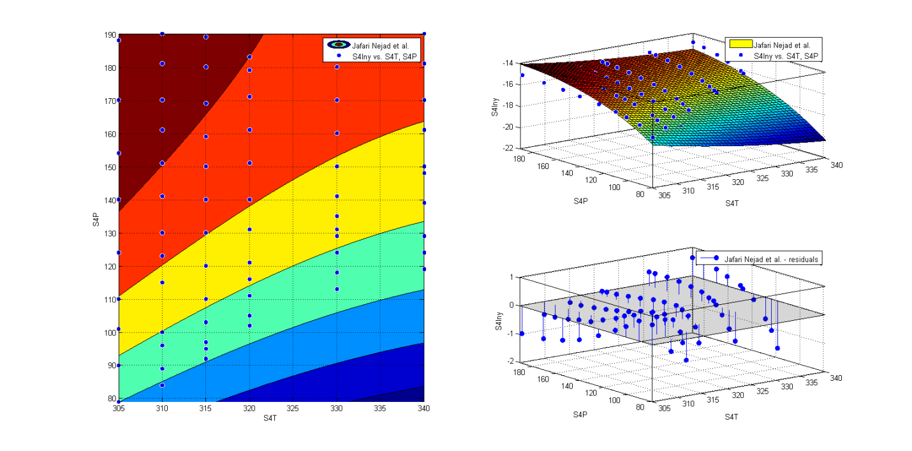
Figure 8. Jafari Nejad et al. Model.
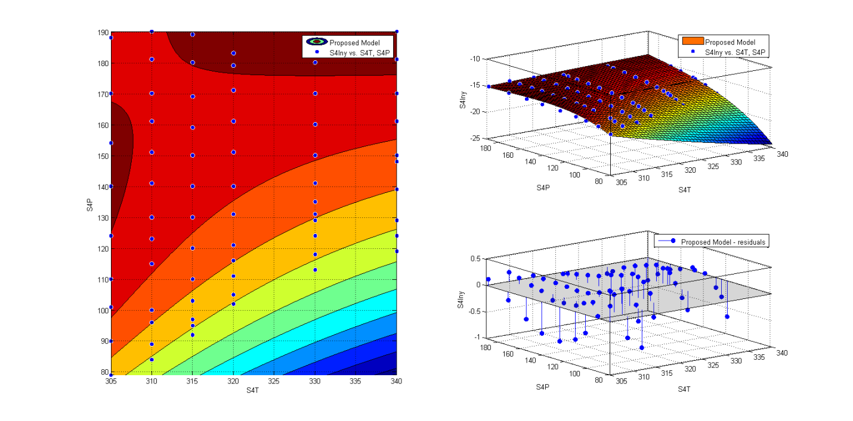
Figure 9. Proposed Model.

