Using Genetic Algorithm (GA) and Particle Swarm Optimization (PSO) Methods for Determination of Interaction Parameters in Multicomponent Systems of Liquid–Liquid Equilibria

Abstract
For the prediction of LLE, Wilson, Universal Quasi Chemical (UNIQUAC) and Non-Random Two Liquid (NRTL) models were used. Evolutionary algorithms such as genetic algorithm (GA) and particle swarm optimization (PSO) are used for estimation of binary interaction parameters of these models. These two optimization methods are rarely used in LLE calculations, as far as we know the PSO algorithm has never been used. For ternary, quaternary and quinary systems, the calculation are done and the obtained results are compared to experimental data. The reliability of GA and PSO in LLE applications successfully approved.
Keywords: Genetic Algorithm, Particle Swarm Optimization, UNIQUAC, NRTL, Wilson, LLE.

1. Introduction
To get knowledge of liquid-liquid equilibrium data is highly important in separation predictions. For the prediction of LLE, Wilson, Universal Quasi Chemical (UNIQUAC), Non-Random Two Liquid (NRTL), and etc. models can be used. All of these models have binary interaction parameters for which estimation requires the utilization of available experimental LLE data. By proper determination of these parameters, models will be able to properly represent behavior of non-ideal liquid mixtures. For this purpose, definition of a proper and suitable objective function (OF) is necessary.
Based on the defined objective function, implementation of an optimization method for maximization/minimization of it in calculations is required (Kang & Sandler 1987). The method must be able to find the global optimum values of variables. Of those methods are Evolutionary algorithms such as genetic algorithm (GA) and particle swarm optimization (PSO) which are rarely used in LLE calculations (Singh et al., 2005; Papadopoulos & Linke 2004). GA and PSO never require initial guesses and only the upper and lower bound must be defined.
In this paper, binary interaction parameters of Wilson, UNIQUAC and NRTL models are optimized using PSO and GA methods for ternary, quaternary and quinary systems.
2. Equilibrium Theories
At LLE, the activities of the component of on both phases are equal and the mole fractions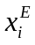, 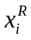of LLE phases (extracted phase and raffinate phase) can be determined using the following equations
- 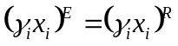
- 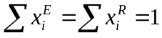
Here 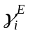 and 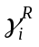 are the corresponding activity coefficients of component in extracted (solvent) and raffinate (aqueous) phases calculated using models. In order to measure the agreement between the experimental data and the calculated values, the root mean square deviation (RMSD) is introduced.
- 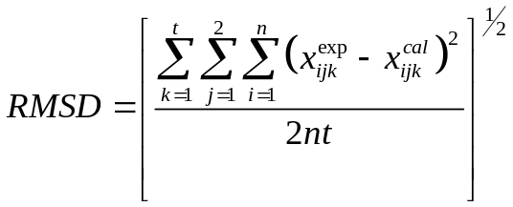
Where is the number of tie-lines, 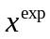 indicates the experimental data, 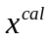is the calculated data, and subscript indexes components, j indexes phases and = 1, 2, . . . t (tie-lines).
The objective function for this study is defined as following equation. It should be noted that the optimization methods mentioned above maximize their input function.
- 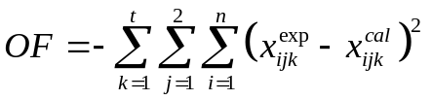
Also one could use the equilibrium criteria as objective function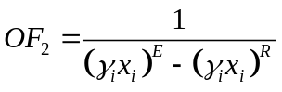.
Three models have been used in this work for calculation of activity coefficient i.e. Wilson, NRTL and UNIQUAC (Appendix C) (Prausnitz et al., 1999).
The Wilson Equation for a multicomponent system activity coefficient for any component is given by
- 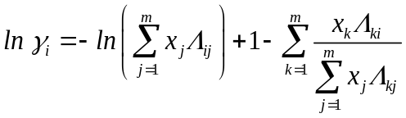
Where, 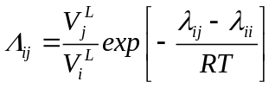are adjustable binary parameters that can be obtained from experimental data and we have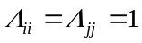. 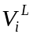 is molar volume of pure liquid component . 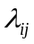are interaction energy between components and , for those we have 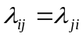. is absolute temperature in Kelvin and is gas constant.
For activity coefficient calculation in a multicomponent system, NRTL Equation is given by
- 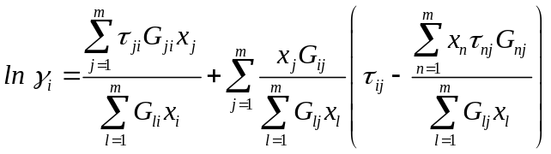
Where 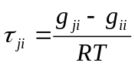 , and 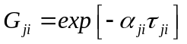. We have 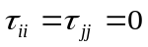 and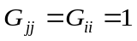. Here 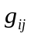 are parameters for interaction between components and, for those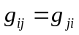, and 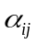 are non-randomness parameters, for those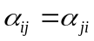.
UNIQUAC Equation is given by Eq. 7 for activity coefficient in a multicomponent system is summation of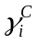, combinatorial part of activity coefficient of component, and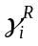, residual part of activity coefficient of component.
- 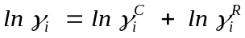
Where
- 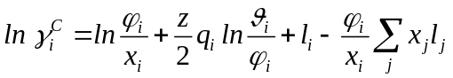
And
- 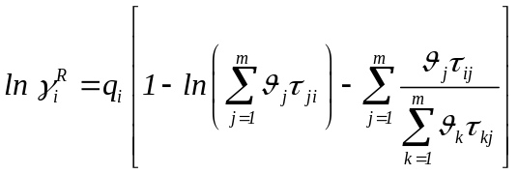
Here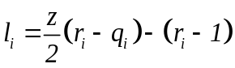, and the coordinate number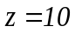,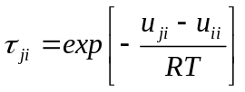 for which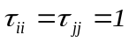. 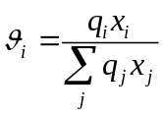 and 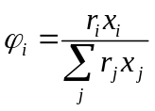Indicates area fraction of component and volume fraction of component respectively. In these equations 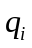 is area parameter of component, is volume parameter of component, 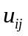 are parameters of interaction between components and for this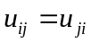.
For estimation and determination of binary interaction parameters, in this study, we use two optimization methods. The Evolutionary algorithms are genetic algorithm (GA) and particle swarm optimization (PSO) which are rarely used in LLE calculations (Appendix A and B).
In GA, individuals are evolved toward the better and best solutions. Each solution is decoded in binary set of 0s and 1s in a string in a length of 8 called chromosomes. A randomly generated population of individuals is created and used in an iterative process (generation). The goodness of each chromosome in populations is evaluated based on objective functions defined. A new generation is formed from the more fit individuals which then used in next iteration of GA loop. Also a maximum number of iteration is introduced in this algorithm for conditions in which the fitness criteria cannot be matched.
In PSO algorithm, the swarms (initial population) move around which is directed by individuals and entire swarms best position. Better solution used for guiding the swarms. This procedure is repeated till a desired solution according to objective function found.
The number of particles/individuals is exactly the number of variables we seek for their optimum values through implementation of PSO/GA. Among all binary interaction parameters, we know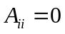. In following paragraphs, constrains which can reduce the number of variables we seek for is described. A reduction in number of these variables leads to a decrease in computation time.
For any system, there’s a linear relationship between binary interaction parameters (Ahmad & Khanna, 2003; Juliá et al., 2005; Sahoo et al., 2007; Hala, 1972). Regardless of number of components, for any ternary pair of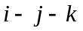, we have following relation between binary interactions parameters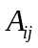
- 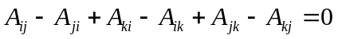
Ahmad and Khanna (Ahmad & Khanna, 2003) showed that for a ternary system a closure relationship exist among its six binary interaction parameters as follows
- 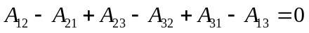
Thus, only five of those six binary interactions parameters are independent. It’s concluded that for a ternary system, the number of variables the algorithms should seek for optimum values is five.
Among the twelve binary interaction parameters, of a quaternary system, only nine out of them are independent according to three closure relationships presented by (Ahmad & Khanna, 2003)
- 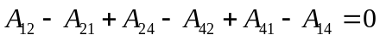
- 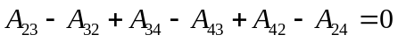
For a quinary system, twenty binary interaction parameters exist; among those there exist six closure relationships according to (Ahmad & Khanna, 2003). Thus fourteen out of these binary interaction parameters are independent.
- 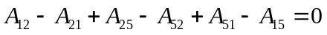
- 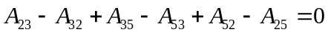
- 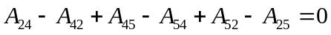
Therefore algorithms should seek for optimum value of five, nine and fourteen for ternary, quaternary and quinary systems respectively. The selection of these variables has various possibilities as reported by (Sahoo et al., 2007). But there’s two rule of thumbs according to (Ahmad & Khanna, 2003) for elimination of depended; (i) Both of and 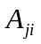 must exist in relationships, and (ii) in all the elimination of depended, same component cannot appear as subscript.
3. LLE Systems and Data
The ternary systems of this study are water + butyric acid + n-hexane and water + butyric acid + n-hexanol (Personal Communications). The data for quaternary and quinary systems consisting of ethanol, water, pentane, hexane, and cyclohexane are collected from literature (Huang et al., 2010). Table 1 shows the UNIQUAC structural parameters for these systems.
Table 1
4. Result and Discussion
In implementation of optimization methods, one should note that the input upper and lower bounds for variables are important factors. If any of the binary interaction parameters is very close to the bounds, it’s recommended that the bound refined to a domain which covers all current. In this study the best bound which is hit by none of is found to be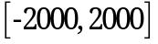. Table 2 summarizes the characteristics of optimization methods.
Table 2
The obtained results for ternary systems using GA and PSO are reported in Table 3. NRTL and UNIQUAC present better agreement than Wilson model. Table 4 and Table 5 show the binary interaction parameters for quaternary and quinary systems respectively.
Table 3
Table 4
Table 5

5. Conclusion
In this paper, binary interaction parameters of Wilson, UNIQUAC and NRTL models are optimized using PSO and GA methods for ternary, quaternary and quinary systems. The PSO method has never been used for such study up to now and before current paper. These two Evolutionary algorithms are important and reliable as they accurately find the global minima/maxima of their input function. The applicability of these models successfully approved in this study. As these methods need no initial guess, they are strongly recommended for LLE calculation.
6. Further Research Opportunity
- New Models:
There’re a wide range of thermodynamics models available. OSMOSPACE and Compressible Regular Solutions (CRS) are latest two models presented for multicomponent systems. The application of these models using the optimization methods of this study can be worthwhile. Other optimization techniques also can be assessed for thermodynamics study of multicomponent systems.
- Applications:
Membrane Technology is the major interest of the first author. The UNIQUAC model in prediction/correlation of polymeric solution of membranes is extensively used. The most recent advance is the modifying of the UNIQUAC model in the form of mass basis instead of its original molar basis as the mass properties are easily available/determined. A similar study of current work in polymeric solutions, using various models/optimization methods is interesting.
References
Ahmad, S. A., & Khanna, A. (2003). Closure Equations in the Estimation of Binary Interaction Parameters. Korean Journal of Chemical Engineering(20), 736–744.
Hala, E. (1972). Note to Bruin-Prausnitz One-Parameter and Palmer-Smith Two-Parameter Local Composition Equation. Industrial and Engineering Chemistry, Process Design Devision, 638-649.
Huang, C., Chung, P., Tseng, I., & Lee, L. (2010). Measurements and Correlations of Liquid-liquid-Equilibria of the Mixtures Consisting of Ethanol, Water, Pentane, Hexane, and Cyclohexane. The Open Thermodynamics Journal, 4, 102-118.
Juliá, J. A., Barrero, C. R., Corso, M. E., Grande, M. C., & Marschoff, C. M. (2005). On the Application of the NRTL Method to Ternary (Liquid + Liquid) Equilibria. Journal of Chemical Thermodynamics(37), 437– 443.
Kang, C. H., & Sandler, S. I. (1987). Phase Behavior of Aqueous Two- Polymer Systems. Fluid Phase Equilibria(38), 245–272.
Papadopoulos, A. I., & Linke, P. (2004). On the Synthesis and Optimization of Liquid-Liquid Extraction Processes Using Stochastic Search Methods. Computers & Chemical Engineering(28), 2391–2406.
Prausnitz, J. M., Lechtenthaler, R. N., & Azevedo, E. G. (1999). Molecular Thermodynamics of Fluid Phase Equilibria (3rd ed.). New York: Prentice-Hall.
Sahoo, R. K., Banerjee, T., & Khanna, A. (2007). UNIQUAC Interaction Parameters with Closure for Imidazolium Based Ionic Liquid Systems Using Genetic Algorithm. The Canadian Journal of Chemical Engineering, 85, 833-853.
Singh, K. M., Banerjee, T., & Khanna, A. (2005). Genetic Algorithm to Estimate Interaction Parameters of Multicomponent Systems for Liquid-Liquid Equilibria. Computers & Chemical Engineering(29), 1712–1719.

