Lower and Upper Critical Solution Temperatures of Binary Polymeric Solutions
Abstract
The phase behavior of binary polymeric solutions such as lower and upper critical solution temperatures has an important role in many polymeric processes. For theoretical investigation on the prediction of these temperatures, a substantial number of data points on binary polymeric solutions were collected from literatures and used to present a reliable calculation routine through chemical engineering thermodynamic modeling approach. The thermodynamic model of Compressible Regular Solution was used. The minimization of errors and predefined objective function was done by applying Particle Swarm Optimization technique. An efficient and accurate empirical correlation employing some quantitative structure–property relationship concept through statistical modeling was developed. To develop the statistical model, the connectivity indices of polymer and solvent were used as the independent variables of the model. Four statistical parameters were defined as auxiliary criteria to evaluate the models and convergence of calculations. In addition, attempts were made to develop and correlate the connectivity indices (topological descriptors) of polymer and solvent to the lattice fluid theory parameters of Sanchez-Lacombe Equation of State. The reliability and accuracy of proposed approaches were discussed in-details and the results were compared to the available experimental data. Desirable agreements between calculated and experimental data were found in thermodynamic model as demonstrated by a maximum Individual Absolute Relative Deviation of 5 %. An averaged IARD of 4.3 % was obtained for the empirical model. The new correlation predicts connectivity indices of components with acceptable accuracy.
Keywords: critical solution temperature; polymeric solution; thermodynamics correlation; the quantitative structure–property relationship; connectivity indices.
- INTRODUCTION
The lower critical solution temperature (LCST) is the temperature below which components of a mixture are completely miscible for all compositions . On the other side, a temperature above which the miscibility of components for all compositions will be observed is referred as upper critical solution temperature (UCST) . UCST and LCST can be observed in partially miscible polymeric solutions and depends on the operating pressure and solution component compositions . The spinodal and binodal curves have shared minimum (critical point) and maximum respectively at LCST and UCST.
In polymeric processes such as polymerization and membrane fabrication , any knowledge on phase behaviors vs. solution composition and operating pressure is highly valuable and plays an important role. While the experimental data on LCST and UCST are available, however still accurate and reliable approach or model to correlate these critical solution temperatures (CST) data is rarely found . The research works in literatures to model and correlate LCST and/or UCST data include ; phase equilibrium data based calculation , empirical correlations , the quantitative structure–property relationship (QSPR) models and etc. .
To develop more accurate and predictive models for LCST and/or UCST, here, the compressible regular solution theory and lattice fluid theory were used for thermodynamic modeling. In addition, the connectivity indices of polymer and solvent were used to develop a reliable empirical model. Attempts were made to correlate the connectivity indices of selected components to the lattice fluid scaling parameters. The evolutionary based algorithm of particle swarm optimization was used for minimization of errors. The details of modeling, calculations and the obtained results are illustrated in following paragraphs.
- Thermodynamic modeling of UCST and LCST
  - Model development
Various miscibility behaviors can be observed in binary polymeric solutions such as showing only one LCST, only one UCST, both LCST and UCST simultaneously, cases in which the LCST and UCST regions have overlapped which are computationally more complicated. For current work, we considered systems that only show one LCST or one UCST, and other cases might be investigated in a future work. The LCST and/or UCST is the point where spinodal and binodal (coexistence) curves cross, in where there’s a shared minima for the case of LCST and a shared maximum for the later.
The binodal curve, itself, represent the local thermodynamic equilibrium of two phases at contact, thus one may write the equilibrium criteria for component "i" at two phases as presented by Eq. 1 , where 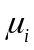 is the chemical potential of component i and superscripts l and r, refer to polymer lean and polymer rich phases respectively.
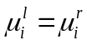 | 1
The spinodal condition requires that the second derivative of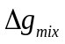, with respect to the composition (in terms of volume fraction), at constant temperature and pressure, to be positive as presented by Eq.2 ;
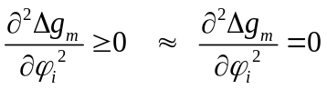 | 2
In addition, applying material balance, in the form of volume fraction of the two components, one obtains Eq. 3, which must be holding on this point (and any point).
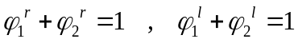 | 3
These set of equations must be solved simultaneously to find the corresponding temperature (LCST / UCST) in a trial and error procedure and by an initial guess, which is a kind of optimization problems that 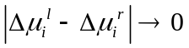 is used as main optimizing criteria (in which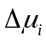=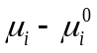and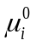 refers to standard state of the chemical potential of component “i”). For optimization purpose, Particle Swarm Optimization (PSO) Technique was used .
Chemical potential, in Eq. 1 (for 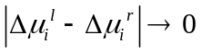) can be calculated by using activity coefficient models such as Flory-Huggins theory and its extensions (such as Lattice Cluster Theory) . These models require binary interaction parameters, which must be calculated or experimentally measured and this limits their application . It must be noted that using a model which needs only pure component properties, is of the much interest . Thus, thermodynamic model of Compressible Regular Solution theory (CRS) was considered in this paper for development of Model. The main equations of this theory for a binary solution are given by Eqs. 4-6 where 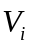accounts for molar volume of component “i”.
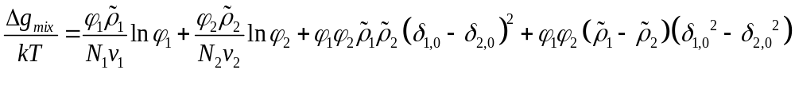 | 4
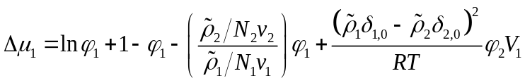 | 5
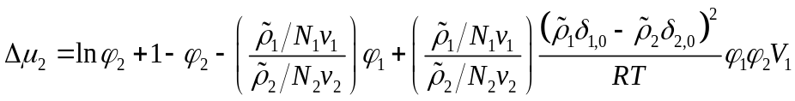 | 6
The pure component properties are needed for the activity coefficient calculations using CRS theory, which can be obtained by group contribution methods (GCM) . Group contribution methods, themselves, can be regarded as some QSPR method for estimation and calculation of physicochemical properties of interest. The solubility parameter values at temperature 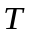 in CRS model requires the estimation of the solubility parameter at 298 K through some group contribution methods (as given by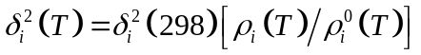), here the van Krevelen GCM was used . In addition, the reduced density (hard core density) were calculated from the modified Sanchez-Lacombe Lattice Fluid model (SL-EOS) (given as 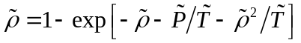) using an iterative root seeking technique and the Constantinou and Gani group contribution method for evaluation for the scaling parameters (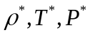) . In addition, the coefficients of thermal expansion for each component were calculated through the modified SL-EOS model . For calculation of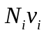 in CRS model (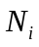 represents number of hard cores in lattices of volume), one might use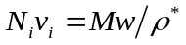equality, where 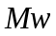 is the molecular weight of components (for polymer the repeating units). In this case, Eq. 2 simplifies to Eq. 8 considering 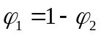 as dependent composition ;
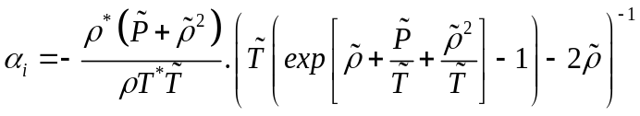 | 7
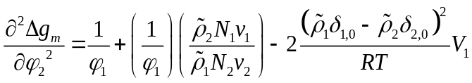 | 8
Using these equations, the temperature of interest, i.e. LCST and/or UCST, can be searched employing an appropriate optimization technique .
  - Method of calculations
Particle Swarm Optimization (PSO) technique was used in this work for determination of temperature which satisfies the thermodynamic modeling criteria. In thermodynamic modeling, the CRS model, itself, requires no optimization and calculation as this model is straightforward , however, finding the temperature of interest i.e. LCST and/or UCST, requires solution of a set of equations as described in previous section, which is an optimization problem. In this case, the number of variables in PSO is 1 (temperature) , and the main objective function is the local equilibrium criteria. The parameters for initialization of PSO are listed in Table 1.
Table 1. PSO parameters
Parameter | Symbol | Value
Maximum Number of Iterations | MaxIt | 1200
Population Size | nPop | 150
Number of Decision Variables | nVar | 1
Upper & Lower Bounds of Variables | VarMin  VarMax | 100  750
Objective Functions | ObjFun | .
The PSO has been considered to ensure both the higher accuracy of calculations and lower computational costs . The swarm intelligence based algorithm of PSO provides a precise evolution of calculations toward the best optimal solution of optimization problems as it employs the local and global optimums to control the goodness of each estimated solution . It is necessary to note that in the any evolutionary/swarm intelligent algorithm, the input upper and lower bounds for variables introduced are important factors . It should be checked whether the reported values are close to the introduced bounds or not. It is recommended that the bound should be refined to a domain that covers all current variables when the variables (particles) are very close to the bounds.
- Empirical modeling of UCST and LCST
  - Model development
In empirical modeling, commonly the available LCST and/or UCST data are related to physiochemical properties, such as density, critical properties, or solubility parameters . However, there are polymers, for those, the mentioned properties are unknown. Thus to nominate required properties, two criteria must be met; (i) the nominated property clearly differ from one polymer (solvent) to the others, and (ii) the experimental data be available in the literature or one can estimate them easily using a reliable routine. To develop the empirical model of interest, the connectivity indices (structural descriptors) of polymeric systems (polymer and solvent) were used as the independent variables of model. It must be noted that, this way, the highly predictive advantage of QSPR will be incorporated to the empirical modeling.
Such connectivity indices (i.e. structural descriptors) have been used by Lie and Zhong for presentation of their simple correlation. They employed eight connectivity indices, five of those were adopted to the polymer are; (i) polymer zero-order valence connectivity index (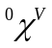), (ii) polymer third-order valence connectivity index contributed by the chain backbone (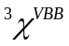), (iii) polymer third-order cluster connectivity index (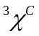), (iv) polymer first order connectivity index contributed by the side groups (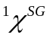) and (v) polymer third-order connectivity index contributed by the side groups (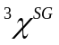). Using chain backbone and side group indices, the local structure of individual different polymers can be determined, and one can assure that no similar values for different system would be obtained. Hence, the chain backbone and side group indices of polymer (as mentioned in paragraph above) together with the third, fourth and fifth-order connectivity indices of solvent (e.g. 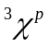, 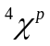 and 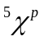) were selected as independent variables to develop the model. The calculation procedure to estimate the connectivity indices is simple and can be found elsewhere in details .
To obtain the empirical model of interest, one can express LCST and/or UCST, the dependent variable indicated by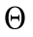, as a function of the selected independent variables, by Eq. 17;
9
The defined independent variables in Eq. 17 can be divided to the following main groups as indicated by subscripts 1 and 2:
1: Polymer variable (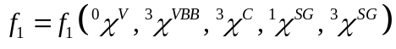)
2: Solvent variables (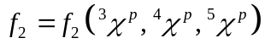)
Mathematically, every algebraic function (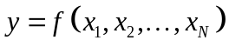) can be approximated by a new function (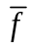) as presented by Eq. 18, which represents the relationship between the approximated dependent variable,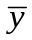 , and independent variables,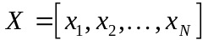.
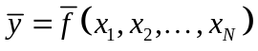 | 10
In which, 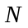shows the number of independent variables.
As shown by Eq. 19, the approximated dependent variable can be expressed in the form of Volterra Functional Series for independent variables ;
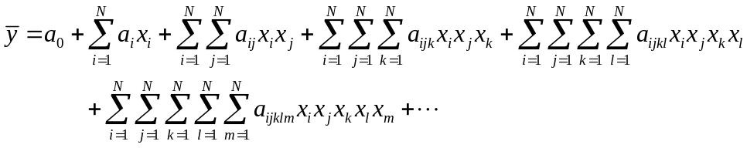 | 11
In which,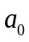,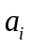,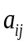,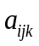, 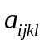 and 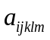 are constant coefficients.
Applying Eq. 19 to Eq. 17 for two main variables of 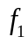and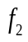, one would obtain Eq. 20, where, -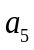 are constant coefficients which must be determined by using the available data.
12
This equation (Eq. 20) can be rewritten in matrix form as shown by Eq. 13 where the superscript refers to the transpose of the matrix. Such matrix formulation would be beneficiated from its easy implementation in calculation routines such as MathWorks MATLAB and etc.
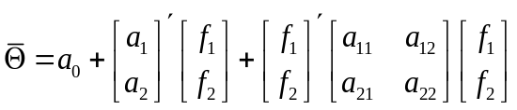 | 13
Applying Eq. 19, one can obtain also the corresponding approximations for and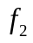, as shown by Eqs. 14-15 in matrix form.
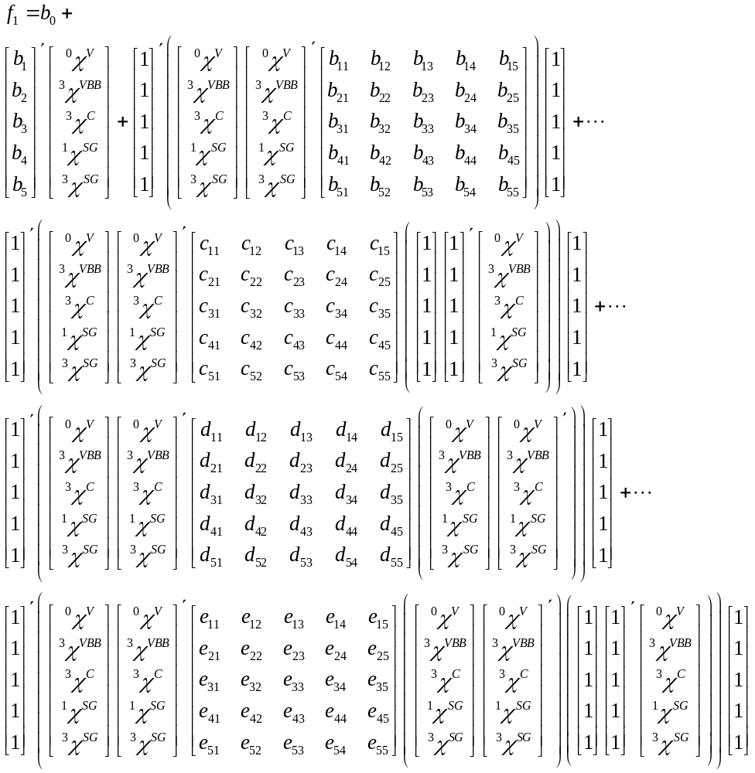 | 14
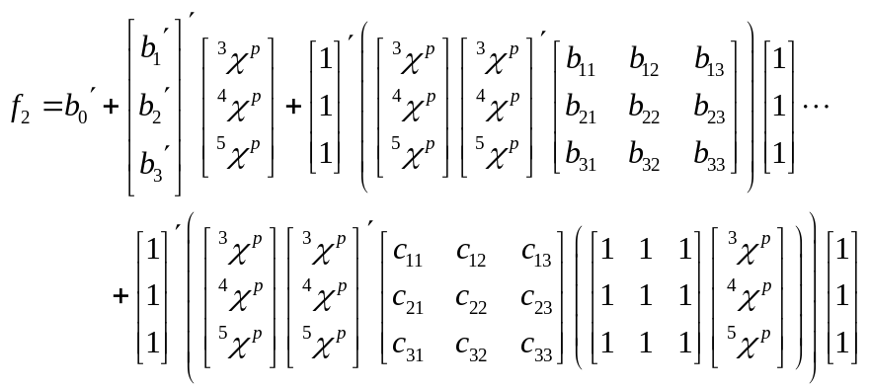 | 15
Eqs. 13-15 show the most generalized approximation of the LCST and/or UCST, in which,,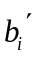,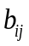,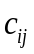, 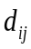 and 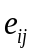are model constants. The optimum values of the model constants can be calculated by implementation of an efficient algorithm by regression of model to the available experimental data . It is necessary to note that, by assuming some of these constants equal to zero, one would find more simple equations and reduce this model to the simple correlations (as of ).
In any empirical study, to evaluate the agreement between the real (experimental) and calculated data, statistical methods and function are required. Here, four statistical parameters including sum of squares due to error of the fit (SSE), square of the correlation (R²), adjusted R-square (R²-adj) and standard error of the regression (RMSE) were implemented based on Refs. as summarized in Table 2. The model that satisfies all these parameters can be accepted.
Considering the presented statistical parameters, one can use the following rules of thumb to evaluate the model parameters ; (1) SSE; value closer to zero indicates a good fitness, which has a smaller random error component, (2) R-sq.; value closer to 1 indicates that a greater proportion of variance is accounted for the model, (3) Adj R-sq.; value closer to 1 indicates a good fitness, however it can take on any value less than or equal to 1 and (4) RMSE; value closer to 0 indicates a fitness that it is more useful for prediction.
Table 2. Statistical Parameters used in this study
Parameter | Equation
sum of squares due to error of the fit | 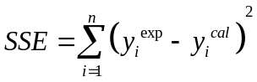
square of the correlation | 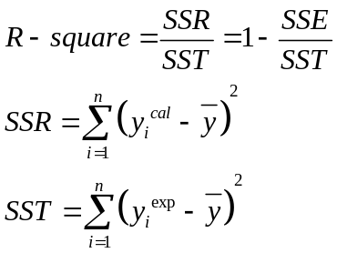
adjusted R-square | 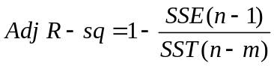
standard error of the regression | 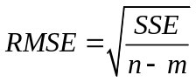
Note: n is number of data and m is number of coefficient in the models.

The standard error of the regression (RMSE) relationship, given as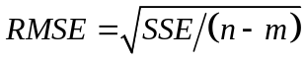, indicates that in any established empirical model of interest, the number of coefficients in the models must be lower than the number of data points () as 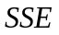 is a non-negative value. Mathematically, for a problem of interest where the number of known variables (data) is lower than that of unknown variables (coefficients), an underdetermined system of equations would be obtained, which requires special iterative regression methods to find the optimal solution. An overdetermined systems of equations is obtained whenever, the number of unknown variables (coefficients) is lower than that of known variables (data).
This implication draws the correct method of application of the presented generalized model for the employed database of experimental CST data in any individual research. In other words, the large number of unknown variables 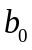-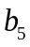, 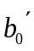-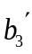,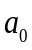-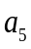 and all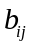,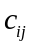, 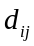, and 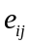 can be reduced and updated according to the number of available experimental data in any research this way. On the other hand, the RMSE relationship and its subsequent implications and the relationship for adjusted R-square clearly show that using a large number of data points in training step of any proposed model, essentially, will not result in reliable and robust solution of unknown constants. In fact, and with no doubt, a large training dataset increases the coverage domain of model, as larger fraction of known data are being used, but significantly reduces the goodness of the model. The best training dataset is the one in which the maximum and minimum data are included and intervals of high fluctuation are sampled concisely. It is interesting that such reduction of an empirical model has the advantage of a reduction in computational costs and enhances consistency of model.
To reduce the number of model coefficients and provide a simpler but still general model, the coefficients indicated by,,, and were eliminated from the model equation and only coefficients of first kind , and were considered in present paper and the obtained relationship is given as presented in Eq. 16, which alternatively can be obtained using the Volterra Functional Series up to second term for the functional variables and .
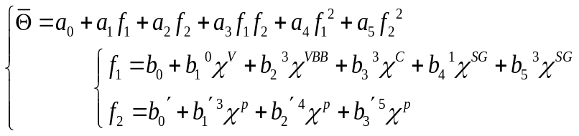 | 16
The final expression for proposed empirical model of LCST and/or UCST is simple as it requires a limited number of coefficients to be regressed to the data, and it is general as it provides all possible crosslinking of considered independent variables of system in its formulation, in other words, all possible binary crosslinking of , , , , , , and are considered and included in the model.
  - Method of calculation
Here, PSO technique was used for determination of model coefficients. In this case, the number of variables in PSO is 16 , and the main objective functions are the prescribed statistical parameters. The parameters for initialization of PSO are listed in Table 3.
Table 3. PSO parameters
Parameter | Symbol | Value
Maximum Number of Iterations | MaxIt | 100
Population Size | nPop | 250
Number of Decision Variables | nVar | 16
Upper & Lower Bounds of Variables | VarMin  VarMax | -500  1000
Objective Functions | ObjFun | Statistical parameters.

- New group contribution based correlation
  - Correlating topological indices with lattice fluid parameters
In QSPR modeling works , the determination and calculation of topological indices of molecules requires the application of commercial software packages and needs a considerable computational cost and time . The optimization of molecules geometry to approach the most stable geometry which has the lowest internal energy needs a number of module selection and applications. On the other side, the lattice fluid parameters such as the scaling parameters of modified SL-EOS () are well-known or can be calculated and determined using some well-established methods, such as the Constantinou and Gani group contribution method . Thus here, having the available topological indices and the scaling parameters of modified SL-EOS, attempts were made to establish reliable correlations which relate each topological index to the scaling parameters of modified SL-EOS.
Eight connectivity indices were investigated among which five parameters were adopted to the polymer (as listed below) (i) polymer zero-order valence connectivity index (), (ii) polymer third-order valence connectivity index contributed by the chain backbone (), (iii) polymer third-order cluster connectivity index (), (iv) polymer first order connectivity index contributed by the side groups () and (v) polymer third-order connectivity index contributed by the side groups (), and the third, fourth and fifth-order connectivity indices (, and ) were set for solvent respectively as 3 remaining parameters. The calculation procedure to estimate the connectivity indices can be found elsewhere in details . On the other hand, the Constantinou and Gani group contribution method was used for evaluation of the scaling parameters () .
A linear discrete form of Volterra functional series was used to relate the connectivity indices (dependent variables) to the modified SL-EOS parameters (independent variables). To obtain the expressions of interest, one can express connectivity indices, the dependent variable indicated by, as a function of the selected independent variables (modified SL-EOS parameters), by Eq. 17;
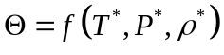 | 17
Mathematically, algebraic function can be approximated by a new function () as presented by Eq. 18, which represents the relationship between the approximated dependent variable, , and independent variables, where shows the number of independent variables.
18
Eq. 19 shows a linear discrete form of Volterra functional series in which is the approximated dependent variable and, , , , and are constant coefficients.
19
Applying Eq. 19 to Eq. 17, after rearrangement and simplification, one would obtain Eq. 20, where, -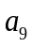 are constant coefficients which must be determined by using the available data.
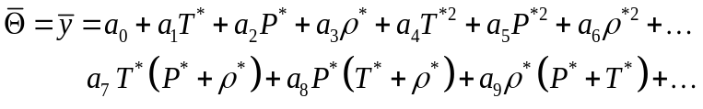 | 20
Eq. 20 is the reduced form of Eq. 19 up to the third term which is known as Kolmogorov-Gabor polynomials . The coefficients are unknown constants that must be determined using the available connectivity indices (dependent variables) and modified SL-EOS parameters (independent variables).
  - Method of calculation
For each connectivity index of interest, a system of equations can be constructed by substituting available data in Eq. 20 as illustrated in Eq. 21 where  is number of data points.
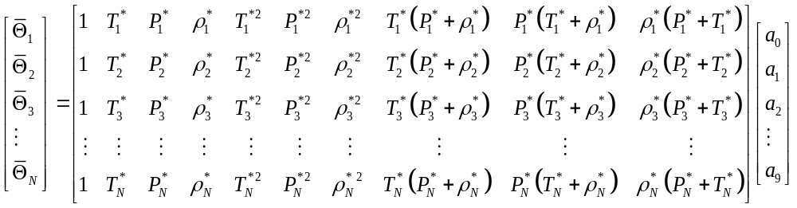 | 21
The solution for system of equations presented in Eq. 21 can be given by Eq. 22;
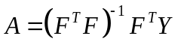 | 22
Here  indicate the matrix of coefficients, is the matrix of known dependent data (connectivity indices) and  is the matrix of coefficients constructed using available/calculated modified SL-EOS parameters. The superscripts and respectively indicates the transpose and invers of matrix.
- Results and discussion
  - Required data
The experimental data of LCST and UCST were collected from literature and listed in appendixes (Table 9 and Table 10 respectively). The structural descriptors of binary polymeric solution are calculated and checked against the available data in Refs. and summarized in appendixes (Table 11 and Table 12 for polymers and solvents respectively). The lattice fluid parameters of modified SL-EOS () were calculated and listed in appendixes (Table 13 and Table 14 for polymers and solvents respectively).
  - Thermodynamic model
For each binary polymeric system listed in Table 9 and Table 10, minimization of the predefined objective function (here, the local equilibrium criteria) was performed using the PSO technique. As illustrated in Table 1, a population of 150 particles is initially produced in PSO as the initial guess of LCST/UCST (dimension) which upper and lower bounds of variables were set within range 100-750. Over iterations, the PSO checks the best local and global guesses and move around to find the final optimal dimension according to the introduced Objective Function. The PSO successfully approaches to the final value of LCST/UCST in each system after 23 iterations in average. The evaluation of objective function and iterations using PSO technique is illustrated in Fig. 1.
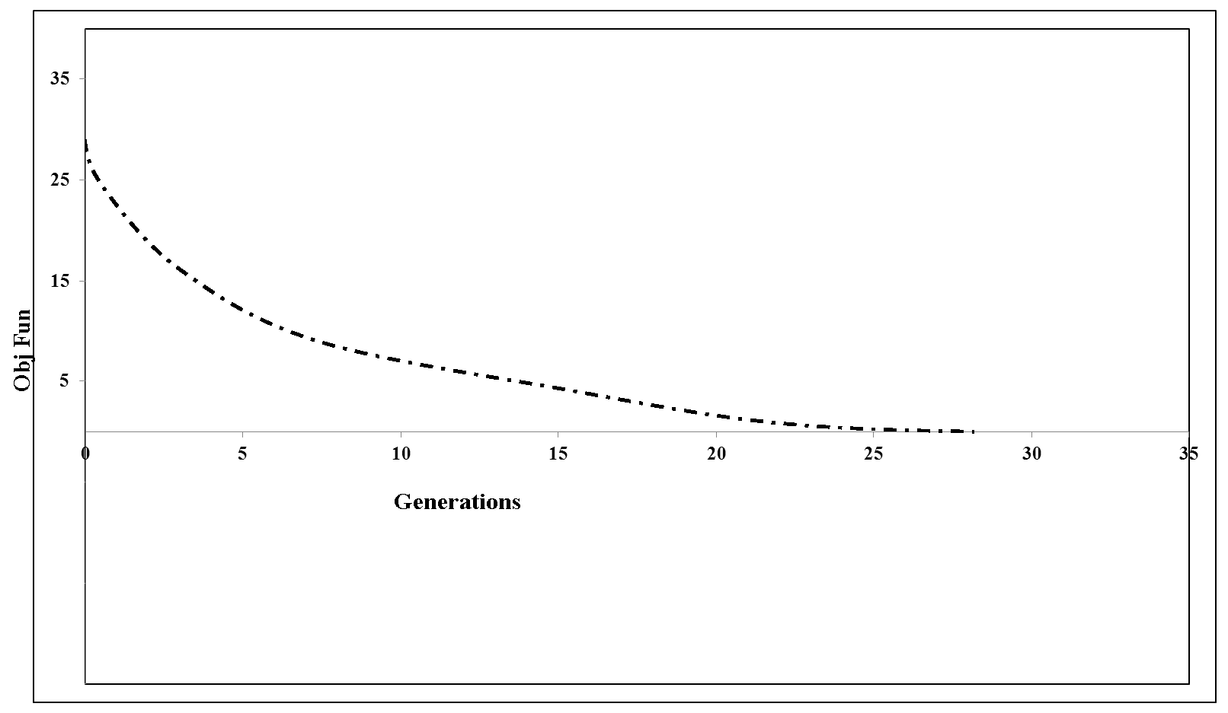
Fig. 1. The average convergence of PSO
The deviation of calculated LCST/UCST data was compared to the experimental data listed in Table 9 and Table 10. For each binary system, the Individual Absolute Relative Deviation (IARD) between calculated and experimental data was used to present the accuracy of calculations as defined in Eq. 23 where temperatures are in Kelvin.
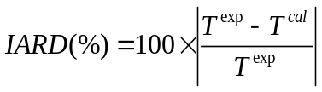 | 23
The correlation results of thermodynamic model are depicted in Fig. 2 and Fig. 3 respectively for LCST and UCST binary systems.
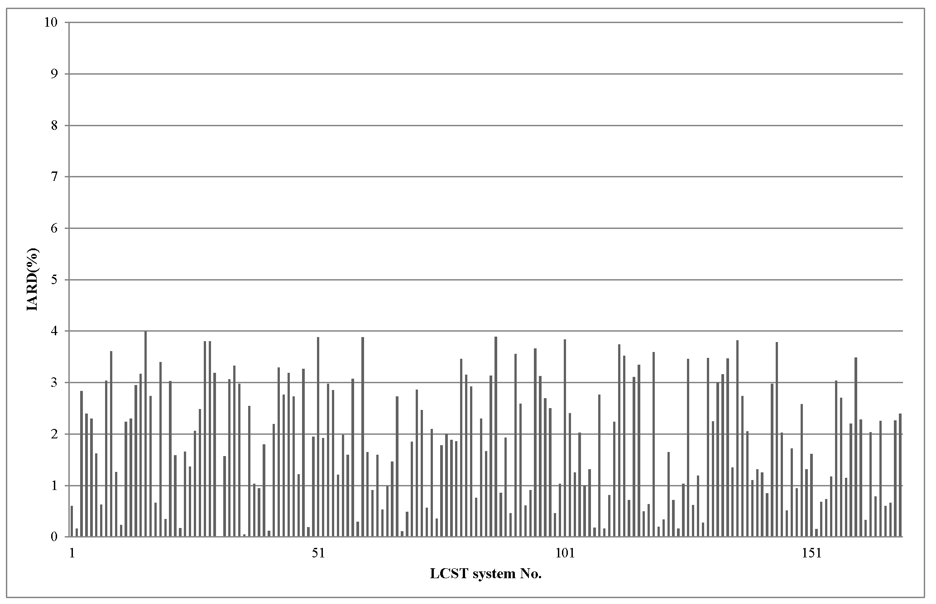
Fig. 2. The Individual Absolute Relative Deviation (IARD) between calculated and experimental LCST data
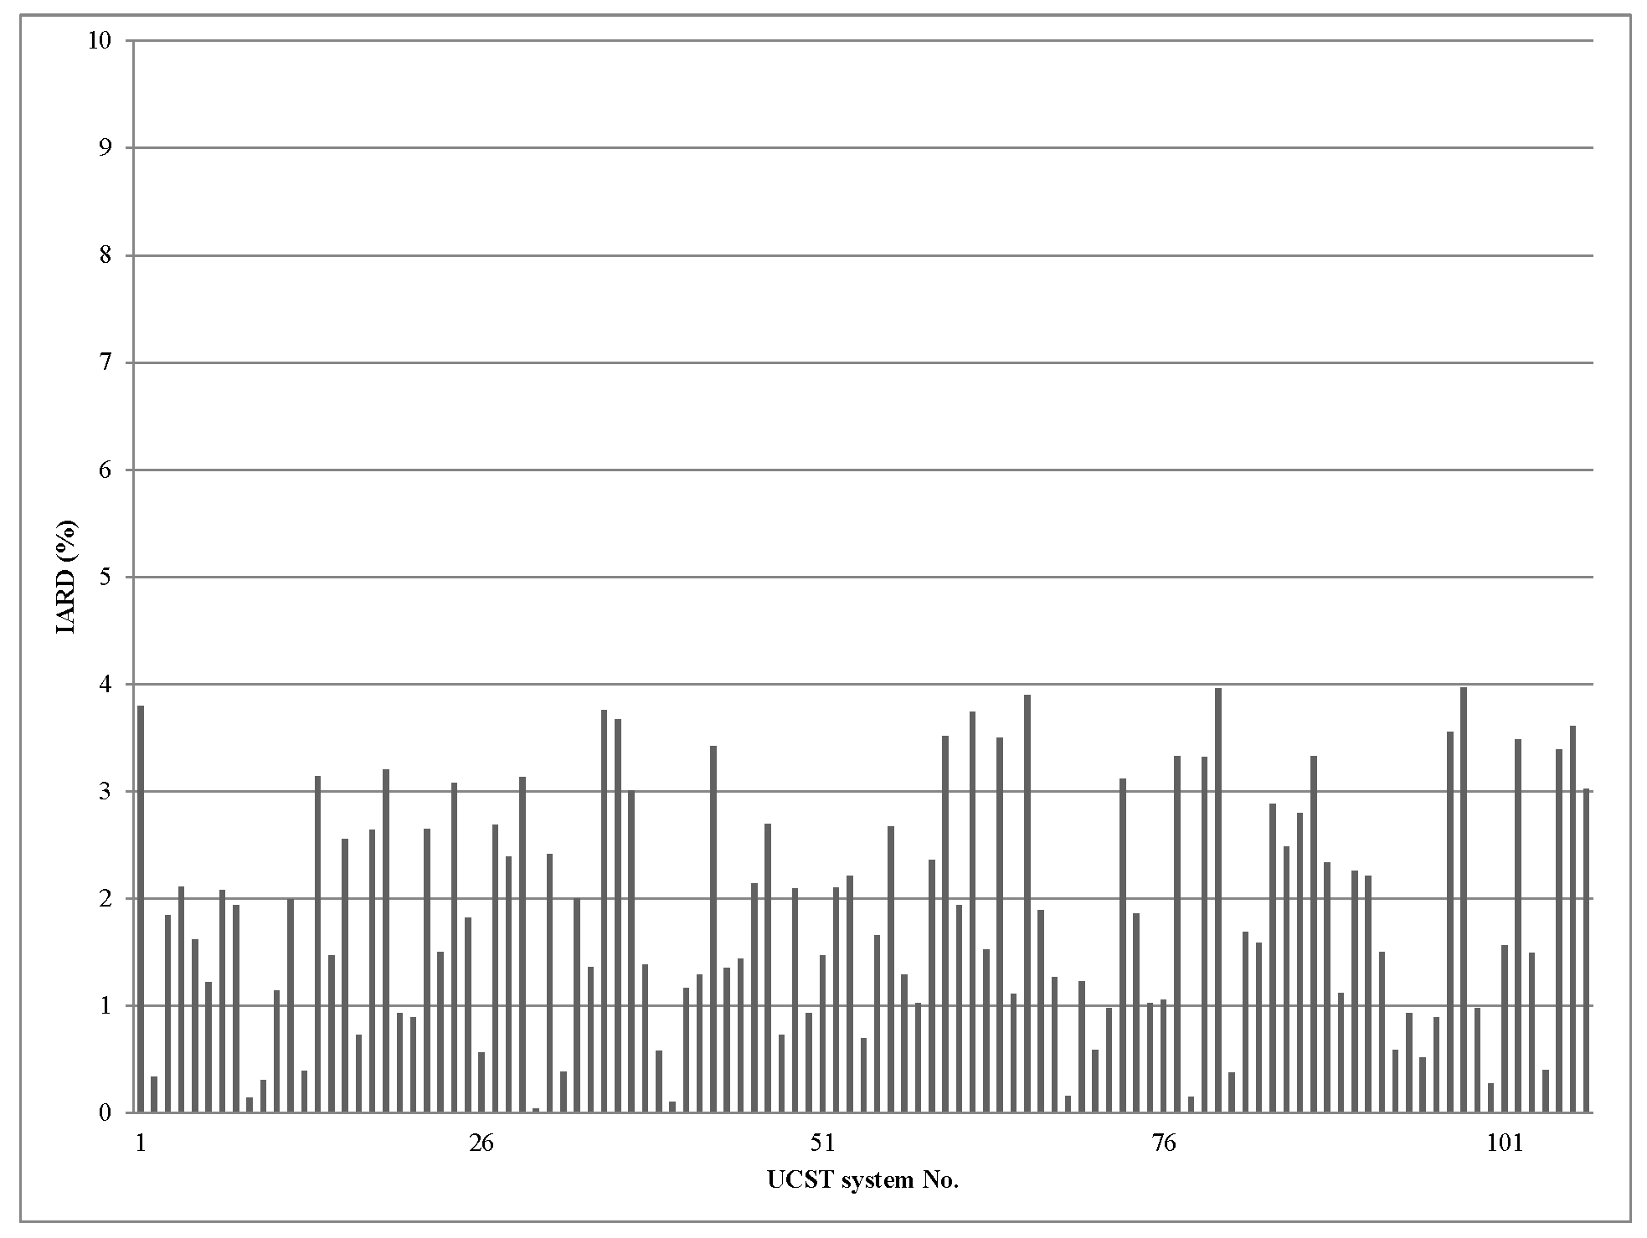
Fig. 3. The Individual Absolute Relative Deviation (IARD) between calculated and experimental UCST data
Desirable agreements between calculated and experimental data were found in the presented thermodynamic model as demonstrated by a maximum IARD of 5 %. Beside the reliable optimization technique which provides fast convergence to the final solution, the CRS thermodynamic model demonstrates confident predictions for polymeric solutions as also reported elsewhere . The required input data of CRS model are the scaling parameters of lattice fluid theory of Sanchez and Lacombe which are known for a substantial number of materials and in the case of unavailability can be simply calculated using some group contribution method. The computational cost of model application is low and the final solution can be obtained by just a few iterations as demonstrated in Fig. 1. The accuracy of model together with fast convergence of computation routine reveals the high potential of proposed method for further applications.
  - Empirical model
The statistical parameters values are summarized in Table 4.
Table 4. Statistical parameters for the obtained LCST / UCST equations
Parameter | Value
Parameter | for LCST | for LCST
SSE | 0.0617 | 0.1591
R-sq. | 0.8919 | 0.9091
adjusted R-sq. | 0.8925 | 0.9096
RMSE | 0.2199 | 0.3517
The obtained optimal coefficients of developed statistical model, i.e. - - and - in Eq. 16, for LCST and UCST are listed in Table 5.
Table 5. Optimal coefficients of statistical model obtained for LCST and UCST data
 | Optimal coefficients of LCST model
 | 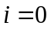 | 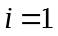 | 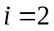 | 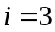 | 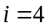 | 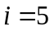
 | 485.3 | 8.633 | 47.04 | -7.221 | 3.262 | -1.733
 | 0 | -0.3127 | 1.0393 | -0.1165 | 1.0266 | -1.3911
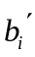 | 0 | 1.2373 | 1.1458 | 1.1040 | - | -
Recommendation: (i) connectivity indices of polymer should be normalized by mean 2.176 and std 0.7416; (ii) connectivity indices of solvent should be normalized by mean 2.955 and std 1.283
 | Optimal coefficients of UCST model
 | 316.8 | 43.29 | 16.22 | 8.266 | 11.42 | -1.56
 | 0 | 4.0885 | 15.4705 | -3.9651 | 195.5912 | -164.3854
 | 0 | 48.3833 | -9.7024 | -9.3262 | - | -
Recommendation: (i) connectivity indices of polymer should be normalized by mean -82.29 and std 132; (ii) connectivity indices of solvent should be normalized by mean 7.248 and std 19.17

The correlation results of obtained models of LCST and UCST are illustrated in Fig. 4 and Fig. 5 respectively.
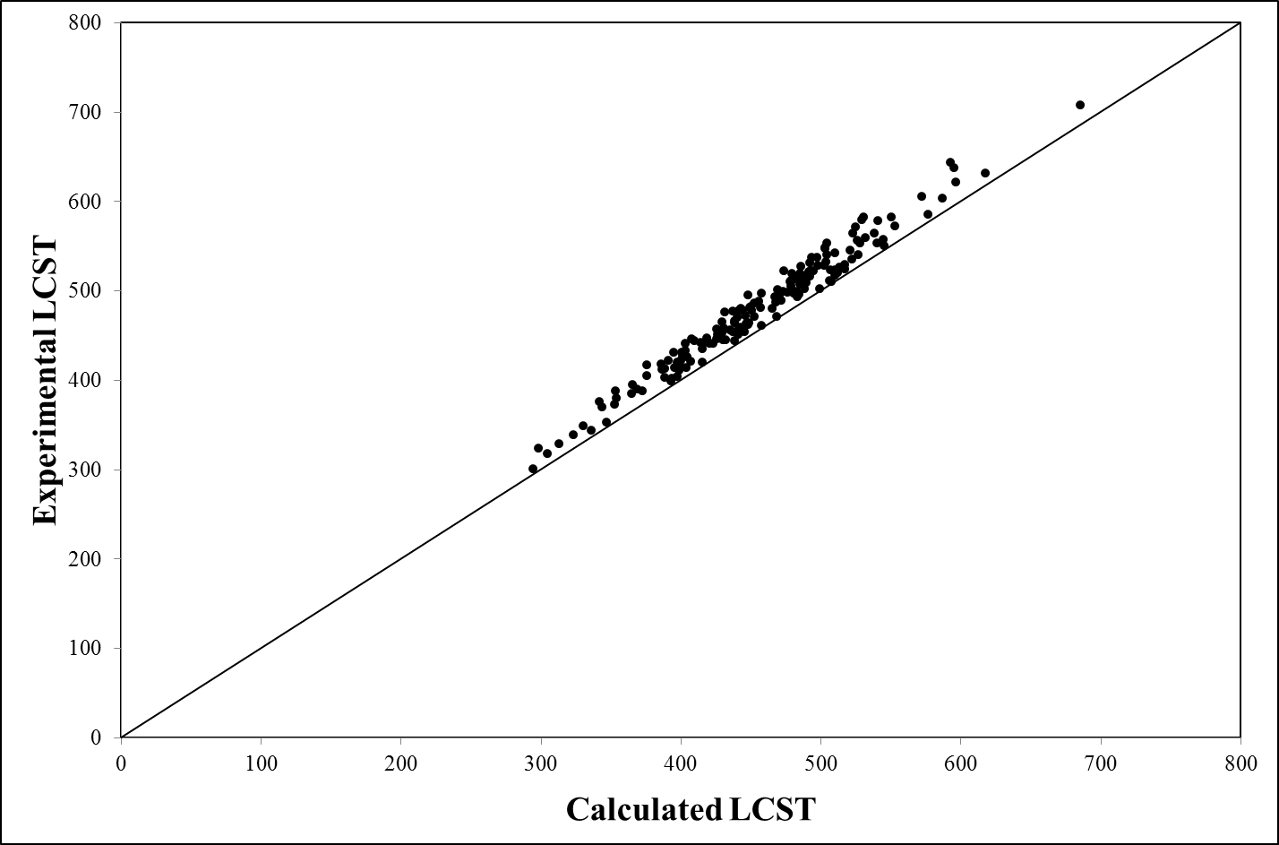
Fig. 4. The correlation results of obtained models of LCST
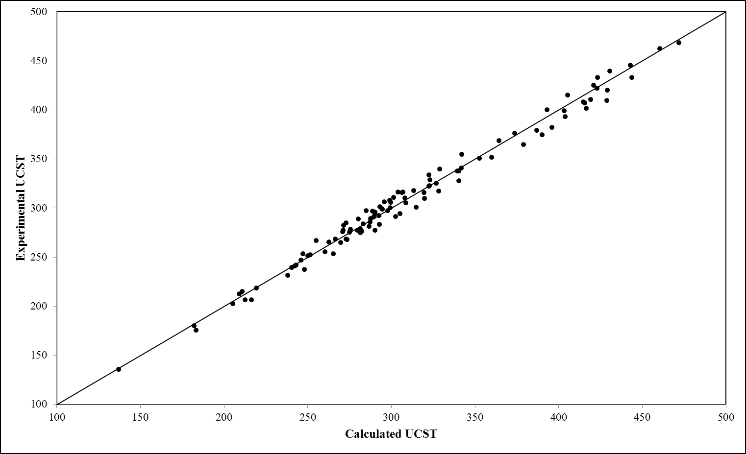
Fig. 5. The correlation results of obtained models of UCST
Based on the obtained statistical parameters listed in Table 4, both the models are desirable and result in considerable accuracy in predictions. The increase in adjusted R-sq. value suggests that the addition of additional constant and coefficients to the model equations may increase the correlation and accuracy of predictions. This can be simply justified as the model equation (Eq. 16) was developed based on some simplification applied to the general form presented in Eqs. 13-15. According to the correlations shown in Fig. 4 and Fig. 5, the agreement between the experimental data and model predications are desirable.
  - New group contribution based correlation
For each connectivity index of interest, the aforementioned system of equations (Eq. 21) was constructed and solved. The coefficients of each model then were calculated using Eq. 22 as listed in Table 6.
Table 6. Obtained model coefficients
a₀ | -3.90332 | 1.03859 | -9.80256×10⁻² | -7.15071 | -4.30298 | 3.38060 | 2.47805 | 1.68207
a₁ | -4.02362×10⁻³ | -2.70222×10⁻³ | 1.55240×10⁻³ | 3.61805×10⁻³ | 3.92652×10⁻³ | 2.47410×10⁻⁴ | -1.77303×10⁻⁴ | -2.29583×10⁻⁴
a₂ | -4.15914×10⁻² | -2.12398×10⁻³ | -3.59079×10⁻³ | -2.46037×10⁻² | -9.16374×10⁻³ | -3.71859×10⁻³ | -2.32192×10⁻³ | -1.15389×10⁻³
a₃ | 2.91502×10⁻² | 1.63677×10⁻³ | 1.76236×10⁻³ | 1.97301×10⁻² | 8.40892×10⁻³ | -2.26346×10⁻³ | -1.78076×10⁻³ | -1.45682×10⁻³
a₄ | 9.90248×10⁻⁶ | 1.24268×10⁻⁶ | 1.30665×10⁻⁷ | 4.56275×10⁻⁶ | 1.14879×10⁻⁶ | 1.88472×10⁻⁶ | 1.45618×10⁻⁶ | 1.08607×10⁻⁶
a₅ | 1.03818×10⁻⁵ | 9.98853×10⁻⁷ | 7.95056×10⁻⁸ | 5.21157×10⁻⁶ | 1.74858×10⁻⁶ | -5.25702×10⁻⁶ | -4.51324×10⁻⁶ | -4.03907×10⁻⁶
a₆ | -1.82260×10⁻⁶ | -3.55109×10⁻⁷ | 4.56412×10⁻⁷ | -1.12049×10⁻⁶ | 4.07587×10⁻⁷ | 2.18997×10⁻⁶ | 1.78060×10⁻⁶ | 1.55828×10⁻⁶
a₇ | 1.54025×10⁻⁵ | 7.95713×10⁻⁷ | 1.53662×10⁻⁶ | 9.07445×10⁻⁶ | 4.32482×10⁻⁶ | -2.05887×10⁻⁶ | -1.18385×10⁻⁶ | -2.15246×10⁻⁷
a₈ | 2.00724×10⁻⁵ | 1.05835×10⁻⁶ | 1.36691×10⁻⁶ | 1.26978×10⁻⁵ | 4.64858×10⁻⁶ | 6.98349×10⁻⁶ | 5.42834×10⁻⁶ | 3.96362×10⁻⁶
a₉ | -3.28928×10⁻⁵ | -1.36473×10⁻⁶ | -3.30425×10⁻⁶ | -2.15038×10⁻⁵ | -1.05731×10⁻⁵ | -3.27922×10⁻⁶ | -2.99776×10⁻⁶ | -2.98750×10⁻⁶
Using the model coefficients listed in Table 6, the connectivity indices were back-calculated and the deviations were obtained in terms of AARD (accumulative averaged relative deviation which equals average of IARD values) as listed in Table 7.

Table 7. Obtained correlation for developed group contribution of connectivity indices
AARD (%) | 28.88 | 28.27 | 7.67 | 48.15 | 43.70 | 31.81 | 41.09 | 41.22

The correlation of model predictions and the calculated connectivity indices are shown in Fig. 6-Fig. 13 for each eight studied connectivity indices.
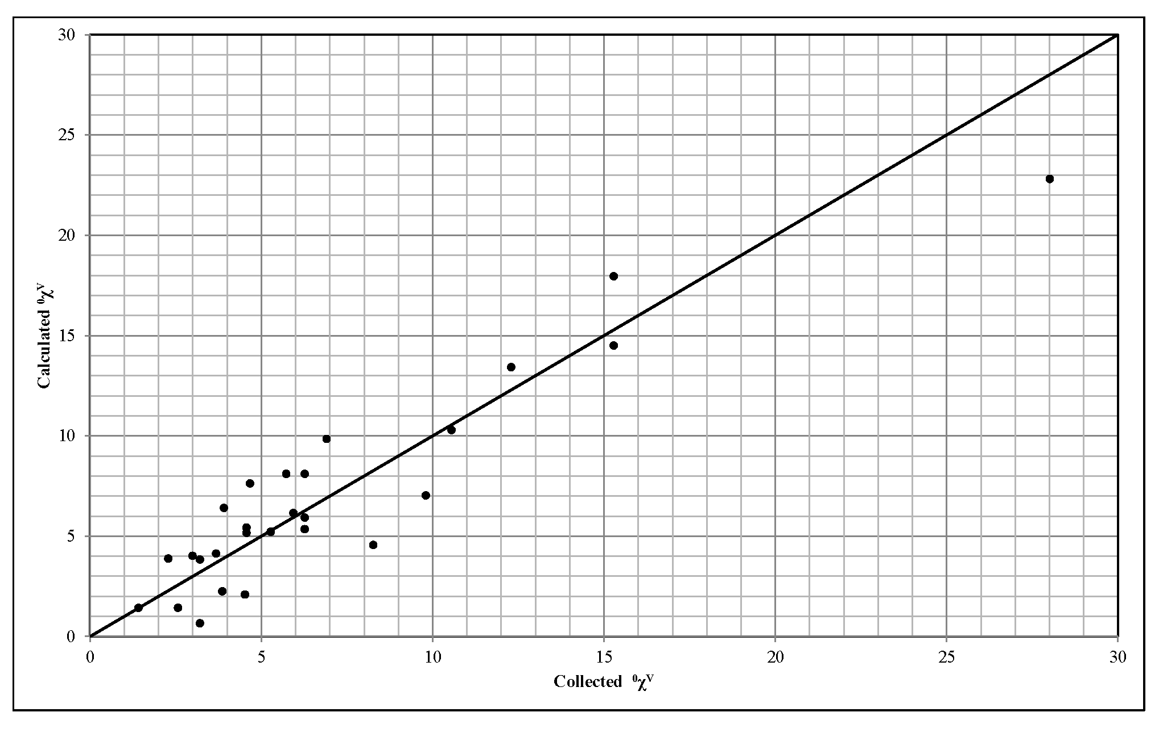
Fig. 6. The correlation results of 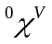
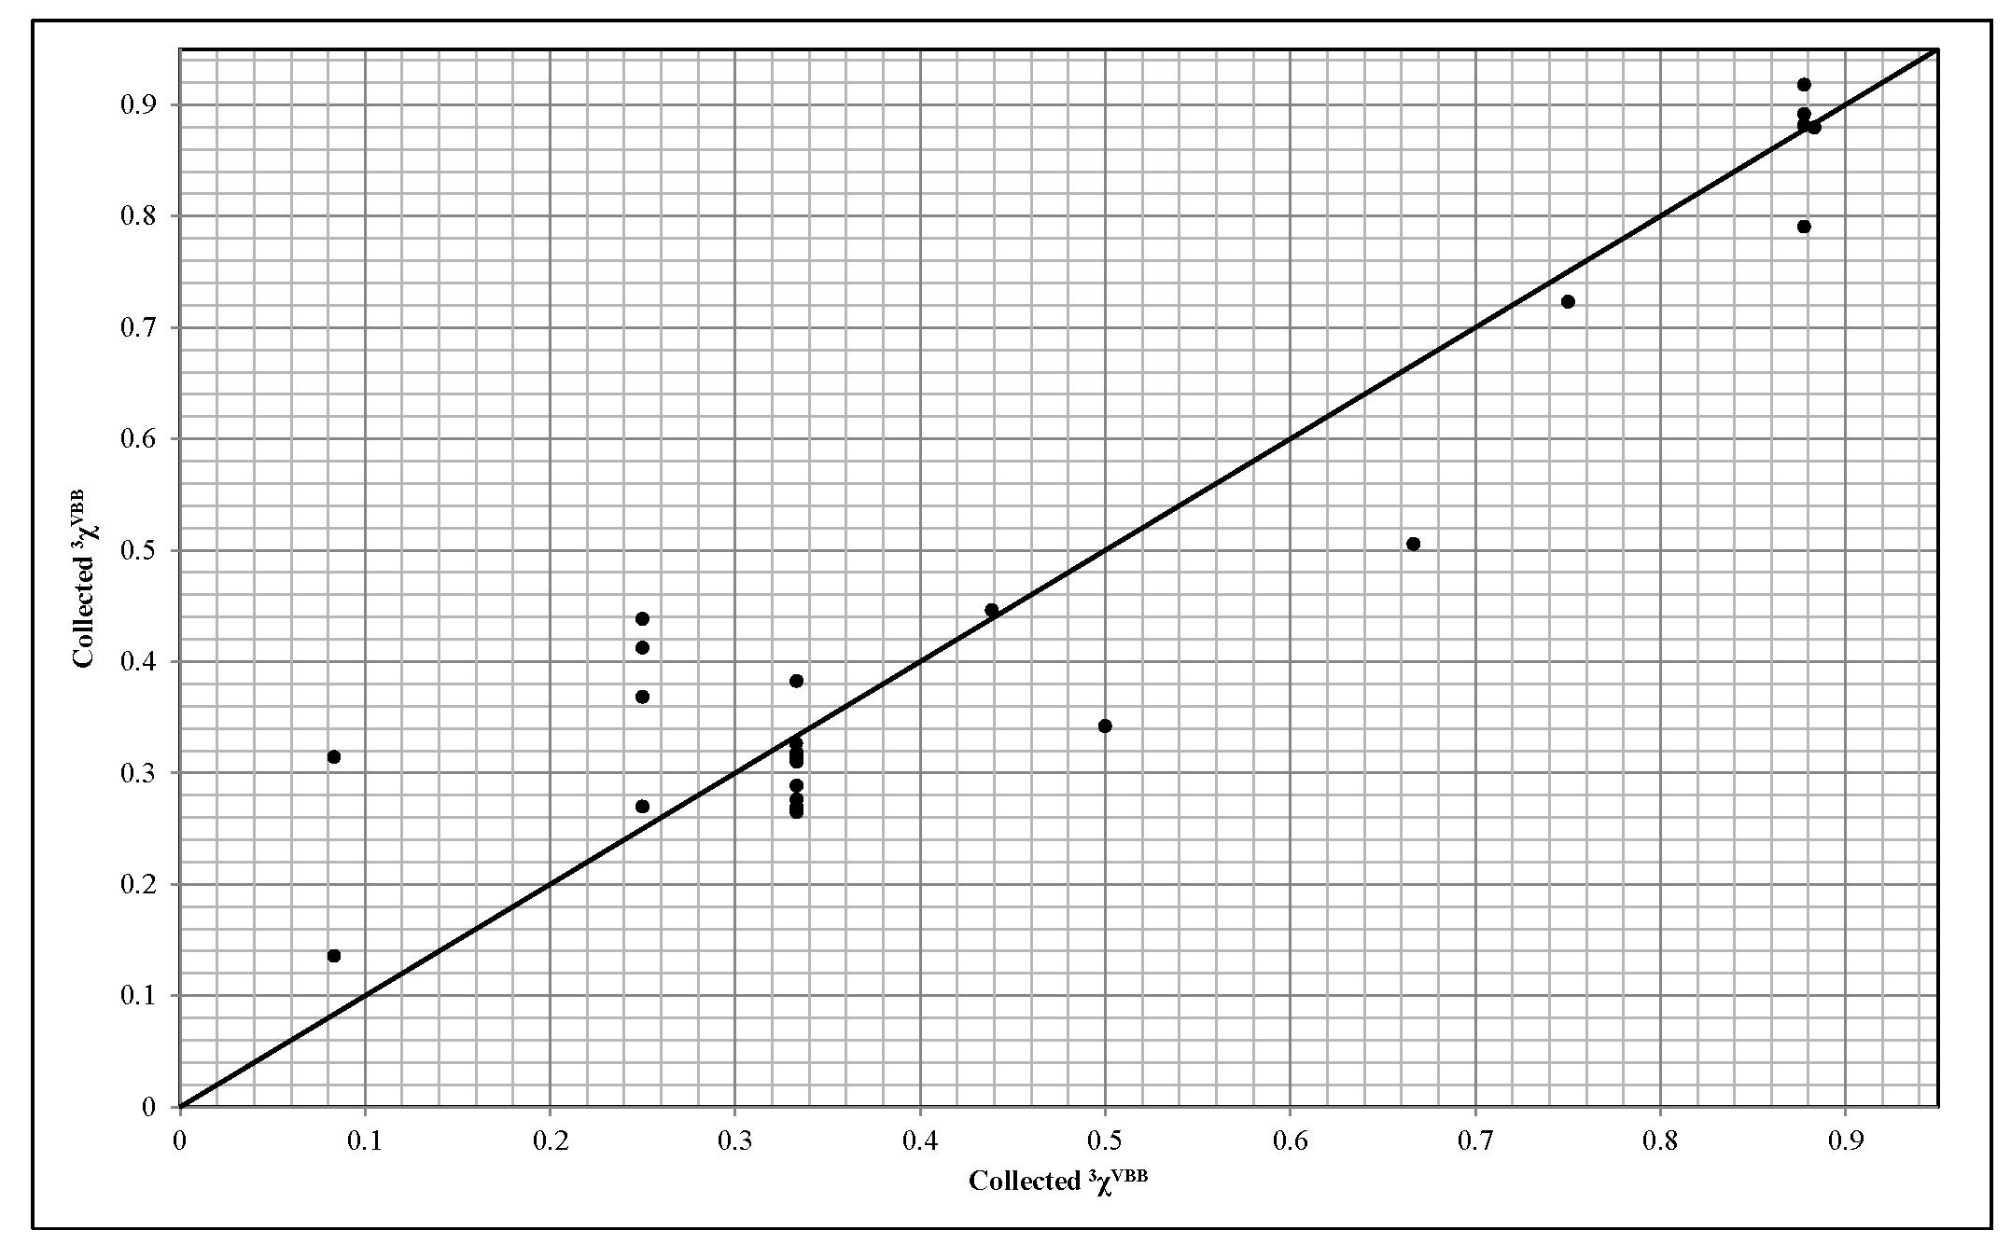
Fig. 7. The correlation results of 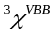
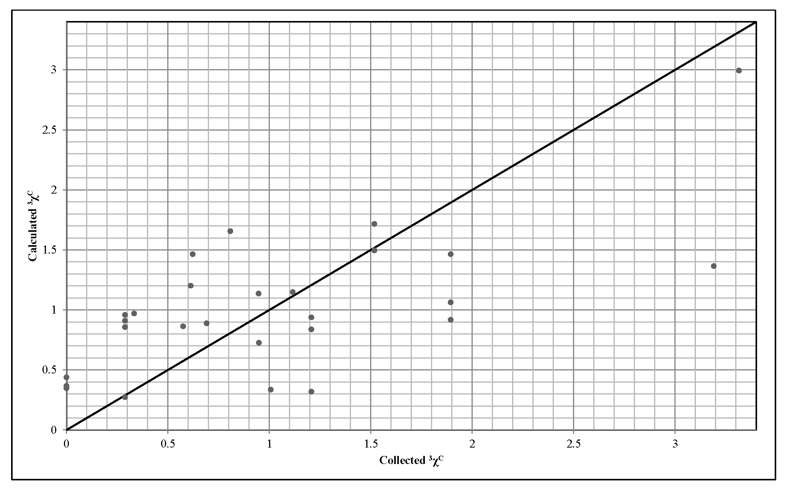
Fig. 8. The correlation results of 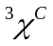
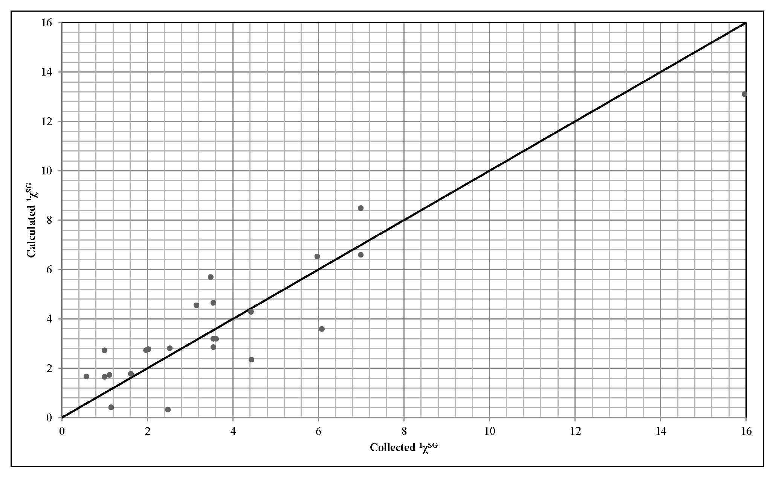
Fig. 9. The correlation results of 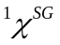
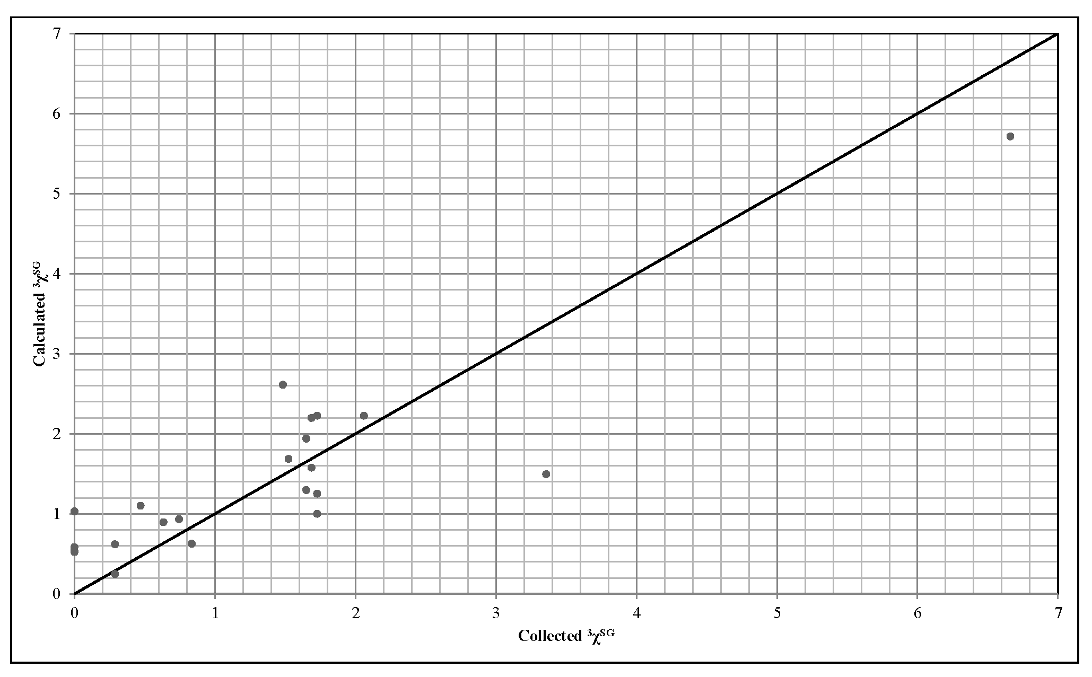
Fig. 10. The correlation results of 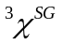
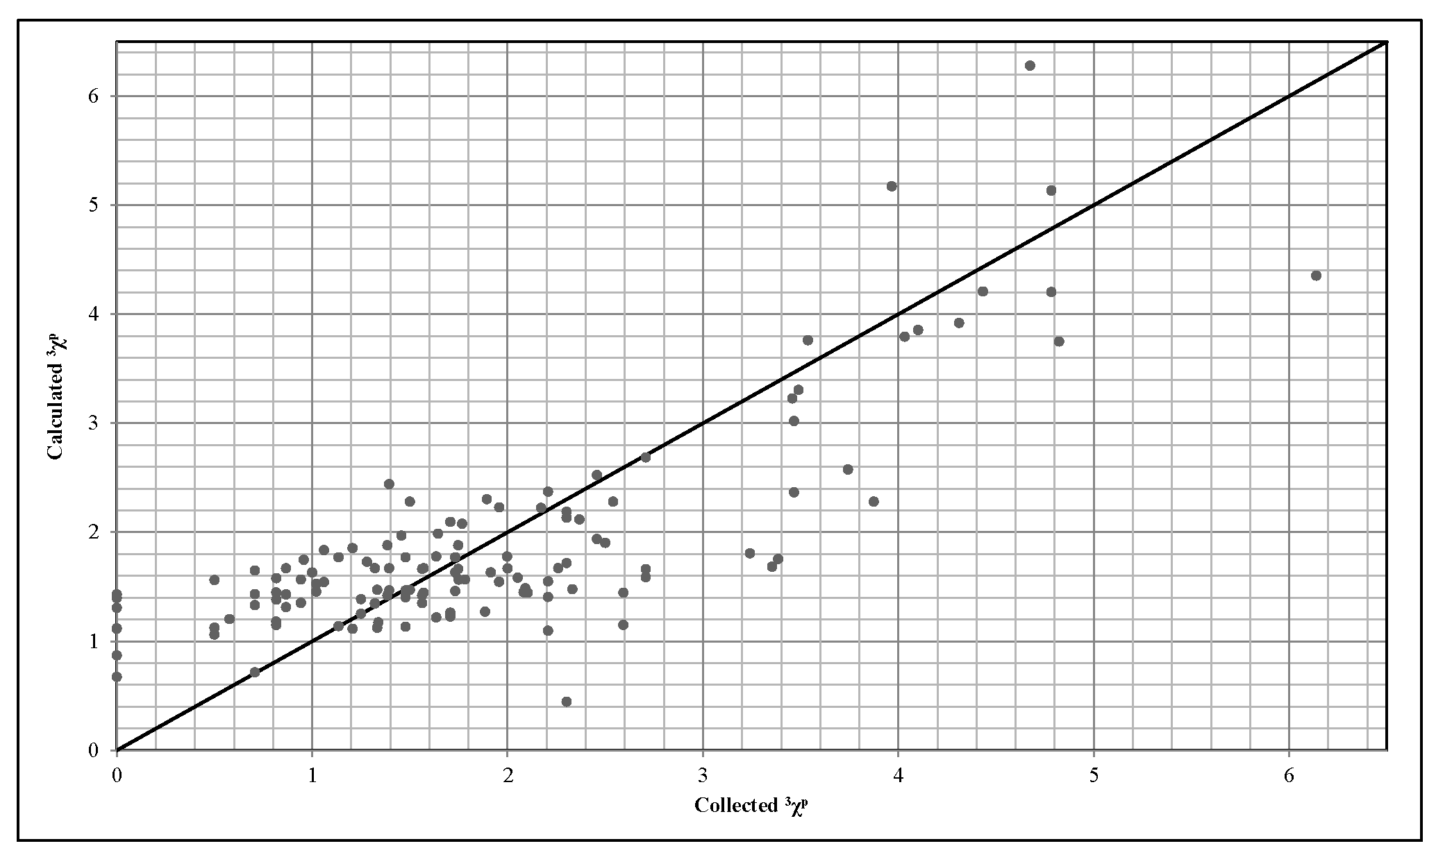
Fig. 11. The correlation results of 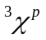
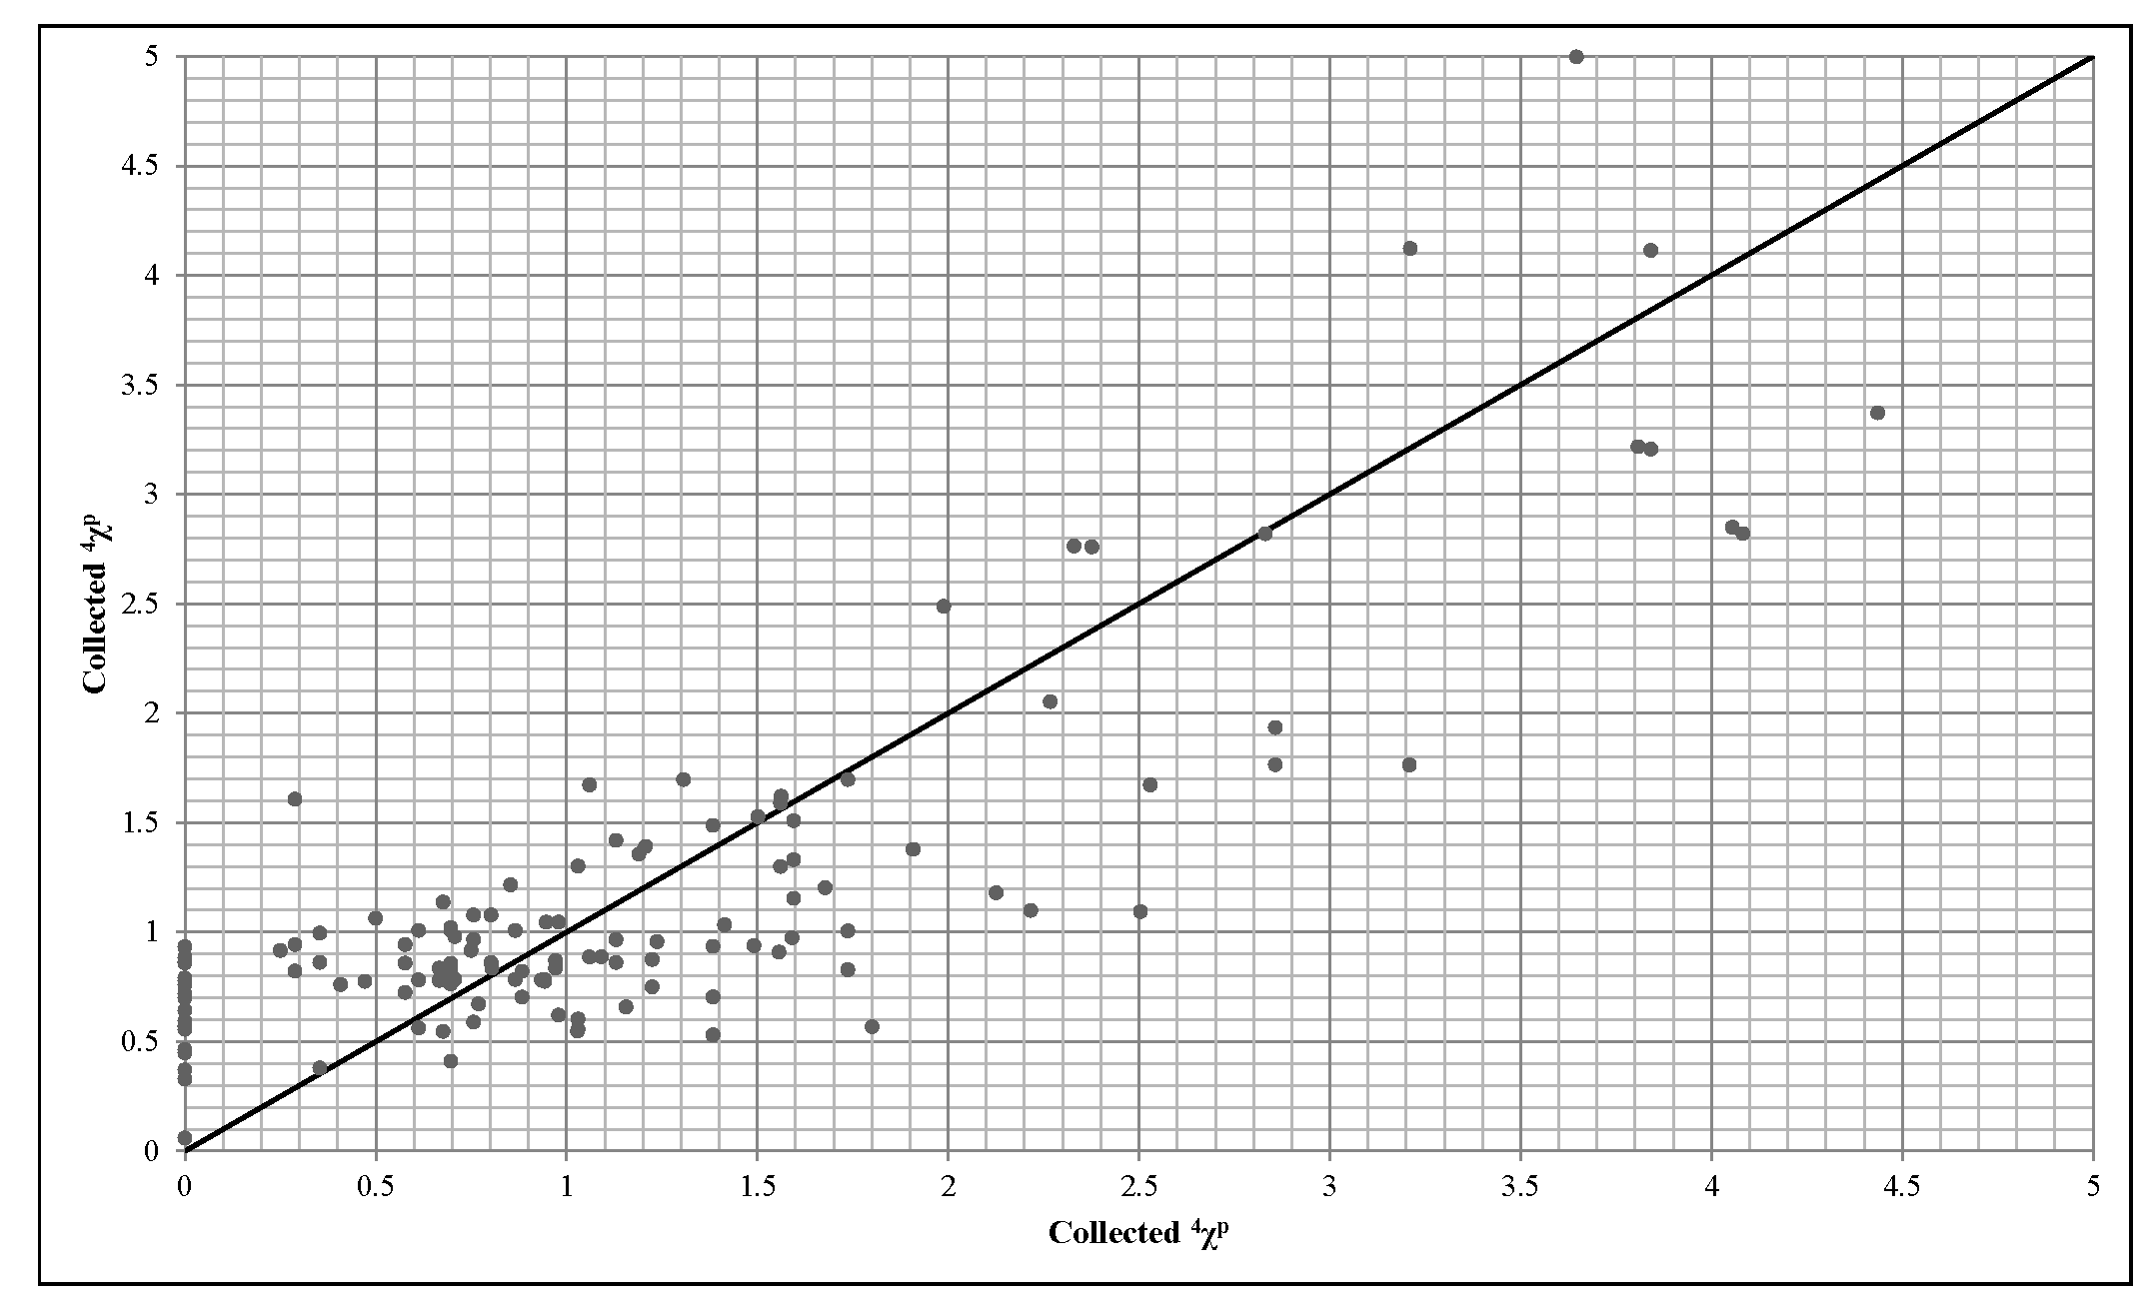
Fig. 12. The correlation results of 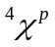
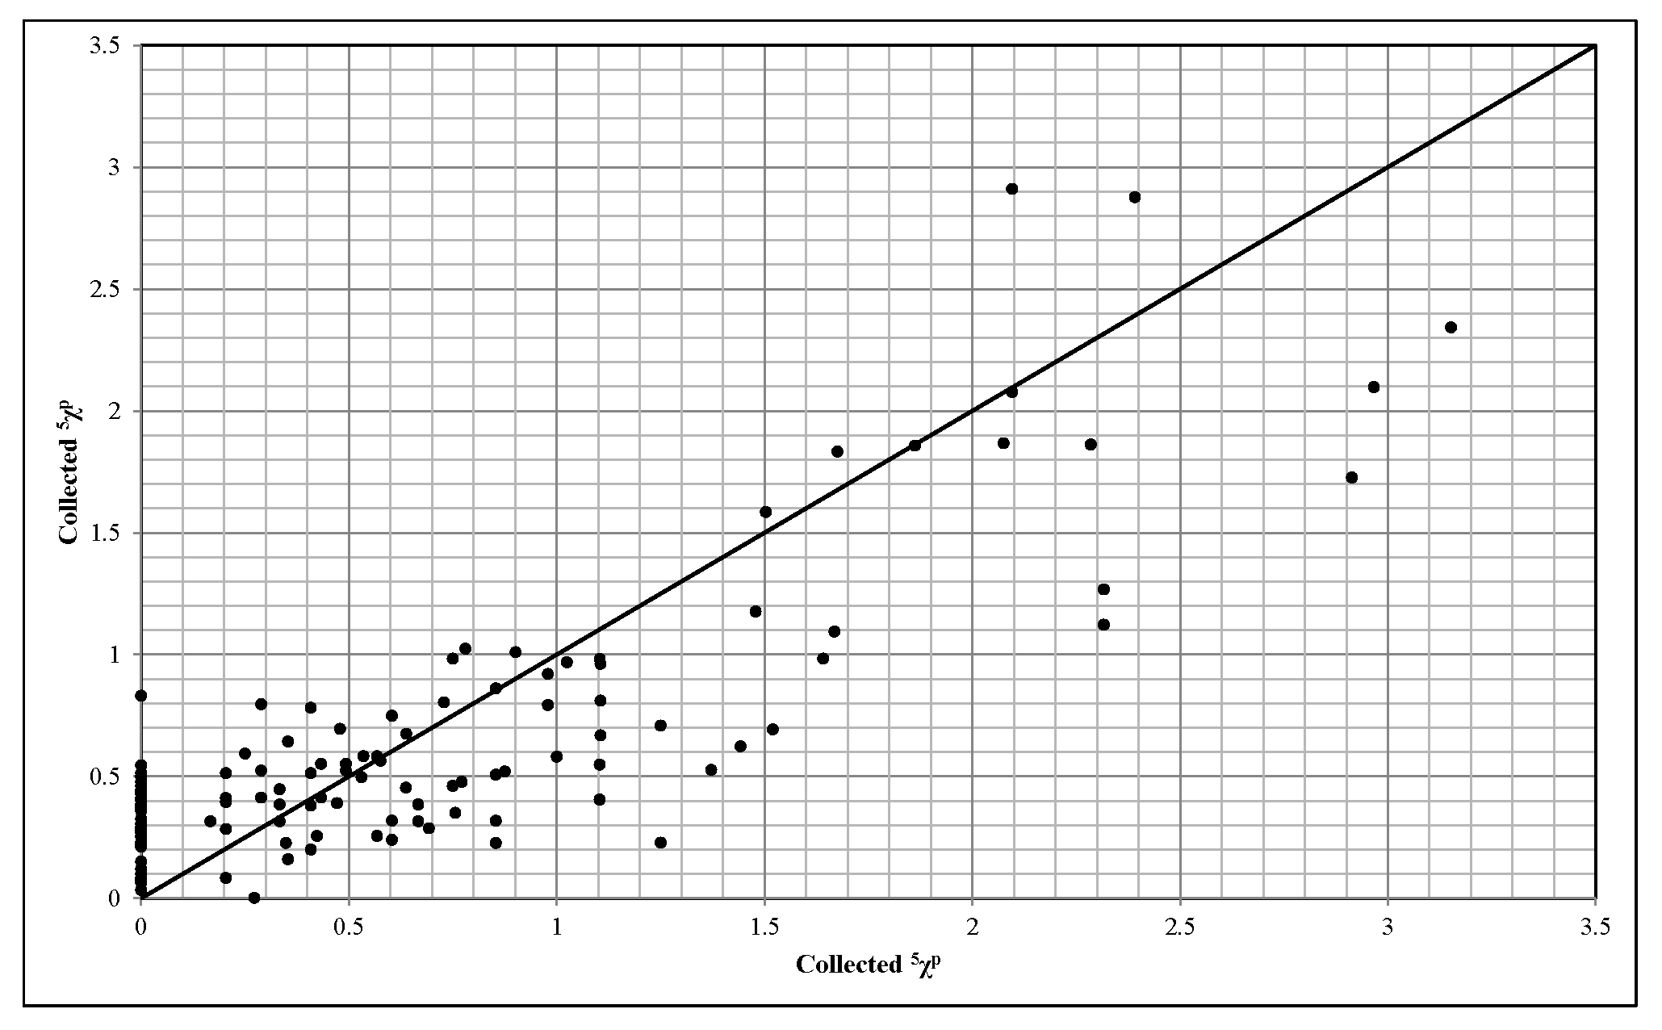
Fig. 13. The correlation results of 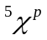
Having the obtained correlations of these connectivity indices, the application of QSPR models, as reported elsewhere could be coupled to the chemical thermodynamic models and approaches. So, the necessity of the utilization of commercial geometry optimization software packages for components topology determination could be removed and molecule descriptors can be substituted by the parameters such as scaling parameters of modified SL-EOS for which well-established calculation and interpretation approaches have been developed. The illustrated correlation results in Fig. 6-Fig. 13 show the desirable accuracy in estimation of connectivity indices using lattice fluid theory parameters as inputs.
The R² of developed models in this work and models available in literature are compared as listed in Table 8. According to the results, both modeling for both LCST and UCST are of superiority over available models. Imre et al. and Liu et al. have developed their correlations for a limited number of systems which fails to be extended to other systems. The neural network (NN) developed by Xu et al. demonstrated great reliability in fitting of experimental data as it is expected from NN which pattern recognition tools, however, they did not provide the details about the structure of NN and the optimal weights and biases which are mandatory if one aims to reproduce the data or to use their model.
Table 8. Comparison of R² of developed models in this work and models available in literature
Ref. | LCST / UCST | R²
Xu et al. | LCST | 0.8874
Melagraki et al. | LCST | 0.8860
Liu et al. | LCST | 0.7700
Gharagheizi et al. | UCST | 0.8824
Xu et al. (NN) | LCST | 0.9625
Xu et al. (MLRA) | LCST | 0.8739
Liu et al. | LCST | 0.9009
Imre et al. (Eq. 3) | LCST | 0.8897
Imre et al. (Eq. 7) | LCST | 0.8979
This work (CRS) | LCST | 0.9619
This work (CRS) | UCST | 0.9618
This work (Empirical) | LCST | 0.8919
This work (Empirical) | UCST | 0.9091

- Conclusion
A thermodynamic model was developed and examined for estimation of upper critical solution temperature (UCST) and lower critical solution temperature (LCST) of binary polymeric solutions focusing on the systems which are used in membranes fabrication. The compressible regular solution theory of Mayes together with the Sanchez-Lacombe lattice fluid theory equation of state was employed. The application of thermodynamic model requires the application of an optimization technique to obtain the temperature of interest. The particle swarm optimization technique was used for minimization of predefined constrains. The accuracy and reliability of model was demonstrated by an Individual Absolute Relative Deviation (IARD) of about 5 % and convergence of 30 iterations. In addition, a statistical model was developed using the connectivity indices of polymer and solvent as the independent variables of the model for which an averaged IARD of 4.3 % was obtained. To improve the QSPR models and remove the necessity of commercial molecular geometry optimizers, some simple correlations were developed to relate the lattice fluid theory scaling parameters to eight connectivity indices. The correlation results show an IARD (%) value of about 5 which is desirable. All presented models and correlations can be used for rapid and accurate prediction of LCST and UCST data.
- Appendix
Table 9. The experimental data of Lower Critical Solution Temperature (LCST)
No. | Polymer | Solvent | LCST [K]
No. | Polymer | Solvent | Exp. | Cal.
1 | Poly(4-methylpent-1-ene) | Butane | 388 | 365
2 |  | Pentane | 441 | 431
3 |  | Heptane | 522 | 499
4 |  | Octane | 553 | 507
5 |  | 2-Methylbutane | 431 | 415
6 |  | 2,2-Dimethylbutane | 462 | 456
7 |  | 2,2-Dimethylpentane | 499 | 486
8 |  | 2,2,3-Trimethylbutane | 521 | 517
9 |  | Cyclopentane | 505 | 469
10 |  | Hexane | 487 | 447
11 |  | Nonane | 579 | 551
12 |  | 2,4-Dimethylpentane | 499 | 481
13 |  | 3-Ethylpentane | 532 | 511
14 | Polybut-1-ene | Pentane | 421 | 397
15 |  | Heptane | 509 | 480
16 |  | Octane | 540 | 510
17 |  | 2-Methylbutane | 416 | 407
18 |  | 2,2-Dimethylbutane | 444 | 424
19 |  | 2,2,3-Trimethylbutane | 507 | 478
20 |  | 2,5-Dimethylhexane | 519 | 491
21 |  | 3-Ethylpentane | 523 | 496
22 |  | 3,4-Dimethylhexane | 559 | 535
23 |  | Hexane | 464 | 454
24 |  | Nonane | 564 | 545
25 |  | 2,4-Dimethylpentane | 480 | 474
26 |  | 2,3-Dimethylpentane | 517 | 487
27 |  | Cyclopentane | 498 | 466
28 | poly(cis-1,4-butadiene) | Hexane | 373 | 355
29 |  | 2,2,3-Trimethylbutane | 414 | 404
30 |  | Octane | 390 | 368
31 |  | Hexan-3-one | 510 | 475
32 |  | Pentan-3-one | 481 | 453
33 |  | 2-Methylhexane | 370 | 351
34 |  | 2,2,4-Trimethylpentane | 388 | 357
35 |  | Propylene oxide | 414 | 407
36 | Poly(dimethyl siloxane) | Pentane | 453 | 413
37 |  | Heptane | 528 | 499
38 |  | Octane | 553 | 510
39 |  | Dodecane | 643 | 616
40 |  | Cetane | 708 | 667
41 |  | Hexane | 493 | 451
42 |  | Decane | 603 | 563
43 | Polyethylene | Hexane | 411 | 382
44 |  | Heptane | 459 | 444
45 |  | Nonane | 531 | 508
46 |  | Decane | 557.55 | 537
47 |  | Dodecane | 605.55 | 574
48 |  | Tridecane | 631.55 | 597
49 |  | 2,2-Dimethylpentane | 399 | 367
50 |  | 2,2,3-Trimethylbutane | 444 | 431
51 |  | 2,3-Dimethylpentane | 463 | 442
52 |  | 3-Ethylpentane | 471 | 440
53 |  | 2,2,4,4-Tetramethylpentane | 513 | 492
54 |  | 2,3,4-Trimethylhexane | 545 | 516
55 |  | Methylcyclopentane | 488 | 454
56 |  | Methylcyclohexane | 537 | 490
57 |  | Octan-1-ol | 621 | 608
58 |  | Pentyl acetate | 528 | 503
59 |  | Pentane | 353 | 331
60 |  | Octane | 496 | 470
61 |  | Undecane | 581.75 | 536
62 |  | 2,4-Dimethylpentane | 395 | 377
63 |  | 2,2,4-Trimethylpentane | 495 | 476
64 |  | 3,4-Dimethylhexane | 515 | 475
65 |  | Cyclopentane | 472 | 447
66 |  | Cyclohexane | 518 | 493
67 |  | Butyl acetate | 490 | 463
68 | Polyisobutene | Cyclopentane | 461 | 433
69 |  | Cyclohexane | 516 | 485
70 |  | Cycloheptane | 572 | 540
71 |  | Cyclooctane | 637 | 588
72 |  | Heptane | 442 | 404
73 |  | Octane | 477 | 450
74 |  | Dodecane | 582 | 567
75 |  | 2-Methylbutane | 318 | 303
76 |  | 2-Methylpentane | 376 | 354
77 |  | 3-Methylpentane | 405 | 384
78 |  | 3-Methylhexane | 446 | 421
79 |  | 3-Ethylpentane | 458 | 418
80 |  | 2,3-Dimethylpentane | 451 | 439
81 |  | 2,4-Dimethylpentane | 403 | 386
82 |  | 2,2,3-Trimethylbutane | 445 | 420
83 |  | Ethylcyclopentane | 524 | 494
84 |  | 3-Methylheptane | 478 | 437
85 |  | 2,2-Dimethylhexane | 454 | 423
86 |  | 2,5-Dimethylhexane | 446 | 416
87 |  | 3.4-Dimethylhexane | 497 | 474
88 |  | Propylcyclopentane | 547 | 529
89 |  | Pentane | 344 | 327
90 |  | Hexane | 402 | 389
91 |  | Methylcyclopentane | 478 | 451
92 |  | 2-Methylhexane | 426 | 413
93 |  | 2,2-Dimethylpentane | 404 | 386
94 |  | 3,3-Dimethylpentane | 451 | 429
95 |  | Methylcyclohexane | 526 | 508
96 |  | 2-Methylheptane | 466 | 430
97 |  | 2,4-Dimethylhexane | 458 | 435
98 |  | 2,2,4-Trimethylpentane | 435 | 409
99 |  | Decane | 535 | 509
100 | Poly(isotactic methyl methacrylate) | Methyl acetate | 441 | 428
101 |  | Ethyl acetate | 478 | 447
102 |  | Hexan-3-one | 511 | 476
103 |  | Pentan-3-one | 497 | 486
104 |  | Butyl chloride | 454 | 416
105 |  | Heptan-4-one | 522 | 519
106 |  | Butan-2-one | 464 | 426
107 |  | Tetrahydrofuran (THF) | 519.5 | 483
108 | Poly(a-methylstyrene) | Cyclopentane | 417.6 | 409
109 |  | Cyclohexane | 456 | 427
110 |  | Butyl chloride | 412 | 391
111 |  | Butyl acetate | 446.9 | 416
112 |  | Hexyl acetate | 500.9 | 479
113 |  | Methyl cyclohexane | 431 | 407
114 |  | Pentyl acetate | 475.8 | 455
115 | Poly(propylene) | Pentane | 422 | 400
116 |  | Hexane | 470 | 433
117 |  | Octane | 542 | 496
118 |  | Nonane | 571 | 538
119 |  | 2,2-Dimethylbutane | 441 | 412
120 |  | 2,3-Dimethylbutane | 465 | 457
121 |  | 2,2-Dimethylpentane | 489 | 483
122 |  | 2,2,3-Trimethylbutane | 511 | 478
123 |  | 2,3-Dimethylpentane | 513 | 492
124 |  | 3-Ethylpentane | 520 | 501
125 |  | 2,2,4,4-Tetramethylpentane | 548 | 505
126 |  | 2,3,4-Trimethylhexane | 585 | 537
127 |  | Methylcyclopentane | 518 | 477
128 |  | Methylcyclohexane | 564 | 560
129 |  | Diethyl ether | 420 | 410
130 |  | Heptane | 511 | 496
131 |  | 2-Methylbutane | 413 | 374
132 |  | 2,4-Dimethylpentane | 481 | 462
133 |  | 2,2,4-Trimethylpentane | 510 | 497
134 |  | 3,4-Dimethylhexane | 553 | 550
135 |  | Cyclopentane | 495 | 491
136 |  | Cyclohexane | 540 | 522
137 | Polypent-1-ene | Pentane | 433 | 423
138 |  | Hexane | 482 | 456
139 |  | Octane | 556 | 542
140 |  | 2-Methylbutane | 422 | 395
141 |  | 2,4-Dimethylpentane | 493 | 482
142 |  | 2,2-Dimethylpentane | 502 | 475
143 |  | 2,3-Dimethylpentane | 529 | 499
144 |  | 3-Methylheptane | 537 | 521
145 |  | Heptane | 522 | 497
146 |  | 2,2-Dimethylbutane | 457 | 442
147 |  | 2,2,4-Trimethylpentane | 527 | 482
148 |  | Cyclopentane | 502 | 470
149 | Poly(pchlorostyrene) | Isobutyl acetate | 348.5 | 317
150 |  | Ethyl carbitol | 300.8 | 291
151 |  | Butyl carbitol | 323.1 | 294
152 |  | tert-Butyl acetate | 338.4 | 331
153 | Polystyrene | Cyclopentane | 427 | 411
154 |  | Cyclohexane | 486 | 463
155 |  | Methylcyclopentane | 417 | 401
156 |  | Methylcyclohexane | 480 | 448
157 |  | Benzene | 523 | 502
158 |  | Toluene | 550 | 498
159 |  | Ethyl acetate | 412 | 395
160 |  | Propyl acetate | 451 | 424
161 |  | i-Propyl acetate | 380 | 353
162 |  | Ethyl butyrate | 471 | 456
163 |  | Isobutyl acetate | 445 | 432
164 |  | sec-Butyl acetate | 442 | 422
165 |  | tert-Butyl acetate | 329 | 321
166 |  | Diethyl malonate | 578 | 548
167 |  | i-Amyl acetate | 493 | 488
168 |  | Methyl acetate | 384.5 | 364
169 |  | Butan-2-one | 420 | 396

Table 10. The experimental data of Upper Critical Solution Temperature (UCST)
No. | Polymer | Solvent | UCST [K]
No. | Polymer | Solvent | Exp. | Cal.
1 | cellulose diacetate | 2-butanone | 310 | 296
2 |  | 2-propanone | 280 | 269
3 | cellulose tricaprylate | N,N-dimethylformamide | 413 | 390
4 | cellulose triacetate | benzyl alcohol | 341 | 324
5 |  | 2-propanone | 300 | 294
6 | hydroxypropylcellulose | water | 343.85 | 336
7 | methylcellulose | water | 332.65 | 308
8 | poly(1-butene) (isotactic) | anisole | 362.3 | 343
9 | poly(butyl methacrylate) | 2-propanol | 297.3 | 284
10 | poly(4-chlorostyrene) | benzene | 274 | 263
11 |  | ethylbenzene | 258.45 | 244
12 |  | ethyl chloroacetate | 271.35 | 253
13 |  | isopropylbenzene | 332.15 | 319
14 |  | isopropyl chloroacetate | 264.95 | 249
15 |  | methyl chloroacetate | 337.75 | 315
16 |  | tetrachloroethene | 317.55 | 308
17 |  | tetrachloromethane | 323.85 | 302
18 | poly(ethyl acrylate) | 1-butanol | 318.05 | 298
19 |  | ethanol | 310.55 | 292
20 |  | methanol | 293.65 | 266
21 |  | 1-propanol | 312.65 | 296
22 | polyethylene (linear) | anisole | 426.65 | 410
23 |  | benzyl phenyl ether | 462.65 | 429
24 |  | biphenyl | 400.65 | 379
25 |  | 1-decanol | 426.45 | 404
26 |  | diphenyl ether | 437.05 | 419
27 |  | diphenylmethane | 415.35 | 388
28 |  | 1-dodecanol | 410.15 | 383
29 |  | 4-nonylphenol | 435.55 | 417
30 |  | 1-octanol | 453.25 | 442
31 |  | 4-octylphenol | 447.65 | 425
32 |  | pentyl acetate | 434 | 423
33 |  | 4-tert-pentylphenol | 463.35 | 426
34 | poly(p-hexylstyrene) | 2-butanone | 302.6 | 291
35 | poly(2-hydroxyethyl methacrylate) | 1-propanol | 326.5 | 308
36 | polyisobutylene | diphenyl ether | 306 | 291
37 |  | ethylbenzene | 249 | 231
38 |  | ethyl heptanoate | 306 | 292
39 |  | ethyl hexanoate | 330 | 320
40 |  | toluene | 260 | 251
41 | poly(dl-lactide) | dibutyl phthalate | 358.8 | 349
42 |  | dipentyl phthalate | 415.8 | 402
43 | poly(methyl methacrylate) | acetonitrile | 314 | 294
44 |  | 1-chlorobutane | 320 | 305
45 |  | 2,2-dimethyl-3-pentanone | 308.15 | 292
46 |  | 2,4-dimethyl-3-pentanone | 319.15 | 315
47 |  | 2-ethylbutanal | 295.15 | 276
48 |  | 3-heptanone | 307.7 | 306
49 |  | 4-heptanone | 309 | 298
50 |  | 2-octanone | 325.15 | 297
51 |  | 3-octanone | 346.85 | 331
52 |  | acetonitrile | 301 | 283
53 |  | 1-chlorobutane | 309 | 295
54 |  | 4-heptanone | 319 | 303
55 |  | 3-hexanone | 279 | 272
56 | poly(4-methyl-1-pentene) (isotactic) | biphenyl | 467.8 | 463
57 |  | diphenyl ether | 483.2 | 460
58 |  | diphenylmethane | 449.8 | 416
59 | poly(R-methylstyrene) | methylcyclohexane | 357 | 342
60 | poly(2-methyl-5-vinylpyridine) | butyl acetate | 294.95 | 289
61 |  | ethyl butyrate | 323.15 | 310
62 |  | ethyl propionate | 298.55 | 273
63 |  | 3-methylbutyl acetate | 322.15 | 299
64 |  | 2-methylpropyl acetate | 326.15 | 310
65 |  | pentyl acetate | 321.35 | 305
66 | poly(2-methyl-5-vinylpyridine) | propionitrile | 269.55 | 261
67 |  | propyl acetate | 292.45 | 270
68 |  | propyl propionate | 331.15 | 327
69 |  | tetrahydronaphthalene | 322.65 | 301
70 | polypropylene (isotactic) | benzyl phenyl ether | 455 | 434
71 |  | benzyl propionate | 430.7 | 395
72 |  | biphenyl | 398.3 | 390
73 |  | 4-tert-butylphenol | 439.2 | 406
74 |  | dibenzyl ether | 456.4 | 425
75 |  | diphenyl ether | 416 | 382
76 |  | 4-tert-pentylphenol | 414 | 396
77 | polystyrene | 1-chloro-n-decane | 279.7 | 274
78 |  | 1-chloro-n-dodecane | 331.7 | 312
79 |  | 1-chloro-n-undecane | 305.9 | 280
80 |  | 1-nitopropane | 272 | 251
81 |  | 2,5-dimethyl furan | 145 | 142
82 |  | 2-methylpropyl acetate | 227 | 216
83 |  | 2-propyl acetate | 250 | 235
84 |  | 3-methylbutyl acetate | 224 | 208
85 |  | cyclodecane | 289 | 270
86 |  | cycloheptane | 290 | 278
87 |  | cyclohexane | 306.51 | 297
88 |  | cyclooctane | 286 | 282
89 |  | cyclopentane | 293 | 277
90 |  | diethyl malonate | 309 | 291
91 |  | dl-menthol | 388.1 | 361
92 |  | dl-terpineol | 351.6 | 332
93 |  | dodecadeuterocyclohexane | 312.5 | 293
94 |  | dodecyl acetate | 285.2 | 273
95 |  | ethyl acetate | 229 | 212
96 |  | ethyl chloroacetate | 255 | 237
97 |  | ethylcyclohexane | 342.95 | 312
98 |  | hexyl-m-xylene | 285.5 | 275
99 |  | isoamyl acetate | 224 | 218
100 |  | isobutyl acetate | 227 | 219
101 |  | isopropyl acetate | 246 | 231
102 |  | methylcyclopentane | 348 | 331
103 |  | n-butyl formate | 264 | 250
104 |  | n-propyl acetate | 193 | 185
105 |  | o-dichlorobenzen | 220 | 214
106 |  | propyl acetate | 193 | 186
107 |  | trans-decahydronaphthalene | 293 | 279

Table 11. Connectivity Indices of selected polymers
No. | Polymer
1 | cellulose diacetate | 12.2925 | 0.8777 | 1.1154 | 5.9733 | 1.5236
2 | cellulose triacetate | 15.2841 | 0.8777 | 1.5177 | 6.9909 | 1.6868
3 | cellulose tricaprylate | 28.0120 | 0.8777 | 3.3148 | 15.9667 | 6.6615
4 | hydroxypropyl cellulose | 15.2841 | 0.8777 | 1.5177 | 6.9909 | 1.6868
5 | methylcellulose | 10.5520 | 0.8833 | 0.2887 | 4.4234 | 0.2887
6 | poly(2-hydroxyethyl methacrylate) | 6.9058 | 0.25 | 0.8077 | 3.4814 | 1.4835
7 | poly(2-methyl-5-vinylpyridine) | 6.2676 | 0.3333 | 1.8938 | 3.5437 | 1.7272
8 | poly(4-chlorostyrene) | 6.2676 | 0.3333 | 1.8938 | 3.5437 | 1.7272
9 | poly(4-methylpent-1-ene) | 4.5689 | 0.3333 | 0.6124 | 1.9712 | 0.4714
10 | poly(a-methylstyrene) | 5.939 | 0.25 | 0.9469 | 3.6052 | 1.6498
11 | poly(butyl methacrylate) | 8.2676 | 0.3333 | 0.9484 | 4.4367 | 0.8347
12 | poly(cis-1,4-butadiene) | 2.5689 | 0.6667 | 0 | 0 | 0
13 | poly(dimethyl siloxane) | 3.9083 | 0.7501 | 1.2071 | 1 | 0
14 | poly(dl-lactide) | 3.8618 | 0.4388 | 0 | 1.1547 | 0
15 | poly(ethyl acrylate) | 5.2760 | 0.3333 | 0.6910 | 2.5260 | 0.7440
16 | poly(isotactic methyl methacrylate) | 4.5236 | 0.25 | 1.0067 | 2.4814 | 0.6124
17 | poly(methyl methacrylate) | 4.5689 | 0.3333 | 0.5749 | 2.0260 | 0.6339
18 | poly(p-hexylstyrene) | 9.8031 | 0.3333 | 3.1907 | 6.0817 | 3.3573
19 | poly(pchlorostyrene) | 5.7273 | 0.25 | 0.622 | 3.5437 | 2.0605
20 | poly(propylene) | 2.2845 | 0.3333 | 0.2887 | 0.5774 | 0
21 | poly(R-methylstyrene) | 6.2676 | 0.3333 | 1.8938 | 3.5437 | 1.7272
22 | polybut-1-ene | 2.9916 | 0.3333 | 0.2887 | 1.1154 | 0
23 | polyethylene | 1.4142 | 0.5 | 0 | 0 | 0
24 | polyisobutene | 3.2071 | 0.0833 | 1.2071 | 1 | 0
25 | polyisobutylene | 3.2071 | 0.0833 | 1.2071 | 1 | 0
26 | polypent-1-ene | 3.6787 | 0.3333 | 0.2887 | 1.6154 | 0.2887
27 | Polystyrene | 4.6712 | 0.333 | 0.3333 | 3.1498 | 1.6498

Table 12. Connectivity Indices of selected solvents
No. | Solvent
1 | 1-butanol | 0.7071 | 0.3536 | 0
2 | 1-chlorobutane | 0.7071 | 0.3536 | 0
3 | 1-chloro-n-decane | 2.2071 | 1.3839 | 0.8536
4 | 1-chloro-n-dodecane | 2.7071 | 1.7374 | 1.1035
5 | 1-chloro-n-undecane | 2.4571 | 1.5607 | 0.9786
6 | 1-decanol | 2.2071 | 1.3839 | 0.8536
7 | 1-dodecanol | 2.7071 | 1.7374 | 1.1035
8 | 1-nitopropane | 0.8660 | 0.5773 | 0
9 | 1-octanol | 1.7071 | 1.0303 | 0.6036
10 | 1-propanol | 0.5 | 0 | 0
11 | 2,2,3-trimethylbutane | 1.7321 | 0 | 0
12 | 2,2,4,4-tetramethylpentane | 1.0607 | 1.591 | 0
13 | 2,2,4-trimethylpentane | 1.0206 | 1.2247 | 0
14 | 2,2-dimethyl-3-pentanone | 2.0908 | 0.6124 | 0
15 | 2,2-dimethylbutane | 1.0607 | 0 | 0
16 | 2,2-dimethylhexane | 1.2803 | 0.7071 | 0.5303
17 | 2,2-dimethylpentane | 1 | 0.75 | 0
18 | 2,3,4-trimethylhexane | 2.5931 | 1.0289 | 0.2722
19 | 2,3-dimethylbutane | 1.3333 | 0 | 0
20 | 2,3-dimethylpentane | 1.782 | 0.4714 | 0
21 | 2,4-dimethylhexane | 1.5707 | 0.9714 | 0.3333
22 | 2,4-dimethylpentane | 0.9428 | 0.9428 | 0
23 | 2,4-dimethyl-3-pentanone | 2.1031 | 0.7698 | 0
24 | 2,5-dimethyl furan | 1.9570 | 1.4916 | 0.7559
25 | 2,5-dimethylhexane | 1.3214 | 0.6667 | 0.6667
26 | 2-butanone | 0.8164 | 0 | 0
27 | 2-ethylbutanal | 1.7320 | 0.8660 | 0
28 | 2-methylbutane | 0.8165 | 0 | 0
29 | 2-methylheptane | 1.385 | 0.8026 | 0.433
30 | 2-methylhexane | 1.135 | 0.6124 | 0.4082
31 | 2-methylpentane | 0.866 | 0.5774 | 0
32 | 2-methylpropyl acetate | 1.3214 | 0.6667 | 0.3333
33 | 2-octanone | 1.6350 | 0.9794 | 0.5675
34 | 2-propanol | 0 | 0 | 0
35 | 2-propanone | 0 | 0 | 0
36 | 2-propyl acetate | 0.9428 | 0.7071 | 0
37 | 3,3-dimethylpentane | 1.9142 | 0.25 | 0
38 | 3,4-dimethylhexane | 2.2593 | 0.8047 | 0.1667
39 | 3-ethylpentane | 1.7321 | 0.866 | 0
40 | 3-heptanone | 1.7474 | 0.7567 | 0.4928
41 | 3-hexanone | 1.4784 | 0.6969 | 0.2041
42 | 3-methylbutyl acetate | 1.5629 | 0.9343 | 0.4714
43 | 3-methylheptane | 1.7474 | 0.7567 | 0.4928
44 | 3-methylhexane | 1.4784 | 0.6969 | 0.2041
45 | 3-methylpentane | 1.3938 | 0.2887 | 0
46 | 3-octanone | 1.9974 | 0.9469 | 0.5350
47 | 4-heptanone | 1.5629 | 1.1299 | 0.2887
48 | 4-nonylphenol | 4.3111 | 4.0550 | 2.2852
49 | 4-octylphenol | 4.1014 | 2.8311 | 2.0752
50 | 4-tert-butylphenol | 3.5370 | 2.3769 | 1.8619
51 | 4-tert-pentylphenol | 4.0323 | 2.3302 | 1.6755
52 | acetonitrile | 0 | 0 | 0
53 | anisole | 2.3021 | 1.5954 | 1.1052
54 | benzene | 1.5 | 1.0607 | 0.75
55 | benzyl alcohol | 2.3021 | 1.5954 | 1.1052
56 | benzyl phenyl ether | 4.4327 | 3.8079 | 2.9663
57 | benzyl propionate | 3.4894 | 1.9888 | 1.5034
58 | biphenyl | 3.9663 | 3.2111 | 2.3914
59 | butyl acetate | 1.3850 | 0.8026 | 0.4330
60 | butylchloride | 0.7071 | 0.3536 | 0
61 | cyclodecane | 2.5 | 1.6778 | 1.25
62 | cycloheptane | 1.75 | 1.2374 | 0.875
63 | cyclohexane | 1.5 | 1.0607 | 0.75
64 | cyclooctane | 2 | 1.4142 | 1
65 | cyclopentane | 1.25 | 0.8839 | 0
66 | dibenzyl ether | 4.6742 | 3.6468 | 2.5412
67 | dibutyl phthalate | 4.8224 | 4.0827 | 2.9137
68 | diethyl ether | 0.7071 | 0.4082 | 0
69 | diethyl ketone | 1.3938 | 0.2887 | 0
70 | diethylmalonate | 2.3677 | 1.9082 | 0.6381
71 | dipentyl phthalate | 6.1389 | 4.4362 | 3.1522
72 | diphenyl ether | 4.7828 | 3.8415 | 2.0956
73 | diphenylmethane | 4.7828 | 3.8415 | 2.0956
74 | dipropylketone | 1.5629 | 1.1299 | 0.2887
75 | dl-menthol | 3.3542 | 2.5044 | 1.3717
76 | dl-terpineol | 3.2406 | 2.1261 | 1.5202
77 | dodecadeuterocyclohexane | 3.8742 | 2.5302 | 1.6412
78 | dodecyl acetate | 3.3850 | 2.2168 | 1.4425
79 | ethanol | 0 | 0 | 0
80 | ethylacetate | 0.866 | 0.5774 | 0
81 | ethylbenzene | 2.3021 | 1.5954 | 1.1052
82 | ethylbutyrate | 1.5629 | 1.1299 | 0.2887
83 | ethylcarbitol | 1.7071 | 1.0303 | 0.6036
84 | ethylchloroacetate | 1.4784 | 0.6969 | 0.2041
85 | ethylcyclohexane | 2.3021 | 1.5954 | 1.1052
86 | ethylcyclopentane | 2.0521 | 0.6969 | 0.5761
87 | ethylheptanoate | 2.3319 | 1.5567 | 0.7716
88 | ethylhexanoate | 2.0819 | 1.0913 | 0.6371
89 | ethylpropionate | 1.4784 | 0.6969 | 0.2041
90 | ethylpropyl | 1.4784 | 0.6969 | 0.2041
91 | hexyl-m-xylene | 3.7421 | 3.2091 | 1.6684
92 | i-amylacetate | 1.5629 | 0.9343 | 0.4714
93 | i-propylacetate | 0.9428 | 0.9428 | 0.4082
94 | isopropylbenzene | 2.5926 | 1.8008 | 1.2504
95 | i-propyl chloroacetate | 1.7671 | 1.1897 | 0.4082
96 | isobutylacetate | 1.3214 | 0.6667 | 0.6667
97 | methanol | 0 | 0 | 0
98 | methylacetate | 0.8165 | 0 | 0
99 | methyl chloroacetate | 1.3938 | 0.2887 | 0
100 | methylcyclohexane | 1.8938 | 1.3067 | 0.901
101 | methylcyclopentane | 1.6438 | 1.1299 | 0.2887
102 | methylethyl | 0.8165 | 0 | 0
103 | N,N-dimethylformamide | 0.8165 | 0 | 0
104 | n-butane | 0.5 | 0 | 0
105 | n-butylacetate | 1.385 | 0.8026 | 0.433
106 | n-butylcarbitol | 2.2071 | 1.3838 | 0.8536
107 | n-butyl formate | 1.2071 | 0.6768 | 0.3536
108 | n-cetane | 3.4571 | 2.2678 | 1.4786
109 | n-decane | 1.9571 | 1.2071 | 0.7286
110 | n-dodecane | 2.4571 | 1.5607 | 0.9786
111 | n-heptane | 1.2071 | 0.6768 | 0.3536
112 | n-hexane | 0.9571 | 0.5 | 0.25
113 | n-hexylacetate | 1.885 | 1.1561 | 0.6925
114 | n-nonane | 1.7071 | 1.0303 | 0.6036
115 | n-octane | 1.4571 | 0.8536 | 0.4786
116 | n-pentane | 0.7071 | 0.3536 | 0
117 | n-pentylacetate | 1.635 | 0.9794 | 0.5675
118 | n-propylacetate | 1.135 | 0.6124 | 0.4082
119 | n-propylcyclopentane | 2.1717 | 1.5629 | 0.7803
120 | n-tridecane | 2.7071 | 1.7375 | 1.1036
121 | n-undecane | 2.2071 | 1.3839 | 0.8536
122 | o-dichlorobenzen | 2.5403 | 1.5017 | 1.0244
123 | pentyl acetate | 1.6350 | 0.9794 | 0.4232
124 | propionitrile | 0.5 | 0 | 0
125 | propyl acetate | 1.1350 | 0.6124 | 0.4082
126 | propyleneoxide | 0.5774 | 0 | 0
127 | propyl propionate | 1.3391 | 0.7567 | 0.3485
128 | sec-butylacetate | 1.5707 | 0.9714 | 0.3333
129 | tert-butylacetate | 1.0206 | 1.2247 | 0
130 | tetrachloroethene | 1.3333 | 0 | 0
131 | tetrachloromethane | 0 | 0 | 0
132 | tetrahydrofuran (THF) | 1.25 | 0.8839 | 0
133 | tetrahydronaphthalene | 3.4663 | 2.8576 | 2.3165
134 | toluene | 1.8938 | 1.3067 | 0.901
135 | trans-decahydronaphthalene | 3.4663 | 2.8576 | 2.3165
136 | water | 0 | 0 | 0

Table 13. Scaling parameters of selected polymers
No. | Polymer | 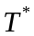 | 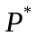 | 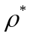
1 | cellulose diacetate | 2532.55 | -787.35 | 702.03
2 | cellulose triacetate | 2221.92 | 125.66 | 1805.38
3 | cellulose tricaprylate | 1341.64 | -932.89 | 659.85
4 | hydroxypropyl cellulose | 1546.36 | -1416.1 | 118.08
5 | methylcellulose | 3638.53 | -1727.74 | -2104.69
6 | poly(2-hydroxyethyl methacrylate) | 809.2 | 160.47 | 1132.86
7 | poly(2-methyl-5-vinylpyridine) | 884.68 | 409.33 | 1202.69
8 | poly(4-chlorostyrene) | 935.72 | 344.21 | 1613.17
9 | poly(4-methylpent-1-ene) | 756.29 | 183.01 | 741.73
10 | poly(a-methylstyrene) | 741.04 | 268.07 | 1002.76
11 | poly(butyl methacrylate) | 928.77 | 478.88 | 1169.34
12 | poly(cis-1,4-butadiene) | 522.01 | 424.01 | 990.01
13 | poly(dimethyl siloxane) | 476.01 | 302.01 | 1104
14 | poly(dl-lactide) | 642.89 | 516.72 | 1299.15
15 | poly(ethyl acrylate) | 917.06 | 419.7 | 1142.98
16 | poly(isotactic methyl methacrylate) | 651.82 | 529.83 | 1318.12
17 | poly(methyl methacrylate) | 925.99 | 432.81 | 1161.95
18 | poly(p-hexylstyrene) | 702.79 | 119.72 | 769.51
19 | poly(pchlorostyrene) | 935.72 | 344.21 | 1613.17
20 | poly(propylene) | 711.62 | 318.09 | 889.07
21 | poly(R-methylstyrene) | 829.52 | 337.19 | 1120.39
22 | polybut-1-ene | 703.97 | 288.42 | 842.42
23 | polyethylene | 651.65 | 430.12 | 926.17
24 | polyisobutene | 720.55 | 331.2 | 908.04
25 | polyisobutylene | 908.04 | 720.55 | 436.61
26 | polypent-1-ene | 696.32 | 258.75 | 795.77
27 | Polystyrene | 1103.45 | 759.12 | 373.48

Table 14. Scaling parameters of selected solvent
No. | Solvent
1 | 1-butanol | 1136.41 | 1052.29 | 443.67
2 | 1-chlorobutane | 557.36 | 322.65 | 1083.23
3 | 1-chloro-n-decane | 511.46 | 144.63 | 803.33
4 | 1-chloro-n-dodecane | 496.16 | 85.29 | 710.03
5 | 1-chloro-n-undecane | 305.63 | 114.96 | 756.68
6 | 1-decanol | 1006.39 | 265.65 | 856.51
7 | 1-dodecanol | 991.09 | 206.31 | 763.21
8 | 1-nitropropane | 775.64 | 366.48 | 863.6
9 | 1-octanol | 1021.69 | 324.99 | 949.81
10 | 1-propanol | 1059.94 | 473.34 | 1183.06
11 | 2,2,3-trimethylbutane | 708.2 | -202.47 | 468.18
12 | 2,2,4,4-tetramethylpentane | 648.23 | -90.44 | 505.28
13 | 2,2,4-trimethylpentane | 736.71 | -21.32 | 622.91
14 | 2,2-dimethyl-3-pentanone | 897.97 | 214.1 | 777.73
15 | 2,2-dimethylbutane | 684.39 | 120.38 | 706.66
16 | 2,2-dimethylhexane | 669.09 | 61.04 | 613.36
17 | 2,2-dimethylpentane | 676.74 | 90.71 | 660.01
18 | 2,3,4-trimethylhexane | 780.1 | -176.13 | 520.19
19 | 2,3-dimethylbutane | 735.43 | -4.76 | 650.59
20 | 2,3-dimethylpentane | 727.78 | -34.43 | 603.94
21 | 2,4-dimethylhexane | 720.13 | -64.1 | 557.29
22 | 2,4-dimethylpentane | 727.78 | -34.43 | 603.94
23 | 2,4-dimethyl-3-pentanone | 949.01 | 88.96 | 721.66
24 | 2,5-dimethyl furan | 488.41 | 526.66 | 1238.52
25 | 2,5-dimethylhexane | 720.13 | -64.1 | 557.29
26 | 2-butanone | 836.72 | 342.69 | 842.51
27 | 2-ethylbutanal | 899.47 | 276.73 | 812.8
28 | 2-methylbutane | 675.46 | 107.27 | 687.69
29 | 2-methylheptane | 652.51 | 18.26 | 547.74
30 | 2-methylhexane | 660.16 | 47.93 | 594.39
31 | 2-methylpentane | 667.81 | 77.6 | 641.04
32 | 2-methylpropyl acetate | 599.08 | 276.23 | 1051.12
33 | 2-octanone | 806.12 | 224.01 | 655.91
34 | 2-propanol | 573.97 | -105.73 | 751.9
35 | 2-propanone | 844.37 | 372.36 | 889.16
36 | 2-propyl acetate | 606.73 | 305.9 | 1097.77
37 | 3,3-dimethylpentane | 676.74 | 90.71 | 660.01
38 | 3,4-dimethylhexane | 720.13 | -64.1 | 557.29
39 | 3-ethylpentane | 660.16 | 47.93 | 594.39
40 | 3-heptanone | 813.77 | 253.68 | 702.56
41 | 3-hexanone | 829.07 | 313.02 | 795.86
42 | 3-methylbutyl acetate | 591.43 | 246.56 | 1004.47
43 | 3-methylheptane | 652.51 | 18.26 | 547.74
44 | 3-methylhexane | 660.16 | 47.93 | 594.39
45 | 3-methylpentane | 667.81 | 77.6 | 641.04
46 | 3-octanone | 806.12 | 224.01 | 655.91
47 | 4-heptanone | 813.77 | 253.68 | 702.56
48 | 4-nonylphenol | -228.89 | -306.45 | 351.27
49 | 4-octylphenol | -221.24 | -276.78 | 397.92
50 | 4-tert-butylphenol | -203.85 | -279.91 | 523.09
51 | 4-tert-pentylphenol | -211.5 | -309.58 | 476.44
52 | acetonitrile | 772.18 | 496.56 | 1159.03
53 | anisole | 1312.35 | 333.72 | 1342.53
54 | benzene | -22.39 | 384.4 | 908.29
55 | benzyl alcohol | 215.88 | 44.18 | 766.16
56 | benzyl phenyl ether | -300.59 | 416.03 | 1131.75
57 | benzyl propionate | -132.15 | 388.61 | 1077.73
58 | biphenyl | -711.73 | 279.34 | 797.11
59 | butyl acetate | 531.46 | 358.59 | 1041.57
60 | butylchloride | 557.36 | 322.65 | 1083.23
61 | cyclodecane | 590.45 | 192.76 | 552.97
62 | cycloheptane | 613.4 | 281.77 | 692.92
63 | cyclohexane | 621.05 | 311.44 | 739.57
64 | cyclooctane | 605.75 | 252.1 | 646.27
65 | cyclopentane | 628.7 | 341.11 | 786.22
66 | dibenzyl ether | -727.52 | 257.56 | 933.3
67 | dibutyl phthalate | -257.21 | 484.96 | 1153.87
68 | diethyl ether | 615 | 256.86 | 954.28
69 | diethyl ketone | 829.07 | 313.02 | 795.86
70 | diethylmalonate | 455.08 | 527.55 | 1405
71 | dipentyl phthalate | -272.51 | 274.14 | 1060.57
72 | diphenyl ether | -285.36 | 427.97 | 1154.69
73 | diphenylmethane | -727.03 | 220 | 703.81
74 | dipropylketone | 813.77 | 253.68 | 702.56
75 | dl-menthol | 381.03 | 444.02 | 1125.92
76 | dl-terpineol | 386.27 | 158.26 | 683.82
77 | dodecadeuterocyclohexane | -22.39 | 384.4 | 908.29
78 | dodecyl acetate | 470.26 | 121.23 | 668.37
79 | ethanol | 514 | 6.3 | 789
80 | ethylacetate | 546.76 | 417.93 | 1134.87
81 | ethylbenzene | 818.57 | 237.88 | 546.89
82 | ethylbutyrate | 531.46 | 358.59 | 1041.57
83 | ethylcarbitol | 1141.64 | 421.92 | 2033.51
84 | ethylchloroacetate | 778.1 | 483.6 | 1430.44
85 | ethylcyclohexane | 317.37 | 257.18 | 701.95
86 | ethylcyclopentane | 432.26 | 274.69 | 720.48
87 | ethylheptanoate | 508.51 | 269.58 | 901.62
88 | ethylhexanoate | 516.16 | 299.25 | 948.27
89 | ethylpropionate | 539.11 | 388.26 | 1088.22
90 | ethylpropyl | 1174.87 | 203.03 | 929.54
91 | hexyl-m-xylene | 191.71 | -39.02 | 400.31
92 | i-amylacetate | 591.43 | 246.56 | 1004.47
93 | i-propylacetate | 606.73 | 305.9 | 1097.77
94 | isopropylbenzene | 730.61 | 192.33 | 948.72
95 | i-propyl chloroacetate | 548.6 | 409.25 | 1456.21
96 | isobutylacetate | 599.08 | 276.23 | 1051.12
97 | methanol | 521.65 | 35.97 | 835.65
98 | methylacetate | 554.41 | 447.6 | 1181.52
99 | methyl chloroacetate | 496.28 | 550.95 | 1539.96
100 | methylcyclohexane | -37.62 | 372.46 | 885.35
101 | methylcyclopentane | 77.27 | 389.97 | 903.88
102 | methylethyl | 730.61 | 192.33 | 948.72
103 | N,N-dimethylformamide | 870.27 | 402.64 | 992.81
104 | n-butane | 615.49 | 219.3 | 724.79
105 | n-butylacetate | 531.46 | 358.59 | 1041.57
106 | n-butylcarbitol | 467.12 | -96.6 | 968.08
107 | n-butyl formate | 839.01 | 426.32 | 1079.39
108 | n-cetane | 523.69 | -136.74 | 164.99
109 | n-decane | 569.59 | 41.28 | 444.89
110 | n-dodecane | 554.29 | -18.06 | 351.59
111 | n-heptane | 592.54 | 130.29 | 584.84
112 | n-hexane | 600.19 | 159.96 | 631.49
113 | n-hexylacetate | 805.63 | 261.57 | 885.4
114 | n-nonane | 577.24 | 70.95 | 491.54
115 | n-octane | 584.89 | 100.62 | 538.19
116 | n-pentane | 607.84 | 189.63 | 678.14
117 | n-pentylacetate | 813.28 | 291.24 | 932.05
118 | n-propylacetate | 828.58 | 350.58 | 1025.35
119 | n-propylcyclopentane | 59.12 | 237.16 | 732.83
120 | n-tridecane | 546.64 | -47.73 | 304.94
121 | n-undecane | 561.94 | 11.61 | 398.24
122 | o-dichlorobenzen | 545.39 | 357.42 | 1533.35
123 | pentyl acetate | 813.28 | 291.24 | 932.05
124 | propionitrile | 764.53 | 466.89 | 1112.38
125 | propyl acetate | 828.58 | 350.58 | 1025.35
126 | propyleneoxide | 711.13 | 355.65 | 1118.56
127 | propyl propionate | 820.93 | 320.91 | 978.7
128 | sec-butylacetate | 553.85 | 298.18 | 1081.62
129 | tert-butylacetate | 570.43 | 340.96 | 1147.24
130 | tetrachloroethene | 1537.77 | 529.92 | 2468.67
131 | tetrachloromethane | 1440.36 | 447.69 | 2332.07
132 | tetrahydrofuran (THF) | 635.86 | 408.34 | 1062.36
133 | tetrahydronaphthalene | -52.99 | 265.72 | 721.69
134 | toluene | -37.62 | 372.46 | 885.35
135 | trans-decahydronaphthalene | 1106.95 | 232.8 | 491.21
136 | water | 647 | 22.1 | 1000

References
[1] I. Sanchez, M. Stone, Statistical Thermodynamics of Polymer Solutions and Blends, John Wiley & Sons, Inc., 2000.
[2] J.M. Prausnitz, R.N. Lichtenthaler, E. Gomes de Azevedo, Molecular Thermodynamics of Fluid-Phase Equilibria 3ed., Prentice Hall, 1998.
[3] IUPAC Compendium of Chemical Terminology, in.
[4] J.M.G. Cowie, V. Arrighi, Polymers: Chemistry and Physics of Modern Materials, Third ed., CRC Press, 2007.
[5] L. Keshavarz, M.A. Khansary, S. Shirazian, Phase diagram of ternary polymeric solutions containing nonsolvent/solvent/polymer: Theoretical calculation and experimental validation, Polymer, 73 (2015) 1-8.
[6] CRC Handbook of Chemistry and Physics, 90 ed., CRC Press, 2010.
[7] C. Wohlfarth, CRC handbook of enthalpy data of polymer-solvent systems, CRC Press, 2006.
[8] C. Wohlfarth, CRC handbook of liquid-liquid equilibrium data of polymer solutions, CRC Press, 2007.
[9] C. Wohlfarth, CRC handbook of thermodynamics data of polymer solutions at elevated pressures, CRC Press, 2005.
[10] G. Melagraki, A. Afantitis, H. Sarimveis, P.A. Koutentis, J. Markopoulos, O. Igglessi-Markopoulou, A novel QSPR model for predicting theta (lower critical solution temperature) in polymer solutions using molecular descriptors, Journal of molecular modeling, 13 (2007) 55-64.
[11] G.M. Kontogeorgis, A. Saraiva, A. Fredenslund, D.P. Tassios, Prediction of Liquid-Liquid Equilibrium for Binary Polymer Solutions with Simple Activity Coefficient Models, Industrial & Engineering Chemistry Research, 34 (1995) 1823-1834.
[12] A.R. Imre, Y.C. Bae, B.H. Chang, T. Kraska, Semiempirical Method for the Prediction of the Theta (Lower Critical Solution Temperature) in Polymer Solutions, Industrial & Engineering Chemistry Research, 43 (2004) 237-242.
[13] H. Liu, C. Zhong, General Correlation for the Prediction of Theta (Lower Critical Solution Temperature) in Polymer Solutions, Industrial & Engineering Chemistry Research, 44 (2005) 634-638.
[14] F. Gharagheizi, M. Sattari, Prediction of the θ(UCST) of Polymer Solutions: A Quantitative Structure−Property Relationship Study, Industrial & Engineering Chemistry Research, 48 (2009) 9054-9060.
[15] H. Liu, C. Zhong, Modeling of the θ(lower critical solution temperature) in polymer solutions using molecular connectivity indices, European Polymer Journal, 41 (2005) 139-147.
[16] J. Xu, B. Chen, H. Liang, Accurate Prediction ofθ (Lower Critical Solution Temperature) in Polymer Solutions Based on 3D Descriptors and Artificial Neural Networks, Macromolecular Theory and Simulations, 17 (2008) 109-120.
[17] J. Xu, L. Liu, W. Xu, S. Zhao, D. Zuo, A general QSPR model for the prediction of theta (lower critical solution temperature) in polymer solutions with topological indices, Journal of molecular graphics & modelling, 26 (2007) 352-359.
[18] Y.-M. Wei, Z.-L. Xu, X.-T. Yang, H.-L. Liu, Mathematical calculation of binodal curves of a polymer/solvent/nonsolvent system in the phase inversion process, Desalination, 192 (2006) 91-104.
[19] J.M. Smith, H. Van Ness, M. Abbott, Introduction to Chemical Engineering Thermodynamics, 7 ed., McGraw-Hill, New York, 2005.
[20] A.-V.G. Ruzette, A.M. Mayes, A Simple Free Energy Model for Weakly Interacting Polymer Blends, Macromolecules, 34 (2001) 1894–1907.
[21] J.A. Lazzús, Hybrid swarm optimization for vapor–liquid equilibrium modeling, Journal of Molecular Liquids, 196 (2014) 167-177.
[22] M. Asgarpour Khansary, A. Hallaji Sani, Using genetic algorithm (GA) and particle swarm optimization (PSO) methods for determination of interaction parameters in multicomponent systems of liquid–liquid equilibria, Fluid Phase Equilibria, 365 (2014) 141-145.
[23] C. Barth, Evidence of ternary interaction parameters for polymer solutions in mixed solvents from headspace-gas chromatography, Polymer, 41 (2000) 8587-8596.
[24] D.W. van Krevelen, K.T. Nijenhuis, Properties of Polymers: Their Correlation with Chemical Structure; Their Numerical Estimation and Prediction from Additive Group Contributions, 4 ed., Elsevier, 2008.
[25] B.E. Poling, J.M. Prausnitz, J.P. O'Connell, Properties of Gases and Liquids, 4 ed., McGraw-Hill Professional, 1987.
[26] P.A. Rodgers, Pressure–volume–temperature relationships for polymeric liquids: A review of equations of state and their characteristic parameters for 56 polymers, Journal of Applied Polymer Science, 48 (1993) 1061-1080.
[27] D. Boudouris, L. Constantinou, C. Panayiotou, A Group Contribution Estimation of the Thermodynamic Properties of Polymers, Industrial & Engineering Chemistry Research, 36 (1997) 3968-3973.
[28] W. Cheney, D. Kincaid, Numerical Mathematics and Computing, Sixth edition ed., Thomson Brooks/Cole, USA, 2008.
[29] R.K. Sahoo, T. Banerjee, S.A. Ahmad, A. Khanna, Improved binary parameters using GA for multi-component aromatic extraction: NRTL model without and with closure equations, Fluid Phase Equilibria, 239 (2006) 107-119.
[30] R.K. Sahoo, T. Banerjee, A. Khanna, UNIQUAC Interaction Parameters with Closure for Imidazolium Based Ionic Liquid Systems Using Genetic Algorithm, The Canadian Journal of Chemical Engineering, 85 (2008) 833-853.
[31] C. Zhong, C. Yang, Approach for the calculation of high-order connectivity indices of polymers and its application, Journal of Polymer Science Part B: Polymer Physics, 40 (2002) 401-407.
[32] A.G. Ivakhnenko, Polynomial Theory of Complex Systems, IEEE Transactions on Systems, Man, and Cybernetics, 1 (1971) 364-378.
[33] M.A. Khansary, A.H. Sani, S. Shirazian, Mathematical-thermodynamic solubility model developed by the application of discrete Volterra functional series theory, Fluid Phase Equilibria, 385 (2015) 205-211.
[34] MathWorks MATLAB, in, 2009.
[35] M. Asgarpour Khansary, F. Amiri, A. Hosseini, A. Hallaji Sani, H. Shahbeig, Representing solute solubility in supercritical carbon dioxide: A novel empirical model, Chemical Engineering Research and Design, 93 (2015) 355-365.
[36] S. Shirazian, M. Alibabaei, Using neural networks coupled with particle swarm optimization technique for mathematical modeling of air gap membrane distillation (AGMD) systems for desalination process, Neural Computing and Applications, (2016).
[37] R. Davarnejad, B. Rahimi, S.H.N. Baghban, M.A. Khansary, A.H. Sani, Development of a thermodynamic model for hydrogen and hydrogen containing mixtures, Fluid Phase Equilibria, 382 (2014) 1-9.
[38] M. Asgarpour Khansary, S. Shirazian, Theoretical modeling for thermophysical properties of cellulose: pressure/volume/temperature data, Cellulose, 23 (2016) 1101-1105.

