1. A Brief Introduction
For compressibility factor prediction, based on M-factor theory, recently Mohammadikhah et al. [1] have presented a new piecewise equation of state (EOS). Following this EOS, Jafari Nejad et al. [2] have developed a novel EOS for the special case of T_{r}<1.1 together with a specialized mixing rule, as the classical mixing rules can never be applied for predicting the compressibility factor under special conditions. The S_{ij} in Eq. 1 (for detailed development of the Equations refer to [2]), is the special parameter of the new EOS, which appeared in Eq. 43 of Ref. [2], and must be estimated till the optimum value (often with some large errors) obtained which requires high computation time and attempts. As the studies on this novel model show great agreement with experimental data, thus it’s worthwhile to find a relationship for S_{ij} for a straightforward predictive model.
- 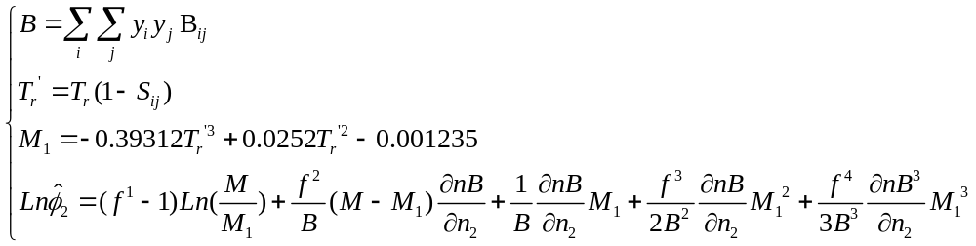
Gathering thirty dyes solubility data in supercritical carbon dioxide, the model were analyzed and modified critically. It’s found that the S_{ij} can be expressed in as an explicit function of temperature and pressure of each solute, thus two relations for precise estimation of S_{ij} have been present here: (I) An empirical model which uses the experimental pressures (bar) and temperatures (K) of each solute (dye) And (II) a general equation which use the critical properties i.e. reduced temperature and pressure of the dye to estimate the S_{ij}. It must be noted that for this parameter, we have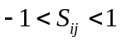.
Without application of modifications presented in this work, the proposed EOS [2] only can be used in isobaric conditions and high errors will be encountered if one chooses improper values for S_{ij}. For example, in a previously study, some of the authors reported the results of application of this model to three systems (D1, D2 and D3) [24]. It must be noted that the values for S_{ij} in that work were an average of individual absolute values of S_{ij} in each temperature. Thus, here, we provide the precise assessment of the EOS and modify it to CMM EOS (The modified model is named CMM by authors, shortly). While using our modifications, the solubility prediction/correlation will be a straightforward calculation using the available data of system under study. The CMM EOS, now, can be simply applied with highly accurate predictions. The current model is highly recommended.
2. Calculation Methods
The available solubility data (in mole fraction) of compounds (dyes) have been collected from the literatures which are listed in Table 1 [3-21]. In order to find the best optimum values of the special parameter of the model (S₁₂) and the Peng-Robinson EOS [22] (PR-EOS) interaction parameters (k_{ij} and l_{ij}), an Objective Function (Eq. 2) was defined and minimized using a reliable optimization method described in [23]. The PR-EOS was used for comparison purpose. As thermodynamic properties’ calculations are the same, one could simply refer to Refs [1, 2].

- 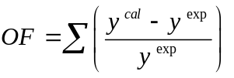
At each point, an initial value estimated for the interaction parameter S₁₂, and then solubility of the dyes calculated. The best values of the S₁₂, which minimize objective function, was determined by the optimizing method used and the results are reported in Table. 2. It should be noted that in this study the program of calculations were written and modified in MATLAB software by the authors.

3. Result and discussion
Investigations on the special parameters (S₁₂) of each system indicate that two relationships exist.
- A linear relationship between S₁₂ and pressure in isothermal conditions, and
- A linear relationship between S₁₂ and temperature in isobaric conditions.
Thus, to estimate the value of S_{ij}, the interaction parameter of the model, at each point of interest, two relationships/models are presented here; an empirical and a general relation.
3.1 Empirical relationship for S_{ij}
Considering the two general rules of thumbs (i, ii) mentioned above, the following empirical model (Eq. 3) was proposed for the special parameter (S₁₂) in modeling of solubility of these dyes in SC CO₂:
- 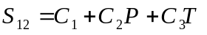
Where, C₁–C₃ all are the model constants reported in Table. 3 together with correlation results obtained for PR-EOS for each individual system.
3.2 General relation for S_{ij}
A general relation for estimation of the special parameter, which represents the temperature, pressure, and material nature (critical properties) dependency of the S_{ij} in terms of reduced temperature and pressure of the dye (solute), has been investigated and defined as follows (R²>0.9984 for all calculations).
- 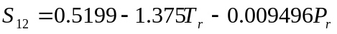
Our studies on other solutes data sets (for example drugs) shows that one can slightly changes the value of coefficients in Eq. 4 (0.5088<0.5199<0.5311; -1.407<-1.375<-1.344; and -0.009821<-0.009496<-0.009172) to obtain the best and optimal estimates for S₁₂ for each material of interest.
Using the Eq. 4, the solubility calculations in supercritical extraction will be a straightforward calculation. The model can be simply used and speedup the industrial process of interest.
4. Conclusion
A serious modification on a reported thermodynamically solubility estimation model in literature has been proposed in this work. It’s been shown that without application of the presented modifications the proposed EOS only can be used in isobaric conditions and high errors will be encountered. Using our modifications, the solubility prediction/correlation will be a straightforward calculation using the available data of system under study. The modified model is named CMM EOS by authors, shortly. Two relationships for estimation of the special parameters proposed here by those highly accurate predications can be obtained. The application of this New CMM EOS is strongly recommended. The model can be simply used and speedup the industrial process of interest.

List of symbols
AARD average absolute relative deviation (%)
B Second Virial coefficients
EOS equation of state
IARD individual absolute relative deviations
k_{ij} binary interaction parameter
l_{ij} binary interaction parameter
N Number of data points
P pressure (bar)
PR Peng–Robinson
S Interaction parameter
T temperature (K)
y mole fraction
Subscripts
r reduced
i,j components
Superscripts
cal calculated
exp experimental

References
[1] R. Mohammadikhah, H. Abolghasemi, A. Mohebbi, Iran. J. Chem. Chem. Eng., 2010, 29 (2), 67.
[2] Sh. Jafari Nejad, R. Mohammadikhah, H. Abolghasemi, M.A. Moosavian, M.G. Maragheh, Can. J. Chem. Eng., 2009, 87, 930.
DOI: 10.1002/cjce.20232.
[3] S.N. Joung, K. P. Yoo, J. Chem. Eng. Data., 1998, 43, 9.
[4] Sh.Y. Huang, M. Tang, Sh.L. Ho, Y.P. Chen, J. Of Supercrit. Fluids, 2007, 42, 165.
[5] B. Wagner, C.B. Kautz, G.M. Schneider, Fluid Phase Equilib, 1999, 158-160, 707.
[6] A.S. Özcan, A. A. Clifford, K. D. Bartle, J. Chem. Eng. Data., 1997, 42, 590.
[7] V.F. Cabral, W.L.F. Santos, E.C. Muniz, A.F. Rubira, L. Cardozo-Filho, J. Of Supercrit. Fluid. 2007, 40, 163.
[8] J.W. Lee, M.W. Park, H. K. Bae, Fluid Phase Equilib. 2001, 179, 387.
[9] M.D. Gordillo, C. Pereyra, E.J. Martı´Nez De La Ossa, J. Of Supercrit. Fluids. 2003, 27, 31.
[10] M.D. Gordillo, C. Pereyra, E.J. Martı´Nez De La Ossa, Dye. Pig. 2005, 67, 167.
[11] P. Coimbra, M. H. Gil, C. M. M. Duarte, B. M. Heron, H. C. De Sousa, Fluid Phase Equilib. 2005, 238, 120.
[12] H.M. Lin, Ch.Y. Liu, Ch.H. Cheng, Y.T. Chen, M.J. Lee, J of Supercrit. Fluids. 2001, 21, 1.
[13] M. Banchero, A. Ferri, L. Manna, S. Sicardi, Fluid Phase Equilib. 2006, 243, 107.
[14] H.M. Lin, Ch.Ch. Ho, M.J. Lee, J. Of Supercrit. Fluids. 2004, 32, 105.
[15] K. Tamura, T. Shinoda, Fluid Phase Equilib. 2004, 219, 25.
[16] J. Fasihi, Y. Yamini, F. Nourmohammadian, N. Bahramifar, Dye. Pig. 2004, 63, 161.
[17] B. Guzel, A. Akgerman, J. Chem. Eng. Data, 1999, 44, 83.
[18] J.W. Lee, J.M. Min, H.K. Bae, J. Chem. Eng. Data., 1999, 44, 684.
[19] T. Shinoda, K. Tamura, Fluid Phase Equilib. 2003, 213, 115.
[20] Z. Jinhua, X. Mingxian, L. Xueyan, L. Chunmian, Chin. J. Of Chem. Eng., 2010, 18(4), 648.
[21] P.Dong, M. Xu, X. Lu, Ch. Lin, Fluid Phase Equilib. 2010, 297, 46.
[22] D. B. Robinson, D. Y. Peng, Ind. Eng. Chem. Fund., 1976, 15, 559.
[23] M. Asgarpour Khansary, A. Hallaji Sani, Fluid. Phase. Equilibria. 2014, 365, 141-145. DOI: 10.1016/j.fluid.2014.01.016.
[24] Sh. Jafari Nejad, M. Asgarpour Khansary, F. Amiri, Int. J. Thermodyn. 2012, 15 (2), 103-110.

