A Novel Equation of State:
Determination and Validation for Dyes and Drugs Solubility Calculations in Supercritical Carbon Dioxide

Abstract
Based on Pitzer correlations for the compressibility factor and virial equation of state, a new equation of state has been developed in this study, which is a function of total number of atoms present in the solute molecule, normal boiling point temperature and reduced temperature. Thirty dyes and sixty drugs solubility data, 2417 data points, have been collected from literature and compared with the Peng-Robinson EOS plus the two adjustable parameters van der Waals mixing rules, and the new proposed EOS. As the results show, the proposed EOS presents more accurate predictions for solubility data in Supercritical Carbon Dioxide.
Keywords: Carbon dioxide; Phase Equilibria; State equation; Supercritical fluid; Thermodynamics Process; Solubility.

1. Introduction
Supercritical fluid processes have been attracted considerable attentions in recent years. This technology is increasingly applied in chemical and petroleum, pharmaceutical, food, biotechnology, biomedical, nuclear, material and polymer processing industries . The need for automated, simpler, faster, non-destructive and selective methods for extraction preferably can be fulfilled by employing supercritical fluid technology using non-toxic extraction media, which are easily disposed of. Supercritical fluids have unique physical and chemical properties and usually low toxicity and this technology is an environment friendly one. By setting suitable operating condition (temperature, pressure and density) a desired selectivity can be obtained which leads to a variation in solvating power .Supercritical fluids are categorized as rapid processes due to high diffusivity and lower viscosity. One of the most commonly used supercritical fluids is carbon dioxide. The critical temperature and pressure of carbon dioxide is relatively low, 304 K and 73.7 bar, respectively. Supercritical carbon dioxide is low in cost, nontoxic, and nonflammable, and the carbon dioxide can be recycled and has no environmental hazard .
For the design of supercritical fluid process, there is a vital need to know about the solubility data and mathematical modeling of these solubility data . In fact, mathematical modeling provides better understanding of the process and also can be used for the prediction of solubility at interested pressures and temperatures. Mathematical modeling leads to different equations of solubility data in supercritical carbon dioxide. Generally, these models are classified into two groups: theoretical or semi-empirical equations (such as models based on equations of state), and empirical equations (such as density based equations).
Some researchers tend to use empirical correlations such as density-based correlations or the Ziger–Eckert semi-empirical correlations . These models are based on the simple error minimization and they use only density of pure supercritical carbon dioxide and operational pressure and temperature. Several equations have been presented by different authors, covering from three to six parameters, which are necessary to determine solutes solubility. But these empirical correlations require accurate experimental solubility data in order to obtain the best coefficients of the models.
On the other hand, using theoretical models such as cubic equation of state require the knowledge of the solute (dyes here) properties including critical properties, acentric factor, molar volumes and sublimation pressure. These properties should be calculated using some group contribution method if these data are unavailable in the literature .
Based on Pitzer correlations for the compressibility factor and virial equation, a new equation of state has been developed in this study as the supercritical fluids are assumed like a gas in modeling. The new equation is a function of n, total number of atoms present in the solute molecule, and T_{b}, normal boiling point temperature and reduced temperature. Solubility data of thirty dyes and sixty drugs are collected from literature and correlated with the Peng-Robinson EOS plus the two adjustable parameters van der Waals mixing rules, and the proposed EOS. Two types of components i.e. dyes and drugs are used to ensure the generality of the obtained EOS. As the results show, the proposed EOS presents more accurate predictions for solubility data in Supercritical Carbon Dioxide.
2. Theoretical
2.1. Peng-Robinson EOS (PR EOS)
The solubility of a solute at equilibrium with a supercritical fluid can be calculated using Eq. 1.
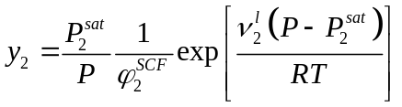 (1)
In solubility calculation using Eq. 1, an equation of state is used to calculate the fugacity coefficient which representing the non-ideality of the fluid phase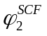. Here 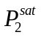 is the saturation pressure of solute, which can be measured experimentally or calculated using some estimation methods from literature. 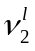 is the molar volume of the solute.
The Peng-Robinson equation of state (PR-EOS) which is commonly used in studies is defined as follows.
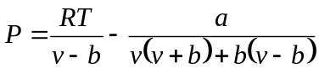 (2)
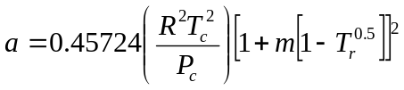 (3)
(4)
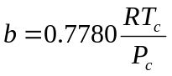 (5)
For a binary mixture the PR-EOS needs some mixing rules. In this study we employed the van der Waals (vdW) mixing rules, with two adjustable parameters, k_{ij} and l_{ij} (vdW2).
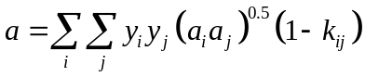 (6)
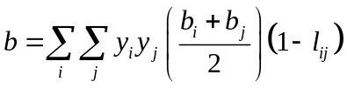 (7)
k_{ij} and l_{ij} are the binary interaction parameters which are obtained by fitting experimental data and through minimization of an objective function. The fugacity coefficient for a component i in a mixture is given by Prausnitz using mixing rules as follows.
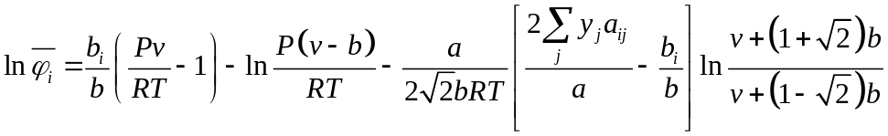 (8)
Here y_{j} is the mole fraction of component j.
2.2. Theory of Proposed Equation of State
For development of the new EOS, Berlin virial EOS which is power series in pressure has been used preferably.
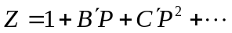 (9)
Where coefficients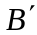, 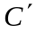 and etc. are virial equivalent coefficients.
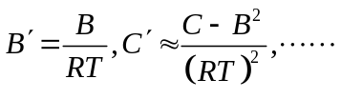 (10)
Pitzer and Curl proposed a correlation for (=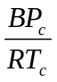) as follows.
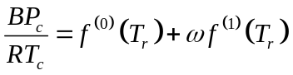 (11)
Here the function represents the reduced second virial coefficient for simple fluid, i.e. ω=0 and the function 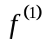 is a correlation represents the effect of eccentricity. These two functions were obtained from experimental data and modified by. Pitzer et al. proposed a second correlation for .
(12)
Where 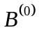 and 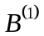 are function of T_{r} only and given by following equations.
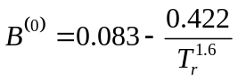 (13.a)
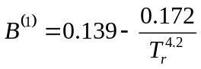 (13.b)
Orbey and Vera expressed the reduced temperature depended coefficients of a Pitzer type correlation for , which itself is related to third virial coefficient through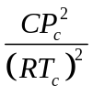 , as illustrated for B as follows.
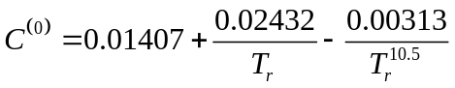 (14.a)
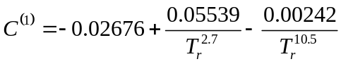 (14.b)
So following equations can be obtained for and.
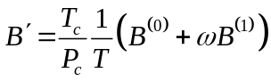 (15)
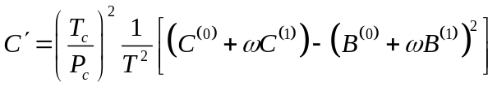 (16)
As mentioned previously,,, and are functions of reduced temperature only. According to Lee and Kessler equation for acentric factor, it can be seen that ω is a function of critical temperature and pressure, and also normal boiling point temperature. As critical properties such as critical temperature and pressure for all materials always can’t be measured experimentally or their values aren’t available in literature, one has to use some group contribution methods like Joback and Reid method for calculation of their value. In fact, Group Contribution Methods relate these critical properties to chemical structure of materials . Thus, From the work of Joback and Reid, it’s can be shown that critical temperature and pressure, themselves, are a function of total number of atoms present in material, n, and normal boiling point temperature, T_{b}, in the form of following equation.
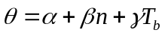 (17)
Here is the critical property of interest. ,  and are constants for each critical property of interest. So far, we qualitatively found that acentric factor and critical temperature and pressure, and consequently virial coefficients, can be expressed as functions of n and T_{b}. Finding these desired functions, new functions can be found for virial coefficients of Eq. 9 by introducing Eq. 15 and 16 into it and the new EOS is obtained. The experimental data of 30 dyes and 60 drugs were used to formulate the critical temperature in the form of Eq. 17 and finding its coefficients. Where there’s an absent of experimental normal boiling point temperature data, one can use some group contribution method for estimation of T_{b}. Equation 18 shows this new obtained relation in this work for T_{c} (R²>0.99). The reason for such replacement is that the need for complicated calculations of chemical structure and arrangement of bonds and groups could be resolved in this way. Then the applicability of obtained new equation for T_{c} calculation, Eq. 18, for other materials was validated using the available data of 60 drugs and it found that the Eq. 18 can be used for other materials also.
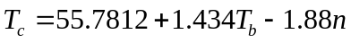 (18)
In development of the new EOS, M is defined as the ratio of P and T (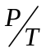), the operating parameter of new EOS. The definition is with regard to the appearance of the reciprocal of T in Eq. 15 and 16 and P in corresponding term in Eq. 9. So by this definition, T and P are merged as the new parameter M. This definition also makes the estimation of P_{c} possible as formulation of critical pressure in the form of Eq. 17 will never result in constant coefficients. The critical pressure appears in nominator of the critical M, M_{c}. So by finding the functionality of M_{c} to n and T_{b}, the critical pressure can be determined indirectly, in other words P_{c} can be calculated by multiplying T_{c} into the M_{c}. Equation 19 is derived and validated in the way described above for T_{c} in this work (R²>0.99).
(19)
So the critical value of M, M_{c}, together with Eq. 18 can be used to estimate the critical pressure. Moreover ω can be calculated using following new proposed equation in this paper (R²>0.98).
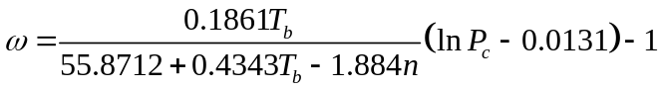 (20)
Inserting Eq. 15 and 16 into Eq. 9, the general form of new EOS is formed as Eq. 21. Separating the new parameter M in each term, what remains is the general coefficient of new EOS, A ⁽¹⁾ and A ⁽²⁾.
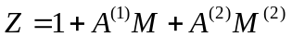 (21)
The coefficients A ⁽¹⁾ and A ⁽²⁾ are formulated in a Pitzer like form as shown Eq. 22 and 22.
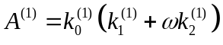 (22)
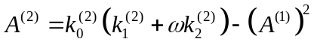 (23)
Here A ⁽¹⁾ and A ⁽²⁾ are two different functions of new independent variables n and T_{b}, and as well as T_{r}, structural parameters. For development of these two coefficients of new EOS and their parameters, the obtained equations for critical properties, acentric factor, and the new parameter M are used and the coefficients of these parameters are found. Then the drugs data are used for evaluation of applicability and generality of coefficients and formulas for using for materials other than the dyes. The obtained functions of these parameters as a function of new independent variable T_{b} and n are (All with R²>0.99).
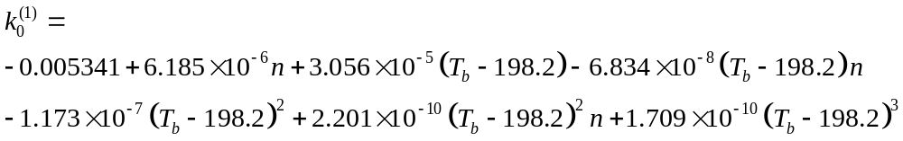 (24)
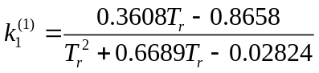 (25)
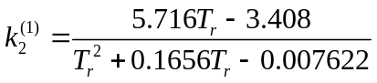 (26)
And for A ⁽²⁾ we have also
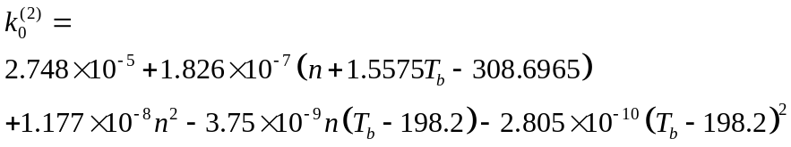 (27)
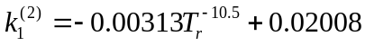 (28)
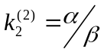
(29)
Although that choosing coefficients A ⁽¹⁾ and A ⁽²⁾ in a Pitzer like form leads to these complicated relationships (Eq. 24-29), but attentions would be given to the accuracy that can be achieved using this EOS with these parameters which will be shown in section 4.
In order to use this new EOS for a binary mixture, Pseudo parameters are defined for the normal boiling temperature and the total number of atoms. Pseudo n and T_{b} can be obtained by solving following system of two equations for a binary mixture (Eq. 30-31). Using experimental solubility data, the value of Pseudo n and T_{b} can be obtained through solving the system of two equations formed employing an objective function, OF, 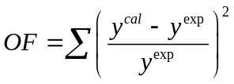and finding the best optimal value of the adjustable parameter K_{ij}. Then the new EOS can be used for the binary mixture calculations with these calculated pseudo n and T_{b}.
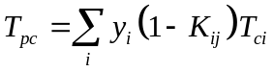 (30)
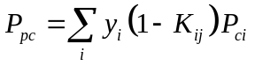 (31)
Finally the fugacity coefficient of component i in the fluid mixture is expressed as.
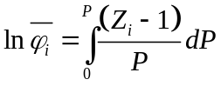 (33)
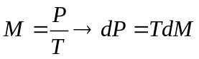 (34)
Inserting relations in Eq. 34 into Eq. 33, we get the fugacity coefficient as following function.
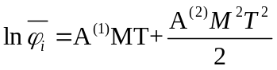 (35)
3. Material and Methods
Solubility data of thirty dyes and sixty drugs, a large number of solubility data more than 2417 data points, have been collected from literature . Table 1 shows the details of these solubility data, references, temperature and pressure ranges, and number of data points for each system. All estimated critical properties and molecular weight of these dyes are listed in Table 2. These critical properties are calculated using proposed equations in this paper. In order to compare the accuracy of the new EOS with PR-EOS as a reference, it is assumed that all the experimental data are correct. The objective function, OF, has been minimized using experimental solubility data of each system of study by the well-known optimization method of genetic algorithm in MATLAB (R2009a) environment [92]. The reported AARD in Figures is Average absolute relative deviation and defined as following function, for comparison of calculated solubility values and experimental ones.
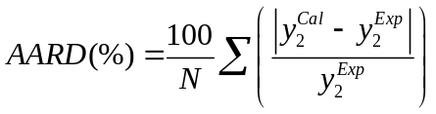 (36)
Where and are calculated and experimental solubility of solute respectively. N is the number of experimental data points.
4. Results and Discussion
The Accumulative AARD% values of each system of dyes, in order of appearance in Table 1, for proposed EOS and PR-EOS are shown in Fig.1. As it can be seen, the new EOS has lower Accumulative AARD% values than PR-EOS. So, it can be concluded that the proposed EOS presented more accurate result for solubility prediction and correlation in supercritical carbon dioxide. Also as a key system (due to largest data points among other systems), Fig. 2 shows the AARD% values corresponding to system 11, AC03, at a range of temperatures. Again it can be concluded that the new EOS is more successful in solubility correlation than PR-EOS. The performance of New EOS for Drugs data is shown in Fig. 3. We provide Fig. 4 as pressure- composition graph of D₂, showing the fitted isotherms at 308K and the experimental points used. Studies on applicability and generality of the new EOS on other solutes (60 Drugs solubility data, 1417 data points) show that the EOS will reveal even more accurate results if the Eq. 22 extended to third order in term of M (pressure to temperature ratio). This extension and derivation of practical thermodynamics relationships from this proposed EOS will be discussed later. It’s clear that the proposed EOS in this paper is able to predict and correlate the solubility of any solute in supercritical carbon dioxide.

Figure 1. The Accumulative AARD% values of each system, in order of appearance in Table 1, for proposed EOS and PR-EOS for Dyes.
Figure 2. The AARD% values corresponding to system 11, AC03, at a range of temperatures.
Figure 3. The Accumulative AARD% values of each system, in order of appearance in Table 1, for proposed EOS and PR-EOS for Drugs.
Figure 4. The pressure- composition graph for D₂ at isotherm 308K.

5. Conclusion
In this study, solubility of thirty dyes and sixty drugs in supercritical carbon dioxide have been used for evaluation and assessment of the new proposed EOS accuracy in correlation of solubility data in supercritical fluids. The solubility data were correlated with two equation of state; PR-EOS together with two adjustable parameter van der Waals mixing and combining rules and Proposed EOS. As the results show the mean AARD for the new EOS is significantly lower than that obtained from PR-EOS. The new EOS presented more accurate prediction for solubility data in supercritical CO₂.

NOMENCLATURE
α energy parameter of the cubic equation of state (Nm⁴mol⁻²)
A coefficients of new EOS
AARD average absolute relative deviation (%)
b volume parameter in the PR EOS and in the SRK EOS (m³mol⁻¹)
A, B, C, D … virial coefficients
A’, B’, C’, D’, virial coefficients
EOS equation of state
GCM group contribution method
k coefficients of proposed EOS
k_{ij} binary interaction parameters
l_{ij} binary interaction parameters
M proposed EOS parameter
Mw molecular weight
N number of data points
n number of atoms
P pressure (Pa)
PR Peng-Robinson
R ideal gas constant (Jmol⁻¹K⁻¹)
T temperature (K)
ν molar volume (cm³mol⁻¹)
vdW2 van der Waals mixing and combining rules with two adjustable parameters
y mole fraction
Z compressibility factor
Greek Symbols
α, β, γ coefficients of Equation (19)
φ fugacity coefficient
ω Pitzer’s acentric factor
Subscripts
1 solvent
2 solute
avg average
b boiling point
c critical property
i, j components
ps pseudo
r reduced
Superscripts
0, 1, 2 indices for new EOS coefficients
cal calculated
exp experimental
l liquid
SCF supercritical fluid
sat saturation

References:
1. V.F. Cabral, W.L.F. Santos, E.C. Muniz, A.F. Rubira, L. Cardozo-Filho. The Journal of Supercritical Fluids 40, 163 (2007).
2. P. Dong, M. Xu, X. Lu, C. Lin. Fluid Phase Equilibria 297, 46 (2010).
3. M.-W. Park, H.-K. Bae. Journal of Supercritical Fluids 22, 65 (2002).
4. M.R. De Giorgi, E. Cadoni, D. Maricca, A. Piras. Dyes and Pigments 45, 75 (2000).
5. M.P. Srinivasan, Y. Gu, R. Begum. Colloids and Surfaces A: Physicochemical and Engineering Aspects 198–200, 527 (2002).
6. E.E. Said-Galiyev, Y.S. Vygodskii, L.N. Nikitin, R.A. Vinokur, M.O. Gallyamov, I.V. Pototskaya, V.V. Kireev, A.R. Khokhlov, K. Schaumburg. Journal of Supercritical Fluids 27, 119 (2003).
7. O. Guney, A. Akgerman, J.M. Wong, K.P. Johnston, B. Subramaniam, R.A. Rajewski, K. Snavely. AIChE Journal 48, 856 (2002).
8. B. Subramaniam, R.A. Rajewski, K. Snavely. Journal of Pharmaceutical Sciences 86, 885 (1997).
9. B. Guzel, A. Akgerman. The Journal of Supercritical Fluids 18, 247 (2000).
10. S.J. Macnaughton, I. Kikic, N.R. Foster, P. Alessi, A. Cortesi, I. Colombo. Journal of Chemical & Engineering Data 41, 1083 (1996).
11. R. Murga, M.a.T. Sanz, S. Beltrán, J.L. Cabezas. The Journal of Supercritical Fluids 23, 113 (2002).
12. N. Ajzenberg, F. Trabelsi, F. Recasens. Chemical Engineering & Technology 23, 829 (2000).
13. K.E. Laintz, E. Tachikawa. Analytical Chemistry 66, 2190 (1994).
14. G. Kateman, M. Sjostriim, K. Furton, L. Chen, R. Jaffe. Rapid Determination of Uranium on Solid Matrices by Synergistic In Situ Chelation Supercritical Fluid Extraction and UV Absorption Spectroscopy (1995).
15. Y. Meguro, S. Iso, H. Takeishi, Z. Yoshida. Chem. Lett. 24, 365 (1995).
16. N.G. Smart, T.E. Carleson, S. Elshani, S. Wang, C.M. Wai. Industrial & Engineering Chemistry Research 36, 1819 (1997).
17. S. Wang, C.M. Wai. Environmental Science & Technology 30, 3111 (1996).
18. P. Dondeti, Y. Desai. Supercritical fluid technology in pharmaceutical research. J. Swarbrick, J.C. Boylan (Eds.), 18Marcel Dekker, New York (1999).
19. A. Tabernero, E.M.M. del Valle, M.Á. Galán. The Journal of Supercritical Fluids 52, 161 (2010).
20. W. Saus. SFD-Dry dyeing of polyester in CO2. Sterling Publication LTD (1995).
21. J. Fasihi, Y. Yamini, F. Nourmohammadian, N. Bahramifar. Dyes and Pigments 63, 161 (2004).
22. F.P. Lucien, N.R. Foster. The Journal of Supercritical Fluids 17, 111 (2000).
23. B. H.K., H.B. K. J. Korean. Inst. Chem. Eng. 34, 379 (1996).
24. U. Haarhaus, P. Swidersky, G.M. Schneider. The Journal of Supercritical Fluids 8, 100 (1995).
25. S. Joung, H. Shin, Y. Park, K.-P. Yoo. Korean Journal of Chemical Engineering 15, 78 (1998).
26. J. Chrastil. The Journal of Physical Chemistry 86, 3016 (1982).
27. K. Bartle, A. Clifford, S. Jafar, G. Shilstone. J. Phys. Chem. Ref. Data 20, 713 (1991).
28. J. Mendez-Santiago, A.S. Teja. Industrial & Engineering Chemistry Research 39, 4767 (2000).
29. D.H. Ziger, C.A. Eckert. Industrial & Engineering Chemistry Process Design and Development 22, 582 (1983).
30. S. Garnier, E. Neau, P. Alessi, A. Cortesi, I. Kikic. Fluid Phase Equilibria 158–160, 491 (1999).
31. J. Smith, H.v. Ness, M. Abbott. Introduction to Chemical Engineering Thermodynamics. McGraw-Hill, New York (2005).
32. D.-Y. Peng, D.B. Robinson. Industrial & Engineering Chemistry Fundamentals 15, 59 (1976).
33. J.M. Prausnitz, R.N. Lichtenthaler, E.G. de Azevedo. Molecular thermodynamics of fluid-phase equilibria. Prentice-Hall (1998).
34. P.K. S., C.R. F. Journal of American Chemical Society 79, 2369 (1957).
35. G. Tsonopoulos. Amer. Instit. Chem. Eng. J. 21, 827 (1975).
36. H. Orbey, J.H. Vera. AIChE Journal 29, 107 (1983).
37. K.G. Joback, R.C. Reid. Chemical Engineering Communications 57, 233 (1987).
38. S.N. Joung, K.-P. Yoo. Journal of Chemical & Engineering Data 43, 9 (1998).
39. S.-Y. Huang, M. Tang, S.L. Ho, Y.-P. Chen. The Journal of Supercritical Fluids 42, 165 (2007).
40. B. Wagner, C.B. Kautz, G.M. Schneider. Fluid Phase Equilibria 158-160, 707 (1999).
41. A.S. Özcan, A.A. Clifford, K.D. Bartle, D.M. Lewis. Journal of Chemical & Engineering Data 42, 590 (1997).
42. J.W. Lee, M.W. Park, H.K. Bae. Fluid Phase Equilibria 173, 277 (2000).
43. H.-D. Sung, J.-J. Shim. Journal of Chemical & Engineering Data 44, 985 (1999).
44. H.-m. Lin, C.-Y. Liu, C.-H. Cheng, Y.-T. Chen, M.-J. Lee. Journal of Supercritical Fluids 21, 1 (2001).
45. H.-m. Lin, C.-C. Ho, M.-J. Lee. The Journal of Supercritical Fluids 32, 105 (2004).
46. K. Tamura, T. Shinoda. Fluid Phase Equilibria 219, 25 (2004).
47. B. Guzel, A. Akgerman. Journal of Chemical & Engineering Data 44, 83 (1998).
48. J.W. Lee, J.M. Min, H.K. Bae. Journal of Chemical & Engineering Data 44, 684 (1999).
49. P. Coimbra, M.H. Gil, C.M.M. Duarte, B.M. Heron, H.C. de Sousa. Fluid Phase Equilibria 238, 120 (2005).
50. Xing, Yang, Su, M. Huang, Ren. Journal of Chemical & Engineering Data 48, 330 (2003).
51. A.R.C. Duarte, P. Coimbra, H.C. de Sousa, C.M.M. Duarte. Journal of Chemical & Engineering Data 49, 449 (2004).
52. M. Asghari-Khiavi, Y. Yamini. Journal of Chemical & Engineering Data 48, 61 (2002).
53. H. Sovová. Journal of Chemical & Engineering Data 46, 1255 (2001).
54. H. Uchida, I. Usui, A. Fuchita, M. Matsuoka. Journal of Chemical & Engineering Data 49, 1560 (2004).
55. I. Medina, J.L. Bueno. Journal of Chemical & Engineering Data 46, 1211 (2001).
56. K. Matsuyama, K. Mishima, R. Ohdate, M. Chidori, H. Yang. Journal of Chemical & Engineering Data 48, 1040 (2003).
57. A. Garmroodi, J. Hassan, Y. Yamini. Journal of Chemical & Engineering Data 49, 709 (2004).
58. Z. Huang, Y.-H. Guo, G.-B. Sun, Y.C. Chiew, S. Kawi. Fluid Phase Equilibria 236, 136 (2005).
59. J.W. Hampson, R.J. Maxwell, S. Li, R.J. Shadwell. Journal of Chemical & Engineering Data 44, 1222 (1999).
60. R. Murga, M.T. Sanz, S. Beltrán, J.L. Cabezas. Journal of Chemical & Engineering Data 49, 779 (2004).
61. E. Sahle-Demessie, U.R. Pillai, S. Junsophonsri, K.L. Levien. Journal of Chemical & Engineering Data 48, 541 (2003).
62. M. Asghari-Khiavi, Y. Yamini, M.A. Farajzadeh. The Journal of Supercritical Fluids 30, 111 (2004).
63. M. Sauceau, J.J. Letourneau, B. Freiss, D. Richon, J. Fages. The Journal of Supercritical Fluids 31, 133 (2004).
64. G.I. Burgos-Solórzano, J.F. Brennecke, M.A. Stadtherr. Fluid Phase Equilibria 220, 55 (2004).
65. A. Stassi, R. Bettini, A. Gazzaniga, F. Giordano, A. Schiraldi. Journal of Chemical & Engineering Data 45, 161 (2000).
66. R. Murga, M.a.T. Sanz, S. Beltrán, J.L. Cabezas. The Journal of Supercritical Fluids 27, 239 (2003).
67. Y. Yamini, J. Hassan, S. Haghgo. Journal of Chemical & Engineering Data 46, 451 (2001).
68. N. Elvassore, K. Vezzù, A. Bertucco. The Journal of Supercritical Fluids 33, 1 (2005).
69. M.D. Gordillo, M.A. Blanco, A. Molero, E. Martinez de la Ossa. The Journal of Supercritical Fluids 15, 183 (1999).
70. T. Mu, B. Han, J. Zhang, Z. Li, Z. Liu, J. Du, D. Liu. The Journal of Supercritical Fluids 30, 17 (2004).
71. S.S.T. Ting, D.L. Tomasko, N.R. Foster, S.J. Macnaughton. Industrial & Engineering Chemistry Research 32, 1471 (1993).
72. A. Cortesi, I. Kikic, P. Alessi, G. Turtoi, S. Garnier. The Journal of Supercritical Fluids 14, 139 (1999).
73. S.L.J. Yun, K.K. Liong, G.S. Gurdial, N.R. Foster. Industrial & Engineering Chemistry Research 30, 2476 (1991).
74. S.J. Macnaughton, N.R. Foster. Industrial & Engineering Chemistry Research 33, 2757 (1994).
75. W.J. Schmitt, R.C. Reid. Journal of Chemical & Engineering Data 31, 204 (1986).
76. Z. Knez, M. Skerget, P. Sencar-Bozic, A. Rizner. Journal of Chemical & Engineering Data 40, 216 (1995).
77. P. Alessi, A. Cortesi, I. Kikic, N.R. Foster, S.J. Macnaughton, I. Colombo. Industrial & Engineering Chemistry Research 35, 4718 (1996).
78. S. Li, G.S. Varadarajan, S. Hartland. Fluid Phase Equilibria 68, 263 (1991).
79. M. Johannsen, G. Brunner. Fluid Phase Equilibria 95, 215 (1994).
80. M. Shamsipur, A.R. Karami, Y. Yamini, H. Sharghi. The Journal of Supercritical Fluids 32, 47 (2004).
81. K. Khimeche, P. Alessi, I. Kikic, A. Dahmani. The Journal of Supercritical Fluids 41, 10 (2007).
82. S. Maeda, K. Mishima, K. Matsuyama, M. Baba, T. Hirabaru, H. Ishikawa, K.-i. Hayashi. Journal of Chemical & Engineering Data 46, 647 (2001).
83. H. Z., L. W.D., K. S., a.C. Y.C. J. Chem. Eng. Data 49, 1323 (2004).
84. M.D. Gordillo, C. Pereyra, E.J. Martı́nez de la Ossa. The Journal of Supercritical Fluids 27, 31 (2003).
85. M. Gordillo, C. Pereyra, E. Martinezdelaossa. Dyes and Pigments 67, 167 (2005).
86. J. Lee, M. Park, H.K. Bae. Fluid Phase Equilibria 179, 387 (2001).
87. M. Banchero, A. Ferri, L. Manna, S. Sicardi. Fluid Phase Equilibria 243, 107 (2006).
88. M.D. Gordillo, C. Pereyra, E.J. Martínez de la Ossa. Dyes and Pigments 67, 167 (2005).
89. T. Shinoda, K. Tamura. Fluid Phase Equilibria 213, 115 (2003).
90. Z. Jinhua, X. Mingxian, L. Xueyan, L. Chunmian. Chinese Journal of Chemical Engineering 18, 648 (2010).
91. J.M. Wong, K.P. Johnston. Biotechnology Progress 2, 29 (1986).
92. M.A. Khansary, A. Hallaji Sani, Fluid Phase Equilib 365 (2014).

