Abstract
Based on the discrete form of Volterra Functional Series in approximation of multivariable functions, a mathematical model proposed for the modeling of solute solubility in supercritical fluids with four independent variables, which can be regarded as the general form of majority of available empirical models in literatures. As far as we know, it is the first time the thermodynamic-mathematical development of empirical models is presented. A substantial number of data points for different solutes and solvents used to analysis the performance and reliability of the proposed model. Peng-Robinson equation of state together with the two adjustable parameters van der Waals mixing rule, as an example of theoretical models, and a number of recent empirical models, as examples of empirical/statistical models, were considered to demonstrate the superiority of the proposed model. The Particle Swarm Optimization (PSO) was used for determination of the optimum coefficients of all models. The results were obtained and discussed in details.
Keyword: Supercritical fluids; Solubility; Modeling, Volterra Functional Series; Particle Swarm Optimization; Matrix Calculation.

Introduction
Supercritical fluids, in particular supercritical carbon dioxide (SC-CO₂) have attracted considerable attentions in recent years and extensively used and applied in chemical and petroleum , pharmaceutical , food, biotechnology, biomedical, nuclear, material and polymer processing industries due to unique physical and chemical properties such as low cost, nontoxicity, non-flammability, easy recycle and no environmental hazards .
For the design of supercritical fluid process, it is a required need to determine and calculate solubility data, which can be obtained in two different ways; (i) experimentally or (ii) by mathematical modeling . The ability of assessing and analysis of models’ parameters and their individual effects on the solubility are the superiority of mathematical modeling. Generally, mathematical models are classified into two groups; (i) theoretical or semi-empirical equations such as models based on equations of state, and (ii) empirical equations such as density based equations .
Different researchers have presented several empirical models using temperature, pressure and/or density as independent variables, for which the best coefficients must be determined based on the simple error minimization methods for each system of interest . On the other hand, for the use of theoretical models such as cubic equation of state, the knowledge of the solute properties including critical temperature and pressure, acentric factor, molar volumes and sublimation pressure are required , and in the case of unavailable data in the literature, one should estimate their values using some group contribution methods (GCM) , that relate these critical properties to chemical structure of materials. The simple form of empirical models is a priority in comparison to the theoretical models.
In this paper, a four independent variable model developed and presented with the use of volterra functional series approximation to the solubility relationship and based on thermodynamics considerations . The obtained model, then, was used for prediction and correlation of solubility data in supercritical solvents. Peng-Robinson equation of state (PR-EOS) together with the two adjustable parameters van der Waals mixing rule (vdW2), as an example of theoretical models, and a number of recent empirical models, as examples of empirical/statistical models, were considered to demonstrate the superiority of the proposed model. The Particle Swarm Optimization (PSO) algorithm was used for determination of the optimum coefficients of all models.
Theory
The solubility of a solute at equilibrium with a supercritical fluid can be calculated using Eq. 1 .
- 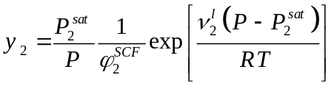
In solubility calculation using Eq. 1, an equation of state can be used to calculate the fugacity coefficient which representing the non-ideality of the fluid phase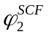. Here 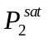 is the saturation pressure of solute, which can be measured experimentally or calculated using some estimation methods in literature . 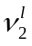 is the molar volume of the solute.
Here, for comparison to theoretical models, the Peng-Robinson EOS has been considered due to its wide applications, which is defined as follows .
- 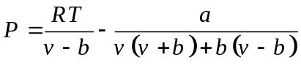
- 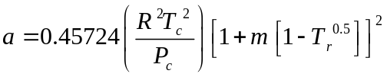
- 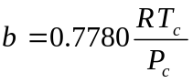
For a binary mixture, to reveal the mixture behavior, the PR-EOS needs some mixing rules such as the van der Waals mixing rules, with two adjustable parameters, k_{ij} and l_{ij} (vdW2) ;
- 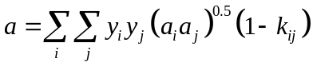
- 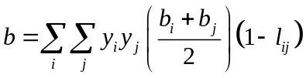
Here k_{ij} and l_{ij} are the binary interaction parameters must be obtained by fitting experimental data and through minimization of an objective function. The fugacity coefficient for a component i in a mixture was given by Prausnitz as follows , where y_{j} is the mole fraction of component j.
- 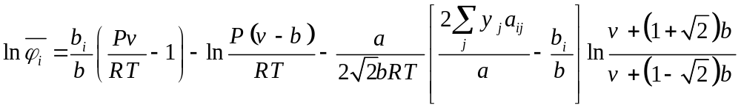
Solubility dependency to operating parameters i.e. temperature and pressure and the materials properties such saturation pressure and fugacity coefficient (as seen in Eq. 1) has been approximated in the form of linear/nonlinear functions of temperature and pressure and/or density in majority of empirical models . To note this relationship and the performance comparison purpose, a number of empirical models reported for solute solubility predication and correlation have been collected from literatures as shown in Eq. 9-16.
- Bartle; 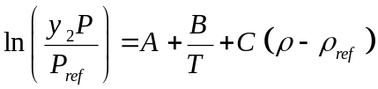
- Chrastil; 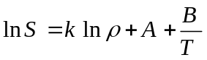
- del Valle and Aguilera; 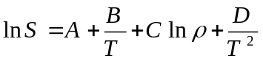
- Gordillo;
- Jafari Nejad; 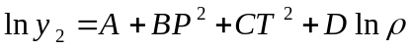
- Jouyban; 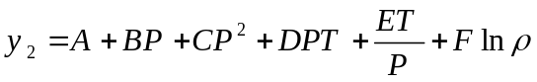
- Méndez-Santiago and Teja; 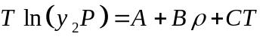
- Yu;
Where, S (kgm⁻³), is the solubility of the solute in the supercritical phase, ρ (kgm⁻³) density of pure supercritical phase, and constants A-F and k are the models coefficients which can be obtained from experimental data fitting.
The solubility (Eq. 1), for a specific solvent, can be approximated by Eq. 17 as function (F) of two main groups of parameters; (i) operating parameters (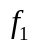) i.e. temperature and pressure, and (ii) solute physicochemical properties (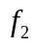) such as critical temperature, pressure, etc.
- 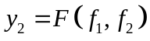
It is worthwhile to note that the most general approximation (G) is in the form of Eq. 18, where 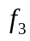corresponds to the properties of solvent.
- 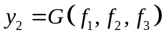
The selection of physicochemical properties for definition of in Eq. 17 and and in Eq. 18, can be regarded of the most important step in development of a statistically empirical model which is disregarded up to now, as far as we know. In fact, majority of empirical models have been developed and presented using the data for one studied system and then the obtained relationship has been applied for other systems of interest using temperature and pressure (and/or density, which itself is a function of temperature and pressure) as independent variables as seen in Eq. 9-16. It might be due the fact that in industrial applications, one deal with a specific material and only the operating parameters has the possibility of variation. It means that, for those empirical models, in Eq. 17 and 18, the and are fixed, and these equations read 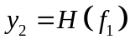.i.e. a relationship uses temperature and pressure as independent variables, and therefore constant coefficients must be determined for each system.
In this work, the attempts were done to establish the reliable form and relationship regarding Eq. 17. For Eq. 18, the development was carried out for a future work. Before continuing to find the appropriate selection of solute physicochemical properties variable i.e., it is possible to establish the approximated form of Eq. 17 by applying the volterra functional series theory in their discrete form (Eq. 19) up to the third term and obtaining Eq. 20, where are the constants . The truncated volterra functional series up to third term is known as Kolmogorov-Gabor polynomials and this Equation (Eq. 20) is the simplest form of the proposed modeling. Simple mathematical calculus together with Taylor series approximation might show that majority of empirical models are of the reduced form of Eq. 19 (carried out for a future work).
- 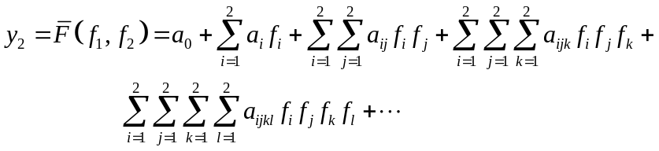
For the definition of variables and, the concepts of a new equation of states were used. Based on Pitzer correlations for the compressibility factor and Virial equation , a new equation of state has been developed which is a function of n, total number of atoms present in the solute molecule, and T_{b}, normal boiling point temperature and reduced temperature. The general form of new EOS is ;
- 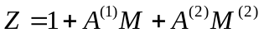
Where, M defined as the ratio of P and T (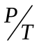) and the coefficients A ⁽¹⁾ and A ⁽²⁾ were formulated in a Pitzer like form and as two different functions of new independent variables n and T_{b}. In fact, the concept of Joback and Reid’s group contribution method was implicitly employed in these coefficients. Defining coefficients A ⁽¹⁾ and A ⁽²⁾ in a Pitzer like form were led to complicated relationships.
The parameter M=, was used as the definition of variable in Eq. 20 for the proposed model. The second variable,, was defined as a combination of n (total number of atoms present in the solute molecule) and T_{b}(normal boiling point temperature) as shown in Eq. 22 with ,  and as constants. In fact, Eq. 22 means that each critical property of interest can be expressed as functions of n and T_{b} as mentioned elsewhere .
- 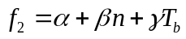
This way, a mathematical approximation to the thermodynamic function of solubility obtained without the violation of the thermodynamic-mathematic functionalities. In other words, the solubility function was approximated by volterra functional series theory, as our mathematical tool, while the thermodynamic concepts were kept in mind. It is an important hierarchy which must be followed if one tends to clearly perform a thermodynamic calculation but not just mathematical calculation as noted elsewhere . All the empirical models fail to adhere to Eq. 17 as they are developed through a mathematical calculation in which the aim is (only) finding the best regression of data without the consideration of thermodynamically relationship must be treated and approximated (Eq. 1 and Eq. 17).
Material and Methods
Table 1 summarizes the details of all solubility data including references. All collected data in literatures has been assumed correct. The solubility data for carbon dioxide as the solvent and dyes and drugs as solute are collected from the author’s previously published works .
Table 1. Details of studied systems .

For determination of the best coefficients of empirical models (A-F and k), the binary interaction parameters (k_{ij} and l_{ij}) of Peng-Robinson equation of state and the constants of proposed modeling, Particle Swarm Optimization (PSO) method was used for the optimization of predefined objective functions based on four statistical parameters which measure the goodness of the fit . Only and only by finding the optimal interaction parameters k_{ij} and l_{ij}, the PR-EOS can be able to regenerate the behavior of the mixture with desirable accuracy (often the errors cannot be negligible) . The authors must declare that choosing the PR-EOS is only due to its wide application in references referred. For calculations of coefficients of all models, a sample data set (30% of the all-available data) was used, which covers all materials of study with the maximum and minimum data point to ensure consistency of calculations .
For a comprehensive and depth comparison between the proposed and previously published models in literature, four statistical parameters have been defined as listed in Table 2, which are described before in details elsewhere . However, it is worth full to mention that;
- An R-square value closer to 1 indicates that a greater proportion of variance is accounted for by the model.
- An Adj R-sq. value closer to 1 indicates a better fit however it can take on any value less than or equal to 1.
- A RMSE value closer to 0 indicates a fit that is more useful for prediction.
- A SSE value closer to zero indicates a fit that has a smaller random error component and is more useful for prediction.

Table 2. The statistical parameters defined for assessment of models’ performance .

As mentioned earlier, the evolutionary algorithm of PSO was used for calculations. For each empirical model, the number of variables (dimension) is equal to the number of model’s coefficients, and finding two variables (i.e. two binary interaction parameters) was the task of optimizer for the PR-EOS calculation. In PSO algorithm , the individuals and entire swarms best position are used to guide the swarms (initial population) to move around the best solution. This procedure is repeated until a desired solution according to objective function being found. The number of variables should be determined is equal to the number of variables these optimizers seek for the optimal value. The summary of this optimizer’s characteristics is summarized in Table 3.

Table 3. PSO parameters.

For Np number of available data points, the simplest form of proposed model i.e. Eq. 20, reads following system of equations written in Matrix form;
- 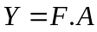
For which we have,
- 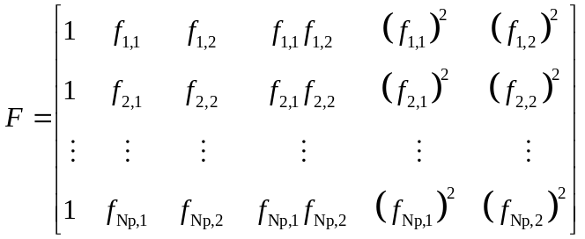
- 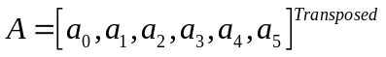
- 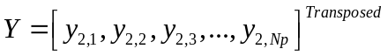
To find the coefficients of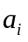, one need to solve the system of equations, thus one may write Eq. 27,
- 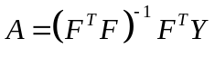
Using such matrix calculations, beside the PSO optimization method of coefficients determination, only linear algebraic calculation over available data point is required which makes the concept of this model unique, easy to use, and more preferable besides it generality over majority of previously published models. In addition, Eq. 22, which corresponds to the second variable of model (), can be written in matrix form to simplify the calculations, similarly. As described, Eq. 22 means that each critical property of interest can be expressed as functions of n and T_{b}. It is worthwhile to note that there are different possibilities for choosing a critical property (as in Eq. 22) to represent each material efficiently such as critical temperature, critical pressure, acentric factor etc. as presented in following paragraphs.
Results and Discussion
Data points of dyes and drugs were used for calculation of the best coefficient of empirical models according to the method described above. The obtained coefficients of models corresponding to each solute system are in common with the previously research reported and the reader may refer to this reference for all individual calculated coefficients to avoid duplicate reporting of data. The Correlation results obtained with the PR-EOS for data of Dyes and Drugs can be found elsewhere .
The appropriate selection of physicochemical property, for definition of in proposed model, was investigated and the results are summarized in Table 4. It is clear that choosing critical temperature give the best result, which itself leads to the model’s unique linearized form as mentioned before.
Table 4. The appropriate selection of physicochemical variable () in proposed modeling.

The resulting values of four statistical parameters are summarized in Table 5 for all considered empirical models and the proposed model. The obtained results clearly approve the superiority of the proposed model as the proposed model has the closer values of SSE and RMSE to zero and R-sq. and Adj R-sq. to unity. It should be noted that models with little number of coefficients are more preferable as they reduce the computation time, so the numbers of coefficients is an important factor. However, for complicated systems, one may try to use Eq. 19 with more terms to achieve higher accuracy.
Table 5. The obtained results of four statistical parameters of models.
Figures 1-3 represent the obtained calculation results of each model together with the experimental data for three systems i.e. Blue 60 and Niflumic acid in supercritical carbon dioxide and water in supercritical methane, respectively. The extended proposed model, i.e. including more terms in Eq. 19, reveals great agreement to the experimental data. The simple form of the proposed model i.e. Eq. 20, also was able to reproduce the experimental data with desirable accuracy.
According to the obtained results, the proposed modeling developed in this work can be applied to systems of interest for correlation and prediction purposes’. One must note that of the most important characteristics of current model, is its development from the solubility relationship by applying the appropriate mathematical operations i.e. volterra functional series approximation, with regard to thermodynamic concepts. It can readily be proved that almost all of the published empirical models might be development from the proposed model main equation i.e. Eq. 19, which will be discussed in a future work more in details.
Figure 1. The calculation results obtained from all the models for Blue 60 in supercritical carbon dioxide at T = 313.15 K.
Figure 2. The calculation results obtained from all the models for Niflumic acid in supercritical carbon dioxide at T = 313.2 K.
Figure 3. The calculation results obtained from all the models for water in supercritical methane at T = 441 K.
Conclusion
The discrete form of Volterra Functional Series was used to establish a mathematical model for the modeling of solute solubility in supercritical fluids. Based on a thermodynamic model, four independent variables n (total number of atoms present in the solute molecule), T_{b} (normal boiling point temperature) and the operating temperature and pressure were chosen to form the two input variables of proposed model. Peng-Robinson equation of state (PR-EOS) together with the two adjustable parameters van der Waals mixing rule (vdW2) and a number of recent empirical models were considered to demonstrate the superiority of the proposed model by means of a large data points. The Particle Swarm Optimization (PSO) was used for determination of the optimum coefficients of all models. The proposed model has a unique linear algebraic form. It’s the first mathematical empirical model adhere to the thermodynamic relationships of solubility, and majority of published empirical models can be simply derived from its main equation using calculus and Taylor series approximation. According to the obtained results, application of the proposed model give desirable agreement to the data.
Acknowledgment
The authors would like to thank the Editor and Reviewers for their positive and practical suggestions on this contribution.
Further information
- The correct thermodynamic-mathematical method for development of empirical models was presented. It might be beneficiating to consider the approach presented here in future development and presentation of empirical models.
- The model can be regarded as a generic equation for development of newer empirical models, which one would be obtained using more terms in Eq. 19 and with the help of calculus.
- The property parameter of solvent can be considered to successfully find the appropriate relationship to approximate for Eq. 18.
References
[1] D.E. Knox, Pure and Applied Chemistry, 77 (2005).
[2] W.H. Hauthal, Chemosphere, 43 (2001) 123-135.
[3] E.E. Said-Galiyev, Y.S. Vygodskii, L.N. Nikitin, R.A. Vinokur, M.O. Gallyamov, I.V. Pototskaya, V.V. Kireev, A.R. Khokhlov, K. Schaumburg, Journal of Supercritical Fluids, 27 (2003) 119-119.
[4] H. Higashi, Y. Iwai, Y. Arai, Chemical Engineering Science, 56 (2001) 3027-3044.
[5] K. Bartle, A. Clifford, S. Jafar, G. Shilstone, J. Phys. Chem. Ref. Data, 20 (1991) 713–725.
[6] M. Asghari-Khiavi, Y. Yamini, Journal of Chemical & Engineering Data, 48 (2002) 61-65.
[7] H. Sovová, Journal of Chemical & Engineering Data, 46 (2001) 1255-1257.
[8] A. Stassi, R. Bettini, A. Gazzaniga, F. Giordano, A. Schiraldi, Journal of Chemical & Engineering Data, 45 (2000) 161-165.
[9] M.D. Gordillo, M.A. Blanco, A. Molero, E. Martinez de la Ossa, The Journal of Supercritical Fluids, 15 (1999) 183-190.
[10] B. Subramaniam, R.A. Rajewski, K. Snavely, Journal of Pharmaceutical Sciences, 86 (1997) 885-890.
[11] S.J. Macnaughton, I. Kikic, N.R. Foster, P. Alessi, A. Cortesi, I. Colombo, Journal of Chemical & Engineering Data, 41 (1996) 1083-1086.
[12] P. Alessi, A. Cortesi, I. Kikic, N.R. Foster, S.J. Macnaughton, I. Colombo, Industrial & Engineering Chemistry Research, 35 (1996) 4718-4726.
[13] S.S.T. Ting, D.L. Tomasko, N.R. Foster, S.J. Macnaughton, Industrial & Engineering Chemistry Research, 32 (1993) 1471-1481.
[14] M. Hosseini Anvari, G. Pazuki, The Journal of Supercritical Fluids, 90 (2014) 73-83.
[15] N. De Zordi, I. Kikic, M. Moneghini, D. Solinas, The Journal of Supercritical Fluids, 66 (2012) 16-22.
[16] J. Zheng, M. Xu, X. Lu, C. Lin, Chinese Journal of Chemical Engineering, 18 (2010) 648-653.
[17] M. Banchero, A. Ferri, L. Manna, S. Sicardi, Fluid Phase Equilibria, 243 (2006) 107-114.
[18] A. Rai, K.D. Punase, B. Mohanty, R. Bhargava, International Journal of Heat and Mass Transfer, 72 (2014) 274-287.
[19] R. Tabaraki, T. Khayamian, A.A. Ensafi, Dyes and Pigments, 73 (2007) 230-238.
[20] C.-S. Su, Y.-P. Chen, Fluid Phase Equilibria, 254 (2007) 167-173.
[21] L.M. Valenzuela, A.G. Reveco-Chilla, J.M. del Valle, The Journal of Supercritical Fluids, 94 (2014) 113-122.
[22] B. Vaferi, M. Karimi, M. Azizi, H. Esmaeili, The Journal of Supercritical Fluids, 77 (2013) 44-51.
[23] M. Yazdizadeh, A. Eslamimanesh, F. Esmaeilzadeh, Chemical Engineering Science, 71 (2012) 283-299.
[24] B. Mehdizadeh, K. Movagharnejad, Chemical Engineering Research and Design, 89 (2011) 2420-2427.
[25] M. Lashkarbolooki, B. Vaferi, M.R. Rahimpour, Fluid Phase Equilibria, 308 (2011) 35-43.
[26] A. Jouyban, H.-K. Chan, N.R. Foster, The Journal of Supercritical Fluids, 24 (2002) 19-35.
[27] M. Asgarpour Khansary, F. Amiri, A. Hosseini, A. Hallaji Sani, H. Shahbeig, Chemical Engineering Research and Design, (2014).
[28] C. Garlapati, G. Madras, Thermochimica Acta, 500 (2010) 123-127.
[29] J. Mendez-Santiago, A.S. Teja, Industrial & Engineering Chemistry Research, 39 (2000) 4767-4771.
[30] B. H.K., H.B. K., J. Korean. Inst. Chem. Eng., 34 (1996) 379-387.
[31] D.H. Ziger, C.A. Eckert, Industrial & Engineering Chemistry Process Design and Development, 22 (1983) 582-588.
[32] J. Chrastil, The Journal of Physical Chemistry, 86 (1982) 3016-3021.
[33] Milad Asgarpour Khansary, Amin Arif, Mohammad Ali Salehi, Ahmad Hallaji Sani, H. Shahbeig, Periodica Polytechnica Chemical Engineering (2014).
[34] S.J. Nejad, R. Mohammadikhah, H. Abolghasemi, M.A. Moosavian, M.G. Maragheh, The Canadian Journal of Chemical Engineering, 87 (2009) 930-938.
[35] F. Abdollahi-Demneh, M.A. Moosavian, M.M. Montazer-Rahmati, M.R. Omidkhah, H. Bahmaniar, Fluid Phase Equilibria, 291 (2010) 48-58.
[36] F. Abdollahi-Demneh, M.A. Moosavian, M.M. Montazer-Rahmati, M.R. Omidkhah, H. Bahmaniar, Fluid Phase Equilibria, 288 (2010) 67-82.
[37] K.G. Joback, R.C. Reid, Chemical Engineering Communications, 57 (1987) 233-243.
[38] B.E. Poling, J.M. Prausnitz, J.P. O'Connell, Properties of Gases and Liquids, 4 ed., McGraw-Hill Professional, 1987.
[39] A.G. Ivakhnenko, IEEE Transactions on Systems, Man, and Cybernetics, 1 (1971) 364-378.
[40] D.-Y. Peng, D.B. Robinson, Industrial & Engineering Chemistry Fundamentals, 15 (1976) 59-64.
[41] J.A. Lazzús, Journal of Molecular Liquids, 196 (2014) 167-177.
[42] H.V.N. J.M. Smith, Michael Abbott, Introduction to Chemical Engineering Thermodynamics, 7 ed., McGraw-Hill, 2005.
[43] John M. Prausnitz, Rudiger N. Lichtenthaler, Edmundo Gomes de Azevedo, Molecular Thermodynamics of Fluid-Phase Equilibria 3ed., Prentice Hall, 1998.
[44] J.M. Del Valle, J.M. Aguilera, Industrial & Engineering Chemistry Research, 27 (1988) 1551-1553.
[45] S. Jafari Nejad, H. Abolghasemi, M.A. Moosavian, M.G. Maragheh, Chemical Engineering Research and Design, 88 (2010) 893-898.
[46] Z.-R. Yu, B. Singh, S.S.H. Rizvi, J.A. Zollweg, The Journal of Supercritical Fluids, 7 (1994) 51-59.
[47] J. Wisniak, A. Apelblat, H. Segura, Physics and Chemistry of Liquids, 35 (1997) 1-58.
[48] S. Jafari Nejad, M. Asgarpour Khansari, F. Amiri, International Journal of Thermodynamics, 15 (2012).
[49] S.J. Nejad, M.A. Khansary, F. Amiri, International Journal of Chemical Engineering and Applications, (2011) 272-277.
[50] A. Hallaji Sani, A. Arif, M.A. Salehi, M. Asgarpour Khansary, Asia-Pacific Journal of Chemical Engineering, (2014).
[51] C.-C. Tsai, H.-m. Lin, M.-J. Lee, The Journal of Supercritical Fluids, 95 (2014) 17-23.
[52] F. Tabasinejad, R.G. Moore, S.A. Mehta, K.C. Van Fraassen, Y. Barzin, J.A. Rushing, K.E. Newsham, Industrial & Engineering Chemistry Research, 50 (2011) 4029-4041.
[53] MathWorks, MATLAB, in, 2009, pp. Surface Fitting Tool.
[54] M. Asgarpour Khansary, A. Hallaji Sani, Fluid Phase Equilibria, 365 (2014) 141-145.

