**Appendix A.**

3D graphical overview of models performance for system no 11 (owning largest data points) is presented here. Each figure has three section; Top view placed in left side, 3D solubility data and model mesh surface on top right side, and residual for each data point in bottom right.

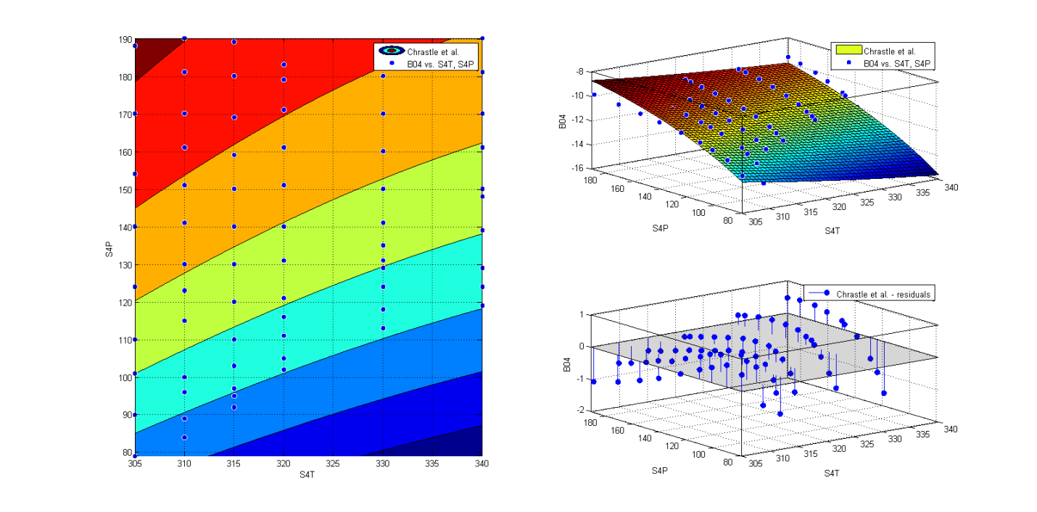**Figure 1**. Chrastil Model.

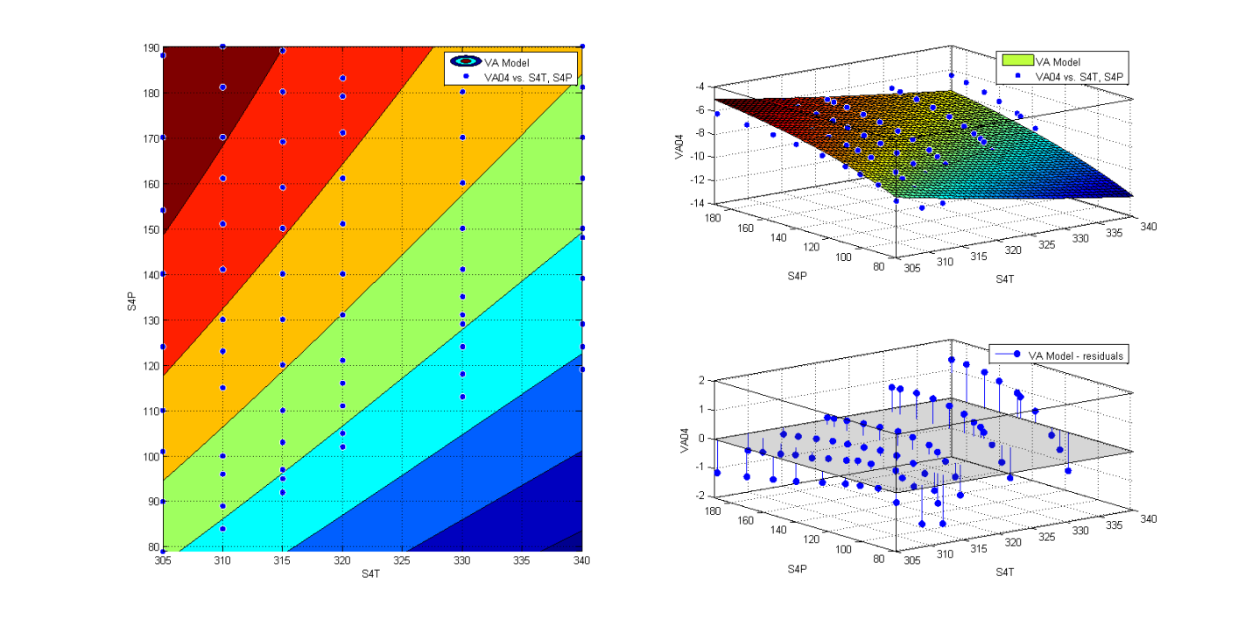

**Figure 2**. VA Model.

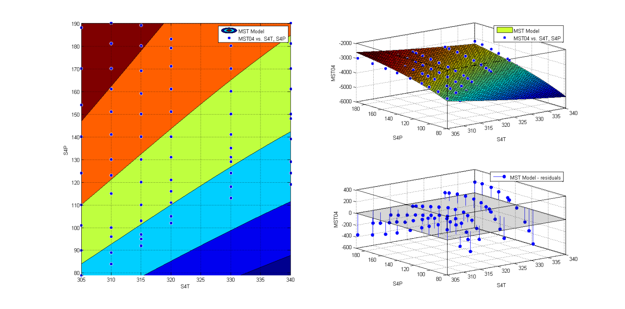

**Figure 3**. MST Model.

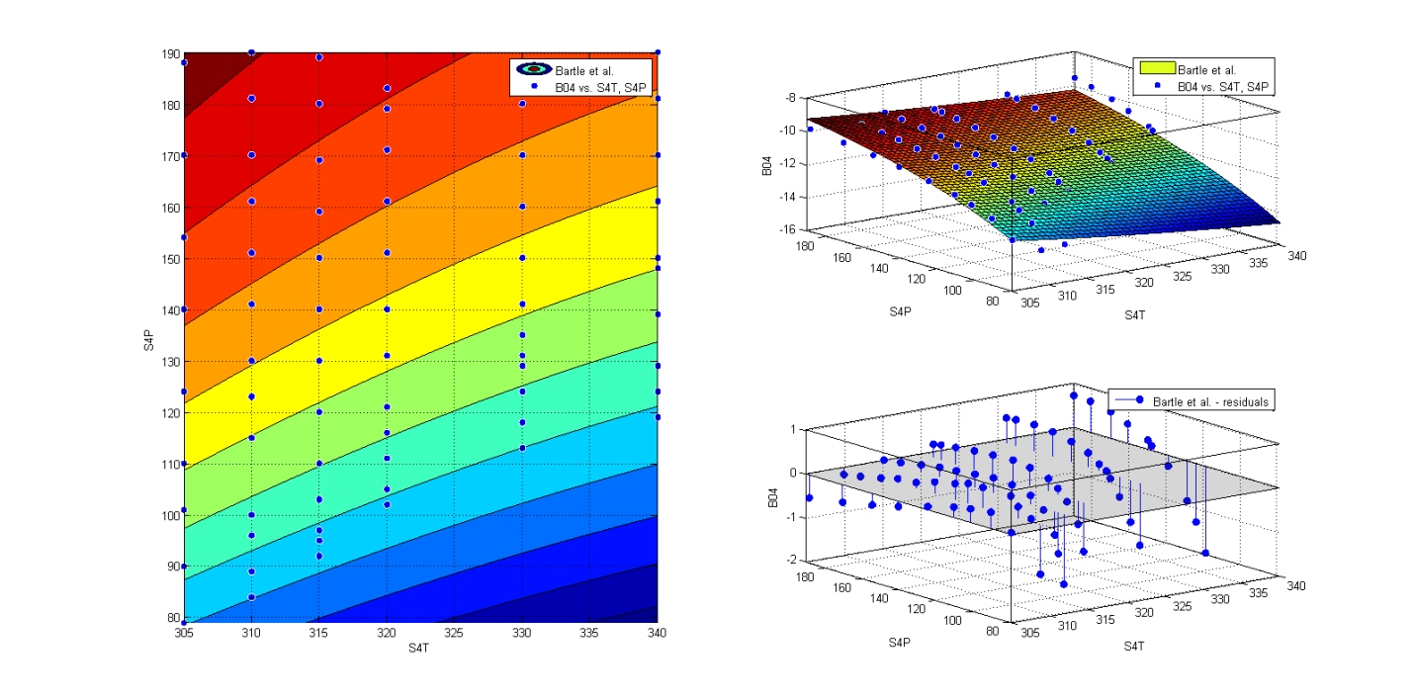

**Figure 4**. Bartle et al. Model.

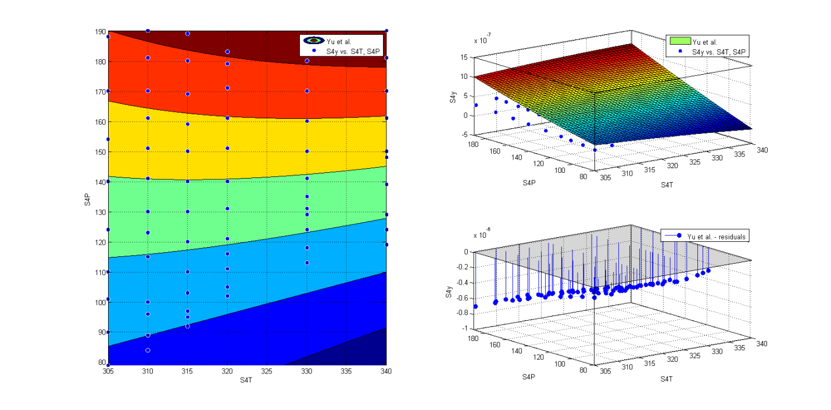

**Figure 5**. Yu et al. Model.

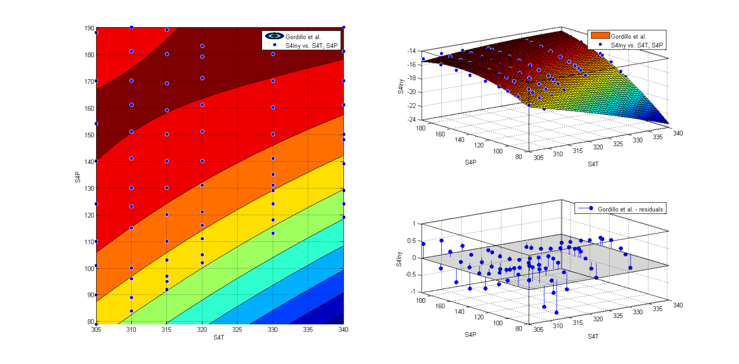

**Figure 6**. Gordillo et al. Model.

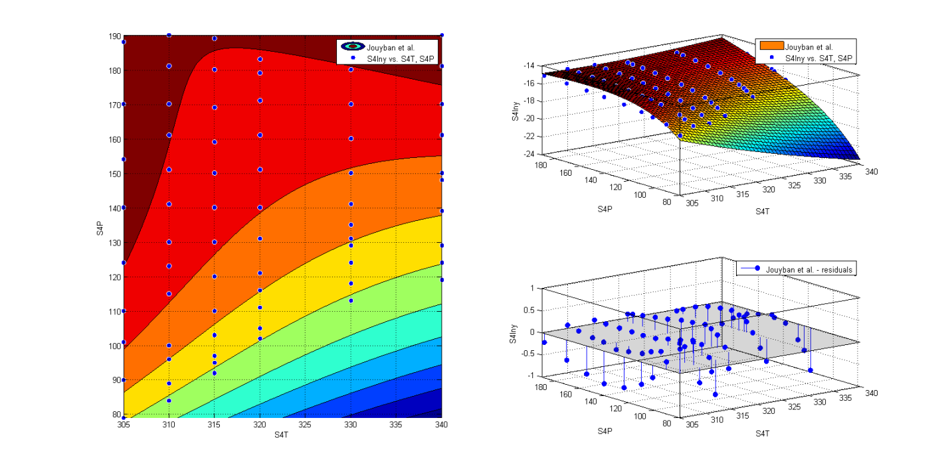

**Figure 7**. Jouyban et al. Model.

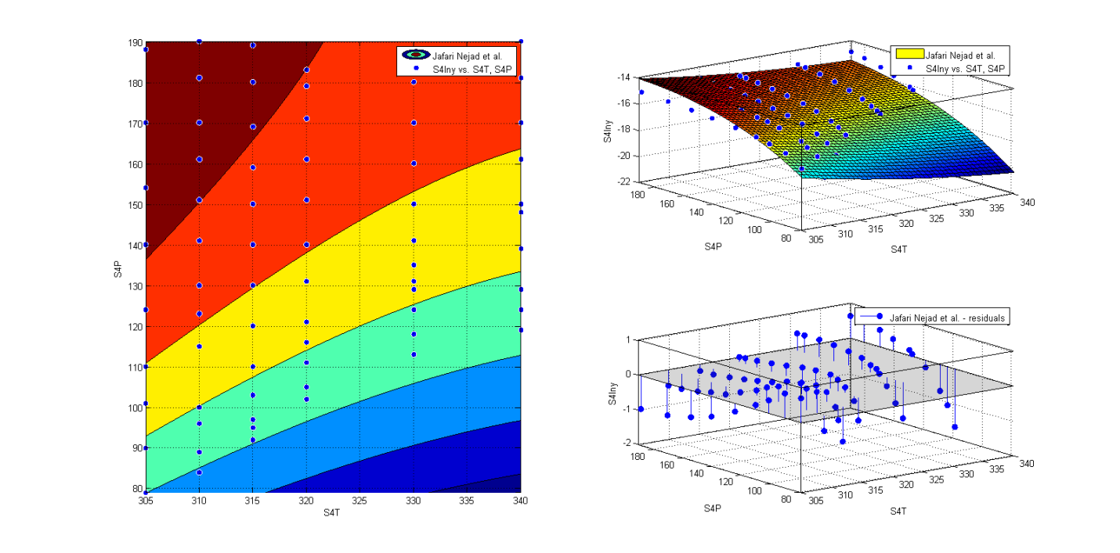

**Figure 8**. Jafari Nejad et al. Model.

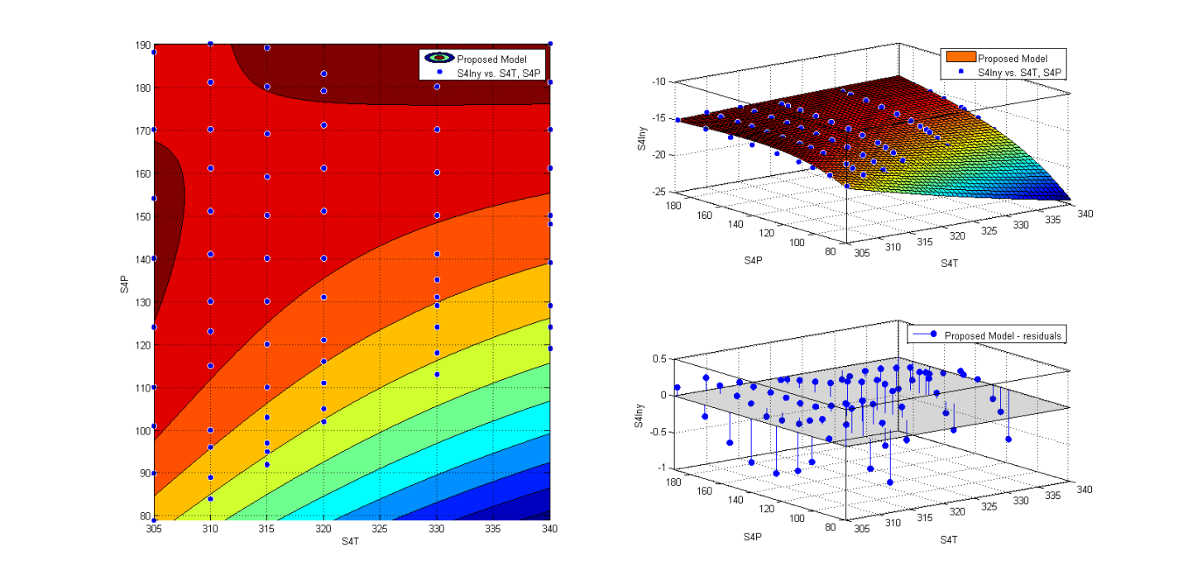

**Figure 9**. Proposed Model.