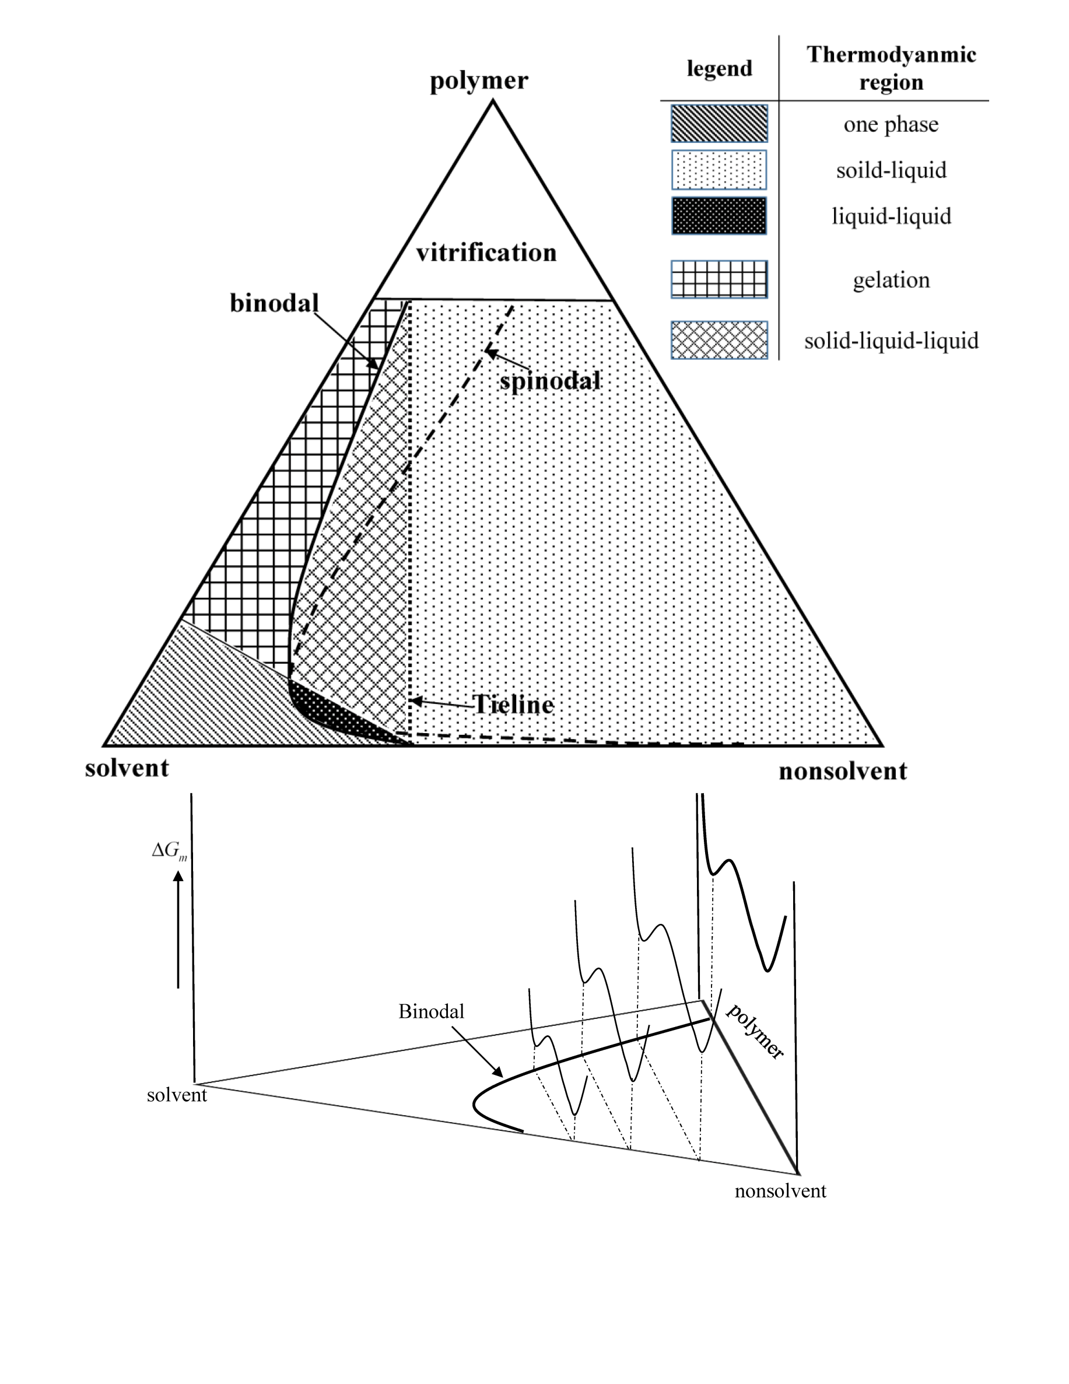

**Figure 2.** Schematic representation of different possible thermodynamic regions for a ternary semicrystalline polymeric system [1, 3, 23]