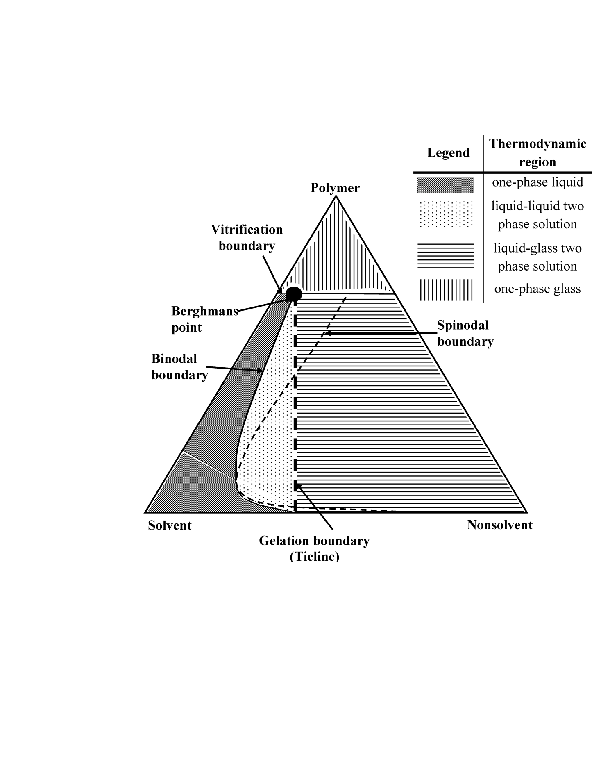

**Figure 4.** Ternary diagram of a amorphous polymer containing ternary system, which has vitrification, gelation and binodal boundaries [24]