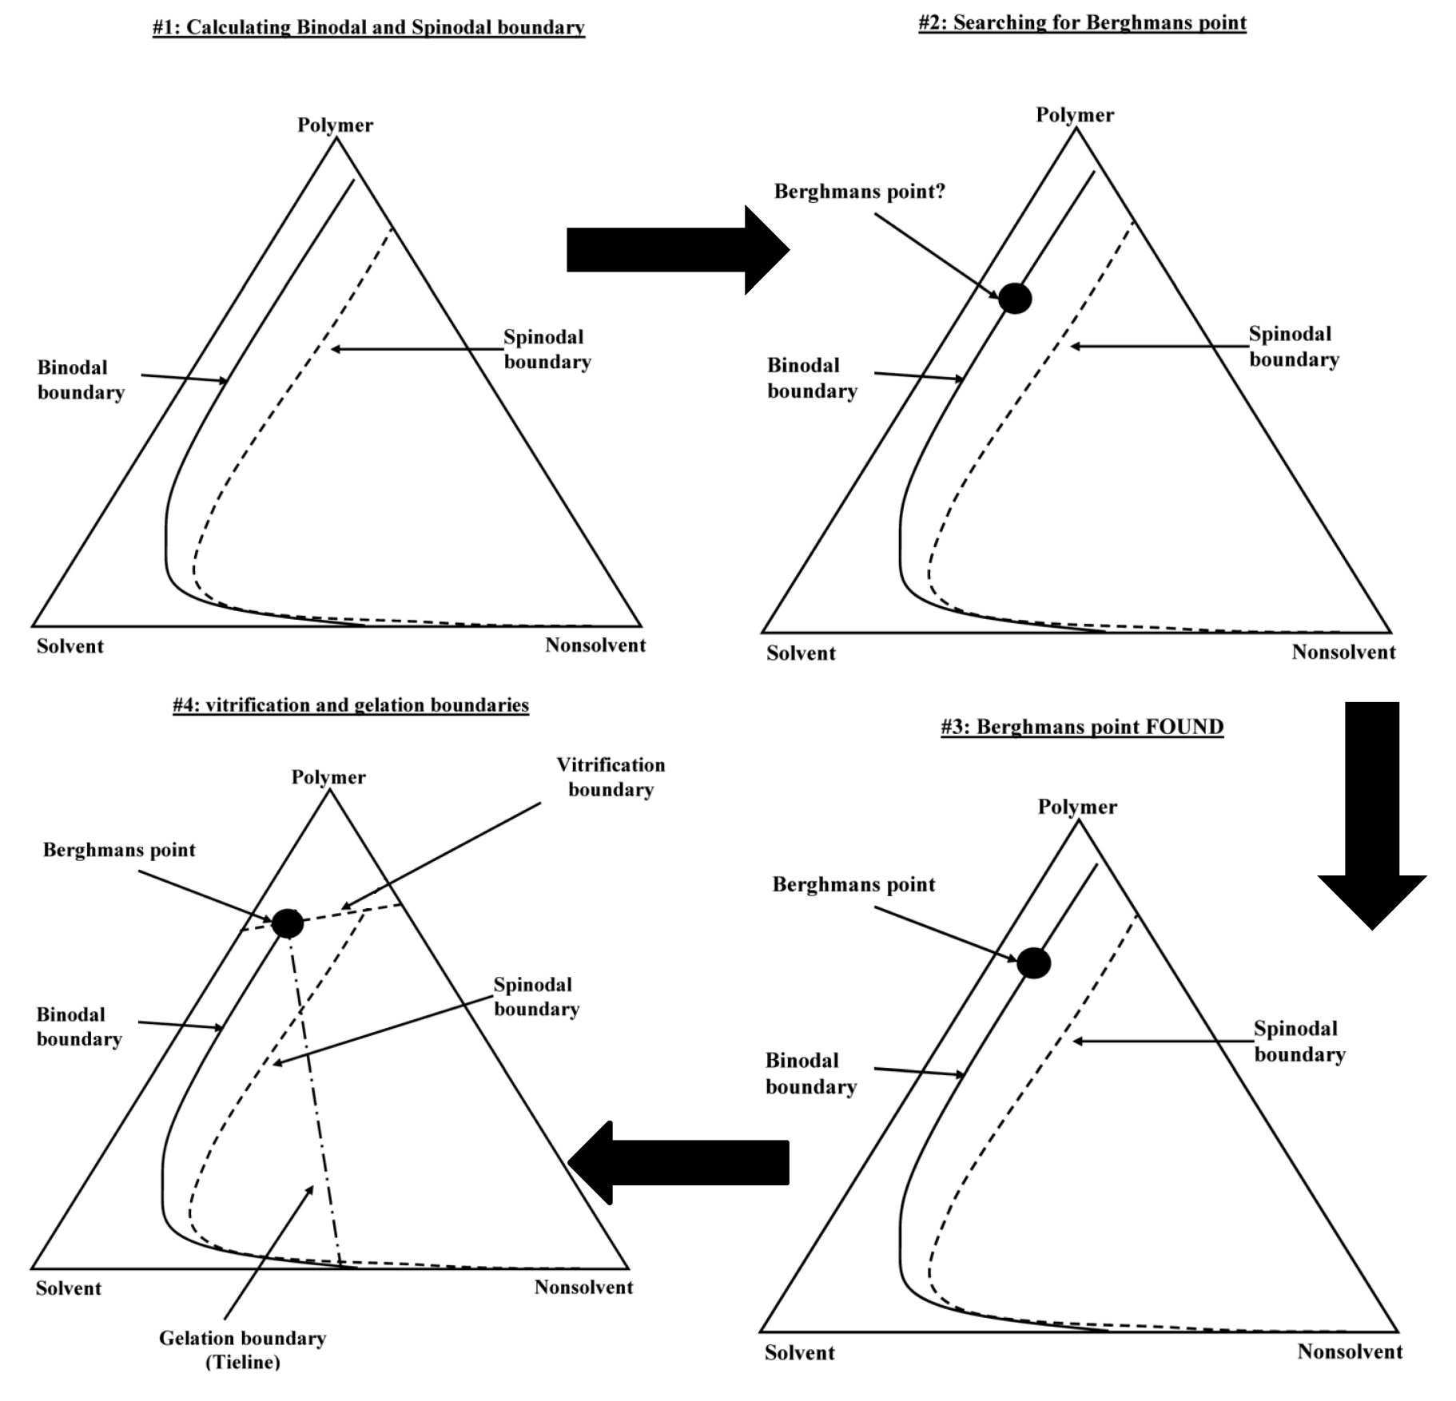**Figure 5.** Calculation scheme