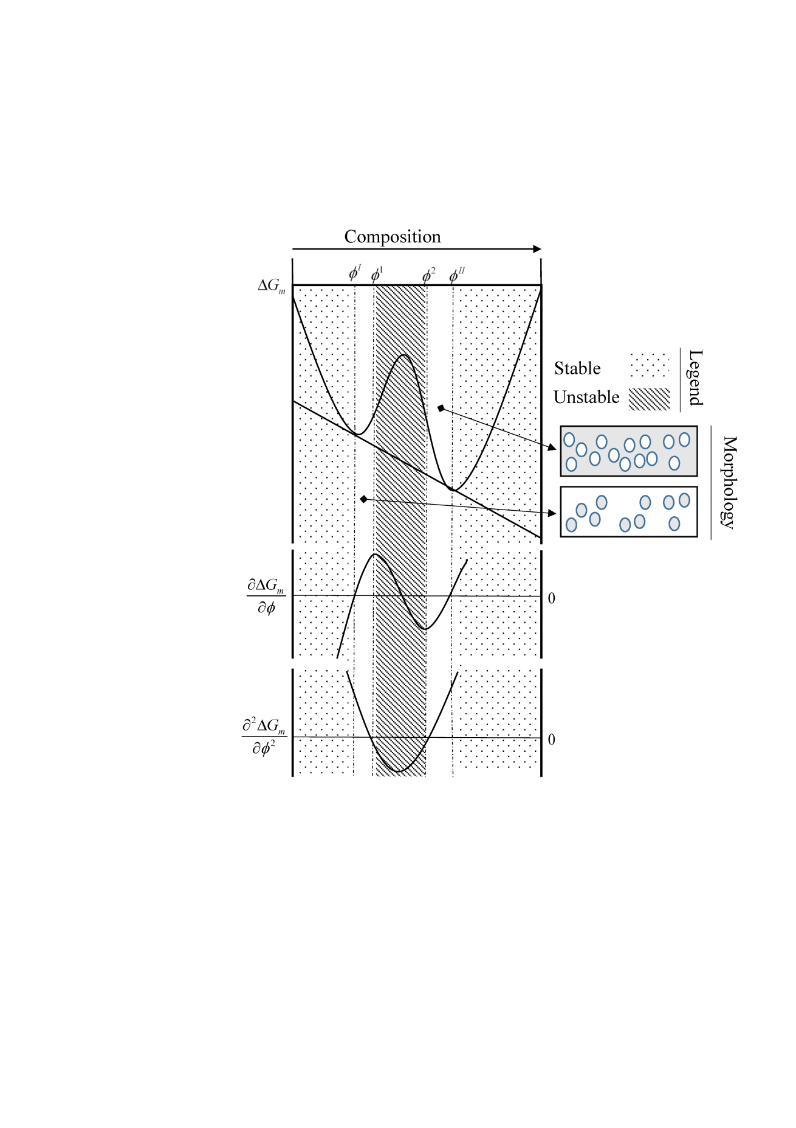

**Figure 3.** Schematic of different instantaneous solution composition [1]