**Correlation of interaction parameters in Wilson, NRTL and UNIQUAC models using theoretical methods**

**Abstract**

The activity coefficient models of Wilson, Nonrandom Two Liquid Theory (NRTL) and Universal Quasi-chemical Theory (UNIQUAC) are of the most applied chemical thermodynamic models in phase equilibria calculations and materials behavior prediction and/or correlation. The reliable and accurate evaluation and determination of interaction/adjustable parameters defined in these models, which are necessary for any future applications of models in binary and multicomponent systems, requires the knowledge on experimental data of binary systems. By using such experimental data and regression and fitting of data, in literatures, these interaction parameters are obtained for a substantial number of systems. Here, a new theoretical methodology has been developed and examined for estimation of these parameters without the use of experimental data. The presented method equates the activity coefficients calculated by a Compressible Regular Solution Theory (CRS) to those calculated using the three aforementioned models and the interaction parameters are obtained by optimally solving the constructed system of equations. For CRS theory, the application of Sanchez and Lacombe Equation of State (LS-EoS), Constantinou and Gani Group Contribution Method and Hoftyzer and van Krevelen Group Contribution Method was considered while for models of Wilson, NRTL and UNIQUAC, the interaction parameters were searched by implementation of an evolutionary optimization technique. The obtained results are compared to those reported in literatures and desirable agreement was found. The method is simple, fast, implementable in computer routines; straightforward and accurate and can be used to estimate these binary interaction parameters for systems of interest. Some phase calculations are also included to demonstrate the applicability of method.

**Keywords**: activity coefficient models; Wilson; NRTL; UNIQUAC; interaction parameters

# Introduction

For prediction/correlation of thermodynamic properties such as equilibrium compositions, it’s required to employ a reliable thermodynamic model based on the considered system and process. The activity coefficient models of Wilson, Nonrandom Two-Liquid Theory (NRTL) and Universal Quasi-chemical Theory (UNIQUAC) are of most applied models used for thermodynamic study of a substantial number of binary and multicomponent systems as they are able to properly represent behavior of non-ideal mixtures [1, 2]. These chemical thermodynamic models have some interaction parameters that require the availability and knowledge on experimental data of systems to be adjusted and made the model ready for further thermodynamic calculations. By determination of these interaction parameters from binary systems data, it’s possible to employ them for property calculations of multicomponent systems that are composed/formed of these binaries [1, 2].

For constituent binary systems, the calculated/determined interaction parameters could have physical interpretations, for example in Wilson activity coefficient model, the interaction parameters are related to the pure component molar volumes and characteristic energy differences. However, in practical applications and uses, the systems of interest are multicomponent or multi-phase systems [1, 2], for which the constituent binary systems data might not be accessible. For such systems, the mixture/solution data are used to calculate interaction parameters numerically by mathematical fitting and regression of data to the models equations aiming to minimize the deviations between model calculations and experimental data. Although numerical values can be obtained by such calculations, however, we’re not then allowed to interpret these values physically. The calculated interaction parameters, in this case, are some correlative parameters that can be used only for reproduction of data using thermodynamic model [2-7].

To be more specific, the calculation of binary interaction parameters from ternary (or multicomponent) systems is nothing more than data fitting practice, in where the mathematical function is the main equations of thermodynamic models and unknowns are the interaction parameters. It means that we would be able to check the goodness of any arbitrary mathematical function by fitting of experimentally measured data to the function and searching for its optimal coefficients and agreement to the available data. Thus, it must be of interest to develop an alternative method to calculate or at least to obtain an estimate of such data that are thermodynamically meaningful as investigated in this work and illustrated in following sections.

# Proposed Methodology and Method of Implementation

In literatures [1, 2], the activity coefficient models of Wilson, NRTL and UNIQUAC are introduced together with their main equations. The required methods and models including Compressible Regular Solution Theory (CRS) [8], Sanchez and Lacombe Equation of State (LS-EoS) [9], Constantinou and Gani Group Contribution Method [10], Hoftyzer and van Krevelen Group Contribution Method [11] are provided and illustrated elsewhere [11, 12]. The reader is advised to read these reference works and then refers to the proposed method.

The basic idea here is employing the Compressible Regular Solution Theory (CRS) model first to calculate the activity coefficients (chemical potentials) of components (as predictive activity model), and then equating this calculated value, by replacing the obtained value in left side of equations provided for Wilson, NRTL and UNIQAUC i.e. , and  respectively, where on the right sides of obtained equations, the unknown sets are the binary interaction parameters , and for Wilson, NRTL and UNIQUAC models respectively. This way, a system of *n* equations would be obtained for an *n* component system, where the unknowns are the binary interaction parameters of the models.

For example, in Wilson model, for a binary system (two-component solution), one can write;

|  |  |
| --- | --- |
|  | 1 |
|  | 2 |

On the right sides of these equations, the unknown sets arefor Wilson model. The procedure is the same for other two models. For NRTL model, one can write;

|  |  |
| --- | --- |
|  | 3 |
|  | 4 |

And for UNIQUAC model, one can write;

|  |  |
| --- | --- |
|  | 5 |
|  | 6 |

On the right sides of these equations, the unknown sets areand for NRTL and UNIQUAC models.

For multicomponent systems, simply the constituent binaries of systems must be constructed and the method described for binary systems must be followed for each binary. To reduce any redundant computational cost, the application of closure equation is advised [3-7, 13, 14]. All the calculations are requested to be restricted on binary systems and constituent binaries of multicomponent systems in order to have some physical interpretation of obtained numeric values.

Such systems of equations are nonlinear with respect to the unknowns and direct calculation of these unknowns seems to be impossible. This limitation requires the application of mathematical techniques such as iterative regression. However, thanks to recent advances in computational science, the calculation and determination of these unknowns is not a challenging work due to availability of computers. The application of iterative techniques is time consuming and the calculated outputs might not be the real values as there might be local minima of considered objective functions. The most reliable, simple and advanced method of numerical solution of such system of equations is the application of an optimization algorithm, where the unknown sets (i.e., and) are searched against the criteria of least (and no) values obtained for the predefined objectives. Of the most common optimization algorithms in engineering applications are evolutionary and swarm intelligent-based techniques such as genetic algorithm and particle swarm optimization methods. Here, the particle swarm optimization (PSO) has been employed [15]. The method of searching for binary interaction parameters by PSO is the same as described in Ref. [15].

The steps of calculations are as described and listed below;

1. Draw desired components molecular structure and identify the each group/class of Boudouris et al. [10],
2. Calculate lattice fluid scaling parameters (,  and ) using data of step #1,
3. Calculate reduced properties (and) using the calculated scaling parameters from step # 2 and the operating condition of considered system,
4. Calculate the reduced density () by iterative solution of SL-EOS using data of step #3 and initial guess of =1,
5. Calculate hard-core solubility parameter at reference temperature of 298 K () using the Hoftyzer and van Krevelen group contribution method [11],
6. Calculate hard-core solubility parameter at system temperature prior which hard-core determine the density at system temperature as where is obtained in step # 4,
7. Calculate  for application of CRS model using equality, where  is the molecular weight of component,
8. Calculate the chemical potential of components using CRS model by determined parameters in previous steps for nominated solution composition,
9. Convert the obtained chemical potential to the activity coefficient using  equality, prior which the volume fraction must be converted to mole fraction,
10. Insert the calculated activity coefficient from step # 9 on the right sides of the constructed system of equations as described for a model of interest,
11. Introduce interaction parameters of considered model as dimensions in PSO algorithm (two interaction parameters, so two dimension exist) as described in Ref. [15] where the MATLAB code is accessible,
12. Introduce the objective functions in PSO as  and  for Wilson model,  and  for NRTL model and finally  and  for UNIQUAC model, which means that the deviation between the models activity coefficients value and those of CRS model must be minimized. Refer to Ref. [15] where the MATLAB code is accessible.

# Results and discussion

The required SL-EOS parameters were obtained from literature [16] and rechecked by recalculation. The proposed method was used for calculation of interaction parameters for a number of binary systems. For evaluation of proposed method for estimation of Wilson model interaction parameters, ten binary systems were considered as listed in **Table 1** together with the estimated interaction parameters. For systems **No. 2-10**, the data were obtained from **Table 12.5** in Ref. [1] (page 474) where the systems temperature chosen fixed at 60 °C. The data for system **No. 1** were obtained from **Table 6.8** in Ref. [2] (page 260) where the system temperature is 45 °C. Errors in the range of 0.001-0.005 between calculated and experimental interaction parameters indicate the reliability of this method for calculation of binary interaction parameters in Wilson model.

Table . The result of application of method for estimation of Wilson model interaction parameters in binary systems

|  |  |  |  |  |  |  |
| --- | --- | --- | --- | --- | --- | --- |
| **No.** | **System** |  | **Interaction parameters ()** | | | |
| **From literatures** | |  | **Calculated** | |
| 12 | 21 |  | 12 | 21 |
| 1 | Nitromethane (1) / carbon tetrachloride (2) | 0.115600 | 0.287900 |  | 0.115398 | 0.287029 |
| 2 | Acetone (1) / water (2) | 0.157160 | 0.459810 |  | 0.156691 | 0.459569 |
| 3 | Methanol (1) / water (2) | 0.377221 | 1.108922 |  | 0.376427 | 1.099091 |
| 4 | 1-propanol (1) / / water (2) | 0.074528 | 0.539485 |  | 0.073991 | 0.536520 |
| 5 | water (2) / 1,4-Dioxane (2) | 0.365380 | 0.293671 |  | 0.364471 | 0.292642 |
| 6 | Methanol (1) / acetonitrile (2) | 0.759870 | 0.456373 |  | 0.755632 | 0.453462 |
| 7 | Acetone (1) / methanol (2) | 0.702414 | 0.753447 |  | 0.695997 | 0.749740 |
| 8 | Methyl acetate (1) / methanol (2) | 0.534757 | 0.573862 |  | 0.531952 | 0.571686 |
| 9 | Methanol (1) / benzene (2) | 0.159801 | 0.345422 |  | 0.158527 | 0.344759 |
| 10 | Ethanol (1) / toluene (2) | 0.173441 | 0.399577 |  | 0.172753 | 0.398427 |

For evaluation of proposed method for estimation of NRTL model interaction parameters, nine binary systems were considered as listed in **Table 2** together with the estimated interaction parameters. For systems **No. 2-9**, the data were obtained from **Table 12.5** in Ref. [1] (page 474) where the systems temperature chosen fixed at 60 °C. Errors in the range of 0.001-0.005 between calculated and experimental interaction parameters indicate the reliability of this method for calculation of binary interaction parameters in NRTL model.

Table . The result of application of method for estimation of NRTL model interaction parameters in binary systems

|  |  |  |  |  |  |  |
| --- | --- | --- | --- | --- | --- | --- |
| **No.** | **System** |  | **Interaction parameters ()** | | | |
| **From literatures** | |  | **Calculated** | |
| 12 | 21 |  | 12 | 21 |
| 1 | Acetone (1) / water (2) | -0.383522 | 1.276812 |  | -0.382352 | 1.274630 |
| 2 | Methanol (1) / water (2) | 0.755927 | 2.472276 |  | 0.755699 | 2.459915 |
| 3 | 1-propanol (1) / / water (2) | 1.081561 | 0.829193 |  | 1.080820 | 0.827124 |
| 4 | water (2) / 1,4-Dioxane (2) | 0.519209 | 0.475234 |  | 0.514870 | 0.474464 |
| 5 | Methanol (1) / acetonitrile (2) | 0.279016 | 0.336330 |  | 0.276548 | 0.335018 |
| 6 | Acetone (1) / methanol (2) | 0.576251 | 0.523499 |  | 0.573568 | 0.518780 |
| 7 | Methyl acetate (1) / methanol (2) | 1.102907 | 1.775627 |  | 1.096830 | 1.772660 |
| 8 | Methanol (1) / benzene (2) | 1.077951 | 1.734009 |  | 1.074277 | 1.720948 |
| 9 | Ethanol (1) / toluene (2) | 0.953292 | 1.808861 |  | 0.949025 | 1.808618 |

For evaluation of proposed method for estimation of UNIQUAC model interaction parameters, ten binary systems were considered as listed in **Table 3** together with the estimated interaction parameters. For systems **No. 1-10**, the data were obtained from **Table 6.10** in Ref. [2] (page 266). Errors in the range of 0.01-0.05 between calculated and experimental interaction parameters indicate the reliability of this method for calculation of binary interaction parameters in UNIQUAC model.

Table . The result of application of method for estimation of UNIQUAC model interaction parameters in binary systems

|  |  |  |  |  |  |  |  |
| --- | --- | --- | --- | --- | --- | --- | --- |
| **No.** | **System** | **T (K)** |  | **Interaction parameters ()** | | | |
| **From literatures** | |  | **Calculated** | |
| 12 | 21 |  | 12 | 21 |
| 1 | Acetonitrile (1) / benzene (2) | 318 | 1.136539 | 0.389561 |  | 1.128315 | 0.388831 |
| 2 | n-Hexane (1) / Nitromethane (2) | 318 | 0.484188 | 1.018599 |  | 0.482329 | 1.010749 |
| 3 | Acetone (1) / chloroform (2) | 323 | 1.701670 | 0.747661 |  | 1.699006 | 0.746472 |
| 4 | Ethanol (1) / n-octane (2) | 348 | 1.426304 | 0.020375 |  | 1.425519 | 0.020303 |
| 5 | Methyl ethyl ketone (1) / n-heptane (2) | 328 | 1.094575 | 0.032101 |  | 1.085764 | 0.032005 |
| 6 | Methanol (1) / benzene (2) | 528 | 1.112627 | 0.158646 |  | 1.111021 | 0.158259 |
| 7 | Chloroform (1) / ethanol (2) | 323 | 0.055446 | 1.906961 |  | 0.055420 | 1.897484 |
| 8 | Chloroform (1) / n-heptane (2) | 323 | 1.061442 | 0.760572 |  | 1.052248 | 0.754270 |
| 9 | Ethanol (1) / n-heptane (2) | 323 | 1.385124 | 0.013935 |  | 1.379620 | 0.013857 |
| 10 | Acetone (1) / methanol (2) | 323 | 0.309025 | 1.398871 |  | 0.307551 | 1.390961 |

An arithmetic averaged error of about 0.1-0.5% indicates the reliability of this theoretical method for calculation of binary interaction parameters for three models of Wilson, NRTL and UNIQUAC. This method is able to predict the binary interaction parameters of each system with desirable accuracy compared to those calculated directly from binary solution experimental data. Having the knowledge on the system components and their structures, by the proposed method and methods introduced, one can directly proceed toward calculation of binary interaction parameters.

For a multicomponent system, by constructing all the constituent binaries of system together with the implementation of closure equations [3, 13] as introduced, it’s possible to calculate the thermodynamically consistent interaction parameters.

For Wilson model, the ternary system of acetone (1) / methyl acetate (2) / methanol (3) at 50 °C was used and obtained from Ref. [2] (**Table 6.13,** page 288). The other systems data were obtained from Ref. [15] at 25 °C. The constituent binaries were constructed and the proposed method was applied simultaneously together with the closure equation. The collected data and the calculated interaction parameters are summarized in **Table 4**. As seen, the agreements between calculated and available data are acceptable.

Table . The result of application of method for estimation of Wilson model interaction parameters in ternary systems (E=experimental, C=calculation)

|  |  |  |  |  |  |  |  |  |
| --- | --- | --- | --- | --- | --- | --- | --- | --- |
| **No.** | **System** | **interaction parameters** | | | | | | |
|  | 12 | 13 | 21 | 23 | 31 | 32 |
| **1** | Acetone (1) / Methyl acetate (2) / Methanol (3) | **E** | 0.5781 | 0.6917 | 1.3654 | 0.6370 | 0.7681 | 0.4871 |
| **C** | 0.5801 | 0.6822 | 1.3719 | 0.6299 | 0.7597 | 0.4900 |
| **2** | Water (1)/Butyric acid (2)/n-hexane (3) | **E** | 2.0093 | -1.2684 | -1.2170 | -0.3605 | 3.4163 | 2.6160 |
| **C** | 2.0166 | -1.2198 | -1.1581 | -0.3691 | 3.4658 | 2.5771 |
| **3** | Water (1)/Butyric acid (2)/n-hexanol (3) | **E** | -1.7140 | 2.4875 | 4.3180 | 0.5356 | -2.2868 | -0.0989 |
| **C** | -1.7215 | 2.5027 | 4.2842 | 0.5172 | -2.3094 | -0.1069 |

For UNIQUAC model, two ternary systems were obtained from Ref. [15] at 25 °C as listed in **Table 5** together with the calculated interaction parameters. The constituent binaries were constructed and the proposed method was applied simultaneously together with the closure equation. The comparison of calculated data to those of collected from literature gives acceptable agreement.

Table . The result of application of method for estimation of UNIQUAC model interaction parameters in ternary systems (E=experimental, C=calculation)

|  |  |  |  |  |  |  |  |  |
| --- | --- | --- | --- | --- | --- | --- | --- | --- |
| **No.** | **System** | **interaction parameters** | | | | | | |
|  | 12 | 13 | 21 | 23 | 31 | 32 |
| **1** | Water (1)/Butyric acid (2)/n-hexane (3) | **E** | 1.2414 | -1.0103 | -2.4743 | 0.6684 | -5.7737 | -6.4516 |
| **C** | 1.2250 | -0.9221 | -2.4569 | 0.7231 | -5.6053 | -6.5977 |
| **2** | Water (1)/Butyric acid (2)/n-hexanol (3) | **E** | -1.2121 | -1.7850 | 1.9058 | 0.9541 | -1.6317 | -5.6418 |
| **C** | -1.1807 | -1.7387 | 1.9134 | 0.9674 | -1.6494 | -5.6899 |

For NRTL model, two ternary systems were obtained from Ref. [15] at 25 °C as listed in **Table 6** together with the calculated interaction parameters. The constituent binaries were constructed and the proposed method was applied simultaneously together with the closure equation. The comparison of calculated data to those of collected from literature gives acceptable agreement.

Table . The result of application of method for estimation of NRTL model interaction parameters in ternary systems (E=experimental, C=calculation)

|  |  |  |  |  |  |  |  |  |
| --- | --- | --- | --- | --- | --- | --- | --- | --- |
| **No.** | **System** | **interaction parameters** | | | | | | |
|  | 12 | 13 | 21 | 23 | 31 | 32 |
| **1** | Water (1)/Butyric acid (2)/n-hexane (3) | **E** | -2.2275 | 5.0080 | 1.8637 | -0.9033 | 3.1733 | 2.5155 |
| **C** | -2.2454 | 4.9543 | 1.8901 | -0.8880 | 3.1394 | 2.5001 |
| **2** | Water (1)/Butyric acid (2)/n-hexanol (3) | **E** | 2.9218 | 3.1341 | 0.6483 | -2.4920 | -1.9846 | 2.6048 |
| **C** | 2.9410 | 3.1080 | 0.6949 | -2.4791 | -1.9619 | 2.6137 |

The good results of proposed method, simple and straightforward procedure, and generality open its extensive application for other systems of interest. Here, in addition, examples of phase calculation results are provided in following paragraphs.

For binary solution of propanol-water at 60°C, the phase calculation results are shown in Figure 1 where the interaction binaries of models were calculated using the presented method. In Figure 1, x and y show the mole fraction of 1-propanol in the liquid phase and in the vapor phases respectively.

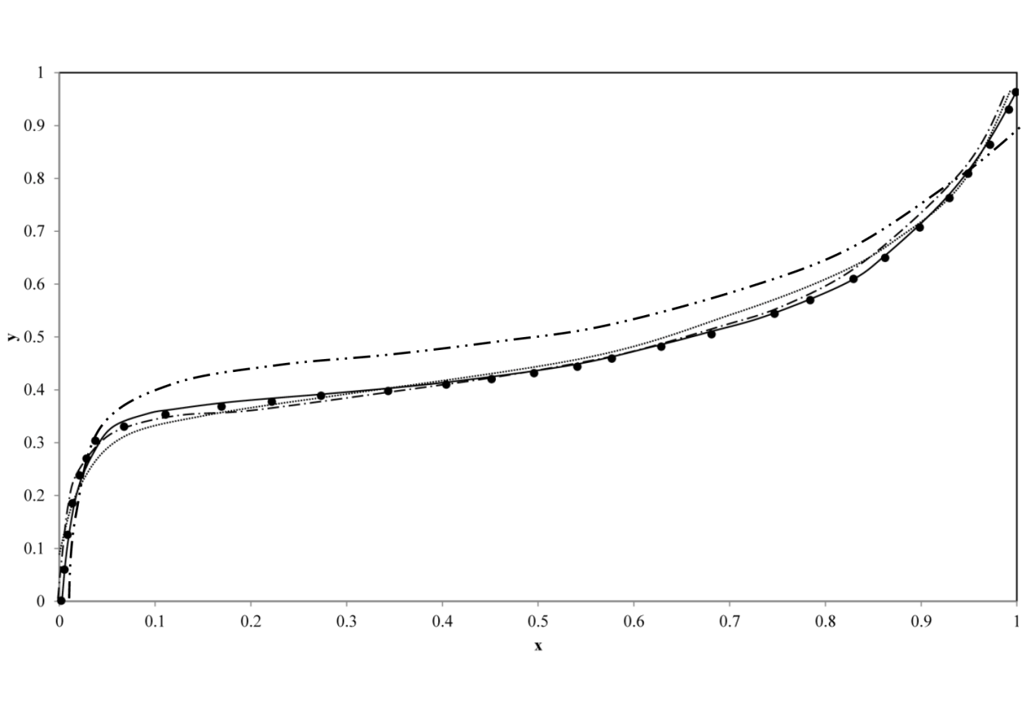

Figure . The result of application of interaction parameters determined from presented method for VLE of propanol-water at 60°C; (●) experimental data obtained from Ref. [17]; solid line = UNIQUAC model; dashed line = NRTL; dotted line = Wilson Model, dashed-dotted line = pure SL-EOS without adjustable parameters

For ternary system of water + butyric acid + n-hexane, the experimental data were obtained from Ref. [18] (the personal communication within Ref. [15]) in three temperatures of 298.2, 308.2, and 318.2 K and the phase calculations results are shown in Figure 2-Figure 4 respectively. Using the predicted binaries, all three activity coefficients models revealed desirable accuracy for reproduction of LLE data. As no adjustable parameters were included in the SL-EOS, it could be expected that large deviation from the experimental data should be observed as seen in phase calculations. These results indicate the applicability of presented method for estimation of binary interaction parameters using some simple chemical thermodynamic models.

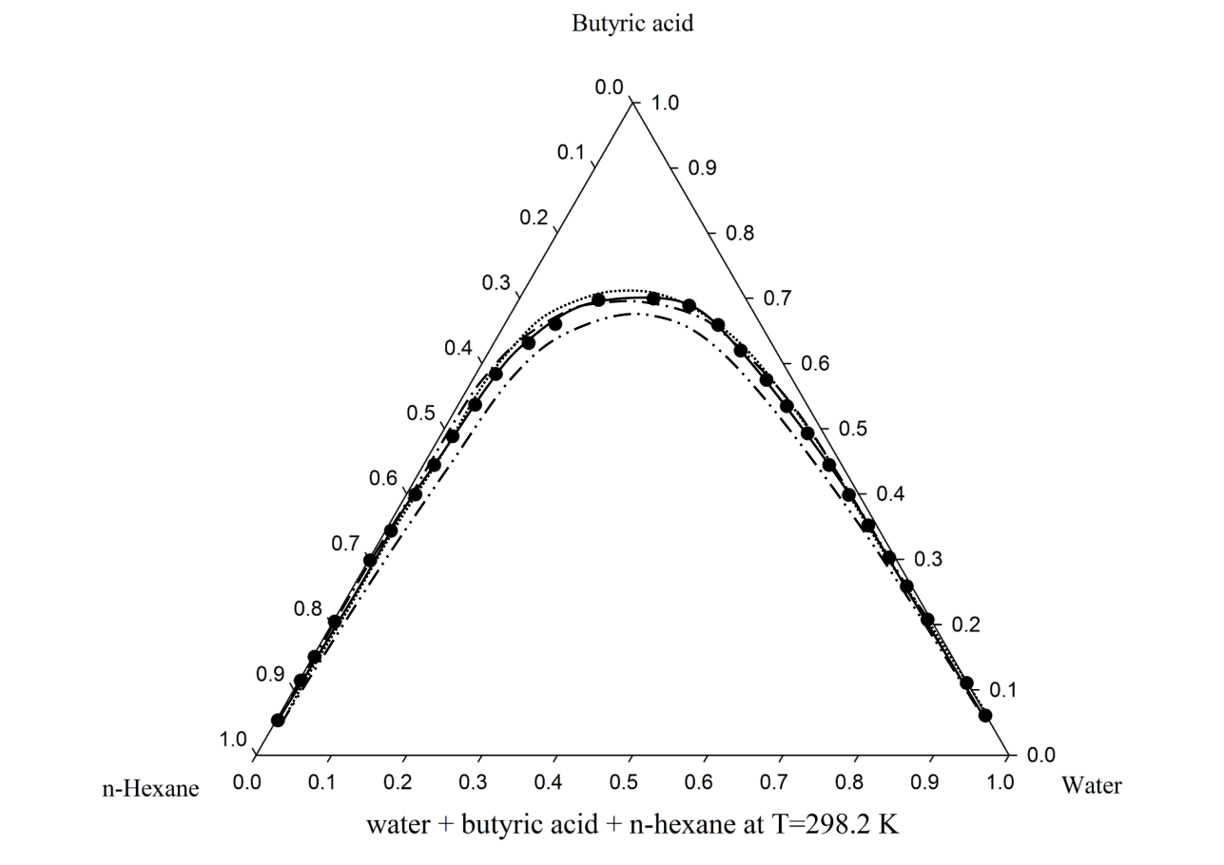

Figure . The result of application of interaction parameters determined from presented method for LLE of water + butyric acid + n-hexane at 298.2 K; (●) experimental data obtained from Ref. [18]; solid line = UNIQUAC model; dashed line = NRTL; dotted line = Wilson Model, dashed-dotted line = pure SL-EOS without adjustable parameters

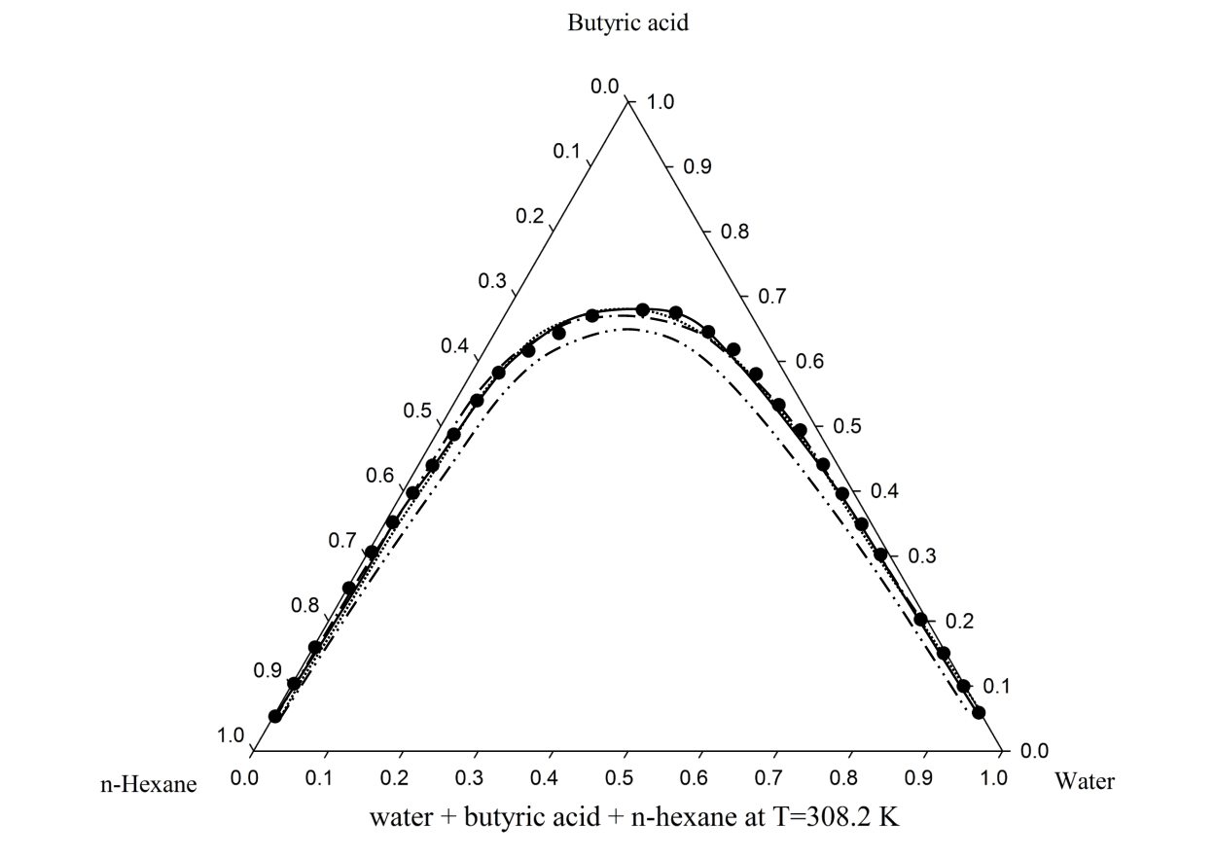

Figure . The result of application of interaction parameters determined from presented method for LLE of water + butyric acid + n-hexane at 308.2 K; (●) experimental data obtained from Ref. [18]; solid line = UNIQUAC model; dashed line = NRTL; dotted line = Wilson Model, dashed-dotted line = pure SL-EOS without adjustable parameters

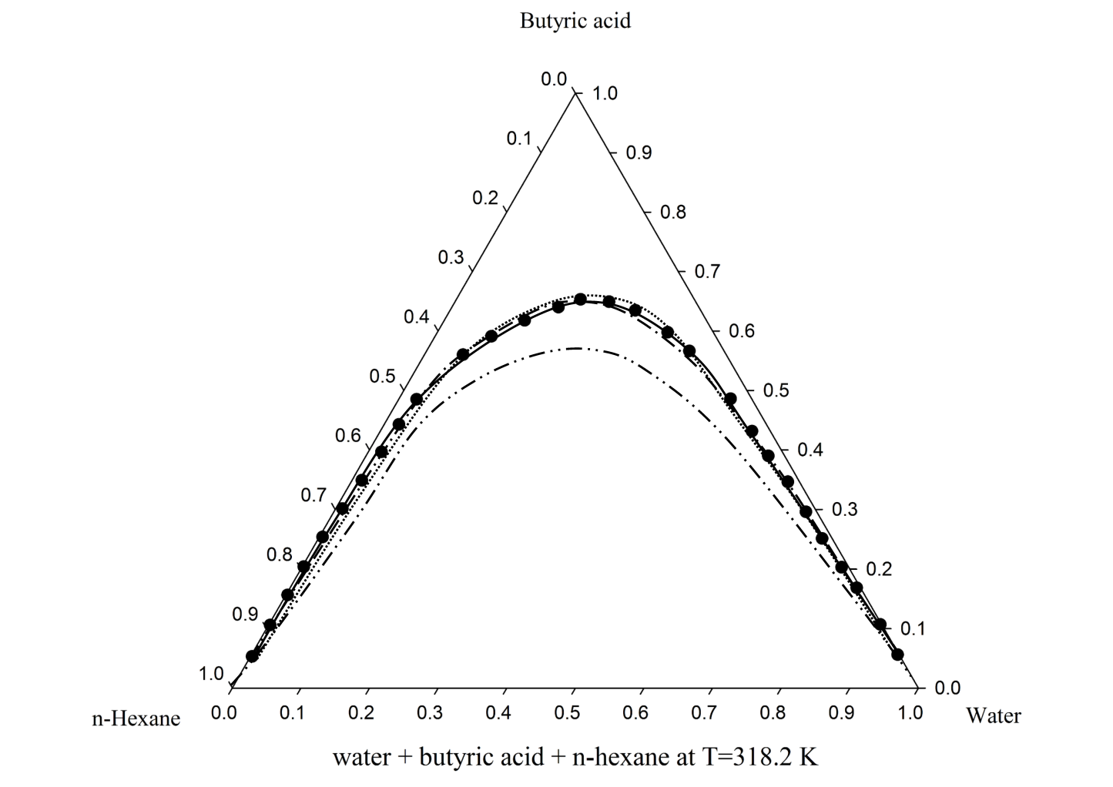

Figure . The result of application of interaction parameters determined from presented method for LLE of water + butyric acid + n-hexane at 318.2 K; (●) experimental data obtained from Ref. [18]; solid line = UNIQUAC model; dashed line = NRTL; dotted line = Wilson Model, dashed-dotted line = pure SL-EOS without adjustable parameters

# Conclusion

A theoretical methodology has been developed and examined for estimation of interaction parameters in activity coefficient models of Wilson, Nonrandom Two Liquid Theory (NRTL) and Universal Quasi-chemical Theory (UNIQUAC) without the use of experimental data. The obtained results were compared to those reported in literatures and desirable agreement was found. The method is simple, fast, implementable in computer routines; straightforward and accurate and can be used to estimate these binary interaction parameters for any system of interest.

**References**

[1] J.M. Smith, H. Van Ness, M. Abbott, Introduction to Chemical Engineering Thermodynamics, 7 ed., McGraw-Hill, New York, 2005.

[2] J.M. Prausnitz, R.N. Lichtenthaler, E. Gomes de Azevedo, Molecular Thermodynamics of Fluid-Phase Equilibria 3ed., Prentice Hall, 1998.

[3] J. Alvarez Juliá, C.R. Barrero, M.E. Corso, M.d.C. Grande, C.M. Marschoff, On the application of the NRTL method to ternary (liquid+liquid) equilibria, The Journal of Chemical Thermodynamics, 37 (2005) 437-443.

[4] M. Asgarpour Khansary, M.A. Aroon, On the consistency and correctness of thermodynamics phase equilibria modeling and correlation reports published in Fuel journal, Fuel, 140 (2015) 810-811.

[5] M.A. Khansary, M.A. Aroon, Reply to the comments “On the consistency and correctness of thermodynamics phase equilibria modeling and correlation reports published in Fuel journal”, Fuel, 142 (2015) 306-307.

[6] A. Mejía, H. Segura, Comments “On The Consistency and Correctness of Thermodynamics Phase Equilibria Modeling and Correlations Reports Published In Fuel Journal”, Fuel, 140 (2015) 812-813.

[7] R.K. Sahoo, T. Banerjee, A. Khanna, UNIQUAC Interaction Parameters with Closure for Imidazolium Based Ionic Liquid Systems Using Genetic Algorithm, The Canadian Journal of Chemical Engineering, 85 (2008) 833-853.

[8] A.-V.G. Ruzette, A.M. Mayes, A Simple Free Energy Model for Weakly Interacting Polymer Blends, Macromolecules, 34 (2001) 1894–1907.

[9] I. Sanchez, M. Stone, Statistical Thermodynamics of Polymer Solutions and Blends, John Wiley & Sons, Inc., 2000.

[10] D. Boudouris, L. Constantinou, C. Panayiotou, A Group Contribution Estimation of the Thermodynamic Properties of Polymers, Industrial & Engineering Chemistry Research, 36 (1997) 3968-3973.

[11] D.W. van Krevelen, K.T. Nijenhuis, Properties of Polymers: Their Correlation with Chemical Structure; Their Numerical Estimation and Prediction from Additive Group Contributions, 4 ed., Elsevier, 2008.

[12] L. Keshavarz, M.A. Khansary, S. Shirazian, Phase diagram of ternary polymeric solutions containing nonsolvent/solvent/polymer: Theoretical calculation and experimental validation, Polymer, 73 (2015) 1-8.

[13] E. Hála, Note to Bruin-Prausnitz One-Parameter and Palmer-Smith Two-Parameter Local Composition Equation, Industrial & Engineering Chemistry Process Design and Development, 11 (1972) 638.

[14] R.K. Sahoo, T. Banerjee, S.A. Ahmad, A. Khanna, Improved binary parameters using GA for multi-component aromatic extraction: NRTL model without and with closure equations, Fluid Phase Equilibria, 239 (2006) 107-119.

[15] M. Asgarpour Khansary, A. Hallaji Sani, Using genetic algorithm (GA) and particle swarm optimization (PSO) methods for determination of interaction parameters in multicomponent systems of liquid–liquid equilibria, Fluid Phase Equilibria, 365 (2014) 141-145.

[16] I.C. Sanchez, R.H. Lacombe, Statistical Thermodynamics of Polymer Solutions, Macromolecules, 11 (1978) 1145-1156.

[17] F.A. Abu Al-Rub, F.A. Banat, J. Simandl, Isothermal vapour–liquid equilibria of 1-propanol–water–salt mixtures, Chemical Engineering Journal, 74 (1999) 205-210.

[18] A. Ghanadzadeh Gilani, H. Ghanadzadeh Gilani, S.L. Seyed Saadat, M. Janbaz, Ternary liquid–liquid equilibrium data for the (water+butyric acid+n-hexane or n-hexanol) systems at T=(298.2, 308.2, and 318.2)K, The Journal of Chemical Thermodynamics, 60 (2013) 63-70.