Appendix A – Sigma profiles of individual compounds

Evaluating cellulose potential for estrogen micropollutants removal from water effluents using quantum chemical calculations

Milad Asgarpour Khansary 1*, Azam Marjani 2, Saeed Shirazian 3

1 – Young Researchers and Elite Club, South Tehran Branch, Islamic Azad University, Tehran, Iran

2 – Department of Chemistry, Arak Branch, Islamic Azad University, Arak, Iran

3 – Department of Chemical Sciences, Bernal Institute, University of Limerick, Limerick, Ireland

* email: [miladasgarpour@ut.ac.ir](mailto:miladasgarpour@ut.ac.ir)

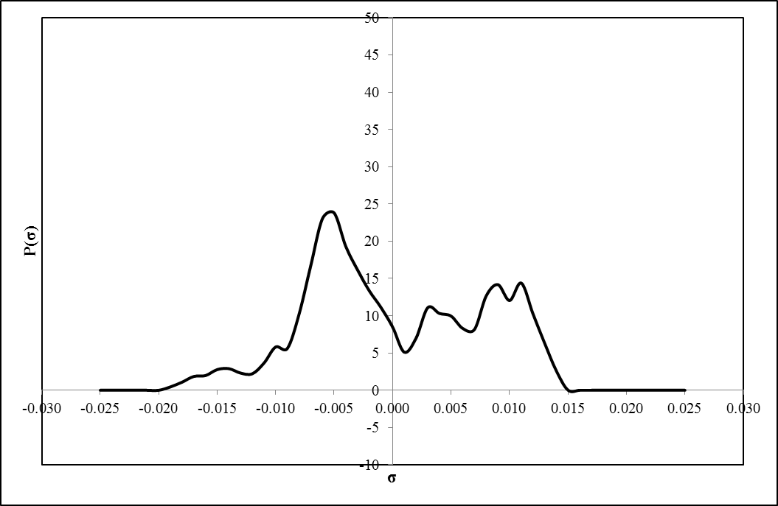

Fig. . Obtained sigma profile for Cellulose

In Fig. 1, the obtained sigma profile for cellulose is illustrated. The six hydrogen atoms in cellulose repeating unit pose positive charges which is distributed over a large are and generates a weak peak at σ = -0.014 e/Å2. Although cellulose has a high capacity for H-bonding as demonstrated by the strong peak around σ = -0.006 e/Å2 (the span of hydrogen bonding is located over a charge density range of −0.0079 to 0.0079 e/Å2), it does not like to H-bond with estrogen due to the misfit of corresponding charge densities in estrogen. It does, however, interact with its own functional groups (Schafer, Akanyeti et al. 2011). This compound is stable and comfortable in its pure state as the two adjunct positive peak play role of a partner for the negative peak ending to no electrostatic misfit.

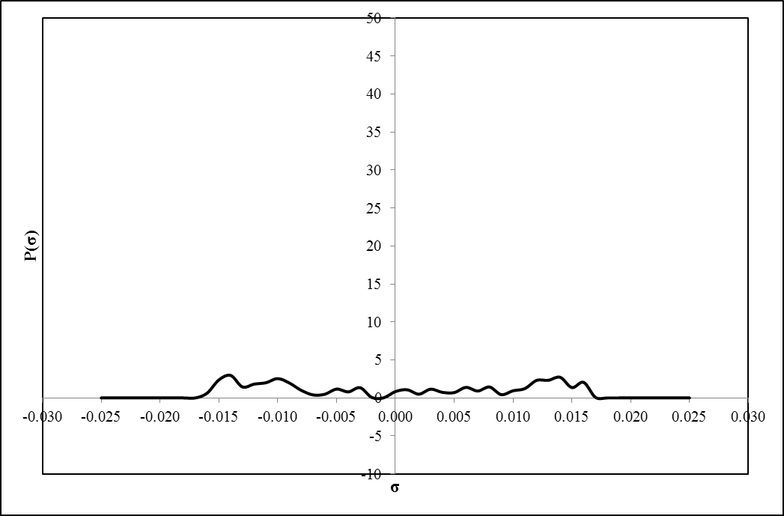

Fig. . Obtained sigma profile for water

In Fig. 2, the obtained sigma profile for water is illustrated which is wide and symmetric. The observed peak around σ = 0.014 e/Å2 is due to the lone-pair electrons on oxygen. The two polar hydrogen atoms, also, generate a peak at σ = -0.014 e/Å2. A flat and symmetric region between these two peaks can be observed denoting the strong hydrogen bonding interactions of water with other molecules (Islam and Chen 2014).

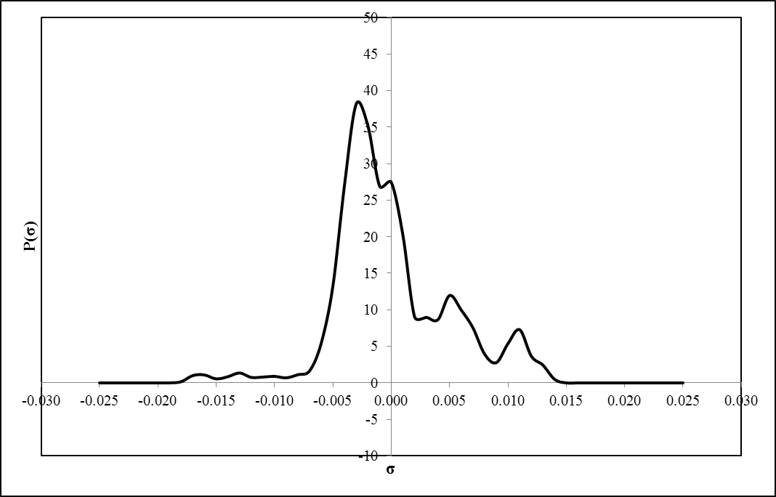

Fig. . Obtained sigma profile for Estrone

In Fig. 3, the obtained sigma profile for Estrone is plotted. It seems that this estrogen is slightly a hydrophilic molecule as its sigma profile is observed to be narrow and inside the sigma cutoff for hydrogen bonding, i.e. −0.0079 ≤ σ ≤ 0.0079 e/Å2. This means that this molecule does not form a hydrogen bond with other molecules, here Cellulose. The strong peak around -0.003 e/Å2 is associated to the hydrogens, whoever, hydrogen bonding is weak up to -0.002 e/Å2. The observed peak around σ = 0.013 e/Å2 is due to the lone-pair electrons on oxygen on carboxyl group. The shoulder like peak around 0.0023 e/Å2 is due to the exposed surfaces of carbon atoms. The peak at σ = 0.005 e/Å2 is due to the π-faced caused by the carbon rings. This estrogen is expected to be dissolved in water as the two peaks beyond hydrogen bonding span of water fit to small peaks in Estrone. The misfit among the sigma charge profile of Estrone and that of cellulose indicates the small and weak interaction of these two compounds. However, two shoulders like peaks around 0.0023 e/Å2 in these two compounds show the potential of possible covalence interaction which implies that the sorption of Estrone in cellulose might be possible but in small values.

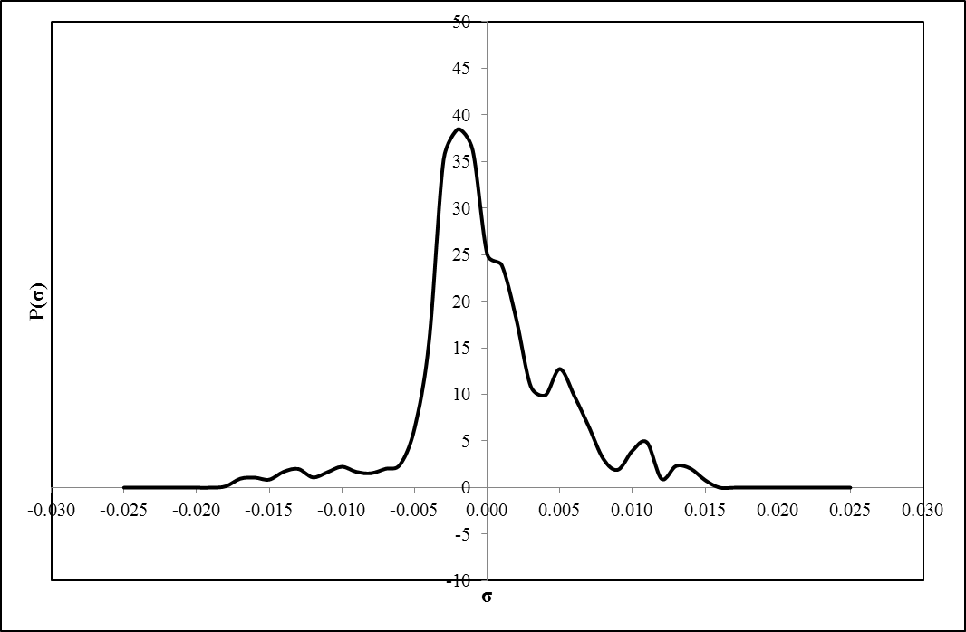

Fig. . Obtained sigma profile for Estradiol

In Fig. 4, the obtained sigma profile for Estradiol is plotted. The observed peak around σ = 0.013 e/Å2 in Estrone due to the lone-pair electrons on oxygen is now absent in Estradiol as it is expected from its chemical structure. The strong peak around -0.003 e/Å2 is associated to the hydrogens. The peak at σ = 0.005 e/Å2 is due to the π-faced caused by the carbon rings. The same explanation as given for Estrone can be for Estradiol.

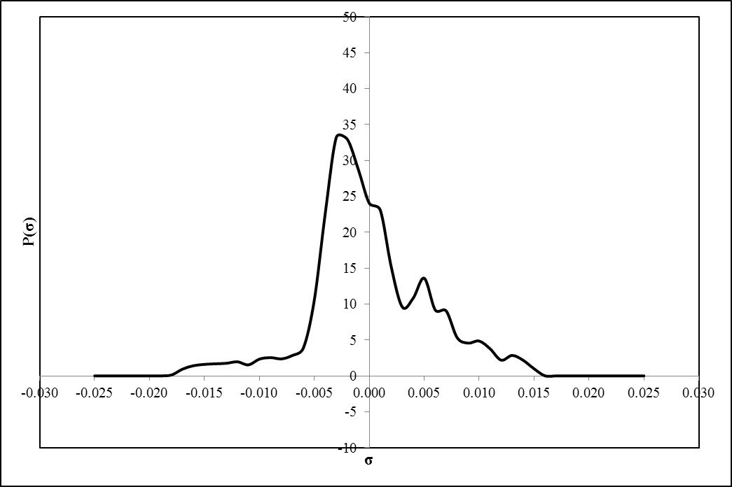

Fig. . Obtained sigma profile for Estriol

In Fig. 5, the obtained sigma profile for Estriol is plotted. The structure of Estriol is similar to Estradiol. Here, the strong peak around -0.003 e/Å2 is associated to the hydrogens. The peak at σ = 0.005 e/Å2 is due to the π-faced caused by the carbon rings. In comparison to Estriol, the –CH3 group lacks in Estradiol and another –OH group is attached to the five-member carbon ring which show themselves with the new peak emerged around 0.006 e/Å2 in sigma profile for Estriol.

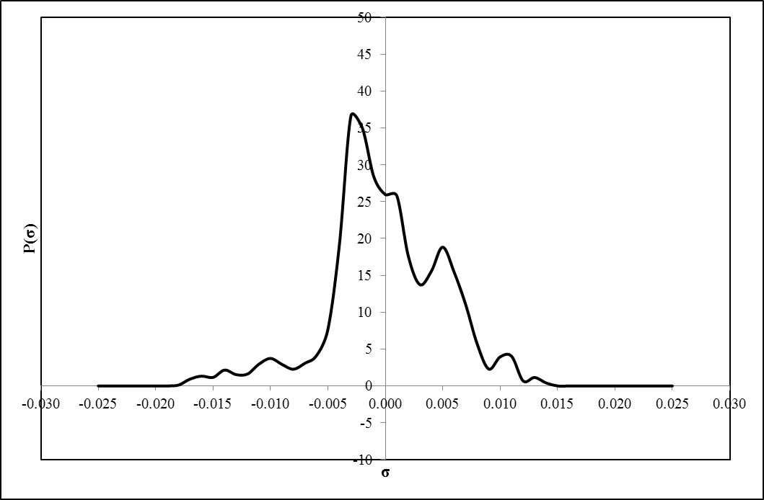

Fig. . Obtained sigma profile for Ethinylestradiol

In Fig. 6, the obtained sigma profile for Ethinylestradiol is plotted. The difference between Ethinylestradiol and Estradiol is addition of a CH group that is attached to the five-member carbon rings by a triple bond on the same carbon atom as attached the –OH group. This emerged as increased and a little width peak at σ = 0.005 e/Å2 due to the π-faced caused by the carbon rings. The same explanation as given for Estradiol can be for Ethinylestradiol. The strong peak around -0.003 e/Å2 is associated to the hydrogens.

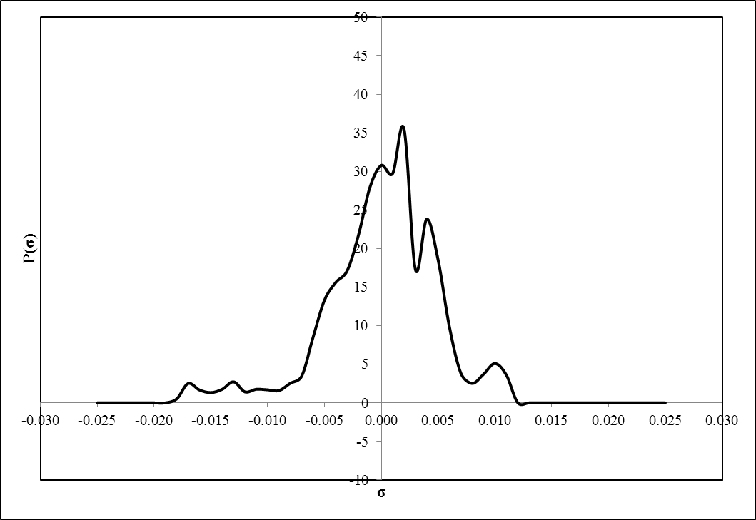

Fig. . Obtained sigma profile for Diethylstilbestrol

In Fig. 7, the obtained sigma profile for Diethylstilbestrol is plotted. The two peak around 0 - 0.002 e/Å2 are due to the two –CH3 groups where the hydrogens are shifted toward σ=0 e/Å2 as a result of covalent bonding and polarized and carbons lead σ=0.002 e/Å2. The peak around 0.0035 e/Å2 is due to the combination of exposed surfaces of carbon atoms and the π-faced caused by the carbon rings. The peaks around σ = -0.0165 – 0.0014 e/Å2 are due to two polar hydrogen atoms in -OH.

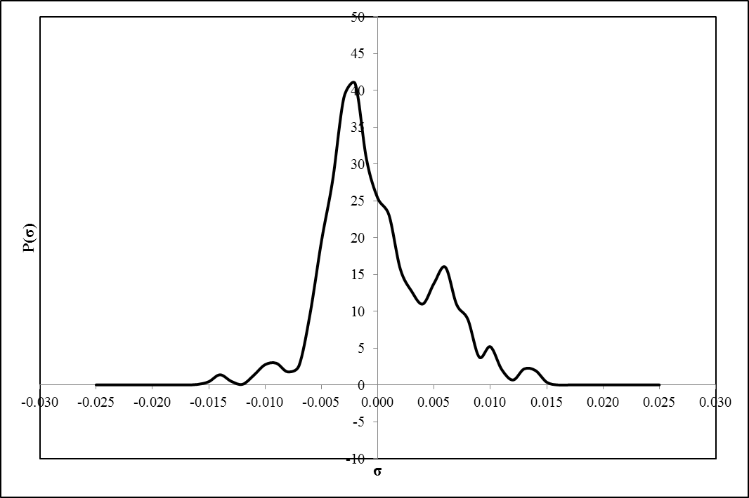

Fig. . Obtained sigma profile for Mestranol

In Fig. 8, the obtained sigma profile for Mestranol is plotted. The strong peak around -0.003 e/Å2 is associated to the hydrogens. The peak at σ = 0.005 e/Å2 is due to the π-faced caused by the carbon rings. The observed peak around σ = 0.013 e/Å2 is due to the lone-pair electrons on oxygen.

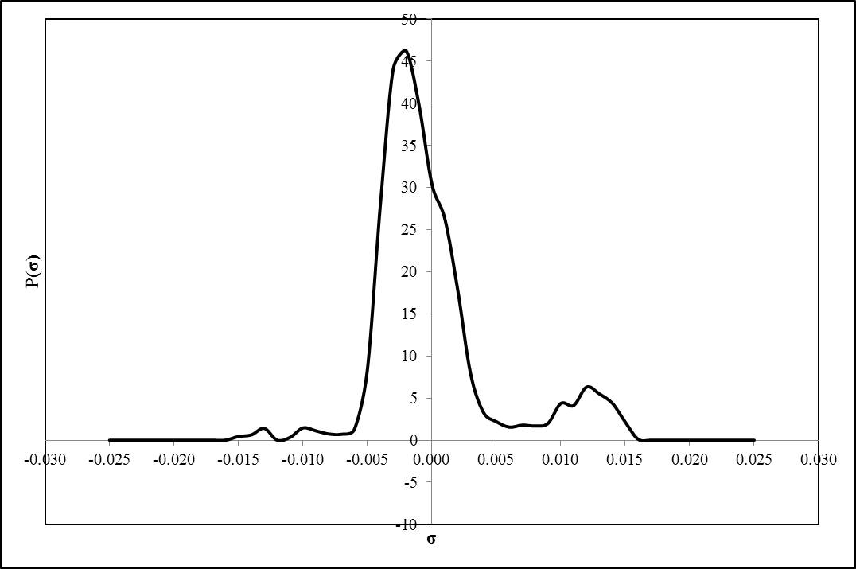

Fig. . Obtained sigma profile for Testosterone

In Fig. 9, the obtained sigma profile for Testosterone is plotted. The observed peak around σ = 0.013 e/Å2 is due to the lone-pair electrons on oxygen. The strong peak around -0.013 e/Å2 is associated to the hydrogens in –OH group. The strong peak around -0.003 e/Å2 is associated to the hydrogens which are polarized due to the presence of oxygen atom.

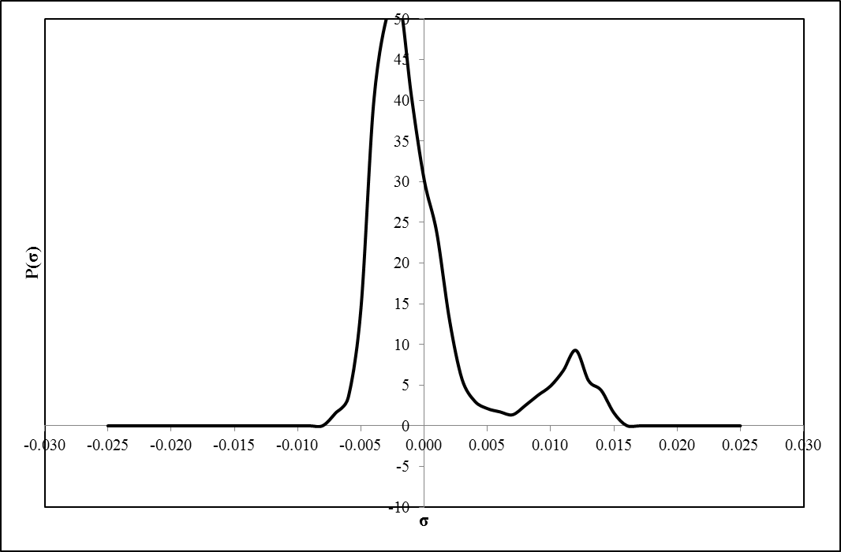

Fig. . Obtained sigma profile for Progesterone

In Fig. 10, the obtained sigma profile for Progesterone is plotted. The observed peak around σ = 0.013 e/Å2 is due to the lone-pair electrons on oxygen. The strong peak around -0.003 e/Å2 is associated to the hydrogens which are polarized due to the presence of two oxygen atoms.

Notes

Islam, M. R. and C.-C. Chen (2014). "COSMO-SAC Sigma Profile Generation with Conceptual Segment Concept." Industrial & Engineering Chemistry Research: 141209090605008.

Schafer, A. I., I. Akanyeti and A. J. Semiao (2011). "Micropollutant sorption to membrane polymers: a review of mechanisms for estrogens." Adv Colloid Interface Sci **164**(1-2): 100-117.