Appendix B – activity coefficients (*γ*) of individual compounds

Evaluating cellulose potential for estrogen micropollutants removal from water effluents using quantum chemical calculations

Milad Asgarpour Khansary 1\*, Azam Marjani 2, Saeed Shirazian 3

1 – Young Researchers and Elite Club, South Tehran Branch, Islamic Azad University, Tehran, Iran

2 – Department of Chemistry, Arak Branch, Islamic Azad University, Arak, Iran

3 – Department of Chemical Sciences, Bernal Institute, University of Limerick, Limerick, Ireland

\* email: [miladasgarpour@ut.ac.ir](mailto:miladasgarpour@ut.ac.ir)

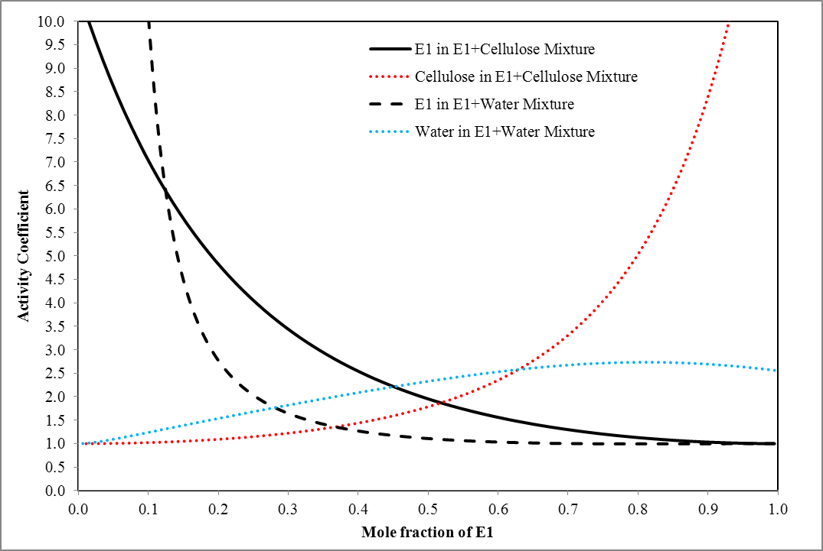

Fig. 1. Obtained activity coefficients for Estrone (E1)

In Fig. 1, the activity coefficients of Estrone in each phase are plotted in terms of Estrone mole fraction in each respective phase. In binary mixture of Estrone and water, in limit of Estrone dilution, the infinite liming activity coefficient of Estrone (1905.662) is relative much larger than that in Estrone and Cellulose mixture (10.42). The activity coefficients of Estrone in both mixtures are larger than 1 (γ>1) which denote positive deviation from Raoult's law. A positive deviation of compound 1 in a solution of 1+2 implies that substance is more volatile than compound 2.

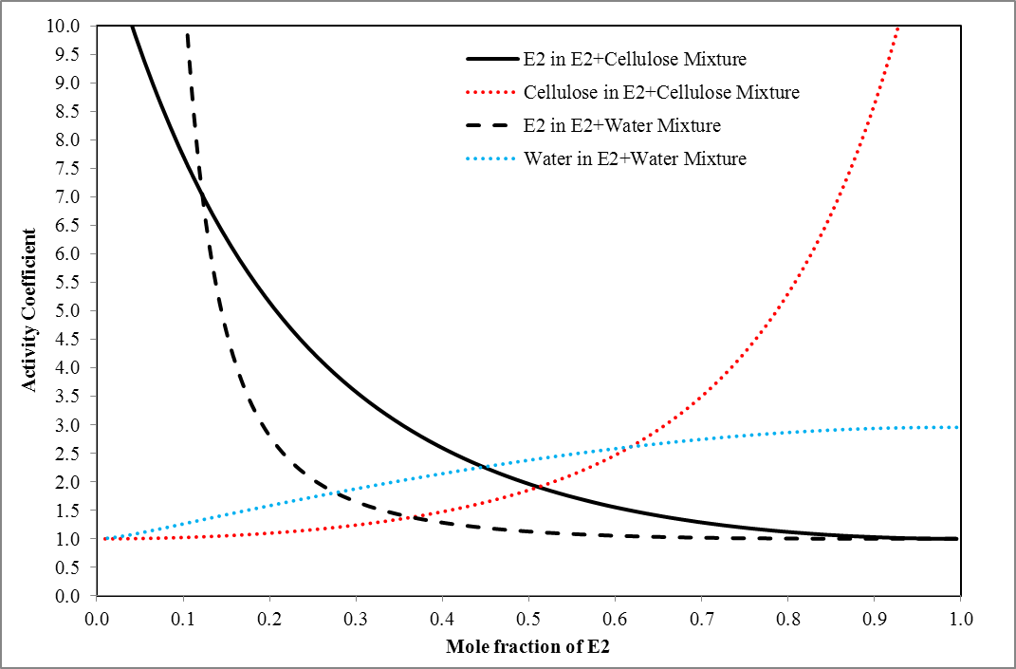

Fig. 2. Obtained activity coefficients for Estradiol (E2)

In Fig. 2, the activity coefficients of Estradiol in each phase are plotted in terms of Estradiol mole fraction in each respective phase. In binary mixture of Estradiol and water, in limit of Estradiol dilution, the infinite liming activity coefficient of Estradiol (3312.678) is relative much larger than that in Estrone and Cellulose mixture (11.7673). The activity coefficients of Estradiol in both mixtures are larger than 1 (γ>1) which denote positive deviation from Raoult's law.

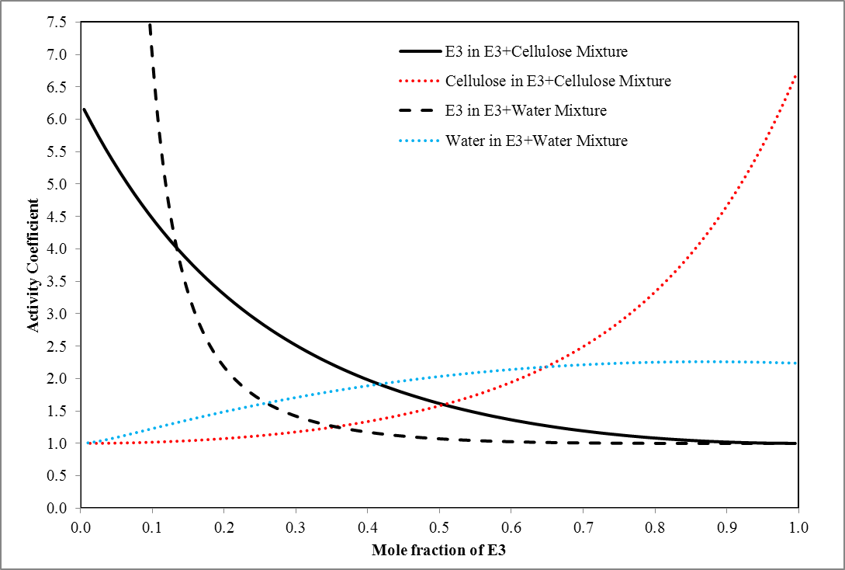

Fig. 3. Obtained activity coefficients for Estriol (E3)

In Fig. 3, the activity coefficients of Estriol in each phase are plotted in terms of Estriol mole fraction in each respective phase. In binary mixture of Estriol and water, in limit of Estriol dilution, the infinite liming activity coefficient of Estriol (1087.596) is relative much larger than that in Estriol and Cellulose mixture (6.152956). The activity coefficients of Estriol in both mixtures are larger than 1 (γ>1) which denote positive deviation from Raoult's law.

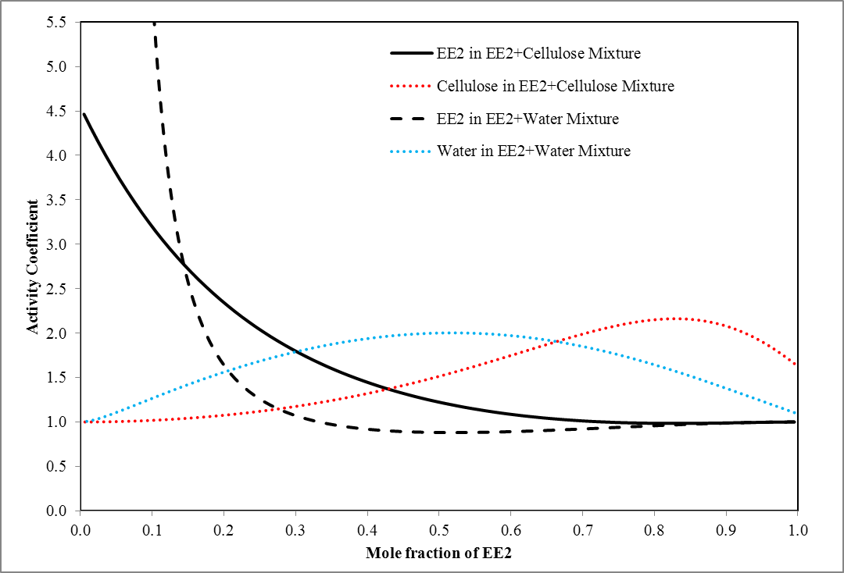

Fig. 4. Obtained activity coefficients for Ethinylestradiol (EE2)

In Fig. 4, the activity coefficients of Ethinylestradiol in each phase are plotted in terms of Ethinylestradiol mole fraction in each respective phase. In binary mixture of Ethinylestradiol and water, in limit of Ethinylestradiol dilution, the infinite liming activity coefficient of Ethinylestradiol (2087.942) is relative much larger than that in Ethinylestradiol and Cellulose mixture (4.464957). The activity coefficients of Ethinylestradiol in both mixtures are larger than 1 (γ>1) which denote positive deviation from Raoult's law.

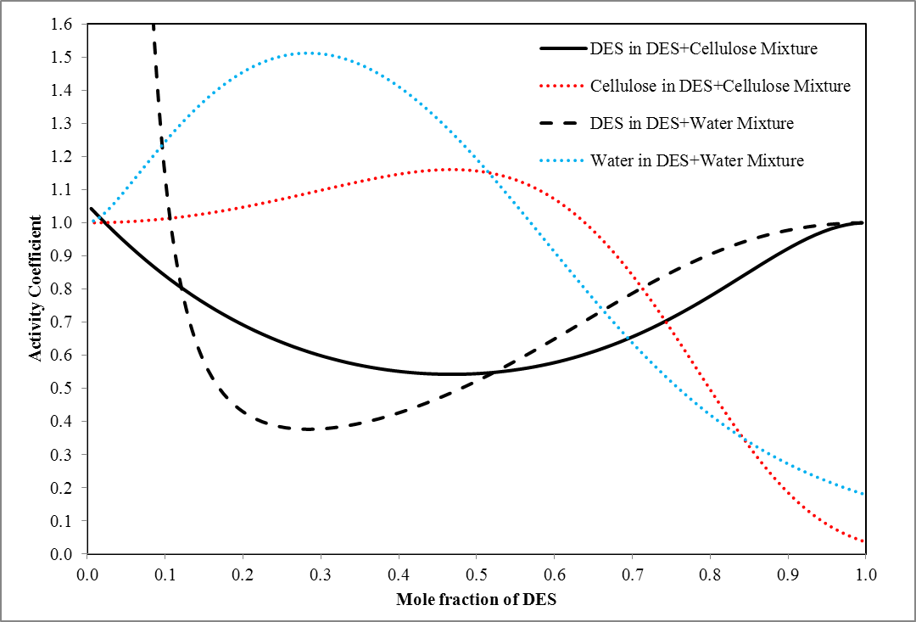

Fig. 5. Obtained activity coefficients for Diethylstilbestrol (DES)

In Fig. 5, the activity coefficients of Diethylstilbestrol in each phase are plotted in terms of Diethylstilbestrol mole fraction in each respective phase. In binary mixture of Diethylstilbestrol and water, in limit of Diethylstilbestrol dilution, the infinite liming activity coefficient of Diethylstilbestrol (282.1289) is relative much larger than that in Diethylstilbestrol and Cellulose mixture (1.043052). The activity coefficients of Diethylstilbestrol in both mixtures are larger than 1 (γ>1) which denote positive deviation from Raoult's law. From Fig. 5, it can be seen that up to DES mole fractions of 0.115, the activity coefficients of DES in DES+water mixture are much more than that in DES+cellulose mixture. This means that up to this mole fraction, the separation and sorption of DES by cellulose is low due to the significant difference in sorption and solubility.

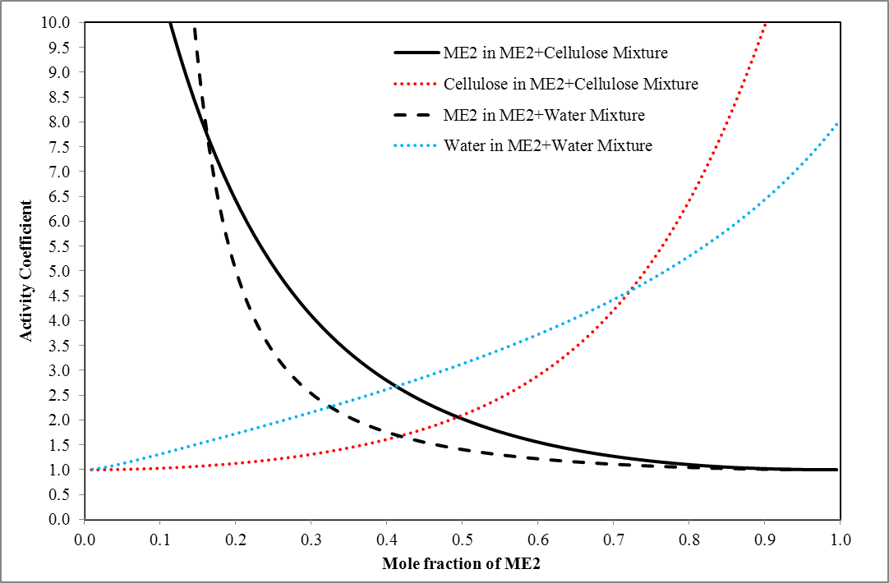

Fig. 6. Obtained activity coefficients for Mestranol (ME2)

In Fig. 6, the activity coefficients of Mestranol in each phase are plotted in terms of Mestranol mole fraction in each respective phase. In binary mixture of Mestranol and water, in limit of Mestranol dilution, the infinite liming activity coefficient of Mestranol (24248.51) is relative much larger than that in Mestranol and Cellulose mixture (18.74879). The activity coefficients of Mestranol in both mixtures are larger than 1 (γ>1) which denote positive deviation from Raoult's law.

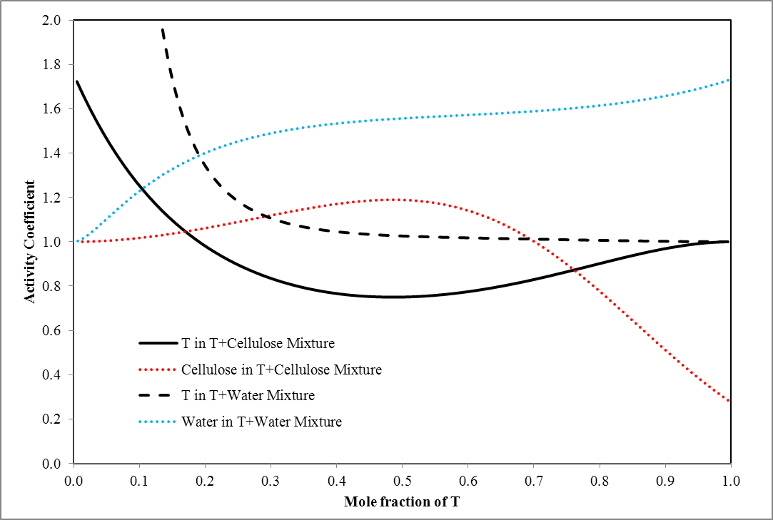

Fig. 7. Obtained activity coefficients for Testosterone (T)

In Fig. 7, the activity coefficients of Testosterone in each phase are plotted in terms of Testosterone mole fraction in each respective phase. In binary mixture of Testosterone and water, in limit of Testosterone dilution, the infinite liming activity coefficient of Testosterone (740.0972) is relative much larger than that in Testosterone and Cellulose mixture (1.722575). For mixture of water and Testosterone, up to Testosterone mole fraction of 0.67, the mixture shows non-ideal behavior as indicated by activity coefficients of Testosterone of larger than 1 (γ>1). The mixture demonstrates slightly ideal behavior for Testosterone mole fraction beyond 0.67 with activity coefficients of Testosterone of unity (γ≈1). For mixture of cellulose and Testosterone, up to Testosterone mole fraction of 0.168, the mixture shows non-ideal behavior as indicated by activity coefficients of Testosterone of larger than 1 (γ>1). The mixture demonstrates ideal behavior for Testosterone mole fraction beyond 0.168 with activity coefficients of Testosterone of smaller than 1 (γ<1).

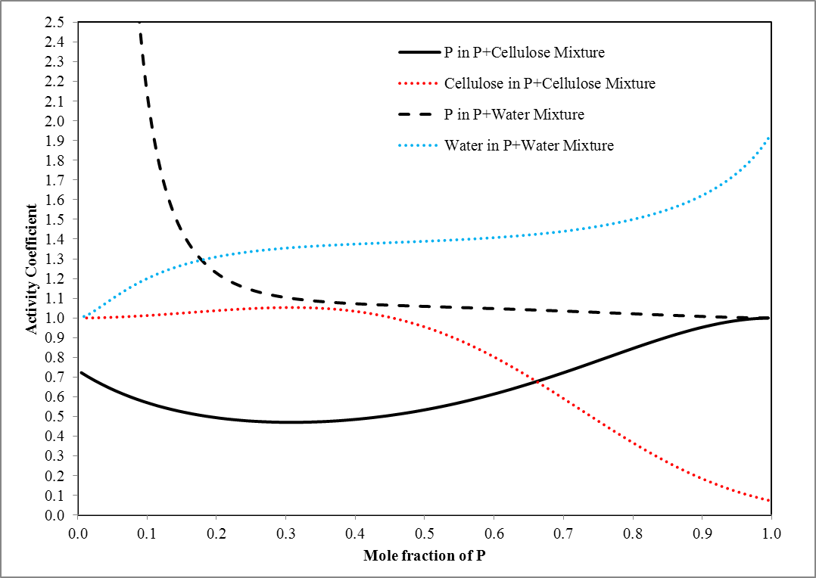

Fig. 8. Obtained activity coefficients for Progesterone (P)

In Fig. 8, the activity coefficients of Progesterone in each phase are plotted in terms of Progesterone mole fraction in each respective phase. In binary mixture of Progesterone and water, in limit of Progesterone dilution, the infinite liming activity coefficient of Progesterone (380.0192) is relative much larger than that in Progesterone and Cellulose mixture (0.7228311). The binary mixture of Progesterone and water shows non-ideal behavior while binary mixture of Progesterone and cellulose shows ideal behavior.