Evaluating cellulose potential for estrogen micropollutants removal from water effluents using quantum chemical modeling and calculations

Abstract

This paper is devoted to investigate the suitability of cellulose for estrogens micropollutants removal from water effluent. For this purpose, the sorption of eight estrogens including Estradiol, Estrone, Testosterone, Progesterone, Estriol, Mestranol, Ethinylestradiol and Diethylstilbestrol were investigated. The charge density profiles and sorption curves were obtained and discussed using quantum chemical calculations where the Accelrys Materials Studio software and COSMO-SAC model were employed. The geometry optimization of compound molecule and energy minimizations was performed using the Dmol3 Module and density functional theory of generalized gradient approximate and Volsko-Wilk-Nusair functional. We found that cellulose cannot be a reliable choice of sorbent for removal of Estrone and Estradiol, but it is a poor choice of sorbent for removal of Estriol, Ethinylestradiol. Cellulose can be used for Diethylstilbestrol, Mestranol, Testosterone and Progesterone removal from estrogens containing effluents.

Keywords: cellulose; estrogens; sorption; prediction; COSMO theory; water effluent

# Introduction

The contribution of human activity and sources in environmental pollution have increased micropollutants content of water which is emerging as a serious global problem that might affect environmental and human health (Jobling, Nolan et al. 1998, Tyler, Jobling et al. 1998, Younes 1999, Gabriel, Routledge et al. 2008, Schafer, Akanyeti et al. 2011, Asgarpour Khansary, Shirazian et al. 2016, Khansary, Mellat et al. 2017). Pesticides, pharmaceuticals, personal care products, plasticizers, antibiotics, hormones, endocrine disrupters and etc. are of various types of micropollutants that are released to the environment. Due to their persistence, they might accumulate in the environment and have measurable concentrations in water effluents. Relatively high concentrations of micropollutants such as pharmaceuticals and antidepressants have caused concern of exposure from drinking water (Körner, Bolz et al. 2000, Zuccato, Calamari et al. 2000, Johnson and Sumpter 2001, Kolpin, Furlong et al. 2002, Williams, Johnson et al. 2003, Schultz and Furlong 2008).

To effectively eliminate micropollutants, various treatment technologies have been introduced such as activated carbon adsorption, coagulation, oxidation, membranes technology and etc. (Baronti, Curini et al. 2000, Johnson and Sumpter 2001, Khansary, Mellat et al. 2017). Due to the low concentrations of micropollutants and their competitive sorption with other natural organic matters, the application of activated carbon adsorption and coagulation are not effective. On the other hand, the by-products produced during the oxidation processes, themselves, might be toxic (Andreozzi, Canterino et al. 2005). For micropollutants removal from water effluents and wastewater, the membrane technology has shown high potential using Nanofiltration (NF) and reverse osmosis (RO) (Khansary, Mellat et al. 2017). The sorption of micropollutants in polymeric materials used membranes plays an important role for reliability and versatility of water treatments (Kimura, Amy et al. 2003, Kimura, Amy et al. 2003).

One of the most freely available biomolecules that can be used for various applications and processes is cellulose (Jallabert, Vaca-Medina et al. 2013, Asgarpour Khansary and Shirazian 2016). Various methods have been developed to produce a wide variety of products from cellulose (Nilsson, Galland et al. 2010, Zhang, Wu et al. 2012, Jallabert, Vaca-Medina et al. 2013, Pintiaux, Viet et al. 2013, Vaca-Medina, Jallabert et al. 2013). With regard to the estrogens micropollutants, cellulose or its derivatives might be used as sorbent for estrogens removal from water effluents. Sorption of estrogens on cellulose can be used for concentrating estrogens on solid surface (cellulose) and eliminating them from the bulk phase (water effluent). New analytical techniques lead to the discovery and detection of sorption of molecules of pollutants of very low concentration in nano gram quantities (Schafer, Akanyeti et al. 2011).

Therefore, it should be a valuable attempt to investigate the suitability of various substrates for pollutants removal through sorption mechanism. This paper aims to explore the suitability of cellulose as a raw material of various polymeric products and extensively available free resource for possible micropollutants removal capability through a predictive approach. The sorption of eight estrogens on cellulose is considered here as illustrated in following sections.

# Sorption of estrogens onto cellulose

The sorption of estrogens contained in water effluents onto cellulose can be predicted by applying the local thermodynamic equilibrium criteria at the interface of cellulose and estrogen-containing water. At operating conditions i.e. temperature (*T*) and Pressure (*P*), the chemical potentials of estrogens in water and cellulose phases must be equal as given in Eq. 1 where superscripts *C* and *W* respectively denotes the cellulose and water phases.

|  |  |
| --- | --- |
|  |  |

Subscript 1 denotes the estrogens of interest. *μ* denotes the chemical potential and Δ accounts for the change in chemical potential referring to a reference state (J.M. Smith, H. Van Ness et al. 2005).

The chemical potential can be obtained from a Gibbs free energy model (J.M. Smith, H. Van Ness et al. 2005), and employing the same reference state for both phases, Eq. 1 can be rewritten as given by Eq. 2 where *x* denotes the mole fraction of estrogens of interest and γ denotes the activity coefficient of estrogens of interest.

|  |  |
| --- | --- |
|  |  |

The mole fractions (*x*) can be converted to concentrations (*c*) using Eq. 3 where *M* denotes molecular weight () and *ρ* is density ().

|  |  |
| --- | --- |
|  | 3 |

For calculation of activity coefficient of estrogens of interest, there is a wide variety of models to be used including equations of state, corresponding state correlations, compressible and incompressible regular solution models and etc. (Ernest J. Henley and Seader 1981, Keizer 1987, Sandler 1993, Prausnitz, Lichtenthaler et al. 1998, Sanchez and Stone 2000, O’Connell and Haile 2005, Kontogeorgis and Folas 2010, Ghasemi, Asgarpour Khansary et al. 2017). Many of these thermodynamic models and theories, require fitting of a number of adjustable parameters and cannot be considered as predictive methods such as Nonrandom Two Liquids model (NRTL), Universal Quasi-Chemical theory (UNIQUAC) (Prausnitz, Lichtenthaler et al. 1998, J.M. Smith, H. Van Ness et al. 2005), the Modified Separation of Cohesive Energy Density (MOSCED) model (Lazzaroni, Bush et al. 2005, 2014), Universal Functional Activity Coefficient (UNIFAC) (Sandler 1993, Prausnitz, Lichtenthaler et al. 1998) and/or Analytical Solution of Groups (ASOG) (Sandler 1993, Prausnitz, Lichtenthaler et al. 1998) and etc.

The COSMO-based models are an outstanding alternative to these models (Shimoyama and Ito 2010, Gonfa, Bustam et al. 2015, Lee and Lin 2015), by which a predictive description of many industrial processes (Klamt, Krooshof et al. 2002, Shah and Yadav 2013, Islam and Chen 2014). These models use quantum chemical calculations combined with a thermodynamic model to predict phase equilibria. For current work, we employed the COSMO-SAC model for our calculations (Shimoyama and Ito 2010, Lee and Lin 2015). The details of model equations can be found in literatures and excluded here for conciseness of paper.

We employed the Accelrys Materials Studio software for the quantum chemical calculations required in COSMO-SAC method. As a first step, in this method, it is required that the geometry of compound molecule being optimized. For this purpose, the Dmol3 Module was used. For COSMO-based model calculations, the use of density functional theory of generalized gradient approximate (GGA) and Volsko-Wilk-Nusair functional (VWN) is recommended which is implemented in Dmol3 Module by GGA/VWN-BP and DNP v.4.0.0 basis option (Shah and Yadav 2013, Islam and Chen 2014). At the second step, using the Dmol3 Module, the same setting was used for energy optimization of optimized molecule geometry. The obtained “.cosmo” file then was used for activity calculations using open source FORTRAN based programs as provided elsewhere (Shah and Yadav 2013, Islam and Chen 2014).

For all the aforementioned simulations, a personal computer (Lap-Top) of Fujitsu brand, model AH531/GFO, with a x64-bit architecture CPU of 2.7 GHz base speed (boasting up to 3.6 GHz) and 8 GB of installed memory (RAM) and by implementation of a USB flash disk of HP brand, model v160w, with 16 GB capacity utilized as virtual memory through ReadyBoost option in Windows 10 professional OS (64-bit OS) were used. All unwanted services and programs in OS were disabled manually to enhance the Lap-Top performance.

# Result and discussion

The selected estrogens micropollutants and cellulose are listed in Table 1. These structures were drawn in Accelrys Materials Studio software package for geometry optimization and then energy minimization.

Table . Selected systems chemical structure

|  |  |  |  |  |
| --- | --- | --- | --- | --- |
| **No.** | **Name** | **Symbol** | **Mw**  **(g/cm3)** | **Chemical Structure** (Schafer, Akanyeti et al. 2011) |
| 1 | Estrone | E1 | 270.372 |  |
| 2 | Estradiol | E2 | 272.388 |  |
| 3 | Estriol | E3 | 288.387 |  |
| 4 | Ethinylestradiol | EE2 | 296.410 |  |
| 5 | Diethylstilbestrol | DES | 268.356 |  |
| 6 | Mestranol | ME2 | 310.437 |  |
| 7 | Testosterone | T | 288.431 |  |
| 8 | Progesterone | P | 314.469 |  |
| 9 | Cellulose | Cel | 325.290 |  |
| 10 | Water | W | 18.015 |  |

The obtained COSMO information including surface area of cavity, volume of cavity and number of segments for considered compounds are listed in Table 2.

Table . Optimal geometries and obtained COSMO information (red: oxygen, white: hydrogen, gray: carbon)

|  |  |  |  |  |  |
| --- | --- | --- | --- | --- | --- |
| **No.** | **Symbol** | **surface area of cavity**  **(A°2)** | **volume of cavity**  **(A°3)** | **segments** | **Optimized Geometry** |
| 1 | E1 | 286.59201 | 338.60693 | 1267 |  |
| 2 | E2 | 288.31577 | 344.92994 | 1285 |  |
| 3 | E3 | 294.44228 | 354.46663 | 1311 |  |
| 4 | EE2 | 316.85655 | 378.6588 | 1355 |  |
| 5 | DES | 311.62743 | 358.64132 | 1301 |  |
| 6 | ME2 | 335.38290 | 397.77549 | 1477 |  |
| 7 | T | 296.56005 | 371.54805 | 1318 |  |
| 8 | P | 321.71243 | 409.92860 | 1402 |  |
| 9 | Cel | 305.20643 | 359.23392 | 1294 |  |
| 10 | W | 43.26923 | 25.73454 | 136 |  |

The obtained Sigma profiles are shown in Fig. 1. Sigma profile, *p*(*σ*), are mainly used to represent the probability distribution of surface area having charge density *σ*. Commonly, histograms of segment surface are reported over a charge density range of −0.025 to 0.025 e/Å2 as ideal screening charge density for most of the molecules are in this range (Islam and Chen 2014). It must be noted that due to sign inversion of the polarization charge density, σ, the peak from the negative lone-pairs is located on the right side of the σ-profile and vice versa (Klamt 2005).

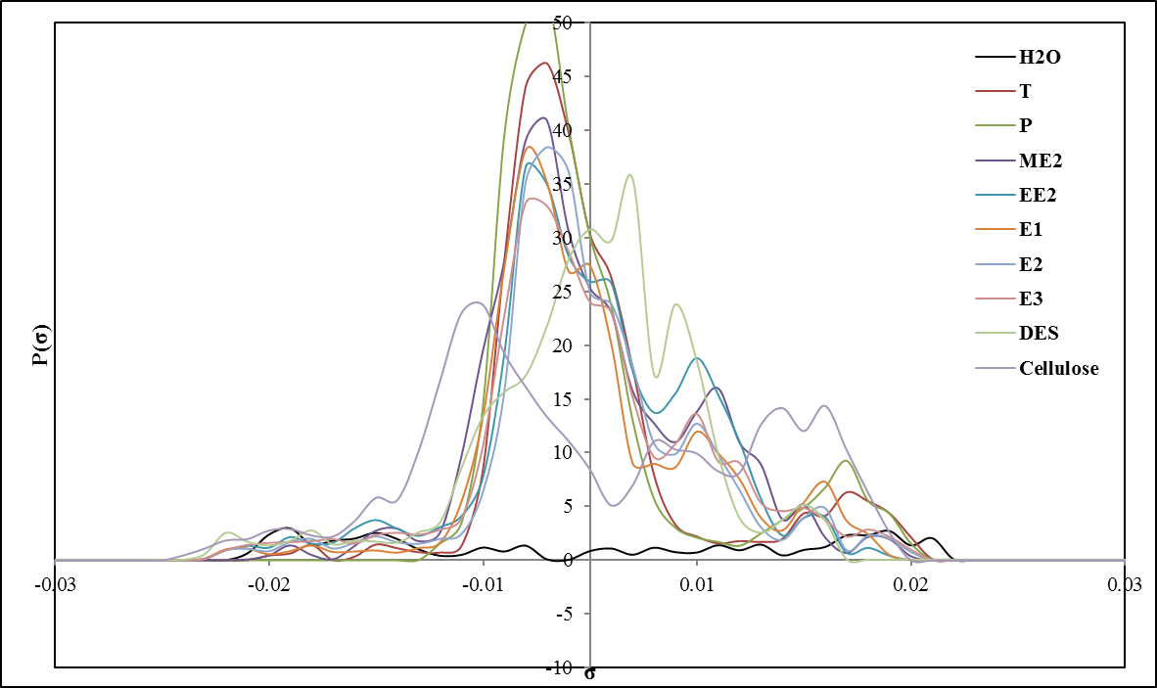

Fig. 1. Obtained sigma profiles

In Fig. 1, the obtained sigma profiles are illustrated. The six hydrogen atoms in cellulose repeating unit pose positive charges which is distributed over a large are and generates a weak peak at σ = -0.014 e/Å2. Although cellulose has a high capacity for H-bonding as demonstrated by the strong peak around σ = -0.006 e/Å2 (the span of hydrogen bonding is located over a charge density range of −0.0079 to 0.0079 e/Å2), it does not like to H-bond with estrogen due to the misfit of corresponding charge densities in estrogen. It does, however, interact with its own functional groups (Schafer, Akanyeti et al. 2011). This compound is stable and comfortable in its pure state as the two adjunct positive peak play role of a partner for the negative peak ending to no electrostatic misfit.

The obtained sigma profile for water is illustrated which is wide and symmetric. The observed peak around σ = 0.014 e/Å2 is due to the lone-pair electrons on oxygen. The two polar hydrogen atoms, also, generate a peak at σ = -0.014 e/Å2. A flat and symmetric region between these two peaks can be observed denoting the strong hydrogen bonding interactions of water with other molecules (Islam and Chen 2014).

It seems that Estrone is slightly a hydrophilic molecule as its sigma profile is observed to be narrow and inside the sigma cutoff for hydrogen bonding, i.e. −0.0079 ≤ σ ≤ 0.0079 e/Å2. This means that this molecule does not form a hydrogen bond with other molecules, here Cellulose. The strong peak around -0.003 e/Å2 is associated to the hydrogens, whoever, hydrogen bonding is weak up to -0.002 e/Å2. The observed peak around σ = 0.013 e/Å2 is due to the lone-pair electrons on oxygen on carboxyl group. The shoulder like peak around 0.0023 e/Å2 is due to the exposed surfaces of carbon atoms. The peak at σ = 0.005 e/Å2 is due to the π-faced caused by the carbon rings. This estrogen is expected to be dissolved in water as the two peaks beyond hydrogen bonding span of water fit to small peaks in Estrone. The misfit among the sigma charge profile of Estrone and that of cellulose indicates the small and weak interaction of these two compounds. However, two shoulders like peaks around 0.0023 e/Å2 in these two compounds show the potential of possible covalence interaction which implies that the sorption of Estrone in cellulose might be possible but in small values.

The observed peak around σ = 0.013 e/Å2 in Estrone due to the lone-pair electrons on oxygen is now absent in Estradiol as it is expected from its chemical structure. The strong peak around -0.003 e/Å2 is associated to the hydrogens. The peak at σ = 0.005 e/Å2 is due to the π-faced caused by the carbon rings. The same explanation as given for Estrone can be for Estradiol. The structure of Estriol is similar to Estradiol. Here, the strong peak around -0.003 e/Å2 is associated to the hydrogens. The peak at σ = 0.005 e/Å2 is due to the π-faced caused by the carbon rings. In comparison to Estriol, the –CH3 group lacks in Estradiol and another –OH group is attached to the five-member carbon ring which show themselves with the new peak emerged around 0.006 e/Å2 in sigma profile for Estriol.

The difference between Ethinylestradiol and Estradiol is addition of a CH group that is attached to the five-member carbon rings by a triple bond on the same carbon atom as attached the –OH group. This emerged as increased and a little width peak at σ = 0.005 e/Å2 due to the π-faced caused by the carbon rings. The same explanation as given for Estradiol can be for Ethinylestradiol. The strong peak around -0.003 e/Å2 is associated to the hydrogens. For Diethylstilbestrol, the two peak around 0 - 0.002 e/Å2 are due to the two –CH3 groups where the hydrogens are shifted toward σ=0 e/Å2 as a result of covalent bonding and polarized and carbons lead σ=0.002 e/Å2. The peak around 0.0035 e/Å2 is due to the combination of exposed surfaces of carbon atoms and the π-faced caused by the carbon rings. The peaks around σ = -0.0165 – 0.0014 e/Å2 are due to two polar hydrogen atoms in -OH.

For Mestranol, the strong peak around -0.003 e/Å2 is associated to the hydrogens. The peak at σ = 0.005 e/Å2 is due to the π-faced caused by the carbon rings. The observed peak around σ = 0.013 e/Å2 is due to the lone-pair electrons on oxygen. For Testosterone, the observed peak around σ = 0.013 e/Å2 is due to the lone-pair electrons on oxygen. The strong peak around -0.013 e/Å2 is associated to the hydrogens in –OH group. The strong peak around -0.003 e/Å2 is associated to the hydrogens which are polarized due to the presence of oxygen atom. For Progesterone, the observed peak around σ = 0.013 e/Å2 is due to the lone-pair electrons on oxygen. The strong peak around -0.003 e/Å2 is associated to the hydrogens which are polarized due to the presence of two oxygen atoms.

The activity coefficients (*γ*) were determined using the COSMO-SAC model using the freely available FORTRAN code. In binary mixture of Estrone and water, in limit of Estrone dilution, the infinite liming activity coefficient of Estrone (1905.662) is relative much larger than that in Estrone and Cellulose mixture (10.42). The activity coefficients of Estrone in both mixtures are larger than 1 (γ>1) which denote positive deviation from Raoult's law. A positive deviation of compound 1 in a solution of 1+2 implies that substance is more volatile than compound 2. The sorption capacity data are obtained for sorption of E1 by cellulose as illustrated in Fig. 2.

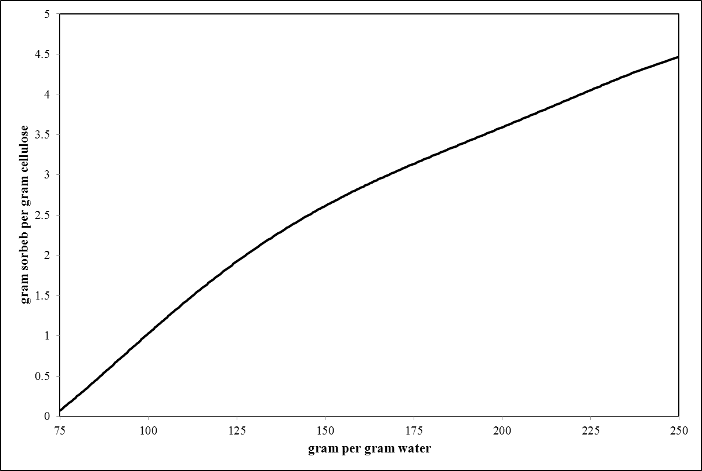

Fig. . Sorption capacity of cellulose for Estrone (E1) removal from water

Based on Fig. 2, cellulose cannot be a reliable choice of sorbent as for removal of E1 from 1 liter water stream containing 75 gram E1, approximately 750 gr cellulose is required. The cellulose cost is low as it is a freely available biomolecule; however, such sorption capacity is not appreciable. This low sorption behavior can be simply justified by comparing the charge density profiles of water, cellulose and Estrone (E1). For E1 in mixture of water+E1, almost of peaks find matching partner and no considerable mismatch can be seen, consequently, E1 will feel electrostatically much stable in comparison to E1 in mixture of cellulose+E1 where only loose π-faces associated peaks find their matching partner. The peaks in charge density within the range of −0.001 to 0.001 e/Å2are associated to weak polar interactions, which in mixture of water+E1 might results in some interactions however, as discussed in previous sections, the cellulose does not tend to show such interactions and if such interactions happen, they are over its own functional groups. Therefore, the weak polar hydrogen peak in cellulose contributes on nothing. Thus, the lower content of E1 in cellulose in comparison to water is expected.

In binary mixture of Estradiol and water, in limit of Estradiol dilution, the infinite liming activity coefficient of Estradiol (3312.678) is relative much larger than that in Estrone and Cellulose mixture (11.7673). The activity coefficients of Estradiol in both mixtures are larger than 1 (γ>1) which denote positive deviation from Raoult's law. The sorption capacity of cellulose for Estradiol (E2) removal from water is evidence in Fig. 3.

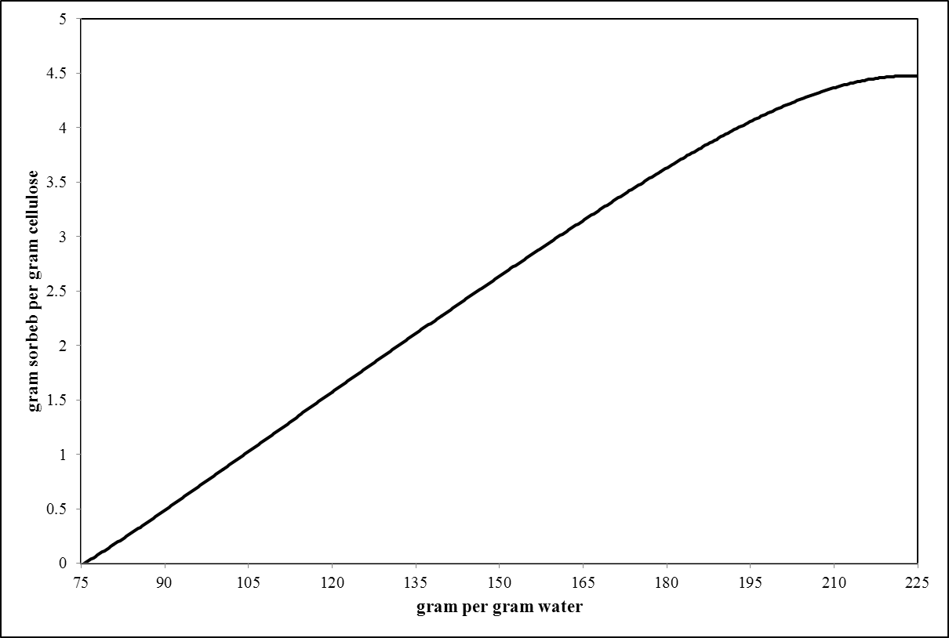

Fig. . Sorption capacity of cellulose for Estradiol (E2) removal from water

As it is evidence in Fig. 3, the sorption capacity of cellulose for Estradiol (E2) removal from water is weak. So, cellulose might be not a good choice of sorbent for E2 as it is able to sorb 1 gr of E2 per gram of cellulose for a water stream of 100 gram E2 per gram water. However, the availability and low cost of application of cellulose would enhance it chance for such application. For removal of E2 from 1 liters water stream containing 100 gram E2 per gram water, approximately 102 grams cellulose is required which must cost not too much. This low sorption behavior can be simply justified by comparing the charge density profiles of water, cellulose and Estradiol (E2) as performed for Estrone (E1).

Similar to E1 systems, for E2 in mixture of water+E2, almost of peaks find matching partner and no considerable mismatch can be seen, consequently, E2 will feel electrostatically much stable in comparison to E2 in mixture of cellulose+E2 where only loose π-faces associated peaks find their matching partner. The oxygen and hydrogen associated peaks of E2 are well matched with those of water. The peaks in charge density within the range of −0.001 to 0.001 e/Å2are associated to weak polar interactions. Thus, the lower content of E2 in cellulose in comparison to water is expected.

In binary mixture of Estriol and water, in limit of Estriol dilution, the infinite liming activity coefficient of Estriol (1087.596) is relative much larger than that in Estriol and Cellulose mixture (6.152956). The activity coefficients of Estriol in both mixtures are larger than 1 (γ>1) which denote positive deviation from Raoult's law. The sorption capacity of cellulose for Estriol (E3) removal is illustrated in Fig. 4.

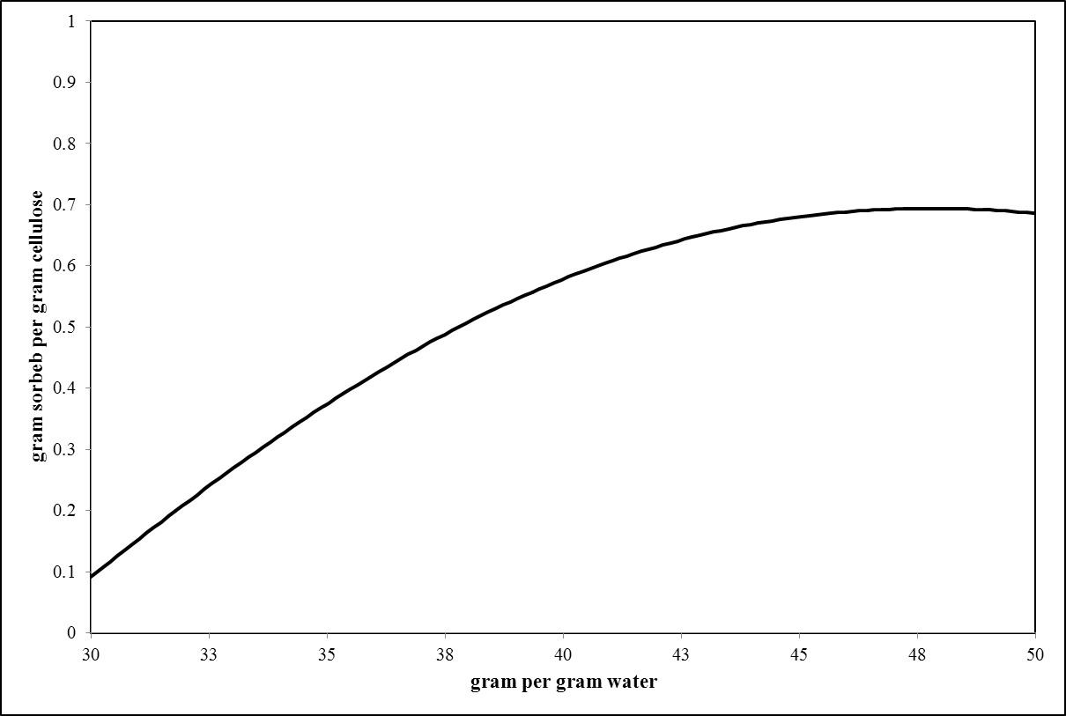

Fig. . Sorption capacity of cellulose for Estriol (E3) removal from water

For this case, the sorption capacity is much better than the two previously discussed estrogens. For removal of E3 from 1 liter water stream containing 30 gram E3 per gram water, approximately 30.61 gram cellulose is required which must cost not too much. From Fig. 4, it can be concluded that the domain of cellulose application for E3 removal is restricted to E3 contents of up to 50 gram per gram water effluent. In comparison to E1 and E2 systems, the sorption behavior of cellulose of Estriol (E3) seems to be more acceptable. This improvement can be simply justified noting to the charge density profiles of water, cellulose and Estriol (E3).

The contribution of π-faces peaks due to the carbon atoms exposure and carbon rings is much wider than previous two cases. Thus a little more attractive covalent bonding and interactions can be expected between cellulose and E3 resulting in an increase in its sorption onto cellulose. The peaks in charge density within the range of −0.001 to 0.001 e/Å2are associated to weak polar interactions.

In binary mixture of Ethinylestradiol and water, in limit of Ethinylestradiol dilution, the infinite liming activity coefficient of Ethinylestradiol (2087.942) is relative much larger than that in Ethinylestradiol and Cellulose mixture (4.464957). The activity coefficients of Ethinylestradiol in both mixtures are larger than 1 (γ>1) which denote positive deviation from Raoult's law. In Fig. 5, the sorption behavior of cellulose for EE2 is shown.

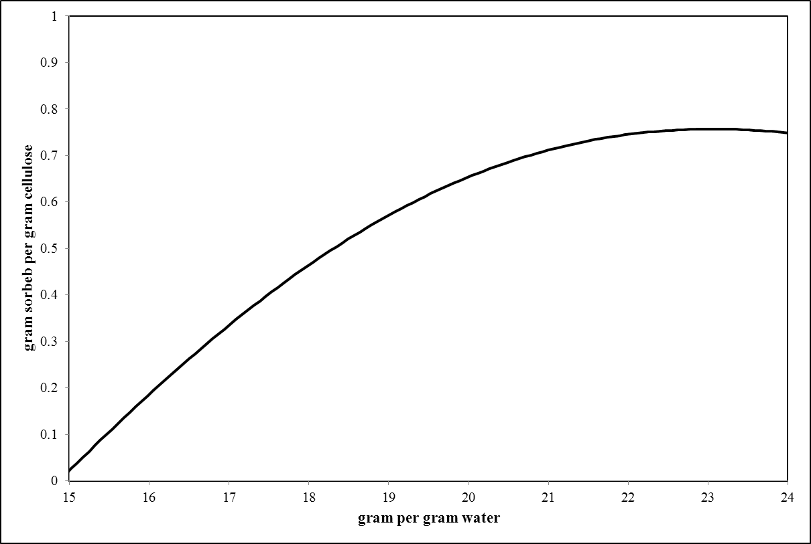

Fig. . Sorption capacity of cellulose for Ethinylestradiol (EE2) removal from water

It can be concluded that cellulose is poorly a good sorbent of low contained EE2 water effluents as for removal of EE2 from 1 liter of water containing 15 gram EE2, approximately 510 gram of cellulose. The concentration domain in which cellulose can be used for EE2 sorption is limited but it is in the practical range of EE2 contained water effluents.

The low sorption capacity of Ethinylestradiol (EE2) in cellulose is due to the fact that no receptive matching on change density profiles can be observed. While the hydrogen associated peaks are matched, however, as mentioned in previous section, cellulose will not interact with other molecules through hydrogen bonding interaction. The covalent interactions, which were observed for three other systems discussed earlier, are now absent and weakly contribute as they found no matching partners. These observations come to the conclusion of very low sorption of EE2 in cellulose.

In binary mixture of Diethylstilbestrol and water, in limit of Diethylstilbestrol dilution, the infinite liming activity coefficient of Diethylstilbestrol (282.1289) is relative much larger than that in Diethylstilbestrol and Cellulose mixture (1.043052). The activity coefficients of Diethylstilbestrol in both mixtures are larger than 1 (γ>1) which denote positive deviation from Raoult's law. it can be seen that up to DES mole fractions of 0.115, the activity coefficients of DES in DES+water mixture are much more than that in DES+cellulose mixture. This means that up to this mole fraction, the separation and sorption of DES by cellulose is low due to the significant difference in sorption and solubility.

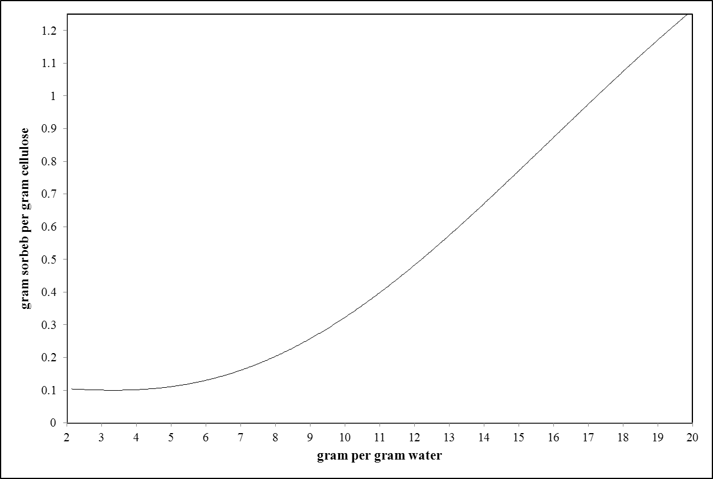

Fig. . Sorption capacity of cellulose for Diethylstilbestrol (DES) removal from water

It can be readily seen in Fig. 6 that cellulose can be used for DES removal from water effluents of higher concentrations as a feasible sorbent. Despite the low sorption of DES by cellulose in low concentration, noting to the wide availability of cellulose, it can be used for as a cheap sorbent for DES removal.

The good performance of cellulose for DES removal is due to combination of exposed surfaces of carbon atoms and the π-faced caused by the carbon as shown by a peak around 0.0035 e/Å2which can interact with the hydrogen atoms of cellulose with the approximately same charge density on the other side of sigma axis. Consequently, one might expect much better interaction between cellulose and DES in comparison to DES and water resulting in good sorption behavior.

In binary mixture of Mestranol and water, in limit of Mestranol dilution, the infinite liming activity coefficient of Mestranol (24248.51) is relative much larger than that in Mestranol and Cellulose mixture (18.74879). The activity coefficients of Mestranol in both mixtures are larger than 1 (γ>1) which denote positive deviation from Raoult's law. The sorption capacity of cellulose for Mestranol (ME2) removal from water is given in Fig. 7 from which it can be concluded that for EE2 removal from one liter of water effluent contains 70 gram ME2 requires approximately 140 gram cellulose which seems to be a feasible choice of sorbent.

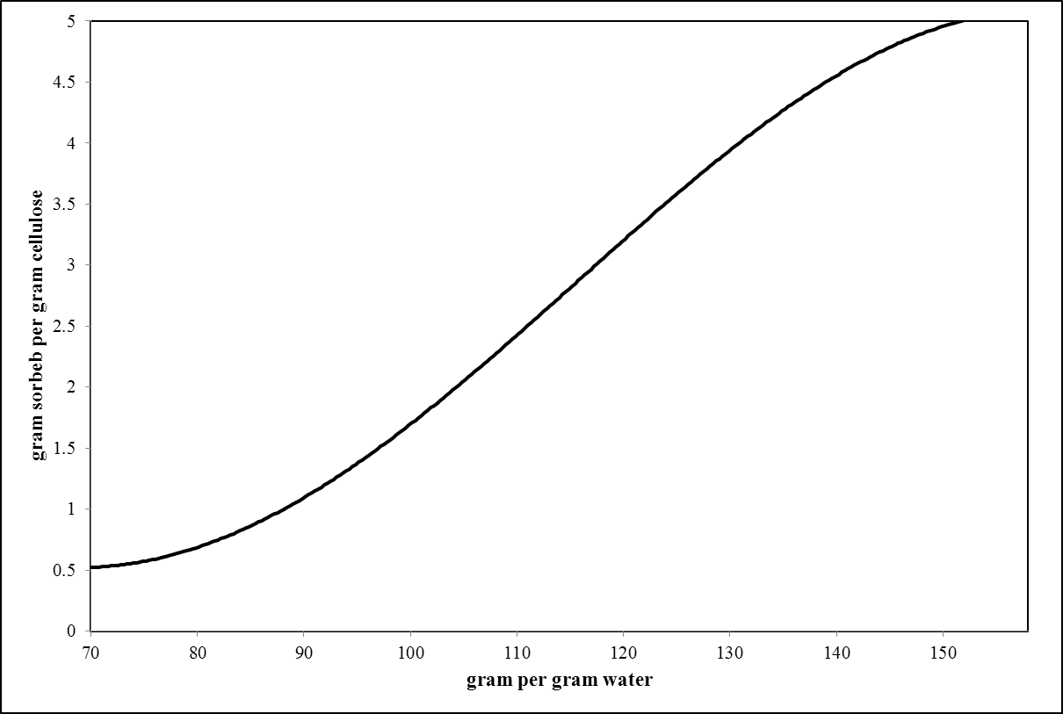

Fig. . Sorption capacity of cellulose for Mestranol (ME2) removal from water

Desirable interaction and peak matching can be observed for water+ME2 mixtures, therefore, ME2 feels much comfortable in water+ME2 mixtures than cellulose+ME2 mixture and prefer to no to leave the water+ME2 mixtures. However, the matching of peaks of carbon rings and π-faces encourage the ME2 to be sorped onto the cellulose even in small contents. This simply justifies the sorption behavior of cellulose of ME2.

In binary mixture of Testosterone and water, in limit of Testosterone dilution, the infinite liming activity coefficient of Testosterone (740.0972) is relative much larger than that in Testosterone and Cellulose mixture (1.722575). For mixture of water and Testosterone, up to Testosterone mole fraction of 0.67, the mixture shows non-ideal behavior as indicated by activity coefficients of Testosterone of larger than 1 (γ>1). The mixture demonstrates slightly ideal behavior for Testosterone mole fraction beyond 0.67 with activity coefficients of Testosterone of unity (γ≈1). For mixture of cellulose and Testosterone, up to Testosterone mole fraction of 0.168, the mixture shows non-ideal behavior as indicated by activity coefficients of Testosterone of larger than 1 (γ>1). The mixture demonstrates ideal behavior for Testosterone mole fraction beyond 0.168 with activity coefficients of Testosterone of smaller than 1 (γ<1). Based on results shown in Fig. 8, only 150 gram of cellulose is required to remove Testosterone from one liter of water effluent containing 7 gram of Testosterone. As cellulose is able to remove small content of Testosterone as illustrated in Fig. 8, it is a good choice of sorbent.

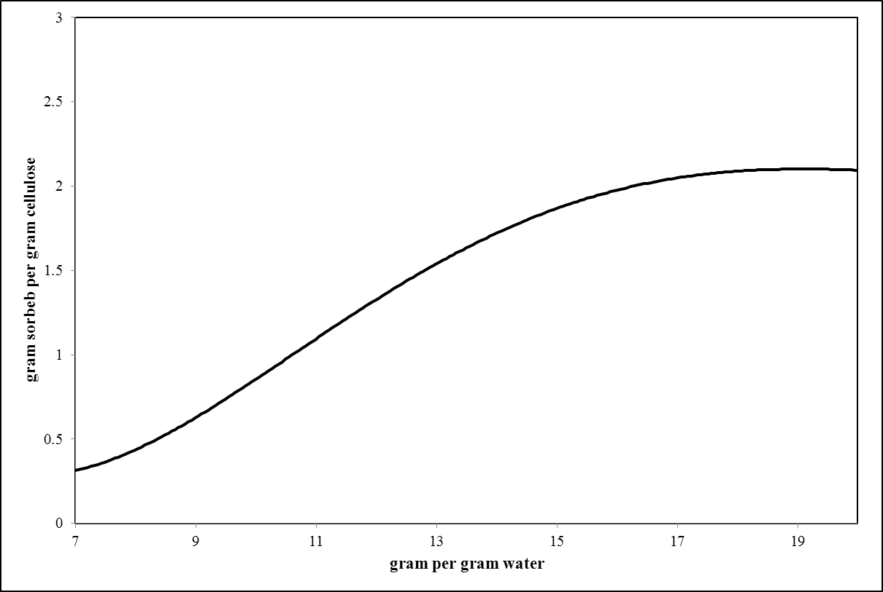

Fig. . Sorption capacity of cellulose for Testosterone (T) removal from water

Comparing charge density profiles of water, cellulose and Testosterone (T), There no considerable and significant peak matching in water+T mixture as well as cellulose mixture. It can be observed that T will not feel comfortable in water too much as no receptive matching can be found for its peaks. The sorption of T on cellulose might be due to the electrostatic interaction between polarized hydrogen in –OH group with those of oxygen group in cellulose that would results in effective sorption.

In binary mixture of Progesterone and water, in limit of Progesterone dilution, the infinite liming activity coefficient of Progesterone (380.0192) is relative much larger than that in Progesterone and Cellulose mixture (0.7228311). The binary mixture of Progesterone and water shows non-ideal behavior while binary mixture of Progesterone and cellulose shows ideal behavior. The sorption results of Progesterone by cellulose is very interesting as based on obtained sorption capacity illustrated in Fig. 9, for removal of 4 grams of Progesterone contained in one liter of water effluent, approximately 10 gram of cellulose is required. Thus, cellulose is good choice of sorbent for this case.

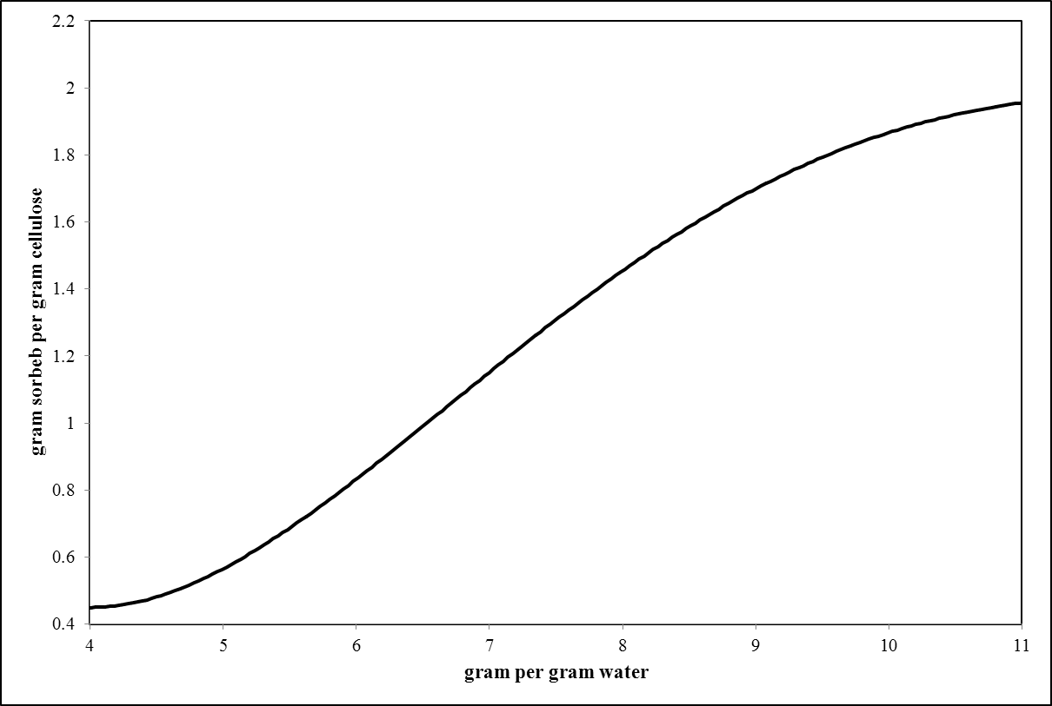

Fig. . Sorption capacity of cellulose for Progesterone (P) removal from water

The interactions between water and Progesterone are not considerable, therefore, P can be much easier removed from water effluents. There is no matching partner for peaks of P in water charge density profile, thus P feels no comfortable in water+P mixture and tends to leave it. The partly matching of oxygen peaks is responsible for active interaction of cellulose and P where the carbon rings are also contributing in some extends.

# Conclusion

Cellulose as widely available biomolecule on the Earth has been used for various application in different industries and products. In this work, we investigate the suitability of cellulose as a low cost sorbent of estrogens that are available in water effluents. For this purpose, eight estrogens were analyses using quantum chemical calculations. The charge density profiles and sorption capacity of cellulose were determined. We found that cellulose cannot be a reliable choice of sorbent for removal of Estrone and Estradiol, but it is a poor choice of sorbent for removal of Estriol, Ethinylestradiol. Cellulose can be used for Diethylstilbestrol, Mestranol, Testosterone and Progesterone removal from estrogens containing effluents.

**Supplementary files**

Appendix A – Sigma profiles of individual compounds

Appendix B – activity coefficients (γ) of individual compounds

Appendix C – Sigma profiles of individual compounds in each mixture

References

(2014). "Limiting Activity Coefficients Calculation by MOSCED." from <http://ddbonline.ddbst.de/MOSCEDCalculation/MOSCEDCGI.exe>.

Andreozzi, R., M. Canterino, R. Marotta and N. Paxeus (2005). "Antibiotic removal from wastewaters: The ozonation of amoxicillin." Journal of Hazardous Materials **122**(3): 243-250.

Asgarpour Khansary, M. and S. Shirazian (2016). "Theoretical modeling for thermophysical properties of cellulose: pressure/volume/temperature data." Cellulose **23**(2): 1101-1105.

Asgarpour Khansary, M., S. Shirazian and M. Asadollahzadeh (2016). "Polymer-water partition coefficients in polymeric passive samplers." Environ Sci Pollut Res Int.

Baronti, C., R. Curini, G. D'Ascenzo, A. Di Corcia, A. Gentili and R. Samperi (2000). "Monitoring Natural and Synthetic Estrogens at Activated Sludge Sewage Treatment Plants and in a Receiving River Water." Environmental Science & Technology **34**(24): 5059-5066.

Ernest J. Henley and J. D. Seader (1981). Equilibrium-Stage Separation Operations in Chemical Engineering, John Wiley & Sons, Inc.

Gabriel, F. L. P., E. J. Routledge, A. Heidlberger, D. Rentsch, K. Guenther, W. Giger, J. P. Sumpter and H.-P. E. Kohler (2008). "Isomer-Specific Degradation and Endocrine Disrupting Activity of Nonylphenols." Environmental Science & Technology **42**(17): 6399-6408.

Ghasemi, A., M. Asgarpour Khansary and M. A. Aroon (2017). "A comparative theoretical and experimental study on liquid-liquid equilibria of membrane forming polymeric solutions." Fluid Phase Equilibria **435**: 60-72.

Gonfa, G., M. A. Bustam, A. M. Sharif, N. Mohamad and S. Ullah (2015). "Tuning ionic liquids for natural gas dehydration using COSMO-RS methodology." Journal of Natural Gas Science and Engineering **27**: 1141-1148.

Islam, M. R. and C.-C. Chen (2014). "COSMO-SAC Sigma Profile Generation with Conceptual Segment Concept." Industrial & Engineering Chemistry Research: 141209090605008.

J.M. Smith, H. Van Ness and M. Abbott (2005). Introduction to Chemical Engineering Thermodynamics. New York, McGraw-Hill.

Jallabert, B., G. Vaca-Medina, S. Cazalbou and A. Rouilly (2013). "The pressure–volume–temperature relationship of cellulose." Cellulose **20**(5): 2279-2289.

Jobling, S., M. Nolan, C. R. Tyler, G. Brighty and J. P. Sumpter (1998). "Widespread Sexual Disruption in Wild Fish." Environmental Science & Technology **32**(17): 2498-2506.

Johnson, A. C. and J. P. Sumpter (2001). "Removal of Endocrine-Disrupting Chemicals in Activated Sludge Treatment Works." Environmental Science & Technology **35**(24): 4697-4703.

Keizer, J. (1987). Statistical Thermodynamics of Nonequilibrium Processes, Springer-Verlag New York.

Khansary, M. A., M. Mellat, S. H. Saadat, M. Fasihi-Ramandi, M. Kamali and R. A. Taheri (2017). "An enquiry on appropriate selection of polymers for preparation of polymeric nanosorbents and nanofiltration/ultrafiltration membranes for hormone micropollutants removal from water effluents." Chemosphere **168**: 91-99.

Kimura, K., G. Amy, J. Drewes and Y. Watanabe (2003). "Adsorption of hydrophobic compounds onto NF/RO membranes: an artifact leading to overestimation of rejection." Journal of Membrane Science **221**(1–2): 89-101.

Kimura, K., G. Amy, J. E. Drewes, T. Heberer, T.-U. Kim and Y. Watanabe (2003). "Rejection of organic micropollutants (disinfection by-products, endocrine disrupting compounds, and pharmaceutically active compounds) by NF/RO membranes." Journal of Membrane Science **227**(1–2): 113-121.

Klamt, A. (2005). COSMO-RS From Quantum Chemistry to Fluid Phase Thermodynamics and Drug Design, Elsevier

Klamt, A., G. J. P. Krooshof and R. Taylor (2002). "COSMOSPACE: Alternative to conventional activity-coefficient models." AIChE Journal **48**(10): 2332-2349.

Kolpin, D. W., E. T. Furlong, M. T. Meyer, E. M. Thurman, S. D. Zaugg, L. B. Barber and H. T. Buxton (2002). "Pharmaceuticals, Hormones, and Other Organic Wastewater Contaminants in U.S. Streams, 1999−2000:  A National Reconnaissance." Environmental Science & Technology **36**(6): 1202-1211.

Kontogeorgis, G. M. and G. K. Folas (2010). Thermodynamic Models for Industrial Applications: From Classical and Advanced Mixing Rules to Association Theories, John Wiley & Sons, Ltd.

Körner, W., U. Bolz, W. Süßmuth, G. Hiller, W. Schuller, V. Hanf and H. Hagenmaier (2000). "Input/output balance of estrogenic active compounds in a major municipal sewage plant in Germany." Chemosphere **40**(9–11): 1131-1142.

Lazzaroni, M. J., D. Bush, C. A. Eckert, T. C. Frank, S. Gupta and J. D. Olson (2005). "Revision of MOSCED Parameters and Extension to Solid Solubility Calculations." Industrial & Engineering Chemistry Research **44**(11): 4075-4083.

Lee, B.-S. and S.-T. Lin (2015). "Screening of ionic liquids for CO2 capture using the COSMO-SAC model." Chemical Engineering Science **121**: 157-168.

Nilsson, H., S. Galland, P. T. Larsson, E. K. Gamstedt, T. Nishino, L. A. Berglund and T. Iversen (2010). "A non-solvent approach for high-stiffness all-cellulose biocomposites based on pure wood cellulose." Composites Science and Technology **70**(12): 1704-1712.

O’Connell, J. P. and J. M. Haile (2005). Thermodynamics Fundamentals for Applications, Cambridge University Press.

Pintiaux, T., D. Viet, V. Vandenbossche, L. Rigal and A. Rouilly (2013). "High Pressure Compression-Molding of α-Cellulose and Effects of Operating Conditions." Materials **6**(6): 2240.

Prausnitz, J. M., R. N. Lichtenthaler and E. Gomes de Azevedo (1998). Molecular Thermodynamics of Fluid-Phase Equilibria Prentice Hall.

Sanchez, I. and M. Stone (2000). Statistical Thermodynamics of Polymer Solutions and Blends, John Wiley & Sons, Inc.

Sandler, S. I. (1993). Models for Thermodynamic and Phase Equilibria Calculations CRC Press.

Schafer, A. I., I. Akanyeti and A. J. Semiao (2011). "Micropollutant sorption to membrane polymers: a review of mechanisms for estrogens." Adv Colloid Interface Sci **164**(1-2): 100-117.

Schultz, M. M. and E. T. Furlong (2008). "Trace Analysis of Antidepressant Pharmaceuticals and Their Select Degradates in Aquatic Matrixes by LC/ESI/MS/MS." Analytical Chemistry **80**(5): 1756-1762.

Shah, M. R. and G. D. Yadav (2013). "Prediction of sorption in polymers using quantum chemical calculations: Application to polymer membranes." Journal of Membrane Science **427**: 108-117.

Shimoyama, Y. and A. Ito (2010). "Predictions of cation and anion effects on solubilities, selectivities and permeabilities for CO2 in ionic liquid using COSMO based activity coefficient model." Fluid Phase Equilibria **297**(2): 178-182.

Tyler, C. R., S. Jobling and J. P. Sumpter (1998). "Endocrine Disruption in Wildlife: A Critical Review of the Evidence." Critical Reviews in Toxicology **28**(4): 319-361.

Vaca-Medina, G., B. Jallabert, D. Viet, J. Peydecastaing and A. Rouilly (2013). "Effect of temperature on high pressure cellulose compression." Cellulose **20**(5): 2311-2319.

Williams, R. J., A. C. Johnson, J. J. L. Smith and R. Kanda (2003). "Steroid Estrogens Profiles along River Stretches Arising from Sewage Treatment Works Discharges." Environmental Science & Technology **37**(9): 1744-1750.

Younes, M. (1999). "Endocrine Disrupting Chemicals and Human HealthSpecific issues in health risk assessment of endocrine disrupting chemicals and international activities." Chemosphere **39**(8): 1253-1257.

Zhang, X., X. Wu, D. Gao and K. Xia (2012). "Bulk cellulose plastic materials from processing cellulose powder using back pressure-equal channel angular pressing." Carbohydrate Polymers **87**(4): 2470-2476.

Zuccato, E., D. Calamari, M. Natangelo and R. Fanelli (2000). "Presence of therapeutic drugs in the environment." The Lancet **355**(9217): 1789-1790.