Abstract

In this work, a model has been developed for the sorption process of pure liquids and liquid mixtures into polymeric membrane. The model is presented in terms of Gauss hypergeometric function and can be simply applied for system of interest using graphical form and step-by-step application procedure illustrated. The model includes both sorption and desorption mechanisms in equations and consequently reaction orders and rate constants can be determined. Collected experimental data of the equilibrium sorption of various liquids including water, linear alcohols, linear alkanes, derivates of cyclohexane, aromates, 1-chlorohexane, chlorobenzene, benzoyl chloride, and nitrobenzene into the low density polyethylene membrane at three temperatures (288.15, 298.15, and 308.15 K) were used for validation of model calculations and assessment of model reliability. Simply the introduced apparent reaction order and reaction rate constant can be calculated, based on which one might readily access to the sorption and desorption individual reaction orders. The computational cost of proposed method is small and much of calculations can be done following procedure provided in the form of graphical diagrams. The reliability of method was successfully examined and revealed potential for further uses.

Keywords: sorption; organic liquids; LDPE membrane

# Introduction

A substantial number of industrial processes employs polymers and polymeric membranes including microfiltration and ultrafiltration [1], gas separation [2-4], desalination [5], passive samplers [6] and etc. where various penetrants including gases, vapors and liquids are transported into and through them [7-10]. To understand these processes, attempts has been made to predict/estimate their physicochemical properties and behaviors [11-13].

Mathematical modeling of unit operations has been a valuable tool to obtain a more clear understanding of processes and influencing parameters prior to any experimental study and results in time and cost savings [9,14]. For sorption process, to investigate the effect of various operating parameters and evaluate design scenarios different modeling works such as isotherms and kinetic models have been developed and found various applications [15-20].

This paper presents an attempt to offer an alternative insight on modeling of sorption process through a unique modeling approach with the help of versatile mathematical and computational tools. In model development process, attempts were made to include both sorption and desorption mechanisms in model equations. The model is given in terms of Gauss hypergeometric function and presented in graphical form for facilitated applications and step-by-step application procedure is also provided. For validation of model, the sorption of organic liquids including water, linear alcohols, linear alkanes, derivates of cyclohexane, aromates, 1-chlorohexane, chlorobenzene, benzoyl chloride, and nitrobenzene into the low density polyethylene membrane has been considered as it is of much interest and has been continuously investigated in literatures [21-26].

# Unified sorption model

## Model equations development

Consider a polymeric film exposed to a penetrant bulk composed of either gases, vapors or liquids as illustrated in Fig. 1, where these penetrant may sorped into the polymeric film.

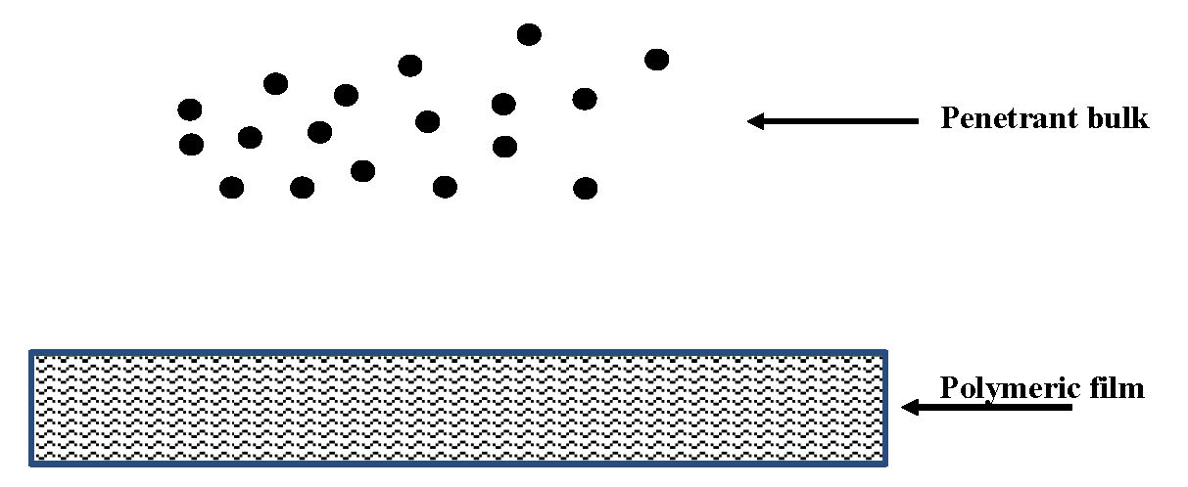

Fig. 1. Polymeric film exposed to a bulk composed of penetrants

For model development, it has been assumed that the penetrants are sorped onto polymer surface and then penetrate into polymer matrix though diffusion into the polymer matrix as shown in Fig. 2.

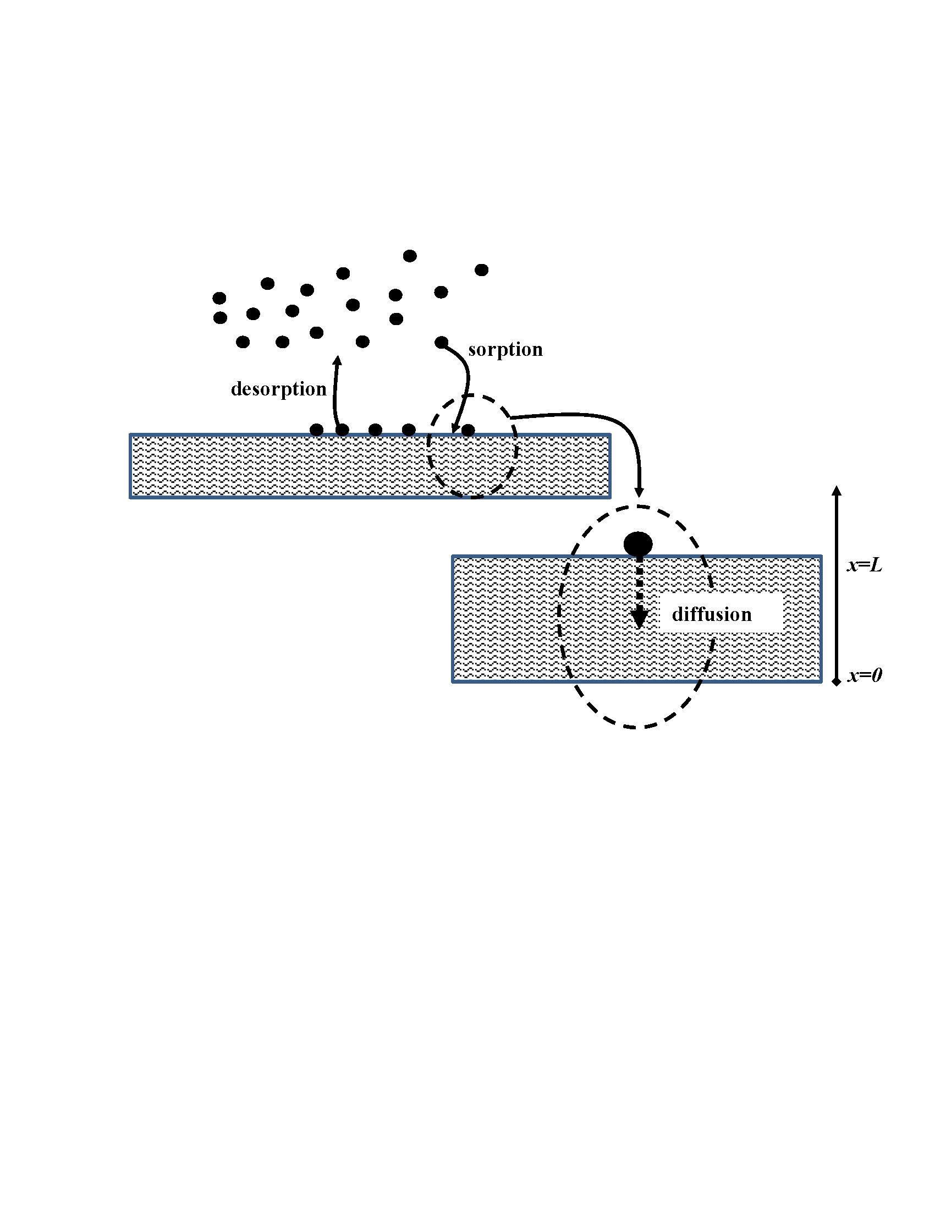

Fig. 2. Considered mechanism for model development

The sorption/desorption kinetic has been considered to follow a reversible/simultaneous reaction as shown in Eq. 1 where *A*, *S* and *AS* indicate sorbate (penetrants), sorbent (polymer) and sorbed/product (swelled polymer) respectively and *a*, *s* and *p*, respectively, are their stoichiometry constants.

|  |  |
| --- | --- |
|  | 1 |

The net depletion rate of sorbate (**) from penetrant phase, then can be written as given in Eq. 2 where superscripts *α*, *β* and *γ* are reaction order. *k1*and *k2* respectively accounts for sorption rate constant and desorption rate constant.  (to differ *CA*, concentration in solid phase, as will be defined later), *CS* and *qA* respectively indicate the concentration of sorbate, sorbent and sorbed/product.

|  |  |
| --- | --- |
|  | 2 |

The net accumulation rate of sorbate in solid phase (), then, can be related to the net depletion rate assuming a sharp interface [27] between liquid and solid phases as given in Eq. 3;

|  |  |
| --- | --- |
|  | 3 |

The concentration of sorbent (*CS*) can be substituted by, and then one might obtain Eq. 4;

|  |  |
| --- | --- |
|  | 4 |

Assuming that all the sorbed sorbate is diffused into the sorbent to maintain the sharp interface implementation [27], on may write Eq. 5;

|  |  |
| --- | --- |
|  | 5 |

For planar sorbent geometry, one may rewrite Eq. 5 as given in Eq. 6 [27,28], where *CA* is the concentration of sorbate in solid phase due to diffusion, is diffusion coefficient, *x* is diffusional mass transfer direction within the planar sorbent geometry as shown in Fig. 2.

|  |  |
| --- | --- |
|  | 6 |

Assuming an apparent reaction rate constant (*k*) and an apparent reaction order (*n*) for sorption process as an intuitive overall reaction, Eq. 6 can be rewritten as given in Eq. 7. This assumption is helpful as the real-time measurement demonstrates only the coupled effect of sorption and desorption. In addition, mathematically, this way, a unique analytical solution could be obtained as follows.

|  |  |
| --- | --- |
|  | 7 |

Prior to solution of these differential equations, appropriate boundary conditions must be introduced. Reviewing literature, it was found that for nonlinear reaction–diffusion in porous catalysts, Magyari [29] has solved similar differential equations. Thus, for planar sorbent geometry, the concentration of sorbate on the sorbent surface, the solid side of interface of liquid and solid phases, () is assigned as first boundary condition where *x=0* is located deep into the sorbent as shown in Fig. 2. For second boundary condition, it can be assumed that deep into the sorbent, the concentration of sorbate gets uniform and constant, so no diffusion could be observed, thus mathematically. For efficient solution, the obtained differential equation and boundary conditions are non-dimensionalized as given in Eq. 8 using  and, where,  accounts for the Thiele coefficient [27,30,10] which shows the ratio of sorption resistance to diffusion resistance.

|  |  |
| --- | --- |
|  | 8 |

Integrating Eq. 8, one might obtain Eq. 9 where *K* is the integration constant which by application of boundary condition is obtained as.

|  |  |
| --- | --- |
|  | 9 |

Integrating Eq. 9, one might obtain Eq. 10;

|  |  |
| --- | --- |
|  | 10 |

For the integral term () [31,32], one might write Eq. 11 where  is the Gauss hypergeometric function [31] given by Eq. 12;

|  |  |
| --- | --- |
|  | 11 |
|  | 12 |

The final solution can be rewritten as given in Eq. 13;

|  |  |
| --- | --- |
|  | 13 |

Using first boundary condition (), one may obtain Eq. 14; Thus, model equations are complete. For the practical application of model, the described method in next section must be followed.

|  |  |
| --- | --- |
|  | 14 |

## Method of model application

For the general solution obtained in previous section, one would be able to numerically calculate the concentration profile for various arbitrary chosen values of *n* and *k*. Here we performed numerical computations for 0<*n*<3 and the general graphs have been obtained as given in Fig. 3.

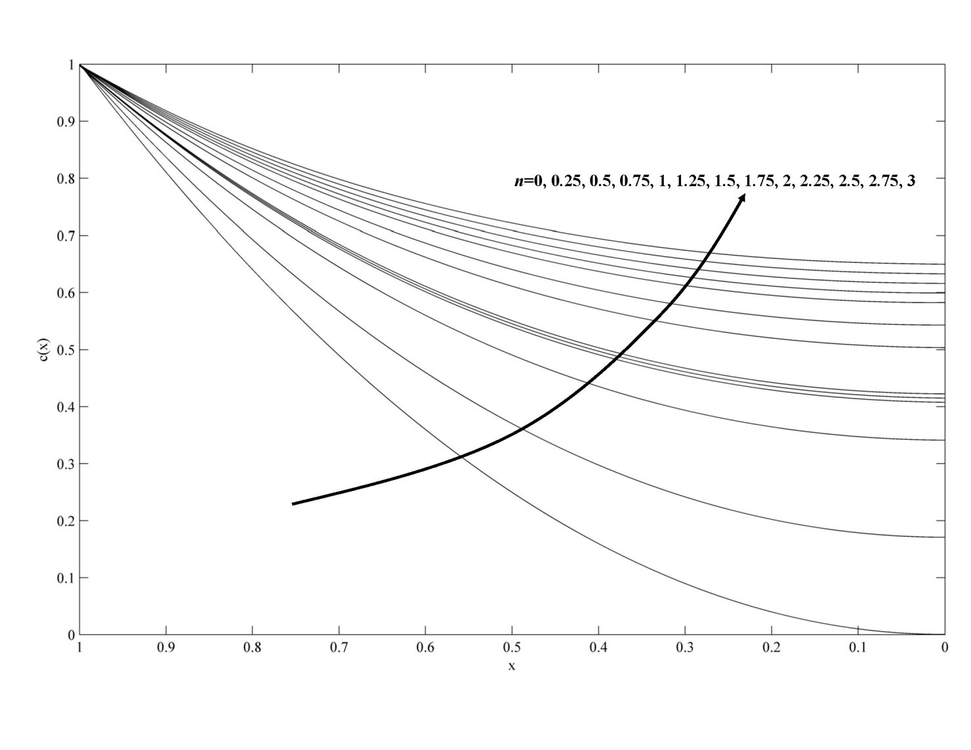

Fig. 3. The concentration profile within the sorbent

Using this general graph, then, only the experimentally measured data of sorption capacity (final equilibrium value, *qm*) must be used to find the corresponding concentration profile. In fact, the equilibrium value (*qA*) of a sorbate onto a sorbent can be related to its concentration profile as  where *A* is the sorbent surface area. Based on obtained solutions, the concentration profiles are given in terms of non-dimensionalized concentration (*c*) and non-dimensionalized depth (*X*), so one might conclude that the surface under curve *c* vs. *X* () as given in Fig. 3 corresponds to by a little of mathematical manipulation. The quantity  is referring hereinafter as non-dimensionalized sorption capacity. To find the apparent reaction order (*n*) corresponding to the known experimental sorption capacity of any system of interest, one must find the curve *c* vs. *X* for which the  is equal to.

The sorption  can be related to equilibrium sorption capacity as where  is a positive number. As sorption proceeds, the property  approaches unity i.e. indicating that. In other words,  is a parameter related to the kinetic of sorption, however, as the current paper follows a steady state methodology, this parameters and its implementation in model equations will be discussed in details in a forthcoming paper focusing on dynamic of sorption as a function of sorption time. For current study, let an upper limit of  be defined as indicating that in practical experimental timescales in laboratory, the real equilibrium might not be reached. Thus, one might conclude that.

For facilitated application of proposed method, the relationship between the apparent reaction order (*n*) and non-dimensionalized sorption was calculated and is given in Fig. 4 and an explicit relationship can be established between non-dimensionalized sorption capacity quantity i.e.  and apparent reaction order (*n*) as given in Eq. 15 and 16;

|  |  |
| --- | --- |
|  | 15 |
|  | 16 |

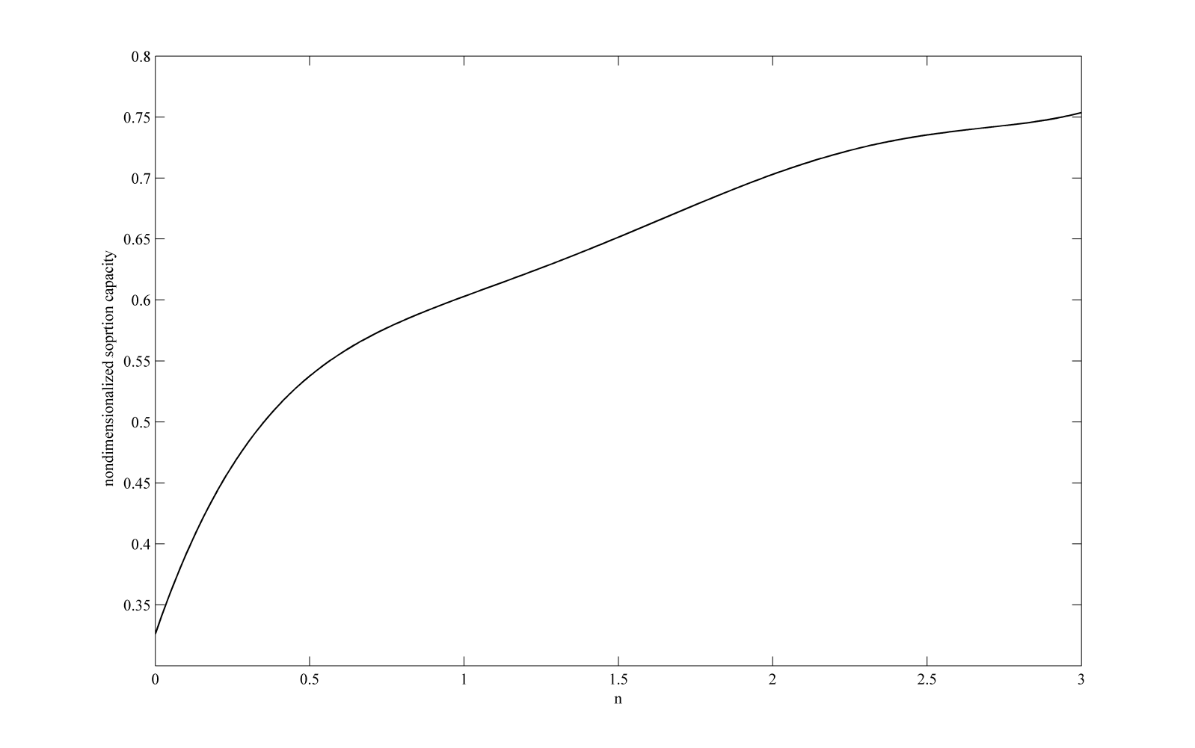

Fig. 4. Relationship between the apparent reaction order (*n*) and sorption capacity

The data of sorbent surface area and thickness are already available as the sorbent geometry and size for each system is known in Labs. However, the parameter *Csr*, concentration of sorbate on the sorbent surface, needs a simple calculation as follows. Practically, the concentration of sorbate in bulk phase is known and the concentration of sorbate on the sorbent surface (*Csr*), which is a required parameter for model application, is unknown, thus there is a required need to develop a method for determination of *Csr*. For this purpose, one might note that the sorbate is in a local equilibrium around the interface of sorbent and bulk liquid phase, for which from the solid-liquid equilibria criterion assuming bulk phase having ideal solution behavior, one might write Eq. 17 for sorbate mole fraction on the sorbent surface [33];

|  |  |
| --- | --- |
|  | 17 |

Here subscripts 1 and 2 respectively accounts for sorbate and sorbent. *z* denotes the mole fraction of sorbate on the sorbent surface which then can be simply converted to the concentration *Csr*. *R* is the universal gas constant, *Tm* indicates the melting point temperature that can be determined or estimated using methods in literatures [34-36], *T* is the system temperature and *ΔHsl* is heat of fusion or enthalpy changing of melting that can be determined or estimated using methods in literatures [34-36]. Thus, the apparent reaction order (*n*) corresponding to the coupled effect of sorption and desorption can be obtained.

The apparent reaction rate constant (*k*), then, requires that the general graphs of *c0* versus Thiele module to be used (Eq. 14). Values of *c0* can be obtained evaluating developed solutions at *x*=0 available in Fig. 3. For facilitated application of proposed method, the relationship between *c0* and *n* was obtained and given as in Fig. 5.

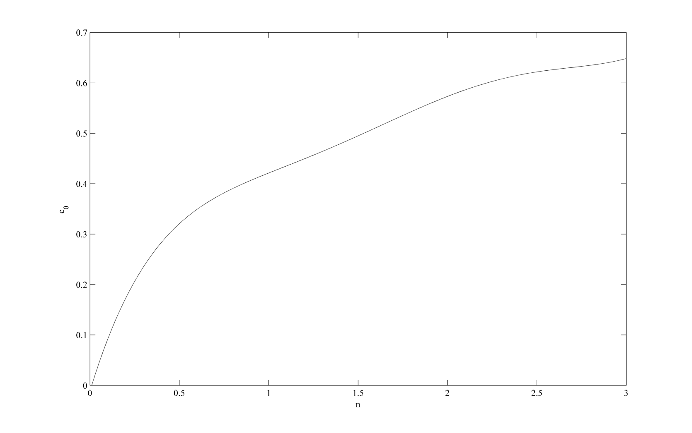

Fig. 5. Relationship between the apparent reaction order (n) and values of *c*0

Thiele module can be calculated for various apparent reaction rate constant as  utilizing the calculated apparent reaction order and the sorption system characteristics such as sorbent bed length, sorbate concentration on sorbent surface (which can be determined using the concentration profiles) and etc. Therefore, having the values of apparent reaction order (*n*) and value of *c0*, then the corresponding apparent reaction rate constant (*k*) could be determined bases on the corresponding  value as shown in Fig. 6.

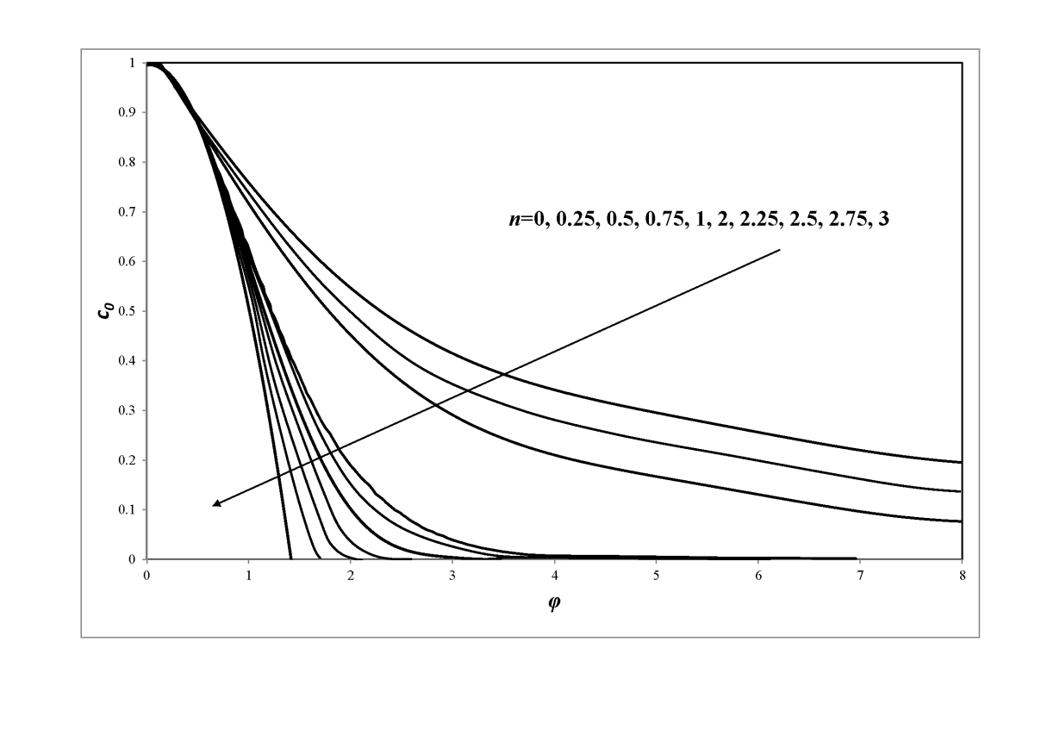

Fig. 6. Relationship between *n* and *c*0 to obtain apparent reaction rate constant in terms of

To sum up, the model application follows steps listed below;

1. From literature or using available prediction methods, find and list the sorbate data including melting point temperature (*Tm*), heat of fusion or enthalpy changing of melting (*ΔHsl*), diffusion coefficient (*D*),
2. From literature or using available prediction methods, find and list the sorbent data including equilibrium sorption capacity, film thickness (*L*) and surface area (*A*),
3. From Eq. 17, calculate sorbate mole fraction on the sorbent surface (*z*), then convert *z* to concentration *Csr*,
4. Calculate quantity  i.e. non-dimensionalized sorption capacity,
5. Find the corresponding apparent reaction order (*n*) using value of non-dimensionalized sorption capacity in Fig. 4,
6. Find the corresponding *c0* using value of apparent reaction order in Fig. 5,
7. Find the corresponding Thiele module (), using value of apparent reaction order and *c0*in Fig. 6,
8. Calculate the apparent reaction rate constant as  given by definition of Thiele module (),

# Collected systems data

The equilibrium sorption of various liquids (water, linear alcohols, linear alkanes, derivates of cyclohexane, aromates, 1-chlorohexane, chlorobenzene, benzoyl chloride, and nitrobenzene) into the low density polyethylene (LDPE) membrane at three temperatures (15, 25, and 35 °C) were collected [26] and used for validation of model calculations. Randová et al. [26] have carried out gravimetric sorption measurements on circularly cut LDPE polymer samples (area~25 cm2, weight~0.11 gr, thickness=0.046 mm) at the temperatures 15, 25, 35 °C and at atmospheric pressure, where the samples were exposed to 40 cm3 of the penetrant bulk. Table 1 and Table 2 summarize the amount of sorbed penetrants for each experiment and the required components data for model calculations.

Table 1. Experimental sorption data and the required components data for model calculations

|  |  |  |  |  |  |  |  |  |  |
| --- | --- | --- | --- | --- | --- | --- | --- | --- | --- |
| **No.** | **Sorbate** | | **Sorbed amount (*gr*) [26]** | | |  |  |  |  |
| **Name** | **CAS #** | **288.15 (K)** | **298.15 (K)** | **308.15 (K)** | **Mw (gr/mol) a** | **δ (MPa1/2)a** | **Tm (K)** | **ΔHsl (kJ/mol) b** |
| 1 | 1-HEPTANOL | 111-70-6 | 0.007513 | 0.011704 | 0.016181 | 116.2013 | 21.6 | 238.55 | -403.4 |
| 2 | 1-HEXANOL | 111-27-3 | 0.006138 | 0.008998 | 0.013002 | 102.18 | 22.1 | 220.15 | -377.5 |
| 3 | 1-OCTANOL | 111-87-5 | 0.009009 | 0.013464 | 0.018271 | 130.23 | 21.1 | 257.15 | -426.6 |
| 4 | 1-PENTANOL | 71-41-0 | 0.004895 | 0.00737 | 0.010142 | 88.15 | 22.8 | 195.15 | -351.6 |
| 5 | 1-PROPANOL | 71-23-8 | 0.002849 | 0.004334 | 0.005918 | 60.10 | 25.0 | 147.15 | -302.5 |
| 6 | BENZENE | 71-43-2 | 0.017798 | 0.026356 | 0.039622 | 78.11 | 18.7 | 278.68 | 49 |
| 7 | BENZOYL-CHLORIDE | 98-88-4 | – | 0.008943 | – | 124.453 | - | 272.15 | -157.3 |
| 8 | CHLOROBENZENE | 108-90-7 | – | 0.021945 | – | 112.56 | 19.8 | 228.15 | 11.5 |
| 9 | CYCLOHEXANE | 110-82-7 | 0.021813 | 0.032494 | 0.043945 | 84.16 | 18.0 | 289.85 | -157.7 |
| 10 | ETHANOL | 64-17-5 | 0.002035 | 0.002838 | 0.003993 | 46.07 | 26.0 | 159.15 | -276 |
| 11 | ETHYLBENZENE | 100-41-4 | 0.012848 | 0.017875 | 0.027192 | 106.17 | 18.0 | 178.15 | -12.5 |
| 12 | ETHYLCYCLOHEXANE | 1678-91-7 | 0.015752 | 0.020592 | 0.028303 | 112.22 | 16.3 | 162.05 | -213 |
| 13 | METHANOL | 67-56-1 | 0.000814 | 0.001199 | 0.001925 | 32.04 | 29.7 | 175.55 | -238.4 |
| 14 | METHYLCYCLOHEXANE | 108-87-2 | 0.014971 | 0.025916 | 0.035398 | 98.19 | 16.0 | 146.85 | -190.2 |
| 15 | N-BUTANOL | 71-36-3 | 0.003773 | 0.006105 | 0.008613 | 74.12 | 23.8 | 183.35 | -328 |
| 16 | N-HEPTANE | 142-82-5 | 0.011385 | 0.019008 | 0.025872 | 100.21 | 15.2 | 182.15 | -224.4 |
| 17 | N-HEXANE | 110-54-3 | 0.013563 | 0.02233 | 0.030921 | 86.18 | 14.9 | 177.15 | -198.7 |
| 18 | NITROBENZENE | 98-95-3 | – | 0.002277 | – | 123.06 | 22.7 | 278.85 | 12.5 |
| 19 | N-OCTANE | 111-65-9 | 0.008052 | 0.012199 | 0.016852 | 114.23 | 15.5 | 398.25 | -250.3 |
| 20 | N-PENTANE | 109-66-0 | 0.023067 | 0.036146 | – | 72.15 | 14.3 | 309.05 | -173.5 |
| 21 | TOLUENE | 108-88-3 | 0.015235 | 0.023386 | 0.033077 | 92.14 | 18.2 | 178.15 | 12 |
| 22 | WATER | 7732-18-5 | 0.000308 | 0.000319 | 0.000495 | 18.015 | 47.9 | 273.15 | -285.8 |
| a obtained from [34-36]; b obtained from [37] | | | | | | | | | |

Table 2. Required data of low density polyethylene (LDPE) for model calculations

|  |  |  |  |  |  |  |  |
| --- | --- | --- | --- | --- | --- | --- | --- |
| **Name** | **Chemical formula** | **Mw (gr/mol)** | **δ (MPa1/2) a** | **Tm (K) a** | **ΔHsl (kJ/mol) a** | **L (mm)** | **A (cm2)** |
| (LDPE | -C37H76- | 521.015 | 17.0 | 414.6 | 8.22 | 0.046 | 25 |
| a obtained from [36] | | | | | |  |  |

# Results and discussion

In order to use Eq. 16 and/or Fig. 4 to obtain the apparent reaction orders, the calculation of *Csr* is required. The calculated *Csr* (gr/gr polymer) using data listed in Table 1 and Table 2 are summarized in Table 3.

Table 3. Calculation of *Csr* as given by Eq. 17

|  |  |  |  |  |  |  |
| --- | --- | --- | --- | --- | --- | --- |
| **Name** | **z1 a** | | | **m1 b (105)** | | |
| **288.15 (K)** | **298.15 (K)** | **308.15 (K)** | **288.15 (K)** | **298.15 (K)** | **308.15 (K)** |
| 1-HEPTANOL | 0.031353 | 0.023925 | 0.018682 | 0.0535 | 0.0405 | 0.0314 |
| 1-HEXANOL | 0.022512 | 0.018043 | 0.014607 | 0.0433 | 0.0345 | 0.0278 |
| 1-OCTANOL | 0.051799 | 0.035621 | 0.026008 | 0.0805 | 0.0544 | 0.0394 |
| 1-PENTANOL | 0.015727 | 0.013076 | 0.010897 | 0.0348 | 0.0288 | 0.024 |
| 1-PROPANOL | 0.009263 | 0.007973 | 0.006841 | 0.0299 | 0.0257 | 0.022 |
| BENZENE | 0.600692 | 0.402498 | 0.289128 | 3.6965 | 1.6553 | 0.9994 |
| BENZOYL-CHLORIDE | *0.37264* | 0.182073 | *0.11334* | *0.916* | 0.3433 | *0.1971* |
| CHLOROBENZENE | *0.45295* | 0.39525 | *0.3433* | *1.4119* | 1.1145 | *0.8914* |
| CYCLOHEXANE | 0.730356 | 1.047049 | 0.269514 | 6.1771 | 50.7526 | 0.8414 |
| ETHANOL | 0.011871 | 0.010148 | 0.008657 | 0.0501 | 0.0427 | 0.0364 |
| ETHYLBENZENE | 0.481865 | 0.378443 | 0.301565 | 1.6812 | 1.1007 | 0.7806 |
| ETHYLCYCLOHEXANE | 0.015896 | 0.013552 | 0.011534 | 0.0276 | 0.0235 | 0.02 |
| METHANOL | 0.017206 | 0.01454 | 0.012281 | 0.1049 | 0.0884 | 0.0745 |
| METHYLCYCLOHEXANE | 0.014426 | 0.0124 | 0.010627 | 0.0286 | 0.0245 | 0.021 |
| N-BUTANOL | 0.014091 | 0.011847 | 0.009965 | 0.037 | 0.031 | 0.0261 |
| N-HEPTANE | 0.020112 | 0.016899 | 0.014206 | 0.0393 | 0.0329 | 0.0276 |
| N-HEXANE | 0.021089 | 0.017784 | 0.014995 | 0.048 | 0.0403 | 0.0339 |
| NITROBENZENE | *0.85735* | 0.72729 | *0.61624* | *9.3736* | 4.1595 | *2.5045* |
| N-OCTANE | 0.034461 | 0.034952 | 0.035535 | 0.06 | 0.0609 | 0.0619 |
| N-PENTANE | 0.175622 | 0.273603 | *0.80676* | 0.5667 | 1.002 | *11.1062* |
| TOLUENE | 0.252424 | 0.22181 | 0.193878 | 0.7034 | 0.5937 | 0.501 |
| WATER | 0.190729 | 0.09732 | 0.061594 | 2.5109 | 1.1486 | 0.6993 |
| a as given in Eq. 17 (mol.%); b concentration of sorbate on sorbent surface (gr/gr polymer); *text in italic*: no experimental sorption data reported | | | | | | |

Using LDPE polymer samples data including area~25 cm2 and thickness=0.046 mm, employing the calculated *Csr* and the reported sorption capacity data, the apparent reaction order can be obtained using MATLAB software as listed in Table 4.

Table 4. Results obtained for apparent reaction order

|  |  |  |  |  |
| --- | --- | --- | --- | --- |
| **Compound Name** | **T (K)** | ***n*** |  |  |
| **Set #1** | **Set #2** | **Set #3** |
| 1-HEPTANOL | 288.15 | 5.221136441 | -0.321547738 | -0.70321781 |
|  | 298.15 | 5.22113644 | -0.321547748 | -0.70321779 |
|  | 308.15 | 5.22113644 | -0.321547752 | -0.70321778 |
| 1-HEXANOL | 288.15 | 5.221136441 | -0.321547719 | -0.703217848 |
|  | 298.15 | 5.221136441 | -0.321547725 | -0.703217836 |
|  | 308.15 | 5.221136441 | -0.321547732 | -0.703217821 |
| 1-OCTANOL | 288.15 | 5.22113644 | -0.321547782 | -0.703217719 |
|  | 298.15 | 5.221136439 | -0.321547783 | -0.703217716 |
|  | 308.15 | 5.22113644 | -0.321547781 | -0.703217721 |
| 1-PENTANOL | 288.15 | 5.221136441 | -0.321547705 | -0.703217876 |
|  | 298.15 | 5.221136441 | -0.321547711 | -0.703217864 |
|  | 308.15 | 5.221136441 | -0.321547716 | -0.703217854 |
| 1-PROPANOL | 288.15 | 5.221136442 | -0.321547694 | -0.703217899 |
|  | 298.15 | 5.221136442 | -0.321547697 | -0.703217893 |
|  | 308.15 | 5.221136441 | -0.3215477 | -0.703217887 |
| BENZENE | 288.15 | 5.221136227 | -0.321556763 | -0.703199334 |
|  | 298.15 | 5.2211363 | -0.321553703 | -0.703205597 |
|  | 308.15 | 5.221136313 | -0.321553148 | -0.703206735 |
| BENZOYL-CHLORIDE | 298.15 | 5.221136432 | -0.321548106 | -0.703217056 |
| CHLOROBENZENE | 298.15 | 5.221136362 | -0.321551058 | -0.703211013 |
| CYCLOHEXANE | 288.15 | 5.221136003 | -0.32156628 | -0.703179849 |
|  | 298.15 | 5.221131067 | -0.321775456 | -0.702751626 |
|  | 308.15 | 5.221136321 | -0.321552785 | -0.703207476 |
| ETHANOL | 288.15 | 5.221136442 | -0.321547696 | -0.703217894 |
|  | 298.15 | 5.221136441 | -0.321547699 | -0.70321789 |
|  | 308.15 | 5.221136441 | -0.321547702 | -0.703217882 |
| ETHYLBENZENE | 288.15 | 5.221136371 | -0.321550663 | -0.703211821 |
|  | 298.15 | 5.221136378 | -0.321550398 | -0.703212364 |
|  | 308.15 | 5.221136373 | -0.321550612 | -0.703211925 |
| ETHYLCYCLOHEXANE | 288.15 | 5.22113644 | -0.321547742 | -0.703217801 |
|  | 298.15 | 5.22113644 | -0.321547749 | -0.703217787 |
|  | 308.15 | 5.22113644 | -0.32154776 | -0.703217764 |
| METHANOL | 288.15 | 5.221136442 | -0.321547694 | -0.703217899 |
|  | 298.15 | 5.221136442 | -0.321547697 | -0.703217893 |
|  | 308.15 | 5.221136441 | -0.321547702 | -0.703217884 |
| METHYLCYCLOHEXANE | 288.15 | 5.22113644 | -0.321547741 | -0.703217802 |
|  | 298.15 | 5.22113644 | -0.32154777 | -0.703217744 |
|  | 308.15 | 5.221136439 | -0.321547785 | -0.703217713 |
| N-BUTANOL | 288.15 | 5.221136441 | -0.321547702 | -0.703217884 |
|  | 298.15 | 5.221136441 | -0.321547708 | -0.70321787 |
|  | 308.15 | 5.221136441 | -0.321547713 | -0.703217861 |
| N-HEPTANE | 288.15 | 5.22113644 | -0.321547744 | -0.703217798 |
|  | 298.15 | 5.22113644 | -0.321547768 | -0.703217747 |
|  | 308.15 | 5.22113644 | -0.32154778 | -0.703217722 |
| N-HEXANE | 288.15 | 5.22113644 | -0.321547772 | -0.703217739 |
|  | 298.15 | 5.221136439 | -0.321547807 | -0.703217669 |
|  | 308.15 | 5.221136438 | -0.321547827 | -0.703217627 |
| NITROBENZENE | 298.15 | 5.221136411 | -0.32154899 | -0.703215247 |
| N-OCTANE | 288.15 | 5.22113644 | -0.321547749 | -0.703217787 |
|  | 298.15 | 5.221136439 | -0.321547785 | -0.703217713 |
|  | 308.15 | 5.221136438 | -0.321547826 | -0.703217629 |
| N-PENTANE | 288.15 | 5.221136399 | -0.321549486 | -0.70321423 |
|  | 298.15 | 5.221136324 | -0.321552681 | -0.70320769 |
| TOLUENE | 288.15 | 5.221136407 | -0.321549161 | -0.703214895 |
|  | 298.15 | 5.221136397 | -0.321549599 | -0.703214 |
|  | 308.15 | 5.221136388 | -0.321549969 | -0.703213241 |
| WATER | 288.15 | 5.221136439 | -0.321547789 | -0.703217705 |
|  | 298.15 | 5.221136441 | -0.321547732 | -0.703217821 |
|  | 308.15 | 5.221136441 | -0.32154773 | -0.703217825 |

Using the obtained apparent reaction orders, the apparent reaction rate constants can be calculated as listed in Table 5.

Table 5. Results obtained for apparent reaction rate constant

|  |  |  |  |  |
| --- | --- | --- | --- | --- |
| **Compound Name** | **T (K)** | ***k (*s-1*)*** | | |
| **Set #1** | **Set #2** | **Set #3** |
| 1-HEPTANOL | 288.15 | 3.001E-13 | 0.178201563 | 1.152523971 |
|  | 298.15 | 1.949E-12 | 0.099194122 | 0.541682569 |
|  | 308.15 | 7.650E-12 | 0.064652071 | 0.311997718 |
| 1-HEXANOL | 288.15 | 1.278E-13 | 0.232769206 | 1.62618365 |
|  | 298.15 | 6.425E-13 | 0.140407793 | 0.847681179 |
|  | 308.15 | 3.039E-12 | 0.086322318 | 0.4528444 |
| 1-OCTANOL | 288.15 | 6.458E-13 | 0.140181312 | 0.845918607 |
|  | 298.15 | 3.521E-12 | 0.082429624 | 0.426698691 |
|  | 308.15 | 1.277E-11 | 0.055063226 | 0.253684961 |
| 1-PENTANOL | 288.15 | 4.918E-14 | 0.313905932 | 2.390848212 |
|  | 298.15 | 2.767E-13 | 0.182785171 | 1.190871683 |
|  | 308.15 | 1.065E-12 | 0.119867181 | 0.691358605 |
| 1-PROPANOL | 288.15 | 5.007E-15 | 0.641863713 | 6.010503827 |
|  | 298.15 | 2.942E-14 | 0.368690139 | 2.941647269 |
|  | 308.15 | 1.096E-13 | 0.244272488 | 1.730489444 |
| BENZENE | 288.15 | 1.144E-11 | 0.057007405 | 0.265255319 |
|  | 298.15 | 5.998E-11 | 0.033930483 | 0.135914056 |
|  | 308.15 | 3.353E-10 | 0.019796986 | 0.067873724 |
| BENZOYL-CHLORIDE | 298.15 | 6.261E-13 | 0.141550353 | 0.856576588 |
| CHLOROBENZENE | 298.15 | 2.769E-11 | 0.043222234 | 0.185674814 |
| CYCLOHEXANE | 288.15 | 2.699E-11 | 0.043570767 | 0.187570249 |
|  | 298.15 | 1.452E-10 | 0.025748951 | 0.095000756 |
|  | 308.15 | 5.191E-10 | 0.017264908 | 0.056898948 |
| ETHANOL | 288.15 | 1.210E-15 | 1.001285665 | 10.66101984 |
|  | 298.15 | 4.926E-15 | 0.645153581 | 6.050236616 |
|  | 308.15 | 2.082E-14 | 0.410860968 | 3.382263258 |
| ETHYLBENZENE | 288.15 | 2.890E-12 | 0.087693451 | 0.462116189 |
|  | 298.15 | 1.165E-11 | 0.056681642 | 0.263325936 |
|  | 308.15 | 6.843E-11 | 0.032558377 | 0.128877173 |
| ETHYLCYCLOHEXANE | 288.15 | 6.830E-12 | 0.066989144 | 0.326608451 |
|  | 298.15 | 2.116E-11 | 0.047013806 | 0.206936051 |
|  | 308.15 | 8.103E-11 | 0.030879825 | 0.12038266 |
| METHANOL | 288.15 | 2.529E-17 | 3.360893055 | 50.76651012 |
|  | 298.15 | 1.297E-16 | 2.014546428 | 26.24852687 |
|  | 308.15 | 9.570E-16 | 1.077585705 | 11.71935304 |
| METHYLCYCLOHEXANE | 288.15 | 5.510E-12 | 0.071645789 | 0.356158082 |
|  | 298.15 | 5.587E-11 | 0.034693108 | 0.139873899 |
|  | 308.15 | 2.083E-10 | 0.022976901 | 0.082243699 |
| N-BUTANOL | 288.15 | 1.639E-14 | 0.442814142 | 3.725013664 |
|  | 298.15 | 1.250E-13 | 0.234433424 | 1.641183864 |
|  | 308.15 | 5.342E-13 | 0.148761112 | 0.913228221 |
| N-HEPTANE | 288.15 | 1.735E-12 | 0.102883609 | 0.56778729 |
|  | 298.15 | 1.510E-11 | 0.052259497 | 0.237161139 |
|  | 308.15 | 5.547E-11 | 0.034771105 | 0.140279293 |
| N-HEXANE | 288.15 | 3.632E-12 | 0.081635411 | 0.421407535 |
|  | 298.15 | 2.979E-11 | 0.042239618 | 0.180260013 |
|  | 308.15 | 1.177E-10 | 0.027472594 | 0.103543847 |
| NITROBENZENE | 298.15 | 1.944E-15 | 0.863121065 | 8.803940067 |
| N-OCTANE | 288.15 | 4.020E-13 | 0.162609406 | 1.024234622 |
|  | 298.15 | 2.322E-12 | 0.09390992 | 0.504782123 |
|  | 308.15 | 9.081E-12 | 0.061272051 | 0.291136067 |
| N-PENTANE | 288.15 | 3.417E-11 | 0.040465578 | 0.170558876 |
|  | 298.15 | 2.275E-10 | 0.022350994 | 0.079363421 |
| TOLUENE | 288.15 | 5.932E-12 | 0.070010072 | 0.345706297 |
|  | 298.15 | 3.621E-11 | 0.039737736 | 0.16661518 |
|  | 308.15 | 1.565E-10 | 0.02513146 | 0.092312439 |
| WATER | 288.15 | 4.182E-19 | 12.14075052 | 265.7419336 |
|  | 298.15 | 4.850E-19 | 11.59057533 | 250.3245894 |
|  | 308.15 | 3.099E-18 | 6.485366081 | 118.4417577 |

As mentioned in the model development, an apparent reaction order (*n*) and apparent reaction rate constant (*k*) have been used which are interrelated to sorption real reaction order and desorption real reaction order as given in Eq. 18;

|  |  |
| --- | --- |
|  | 18 |

While the apparent reaction order and apparent reaction rate constant can be simply obtained following the method presented and illustrated in previous section for calculation of right side of Eq. 18, the values for reaction order (*α*, *β* and *γ* )and reaction rate constants (*k1* and *k2*) must be determined using regression of experimental data.

Close to equilibrium, one might assume that *k*=*k1*=*k2*, so Eq. 18 reads;

|  |  |
| --- | --- |
|  | 19 |

As a side, the sorption  was be related to equilibrium sorption capacity as , thus, Eq. 19 reads;

|  |  |
| --- | --- |
|  | 20 |

The concentration of sorbate in penetrant bulk phase , considering a local equilibrium around the interface of sorbent and bulk liquid phase, following the same procedure given to obtain Eq. 17 [33], can be obtained as given in Eq. 21;

|  |  |
| --- | --- |
|  | 21 |

Here, again, subscripts 1 and 2 respectively accounts for sorbate and sorbent. *z* denotes the mole fraction of sorbate in penetrate bulk phase i.e. . *R* is the universal gas constant, *Tm* indicates the melting point temperature that can be determined or estimated using methods in literatures [34-36], *T* is the system temperature and *ΔHsl* is heat of fusion or enthalpy changing of melting that can be determined or estimated using methods in literatures [34-36]. For the present considered systems, the penetrant bulk phase is pure and consequently, one might conclude *z*=1 and =*MwA*.

In such circumstance, without the loss of generality, one might replace *CA* with its spatial average value. Thus, Eq. 20 can be rewritten as Eq. 22;

|  |  |
| --- | --- |
|  | 22 |

From the definition, one might write Eq. 23;

|  |  |
| --- | --- |
|  | 23 |

Inserting the non-dimensional concentration and depth in Eq. 23, one obtains Eq. 24;

|  |  |
| --- | --- |
|  | 24 |

As discussed in previous sections, the integral term  is equal to, so one obtains. Thus Eq. 22 can be rewritten as given in Eq. 25;

|  |  |
| --- | --- |
|  | 25 |

Using LDPE polymer samples data including area~25 cm2 and thickness=0.046 mm, penetrants *Mw*, employing the calculated *Csr* and the reported sorption capacity data, the values of *α*, *β* and *γ* can be calculated. To obtain these unknowns, a nonlinear regression method can be used. However, due to the high nonlinearity and the risk of ill-calculated values due to local optimal solution of system of equations, a more versatile and computationally efficient method must be employed. Thus, due to the outstanding performance of evolutionary algorithms such as genetic algorithm (GA) and/or particle swarm optimization (PSO); one might use such highly reliable techniques. For details of application of these techniques, one might refer to literatures [38]. Generally speaking, some initial guesses for the five unknowns are generated in GA and/or PSO, which is then monitored by operators implemented in algorithms toward the best global optimal solution. The main criterion to select optimal values is that the obtained values must satisfy Eq. 25. For current work, the PSO code was used which is already accessible in Ref. [38]. The average of obtained orders over all the experiments temperatures are also provided in Table S1 and visually illustrated in Fig. 7. Overall values of 0.95, 1.74 and 1.68 can be obtained respectively for *α*, *β* and *γ* using regression of averaged values.

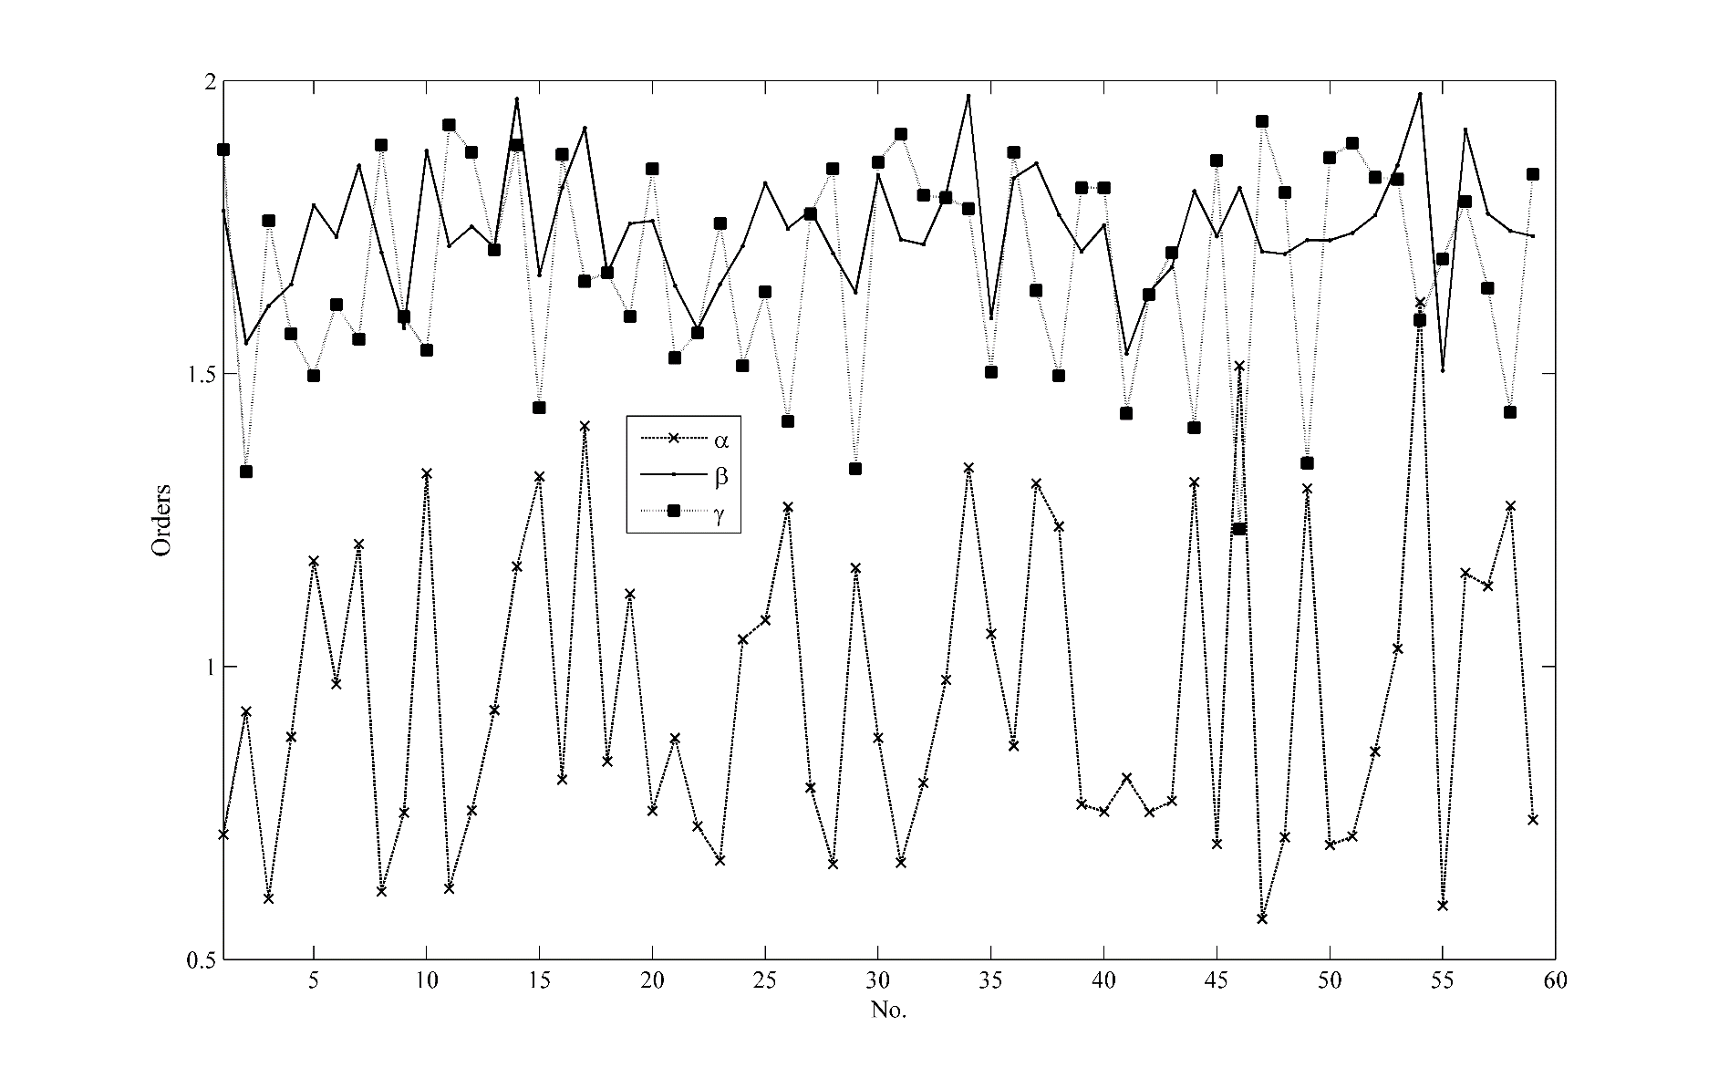

Fig. 7. Averaged orders of *α*, *β* and *γ* for each compound indicated by their No. in tables

As seen, the obtained model was successfully applied to a number of sorption data in LDPE, and following a graphical approach, we were able to determine the order of sorption and desorption reactions. Due to the final assumption made on the model, the real reaction rate constant of individual sorption and desorption mechanism could not be obtained but as assumed *k*=*k1*=*k2*. This point will be investigated more in details in our ongoing research to develop an alternative to calculate *k1* and *k2*.

# Conclusion

An alternative model on sorption process of solvents into polymers was developed which includes both sorption and desorption mechanisms. The model was given in terms of Gauss hypergeometric function and presented in graphical form for facilitated applications. The sorption of various liquids (water, linear alcohols, linear alkanes, derivates of cyclohexane, aromates, 1-chlorohexane, chlorocyclohexane, chlorobenzene, benzoyl chloride, and nitrobenzene) into the low density polyethylene membrane at three temperatures (15, 25, and 35 °C) has been used for validation of calculations. Simply the introduced apparent reaction order and reaction rate constant can be calculated, based on which one might readily access to the sorption and desorption individual reaction orders. The computational cost of proposed method is small and much of calculations are provided in the form of graphical diagrams. The reliability of method was successfully examined and it showed potential for further uses.

References

1. L. J. Zeman, Zydney AL (1996) Microfiltration and Ultrafiltration: Principles and Applications. CRC Press,

2. Donald R. Paul, Yampol'skii YP (1993) Polymeric Gas Separation Membranes. CRC Press, USA

3. Basic aspects of membrane science and engineering (2010), vol 1. Comprehensive Membrane Science and Engineering, First edition edn. Elsevier, Italy

4. Mulder M (1996) Basic Principles of Membrane Technology. 2 edn. Springer Netherlands, Kluwer, Netherlands, Dordrecht

5. Membrane and Desalination Technologies (2011), vol 13. Handbook of Environmental Engineering. Springer New York Dordrecht Heidelberg London, New York, NY 10013, USA. doi:10.1007/978-1-59745-278-6

6. Thompson JM, Hsieh CH, Luthy RG (2015) Modeling uptake of hydrophobic organic contaminants into polyethylene passive samplers. Environ Sci Technol 49 (4):2270-2277. doi:10.1021/es504442s

7. Ernest J. Henley, Seader JD (1981) Equilibrium-Stage Separation Operations in Chemical Engineering. John Wiley & Sons, Inc.,

8. Seader JD, Henley EJ, Roper DK (2010) Separation Process Principles: Chemical and Biochemical Operations. 3rd ed. edn. John Wiley & Sons, Inc.,

9. Tosun I (2007) Modeling in Transport Phenomena : A Conceptual Approach. 2 edn. Elsevier,

10. Treybal RE (1980) Mass Transfer Operations. McGraw-Hill Chemical Engineering Series, 3rd edn. McGraw-Hill,

11. Asgarpour Khansary M, Shirazian S, Asadollahzadeh M (2017) Polymer-water partition coefficients in polymeric passive samplers. Environ Sci Pollut Res Int 24 (3):2627-2631. doi:10.1007/s11356-016-8029-7

12. Ghasemi A, Asgarpour Khansary M, Aroon MA (2017) A comparative theoretical and experimental study on liquid-liquid equilibria of membrane forming polymeric solutions. Fluid Phase Equilibria 435:60-72. doi:10.1016/j.fluid.2016.12.005

13. Keshavarz L, Khansary MA, Shirazian S (2015) Phase diagram of ternary polymeric solutions containing nonsolvent/solvent/polymer: Theoretical calculation and experimental validation. Polymer 73:1-8. doi:10.1016/j.polymer.2015.07.027

14. Ali Aroon M, Khansary MA (2017) Generalized similarity transformation method applied to partial differential equations (PDEs) in falling film mass transfer. Computers & Chemical Engineering 101:73-80. doi:10.1016/j.compchemeng.2017.02.047

15. Ho YS, McKay G (1998) A Comparison of Chemisorption Kinetic Models Applied to Pollutant Removal on Various Sorbents. Process Safety and Environmental Protection 76 (4):332-340. doi:10.1205/095758298529696

16. Du X, Yuan Q, Zhao J, Li Y (2007) Comparison of general rate model with a new model--artificial neural network model in describing chromatographic kinetics of solanesol adsorption in packed column by macroporous resins. Journal of chromatography A 1145 (1-2):165-174. doi:10.1016/j.chroma.2007.01.065

17. Malek A, Farooq S (1996) Comparison of isotherm models for hydrocarbon adsorption on activated carbon. AIChE Journal 42 (11):3191-3201. doi:10.1002/aic.690421120

18. Qiu H, Lv L, Pan B-c, Zhang Q-j, Zhang W-m, Zhang Q-x (2009) Critical review in adsorption kinetic models. Journal of Zhejiang University SCIENCE A 10 (5):716-724. doi:10.1631/jzus.A0820524

19. Ho YS (2006) Review of second-order models for adsorption systems. Journal of hazardous materials 136 (3):681-689. doi:10.1016/j.jhazmat.2005.12.043

20. Plazinski W, Rudzinski W, Plazinska A (2009) Theoretical models of sorption kinetics including a surface reaction mechanism: a review. Advances in colloid and interface science 152 (1-2):2-13. doi:10.1016/j.cis.2009.07.009

21. Izák P, Bartovská L, Friess K, Šı́pek M, Uchytil P (2003) Comparison of various models for transport of binary mixtures through dense polymer membrane. Polymer 44 (9):2679-2687. doi:<http://dx.doi.org/10.1016/S0032-3861(03)00137-X>

22. Randová A, Bartovská L, Hovorka Š, Friess K, Izák P (2009) The membranes (Nafion and LDPE) in binary liquid mixtures benzene + methanol – sorption and swelling. European Polymer Journal 45 (10):2895-2901. doi:<http://dx.doi.org/10.1016/j.eurpolymj.2009.06.023>

23. Friess K, Jansen JC, Vopička O, Randová A, Hynek V, Šípek M, Bartovská L, Izák P, Dingemans M, Dewulf J, Van Langenhove H, Drioli E (2009) Comparative study of sorption and permeation techniques for the determination of heptane and toluene transport in polyethylene membranes. Journal of Membrane Science 338 (1–2):161-174. doi:<http://dx.doi.org/10.1016/j.memsci.2009.04.030>

24. Randová A, Bartovská L, Hovorka Š, Izák P, Poloncarzová M, Bartovský T (2010) Low-density polyethylene in mixtures of hexane and benzene derivates. Chemical Papers 64 (5):652-656. doi:10.2478/s11696-010-0038-2

25. Randová A, Bartovská L, Hovorka Š, Izák P, Friess K, Janků J (2011) Sorption of binary mixtures of toluene + lower aliphatic alcohols C1 – C6 in low-density polyethylene. Journal of Applied Polymer Science 119 (3):1781-1787. doi:10.1002/app.32878

26. Randová A, Bartovská L, Friess K, Hovorka Š, Izák P (2014) Fundamental study of sorption of pure liquids and liquid mixtures into polymeric membrane. European Polymer Journal 61:64-71. doi:10.1016/j.eurpolymj.2014.09.021

27. Bird RB, Stewart WE, Lightfoot EN (2006) Transport Phenomena. John Wiley & Sons, Inc.,

28. Taylor R, Krishna R (1993) Multicomponent mass transfer. Wiley series in chemical engineering. John Wiley & Sons, Inc.,

29. Magyari E (2008) Exact analytical solution of a nonlinear reaction–diffusion model in porous catalysts. Chemical Engineering Journal 143 (1-3):167-171. doi:10.1016/j.cej.2008.03.018

30. Prieve DC (2000) Unit Operations of Chemical Engineering. Department of Chemical Engineering, Carnegie Mellon University, Pittsburgh, PA 15213

31. Murray R. Spiegel, Liu J (1999) Mathematical Handbook of Formulas and Tables. McGraw Hill Professional,

32. Polyanin AD, Zaitsev VF (2002) Handbook of Exact Solutions for Ordinary Differential Equations Second. 2nd ed. edn. CRC Press,

33. J.M. Smith, H. Van Ness, Abbott M (2005) Introduction to Chemical Engineering Thermodynamics. 7 edn. McGraw-Hill, New York

34. Poling BE, Prausnitz JM, O'Connell JP (1987) Properties of Gases and Liquids. 4 edn. McGraw-Hill Professional,

35. van Krevelen DW, Nijenhuis KT (2008) Properties of Polymers: Their Correlation with Chemical Structure; Their Numerical Estimation and Prediction from Additive Group Contributions. 4 edn. Elsevier,

36. Wohlfarth C (2010) Polymers: Group VIII: Advanced Materials and Technologies, vol 6. Landolt-Börnstein

Numerical Data and Functional Relationships in Science and Technology. Springer-Verlag Berlin Heidelberg, Germany

37. NIST Chemistry WebBook: NIST Standard Reference Database. (2016). <http://webbook.nist.gov>. Accessed 2016

38. Asgarpour Khansary M, Hallaji Sani A (2014) Using genetic algorithm (GA) and particle swarm optimization (PSO) methods for determination of interaction parameters in multicomponent systems of liquid–liquid equilibria. Fluid Phase Equilibria 365:141-145. doi:10.1016/j.fluid.2014.01.016