**Supplementary online file**

**Polymer-water partition coefficients in polymeric passive samplers**

For each polymeric passive sampler and the dissolved compounds considered, the results are provided in this supplementary online file.

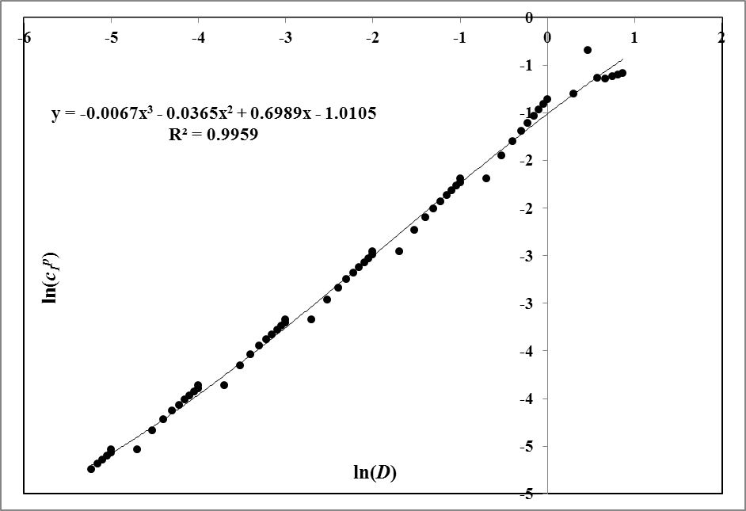

Fig. . Partition Coefficient of Phenanthrene + LDPE system: solid bullets denote calculated points, solid line shows the fit

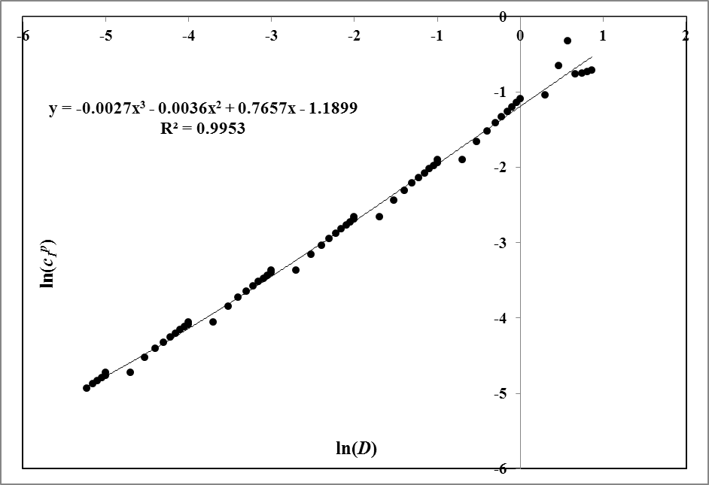

Fig. . Partition Coefficient of Pyrene + LDPE system: solid bullets denote calculated points, solid line shows the fit

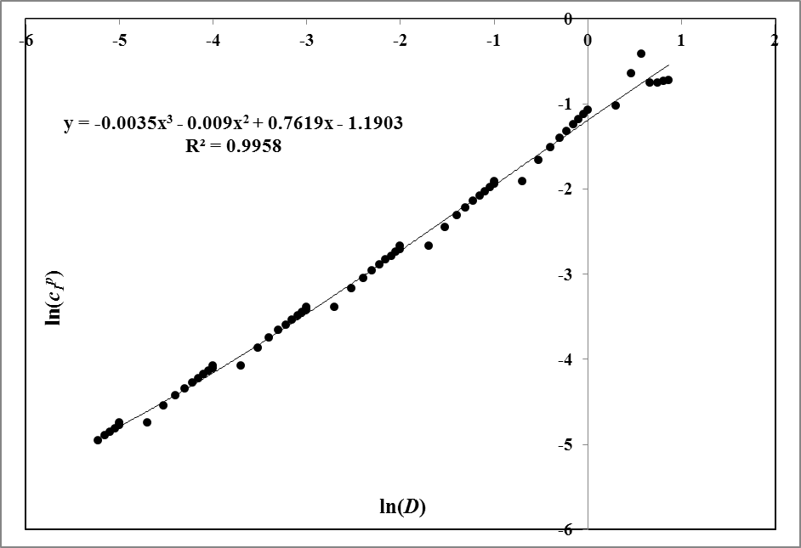

Fig. . Partition Coefficient of Chrysene + LDPE system: solid bullets denote calculated points, solid line shows the fit

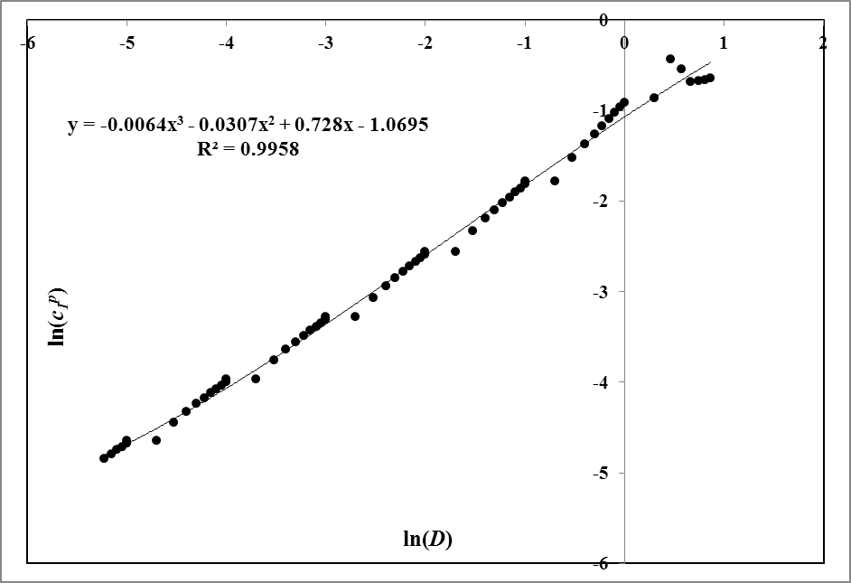

Fig. . Partition Coefficient of Perylene + LDPE system: solid bullets denote calculated points, solid line shows the fit

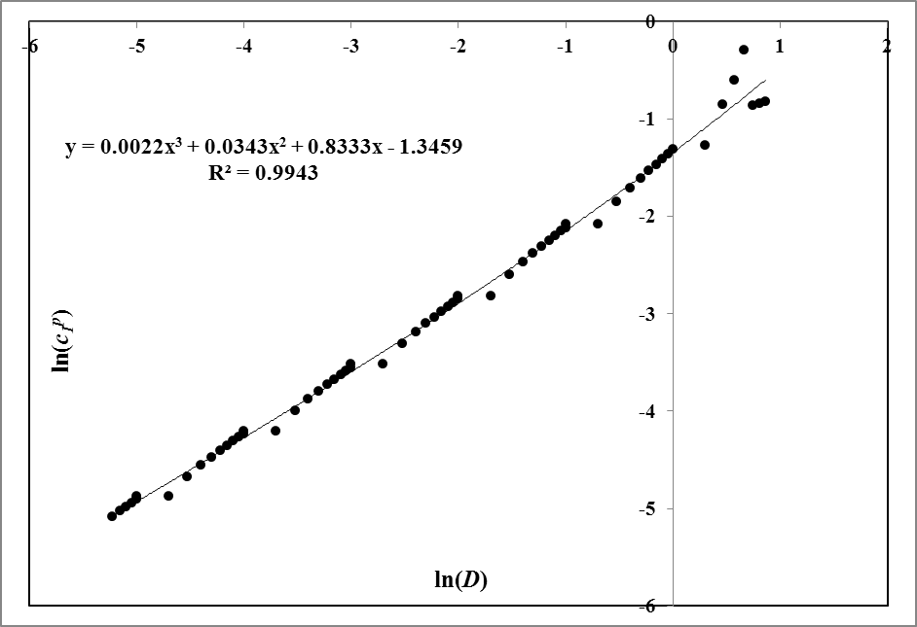

Fig. . Partition Coefficient of Anthracene + LDPE system: solid bullets denote calculated points, solid line shows the fit

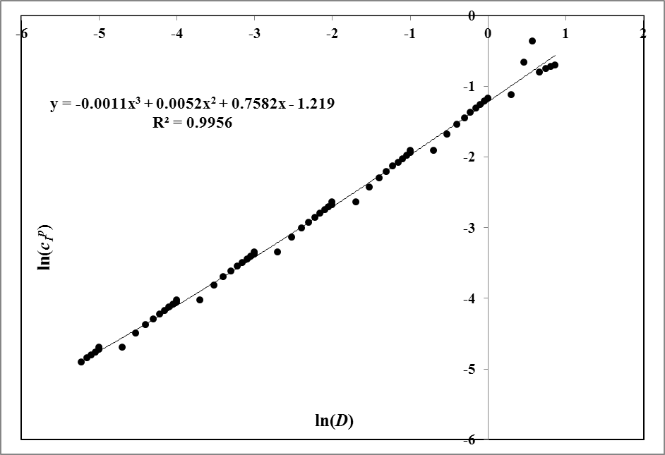

Fig. . Partition Coefficient of Caffeine + LDPE system: solid bullets denote calculated points, solid line shows the fit

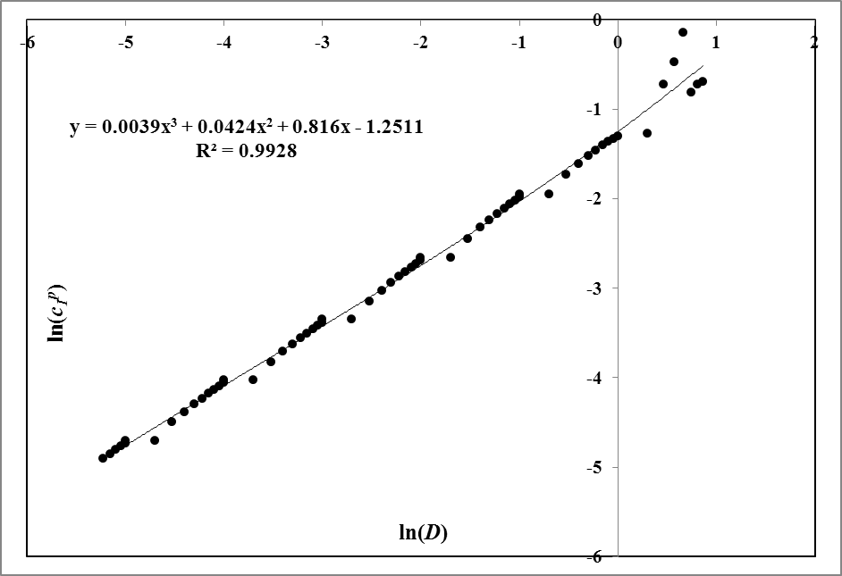

Fig. . Partition Coefficient of Phenol + LDPE system: solid bullets denote calculated points, solid line shows the fit

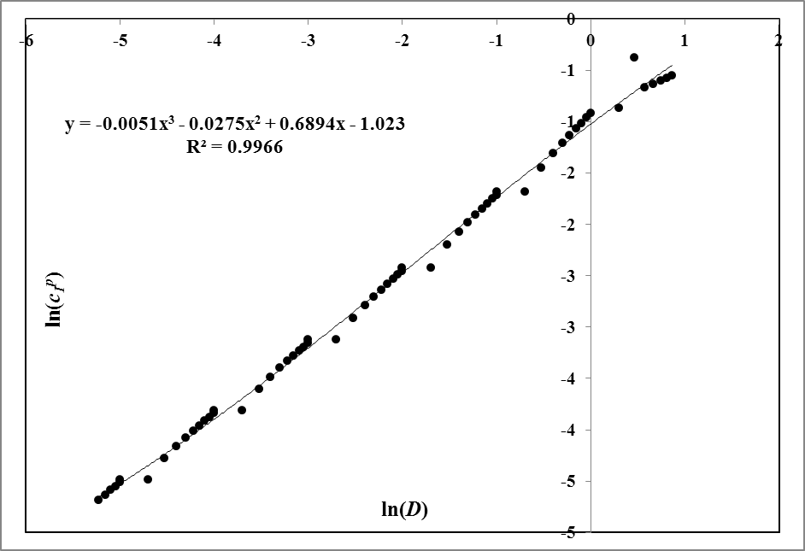

Fig. . Partition Coefficient of Acetanilide + LDPE system: solid bullets denote calculated points, solid line shows the fit

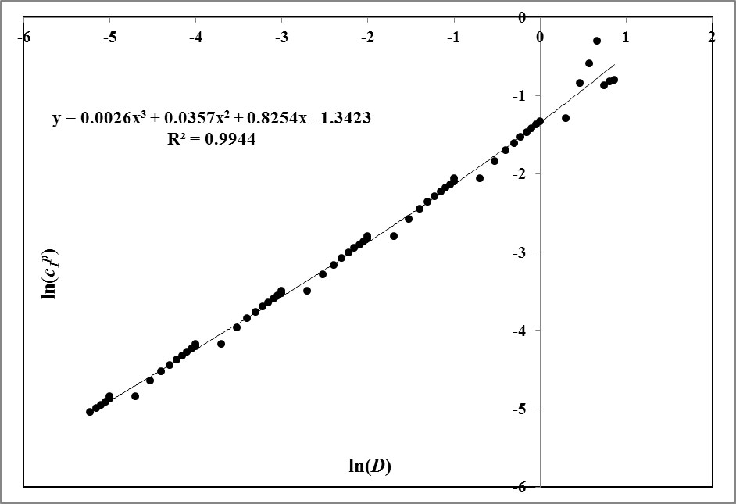

Fig. . Partition Coefficient of Carbazole + LDPE system: solid bullets denote calculated points, solid line shows the fit

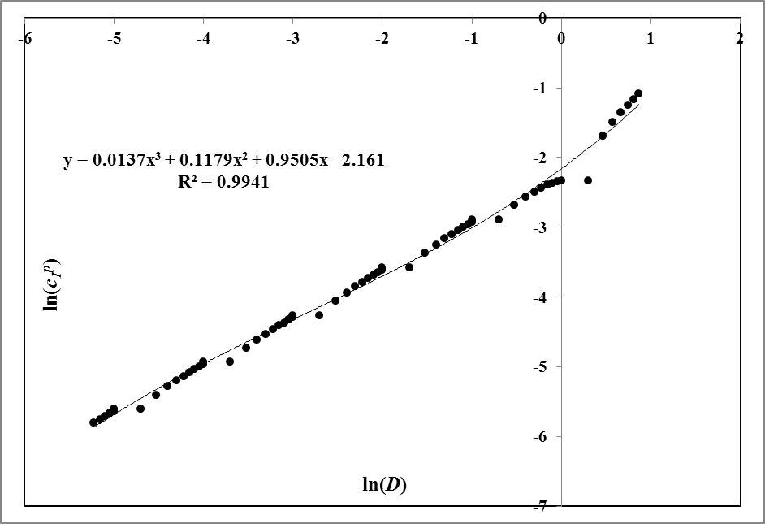

Fig. . Partition Coefficient of Estrone + LDPE system: solid bullets denote calculated points, solid line shows the fit

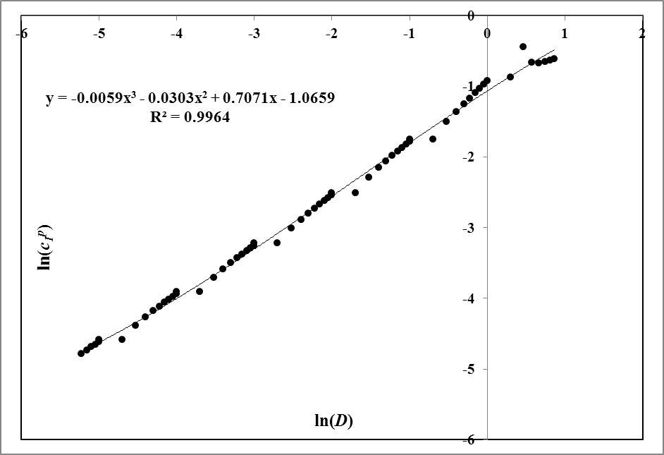

Fig. . Partition Coefficient of Phenanthrene + PDMS system: solid bullets denote calculated points, solid line shows the fit

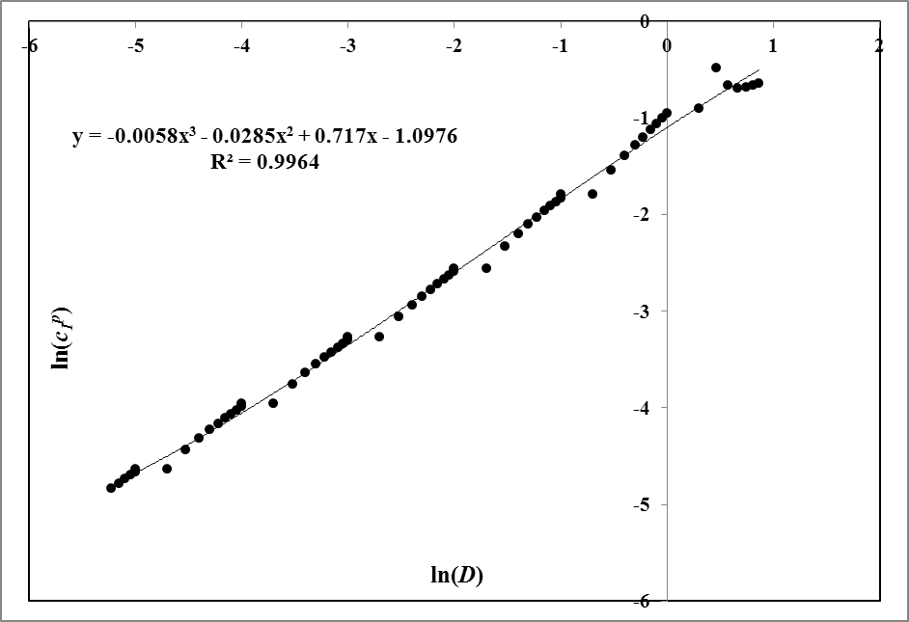

Fig. . Partition Coefficient of Pyrene + PDMS system: solid bullets denote calculated points, solid line shows the fit

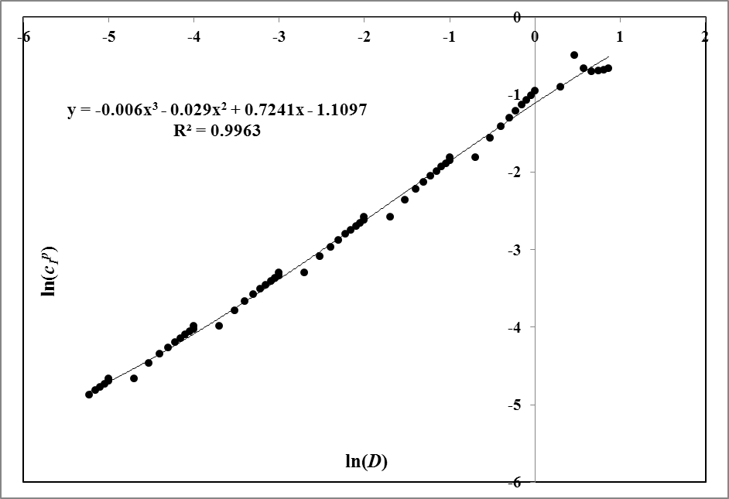

Fig. . Partition Coefficient of Chrysene + PDMS system: solid bullets denote calculated points, solid line shows the fit

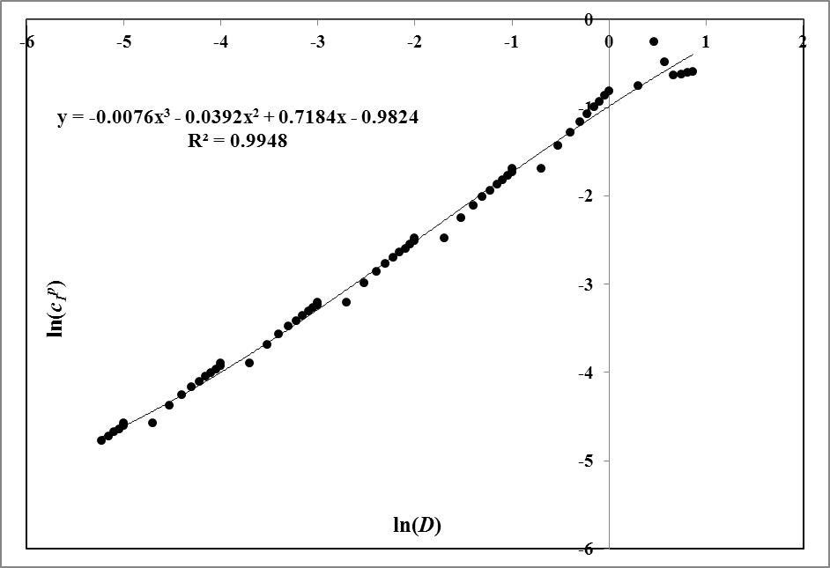

Fig. . Partition Coefficient of Perylene + PDMS system: solid bullets denote calculated points, solid line shows the fit

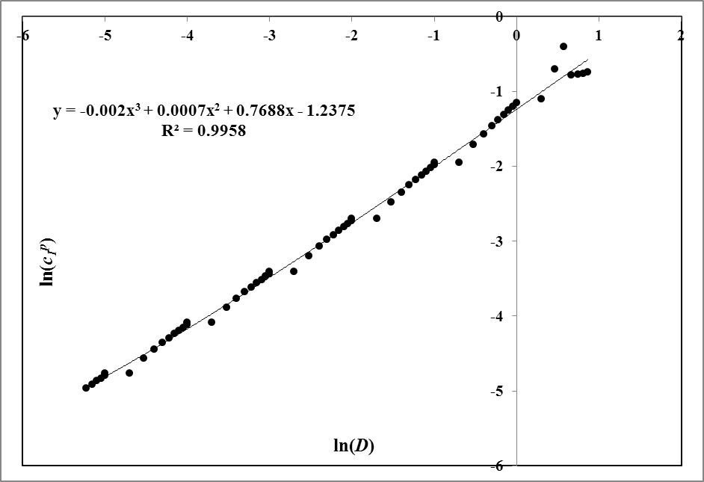

Fig. . Partition Coefficient of Anthracene + PDMS system: solid bullets denote calculated points, solid line shows the fit

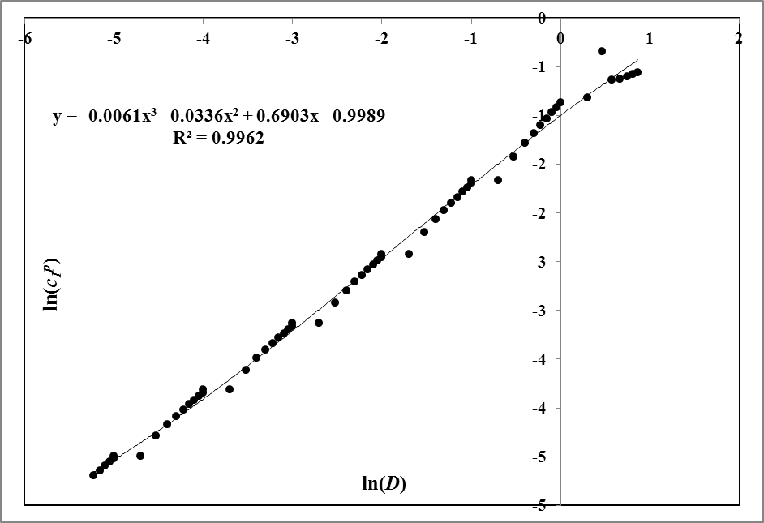

Fig. . Partition Coefficient of Caffeine + PDMS system: solid bullets denote calculated points, solid line shows the fit



Fig. . Partition Coefficient of Phenol + PDMS system: solid bullets denote calculated points, solid line shows the fit

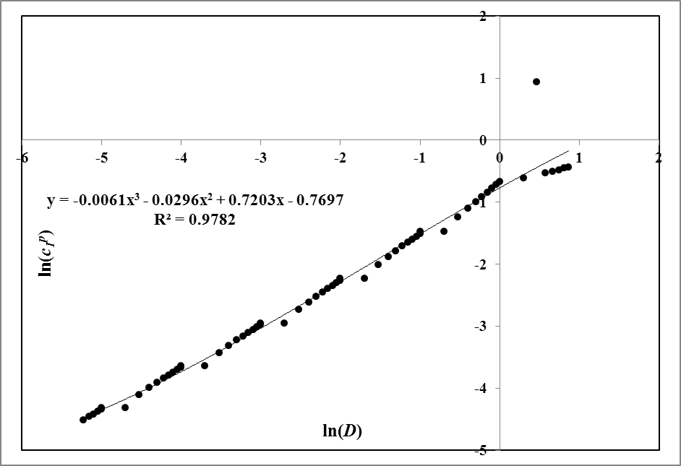

Fig. . Partition Coefficient of Acetanilide + PDMS system: solid bullets denote calculated points, solid line shows the fit

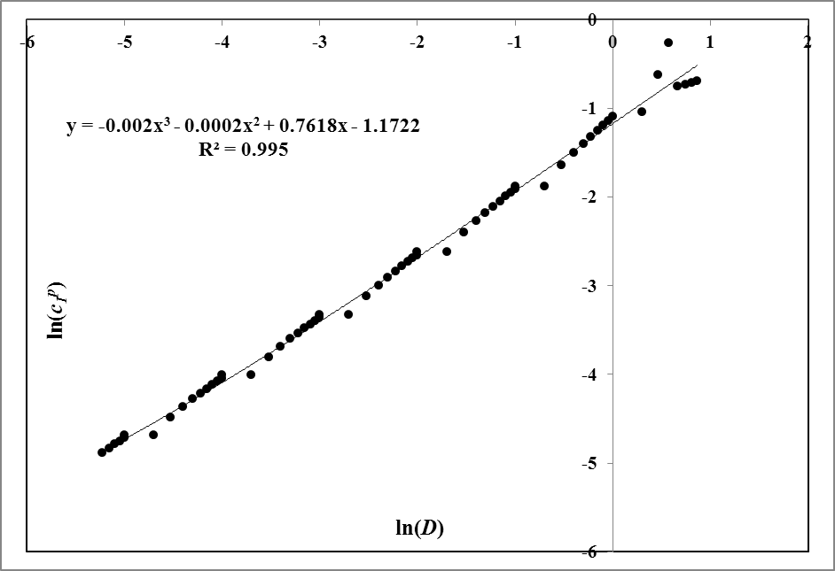

Fig. . Partition Coefficient of Carbazole + PDMS system: solid bullets denote calculated points, solid line shows the fit

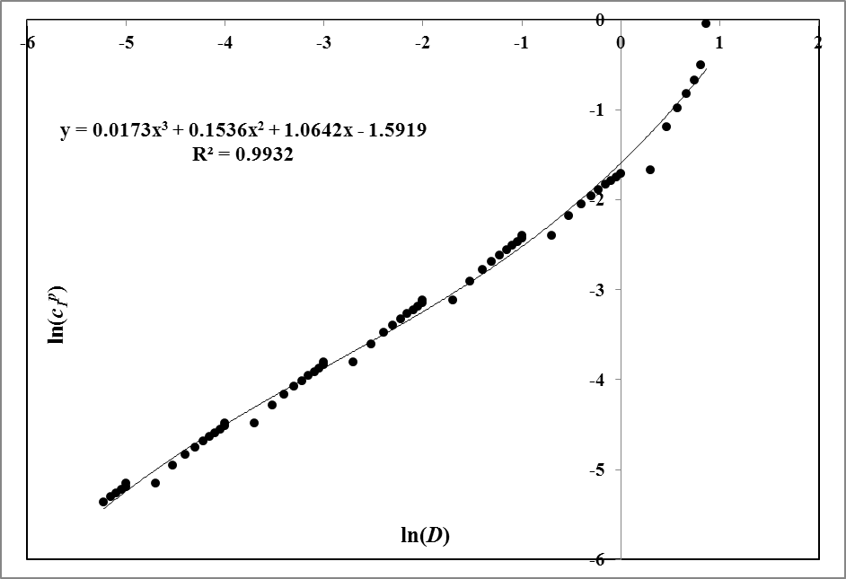

Fig. . Partition Coefficient of Estrone + PDMS system: solid bullets denote calculated points, solid line shows the fit

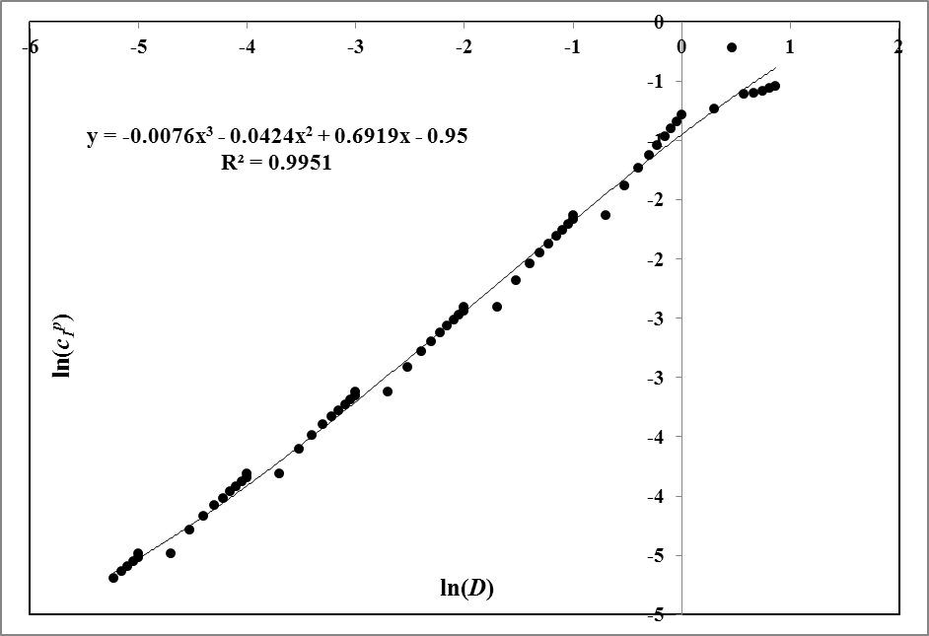

Fig. . Partition Coefficient of Phenanthrene + POM system: solid bullets denote calculated points, solid line shows the fit

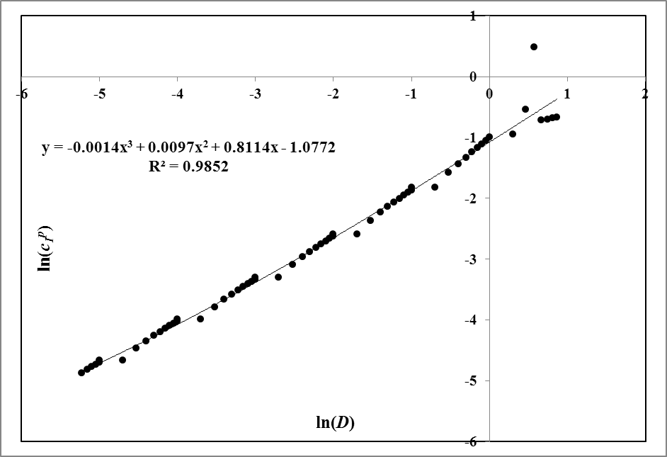

Fig. . Partition Coefficient of Pyrene + POM system: solid bullets denote calculated points, solid line shows the fit

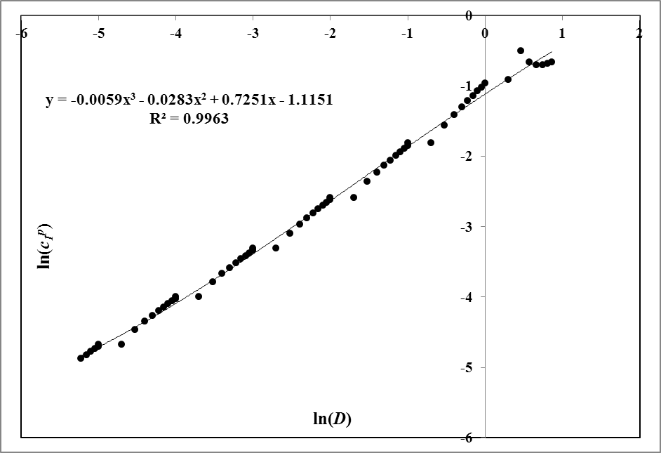

Fig. . Partition Coefficient of Chrysene + POM system: solid bullets denote calculated points, solid line shows the fit

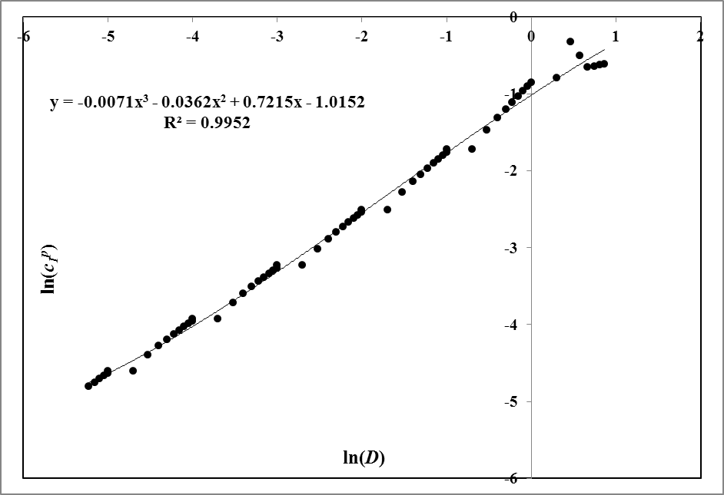

Fig. . Partition Coefficient of Perylene + POM system: solid bullets denote calculated points, solid line shows the fit

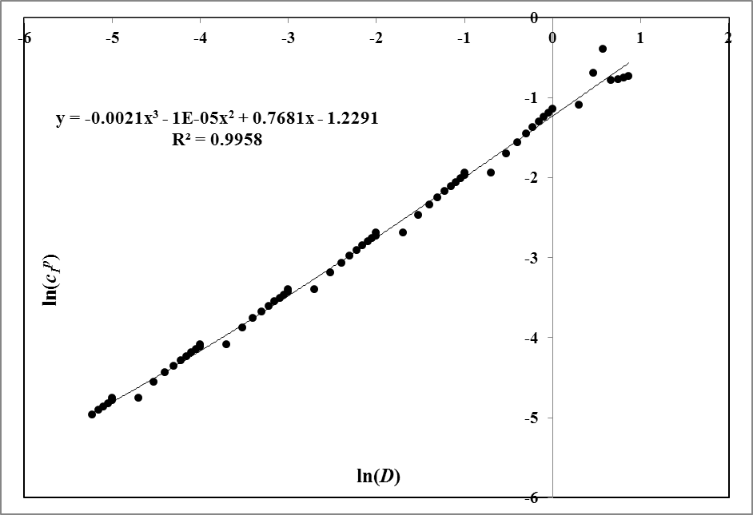

Fig. . Partition Coefficient of Anthracene + POM system: solid bullets denote calculated points, solid line shows the fit

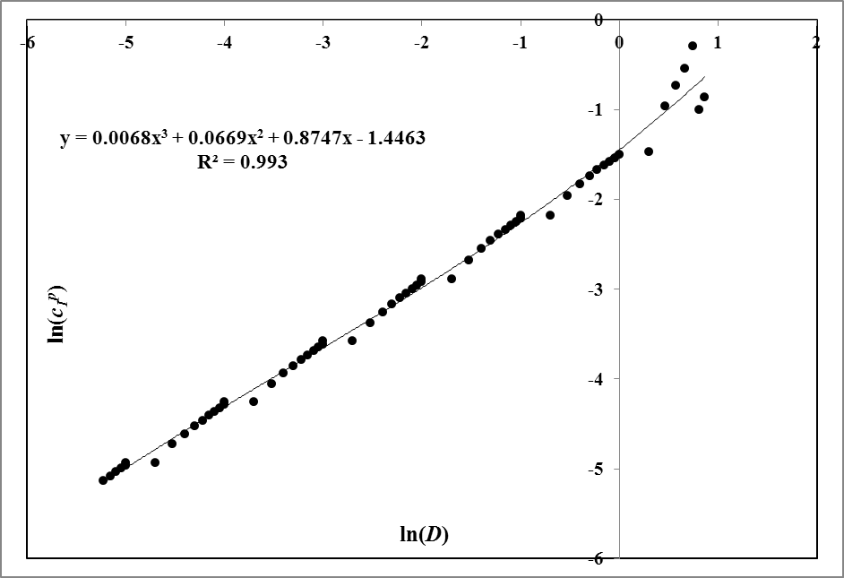

Fig. . Partition Coefficient of Caffeine + POM system: solid bullets denote calculated points, solid line shows the fit

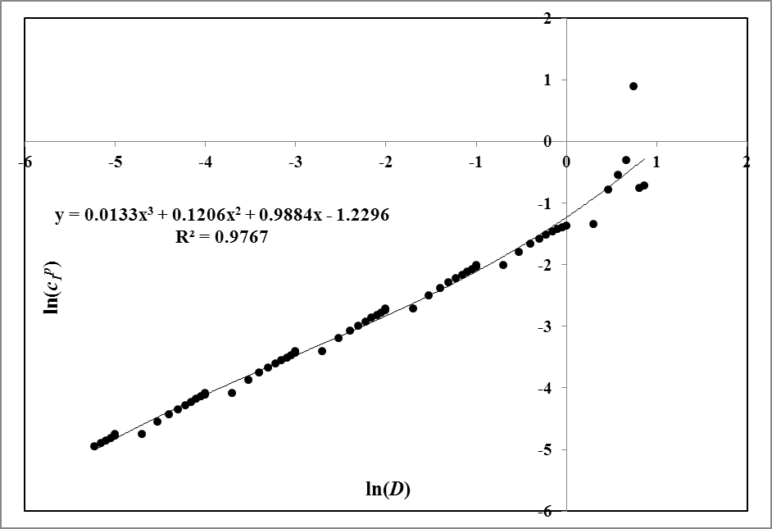

Fig. . Partition Coefficient of Phenol + POM system: solid bullets denote calculated points, solid line shows the fit

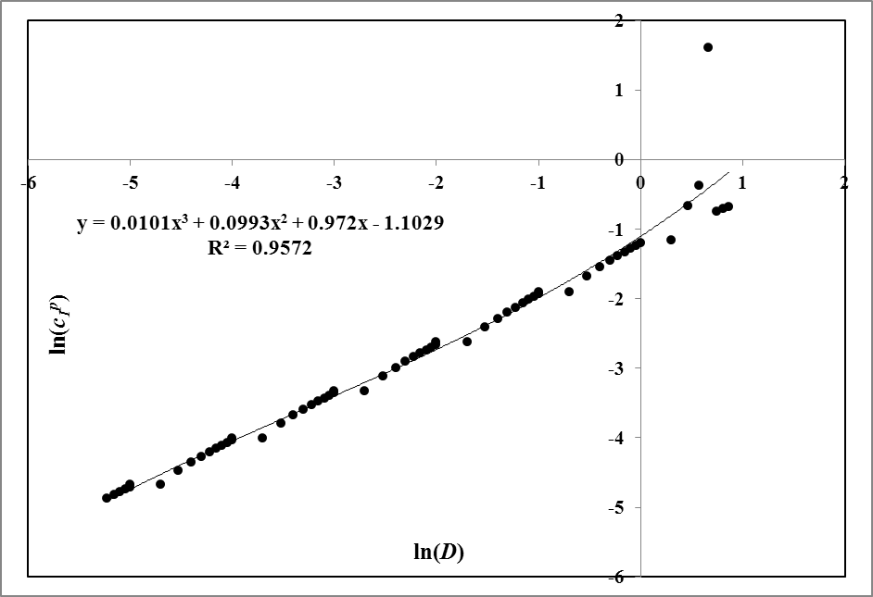

Fig. . Partition Coefficient of Acetanilide + POM system: solid bullets denote calculated points, solid line shows the fit

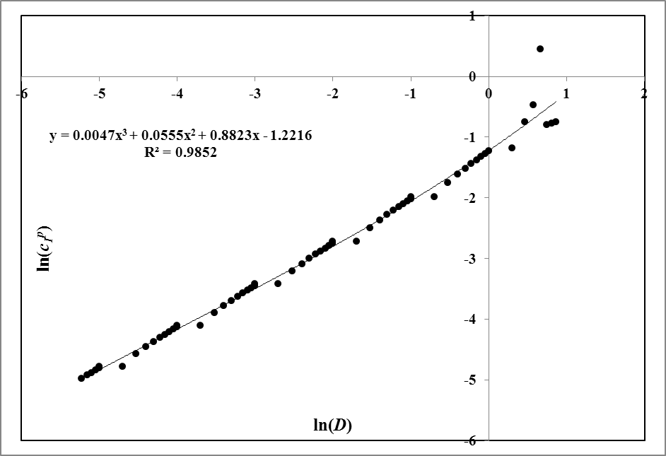

Fig. . Partition Coefficient of Carbazole + POM system: solid bullets denote calculated points, solid line shows the fit

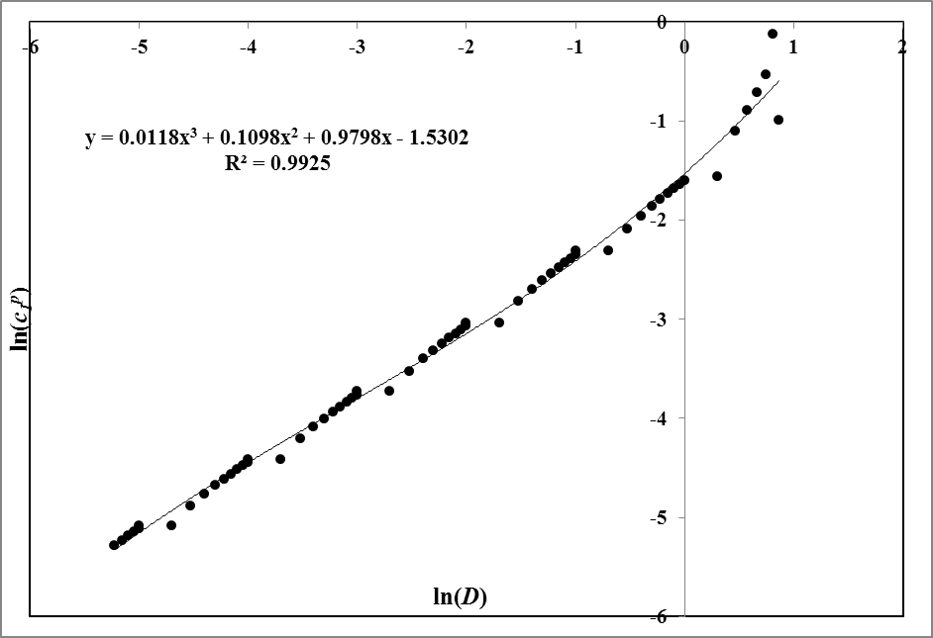

Fig. . Partition Coefficient of Estrone + POM system: solid bullets denote calculated points, solid line shows the fit