Appendix C – Sigma profiles of individual compounds in each mixture

Evaluating cellulose potential for estrogen micropollutants removal from water effluents using quantum chemical calculations

Milad Asgarpour Khansary 1\*, Azam Marjani 2, Saeed Shirazian 3

1 – Young Researchers and Elite Club, South Tehran Branch, Islamic Azad University, Tehran, Iran

2 – Department of Chemistry, Arak Branch, Islamic Azad University, Arak, Iran

3 – Department of Chemical Sciences, Bernal Institute, University of Limerick, Limerick, Ireland

\* email: [miladasgarpour@ut.ac.ir](mailto:miladasgarpour@ut.ac.ir)

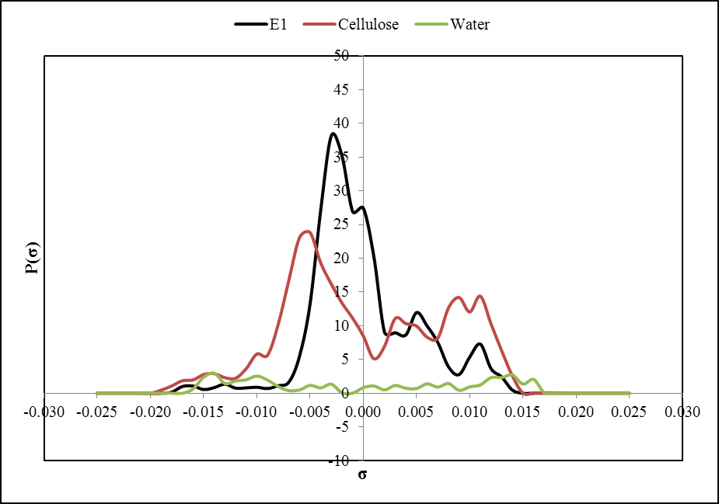

Fig. . Comparing charge density profiles of water, cellulose and Estrone (E1)

For E1 in mixture of water+E1, almost of peaks find matching partner and no considerable mismatch can be seen, consequently, E1 will feel electrostatically much stable in comparison to E1 in mixture of cellulose+E1 where only loose π-faces associated peaks find their matching partner. The peaks in charge density within the range of −0.001 to 0.001 e/Å2are associated to weak polar interactions, which in mixture of water+E1 might results in some interactions however, as discussed in previous sections, the cellulose does not tend to show such interactions and if such interactions happen, they are over its own functional groups. Therefore, the weak polar hydrogen peak in cellulose contributes on nothing. Thus, the lower content of E1 in cellulose in comparison to water is expected.

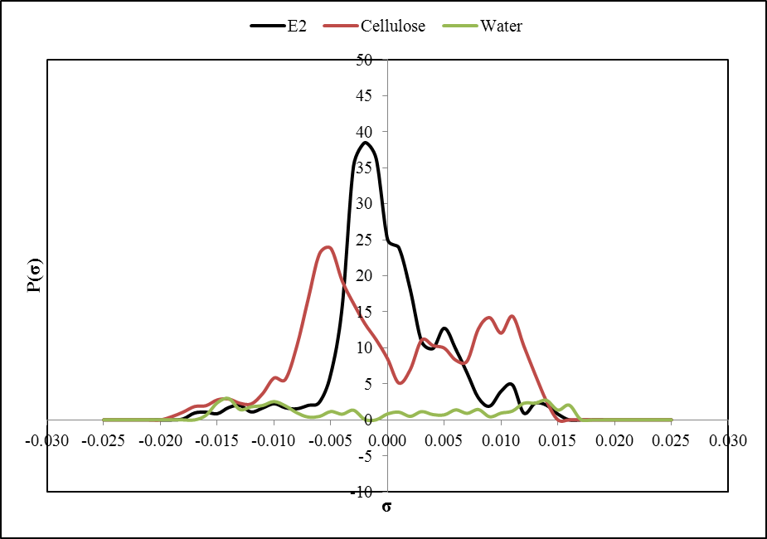

Fig. . Comparing charge density profiles of water, cellulose and Estradiol (E2)

Similar to E1 systems, for E2 in mixture of water+E2, almost of peaks find matching partner and no considerable mismatch can be seen, consequently, E2 will feel electrostatically much stable in comparison to E2 in mixture of cellulose+E2 where only loose π-faces associated peaks find their matching partner. The oxygen and hydrogen associated peaks of E2 are well matched with those of water as shown in Fig. 2. The peaks in charge density within the range of −0.001 to 0.001 e/Å2are associated to weak polar interactions. Thus, the lower content of E2 in cellulose in comparison to water is expected.

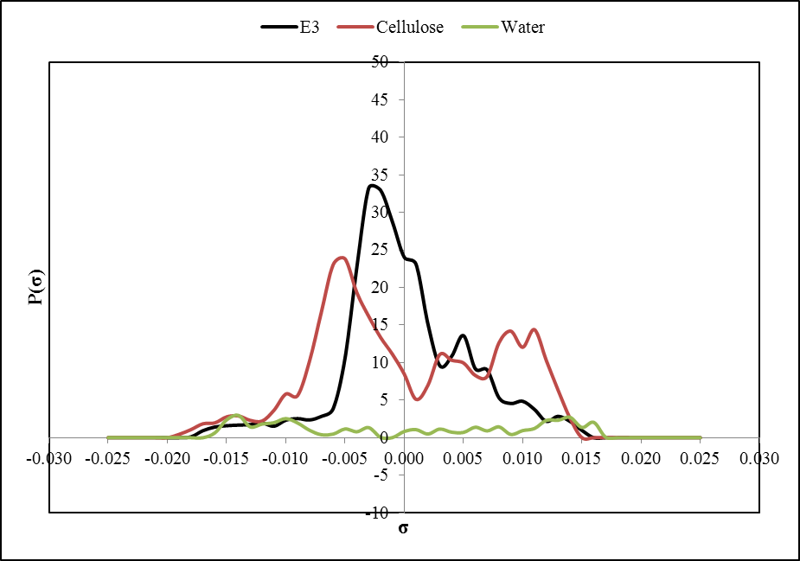

Fig. . Comparing charge density profiles of water, cellulose and Estriol (E3)

As seen the contribution of π-faces peaks due to the carbon atoms exposure and carbon rings is much wider than previous two cases. Thus a little more attractive covalent bonding and interactions can be expected between cellulose and E3 resulting in an increase in its sorption onto cellulose. The peaks in charge density within the range of −0.001 to 0.001 e/Å2are associated to weak polar interactions.

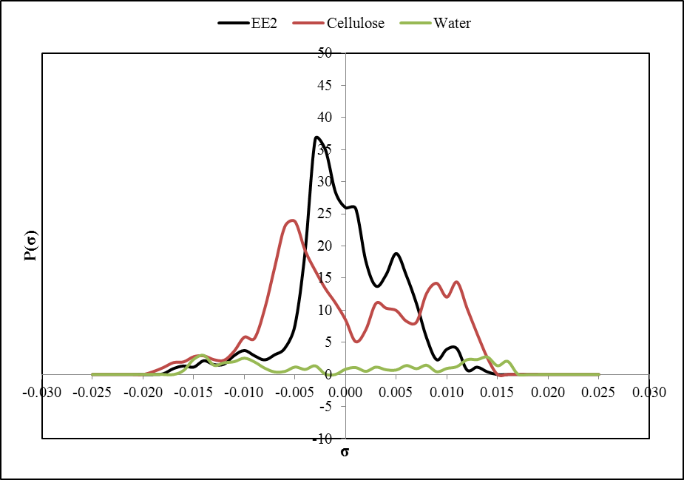

Fig. . Comparing charge density profiles of water, cellulose and Ethinylestradiol (EE2)

The low sorption capacity of Ethinylestradiol (EE2) in cellulose is due to the fact that no receptive matching on change density profiles can be observed (Fig. 4). While the hydrogen associated peaks are matched, however, as mentioned in previous section, cellulose will not interact with other molecules through hydrogen bonding interaction. The covalent interactions, which were observed for three other systems discussed earlier, are now absent and weakly contribute as they found no matching partners. These observations come to the conclusion of very low sorption of EE2 in cellulose.

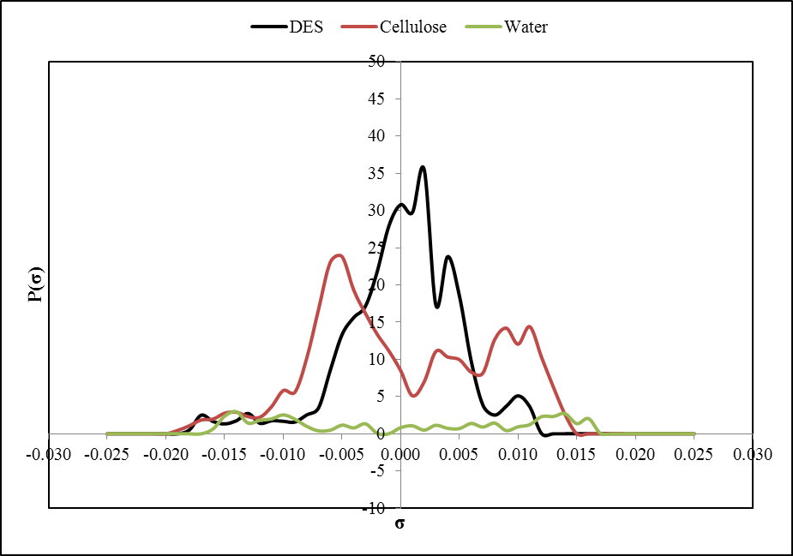

Fig. . Comparing charge density profiles of water, cellulose and Diethylstilbestrol (DES)

The good performance of cellulose for DES removal is due to combination of exposed surfaces of carbon atoms and the π-faced caused by the carbon as shown by a peak around 0.0035 e/Å2which can interact with the hydrogen atoms of cellulose with the approximately same charge density on the other side of sigma axis (Fig. 5). Consequently, one might expect much better interaction between cellulose and DES in comparison to DES and water resulting in good sorption behavior.

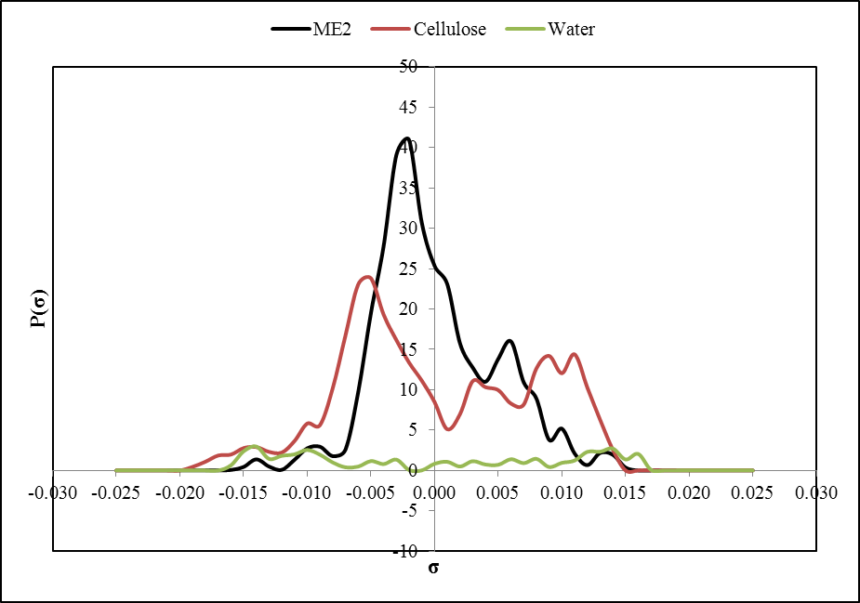

Fig. . Comparing charge density profiles of water, cellulose and Mestranol (ME2)

Charge density profiles of water, cellulose and Mestranol (ME2) are shown in Fig. 6. As seen, desirable interaction and peak matching can be observed for water+ME2 mixtures, therefore, ME2 feels much comfortable in water+ME2 mixtures than cellulose+ME2 mixture and prefer to no to leave the water+ME2 mixtures. However, the matching of peaks of carbon rings and π-faces encourage the ME2 to be sorbed onto the cellulose even in small contents. This simply justifies the sorption behavior of cellulose of ME2.

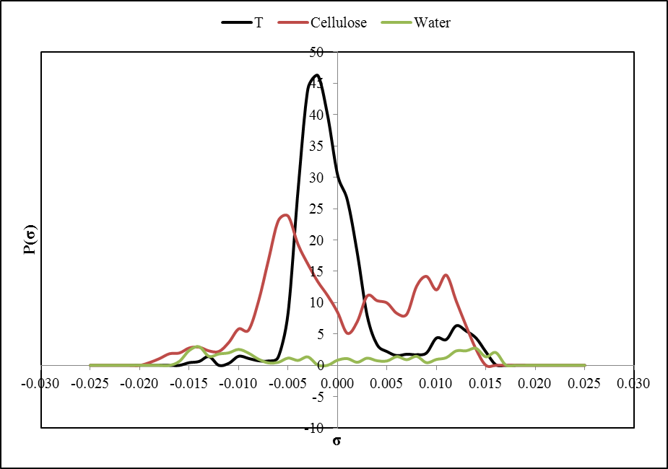

Fig. . Comparing charge density profiles of water, cellulose and Testosterone (T)

Comparing charge density profiles of water, cellulose and Testosterone (T) is shown in Fig. 7. There no considerable and significant peak matching in water+T mixture as well as cellulose mixture. It can be observed that T will not feel comfortable in water too much as no receptive matching can be found for its peaks. The sorption of T on cellulose might be due to the electrostatic interaction between polarized hydrogen in –OH group with those of oxygen group in cellulose that would results in effective sorption.

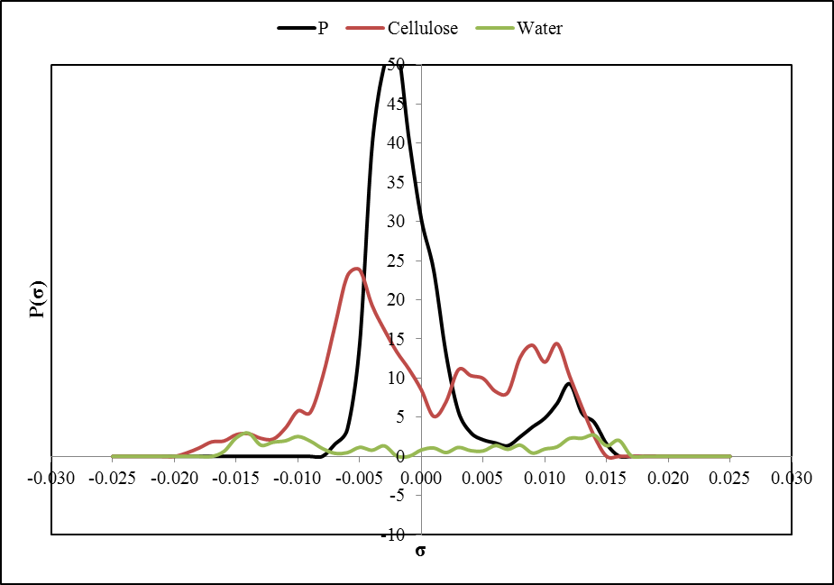

Fig. . Comparing charge density profiles of water, cellulose and Progesterone (P)

The interactions between water and Progesterone are not considerable as shown in Fig. 8, therefore, P can be much more easier removed from water effluents. There is no matching partner for peaks of P in water charge density profile, thus P feels no comfortable in water+P mixture and tends to leave it. The partly matching of oxygen peaks is responsible for active interaction of cellulose and P where the carbon rings are also contributing in some extends.