A comparative theoretical and experimental study on Liquid-Liquid Equilibria (LLE) of membrane forming polymeric solutions

**Abstract**

The phase equilibria of two ternary system of Polyethersulfone (PES) - n-methyl pyrolidine (NMP) – distilled Tap water (H2O) and Polysulfone (PSf) – NMP - H2O has been investigated critically using both theoretical and experimental methods. The cloud point measurement technique was used for determination of experimental binodal curves. Gamma-gamma (γ-γ), gamma-phi (γ-φ), phi-gamma (φ-γ) and phi-phi (φ- φ) approaches were assessed using measured binodal data. Compressible regular solution (CRS), Nonrandom Two Liquids model (NRTL), Universal Quasi-Chemical theory (UNIQUAC) were used for activity coefficient (gamma) calculations and Gasem–Gao–Pan–Robinson modification to the PR EOS (PRGGPR) and Twu–Coon–Cunningham modification to the RK EOS (RKTCC) were used for fugacity coefficient (phi) calculations. The Othmer-Tobias and the Hand correlation equations were used to check the consistency of the obtained tie-line data, by which the distribution coefficients (D) and separation factors (S) were calculated. Description of LLE using CRS-UNIQUAC in a gamma-gamma approach, the RKTCC-RKTCC in a phi-phi approach, CRS-RKTCC in a gamma-phi approach and the RKTCC-UNIQUAC in a phi-gamma approach gives the best agreement and correlation to the experimental data. The overall performance of gamma-gamma approach using CRS-UNIQUAC model revealed an averaged Accumulative Absolute Relative Deviation (AARD) of 2.47 %.

**Keywords:** wet phase inversion; polymeric membranes; phase equilibria; thermodynamic models; binodal data

1. Introduction

Phase inversion process has found many applications in fabrication of commercial polymeric membranes [1-4] and fueled the increasing interest and studies in this field of research [5-10]. The wet phase inversion (as illustrated in Fig. 1) is the industrial method of commercial membrane fabrication [4], in which a thin polymeric film, obtained by casting of a binary polymer/solvent solution on a support layer, is immersed into a coagulation bath containing an appropriate content of nonsolvent (commonly water) [3, 4, 11-13].

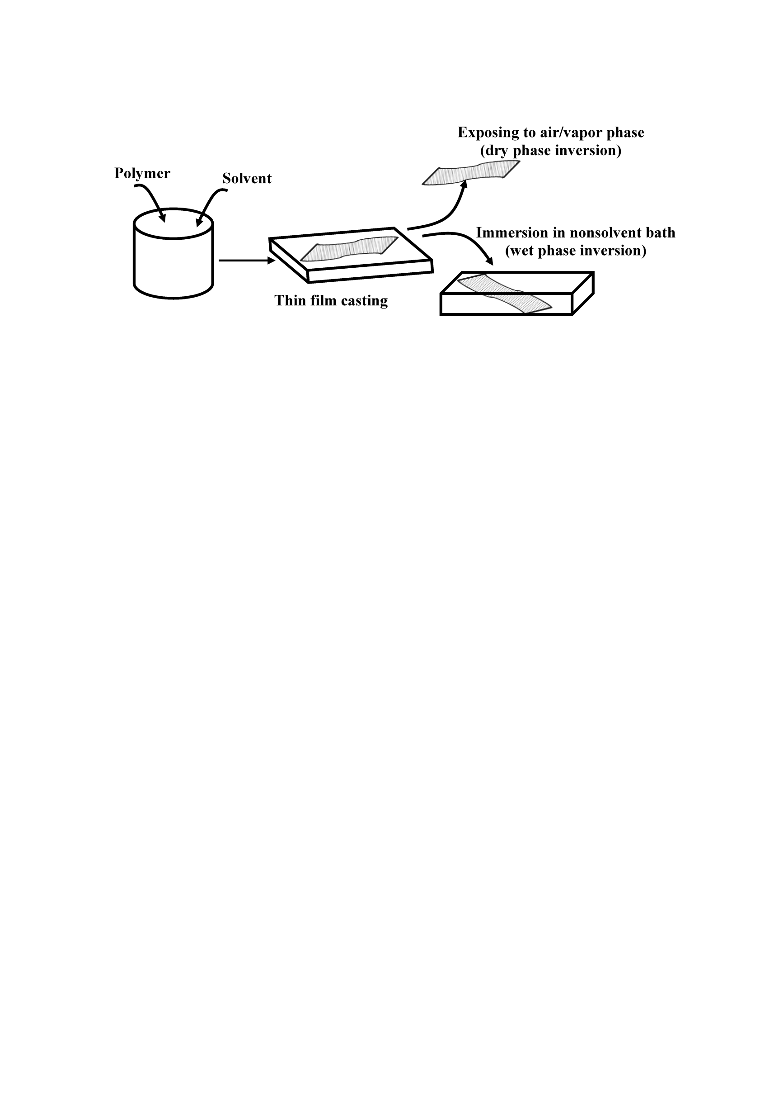

Fig. 1. The schematic of wet/dry phase inversion (adapted from [11])

At the interface of cast thin polymeric film and the coagulation bath phases, a local equilibrium will be reached [14]. The proper description of equilibrium compositions in both phases on two sides of interface through appropriate thermodynamic models and approaches plays a critical rule on the accuracy of mathematical models and numerical computer simulations of the phase inversion phenomenon, and affects the prediction of final membrane properties [8, 15-17]. Since phase inversion process occurs rapidly, there is no practical way to measure the interfacial equilibrium compositions experimentally ; therefore, application of theoretical models for this purpose comes to attention [8, 14].

A substantial amount of reports in literature were devoted to the investigation of the local composition change within the cast film and evolution of film composition with time and direction (precipitation path) [11, 15]. One important fact regarding to the accurate prediction of precipitation path is the proper determination of instantaneous interfacial compositions of two phases at contact, as the boundary condition in the governing equation obtained by components mass balance [14, 15, 18]. The evolution of film thickness with time, the chemical potential differences of components in two phases over the interface and mass flux of solvent and nonsolvent are directly related to these values [15, 18].

For theoretical phase equilibria calculations, one needs to use thermodynamic models for the determination of component’s fugacity in each phase of interest, which can be done by means of activity coefficient models (such as gE based models) and/or fugacity coefficient models (such as equations of state, corresponding states correlations, etc.) [19-21]. In consequence, four different approaches can be considered for the calculation of the fugacity of components in each phase, namely (1) gamma-gamma (), (2) gamma-phi (), (3) phi-gamma () and (4) phi-phi () approaches, where phi and gamma indicate fugacity coefficient and activity coefficient of components respectively [19, 22, 23]. The reliability and applicability of each models and approaches must be evaluated and compared to any available and relevant experimental data of polymeric solutions that are primarily used in fabrication of polymeric membranes through wet phase inversion technique. The binodal curve or the coexistence curve of each ternary system can be determined both theoretically using the aforementioned models and approaches and experimentally using cloud point measurement and this is an advantage for current investigation.

Thus, a number of thermodynamics models were retrieved from literature for calculation of equilibrium compositions (the binodal data) of polymeric solutions and the calculated data were then compared by experimentally measured data for two systems of polyethersulfone (PES) - n-methyl pyrolidine (NMP) - H2O and polysulfone (PSf) – NMP - H2O. The results were discussed in details and the drawback and advantage of each approach was provided and guidelines on proper phase equilibria description were presented. In following sections, the method of thermodynamic analysis of equilibrium for theoretical determination of binodal curved and experimental cloud point measurement will be discussed.

1. Liquid-liquid equilibrium from experimental and theoretical point of view
   1. Ternary systems and experimental data measurements

The binodal data were measured experimentally in Lab as follows. The Polyethersulfone (PES) and Polysulfone (PSf) were purchased from BASF, Germany. The N-Methyl-2-pyrrolidone (NMP) was provided from Merck, Germany. Distilled water was prepared in Laboratory. The cloud points were determined experimentally by a titration method as shown in **Fig. 2** schematically [24, 25]. In this method, a polymeric solution was prepared by dissolving a predetermined amount (gr) of polymer in a predetermined amount (gr) of solvent and then distilled water was added dropwise and agitated continuously until a homogeneous polymeric solution obtained. This operation (adding water) followed until homogeneous solution (containing polymer, solvent and dissolved distilled water) changed to a cloudy solution. This point (cloud point) means that the cloudy solution cannot dissolve more distilled water and so it is in equilibrium and its composition is an equilibrium point of bimodal curve.

Due to slow dissolution of Polysulfone (PSf) in n-methyl-2-pyrrolidone (NMP), in preparation of dope solution, the mixture was heated at constant temperature of **38 °C** which was maintained and controlled by utilization of an automated heater. This temperature was sufficient to prepare the relatively high concentration dope solutions in a practical time in laboratory. For Polyethersulfone (PES) containing dope solution, heating at constant temperature of **27 °C** was performed.

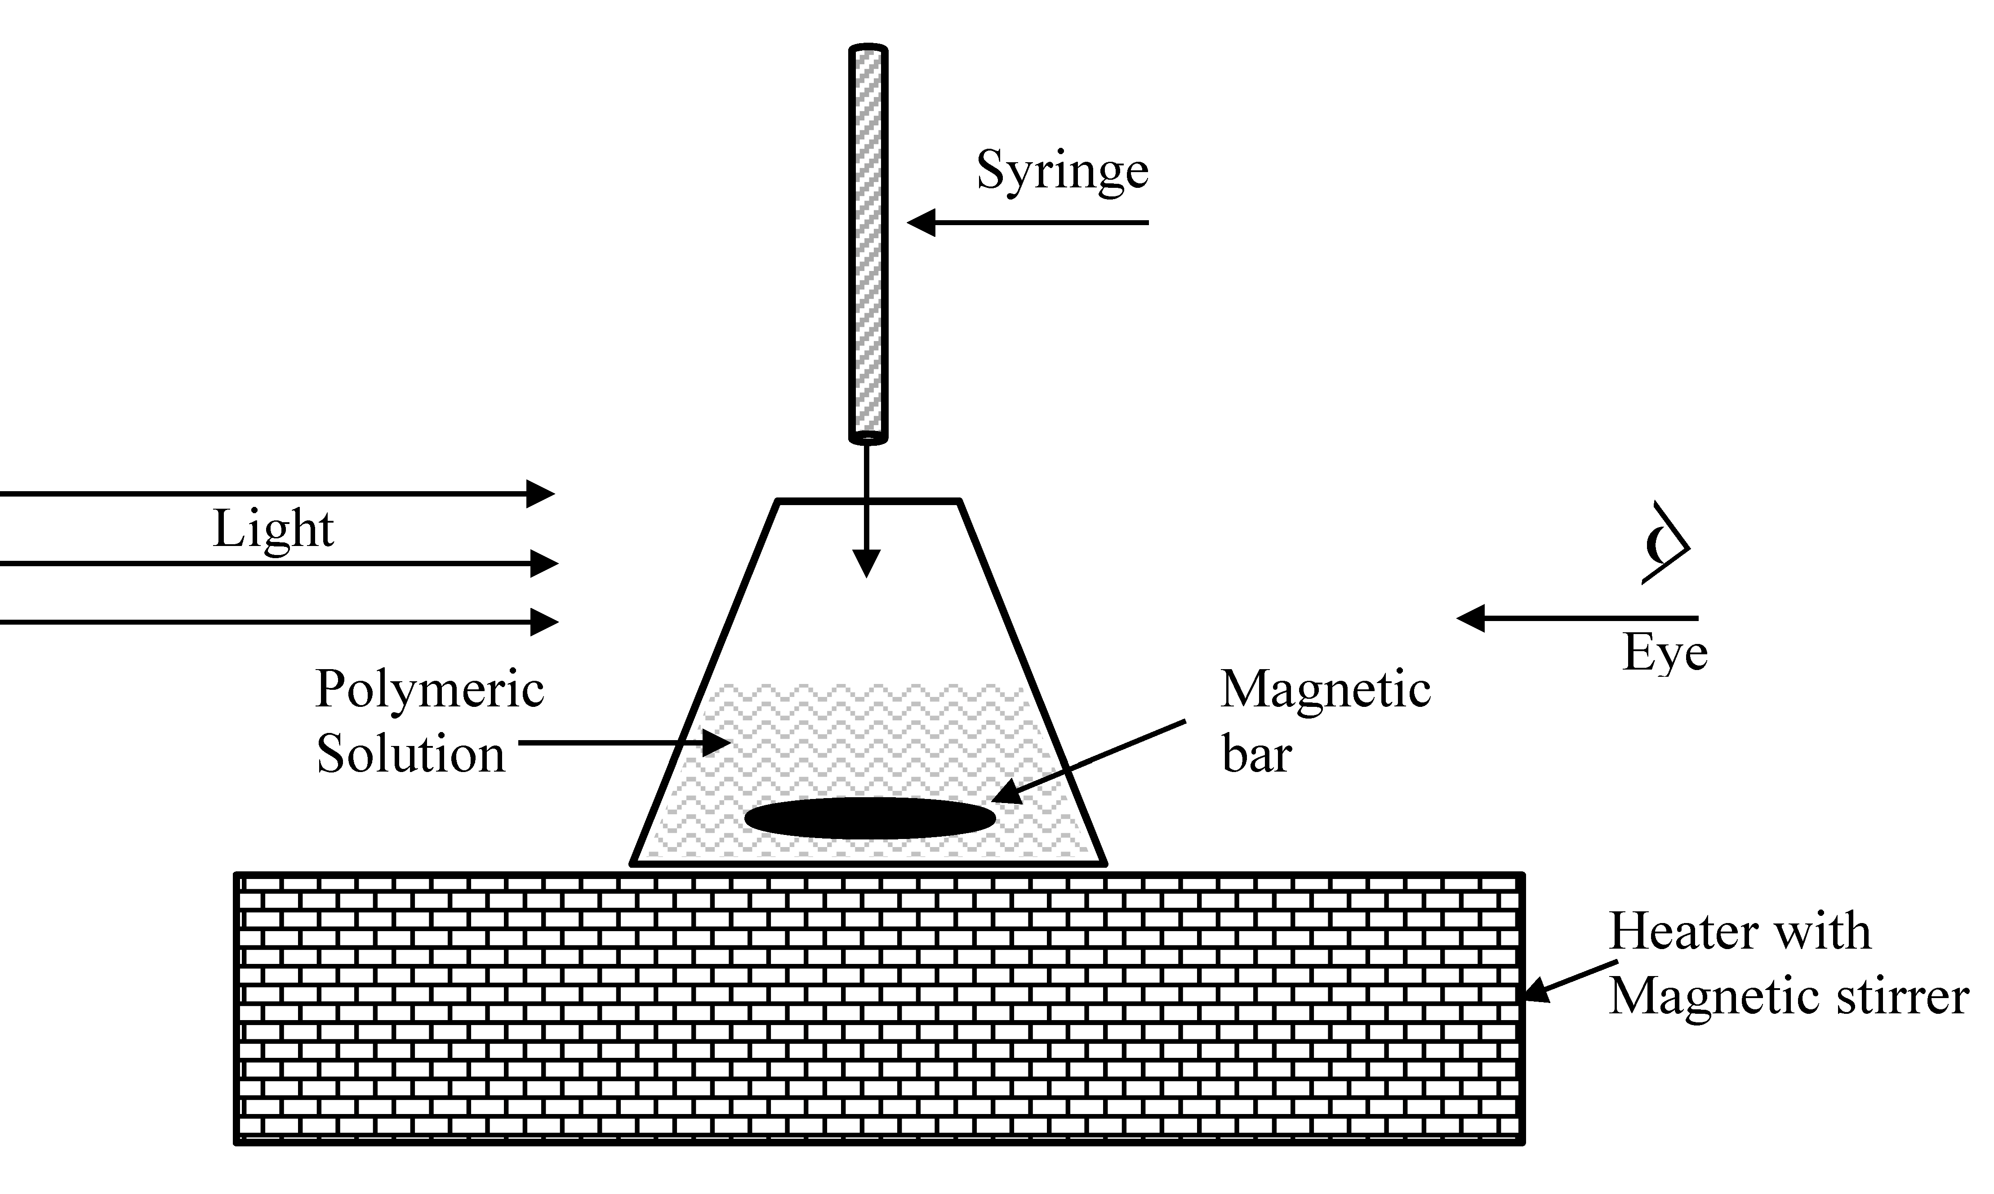

Fig. 2. Schematic diagram of cloud point measurement setup

The cloud point measurements for each system were carried out in temperature in which the dope solution was prepared (i.e. for PSf/NMP/H2O system at 38 °C and for PES/NMP/H2O system at 27°C) by fixing the controlled temperature of automatic heater. It must be noted that, consequently, in modeling of these systems, each system was modeled in the corresponding aforementioned temperature in which the measurements were performed. Each cloud point measurement has been repeated three times and the average of these data were reported.

To keep the prepared dope solution well-mixed and homogeneous, during the addition of nonsolvent (distilled water) droplets, a magnetic bar was placed in the bottom of polymeric solution-containing bottle and a heater equipped with a magnetic stirrer was used. Then, the nonsolvent (distilled water) was added drop-wise from a burette (syringe) to the solution under continuous stirring at fixed temperature as noted above. Upon observation and presence of any turbidity, the addition of droplets was slowed down. It must be noted that because of the clarity of the polymer solutions of current study, turbidity was easily recognized by visual observation. To avoid and minimize solvent loss due to evaporation during the measurements, the polymer solution-containing bottle was covered with a plastic rubber. The total amount of added water droplets was evaluated by counting the number of droplets and multiplying it to the average weight of one droplet (0.01868 gr) determined previously in Lab. It must be noted that for theoretical modeling, the distilled water can be considered as pure H2O.

* 1. Chemical thermodynamic phase equilibria for binodal (coexistence) curve

The dope/coagulation phases’ equilibrium can be described by using chemical thermodynamic relationships. At fixed temperature and pressure, the phase equilibria criteria requires that the fugacity of each component in two phases be equal [19, 23] as presented by Eq.1, where and refers to dope and coagulation (Upper) phases respectively [19, 23].

|  |  |
| --- | --- |
|  | 1 |

The fugacity of component  in a mixture () can be related to activity coefficient () and fugacity coefficient () using Eq. 2 and Eq. 3 respectively [19, 23].

|  |  |
| --- | --- |
|  | 2 |
|  | 3 |

Here  and indicates the component compositions in dope and coagulation (upper) phases respectively,is the fugacity of pure component  at some fixed condition known as the standard state [19].

The use of activity coefficient and fugacity coefficient in fugacity calculation is referred to as gamma approach and phi approach respectively [19]. In this regard, four possible combinations of these approaches are possible. It is practically convenient to consider the polymeric solution (dope) as a liquid to provide better representation of its behavior by thermodynamic models. The coagulation (upper) phase is considered as liquid for wet casting. Thus, assuming, one might write as Eqs. 4-7 respectively,

|  |  |
| --- | --- |
|  | 4 |
|  | 5 |
|  | 6 |
|  | 7 |

Where,  is the saturation vapor pressure of pure component. Because phase inversion usually is done under atmospheric condition, the Poynting correction factor () was neglected and is defined as [19].

To carry out the calculations for four approaches (presented by Eqs. 4-7 ) of (1) gamma-gamma, (2) gamma-phi, (3) phi-gamma and (4) phi-phi, it’s required to consider appropriate chemical thermodynamic model for determination of fugacity coefficient () and activity coefficient ().

For fugacity coefficient () calculation, the application of cubic equation of states (EOS) has been considered following the formulation of Ref. [19] (refer to pages 92-99 and 394-399 therein or see **Appendix A** for details), which makes possible the extensive investigation and evaluation on performance for all individual equations of state and/or activity coefficient models. For present work, RKTCC (Twu–Coon–Cunningham modification to the RK EOS [26]) and PRGGPR (Gasem–Gao–Pan–Robinson modification to the PR EOS [27]) equations of state were applied. The equations of state require the physicochemical properties such as critical pressure and temperature, acentric factor, etc. [28-30], which for polymers are often difficult to find, if not at all available. One may however estimate these parameters using appropriate group contribution methods (GCM) [31]. In this work, particularly, Constantinou and Gani group contribution method was employed [31]. For determination of the saturation vapor pressure of component,  the Ambrose-Walton corresponding state method [31, 32] was used.

For activity coefficient () calculation, in this work, the application of gE based models of Nonrandom Two Liquids model (NRTL), Universal Quasi-Chemical theory (UNIQUAC) [19, 23] and Compressible Regular Solution theory (CRS) [33-35] has been considered, as listed in Table 21 in **Appendix B**. The limiting activity coefficient models such as the Modified Separation of Cohesive Energy Density (MOSCED) model [36, 37], Universal Functional Activity Coefficient (UNIFAC) [22, 23] and/or Analytical Solution of Groups (ASOG) [22, 23] have been advised to be employed for thermodynamically consistence calculation of interaction parameters defined in NRTL, UNIQUAC and Flory-Huggins [19, 23, 37-45]. However, the application of these limiting activity coefficient models suffers from the fact that they need first some experiential data themselves. For example, the number of systems for which the MOSCED parameters are known is still limited [36, 37] or UNIFAC groups and interaction parameters are updating in timely manner. So, here, for estimation of interaction parameters, a recently proposed prediction method [46] was used as presented elsewhere. The method of application of CRS model for polymeric solutions is fully described and covered elsewhere [11, 33-35].

1. Results and discussion

The experimental binodal data points (weight fractions) for Polysulfone (PSf) / n-methyl-2-pyrrolidone (NMP) / H2O (38 °C) and Polyethersulfone (PES) / n-methyl-2-pyrrolidone (NMP) / H2O ternary systems (27 °C), which were measured by cloud point experiment , are summarized in Table 1.

Table 1. The experimental binodal data of studied ternary systems

|  |  |  |  |  |  |  |
| --- | --- | --- | --- | --- | --- | --- |
| PSf(3)-NMP(2)-H2O(1) | | |  | PES(3)-NMP(2)-H2O(1) | | |
| *w3* | *w2* | *w1* |  | *w3* | *w2* | *w1* |
| 0.013901 | 0.912788 | 0.073311 |  | 0.00524 | 0.86739 | 0.12738 |
| 0.018572 | 0.910012 | 0.071415 |  | 0.00611 | 0.86689 | 0.12700 |
| 0.023264 | 0.907280 | 0.069456 |  | 0.00699 | 0.86639 | 0.12662 |
| 0.027978 | 0.904622 | 0.067399 |  | 0.00786 | 0.86590 | 0.12624 |
| 0.032709 | 0.901828 | 0.065462 |  | 0.00874 | 0.86539 | 0.12586 |
| 0.037453 | 0.898853 | 0.063694 |  | 0.01753 | 0.85911 | 0.12336 |
| 0.042199 | 0.895561 | 0.062240 |  | 0.02640 | 0.85368 | 0.11992 |
| 0.046927 | 0.891623 | 0.061450 |  | 0.03532 | 0.84775 | 0.11693 |
| 0.051648 | 0.887410 | 0.060942 |  | 0.04428 | 0.84133 | 0.11439 |
| 0.056410 | 0.883762 | 0.059828 |  | 0.05330 | 0.83508 | 0.11162 |
| 0.065944 | 0.876109 | 0.057947 |  | 0.06235 | 0.82838 | 0.10927 |
| 0.075385 | 0.866925 | 0.057691 |  | 0.07141 | 0.82118 | 0.10742 |
| 0.084900 | 0.858430 | 0.056671 |  | 0.08049 | 0.81386 | 0.10565 |
| 0.094458 | 0.850125 | 0.055417 |  | 0.08961 | 0.80649 | 0.10390 |
| 0.104033 | 0.841720 | 0.054247 |  | 0.09867 | 0.79835 | 0.10298 |
| 0.113655 | 0.833469 | 0.052875 |  | 0.10764 | 0.78933 | 0.10303 |
| 0.123266 | 0.824935 | 0.051799 |  | 0.11671 | 0.78106 | 0.10223 |
| 0.132929 | 0.816562 | 0.050509 |  | 0.12589 | 0.77333 | 0.10078 |
| 0.142680 | 0.808521 | 0.048799 |  | 0.13505 | 0.76527 | 0.09968 |
| 0.152390 | 0.800048 | 0.047562 |  | 0.14417 | 0.75688 | 0.09896 |
| 0.171934 | 0.783253 | 0.044813 |  | 0.16236 | 0.73965 | 0.09799 |
| 0.191794 | 0.767174 | 0.041032 |  | 0.18067 | 0.72268 | 0.09665 |

The physiochemical properties of components including critical pressure () and temperature (), acentric factor (), molecular weight () were calculated by Constantinou and Gani group contribution method and saturation vapor pressure () was calculated by Ambrose-Walton corresponding state method. Results are summarized in Table 2.

Table 2. The calculated physicochemical properties of dope components

|  |  |  |  |  |  |  |
| --- | --- | --- | --- | --- | --- | --- |
| **component** |  | **physicochemical properties** | | | | |
| (K) | () |  | () | () |
| H2O | 647.1000 | 5.39000 | 0.3450 | 0.00317 | 18.015 |
| NMP | 721.8000 | 4.60000 | 0.6630 | 3.45×10-5 | 99.130 |
| PES | 671.1303 | 9.45055 | -1.3968 | 5.60×10-7 | 14600 |
| PSf | 780.0094 | 9.05046 | -3.9400 | 5.92×10-7 | 14000 |

The properties of the pure component in the systems required for calculations in CRS model, i.e. solubility parameter (using Hoftyzer and van Krevelen group contribution method), coefficient of thermal expansion, hard-core density (using modified Sanchez-Lacombe Lattice Fluid model (SL-LF) and Constantinou and Gani group contribution method modified by Boudouris et al.) andwere calculated [11] and the results are summarized in Table 3.

Table 3. The calculated pure component properties for CRS theory [11]

|  |  |  |  |  |  |  |  |  |
| --- | --- | --- | --- | --- | --- | --- | --- | --- |
| **component** |  | **CRS Parameters** | | | | | |  |
|  |  |  |  |  |  |  |
| H2O | 15.5 | 16.0 | 42.30 | 51.07 | 0.940 | 2.0703×10-4 | 16.82 |
| NMP | 18.0 | 12.3 | 7.20 | 22.90 | 1.026 | 2.2593×10-4 | 96.62 |
| PES | 19.6 | 10.8 | 9.20 | 24.25 | 1.340 | 0.55×10-4 | 56915.96 |
| PSf | 19.7 | 8.3 | 8.00 | 22.82 | 1.770 | 0.7294×10-4 | 7859.20 |
| Parameters,, , are given in,in , in and in | | | | | | | | |

Table 4 shows the molecular structure constants required in UNIQUAC model, such as molecular size and external surface areas. A typical choice of non-randomness parameter () in NRTL model is 0.3 as suggested in Ref. [23].

Table 4. Component structural parameters for UNIQUAC model [19, 23, 47]

|  |  |  |  |  |
| --- | --- | --- | --- | --- |
| **component** |  | **UNIQUAC Parameters** | |  |
|  |  |  |
| H2O | 0.9200 | 1.4000 | 1.00 |
| NMP | 3.9810 | 3.2000 |  |
| PES | 7.8324 | 8.0984 |  |
| PSf | 12.2195 | 7.7168 |  |

The binary interaction parameters were calculated for UNIQUAC and NRTL models for Polysulfone (PSf) / n-methyl-2-pyrrolidone (NMP) / H2O ternary system at 38 °C and Polyethersulfone (PES) / n-methyl-2-pyrrolidone (NMP) / H2O ternary system at 27 °C using method described in Ref. [46].

Table 5. NRTL binary interaction () parameters

|  |  |  |  |  |
| --- | --- | --- | --- | --- |
| **component i** |  | **component j** | | |
| H2O | NMP | PSf |
| H2O | 0 | -9.3729 | 501.2571 |
| NMP | 821.38 | 0 | -426.1678 |
| PSf | -518.6411 | 433.7196 | 0 |
|  | H2O | NMP | PES |
| H2O | 0 | -10.9715 | 497. 7215 |
| NMP | 11.0037 | 0 | -447.4918 |
| PES |  | -502.9178 | 450.0171 | 0 |

Table 6. UNIQUAC binary interaction () parameters

|  |  |  |  |  |
| --- | --- | --- | --- | --- |
| **component i** |  | **component j** | | |
| H2O | NMP | PSf |
| H2O | 0 | -798.3120 | -581. 7613 |
| NMP | 820.0081 | 0 | -749.6203 |
| PSf | 547.9323 | 594.7264 | 0 |
|  | H2O | NMP | PES |
| H2O | 0 | -781.9725 | -601.7643 |
| NMP | 797.7291 | 0 | -588.9167 |
| PES |  | 564.3563 | 579.6367 | 0 |

It is well-known that the NRTL and also UNIQUAC binary interaction parameters are temperature dependent [43, 48] and consequently, for the studied systems, distinct pairs of interaction parameters will be obtained due to the difference in experimental measurement temperatures. However, as the temperature differences are not too much (for PES containing system, the temperature was controlled at 27 °C and for PSf containing system, the temperature was controlled at 38 °C in experiments), the obtained values are marginally close.

The correlation results for each phase equilibria approach (as described above) were presented in terms of Accumulative Absolute Relative Deviation (AARD (%)) (Eq. 12) and reported in the following sections where  and  respectively show the experimental and calculated cloud points.

|  |  |
| --- | --- |
|  | 8 |

**Table 7** summarizes the correlation results of a gamma-gamma approach averaged over all cloud points of two systems, in which both dope and coagulation phases were considered as liquid phases and described by the activity coefficient models of CRS, NRTL and UNIQUAC.

Table 7. Correlation results for gamma-gamma approach in terms of AARD (%)

|  |  |  |  |  |  |
| --- | --- | --- | --- | --- | --- |
| Dope phase |  | Coagulation phase | | |  |
| NRTL | UNIQUAC | CRS |
| NRTL |  | 2.71 | 2.64 | **3.16** |  |
| UNIQUAC |  | 2.57 | 2.51 | 2.84 |  |
| CRS |  | 2.49 | **2.47** | 2.50 |  |

For two studied ternary systems of PSf/NMP/H2O and PES/NMP/H2O, the best performance was obtained by CRS-UNIQUAC combination with an AARD of 2.47 %. The combination of NRTL-CRS gives the worst performance with an AARD (%) of 3.16. Generally, the description of dope and nonsolvent bath phases using activity coefficient models in a gamma-gamma approach gives desirable correlation results. Obviously, it can be seen that application of activity coefficient models in this approach results in similar AARD (%) values around 2.5 %, which itself indicates the reliability of gamma-gamma approach and these models for description of such non-ideal (far from the ideality) phases. The averaged AARD (%) of 2.65 was obtained over all the calculations for this approach. The CRS model principally has been developed for polymeric solution (polymer blends) [34] and it can be expected that for coagulation bath which is composed of solvent and nonsolvent, this model would results in lower performance than models such as NRTL and UNQUAC. However, based on the correlation results listed in **Table 7**, the application of CRS model for both phases is still desirable and accurate (AARD = 2.50 %). In addition, the application of CRS-CRS combination has the advantage of pure predictive and straightforward calculations with the need of no experimental data [11].

**Table 8** summarizes the correlation results of a phi-phi approach over all cloud points of two systems, in which dope and coagulation phases are assumed as liquids and described by the fugacity coefficient models (that they are calculated by equations of states).

Table 8. Correlation results for phi-phi approach in terms of AARD (%)

|  |  |  |
| --- | --- | --- |
| Dope phase | Coagulation phase | |
| PRGGPR | RKTCC |
| PRGGPR | 8.71 | 8.73 |
| RKTCC | 7.91 | **7.19** |

The correlation results indicate that the RKTCC-RKTCC combination of fugacity coefficient models in a phi-phi approach gives the best agreement to the experimentally measured data with an AARD (%) of 7.19. Although the AARD (%) values can be regarded *as good agreement*, but large deviation in smoothness of final binodal curves using a phi-phi approach will be emerged, which is not desirable and the application of this approach only can be applied over the range of data where data points are distributed orderly and mainly to the point upper than the critical point. The least accurate result was obtained for application of PRGGPR for both phases with an AARD (%) of 8.71.

It is necessary to note that for application of this approach, first 30% of obtained cloud point data were used to correlate the binary adjustable parameters. The root-mean square deviation (RMSD) [49] as given by Eq. 9 is generally used to evaluate the quality of correlations of adjustable parameters which here is used for fitting of experimental data to the selected van der Waals two adjustable parameters mixing rules (vdW2) [19]; where, *i* is component, *j* is phase, *k* is the number of tie lines (data points) and  is the calculated compositions.

|  |  |
| --- | --- |
|  | 9 |

The correlation results for the vdW2 adjustable parameters are listed in Table 9 and Table 10 for the optimal combination of EOSs i.e. RKTCC-RKTCC only;

Table 9. The obtained vdW2 adjustable parameter *kij*in RKTCC-RKTCC

|  |  |  |  |  |
| --- | --- | --- | --- | --- |
| **component i** |  | **component j** | | |
| H2O | NMP | PSf |
| H2O | 0 | 0.708 | 0.491 |
| NMP | -0.708 | 0 | 0.519 |
| PSf | -0.491 | -0.519 | 0 |
|  | H2O | NMP | PES |
| H2O | 0 | 0.708 | 0.539 |
| NMP | -0.708 | 0 | 0.547 |
| PES |  | -0.539 | -0.547 | 0 |

Table 10. The obtained vdW2 adjustable parameter *lij* in RKTCC-RKTCC

|  |  |  |  |  |
| --- | --- | --- | --- | --- |
| **component i** |  | **component j** | | |
| H2O | NMP | PSf |
| H2O | 0 | 0.713 | -0.501 |
| NMP | -0.713 | 0 | 0.564 |
| PSf | -0.564 | 0.501 | 0 |
|  | H2O | NMP | PES |
| H2O | 0 | 0.736 | -0.536 |
| NMP | -0.736 | 0 | 0.564 |
| PES |  | -0.536 | 0.564 | 0 |

**Table 11** summarizes the correlation results of gamma-phi approach over all cloud points of two systems, where dope and coagulation phases are assumed as liquid phases and described by activity coefficient models and the fugacity coefficient models respectively.

Table 11. Correlation results for gamma-phi approach in terms of AARD (%)

|  |  |  |
| --- | --- | --- |
| Dope phase | Coagulation phase | |
| PRGGPR | RKTCC |
| NRTL | 6.11 | 5.69 |
| UNIQUAC | 6.08 | 5.67 |
| CRS | 5.19 | **4.47** |

It is necessary to note that for application of this approach, first 30% of obtained cloud point data were used to correlate the binary adjustable parameters as described earlier for phi-phi approach. The correlation results for the vdW2 adjustable parameters are listed in Table 12 and Table 13 for the optimal combination models i.e. CRS-RKTCC only.

Table 12. The obtained vdW2 adjustable parameter *kij*in CRS-RKTCC

|  |  |  |  |  |
| --- | --- | --- | --- | --- |
| **component i** |  | **component j** | | |
| H2O | NMP | PSf |
| H2O | 0 | 0.809 | 0.681 |
| NMP | -0.809 | 0 | 0.704 |
| PSf | 0.681 | -0.704 | 0 |
|  | H2O | NMP | PES |
| H2O | 0 | 0.839 | 0.667 |
| NMP | -0.839 | 0 | 0.727 |
| PES |  | -0.667 | -0.727 | 0 |

Table 13. The obtained vdW2 adjustable parameter *lij* in CRS-RKTCC

|  |  |  |  |  |
| --- | --- | --- | --- | --- |
| **component i** |  | **component j** | | |
| H2O | NMP | PSf |
| H2O | 0 | 0.814 | 0.670 |
| NMP | -0.814 | 0 | 0.732 |
| PSf | 0.670 | -0.732 | 0 |
|  | H2O | NMP | PES |
| H2O | 0 | 0.811 | 0.679 |
| NMP | -0.811 | 0 | 0.763 |
| PES |  | -0.679 | -0.763 | 0 |

Clearly, changing the fugacity coefficient model in a fixed choice of activity coefficient model; no significant improvement on the accuracy of calculations was observed. Such observation can be simply justified noting that the accuracy of calculations is mainly dependent on the dope phase which in comparison to the coagulation bath, reveals higher nonideality. Thus, employing the chemical thermodynamic model that is more versatile in handling of such nonideality, better and more desirable accuracy can be obtained as seen in reported value listed in **Table 11**.

**Table 14** summarizes the correlation results of phi-gamma approach over all cloud points of two systems, where dope and coagulation phases are assumed as liquids and described by the fugacity coefficient models and activity coefficient models respectively.

Table 14. Correlation results for phi-gamma approach in terms of AARD (%)

|  |  |  |  |  |
| --- | --- | --- | --- | --- |
| Dope phase | Upper phase | | |  |
| NRTL | UNIQUAC | CRS |
| PRGGPR | 17.61 | 17.01 | 17.37 |  |
| RKTCC | 16.88 | **15.49** | 16.81 |  |

It is necessary to note that for application of this approach, first 30% of obtained cloud point data were used to correlate the binary adjustable parameters as described earlier for phi-phi approach. The correlation results for the vdW2 adjustable parameters are listed in Table 15 and Table 16 for the optimal combination models i.e. RKTCC-UNIQUAC only.

Table 15. The obtained vdW2 adjustable parameter *kij*in RKTCC-UNIQUAC

|  |  |  |  |  |
| --- | --- | --- | --- | --- |
| **component i** |  | **component j** | | |
| H2O | NMP | PSf |
| H2O | 0 | 0.1236 | 0.1468 |
| NMP | 0.1236 | 0 | 0.1420 |
| PSf | 0.1468 | 0.1420 | 0 |
|  | H2O | NMP | PES |
| H2O | 0 | 0.1421 | 0.1677 |
| NMP | 0.1421 | 0 | 0.1472 |
| PES |  | 0.1677 | 0.1472 | 0 |

Table 16. The obtained vdW2 adjustable parameter *lij* in RKTCC-UNIQUAC

|  |  |  |  |  |
| --- | --- | --- | --- | --- |
| **component i** |  | **component j** | | |
| H2O | NMP | PSf |
| H2O | 0 | 0.1311 | 0.1541 |
| NMP | 0.1311 | 0 | 0.1420 |
| PSf | 0.1541 | 0.1420 | 0 |
|  | H2O | NMP | PES |
| H2O | 0 | 0.1371 | 0.1577 |
| NMP | 0.1371 | 0 | 0.1467 |
| PES |  | 0.1577 | 0.1467 | 0 |

The AARD values of higher than 15% were obtained for all employed models in this approach, which indicate that such combination of the fugacity coefficient models and activity coefficient models cannot be reliable in phase calculation of polymeric solutions. Changing the fugacity coefficient models has no considerable effect on the AARD (%) values. These high errors are simply due the fact that, the nonideal behavior of polymeric phase cannot be represented by the equations of state and the use of activity coefficient models for this phase is advised, which itself is consistent with the obtained results for gamma-phi approach in previous paragraphs.

According to the obtained results, the best approach to predict the binodal curve of the considered ternary polymer-solvent-nonsolvent systems is the gamma-gamma approach with an averaged AARD (%) of 2.47. The application of phi-gamma approach should be avoided and cannot be advised. The AARDs of gamma-phi approach were close enough to conclude that activity coefficient models and fugacity coefficient models were combined reasonably well. The non-ideal behavior of dope phase, i.e. polymeric solution, would successfully be described by the activity coefficient models. The coagulation bath phase can be described by fugacity coefficient models with desirable accuracy and the predictions are highly reliable. For wet casting, where the coagulation bath phase is a liquid (generally H2O), the gamma-phi approach uses the compressibility factor () calculated for a liquid from the equation of state. This approach brings the versatility of activity coefficient models and solid theoretical foundation of equations of state together at the same time. In gamma-gamma approach, the combination of CRS and UNIQUAC model revealed the best results. The combination of CRS-CRS model also, has desirable accuracy and provides the benefit of not requiring any experimental data.

The quick review of obtained results for phi-gamma and phi-phi provides very important implications. The dope phase is described by the fugacity coefficients considering *as liquid* assumption. For the Coagulation phase, the use of gamma or phi for liquid does not result in any significant change in AARD. In fact, the dope phase is extremely far from the ideality and its non-ideal behavior might not ever be described by fugacity coefficients successfully. It must be noted that the application of fugacity coefficients are not an appropriate choice for dope phase which can be simply seen by reviewing the correlation results of phi-phi and phi-gamma approach. As shown, one should avoid using a phi approach for dope solution except that the Coagulation also being described by a phi approach.

The combination of CRS-UNIQUAC models in a gamma-gamma approach was used to theoretically calculate the binodal curve of studied ternary systems and determining the tie lines. The obtained binodal curve and tie lines for two systems are shown in Fig. 3 and Fig. 4.

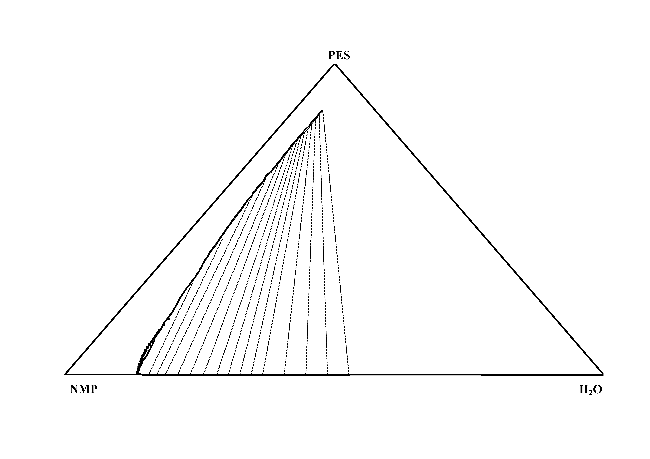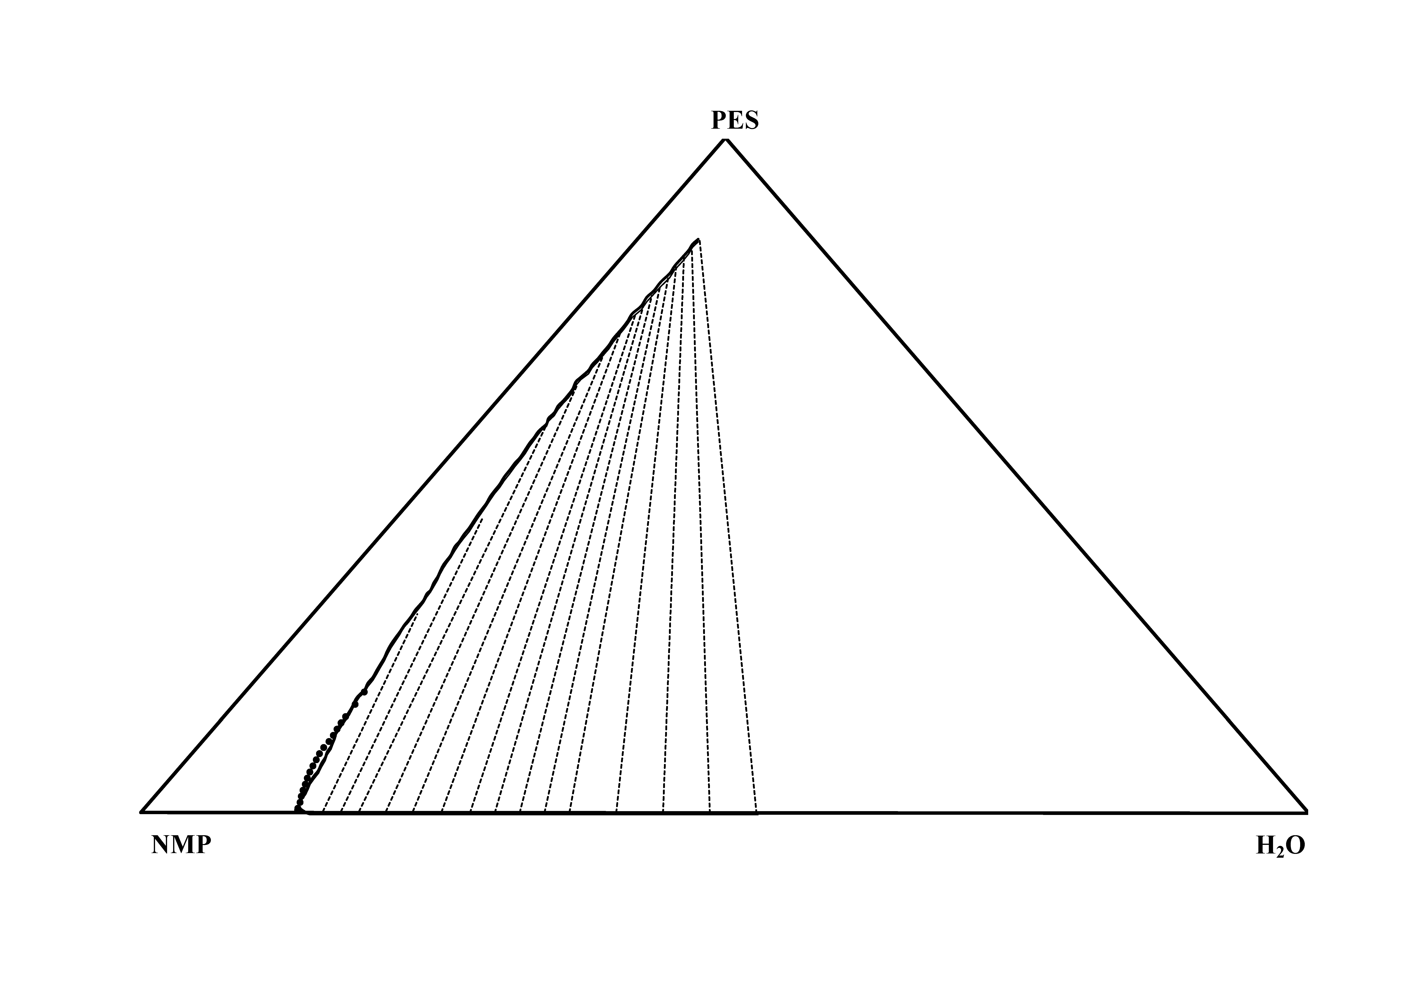

Fig. 3. The binodal curve (bold solid line), measured cloud point (solid circles) and tie lines (dotted lines) for ternary system Polyethersulfone (PES) / n-methyl-2-pyrrolidone (NMP) /H2O

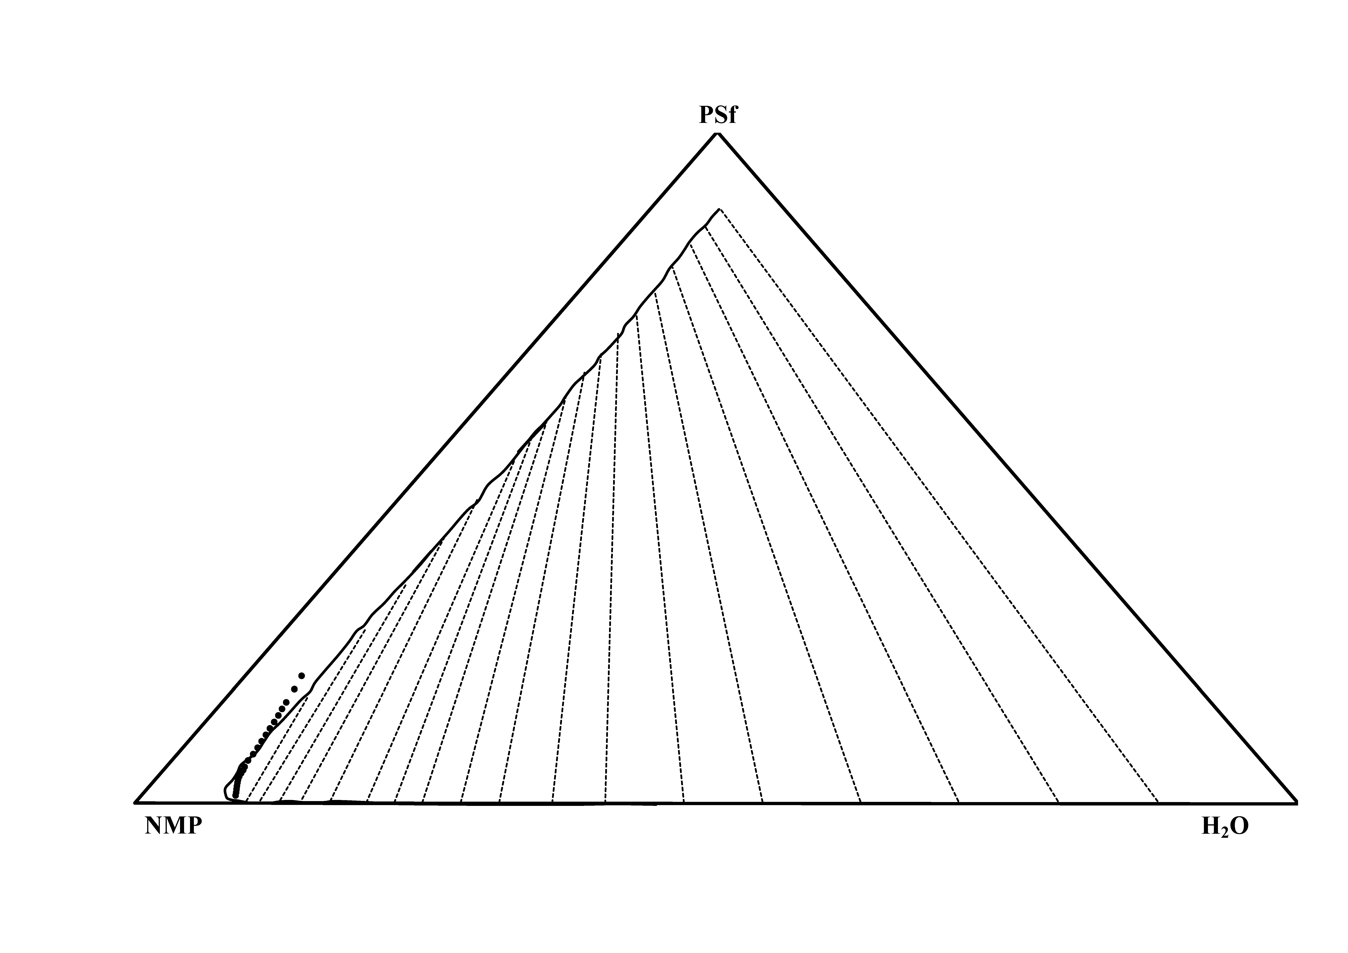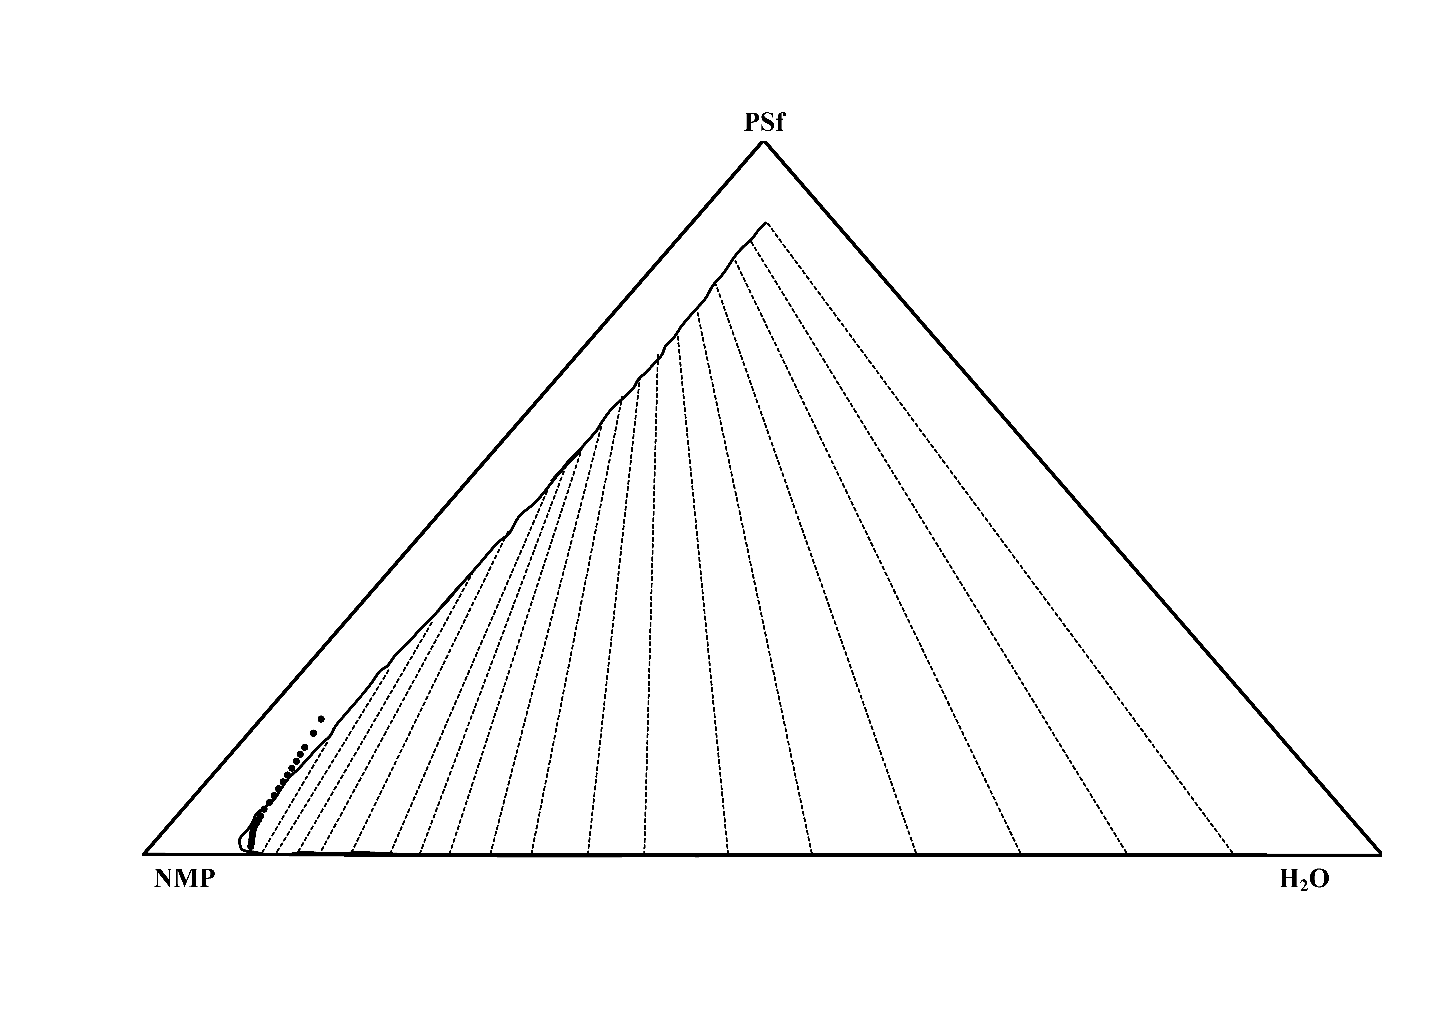

Fig. 4. The binodal curve (bold solid line), cloud point (solid circles) and tie lines (dotted lines) for ternary system Polysulfone (PSf) / n-methyl-2-pyrrolidone (NMP) /H2O

The effectiveness of the wet phase inversion, which is induced due to introduction of nonsolvent to dope phase, can be assessed using distribution coefficients (D) and separation factor (S). The separation factor, here, is measure of the ability of nonsolvent to separate the NMP from polymer and defined as the ratio of distribution coefficients of the NMP (Ds) to Polymer (Dp) [50] as given by Eq. 14;

|  |  |
| --- | --- |
|  | 10 |

Here and  are the mass fractions of solvent and polymer in polymer-lean phase (indicated by superscript L), and  are the mass fractions of solvent and polymer in polymer-rich phase (indicated by superscript R), and  are distribution coefficients of solvent and polymer respectively. The distribution coefficients and separation factors, for each system, are given in Table 17 and Table 18 respectively for PSf/NMP/H2O and PES/NMP/H2O ternary systems.

Table 17. The obtained phase compositions, distribution coefficients and separation factors for ternary system of PSf(3)/NMP(2)/H2O(1)

|  |  |  |  |  |  |  |  |  |  |  |
| --- | --- | --- | --- | --- | --- | --- | --- | --- | --- | --- |
| Polymer Lean Phase | | |  | Polymer Rich Phase | | |  | Ds | Dp | S |
| *w1* | *w2* | *w3* |  | *w1* | *w2* | *w3* |  |
| 0.8777 | 0.1170 | 0.0052 |  | 0.0607 | 0.0519 | 0.8873 |  | 2.2532 | 0.0059 | 384.28820 |
| 0.7921 | 0.2027 | 0.0052 |  | 0.0619 | 0.0782 | 0.8599 |  | 2.5917 | 0.0061 | 428.35310 |
| 0.7065 | 0.2883 | 0.0052 |  | 0.0631 | 0.1044 | 0.8324 |  | 2.7601 | 0.0062 | 441.61910 |
| 0.6227 | 0.3727 | 0.0046 |  | 0.0641 | 0.1367 | 0.7992 |  | 2.7260 | 0.0058 | 471.09380 |
| 0.5389 | 0.4571 | 0.0040 |  | 0.0651 | 0.1690 | 0.7659 |  | 2.7050 | 0.0053 | 512.01320 |
| 0.4719 | 0.5252 | 0.0029 |  | 0.0657 | 0.2009 | 0.7334 |  | 2.6147 | 0.0039 | 663.47970 |
| 0.4049 | 0.5934 | 0.0017 |  | 0.0663 | 0.2328 | 0.7009 |  | 2.5492 | 0.0025 | 1030.2884 |
| 0.3590 | 0.6386 | 0.0023 |  | 0.0664 | 0.2616 | 0.6720 |  | 2.4411 | 0.0034 | 709.45570 |
| 0.3132 | 0.6839 | 0.0029 |  | 0.0664 | 0.2905 | 0.6431 |  | 2.3546 | 0.0045 | 523.89060 |
| 0.2802 | 0.7170 | 0.0029 |  | 0.0674 | 0.3227 | 0.6099 |  | 2.2216 | 0.0047 | 468.74740 |
| 0.2471 | 0.7500 | 0.0029 |  | 0.0684 | 0.3550 | 0.5766 |  | 2.1127 | 0.0050 | 421.48700 |
| 0.2231 | 0.7740 | 0.0029 |  | 0.0699 | 0.3853 | 0.5448 |  | 2.0090 | 0.0053 | 378.69460 |
| 0.1991 | 0.7981 | 0.0029 |  | 0.0714 | 0.4156 | 0.5130 |  | 1.9204 | 0.0056 | 340.86800 |
| 0.1830 | 0.8130 | 0.0040 |  | 0.0698 | 0.4453 | 0.4849 |  | 1.8257 | 0.0083 | 218.75840 |
| 0.1669 | 0.8279 | 0.0052 |  | 0.0683 | 0.4750 | 0.4567 |  | 1.7429 | 0.0114 | 152.98580 |
| 0.1540 | 0.8391 | 0.0069 |  | 0.0683 | 0.5034 | 0.4283 |  | 1.6667 | 0.0162 | 102.89660 |
| 0.1411 | 0.8502 | 0.0087 |  | 0.0683 | 0.5318 | 0.3998 |  | 1.5987 | 0.0217 | 73.717300 |
| 0.1322 | 0.8603 | 0.0075 |  | 0.0695 | 0.5663 | 0.3642 |  | 1.5191 | 0.0206 | 73.617200 |
| 0.1232 | 0.8704 | 0.0064 |  | 0.0706 | 0.6009 | 0.3285 |  | 1.4486 | 0.0194 | 74.845700 |
| 0.1147 | 0.8789 | 0.0064 |  | 0.0699 | 0.6352 | 0.2948 |  | 1.3836 | 0.0216 | 64.149500 |
| 0.1062 | 0.8874 | 0.0064 |  | 0.0693 | 0.6696 | 0.2611 |  | 1.3253 | 0.0244 | 54.416900 |
| 0.1005 | 0.8937 | 0.0058 |  | 0.0698 | 0.7202 | 0.2100 |  | 1.2410 | 0.0275 | 45.088900 |
| 0.0948 | 0.9000 | 0.0052 |  | 0.0703 | 0.7707 | 0.1590 |  | 1.1677 | 0.0327 | 35.680900 |

Table 18. The obtained phase compositions, distribution coefficients and separation factors for ternary system of PES(3)/NMP(2)/H2O(1)

|  |  |  |  |  |  |  |  |  |  |  |
| --- | --- | --- | --- | --- | --- | --- | --- | --- | --- | --- |
| Polymer Lean Phase | | |  | Polymer Rich Phase | | |  | Ds | Dp | S |
| *w1* | *w2* | *w3* |  | *w1* | *w2* | *w3* |  |
| 0.5281 | 0.4706 | 0.0013 |  | 0.0536 | 0.0938 | 0.8525 |  | 5.0164 | 0.0015 | 3411.125200 |
| 0.4880 | 0.5105 | 0.0016 |  | 0.0541 | 0.1076 | 0.8383 |  | 4.7445 | 0.0019 | 2537.838600 |
| 0.4478 | 0.5504 | 0.0019 |  | 0.0546 | 0.1214 | 0.8240 |  | 4.5344 | 0.0023 | 1986.8196 |
| 0.4076 | 0.5902 | 0.0022 |  | 0.0551 | 0.1352 | 0.8098 |  | 4.3671 | 0.0027 | 1611.7805 |
| 0.3674 | 0.6301 | 0.0025 |  | 0.0556 | 0.1489 | 0.7955 |  | 4.2308 | 0.0032 | 1342.2241 |
| 0.3461 | 0.6515 | 0.0024 |  | 0.0555 | 0.1630 | 0.7816 |  | 3.9978 | 0.0030 | 1329.1255 |
| 0.3249 | 0.6729 | 0.0022 |  | 0.0554 | 0.1770 | 0.7676 |  | 3.8017 | 0.0029 | 1330.0450 |
| 0.3037 | 0.6943 | 0.0020 |  | 0.0553 | 0.1910 | 0.7537 |  | 3.6344 | 0.0027 | 1344.4469 |
| 0.2824 | 0.7157 | 0.0019 |  | 0.0552 | 0.2051 | 0.7397 |  | 3.4900 | 0.0025 | 1372.7351 |
| 0.2700 | 0.7277 | 0.0024 |  | 0.0554 | 0.2179 | 0.7267 |  | 3.3387 | 0.0032 | 1032.0968 |
| 0.2575 | 0.7396 | 0.0028 |  | 0.0555 | 0.2308 | 0.7137 |  | 3.2042 | 0.0040 | 810.6737 |
| 0.2451 | 0.7516 | 0.0033 |  | 0.0556 | 0.2437 | 0.7007 |  | 3.0840 | 0.0047 | 656.6029 |
| 0.2326 | 0.7636 | 0.0038 |  | 0.0557 | 0.2566 | 0.6877 |  | 2.9759 | 0.0055 | 544.0885 |
| 0.2211 | 0.7751 | 0.0038 |  | 0.0569 | 0.2827 | 0.6604 |  | 2.7417 | 0.0057 | 481.4016 |
| 0.2096 | 0.7867 | 0.0038 |  | 0.0580 | 0.3088 | 0.6331 |  | 2.5472 | 0.0059 | 428.7770 |
| 0.1980 | 0.7982 | 0.0038 |  | 0.0592 | 0.3350 | 0.6059 |  | 2.3830 | 0.0062 | 383.8607 |
| 0.1865 | 0.8097 | 0.0038 |  | 0.0603 | 0.3611 | 0.5786 |  | 2.2426 | 0.0065 | 344.9796 |
| 0.1788 | 0.8175 | 0.0038 |  | 0.0678 | 0.4242 | 0.5079 |  | 1.9269 | 0.0074 | 260.2128 |
| 0.1710 | 0.8252 | 0.0038 |  | 0.0754 | 0.4874 | 0.4372 |  | 1.6931 | 0.0086 | 196.8195 |
| 0.1633 | 0.8329 | 0.0038 |  | 0.0829 | 0.5506 | 0.3666 |  | 1.5129 | 0.0103 | 147.4434 |
| 0.1556 | 0.8407 | 0.0038 |  | 0.0904 | 0.6137 | 0.2959 |  | 1.3698 | 0.0127 | 107.7569 |

For the systems investigated, the results listed in Table 17 and Table 18 indicate that the nonsolvent (in both systems) has high separation factors, which itself illustrates the ability of this nonsolvent to extract solvent from polymeric dope solution. Comparing separation factors of two systems, it can be seen that separation factors in PES/NMP/H2O ternary system are much higher than that of PSf/NMP/H2O which can related to kinetic of phase separation and precipitation which is dependent on the molecular characteristics of components such as mobility and mutual diffusion coefficients. According to calculated lattice fluid densities listed in Table 3, PSf is denser than PES and subsequently, it can be expected that the solvent/nonsolvent exchanges in PES/NMP/H2O is much more and facilitated than in PSf/NMP/H2O. It might be interesting to mention that in a dope solution prepared from PES and PSf blend dissolved in NMP, the precipitation rates increase as the PES weight fraction in blend increases [51, 52] which can be simply justified according to the separation factors listed in Table 17 and Table 18.

Finally, to check the reliability and consistency of tie-line data, the Othmer–Tobias (Eq. 15) [53] and Hand (Eq. 16) [54] correlation equations were used.

|  |  |
| --- | --- |
|  | 11 |
|  | 12 |

Here, and  are the mass fractions of solvent, nonsolvent and polymer in polymer-lean phase,, and  are the mass fractions of solvent, nonsolvent and polymer in polymer-rich phase. The *A*, *B*, *A’* and *B’* are Othmer–Tobias and Hand correlations constants respectively.

The obtained results of Othmer–Tobias and Hand correlations are shown in Fig. 5 and Fig. 6 respectively. The obtained correlations are desirable and the reliability of tie lines can be validated. It must be noted that these two correlations are mainly developed and proposed for ordinary LLE systems and for current case where the systems contain high branched polymer chains (PES and PSf), R2 values in order of 0.80 are acceptable.

Fig. 5. The Othmer–Tobias correlation (Eq. 15): *A=0.6826*, *B=0.6521*, *y* is  and *x* is ; solid circles calculated using experimental data and the solid line is the linear fitting obtained

Fig. 6. The Hand correlation (Eq. 16): *A’=1.4011*, *B’=1.0301*, *y* is  and *x* is; solid circles calculated using experimental data and the solid line is the linear fitting obtained

1. Conclusion

An investigation of experimental and theoretical phase equilibrium calculations is presented in this study to assess and provide the guidelines to choose appropriate chemical thermodynamic models for the local thermodynamic equilibria emerged in mathematical simulations applicable for wet casting process of polymeric membrane fabrication. In this work, four phase equilibria approaches of gamma-gamma, phi-gamma, gamma-phi and phi-phi were considered and a number of equations of state and activity coefficient models were considered for fugacity (chemical potential) calculations. The calculation results are compared with experimental phase equilibrium data for two ternary systems of NMP/PES/H2O and NMP/PSf/H2O, which were obtained through the cloud point measurements, to compare the precision of the different models and approaches.

According to obtained results, the gamma-gamma approaches and application of CRS model for dope phase and UNIQUAC for coagulation phase is most highly recommended choice. In addition, it has been shown that the appropriate and thermodynamically sound combination of activity coefficient and fugacity coefficient models is enabled by the gamma-phi approach. The application of fugacity coefficients is not an appropriate choice for dope phase at all; and one should avoid using a phi approach for dope solution.

The optimal phase approach was used, then, for calculation of tie lines from which the distribution coefficients and separation factors were determined. Based obtained separation factors, it was approved that wet phase inversion is a practical technique to remove solvent from dope phase. It was found that the separation performance of wet phase inversion depends on the intrinsic properties and mobility characteristic of components. Finally, the obtained correlations were checked for consistency and reliability using the Othmer–Tobias and Hand correlations and desirable results were obtained.

1. Appendixes
   1. Appendix A – Equations of State

The generic form of cubic equations of state is given by Eq. **12**;

|  |  |
| --- | --- |
|  | 13 |

where  and[19]. The coefficients  and  are constant numbers for each equation of state. is given as a function of physicochemical properties such as reduced temperature and acentric factor for each equation of state.  and  indicate the critical temperature and pressure respectively, and the  in the universal gas constant.

Considering the equations of state as chemical thermodynamic model, the fugacity coefficient of pure component () *at* liquid state can be calculated using Eq. 14 [19], setting temperature and pressure to the dope phase temperature and corresponding , where,, and .,,  and  are parameters specific to each equation of state (EOS).

|  |  |
| --- | --- |
|  | 14 |

The compressibility factor, *as* liquid can be calculated from Eq.15 using an iterative root seeking method [19], which is a reformed expression obtained for the generic formulation of cubic equation of state (Eq. 12) [19],.

|  |  |
| --- | --- |
|  | 15 |

For the calculation of, one might use Eq. 16. However, prior to the application of Eq. 16, the liquid mixture compressibility factor,must be calculated from Eq. 15 by substitution of the mixture parameters, where and  can be obtained upon selection of appropriate mixing rules for parameters and [19] using Eqs. 17.

|  |  |
| --- | --- |
|  | 16 |
|  | 17 |

For the current study, a linear and a quadratic mixing rule is employed for and respectively, as presented by Eqs. 18-19, which is known as van der Waals two adjustable parameters mixing rules (vdW2) [19];

|  |  |
| --- | --- |
|  | 18 |
|  | 19 |

It must be noted that these relationships explicitly show the importance of employed mixing rules and the subsequent concern on their appropriate selection. At present, we are not concerned with such issues and this might be investigated in a future work. For current study, **Table 19** and **Table 20** summarize the details of considered equations of state.

Table 19. Details of coefficients in studied equations of state (EOSs)

|  |  |  |  |  |
| --- | --- | --- | --- | --- |
|  |  |  |  | EOS |
|  |  |  |  | RKTCC (Twu–Coon–Cunningham modification to the RK EOS [26]) |
|  |  |  |  | PRGGPR (Gasem–Gao–Pan–Robinson modification to the PR EOS [27]) |

Table 20. Details of relationships  in studied equations of state (EOSs) [55]

|  |  |
| --- | --- |
|  | EOS |
| where   |  |  |  |  |  | | --- | --- | --- | --- | --- | |  |  | |  | | |  |  |  |  |  | | L |  |  |  |  | | M |  |  |  |  | | N |  |  |  |  | | RKTCC |
|  | PRGGPR |

* 1. Appendix B – gE-based Models

Table 21. Details of studied activity coefficient models [19, 22, 23]

|  |  |
| --- | --- |
| Model | Main Equations |
| NRTL |  |
| UNIQUAC |  |
| CRS |  |

**List of Symbols**

|  |  |  |
| --- | --- | --- |
|  |  | interaction parameters defined in UNIQUAC |
|  |  | Parameter of each equation of state, given as |
|  |  | the mixture parameters of each equation of state |
|  |  | Parameter of each equation of state, given as |
|  |  | Accumulative Absolute Relative Deviation |
|  |  | the mixture parameters of each equation of state |
|  |  | Dope (Upper) phase |
|  |  | fugacity of pure component |
|  |  | fugacity of pure component  at the standard state |
|  |  | fugacity of component  in mixture |
|  |  | Gibbs free energy |
|  |  | Characteristic energy in NRTL |
|  |  | Boltzmann constant |
|  |  | van der Waals two adjustable parameters mixing rules (vdW2) |
|  |  | van der Waals two adjustable parameters mixing rules (vdW2) |
|  |  | the molecular weight of components |
|  |  | Product of number of hard cores in molar volume of each core |
|  |  | number of data points |
|  |  | Pressure |
|  |  | critical pressure |
|  |  | saturation vapor pressure of pure component |
|  |  | reduced pressure (hard-core pressure) |
|  |  | Parameter of each equation of state, given as |
|  |  | molecular structure constants required in UNIQUAC model |
|  |  | molecular structure constants required in UNIQUAC model |
|  |  | the mixture parameters of each equation of state |
|  |  | Parameter of each equation of state, given as |
|  |  | the universal gas constant |
|  |  | molecular structure constants required in UNIQUAC model |
|  |  | Temperature |
|  |  | critical temperature |
|  |  | Reduced temperature |
|  |  | reduced temperature (hard-core temperature) |
|  |  | coagulation (Upper) phase |
|  |  | component compositions in dope phase |
|  |  | component compositions in coagulation (upper) phase |
|  |  | mixture compressibility factor |
|  |  | compressibility factor of pure component |
|  |  | Coordinate number in UNIQUAC model (=10) |
|  |  | coefficient of thermal expansion |
|  |  | a function of physicochemical properties for each equation of state |
|  |  | Non-randomness parameter in NRTL |
|  |  | Parameter of each equation of state, given as |
|  |  | Acentric factor |
|  |  | activity coefficient of component |
|  |  | Poynting factor |
|  |  | defined as |
|  |  | saturation fugacity coefficient of pure component |
|  |  | fugacity coefficient of component in mixture |
|  |  | constant number for each equation of state |
|  |  | constant number for each equation of state |
|  |  | parameter specific to each equation of state |
|  |  | parameter specific to each equation of state |
|  |  | interaction parameters defined in NRTL |
|  |  | density |
|  |  | reduced density (hard-core density) |
|  |  | Scaled density the modified Sanchez-Lacombe Lattice Fluid model (SL-LF) in Boudouris et al. |
|  |  | Solubility parameter |
|  |  | solubility parameter in 298 K |
|  |  | calculated data |
|  |  | experimental data |
|  |  | Chemical potential |
|  |  | Difference in property |

**References**

[1] Basic aspects of membrane science and engineering, Elsevier, Italy, 2010.

[2] M. Mulder, Basic Principles of Membrane Technology, 2 ed., Springer Netherlands, Kluwer, Netherlands, Dordrecht, 1996.

[3] K. Ghosal, B.D. Freeman, Gas separation using polymer membranes: an overview, Polymers for Advanced Technologies, 5 (1994) 673-697.

[4] M. Mulder, MEMBRANE PREPARATION | Phase Inversion Membranes, Elsevier Science Ltd, 2000.

[5] U. Jack, Fabrication of wet phase inversion capillary membrane, dimension and diffusion effects, in: Chemical Engineering, Cape Peninsula University ofTechnology, 2006.

[6] H. Ohya, S. Shiki, H. Kawakami, Fabrication study of polysulfone hollow-fiber microfiltration membranes: Optimal dope viscosity for nucleation and growth, Journal of Membrane Science, 326 (2009) 293–302.

[7] Č. Stropnik, V. Musil, M. Brumen, Polymeric membrane formation by wet-phase separation; turbidity and shrinkage phenomena as evidence for the elementary processes, Polymer, 41 (2000) 9227-9237.

[8] W.B. Krantz, A.R. Greenberg, D.J. Hellman, Dry-casting: Computer simulation, sensitivity analysis, experimental and phenomenological model studies, Journal of Membrane Science, 354 (2010) 178-188.

[9] S.A. Altinkaya, H. Yenal, B. Ozbas, Membrane formation by dry-cast process, Journal of Membrane Science, 249 (2005) 163-172.

[10] D. Li, W.B. Krantz, A.R. Greenberg, R.L. Sani, Membrane formation via thermally induced phase separation (TIPS): Model development and validation, Journal of Membrane Science, 279 (2006) 50-60.

[11] L. Keshavarz, M.A. Khansary, S. Shirazian, Phase diagram of ternary polymeric solutions containing nonsolvent/solvent/polymer: Theoretical calculation and experimental validation, Polymer, 73 (2015) 1-8.

[12] B.S. Lalia, V. Kochkodan, R. Hashaikeh, N. Hilal, A review on membrane fabrication: Structure, properties and performance relationship, Desalination, 326 (2013) 77-95.

[13] L. J. Zeman, A.L. Zydney, Microfiltration and Ultrafiltration: Principles and Applications, CRC Press, 1996.

[14] H. Lee, W.B. Krantz, S.-T. Hwang, A model for wet-casting polymeric membranes incorporating nonequilibrium interfacial dynamics, vitrification and convection, Journal of Membrane Science, 354 (2010) 74-85.

[15] L. Yilmaz, A.J. McHugh, Analysis of nonsolvent–solvent–polymer phase diagrams and their relevance to membrane formation modeling, Journal of Applied Polymer Science, 31 (1986) 997-1018.

[16] H. Strathmann, K. Kock, The formation mechanism of phase inversion membranes, Desalination, 21 (1977) 241-255.

[17] Y.-D. He, Y.-H. Tang, X.-L. Wang, Dissipative particle dynamics simulation on the membrane formation of polymer–diluent system via thermally induced phase separation, Journal of Membrane Science, 368 (2011) 78-85.

[18] P. van de Witte, P.J. Dijkstra, J.W.A. van den Berg, J. Feijen, Phase separation processes in polymer solutions in relation to membrane formation, Journal of Membrane Science, 117 (1996) 1-31.

[19] J.M. Smith, H. Van Ness, M. Abbott, Introduction to Chemical Engineering Thermodynamics, 7 ed., McGraw-Hill, New York, 2005.

[20] G.M. Kontogeorgis, G.K. Folas, Thermodynamic Models for Industrial Applications: From Classical and Advanced Mixing Rules to Association Theories, 1 ed., John Wiley & Sons, Ltd., 2010.

[21] J.P. O’Connell, J.M. Haile, Thermodynamics Fundamentals for Applications, Cambridge University Press, 2005.

[22] S.I. Sandler, Models for Thermodynamic and Phase Equilibria Calculations CRC Press, 1993.

[23] J.M. Prausnitz, R.N. Lichtenthaler, E. Gomes de Azevedo, Molecular Thermodynamics of Fluid-Phase Equilibria 3ed., Prentice Hall, 1998.

[24] J.G. Wijmans, J. Kant, M.H.V. Mulder, C.A. Smolders, Phase separation phenomena in solutions of polysulfone in mixtures of a solvent and a nonsolvent: relationship with membrane formation, Polymer, 26 (1985) 1539-1545.

[25] J. Barzin, B. Sadatnia, Theoretical phase diagram calculation and membrane morphology evaluation for water/solvent/polyethersulfone systems, Polymer, 48 (2007) 1620-1631.

[26] C.H. Twu, J.E. Coon, J.R. Cunningham, A new generalized alpha function for a cubic equation of state Part 2. Redlich-Kwong equation, Fluid Phase Equilibria, 105 (1995) 61-69.

[27] K.A.M. Gasem, W. Gao, Z. Pan, R.L. Robinson, A modified temperature dependence for the Peng–Robinson equation of state, Fluid Phase Equilibria, 181 (2001) 113-125.

[28] C. Wohlfarth, CRC handbook of enthalpy data of polymer-solvent systems, CRC Press, 2006.

[29] C. Wohlfarth, CRC handbook of liquid-liquid equilibrium data of polymer solutions, CRC Press, 2007.

[30] C. Wohlfarth, CRC handbook of thermodynamics data of polymer solutions at elevated pressures, CRC Press, 2005.

[31] B.E. Poling, J.M. Prausnitz, J.P. O'Connell, Properties of Gases and Liquids, 4 ed., McGraw-Hill Professional, 1987.

[32] D.W.V. Krevelen, K.T. Nijenhuis, Properties of Polymers: Their Correlation with Chemical Structure; Their Numerical Estimation and Prediction from Additive Group Contributions, 4 ed., Elsevier.

[33] A.M. Mayes, CRS, in, Massachusetts Institute of Technology, Department of Materials Science and Engineering, 2014.

[34] A.-V.G. Ruzette, A.M. Mayes, A Simple Free Energy Model for Weakly Interacting Polymer Blends, Macromolecules, 34 (2001) 1894–1907.

[35] J.A. Gonzalez-Leon, A.M. Mayes, Phase Behavior Prediction of Ternary Polymer Mixtures, Macromolecules, 36 (2003) 2508-2515.

[36] Limiting Activity Coefficients Calculation by MOSCED, in, the Dortmund Data Bank Software & Separation Technology GmbH (DDBST GmbH), 2014.

[37] M.J. Lazzaroni, D. Bush, C.A. Eckert, T.C. Frank, S. Gupta, J.D. Olson, Revision of MOSCED Parameters and Extension to Solid Solubility Calculations, Industrial & Engineering Chemistry Research, 44 (2005) 4075-4083.

[38] J. Wisniak, A. Apelblat, H. Segura, An Assessment of Thermodynamic Consistency Tests for Vapor-Liquid Equilibrium Data, Physics and Chemistry of Liquids, 35 (1997) 1-58.

[39] G. Varhegyi, C.H. Eon, Calculation of the Free Energy Equation Parameters from Ternary Liquid-Liquid Equilibrium Data, Industrial & Engineering Chemistry Fundamentals, 16 (1977) 182-185.

[40] R.K. Sahoo, T. Banerjee, S.A. Ahmad, A. Khanna, Improved binary parameters using GA for multi-component aromatic extraction: NRTL model without and with closure equations, Fluid Phase Equilibria, 239 (2006) 107-119.

[41] J.M. Sørensen, T. Magnussen, P. Rasmussen, A. Fredenslund, Liquid—liquid equilibrium data: Their retrieval, correlation and prediction Part II: Correlation, Fluid Phase Equilibria, 3 (1979) 47-82.

[42] E. Hála, Note to Bruin-Prausnitz One-Parameter and Palmer-Smith Two-Parameter Local Composition Equation, Industrial & Engineering Chemistry Process Design and Development, 11 (1972) 638.

[43] J. Alvarez Juliá, C.R. Barrero, M.E. Corso, M.d.C. Grande, C.M. Marschoff, On the application of the NRTL method to ternary (liquid+liquid) equilibria, The Journal of Chemical Thermodynamics, 37 (2005) 437-443.

[44] R.K. Sahoo, T. Banerjee, A. Khanna, UNIQUAC Interaction Parameters with Closure for Imidazolium Based Ionic Liquid Systems Using Genetic Algorithm, The Canadian Journal of Chemical Engineering, 85 (2008) 833-853.

[45] M. Asgarpour Khansary, M.A. Aroon, On the consistency and correctness of thermodynamics phase equilibria modeling and correlation reports published in Fuel journal, Fuel, 140 (2015) 810-811.

[46] A. Farajnezhad, O.A. Afshar, M.A. Khansary, S. Shirazian, M. Ghadiri, Correlation of interaction parameters in Wilson, NRTL and UNIQUAC models using theoretical methods, Fluid Phase Equilibria, (2016).

[47] A.S. Al-Jimaz, M.S. Fandary, J.A. Al-Kandary, M.A. Fahim, Liquid−Liquid Equilibria Measurements for Ternary System of Hexadecane + 1,3,5-Trimethylbenzene +N-Methyl-2-pyrrolidone, Journal of Chemical & Engineering Data, 51 (2006) 1026-1030.

[48] F.R. do Carmo, N.S. Evangelista, R.S. de Santiago-Aguiar, F.A.N. Fernandes, H.B. de Sant’Ana, Evaluation of optimal activity coefficient models for modeling and simulation of liquid–liquid equilibrium of biodiesel+glycerol+alcohol systems, Fuel, 125 (2014) 57-65.

[49] Z. Li, K.H. Smith, K.A. Mumford, Y. Wang, G.W. Stevens, Regression of NRTL parameters from ternary liquid–liquid equilibria using particle swarm optimization and discussions, Fluid Phase Equilibria, 398 (2015) 36-45.

[50] A. Ghanadzadeh Gilani, H. Ghanadzadeh Gilani, S.L. Seyed Saadat, M. Janbaz, Ternary liquid–liquid equilibrium data for the (water+butyric acid+n-hexane or n-hexanol) systems at T=(298.2, 308.2, and 318.2)K, The Journal of Chemical Thermodynamics, 60 (2013) 63-70.

[51] K.J. Baik, J.Y. Kim, J.S. Lee, S.C. Kim, H.K. Lee, Morphology of Membranes Formed from PSf/PES/NMP/Water System by Immersion Precipitation, Korea Polymer Journal,, 9 (2001) 285-291.

[52] K.-J. Baik, J.Y. Kim, H.K. Lee, S.C. Kim, Liquid–liquid phase separation in polysulfone/polyethersulfone/N-methyl-2- pyrrolidone/water quaternary system, Journal of Applied Polymer Science, 74 (1999) 2113-2123.

[53] D.F. Othmer, P.E. Tobias, Liquid -Liquid Extraction Data -Toluene and Acetaldehyde Systems, Industrial & Engineering Chemistry, 34 (1942) 690-692.

[54] D.B. Hand, Dineric Distribution, The Journal of Physical Chemistry, 34 (1929) 1961-2000.

[55] F. Abdollahi-Demneh, M.A. Moosavian, M.M. Montazer-Rahmati, M.R. Omidkhah, H. Bahmaniar, Comparison of the prediction power of 23 generalized equations of state: Part I. Saturated thermodynamic properties of 102 pure substances, Fluid Phase Equilibria, 288 (2010) 67-82.