Lithium as an Adsorbent for nitrogen gas separation and purification

Milad Asgarpour Khansary1, Jin Shang1, OTHER COLLABORATORS, Saeed Shirazian

1School of Energy and Environment, City University of Hong Kong, Tat Chee Avenue, Kowloon, Hong Kong SAR

OTHER COLLABORATORS

Department of Chemical Sciences, Bernal Institute, University of Limerick, Limerick, Ireland

**Abstract**

This paper addresses computational and experimental investigations on feasibility study of lithium as an adsorbent for nitrogen gas separation in natural gas processing applications. The possible chemo- and physio- sorption phenomena were considered far from ignition temperatures in adsorption modeling and then combined with possible diffusional dispersion employing a temperature programmed kinetic Monte Carlo method where presence of moisture, methan, carbon dioxide, oxygen, nitrogen and hydrogen was focused.

RESULTS HERE: RESULTS HERE: RESULTS HERE: RESULTS HERE

**Keywords**: Gas separation; Lithium; computational chemistry; nitrogen; adsorption

# Introduction

# Methodology

## Outline of experimental measurements

## Outline of theoretical calculations

For theoretical process modeling of adsorption and separation of nitrogen by lithium, contribution of different mechanisms must be considered. Due to reactivity of lithium [1-4], the occurrence of reaction between lithium and gases and even their by-products are expected [5-7], which is referred hereinafter as chemo-sorption. Gases may interact with lithium crystal surface and physically adsorbed onto (hereinafter physio-sorption) or even may diffuse into the crystal structure. It is worthy to mention that many of products/byproducts of possible reactions of lithium and other reactants are solids and may form layers on crystal structure of lithium [8, 9], which might be considered in diffusion and/or physio-sorption, however, for the purpose of present paper, these are excluded from diffusivity and physical interactions analysis. The overall adsorption process is collective effect of these three mechanisms which are focused in following paragraphs. For coupling of these mechanisms, a temperature programmed kinetic Monte-Carlo calculations is then used [10].

***Reaction schemes*** that can be found in literature [11-17] involving lithium and one of the considered gases as reactant and/or their byproducts are listed in Scheme. 2. However, for proposed application of lithium as adsorbent, the operating conditions are in low temperatures and far from ignition and melting temperatures, so as a rule of thumb, one may expect that some of these reactions won’t contribute to the overall process as for present work, the temperature programmed kinetic Monte-Carlo calculations are performed over 35 – 100 °C. Thus, for our present purpose, following reaction scheme is used.

|  |  |
| --- | --- |
| **#** | **Reaction** |
| 1 | 2Li + H2 ↔ 2LiH |
| 2 | 2 LiH + O2 ↔ 2 LiOH |
| 3 | 2 LiOH + CO2 ↔ Li2CO3 + H2O |
| 4 | Li2O + H2O ↔ 2LiOH |
| 5 | Li2O + CO2 ↔ Li2CO3 |
| 6 | 2Li + 2H2O ↔ 2LiOH + H2 |
| 7 | 10Li + 3CO2 ↔ Li2CO3 + 3Li2O + Li2C2 |
| 8 | 4Li + O2 ↔ 2Li2O + Li2O2 |
| 9 | 2 Li2O2 + 2 H2O ↔ 4 LiOH + O2 |
| 10 | 2 Li2O2 + 2 CO2 ↔ 2 Li2CO3 + O2 |
| 11 | 3 LiH + N2 ↔ Li3N +NH3 |
| 12 | NH3 +2 Li ↔ Li2NH + H2 |
| 13 | 3 Li2NH ↔ 2Li3N + NH3 |
| 14 | 2LiOH + H2 ↔ Li2O + H2O |
| 15 | 3 LiH + NH3 + Li2NH ↔ Li3N + 3H2 |
| 16 | 2Li + CH4 ↔ Li2C2 + H2 |
| 17 | LiH + H2O ↔ LiOH + H2 |
| 18 | LiH + LiOH ↔ Li2O + H2 |
| 19 | 6Li + N2 ↔ 2Li3N |
| Scheme. 1. Considered reactions scheme | |

***Density Functional Theory (DFT)*** calculations of COnductor-like Screening MOdel (COSMO) [18] were used for calculation of screening charge on the molecular surface with screening charge density (*σ*) and the probability distribution of such surface *p*(*σ*), (Sigma profile) which itself can be used for qualitative determination of the interactions between molecules [19]. A fit of sigma profiles may be used to imply that two compounds feel comfortable to be in contact while a misfit shows the interaction of the two compounds might be weak [18]. The particles may have desirable interactions provided that they showed matched Sigma profiles with similar shapes and peaks. In COMSO, three type of surfaces types are categorized as (1) non-hydrogen bonding, (2) hydrogen bonding from OH groups, and (3) other hydrogen bonding groups [20, 21]. For determination of these Sigma profiles, the basic quantum chemical calculations and DFT of COSMO needs to be carried out to generate COSMO files. For this purpose, the DMol3 module in MS software package was used as it contains all required scripts. For geometry optimization of compound molecules, the density functional theory (DFT) of Generalized Gradient Approximate (GGA) with Volsko-Wilk-Nusair functional (VWN) and double numerical basis including d-polarization function (DND) level of theory was implemented as recommended [18]. The geometry optimization of molecules was followed by an energy minimization step with the same settings and by inserting COSMO keywords in DMol3 module scripts, and thus the required COMSO files were obtained. The Sigma profiles were computed for all particles.

***Molecular Dynamics (MD)*** calculations in NPT (constant number of molecules, pressure and temperature) and NVE (constant number of molecules, volume and energy) ensembles were performed to evaluate mobility of gas particles in terms of diffusivity [22-25]. The diffusivity can be investigated by determination of mean square displacement (MSD) which is defined as  where *ri* denotes the position vector of atom *α* [24]. The angular bracket indicates that averaging must be performed over all choices of time origin within a dynamics trajectory. The diffusion coefficient, *D*, is related to MSD as  [24] where *Nα* is the number of diffusive atoms in the system. These calculations may be performed with the help of Forcite module in MS software package [25] because it contains all these scripts as used in this work. The computed results by Forcite module are needed to be fitted to a straight line (say *y=a×x+b*), then the slope “*a*” can be used for calculation of diffusivity as  [24, 25] which is in unit of A°2/ps (square of Angstrom per Pico second) and can be converted to cm2/s unit multiplying it by 10-4. To perform simulations, the atomistic models were optimized geometrically and energetically minimized using Universal Force Field (UFF) implemented in the Forcite module of MS software package [26-28]. The optimized structures then used an input atomistic models in Amorphous Cell module. As it is possible that the molecules being unequally distributed throughout the created cell, the cells need to be relaxed. For this, an energy minimization is followed by a short NPT-ensemble MD simulation with a periodically changing temperature known as annealing to equilibrate the cell. To calculate MSD, another molecular dynamics simulation at NVE ensemble was performed. The MSD data then can be used for calculation of diffusivity as mentioned.

***Physio-sorption*** was investigated using the Metropolis and configurational bias Monte Carlo techniques [29-32] according to a simulated annealing schedule [25-28] to study the interactions between solid structures and gases [10]. In this techniques, a canonical ensemble is constructed in which loading of all one peer of considered pairs (say screen) on the other peer (say base) as well as the temperature are fixed [26-28] and candidate pairs are sampled from this canonical ensemble. Each configuration *i* could have a probability  [29-32] where *kB* is the Boltzmann constant (1.38064852×10-23 *J*/*K*) and *T* is the absolute temperature (Kelvin), *C* is an arbitrary constant and *Ei* is the total energy of configuration *i* which is given as a sum of (1) intermolecular energy between the screen molecules, (2) interaction energy between the base and screen molecules, and (3) total intramolecular energy of the screen molecules. As the energy contribution of base is constant due to fixed structure, therefore, in simulations, the intramolecular energy of base vanishes and was not considered therefore. Metropolis and configurational bias Monte Carlo are already incorporated in MS software package [25] under Adsorption locator and sorption modules which is used here for the aforementioned calculations. To perform simulations, the atomistic models were optimized geometrically and energetically minimized using a Universal Force Field (UFF) implemented in the Forcite module of MS software package [26-28]. The optimized structures then used an input atomistic models in adsorption locator module and calculations were performed. To ensure consistency of calculations, for each sample, runs were repeated 10 times.

***Energy barriers and Reaction rates (Chemo-sorption)*** were calculated by use of the transition state theory of chemical reactions formulated by wigner-eyring-polanyi-evans (WEPE) [33-35], the free energies of chemical reactions were used which were calculated through a vibrational analysis from first principles calculations [36-38]. The reaction rate constants in the transition state theory of chemical reactions formulated by WEPE is given as where *kB* is Boltzmann’s constant (1.38064852×10-23 J.K-1), *h* is Planck’s constant (6.626069934×10-34 J.s), *R* is universal gas constant (8.3144598 J.K-1.mol-1), *T* is temperature in Kelvin and *∆G* is the Gibbs free energy of activation [39-41]. Prior to the vibrational analysis calculations, the structures of reactants and products molecules were geometrically optimized using geometry optimization functionality in DMol3 module of Biovia Material Studio (MS) [25]. In this step, ultrafine quality was applied for all calculations where generalized-gradient approximations (GGA) and becke-lee-yang-parr (BLYP) density-functional theory (DFT) were employed [42-45]. For accurate thermodynamic properties computation, the use of gradient corrected functionals is of interest. The Hamiltonian was specified to be used and d-polarization function (DND) level of theory was implemented. The thermal smearing was applied to control convergence behavior in which the Fermi level energies according to a thermal distribution are populated resulting in enhanced self-consistent field (SCF) calculations convergence [46-48]. The results of this analysis were used for energy of activation.

***Adsorption process kinetics*** were studied using diffusivity, reaction rates and sorption analysis results where a coupled and combined adsorption/sorption-diffusion process was constructed employing a kinetic Monte Carlo method by using Kinetix module in MS [25]. The calculations in this module are discrete event simulations (DES).This module allows to investigate rates of complex chemical processes under different external conditions. For purpose of present work, a temperature programmed calculations (TPC) is considered where process rates can be analyzed as a function of temperature where temperature changes linearly [10, 49]. The characteristics of reactions studied in previous steps are used to construct the process atomistic documents which allow description of the process, its frequency and interactions. Label sites were introduced as counters in Monte-Carlo simulations. Through temperature programmed Monte-Carlo calculations, the combined effects of considered mechanisms can be demonstrated on concertation of compounds.

# Results

## Experimental measurements

## Theoretical calculations

To qualitatively identify the suitability of lithium for interaction with selected gases, the sigma profiles were obtained using COMSO theory and the results are shown in Fig. 1. The main use of sigma profile, *p*(*σ*), is the visualization of the probability distribution of surface area with charge density *σ* [18]. Mostly, histograms of segment surface are plotted over a charge density range of −0.025 to 0.025 e/Å2 [50] where due to sign inversion of the polarization charge density, σ, the peaks are located on opposite sides of σ-profile [21]. For current analysis’s, as mentioned, a fit and matching of sigma profiles may be used to imply that two compounds feel comfortable to be in contact [18]. With this regard and based on the demonstrated results (Fig. 1), one may expect that CH4, N2, and O2 would find lithium a desirable and comfortable surface to attach and interact with as significant fit and matching of corresponding sigma profiles are observed [10, 18].

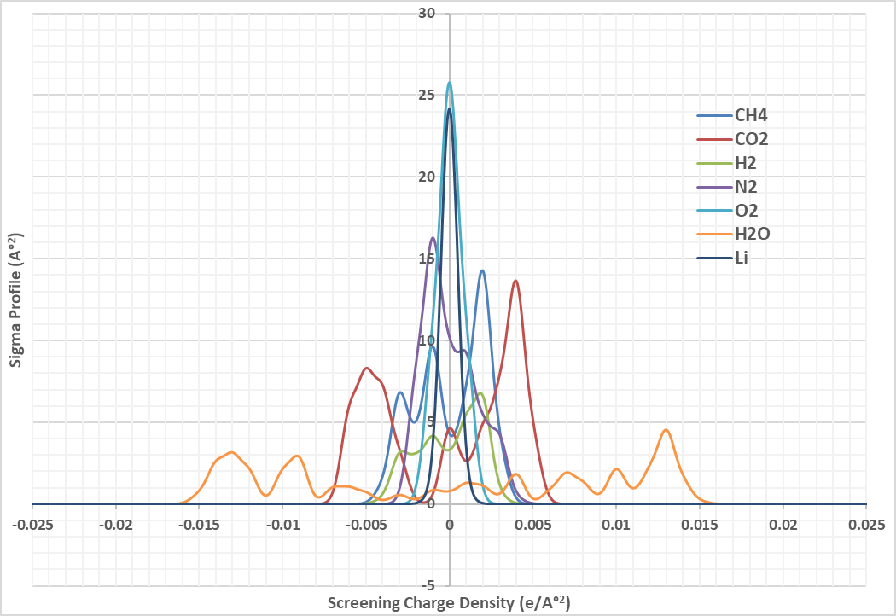

Fig. 1. COSMO sigma profiles

For oxygen, methane, carbon dioxide and nitrogen, both MSD and physio-sorption calculations showed no effective presence of these compounds inside the Lithium crystal. These compounds are bounced back and showed only some close contacts and weak interactions with lithium atoms at the interface. It must be noted that physio-sorption is blind to chemical reactivity [25] which is studied under chemo-sorption analysis in this work. The physio-sorption results for hydrogen and water are illustrated in Fig. 2, from which, it can be observed that hydrogen and water (moisture) are captured physically in small amounts as they should diffuse into lithium crystal, however, due to strong interactions, these compounds would be trapped inside the internal gaps of lithium crystal which itself can be concluded from their small MSD values as shown in Fig. 3 which fall in the range of gas diffusion coefficient in solids. In Fig. 3, a snapshot of such strong interactions and close contacts for both hydrogen and water is provided.

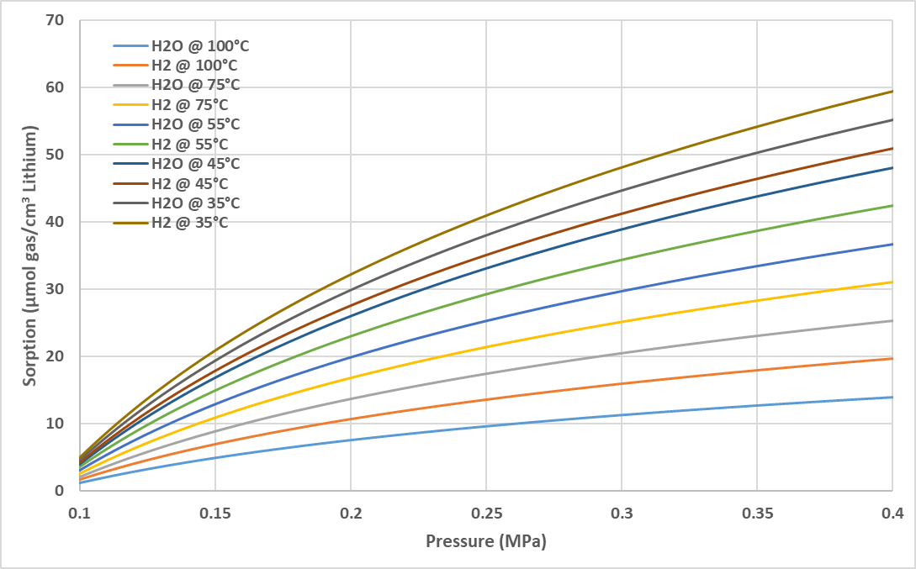

Fig. 2. Physio-sorption results

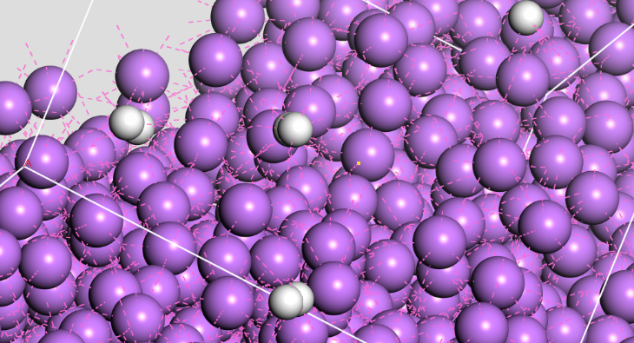

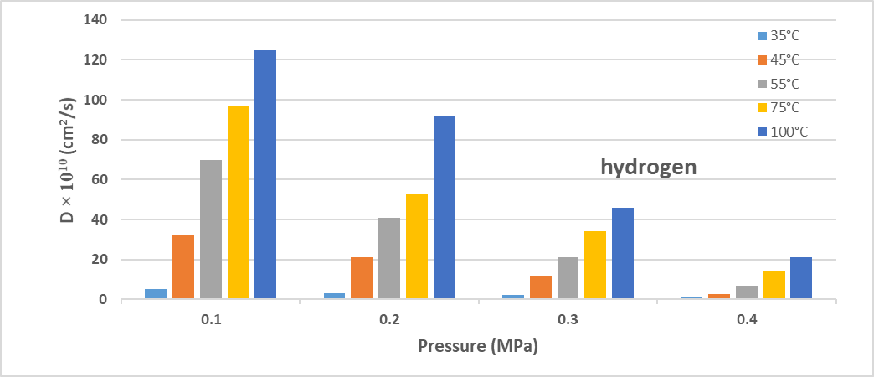

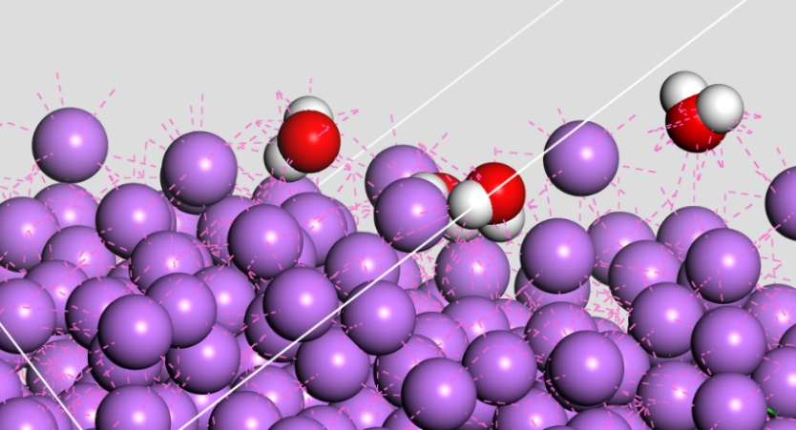

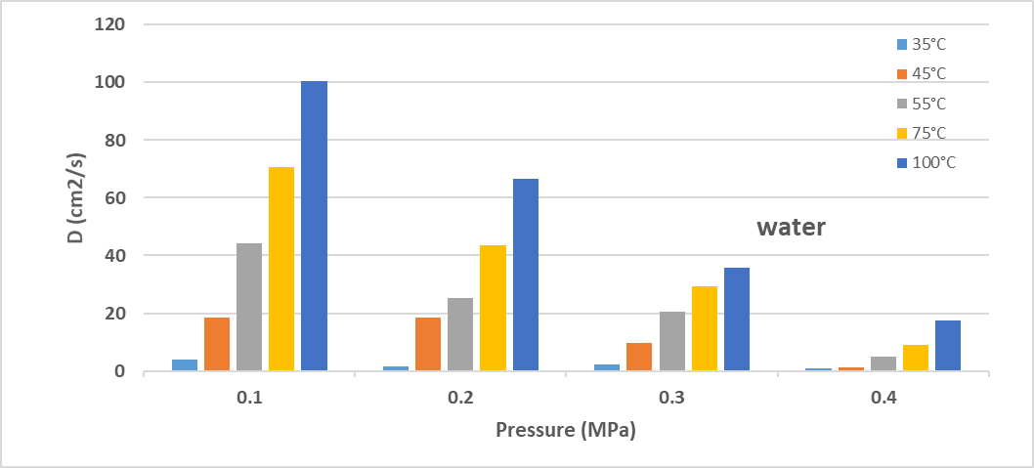

Fig. 3. Diffusivity data from MSD results; in snapshots, purple, red, white respectively shows lithium, oxygen and hydrogen atoms; red dashed lines represent close contacts and strong interactions

A rough analysis of these results can be combined by considering and paying attention to compounds’ kinetic diameters [51-53] as listed in Table 1. One may explain these observations based on the fact that oxygen, methane, carbon dioxide and nitrogen pose large kinetic diameters, larger than the displacement between two neighboring lithium atoms in lithium crystal structure (3.04 °A) [54], revealing the fact that there would be no chance for these compounds to penetrate inside lithium crystal gaps physically. On the other side, both physio-sorption and MSD calculations for hydrogen and water well agree with their kinetic diameters effect on their mobility.

Table 1. Kinetic diameter of considered compounds

|  |  |  |  |  |  |  |
| --- | --- | --- | --- | --- | --- | --- |
| **Compound** | Oxygen | Hydrogen | Methane | Water | Nitrogen | Carbon dioxide |
| **Kinetic diameter (°A)** | 3.46 | ***2.89*** | 3.8 | ***2.65*** | 3.64 | 3.30 |
| Distance of Lithium atoms in its crystal = 3.04 °A | | | | | | |

In addition to physio-sorption into the crystal internal gaps, the lateral surface of crystal may interact with gas compounds and contribute on the accumulation and adsorption of gases by lithium. The stability or trapping ability of lateral surface can be examined and analyzed using the detachment energies (dEad/dNi) of gas compounds on the surface of lithium crystal which is the energy needed to remove one attached molecule from surface [10]. This energy shows how strongly a molecule of one gas compound is attracted by crystal lateral surface which itself demonstrates how selectively and practically crystal surface may interact through its lateral surface with gas compounds [18]. In Table 1, the average detachment energies of gases on the surface of lithium crystal are listed. The low detachment energies for oxygen, methane, carbon dioxide and nitrogen were expected based on the previous step. The detachment energy of water is considerably higher than other compounds demonstrating strong interaction of water and crystal surface which can be related to polarity of this molecule which lacks in the other molecules and also can be linked to the wettability of water for crystal surface [55].

Table 2. The detachment energies of gases on the surface of lithium crystal (averaged over temperatures studied as in Fig. 2- Fig. 3)

|  |  |  |  |  |  |  |
| --- | --- | --- | --- | --- | --- | --- |
| **Compound** | Oxygen | Hydrogen | Methane | Water | Nitrogen | Carbon dioxide |
| **dEad/dNi (kcal/mol)** | -0.0038 | -0.8461 | -0.0026 | -7. 9871 | -0.0039 | -0.0027 |

The physio-sorption of water is of great interest and importance for proposed application of lithium as adsorbent of nitrogen with regard to lithium and nitrogen reaction. As noted elsewhere [16, 17], it’s impossible for lithium to react with nitrogen at ambient conditions except when they are exposed to moisture which acts as a catalyst by producing lithium hydroxide and hydrogen gas in a competitive reaction parallel to lithium and nitrogen reaction. The presence of lithium hydroxide is vital for lithium and nitrogen reaction to initiate [16]. This means that exposure of moisture plays highly important role in our proposed application of lithium at ambient conditions and far from ignition temperatures. In ambient conditions, up to 250 °C, no reaction may occur between lithium and oxygen, hydrogen, methan, nitrogen or carbon dioxide when there’s no moisture content while the reaction of lithium and water (moisture) may occur in room temperatures.

For construction of whole process kinetic model through a temperature-programmed kinetic Monte-Carlo method, as mentioned in previous sections, the last remaining step is determination of reactions kinetics in terms of reaction rate constants which by use of the transition state theory of chemical reactions formulated by WEPE () as computed and listed in Table 3.

Table 3. Calculated Gibbs free energy of activation

|  |  |  |  |  |  |  |  |  |  |  |
| --- | --- | --- | --- | --- | --- | --- | --- | --- | --- | --- |
| **Reaction #** | 1 | 2 | 3 | 4 | 5 | 6 | 7 | 8 | 9 | 10 |
| **(kJ/mole)** | 21.19 | 18.34 | 6.71 | 7.04 | 30.71 | 1.29 | 41.73 | 23.14 | 9.18 | 16.09 |
|  |  |  |  |  |  |  |  |  |  |  |
| **Reaction #** | 11 | 12 | 13 | 14 | 15 | 16 | 17 | 18 | 19 |  |
| **(kJ/mole)** | 19.41 | 13.53 | 25.91 | 5.09 | 8.43 | 67.28 | 13.17 | 11.74 | 27.95 |  |

Having all required data, one would be able to construct a combined kinetic process using kinetix module of MS software package [25]. The initial configurations in kinetic Monte-Carlo process design step were inspired from data of natural gas samples [56] to identify composition ranges of each compound as listed in Table 4. For these ranges, the changes in concentrations were tracked and computed over an operating period of 24 hours (24×60 minutes) as shown in Fig. 4-Fig. 5.

Table 4. natural gas composition ranges (based on data of Ref. [56] excluding hydrocarbons heavier than methane and including moisture (water) and air (hydrogen and oxygen))

|  |  |  |  |  |  |  |
| --- | --- | --- | --- | --- | --- | --- |
| **Compound** | Oxygen | Hydrogen | Methane | Water | Nitrogen | Carbon dioxide |
| **Range (mole. %)** | 0-5 | 0-5 | 80-95 | 0-15 | 1-15 | 1-10 |

Fig. 4. Concentration changes of gases over reaction time: dashed square in each plot shows the initial range of compositions as listed in Table 4, think solid lines are composition curves averaged for each initial tracked composition over all other factors, the two thin lines surrounding each thick solid line show the extend of change for combined changes of other parameters including other compounds composition, temperature and pressure

Based on the results, it can be seen that over process progress, water and nitrogen concentrations, both, decrease with process time which indicates desirable interaction of lithium with water and nitrogen resulting in separation of these compounds from gas samples. Noting that computational results for physio-sorption and diffusion for nitrogen showed that these two mechanism play less significant role in nitrogen interaction with lithium, thus it can be concluded that chemo-sorption is mainly responsible for these changes in concentrations of nitrogen. This, in other hand, can be related to presence of water due to acceptable interactions through physical mechanisms (physio-sorption and diffusion) and its low energy barrier for reaction with lithium which enables it immediacy produce solid lithium hydroxide (LiOH) and gaseous hydrogen [16]. It must be noted that this reaction between water and lithium produces LiOH and hydrogen radicals (H·) first [57]. These two products contribute to a number of other side reactions and their subsequent effects combined with the heat released from water and lithium reaction [17] provides additional potential so that energy barrier of lithium and nitrogen can be compensated. The produced hydrogen involves in other reactions either consumed or produced and as it’s in gaseous phase, it significantly affects system pressure and directly influences on progress of other reactions. Hydrogen reactions with lithium itself produce lithium hydride which then may react with nitrogen to produce lithium nitride (Li3N) [58]. And based on energy barriers computed, it’s most probable that the reaction between lithium hydride and nitrogen is mainly responsible for production of lithium nitride (consumption of nitrogen) rather than direct reaction of lithium and nitrogen due to lower energy barrier values as listed in Table 3. This conclusion even well agrees with the experimental observations in literatures [16, 17], when mixture of water and nitrogen (moist nitrogen) contacted with lithium and it’s reported that water and lithium reaction takes over the competition in comparison to reaction of lithium and nitrogen where the mostly observed product was lithium hydroxide rather than lithium nitride. So, based on the aforementioned justification, the subsequent reactions following reaction of water and lithium are responsible for consumption of nitrogen while the direct reaction of nitrogen and lithium would find chance to contribute in nitrogen consumption in the case the required energy barriers might be met by released heats. Noting to concentration changes of hydrogen and oxygen over progress of process, it can be seen that both gases showed small increase after one hour of process time which is interesting. In early moments of process, both hydrogen and oxygen showed decrease in concentration as enough lithium is available to contribute in consumption of these gases together with other side reactions, however, as the process progresses, it would be hard for oxygen and hydrogen to compete with other compounds especially moisture to use lithium and get consumed [58]. On the other hand, both gases are produced in many reactions with higher stoichiometry coefficients so that an accumulation of these gases would be expected and this well justifies these observations. No significant change in concentration of methane was observed which is highly desirable for proposed scope of present work which can be related to high activation energy requirements.

Fig. 5. Concentration changes of main products over reaction time: see Fig. 4 for notations

Considering products, lithium carbonate (Li2CO3) and lithium nitride (Li3N) are major products from which carbon dioxide and nitrogen can be retrieved either by heating to decompose or charge transfer [59]. Variations in the concentrations of lithium hydrate (LiH) and lithium hydroxide (LiOH) can be observed which is related to their contribution in different reactions and the progress of reactions. It was observed that other products are of minor quantity including lithium oxide (Li2O), lithium carbide (Li2C2), lithium peroxide (Li2O2) and lithium imide (Li2NH) which is agree with observations reported in literature [16, 17].

The averaged efficiencies where efficiency is defined as the ratio of total changes of concentration of nitrogen over process to the initial concentration are plotted over different temperature and pressures in Fig. 6 to identify optimal operating condition of proposed process. Based on analysis of results, the optimal operating conditions are T = 55°C and P = 0.2 MPa (≈ 2 bar). The optimal added water (moisture) content is 15 % (mole.) resulting in separation of nitrogen with efficiency from 24% (at low nitrogen content) to 57% (at high nitrogen content). While higher pressures are desirable for physio-sorption and diffusion mechanisms to enhance their contributions [60], however, as discussed, due to presence of gaseous compounds as reactants and/or products, a shift of reaction path may happen and thus reduces the efficiency of process. In addition, although that for chemical reactions, an increase in temperature may compensate the energy barrier for initiation of reactions, increasing temperature is not favorable for lithium and water reaction as it’s an exothermic and higher temperatures hinder progress of this highly important reaction for subsequent reactions leading to nitrogen separation in the form of Li3N.

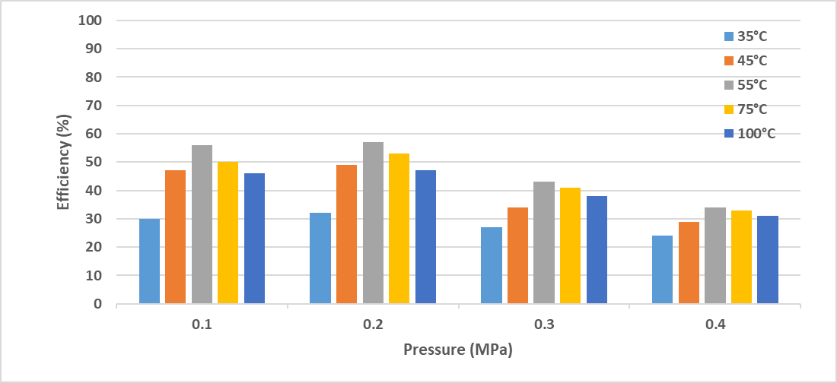

Fig. 6. Averaged changes with respect to temperature and pressure

# Discussion

# Conclusion

# Appendix

Reaction schemes that can be found in literature involving lithium and one of the considered gases as reactant and/or their byproducts are listed in Scheme. 2.

|  |  |
| --- | --- |
| **#** | **Reaction** |
| 1 | 2Li + H2 → 2LiH |
| 2 | 2LiH → 2Li + H2 |
| 3 | 2 LiH + O2 → 2 LiOH |
| 4 | 2 LiOH + CO2 → Li2CO3 + H2O |
| 5 | Li2CO3 → Li2O + CO2 |
| 6 | Li2CO3 + H2O + CO2 → 2LiHCO3 |
| 7 | Li2O + H2O → 2LiOH |
| 8 | Li2O + CO2 → Li2CO3 |
| 9 | 2Li + 2H2O → 2LiOH + H2 |
| 10 | 6Li + 4H2O → LiOH + LiOH.H2O + Li2O + 2LiH + H2 |
| 11 | LiOH.H2O + H2 → LiOH + H2O |
| 12 | 16Li + 10CO2 → 6Li2CO3 + Li2O + Li2C2 + CO + C |
| 13 | C + Li2CO3 → Li2O + 2CO |
| 14 | 4C + 2 LiH → Li2C2 + C2H2 |
| 15 | 2C + 2Li → Li2C2 |
| 16 | C + O2 → CO2 |
| 17 | 4Li + O2 → 2Li2O + Li2O2 |
| 18 | 2 Li2O2 → 2Li2O + O2 |
| 19 | Li2O2 + 2 H2O → 2 LiOH + H2O2 |
| 20 | 2 Li2O2 + 2 H2O → 4 LiOH + O2 |
| 21 | 2 Li2O2 + 2 CO2 → 2 Li2CO3 + O2 |
| 22 | Li2O2 + CO → Li2CO3 |
| 23 | 3 LiH + N2 → Li3N +NH3 |
| 24 | NH3 +2 Li → Li2NH + H2 |
| 25 | 3 Li2NH → 2Li3N + NH3 |
| 26 | 2 NH3 + 2 Li → 2 LiNH2 + H2 |
| 27 | 2 LiNH2 → Li2NH + NH3 |
| 28 | Li2NH + 3Н2О → 2LiOH + NH3.Н2О |
| 29 | Li2NH + H2 → LiNH2 + LiH |
| 30 | LiNH2 + 2 H2O → LiOH + NH3.H2O |
| 31 | 2LiOH + H2 → Li2O + H2O |
| 32 | NH3 + LiH → LiNH2 + H2 |
| 33 | 2Li3N → 6Li + N2 |
| 34 | Li3N + 3H2 → 3 LiH + NH3 + Li2NH |
| 35 | Li3N + 4 H2O → 3 LiOH + NH3.H2O |
| 36 | LiH + H2O → LiOH + H2 |
| 37 | LiH + LiOH → Li2O + H2 |
| 38 | LiH + CO2 → Li(HCOO) |
| 39 | 6Li + N2 → 2Li3N |
| 40 | N2 + O2 → 2 NO |
| 41 | 2 NO + O2 → 2 NO2 |
| 42 | 3 NO2 + H2O → 2 HNO3 + NO |
| 43 | Li2CO3 + 2 HNO3 → 2 LiNO3 + H2O + CO2 |
| 44 | 4LiNO3 → 2Li2O + 4NO2 + O2 |
| 45 | 2Li + CH4 ↔ Li2C2 + H2 |
| 46 | CH4 + 2 O2 → CO2 + 2 H2O |
| 47 | CH4 + H2O → CO + 3 H2 |
| Scheme. 2. Available reactions scheme involving lithium and gases: indents are increased wherever a product was seen being involved in another reaction. The order of appearance does not stand for order of reactions occurrence and it’s only for better visual presentation of reaction equations | |

In each plausible reaction pathway, linear synchronous transit (LST) and quadratic synchronous transit (QST) methods were used for finding any possible transition-state structures. In this work, the LST/QST tool in DMol3 module of material studio (MS) software package was used. In the simulated IR spectrum, an imaginary frequency denotes a transition state. In this module, the first step is the pairing of all the atoms in the reactant and product atomistic documents by means of reaction preview (RP) tools in MS to perform transition-state (TS) searches. In TS searches, ultrafine quality was applied for all calculations where generalized-gradient approximations (GGA) and becke-perdew (BP) density-functional theory (DFT) were employed. The Hamiltonian was specified to be used and double numerical basis including d-polarization function (DND) level of theory was implemented. The thermal smearing was applied to control convergence behavior in which the Fermi level energies according to a thermal distribution are populated resulting in enhanced self-consistent field (SCF) calculations convergence. A TS optimization step was utilized to refine TS structures. A vibrational analysis was performed to obtain frequencies spectra and identification of optimal TS structures and calculation of reaction energy barrier (activation energy). For calculation of minimum energy path (MEP) of each reaction where a TS is identified in prior step, to identify other possible minima on MEP missed in TS searches, the nudged elastic band (NEB) method was employed. The neighboring points on the path are connected by a fictitious spring force so that the continuity of the path and projection of the force can be ensured and MEP can be achieved. The TS Confirmation tool of Dmol3 module in MS then can be used for other minima on MEP missed.

References

1. Jeppson, D.W., et al., *Lithium literature review: lithium's properties and interactions*. 1978, ; Hanford Engineering Development Lab., Richland, Wash. (USA). p. Medium: ED; Size: Pages: 109.

2. Kraytsberg, A. and Y. Ein-Eli, *Review on Li–air batteries—Opportunities, limitations and perspective.* Journal of Power Sources, 2011. **196**(3): p. 886-893.

3. Marom, R., et al., *A review of advanced and practical lithium battery materials.* Journal of Materials Chemistry, 2011. **21**(27): p. 9938-9954.

4. Olsher, U., et al., *Coordination chemistry of lithium ion: a crystal and molecular structure review.* Chemical Reviews, 1991. **91**(2): p. 137-164.

5. Sapse, A.M. and P. von R. Schleyer, *Lithium Chemistry: A Theoretical and Experimental Overview*. 1995: Wiley.

6. Shpil'rain, E.E., *Thermophysical Properties of Lithium Hydride, Deuteride and Tritide*. 1987: American Inst. of Physics.

7. Johanson, P., *Lithium*. 2007: Rosen Publishing Group.

8. Company, F.M., *Chemical and Physical Properties of Lithium Compounds*. 1957: Foote Mineral Company.

9. Manelis, G.B., *Thermal Decomposition and Combustion of Explosives and Propellants*. 2003: Taylor & Francis.

10. Karezani, E., A. Hallajisani, and M. Asgarpour Khansary, *A quantum mechanics/molecular mechanics (QM/MM) investigation on the mechanism of adsorptive removal of heavy metal ions by lignin: single and competitive ion adsorption.* Cellulose, 2017. **24**(8): p. 3131-3143.

11. Grande, L., et al., *The Lithium/Air Battery: Still an Emerging System or a Practical Reality?* Advanced Materials, 2015. **27**(5): p. 784-800.

12. Christensen, J., et al., *A Critical Review of Li/Air Batteries.* Journal of The Electrochemical Society, 2011. **159**(2): p. R1-R30.

13. Lim, H.-K., et al., *Toward a Lithium–“Air” Battery: The Effect of CO2 on the Chemistry of a Lithium–Oxygen Cell.* Journal of the American Chemical Society, 2013. **135**(26): p. 9733-9742.

14. Hummelshøj, J.S., A.C. Luntz, and J.K. Nørskov, *Theoretical evidence for low kinetic overpotentials in Li-O2 electrochemistry.* The Journal of Chemical Physics, 2013. **138**(3): p. 034703.

15. Black, R., et al., *Screening for Superoxide Reactivity in Li-O2 Batteries: Effect on Li2O2/LiOH Crystallization.* Journal of the American Chemical Society, 2012. **134**(6): p. 2902-2905.

16. Rhein, R.A., *Lithium Combustion: A Review*, in *Naval Air Systems Command*. 1990.

17. Schiemann, M., et al., *A review on lithium combustion.* Applied Energy, 2016. **162**: p. 948-965.

18. Ghasemi, A., et al., *Using quantum chemical modeling and calculations for evaluation of cellulose potential for estrogen micropollutants removal from water effluents.* Chemosphere, 2017. **178**: p. 411-423.

19. Lin, S.-T. and S.I. Sandler, *A Priori Phase Equilibrium Prediction from a Segment Contribution Solvation Model.* Industrial & Engineering Chemistry Research, 2002. **41**(5): p. 899-913.

20. Hsieh, C.-M., S.I. Sandler, and S.-T. Lin, *Improvements of COSMO-SAC for vapor–liquid and liquid–liquid equilibrium predictions.* Fluid Phase Equilibria, 2010. **297**(1): p. 90-97.

21. Klamt, A., *COSMO-RS From Quantum Chemistry to Fluid Phase Thermodynamics and Drug Design*. 2005: Elsevier

22. Frenkel, D. and B. Smit, *Chapter 4 - Molecular Dynamics Simulations*, in *Understanding Molecular Simulation (Second Edition)*. 2002, Academic Press: San Diego. p. 63-107.

23. Frenkel, D. and B. Smit, *Chapter 6 - Molecular Dynamics in Various Ensembles*, in *Understanding Molecular Simulation (Second Edition)*. 2002, Academic Press: San Diego. p. 139-163.

24. Meunier, M., *Diffusion coefficients of small gas molecules in amorphous cis-1,4-polybutadiene estimated by molecular dynamics simulations.* J Chem Phys, 2005. **123**(13): p. 134906.

25. *Dassault Systemes Materials Studio Tutorials*. 2017, 5005 Wateridge Vista Drive, San Diego, CA 92121 USA: BIOVIA Support.

26. Metropolis, N., et al., *Equation of State Calculations by Fast Computing Machines.* The Journal of Chemical Physics, 1953. **21**(6): p. 1087-1092.

27. Kirkpatrick, S., C.D. Gelatt, and M.P. Vecchi, *Optimization by Simulated Annealing.* Science, 1983. **220**(4598): p. 671.

28. Černý, V., *Thermodynamical approach to the traveling salesman problem: An efficient simulation algorithm.* Journal of Optimization Theory and Applications, 1985. **45**(1): p. 41-51.

29. Frenkel, D. and B. Smit, *Chapter 3 - Monte Carlo Simulations*, in *Understanding Molecular Simulation (Second Edition)*. 2002, Academic Press: San Diego. p. 23-61.

30. Frenkel, D. and B. Smit, *Chapter 5 - Monte Carlo Simulations in Various Ensembles*, in *Understanding Molecular Simulation (Second Edition)*. 2002, Academic Press: San Diego. p. 111-137.

31. Frenkel, D. and B. Smit, *Chapter 13 - Biased Monte Carlo Schemes*, in *Understanding Molecular Simulation (Second Edition)*. 2002, Academic Press: San Diego. p. 321-387.

32. Frenkel, D. and B. Smit, *Chapter 14 - Accelerating Monte Carlo Sampling*, in *Understanding Molecular Simulation (Second Edition)*. 2002, Academic Press: San Diego. p. 389-408.

33. Eyring, H., *The Activated Complex in Chemical Reactions.* The Journal of Chemical Physics, 1935. **3**(2): p. 107-115.

34. Miller, W.H., *Beyond transition-state theory: a rigorous quantum theory of chemical reaction rates.* Accounts of Chemical Research, 1993. **26**(4): p. 174-181.

35. Manthe, U., *Accurate calculations of reaction rates: predictive theory based on a rigorous quantum transition state concept.* Molecular Physics, 2011. **109**(11): p. 1415-1426.

36. Minkin, V.I., B.Y. Simkin, and R.M. Minyaev, *Quantum Chemistry of Organic Compounds: Mechanisms of Reactions*. 2012: Springer Berlin Heidelberg.

37. Rai, B., *Molecular Modeling for the Design of Novel Performance Chemicals and Materials*. 2012: CRC Press.

38. Satoh, A., *Introduction to Practice of Molecular Simulation: Molecular Dynamics, Monte Carlo, Brownian Dynamics, Lattice Boltzmann, Dissipative Particle Dynamics*. 2011: Elsevier.

39. Truhlar, D.G., B.C. Garrett, and S.J. Klippenstein, *Current Status of Transition-State Theory.* The Journal of Physical Chemistry, 1996. **100**(31): p. 12771-12800.

40. Greene, S.M., X. Shan, and D.C. Clary, *Rate constants of chemical reactions from semiclassical transition state theory in full and one dimension.* The Journal of Chemical Physics, 2016. **144**(24): p. 244116.

41. Laidler, K.J. and M.C. King, *Development of transition-state theory.* The Journal of Physical Chemistry, 1983. **87**(15): p. 2657-2664.

42. Imamura, Y., T. Otsuka, and H. Nakai, *Description of core excitations by time-dependent density functional theory with local density approximation, generalized gradient approximation, meta-generalized gradient approximation, and hybrid functionals.* Journal of Computational Chemistry, 2007. **28**(12): p. 2067-2074.

43. Perdew, J.P., et al., *Accurate Density Functional with Correct Formal Properties: A Step Beyond the Generalized Gradient Approximation.* Physical Review Letters, 1999. **82**(12): p. 2544-2547.

44. Wu, Z. and R.E. Cohen, *More accurate generalized gradient approximation for solids.* Physical Review B, 2006. **73**(23): p. 235116.

45. Perdew, J.P., et al., *Atoms, molecules, solids, and surfaces: Applications of the generalized gradient approximation for exchange and correlation.* Physical Review B, 1992. **46**(11): p. 6671-6687.

46. Rabuck, A.D. and G.E. Scuseria, *Improving self-consistent field convergence by varying occupation numbers.* The Journal of Chemical Physics, 1999. **110**(2): p. 695-700.

47. Spencer, N.D. and J.H. Moore, *Encyclopedia of Chemical Physics and Physical Chemistry: Fundamentals*. 2001: Institute of Physics Pub.

48. Natiello, M.A. and G.E. Scuseria, *Convergence properties of Hartree–Fock SCF molecular calculations.* International Journal of Quantum Chemistry, 1984. **26**(6): p. 1039-1049.

49. Somorjai, G.A., *Introduction to surface chemistry and catalysis*. 1994: Wiley.

50. Islam, M.R. and C.-C. Chen, *COSMO-SAC Sigma Profile Generation with Conceptual Segment Concept.* Industrial & Engineering Chemistry Research, 2014: p. 141209090605008.

51. Loeb, L.B., *The Kinetic Theory of Gases*. 2004: Dover Publications.

52. Lilov, S.K., *Determination of the Effective Kinetic Diameter of the Complex Molecules.* Crystal Research and Technology, 1986. **21**(10): p. 1299-1302.

53. Mehio, N., S. Dai, and D.-e. Jiang, *Quantum Mechanical Basis for Kinetic Diameters of Small Gaseous Molecules.* The Journal of Physical Chemistry A, 2014. **118**(6): p. 1150-1154.

54. Nadler, M.R. and C.P. Kempier, *Crystallographic Data 186. Lithium.* Analytical Chemistry, 1959. **31**(12): p. 2109-2109.

55. Giro, R., et al., *Adsorption energy as a metric for wettability at the nanoscale.* Scientific Reports, 2017. **7**: p. 46317.

56. Davarnejad, R., et al., *Development of a thermodynamic model for hydrogen and hydrogen containing mixtures.* Fluid Phase Equilibria, 2014. **382**: p. 1-9.

57. Plane, J.M.C. and E.S. Saltzman, *A study of the reaction Li+HCl by the technique of time‐resolved laser‐induced fluorescence spectroscopy of Li (2 2PJ–2 2S1/2, λ=670.7 nm) between 700 and 1000 K.* The Journal of Chemical Physics, 1987. **87**(8): p. 4606-4611.

58. Brauer, G., *Handbook of Preparative Inorganic Chemistry*. 2012: Elsevier Science.

59. Wietelmann, U. and M. Steinbild, *Lithium and Lithium Compounds*, in *Ullmann's Encyclopedia of Industrial Chemistry*. 2000, Wiley-VCH Verlag GmbH & Co. KGaA.

60. Seader, J.D., E.J. Henley, and D.K. Roper, *Separation process principles : chemical and biochemical operations*. 3 ed. 2010: John Wiley & Sons, Inc.