Revealing the Underlying Mechanism of Lithium-Gas Reactions as an Interplay of Ambient Temperature Facilitated Water Dissociation at the Lithium Metal Surface

Milad Asgarpour Khansary†, Jin Shang†[‡](https://pubs.acs.org/doi/10.1021/acsami.7b07100#aff2)*, Saeed Shirazian⸸

†School of Energy and Environment, City University of Hong Kong, Tat Chee Avenue, Kowloon, Hong Kong SAR

[‡](https://pubs.acs.org/doi/10.1021/acsami.7b07100#aff2)City University of Hong Kong Shenzhen Research Institute, 8 Yuexing 1st Road, Shenzhen Hi-Tech Industrial Park, Nanshan District, Shenzhen, China

⸸Department of Chemical Sciences, Bernal Institute, University of Limerick, Limerick, Ireland

ABSTRACT Despite the wealth of experimental observations reporting the high reactivity of lithium metal with gas molecules under ambient conditions, the underlying mechanism is still unclear. To elucidate which, an in-depth investigation is needed at the molecular scale. Such an understanding opens up opportunities to design highly selective gas separation and capture processes where lithium would be the adsorbent. Such objective is addressed here using density functional theory and monte-carlo techniques. A facilitated water dissociation in the presence of lithium metal at ambient conditions is revealed with relatively considerable energy release such that affords subsequent reactions with other gases as further investigated. As an interplay of dissociation species and corresponding energy barriers, the dissociation plays a key role, negative or positive depending on the gas molecules involved. According to results, it can be concluded that a controlled exclusive reaction of lithium with nitrogen in the nitrogen/methane mixture would provide infinite selectivity of nitrogen over methane revolutionizing natural gas purification industry.

INTRODUCTION

Lithium is a highly reactive element and never found in its pure form in nature1. It reacts with moisture/water and produces lithium hydroxide, hydrogen, and heat at ambient temperature2. However, at ambient temperature either no reaction would occur or the reaction kinetics are negligibly slow between lithium metal and dry common gases such as methane, carbon dioxide, oxygen, nitrogen, and hydrogen3. Nevertheless, some of these reactions could occur readily upon exposing lithium to moist gas streams4. Such observations indicate that water plays an indispensable role in enabling lithium-gas reactions. Through the analysis of final products of lithium-gas reactions2, it is acknowledged that the presence of lithium hydroxide or lithium hydride might be responsible for those reactions3, although the underlying mechanism is still unclear. The interplay of water molecules with either gases or lithium surface needs to be addressed more precisely to elucidate how such an exposure lowers the reaction energy barriers leading to low temperature lithium-gas reactions. Indeed, it is unclear why such reactions showed direct relationship with water content while higher water contents reverse and lower the reactivities2. It is unclear how and when, in the course of reaction, lithium hydroxide is generated and how it participates in the progress of reaction or whether does it play any critical role in these reactions or it’s a prominent byproduct.

Understanding the interaction and/or reaction between lithium metal and water at ambient conditions is then crucial to establish the lithium reactivity with other gases in a moist environment5. It in turn allows for rationally designing and optimizing potential applications of lithium in gas separation and capture. A special example of such application is the separation of nitrogen from pretreated natural gas streams (mainly containing nitrogen and methane) as one of the most challenging and important gas separation applications6. In such gas streams, nitrogen is regarded as an impurity that needs to be removed7. The state-of-the-art technology for nitrogen removal from natural gas is cryogenic distillation, a process being highly energy intensive8. A material capable of reacting with nitrogen but not with methane at ambient temperature and thus exclusively removing nitrogen would afford an exceptionally high selectivity and thus efficient route for natural gas purification. This indicates that a manipulated exclusive reaction of lithium with nitrogen will find potential applications in such separation practice.

Aiming to understand the interplay of water in lithium-gas reactions in the moist environment, the presence of lithium hydroxide in the final product of most of these reactions3 suggests the requisite for release/generation of hydroxide group (-OH) which can be credited to a possible water dissociation (H2O* → OH* + H*) over the lithium metal surface as hypothesized and confirmed here. It is interesting to note that water dissociation reaction could occur at any temperature but at different scales depending the energy barrier demanded9, 10. This dissociation can be enhanced in the case of interacting with an appropriately introduced and exposed surface10, 11. Such a manipulation has been practiced in literature using both experimental measurements and density functional theory calculations12-30 addressing the water-gas shift reaction31 where the water dissociation needed to be enhanced in Fischer–Tropsch process32. Due to the high reactive nature of lithium, it is contended that lithium may promote water dissociation via interacting with water molecules and the species generated and therefore enhancing the bond breakings and dissociation. we are referring to such possible/potential interplay as facilitated water dissociation hereinafter.

Following the aforementioned discussion, this study for the first time establishes the water dissociation process in the presence of lithium metal surface at near-ambient temperature (i.e., 35 – 100 °C) using density functional theory and monte-carlo techniques. It is revealed that the generated hydroxide (-OH) and hydride (-H) species react with lithium metal and other water molecules and produce mostly lithium hydroxide, small amount of lithium hydride, hydrogen gas, and water complexes in the form of Zundel33, 34 and Eigen-*like* complexes35. It is concluded that this water dissociation is a facilitated process in which lithium pushes water molecules to dissociate favorably. The fundamental knowledge established in this study shed light on advancing lithium applications involving the participation of gases.

Computational Procedures

The analysis of reactivities were carried out using density functional theory calculations as follows. The linear and quadratic synchronous transition methods were employed for identifying transition-state structures using DMol3 package36. In transition-state search, ultrafine quality was applied for all calculations (tolerances: displacement = 10-5 Å, energy = 10-4 kJ/mol, force = 0.001 kJ/mol·Å, self-consistent field criteria = 10-6). In the density functional theory calculations, the generalized gradient approximations and becke-perdew-ernzerhof functionals were used37. The Hamiltonian and double numerical basis including d-polarization function level of theory (v.4.4) was implemented. The thermal smearing38 was applied to control the convergence behavior in which the Fermi level energies are populated according to a thermal distribution resulting in enhanced self-consistent field calculations convergence39. A transition-state optimization step was utilized to refine the structures found in each transition-state. A vibrational analysis was performed to (i) obtain frequencies spectra, (ii) identify optimal structures of transition-states, and (iii) determine free energies40. To calculate/confirm the minimum energy path41 where a transition-state is identified in the prior steps, the nudged elastic band method42 was employed. In this method, the neighboring points on the path are connected by a fictitious spring force so that the continuity of the path and projection of the force can be ensured and the minimum energy path can be achieved while brings the potential to identify other possible minima that might be missed in transition-states searches. This was carried out using the transition-states confirmation tools accommodated in the DMol3 package36. Obtaining/identifying all the transition state structures as well as reactants and products, the next step for free energy of activation calculations is an extra ensuring energy optimization step for each structure. This energy optimization was performed using the DMol3 package36 where generalized gradient approximations and becke-lee-yang-parr functionals were employed43 with aforementioned ultrafine quality. In all calculations, the solvation effect was considered using COnductor-like Screening MOdel44. The reason to use becke-perdew-ernzerhof functionals in transition-states search and becke-lee-yang-parr functionals for final energy optimization is the fact the possible electron/charge transfer in the course of reactions can be handled by the first mostly reliably, while in the energy optimization of finally confirmed structures, such phenomenon is not of concern, thus the latter provides a fast and reliable option. The free energy of activation of each step from state *i* toward the neighboring state *j* in the course of reaction coordinate is defined as difference of respective free energies. The free energy of activation is defined as the difference between reactants free energy and free energy of the transition state with the highest energy. In this case, the calculated free energies of structures were retrieved from outmol files.

In practice, the simulations follow following steps. The calculation starts with creating the overall plausible reaction related documents i.e. reactant (lithium and water) and products (lithium hydroxide and hydrogen). Then using reaction preview tool, the atoms were matched and balanced followed by generation of an initial pathway trajectory between the reactant and product. Then the aforementioned transition state search method as implemented in Dmol3 package was applied on the generated trajectory file while the “bond monitoring” was requested by using keyword asking for Frequency properties of trajectory file. At a transition state, one imaginary frequency appears in the IR spectrum. The frequencies were calculated by using Vibrational Analysis tool of Dmol3 package. For each identified frequency, to make sure of approaching to correct transition state, a transition state optimization step was performed followed by a transition state confirmation step which uses the nudged elastic band calculations. This is to guarantee that no transition state structure is missed.

To study the interactions between solid structures, water and water dissociation species, the adsorption energies were also determined using the configurational bias Monte Carlo techniques45 according to a simulated annealing schedule46 and compared with the activation free energies. For these calculations, lithium crystal structure was retrieved from Cambridge Structural Database. A unit cell of lithium contains five lithium atoms. The substrate for Monte Carlo calculations were constructed as three times in thickness and 15 times in both width and length (a total of 1800 lithium atoms in substrate). The structures were optimized in DMol3 package using the generalized gradient approximations and becke-perdew-ernzerhof functionals first and then used for adsorption studies. In the adsorption simulations, the COMPASS (Condensed-phase Optimized Molecular Potentials for Atomistic Simulation Studies) force field was used following a relaxation step and charge assignment. Adsorption orientations and energies were determined for water molecules varied from 1 to 100 for ten different runs.

Results and discussion

The calculated energy landscape of water dissociation over lithium metal surface is shown in Figure 1. The computed activation free energy (∆*G*) of water dissociation is 2.715 kJ/mol. Note that the scaling factor for energy in molecular-scale systems with a large number of molecules47 (*RT*=*kBT*·*NA*, *NA* being Avogadro number) at the investigated temperature range (35 – 100 °C) corresponds to ≈1 kJ/mol. As the ∆*G* of water dissociation is a bit larger than the scaling factor, extra energy must be supplied to enable this reaction to occur. We hypothesized that the released energy from the initial adsorption of water molecule on lithium surface affords the extra energy for propelling the water dissociation. To examine this, the adsorption energy of water on lithium was computed to be - 76.013 kJ/mol. The magnitude of this value is reasonable with respect to similar systems reported48-52. For example, the energy released upon water adsorption on copper was measured to be - 40.524 kJ/mol48, sufficient for water molecules to undergo dissociation and form hydroxide and hydride species26.

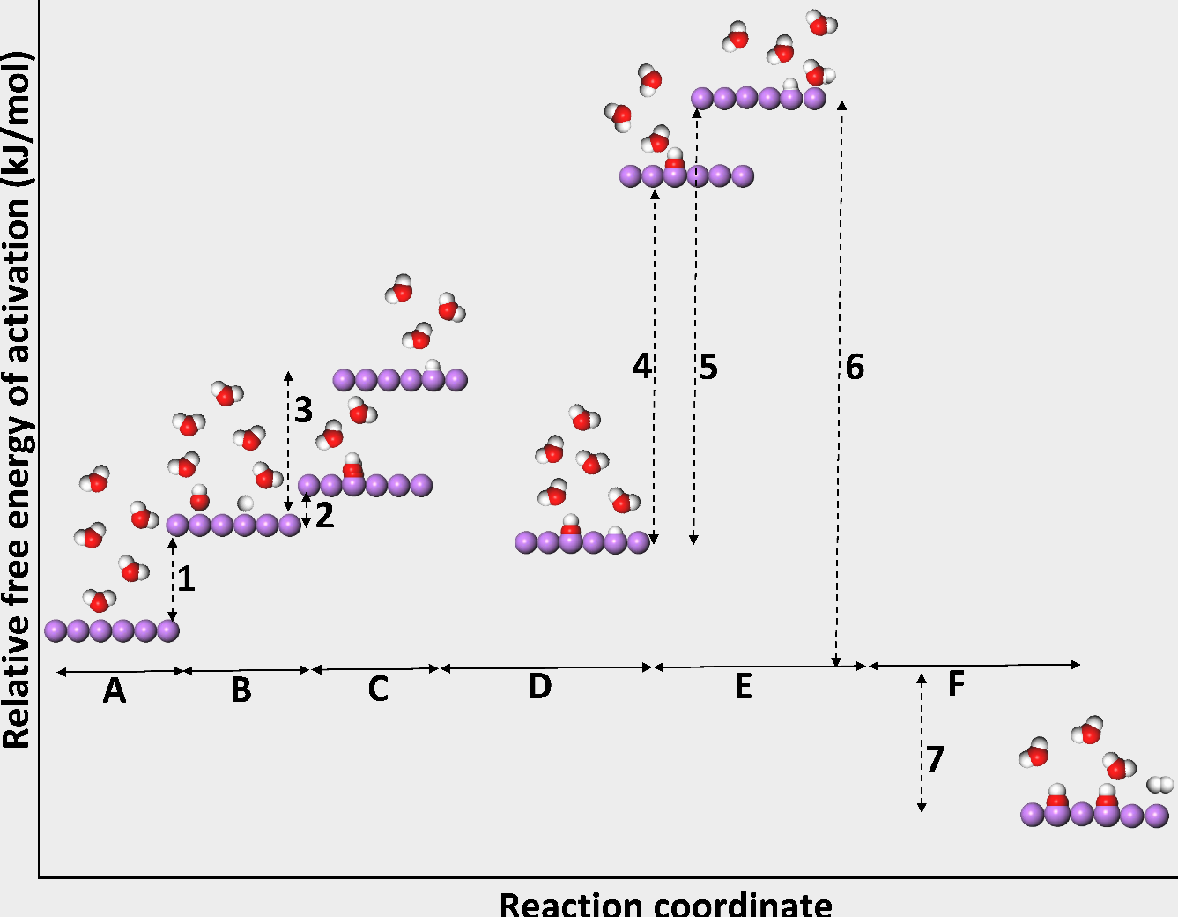

Figure 1. Energy landscape of water dissociation on lithium surface: red, white, purple colors correspond to oxygen, hydrogen and lithium, respectively. (A) induction stage, (B) occurrence of dissociation (C) close contact between lithium and dissociation species, (D) formation of lithium hydride and lithium hydroxide, (E) late stage interactions between lithium hydride, lithium hydroxide, and water leading to lithium hydroxide and hydrogen generation as final products, (F) products stable state. ∆G in kJ/mol for (1) 2.175, (2) 0.41, (3) 3.82, (4) 8.17, (5) 9.36, and (6) 24.47. Total energy release is 375 kJ/mol, as indicated by (7).

The evolution of water dissociation on the lithium metal surface is presented in Figure 2. Upon approaching to lithium surface, a water molecule orients itself with its molecular plane perpendicular to the metal surface where the oxygen atom of this water molecule pointing downward. A slight elongation of O–H bonds (to 1.12 Å) is caused due to the interplay of the strong attractive interaction between the oxygen atom of this molecule and lithium as well as the attractive interaction between the hydrogen atoms of this molecule and oxygen atoms of other surrounding water molecules. Subsequent interactions of the lithium with hydrogen atoms of this water molecule result in the titling of the water molecule, making the axis of one of the O–H bonds orient perpendicularly to the surface normal and breakage of this O–H bond afterward. The separated hydrogen atom (hydride) moves away and then binds to the lithium surface after a while (not instantaneously). The left O–H group, in parallel to the surface normal, binds to the lithium surface, too. A similar behavior was also observed on transition and noble metals (Cu, Au, Ni, Pd, and Pt)17, 26 and their dimers M2 (M = Fe, Ru, Os, Co, Rh, Ir, Ni, Pd, Pt, Cu, Ag, and Au)20, 53-55, and metal ions (Al3+, Cr3+, and Fe3+)27.

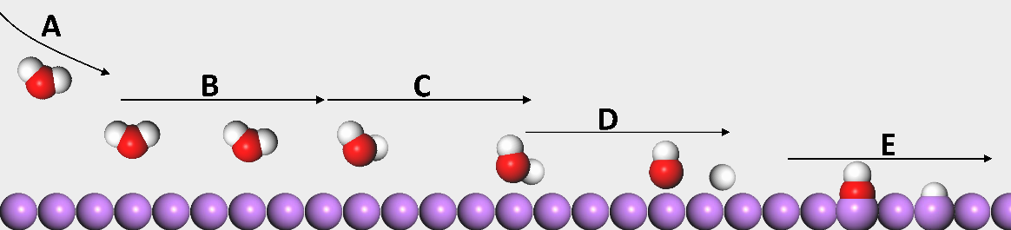

**Figure 2.** Schematic representation of the evolution of intermediates in water dissociation on lithium (legends are the same as in Figure 1): (A) water molecule moving towards metal surface, (B) water rotating due to the close contact (oxygen-metal distance upon water adsorption being 2.1 Å), (C) O-H bond elongates due to oxygen-metal interactions, (D) hydroxide and hydride release, and (E) hydroxide and hydride binding to metal surface generating lithium hydroxide and lithium hydride.

In the course of simulations, different species generated during water dissociation as shown in Figure 3. These species include molecular water, hydride and hydroxide group, as well as a small number of hydroxide and hydride groups interacting with water molecules in the form of Zundel (H5O2+)33, 34 and Eigen (H9O4+)-*like* (as interactions with H from hydroxide group is involved) complexes35. A survey of literature shows the observation of these species is consistent with those on other metals reported16, 56-62.

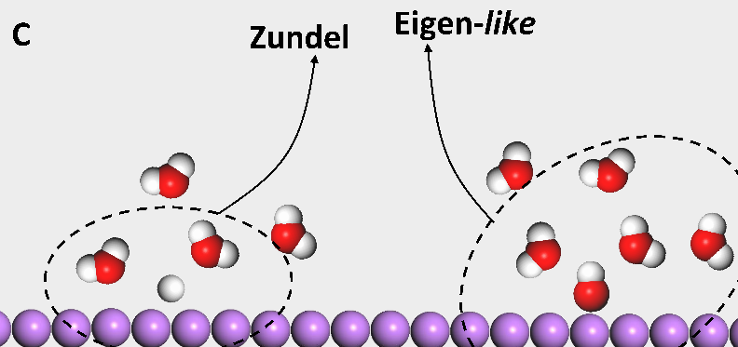

**Figure 3.** Schematic representation of the observed formation of Zundel and Eigen- *like* complexes.

The movement and mobility of hydroxide and hydride groups is of interest as it may reveal their availability to lithium surface for binding. According to the simulations, different movement behavior for hydroxide and hydride groups were observed as shown in Figure 4. While hydroxide groups bind onto the lithium surface immediately upon generation, hydride groups do the same after traveling a short distance. Such a different movement behavior between hydride and hydroxide groups was also observed in literature17, 20, 27, 63. The higher movability of hydride groups in comparison with hydroxide group on metal surfaces is related to the relative bond strength64, 65 and the relative sizes of these two groups. Between hydride and metal, a metastable bond of both ionicity-covalency nature is formed which is weaker than the ionic bond between hydroxide and metal. This in turn means that hydride group is less strongly sticking to lithium surface66, 67 and may move further on prior to binding68-70. In addition, the smaller size of hydride group in comparison to hydroxide brings it more opportunities to move around.

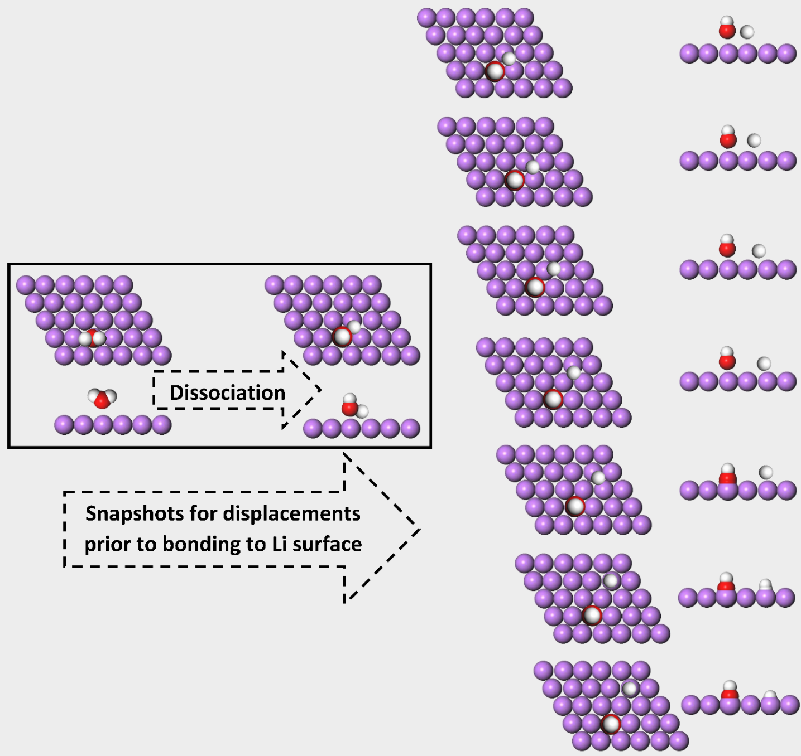

**Figure 4.** Schematic representation of different movement behavior of hydride and hydroxide groups (legends are the same as in Figure 1).

Finally, at the final stage of dissociation process, lithium hydroxide is generated as the major product with a ∆*G* of 0.41 kJ/mol and lithium hydride as the minor product with a ∆*G* of 3.82 kJ/mol. The ∆*G* for lithium hydride generation is just a bit higher than scaling factor (i.e., ≈1 kJ/mol) but would be suppressed by the parallel competing lithium hydroxide generation which associates with a lower ∆*G* than scaling factor. The higher ∆*G* leads to a lower reaction rate based on the transition state theory of chemical reactions (*k* ≡ exp(-∆*G)*)71-73. Thus one would expect a higher frequency of lithium hydroxide generation over lithium hydride. This is consistent with the reported observations74-77 as well.

These interactions/reactions consume hydroxide and hydride groups and promote dissociation to proceed. In other words, water molecules experience facilitated or autocatalytic dissociation in the presence of lithium surface. The first observation of lithium hydride in our simulation is worthy to be further investigated by experiments as this could provide a complete picture of lithium-water reaction and have implications in subsequent reactions with other molecules. As seen from Figure 1, for the overall lithium-water reaction, the ∆*G* equals to 24.47 kJ/mol. This computed value is in excellent agreement with the experimentally measured value (25.94 kJ/mol)75. From Figure 1, the overall heat release of reaction is determined to be 375 + 76.013 - 24.47 ≈ 427 kJ/mol. This value is consistent with experimentally measured heat release, i.e., ≈ 480 kJ/mol78 as well.

To explain the observed reactivity of lithium with other gases including oxygen, carbon dioxide, nitrogen in presence of water, the interaction/reaction of these gases with lithium as well as the produced lithium hydroxide and lithium hydride were studied, however; as the detailed discussion of these reactions is beyond the scope of the current work, it will be communicated elsewhere. Figure 5-7 show a summary of such a study reporting ∆G of lithium, lithium hydride and lithium hydroxide reacting with each aforementioned gases. The reaction between pure lithium and the gases cannot readily occur at ambient temperatures because the ∆*G* are much larger than the scaling factor as seen in Figure 5. This finding is consistent with reactivity analysis of pure lithium and considered gases in literature2, 3. The spontaneous reaction between lithium and water and considerable energy release affords to overcome the ∆*G* for the reaction between the either produced lithium hydride or lithium hydroxide and some of these gases as shown in Figure 6 and 7. Thus, the occurrence of facile reaction would be observed upon contacting lithium with these gases in a moist environment. Taking nitrogen reaction as an example, it follows a reaction between lithium hydride and nitrogen producing lithium nitride and hydrogen as well as may initiate direct dissociation of nitrogen over lithium surface79, 80. In the case of carbon dioxide, the interaction between lithium hydroxide and carbon dioxide provides a route for the production of lithium carbonate. In the case of oxygen, both lithium hydride and lithium hydroxide are responsible and contribute almost equally to the production of lithium peroxide. These computed pathways are in excellent agreement with experimental observations.

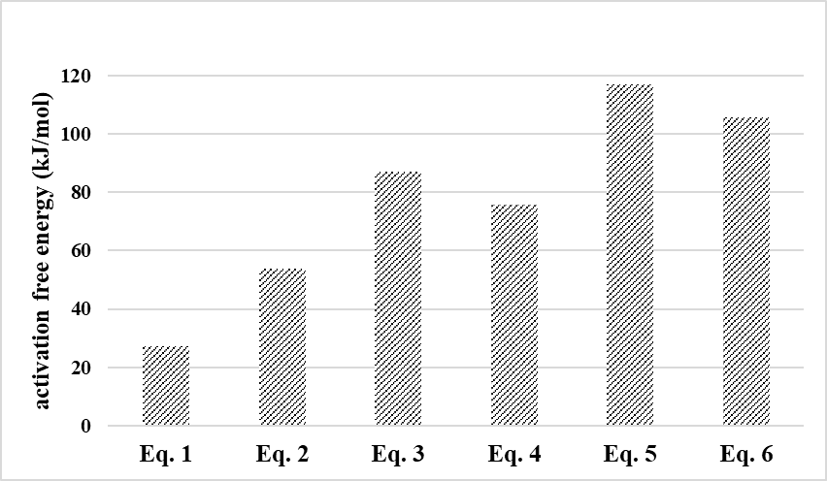

**Figure 5.** Computed ∆*G* for pure lithium reaction with considered gases: Eqs. 1 – 6 stands for (1) 2Li + 2H2O → 2LiOH + H2, (2) 2Li + H2 → 2LiH, (3) 6Li + N2 → 2Li3N, (4) 4Li + O2 → 2Li2O + Li2O2, (5) 10Li + 3CO2 → Li2CO3 + 3Li2O + Li2C2, and (6) 2Li + 2CH4 → Li2C2 + 4H2, respectively.

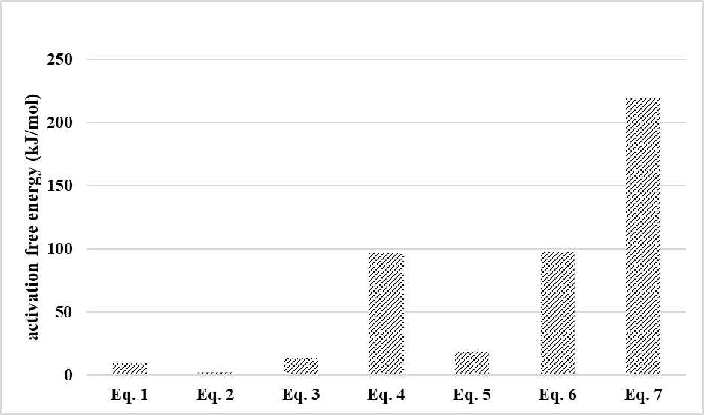

**Figure 6.** Computed ∆*G* for lithium hydride reaction with considered gases: Eqs. 1 – 7 stands for (1) LiH + H2O → LiOH + H2, (2) LiH + H2 → LiH + H2, (3) 6LiH + N2 → 2Li3N + 3H2, (4) 3LiH + N2 → Li3N + NH3, (5) 2LiH + O2 → 2LiOH, (6) 10LiH + 3CO2 → Li2CO3 + 3Li2O + Li2C2 + 5H2, and (7) 2LiH + 2CH4 → Li2C2 + 5H2, respectively. The absolute heat release by water adsorption on Li is 76.013 kJ/mol.

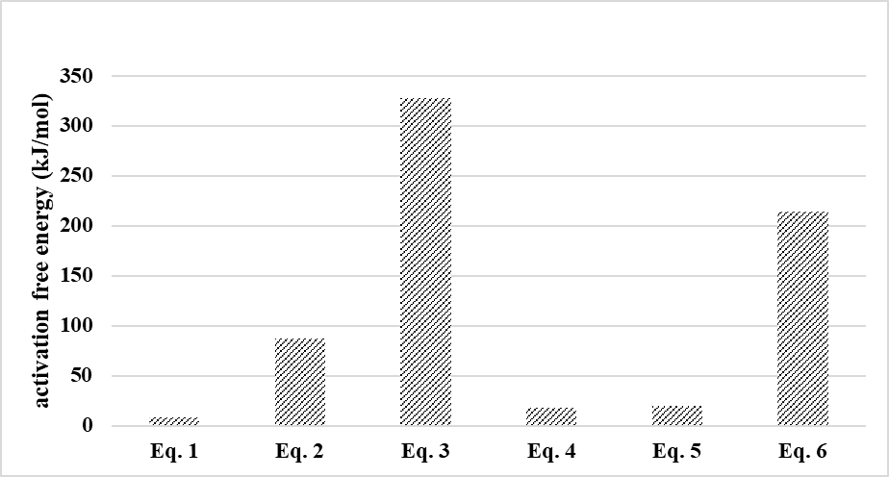

**Figure 7.** Computed ∆*G* for lithium hydroxide reaction with considered gases: Eqs. 1 – 6 stands for (1) LiOH + 2H2O → LiOH.H2O + H2O, (2) 2LiOH + H2 → LiOH + LiH + H2O, (3) 3LiOH + N2 → Li3N + N(OH)3, (4) 4LiOH + O2→ 2Li2O2 + 2H2O, (5) 2LiOH + CO2 → Li2CO3 + H2O, and (6) 2LiOH + 2CH4 → Li2C2 + 2H2O + 3H2, respectively. The absolute heat release by water adsorption on Li is 76.013 kJ/mol.

Conclusion

A facilitated water dissociation on lithium metal surface at near-ambient temperature and its subsequent role in enabling lithium reaction with other gases are illustrated. The presence of lithium promotes the water dissociation process via consuming the dissociation products, i.e., H and OH. On the other hand, the presence of water enables lithium reaction with other gases via lithium-water reaction products, i.e., lithium hydride and lithium hydroxide. Such an in-depth understanding promises a wide range of applications of lithium metal involving the participation of gases. The controlled mediation of water in the reaction between mixed gases and lithium metal could allow for exclusive consumption of certain gases. For example, lithium can exclusively react and thus remove nitrogen from a mixture of nitrogen and methane, implying promising highly efficient natural gas purification (infinite selectivity of nitrogen over methane) which represents the most challenging and important gas separation application.

AUTHOR INFORMATION

Corresponding Author

* [jinshang@cityu.edu.hk](mailto:jinshang@cityu.edu.hk)

ACKNOWLEDGMENT

J. Shang gratefully acknowledges the financial support from the Research Grants Council of Hong Kong (Ref: CityU 21301817) and the Science and Technology Innovation Commission of Shenzhen Municipality (Refs: JCYJ20170307090749744).

Supplementary file

The constructed library can be accessed using following link <https://sites.google.com/site/miladasgarpour/resource>.

REFERENCES

1. Jeppson, D. W.; Ballif, J. L.; Yuan, W. W.; Chou, B. E. *Lithium literature review: lithium's properties and interactions*; HEDL-TME-78-15; TRN: 78-012421 United States 10.2172/6885395 TRN: 78-012421 Dep. NTIS, PC A06/MF A01. HNF English; ; Hanford Engineering Development Lab., Richland, Wash. (USA): 1978; p Medium: ED; Size: Pages: 109.

2. Rhein, R. A. *Lithium Combustion: A Review*; 1990.

3. Schiemann, M.; Bergthorson, J.; Fischer, P.; Scherer, V.; Taroata, D.; Schmid, G., A review on lithium combustion. *Applied Energy* **2016,** *162*, 948-965.

4. Besson, J.; Muller, W., The reaction of nitrogen on lithium at ordinary temperatures and the role of water vapor in this reaction. *Compt. Rend.* **1958,** *247*, 2370-2372.

5. Schiemann, M.; Fischer, P.; Bergthorson, J.; Schmid, G.; Taroata, D., Combustion of Lithium Particles in N2—Reaction Rates. *Combustion Science and Technology* **2016,** *189* (1), 169-186.

6. Bahadori, A., *Natural Gas Processing: Technology and Engineering Design*. Elsevier Science: 2014.

7. Xiong, L.; Peng, N.; Liu, L.; Gong, L., Helium extraction and nitrogen removal from LNG boil-off gas. *IOP Conference Series: Materials Science and Engineering* **2017,** *171* (1), 012003.

8. Rufford, T. E.; Smart, S.; Watson, G. C. Y.; Graham, B. F.; Boxall, J.; Diniz da Costa, J. C.; May, E. F., The removal of CO2 and N2 from natural gas: A review of conventional and emerging process technologies. *Journal of Petroleum Science and Engineering* **2012,** *94-95*, 123-154.

9. Olschewski, H. A.; Troe, J.; Wagner, H. G., Studies of unimolecular reactions of triatomic molecules. *Symposium (International) on Combustion* **1967,** *11* (1), 155-161.

10. Seenivasan, H.; Tiwari, A. K., Water dissociation on Ni(100) and Ni(111): Effect of surface temperature on reactivity. *The Journal of Chemical Physics* **2013,** *139* (17), 174707.

11. Seenivasan, H.; Tiwari, A. K., Water adsorption and dissociation on Ni(110): How is it different from its close packed counterparts? *The Journal of Chemical Physics* **2014,** *140* (17), 174704.

12. Mason, S. E.; Iceman, C. R.; Trainor, T. P.; Chaka, A. M., Molecular-level understanding of environmental interfaces using density functional theory modeling. *Physics Procedia* **2010,** *4* (Supplement C), 67-83.

13. Wang, G.; Tao, S.; Bu, X., A systematic theoretical study of water dissociation on clean and oxygen-preadsorbed transition metals. *Journal of Catalysis* **2006,** *244* (1), 10-16.

14. Andersson, K.; Ketteler, G.; Bluhm, H.; Yamamoto, S.; Ogasawara, H.; Pettersson, L. G.; Salmeron, M.; Nilsson, A., Autocatalytic water dissociation on Cu(110) at near ambient conditions. *J Am Chem Soc* **2008,** *130* (9), 2793-7.

15. Ma, F. F.; Ma, S. H.; Jiao, Z. Y.; Dai, X. Q., Adsorption and decomposition of H 2 O on cobalt surfaces: A DFT study. *Applied Surface Science* **2016,** *384*, 10-17.

16. Donadio, D.; Ghiringhelli, L. M.; Delle Site, L., Autocatalytic and cooperatively stabilized dissociation of water on a stepped platinum surface. *J Am Chem Soc* **2012,** *134* (46), 19217-22.

17. Phatak, A. A.; Delgass, W. N.; Ribeiro, F. H.; Schneider, W. F., Density Functional Theory Comparison of Water Dissociation Steps on Cu, Au, Ni, Pd, and Pt. *The Journal of Physical Chemistry C* **2009,** *113* (17), 7269-7276.

18. Fajin, J. L.; MN, D. S. C.; Gomes, J. R., Density functional theory study of the water dissociation on platinum surfaces: general trends. *J Phys Chem A* **2014,** *118* (31), 5832-40.

19. Peköz, R.; Donadio, D., Dissociative Adsorption of Water at (211) Stepped Metallic Surfaces by First-Principles Simulations. *The Journal of Physical Chemistry C* **2017,** *121* (31), 16783-16791.

20. Zeinalipour-Yazdi, C. D.; van Santen, R. A., Kinetic rates and linear free energy relationships for water dissociation on transition and noble metal dimers. *J Phys Chem A* **2009,** *113* (25), 6971-8.

21. Williams, K. S.; Rodriguez-Santiago, V.; Andzelm, J. W., Modeling reaction pathways for hydrogen evolution and water dissociation on magnesium. *Electrochimica Acta* **2016,** *210*, 261-270.

22. McBride, F.; Hodgson, A., Water and its partially dissociated fragments at metal surfaces. *International Reviews in Physical Chemistry* **2017,** *36* (1), 1-38.

23. Fajín, J. L. C.; Cordeiro, M. N. D. S.; Gomes, J. R. B., Water Dissociation on Bimetallic Surfaces: General Trends. *The Journal of Physical Chemistry C* **2012,** *116* (18), 10120-10128.

24. Fajín, J. L. C.; Cordeiro, M. N. D. S.; Gomes, J. R. B., Water dissociation on multimetallic catalysts. *Applied Catalysis B: Environmental* **2017,** *218*, 199-207.

25. Seenivasan, H.; Tiwari, A. K., Water dissociation on Ni(100) and Ni(111): effect of surface temperature on reactivity. *J Chem Phys* **2013,** *139* (17), 174707.

26. Chen, L.; Zhang, Q.; Zhang, Y.; Li, W. Z.; Han, B.; Zhou, C.; Wu, J.; Forrey, R. C.; Garg, D.; Cheng, H., A first principles study of water dissociation on small copper clusters. *Phys Chem Chem Phys* **2010,** *12* (33), 9845-51.

27. Coskuner, O.; Jarvis, E. A.; Allison, T. C., Water dissociation in the presence of metal ions. *Angew Chem Int Ed Engl* **2007,** *46* (41), 7853-5.

28. Guvelioglu, G. H.; Ma, P.; He, X.; Forrey, R. C.; Cheng, H., Evolution of Small Copper Clusters and Dissociative Chemisorption of Hydrogen. *Physical Review Letters* **2005,** *94* (2), 026103.

29. Poater, A.; Duran, M.; Jaque, P.; Toro-Labbé, A.; Solà, M., Molecular Structure and Bonding of Copper Cluster Monocarbonyls CunCO (n = 1−9). *The Journal of Physical Chemistry B* **2006,** *110* (13), 6526-6536.

30. Florez, E.; Tiznado, W.; Mondragón, F.; Fuentealba, P., Theoretical Study of the Interaction of Molecular Oxygen with Copper Clusters. *The Journal of Physical Chemistry A* **2005,** *109* (34), 7815-7821.

31. Newsome, D. S., The Water-Gas Shift Reaction. *Catalysis Reviews* **1980,** *21* (2), 275-318.

32. Rofer-DePoorter, C. K., A comprehensive mechanism for the Fischer-Tropsch synthesis. *Chemical Reviews* **1981,** *81* (5), 447-474.

33. Zundel, G., Hydrogen Bonds with Large Proton Polarizability and Proton Transfer Processes in Electrochemistry and Biology. In *Advances in Chemical Physics*, John Wiley & Sons, Inc.: 2007; pp 1-217.

34. Zundel, G.; Metzger, H., Energiebänder der tunnelnden Überschuß-Protonen in flüssigen Säuren. Eine IR-spektroskopische Untersuchung der Natur der Gruppierungen H5O2+. In *Zeitschrift für Physikalische Chemie*, 1968; Vol. 58, p 225.

35. Eigen, M., Protonenübertragung, Säure-Base-Katalyse und enzymatische Hydrolyse. Teil I: Elementarvorgänge. *Angewandte Chemie* **1963,** *75* (12), 489-508.

36. *Dassault Systemes Materials Studio Tutorials*; BIOVIA Support: 5005 Wateridge Vista Drive, San Diego, CA 92121 USA, 2017.

37. Dal Corso, A.; Pasquarello, A.; Baldereschi, A.; Car, R., Generalized-gradient approximations to density-functional theory: A comparative study for atoms and solids. *Physical Review B* **1996,** *53* (3), 1180-1185.

38. Leavens, C. R., Effect of thermal smearing on the electron-phonon spectral function obtained by inversion of normal metal tunneling data. *Solid State Communications* **1985,** *54* (7), 625-628.

39. Rabuck, A. D.; Scuseria, G. E., Improving self-consistent field convergence by varying occupation numbers. *The Journal of Chemical Physics* **1999,** *110* (2), 695-700.

40. Wong, M. W., Vibrational frequency prediction using density functional theory. *Chemical Physics Letters* **1996,** *256* (4), 391-399.

41. Quapp, W.; Heidrich, D., Analysis of the concept of minimum energy path on the potential energy surface of chemically reacting systems. *Theoretica chimica acta* **1984,** *66* (3), 245-260.

42. Bohner, M. U.; Zeman, J.; Smiatek, J.; Arnold, A.; Kästner, J., Nudged-elastic band used to find reaction coordinates based on the free energy. *The Journal of Chemical Physics* **2014,** *140* (7), 074109.

43. Perdew, J. P.; Chevary, J. A.; Vosko, S. H.; Jackson, K. A.; Pederson, M. R.; Singh, D. J.; Fiolhais, C., Atoms, molecules, solids, and surfaces: Applications of the generalized gradient approximation for exchange and correlation. *Physical Review B* **1992,** *46* (11), 6671-6687.

44. Klamt, A., *COSMO-RS From Quantum Chemistry to Fluid Phase Thermodynamics and Drug Design*. Elsevier 2005.

45. Frenkel, D.; Smit, B., Chapter 5 - Monte Carlo Simulations in Various Ensembles. In *Understanding Molecular Simulation (Second Edition)*, Academic Press: San Diego, 2002; pp 111-137.

46. Kirkpatrick, S.; Gelatt, C. D.; Vecchi, M. P., Optimization by Simulated Annealing. *Science* **1983,** *220* (4598), 671.

47. Atkins, P.; de Paula, J., *Atkins' Physical Chemistry*. OUP Oxford: 2010.

48. Nakamura, J.; Campbell, J. M.; Campbell, C. T., Kinetics and mechanism of the water-gas shift reaction catalysed by the clean and Cs-promoted Cu(110) surface: a comparison with Cu(111). *Journal of the Chemical Society, Faraday Transactions* **1990,** *86* (15), 2725-2734.

49. Hodgson, A.; Haq, S., Water adsorption and the wetting of metal surfaces. *Surface Science Reports* **2009,** *64* (9), 381-451.

50. Revilla-Lopez, G.; Lopez, N., A unified study for water adsorption on metals: meaningful models from structural motifs. *Physical Chemistry Chemical Physics* **2014,** *16* (35), 18933-18940.

51. Javier, C.; David, L. D.; Zongyuan, L.; Tomáš, D.; Jaime, E.; D., S. S.; J., C. E.; Vladimir, M.; A., R. J.; Verónica, G. P. M., In Situ and Theoretical Studies for the Dissociation of Water on an Active Ni/CeO2 Catalyst: Importance of Strong Metal–Support Interactions for the Cleavage of O–H Bonds. *Angewandte Chemie International Edition* **2015,** *54* (13), 3917-3921.

52. Mohsenzadeh, A.; Bolton, K.; Richards, T., DFT study of the adsorption and dissociation of water on Ni(111), Ni(110) and Ni(100) surfaces. *Surface Science* **2014,** *627*, 1-10.

53. Seenivasan, H.; Jackson, B.; Tiwari, A. K., Water dissociation on Ni(100), Ni(110), and Ni(111) surfaces: Reaction path approach to mode selectivity. *The Journal of Chemical Physics* **2017,** *146* (7), 074705.

54. Ghosh, S.; Hariharan, S.; Tiwari, A. K., Water Adsorption and Dissociation on Copper/Nickel Bimetallic Surface Alloys: Effect of Surface Temperature on Reactivity. *The Journal of Physical Chemistry C* **2017,** *121* (30), 16351-16365.

55. Nave, S.; Tiwari, A. K.; Jackson, B., Dissociative Chemisorption of Methane on Ni and Pt Surfaces: Mode-Specific Chemistry and the Effects of Lattice Motion. *The Journal of Physical Chemistry A* **2014,** *118* (41), 9615-9631.

56. Andersson, K.; Gómez, A.; Glover, C.; Nordlund, D.; Öström, H.; Schiros, T.; Takahashi, O.; Ogasawara, H.; Pettersson, L. G. M.; Nilsson, A., Molecularly intact and dissociative adsorption of water on clean Cu(110): A comparison with the water/Ru(001) system. *Surface Science* **2005,** *585* (3), L183-L189.

57. Spitzer, A.; Lüth, H., An XPS study of the water adsorption on Cu(110). *Surface Science* **1985,** *160* (2), 353-361.

58. Ammon, C.; Bayer, A.; Steinrück, H. P.; Held, G., Low-temperature partial dissociation of water on Cu(110). *Chemical Physics Letters* **2003,** *377* (1), 163-169.

59. Clendening, W. D.; Rodriguez, J. A.; Campbell, J. M.; Campbell, C. T., The chemisorption and coadsorption of water and oxygen on Cs-dosed Cu(110). *Surface Science* **1989,** *216* (3), 429-461.

60. Andersson, K.; Ketteler, G.; Bluhm, H.; Yamamoto, S.; Ogasawara, H.; Pettersson, L. G. M.; Salmeron, M.; Nilsson, A., Bridging the Pressure Gap in Water and Hydroxyl Chemistry on Metal Surfaces:  The Cu(110) Case. *The Journal of Physical Chemistry C* **2007,** *111* (39), 14493-14499.

61. Headrick, J. M.; Diken, E. G.; Walters, R. S.; Hammer, N. I.; Christie, R. A.; Cui, J.; Myshakin, E. M.; Duncan, M. A.; Johnson, M. A.; Jordan, K. D., Spectral Signatures of Hydrated Proton Vibrations in Water Clusters. *Science* **2005,** *308* (5729), 1765.

62. Amir, W.; Gallot, G.; Hache, F.; Bratos, S.; Leicknam, J. C.; Vuilleumier, R., Time-resolved observation of the Eigen cation in liquid water. *The Journal of Chemical Physics* **2007,** *126* (3), 034511.

63. Gómez, E. D. V.; Amaya-Roncancio, S.; Avalle, L. B.; Linares, D. H.; Gimenez, M. C., DFT study of adsorption and diffusion of atomic hydrogen on metal surfaces. *Applied Surface Science* **2017,** *420*, 1-8.

64. Koper, M. T. M.; Van Santen, R. A., Interaction of H, O and OH with metal surfaces. *Journal of Electroanalytical Chemistry* **1999,** *472* (2), 126-136.

65. Pang, X. Y.; Xue, L. Q.; Wang, G. C., Adsorption of atoms on Cu surfaces: A density functional theory study. *Langmuir* **2007,** *23* (9), 4910-4917.

66. Montoya, A.; Schlunke, A.; Haynes, B. S., Reaction of hydrogen with Ag(111): Binding states, minimum energy paths, and kinetics. *Journal of Physical Chemistry B* **2006,** *110* (34), 17145-17154.

67. Qin, C.; Whitten, J. L., Adsorption of O, H, OH, and H 2O on Ag(100). *Journal of Physical Chemistry B* **2005,** *109* (18), 8852-8856.

68. Kresse, G.; Furthmüller, J., Efficient iterative schemes for ab initio total-energy calculations using a plane-wave basis set. *Physical Review B* **1996,** *54* (16), 11169-11186.

69. Kresse, G.; Furthmüller, J., Efficiency of ab-initio total energy calculations for metals and semiconductors using a plane-wave basis set. *Computational Materials Science* **1996,** *6* (1), 15-50.

70. Anderson, A. B.; Neshev, N. M.; Sidik, R. A.; Shiller, P., Mechanism for the electrooxidation of water to OH and O bonded to platinum: Quantum chemical theory. *Electrochimica Acta* **2002,** *47* (18), 2999-3008.

71. Eyring, H., The Activated Complex in Chemical Reactions. *The Journal of Chemical Physics* **1935,** *3* (2), 107-115.

72. Miller, W. H., Beyond transition-state theory: a rigorous quantum theory of chemical reaction rates. *Accounts of Chemical Research* **1993,** *26* (4), 174-181.

73. Manthe, U., Accurate calculations of reaction rates: predictive theory based on a rigorous quantum transition state concept. *Molecular Physics* **2011,** *109* (11), 1415-1426.

74. Plane, J. M. C.; Rajasekhar, B., Study of the reaction Li + H2O over the temperature range 850–1000 K by time-resolved laser-induced fluorescence of Li(22PJ–22S1/2). *J. Chem. Soc., Faraday Trans. 2* **1988,** *84* (3), 273-285.

75. Deal, B. E.; Svec, H. J., Metal—Water Reactions. II. Kinetics of the Reaction between Lithium and Water Vapor. *Journal of the American Chemical Society* **1953,** *75* (24), 6173-6175.

76. Patrick, R.; Golden, D. M., Termolecular reactions of alkali metal atoms with O2 and OH. *International Journal of Chemical Kinetics* **1984,** *16* (12), 1567-1574.

77. Husain, D.; Lee, Y. H.; Marshall, P., Temperature dependence of the absolute third-order rate constant for the reaction between K + O2 + N2 over the range 680–1010K studied by time-resolved atomic resonance absorption spectroscopy. *Combustion and Flame* **1987,** *68* (2), 143-154.

78. Dannent, G., Lithium, Sodium, Potassium. An Inadmissible Simplification in the Comparative Analysis of Alkali Metals with Regards to the Reaction Capability with Water. *Prax. Naturwiss., Chem* **1978,** *27*, 100-103.

79. Yamaguchi, S.; Ichikawa, T.; Wang, Y.; Nakagawa, Y.; Isobe, S.; Kojima, Y.; Miyaoka, H., Nitrogen Dissociation via Reaction with Lithium Alloys. *ACS Omega* **2017,** *2* (3), 1081-1088.

80. McEnaney, J. M.; Singh, A. R.; Schwalbe, J. A.; Kibsgaard, J.; Lin, J. C.; Cargnello, M.; Jaramillo, T. F.; Norskov, J. K., Ammonia synthesis from N2 and H2O using a lithium cycling electrification strategy at atmospheric pressure. *Energy & Environmental Science* **2017,** *10* (7), 1621-1630.

**TOC**

