**Contaminant uptake by polymeric passive samplers: A modeling study with experimental validation**

**Abstract**

Accurate determination of contaminant partitioning in polymeric passive samplers (PPSs) is of much interest, especially to plan monitoring programs in environmental investigations. In this study, a predictive partition coefficient model is developed which only requires the chemical structures of polymer in PPSs and contaminant. As such, a kinetic model is developed to account for time evolution of the contaminant uptake. To analyze the performance of developed model, experimental data were collected from literature. The accumulative absolute relative deviation (AARD (%)) was used in order to evaluate the goodness of predictions. The measured and calculated partition coefficients indicated an overall prediction error of 5.17%. The developed model can provide valuable information regarding polymers selection for PPSs fabrication and the time evolution of uptake process.

**Keywords**: Polymeric samplers; Contaminant uptake; Partition coefficient; Predictive modeling; Kinetic description

# Introduction

In fabrication of polymeric passive samplers (PPSs), low density polyethylene (LDPE) has been one of the most widely used polymers [1]. PPSs are mainly used to measure the concentration of hydrophobic organic compounds in water and wastewater which is then used for analyzing health risk level of water streams [1-5]. Based on such analysis, it can be concluded that which water treatment technology should be used [6-8], and practically is suitable. Development of a mathematical model to predict the performance of PPSs [5] is of much interest to reduce the costs associated with experimental analysis [9, 10]. Availability of an efficient mathematical models is valuable as site-related measurement faults and necessities may occur [11-15], and these models can be used to correlate obtained data. Also, the effect of various operating parameters and design scenarios can be theoretically analyzed is another advantage of model development for PPSs [5].

Experimentally measured data on polymer-water partition coefficients for various PPSs are reported in literature [1-4], however theoretical models have been rarely noted and considered [5]. Thus, in this work attempts were made to establish a theoretical model of polymer-water partition coefficients and time evolution of contaminants uptake by PPSs. Some available experimental data reported in literature were collected and used for evaluation of the model performance. The accumulative absolute relative deviation (AARD (%)) was used to demonstrate the goodness of model predictions.

# Contaminant uptake model

Contaminant uptake by polymeric passive samplers takes place in two steps; (*i*) sorption of species at the interface of sampler/sampling phases, and (*ii*) diffusion of species through the passive sampler. For the first step, partition coefficient (*K*) of contaminant between the sampling phase and polymeric sampler correlates the concentration of contaminant in the sampling phase () to the concentration of contaminant in polymeric sampler () adjacent to the interface of sampling phase and polymeric sampler as defined in Eq. 1.

|  |  |
| --- | --- |
|  |  |

In a recent work [5], a modeling approach for prediction of partition coefficients of PPSs was developed following the fundamental chemical thermodynamic equations governing the concerned local equilibrium using a Flory–Huggins model [16] based on the Hansen solubility parameters. The model of Ref. [5] is given in Eq. 2:

|  |  |
| --- | --- |
|  |  |

where superscripts *I* and *II* denotes the sampling phase (water, air, etc.) and the polymeric phases, respectively. is the Flory–Huggins interaction parameter between compound 1 and compound 2 (in phase *I*: sampling phase (air, water, etc.), in phase *II*: polymer).  refers to the partition coefficient defined as [17].  and denote the molecular weight and density, respectively.

The Flory–Huggins interaction parameter used in Eq. 2, between compound 1 and compound 2 (), is given by Eq. 3 [16]:

|  |  |
| --- | --- |
|  |  |

where *V1,* *R,* and *T* refer to the molar volume, universal gas constant, and temperature, respectively.  denotes dispersion contribution of Hansen solubility parameter,  polar contribution of Hansen solubility parameter, and  hydrogen-bonding contribution of Hansen solubility parameter [16, 17].

In Eq. 3,  is the ***composition*-*independent*** interaction parameter in Flory–Huggins model, however it has been demonstrated [18-21] that a ***composition-dependent*** interaction parameter increases the predictive capabilities of Flory–Huggins model. In Ref. [22], a model for Flory-Huggins interaction parameter was introduced by combination of regular solution model of Flory and Huggins as well as regular solution model of Ruzette and Mayes [23] as given in Eq. 4.

|  |  |
| --- | --- |
|  |  |

where  is the reduced density which can be obtained from the modified Sanchez and Lacombe’s lattice-fluid (LF) equation of state [24] in which the characteristic pressure and temperature are calculated using group contribution method developed by Boudouris et al. [24]. is the hard-core solubility parameter at *0 K* obtained from the Hoftyzer and van Krevelen group contribution method [25]. The hard-core solubility parameter at temperature of system () can be simply evaluated using where  is calculated using modified SL-EOS at STP condition.  is the hard-core volume; , and [26-28]. is volume fraction that can be related to the concentration using.

The current modification of the model of Ref. [5] provides a predictive approach for calculation of both partition coefficients and compounds concentrations in each phase consistent with the nature of Flory–Huggins interaction parameter (). The employed model for composition-dependent interaction parameter implicitly incorporates regular solution model of Ruzette and Mayes into regular solution model of Flory and Huggins [22], and this enhances its predictive capabilities. The versatility and reliability of regular solution model of Ruzette and Mayes for description of phase behavior of various solutions have been demonstrated in literature [18, 29-32].

The steps of calculation for application of modified partition coefficient model are described below:

1. Drawing the desired components molecular structure and identifying each group/class using group contribution method of Boudouris et al. [24],
2. Calculating lattice fluid scaling parameters (,  and ) using data of step #1,
3. Calculating reduced properties (and) using the calculated scaling parameters from step # 2 and the operating conditions of the considered system,
4. Calculation of the reduced density () by iterative solution of SL-EOS using data of step #3 and initial guess of =1,
5. Calculating hard-core solubility parameter at reference temperature of 298 K () using the Hoftyzer and van Krevelen group contribution method [25],
6. Calculating hard-core solubility parameter at system temperature prior which hard-core density should be determined at system temperature as where is obtained in step # 4,
7. Calculating  model using equality, where  is the molecular weight of component,
8. Calculating the composition-dependent Flory–Huggins interaction parameter using Eq. 4 for each phase,
9. For each partition coefficient (*K*) value,
   1. Solving Eq. 2 to obtain volume fraction of sampling compounds in sampling phase (phase *I*) using expressions given by Spiegel and Liu [33],
   2. Converting volume fraction to the concentration using,
   3. Calculating the concentration of compounds in the passive sampler (phase II) using as ,

The calculated is the equilibrium concentration of contaminant in the polymeric passive sampler. It must be noted that equilibrium will not be attained instantaneously upon contacting two phases. The kinetics of uptake can be described considering contaminant uptake as a reversible and simultaneous uptake and release reaction [34] as shown in Eq. 5 where *A*, *S* and *AS* indicate contaminant, active uptaking sites on the surface of polymeric passive sampler and uptaken product respectively and *a*, *s* and *p*, respectively, are their stoichiometry constants.

|  |  |
| --- | --- |
|  |  |

The net depletion rate of contaminant from sampling phase or alternatively, the net accumulation rate of contaminant onto the polymeric passive sampler, can be written as given in Eq. 6.

|  |  |
| --- | --- |
|  |  |

where superscripts *α*, *β* and *γ* are arbitrary reaction orders. *k1* and *k2* stand for uptake rate constant and release rate constant, respectively. *cA*, *cS* and *cAS* indicate concentrations.

Noting to the reaction kinetic given in Eq. 5, one might write;

|  |  |
| --- | --- |
|  |  |

Then, Eq. 6 can be rewritten as given in Eq. 8;

|  |  |
| --- | --- |
|  |  |

For PPSs, no release of contaminant is expected (or it can be assumed), thus, Eq. 8 can be simplified to Eq. 9;

|  |  |
| --- | --- |
|  |  |

Therefore, the kinetic model of contaminant uptake by the PPS can be calculated by solving Eq. 9 using Mathematica© Software package [35] as given in Eq. 10 which is an implicit expression.

|  |  |
| --- | --- |
|  |  |

In Eq. 10,  is the hypergeometric function [35], for which one might write Eq. 11.

|  |  |
| --- | --- |
|  |  |

Noting that  and using Eq. 11, Eq. 10 can be rewritten as in Eq. 12;

|  |  |
| --- | --- |
|  |  |

This implicit expression can be rearranged so that an explicit expression of contaminant uptake by the PPS in terms of contact time, *t*, could be obtained. For this purpose, the reversion of power series method by employing Mathematica© Software package [35] was used.

Generally, considering, then to obtain, the relationship between *Ai* and *ai* can be obtained using reversion of power series method as presented in Eq. 13 [35];

|  |  |
| --- | --- |
|  | 13 |

where following the relationship between indexes *s*, *t*, *u*, … holds.

|  |  |
| --- | --- |
|  | 14 |

To apply the reversion of power series method for Eq. 12, first, it is rewritten as in Eq. 15.

|  |  |
| --- | --- |
|  |  |

where  and.

To be more specific, for the expanded form of Eq. 15 i.e. Eq. 16, applying the reversion of power series method, one obtains Eq. 17.

|  |  |
| --- | --- |
|  |  |
|  |  |

Here, f*1*-*f6* are given by Eqs. 18-23;

|  |  |
| --- | --- |
|  | 18 |
|  | 19 |
|  | 20 |
|  | 21 |
|  | 22 |
|  | 23 |

Finally, inserting and in Eq. 17, one obtains Eq. 24.

|  |  |
| --- | --- |
|  |  |

Eq. 24 is the explicit expression of contaminant uptake by polymeric passive samplers in terms of contact time, *t*, which describes the kinetics of uptake through iterative calculations. According to the observations [36], the kinetic of uptake would not exceed third power of time *t*, thus Eq. 24 can be simplified as in Eq. 25.

|  |  |
| --- | --- |
|  |  |

From Eq. 7, at equilibrium, one might obtain Eq. 26

|  |  |
| --- | --- |
|  |  |

Thus, Eq. 25 can be simplified to Eq. 27.

|  |  |
| --- | --- |
|  |  |

By using experimental kinetic data, parameters *α*, *β*, *k1*, *a* and *s* can be calculated utilizing a nonlinear regression method [37] and at least four data points of *cA* vs. *t* are required (*a* and *b* are evaluated as *s*/*a*). In addition, a graphical method developed in literature [34] can be used for determination of these parameters as a straightforward numerical algorithm.

# Validation of model

To analyze performance of the developed model, some experimental data were collected from literature [38, 39] and those covered [1-4] by Ref. [5] to show the improvement achieved by modifications described in this work. PPSs include Polyethylene (LDPE), Polydimethylsiloxane (PDMS) and Polyoxymethylene (POM). The contaminants include phenanthrene, pyrene, chrysene, perylene, anthracene, caffeine, phenol, acetanilide, carbazole and estrone.

The accumulative absolute relative deviation (AARD (%)) was used to demonstrate the goodness of predictions over all studied systems as given by Eq. 28.

|  |  |
| --- | --- |
|  |  |

In Ref. [5], the relationship between polymer-water partition coefficients and the concentration of hydrophobic organic compounds in water (***c1I***) for data of Refs. [1-4] is given as **ln(*K*) = 2.412ln(*c1I*) – 9.348** which is found to be fairly accurate as by regression of calculated *K* values using the modified model, the new relationship was obtained as **ln(*K*) = 2.408ln(*c1I*) – 9.537**. This modification shows an improvement of AARD (%) from 8.17% to 4.15% over the same data points. For example, by the modified model, for the case of uptake of chrysene by polyethylene PPSs, for chrysene concentration of 0.17 ng/Lit in water, the measured partition coefficient of chrysene (*K*) was 6.12. The calculated partition coefficient using the developed partition model (Eq. 2 and Eq. 4) was 6.11. The concentration of chrysene in polyethylene passive sampler is then calculated to be 6.11×0.17=1.0387.

The PE−water partitioning coefficients, log *KPE*, are reported for parent-PAHs and alkylated-PAHs at 20 °C in water by Choi et. al. [39]. The model results are compared to these experimental data as shown in Fig. 1.

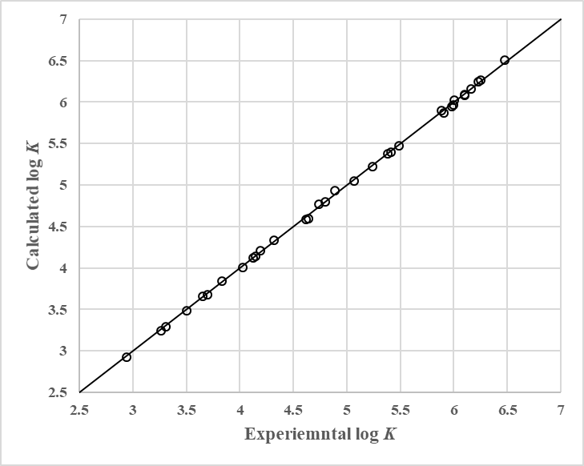

Fig. . Correlations result of modified model to the experimental data of Ref. [39].

Using the modified partition coefficient model, as its basis model in Ref. [5], the concentration of contaminants in water and polymeric passive sampler can be predicted in which only the chemical structures of compounds (polymer and contaminant) are required. By using these data, one can proceed to determine the kinetics of passive samplers’ uptake by utilization of the developed kinetic model. The prediction error of partition coefficient model for all data points was about 5.1% in terms of AARD which has an acceptable accuracy.

In order to determine the kinetic model parameters, two methods can be used; (1) regression of experimental data to the model equation and (2) use of the graphical method presented in Ref. [34]. Here, the first method is used and main results are provided for chrysene uptake by polyethylene PPSs as kinetic data are almost unavailable for other systems used in this work. The experimental kinetic data of chrysene uptake by polyethylene PPSs are shown in Fig. 2 together with the calculated curve by using the developed kinetic model of Eq. 27 for four data points and regressing the parameters *α*, *β*, *k1*, *a* and *s*.

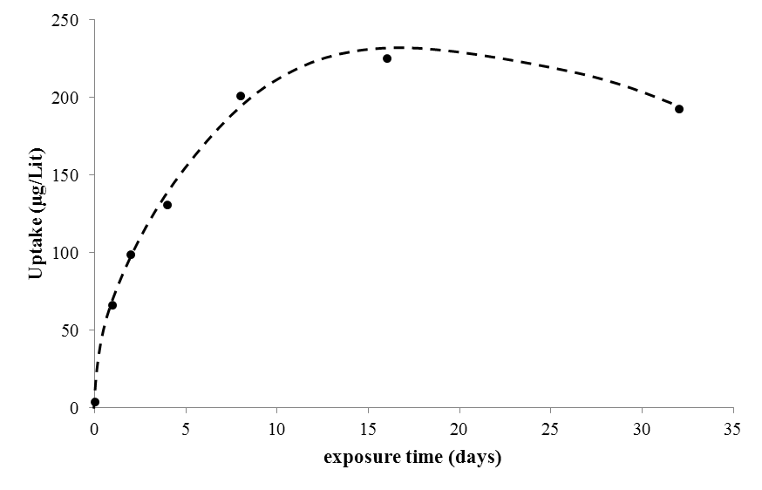

Fig. . The correlation results of kinetic model for chrysene uptake by polyethylene passive sampler: solid bullets show experimental data collected from Ref. [38] and dashed line shows the model predictions.

The optimal regressed values of parameters *α*, *β*, *k1*, and *s*/*a* are 1.15, 6.28, 460.4 and 0.962742 respectively. The value of *β*=6.28 clearly demonstrates the high potential of polyethylene and its uptake capability for passive sampling applications. By using no more than four data points – addition of more data points increases the adherence and convergence as a side – the developed kinetic model can provide valuable information regarding the polymer selection for sampler fabrication and the time evolution of uptake process. The kinetic model clearly says that the potential and capacity of polymeric passive sampler material are the controlling factors for contaminant uptake.

# Conclusions

A partition model of our recent work [5] was modified by introduction of a composition-dependent Flory–Huggins interaction parameter to increase its predictive capabilities for accurate determination of contaminant partitioning from wastewater to polymeric passive samplers. Experimental uptake data were collected and used for model evaluation. The measured and calculated partition coefficients indicate a prediction error of 5.17%. For description of time evolution of contaminant uptake, a kinetic model was developed which uses only four data points for regression of model constants leading to valuable overview of uptake process. The developed kinetic model can provide valuable information regarding the polymer selection for sampler fabrication and the time evolution of uptake process.

**References**

1. Thompson, J.M., C.H. Hsieh, and R.G. Luthy, *Modeling uptake of hydrophobic organic contaminants into polyethylene passive samplers.* Environ Sci Technol, 2015. **49**(4): p. 2270-7.

2. Adams, R.G., et al., *Polyethylene Devices:  Passive Samplers for Measuring Dissolved Hydrophobic Organic Compounds in Aquatic Environments.* Environmental Science & Technology, 2007. **41**(4): p. 1317-1323.

3. Endo, S., et al., *Equilibrium partition coefficients of diverse polar and nonpolar organic compounds to polyoxymethylene (POM) passive sampling devices.* Environ Sci Technol, 2011. **45**(23): p. 10124-32.

4. Rainer Lohmann and D. Muir, *Global Aquatic Passive Sampling (AQUA-GAPS): Using Passive Samplers to Monitor POPs in the Waters of the World.* Environ Sci Technol, 2009. **44**(3): p. 860–864.

5. Asgarpour Khansary, M., S. Shirazian, and M. Asadollahzadeh, *Polymer-water partition coefficients in polymeric passive samplers.* Environ Sci Pollut Res Int, 2017. **24**(3): p. 2627-2631.

6. Xu, M., et al., *A research on application of water treatment technology for reclaimed water irrigation.* International Journal of Hydrogen Energy, 2016. **41**(35): p. 15930-15937.

7. Zanacic, E., J. Stavrinides, and D.W. McMartin, *Field-analysis of potable water quality and ozone efficiency in ozone-assisted biological filtration systems for surface water treatment.* Water Research, 2016. **104**: p. 397-407.

8. Mahmoud, B., M. Yosra, and A. Nadia, *Effects of magnetic treatment on scaling power of hard waters.* Separation and Purification Technology, 2016. **171**: p. 88-92.

9. Tosun, I., *Modeling in Transport Phenomena : A Conceptual Approach*. 2 ed. 2007: Elsevier.

10. Khansary, M.A., et al., *Modeling Drying of a Coated Paper.* International Journal of Modeling, Simulation, and Scientific Computing, 2014. **05**(01): p. 1350019.

11. Bergmair, D., et al., *System analysis of membrane facilitated water generation from air humidity.* Desalination, 2014. **339**: p. 26-33.

12. Bergmair, D., et al., *A low pressure recirculated sweep stream for energy efficient membrane facilitated humidity harvesting.* Separation and Purification Technology, 2015. **150**: p. 112-118.

13. Bar, E., *Extraction of water from air — an alternative solution for water supply.* Desalination, 2004. **165**: p. 335.

14. Wahlgren, R.V., *Atmospheric water vapour processor designs for potable water production: a review.* Water Research, 2001. **35**(1): p. 1-22.

15. Milani, D., et al., *Experimentally validated model for atmospheric water generation using a solar assisted desiccant dehumidification system.* Energy and Buildings, 2014. **77**: p. 236-246.

16. Lindvig, T., M.L. Michelsen, and G.M. Kontogeorgis, *A Flory–Huggins model based on the Hansen solubility parameters.* Fluid Phase Equilibria, 2002. **203**(1-2): p. 247-260.

17. Khansary, M.A., et al., *An enquiry on appropriate selection of polymers for preparation of polymeric nanosorbents and nanofiltration/ultrafiltration membranes for hormone micropollutants removal from water effluents.* Chemosphere, 2017. **168**: p. 91-99.

18. Farajnezhad, A., et al., *Correlation of interaction parameters in Wilson, NRTL and UNIQUAC models using theoretical methods.* Fluid Phase Equilibria, 2016. **417**: p. 181-186.

19. Asgarpour Khansary, M. and M.A. Aroon, *On the consistency and correctness of thermodynamics phase equilibria modeling and correlation reports published in Fuel journal.* Fuel, 2015. **140**: p. 810-811.

20. Khansary, M.A. and M.A. Aroon, *Reply to the comments “On the consistency and correctness of thermodynamics phase equilibria modeling and correlation reports published in Fuel journal”.* Fuel, 2015. **142**: p. 306-307.

21. Mejía, A. and H. Segura, *Comments “On The Consistency and Correctness of Thermodynamics Phase Equilibria Modeling and Correlations Reports Published In Fuel Journal”.* Fuel, 2015. **140**: p. 812-813.

22. Khansary, M.A., *Vapor pressure and Flory-Huggins interaction parameters in binary polymeric solutions.* Korean Journal of Chemical Engineering, 2016. **33**(4): p. 1402-1407.

23. Ruzette, A.-V.G. and A.M. Mayes, *A Simple Free Energy Model for Weakly Interacting Polymer Blends.* Macromolecules, 2001. **34**(6): p. 1894–1907.

24. Boudouris, D., L. Constantinou, and C. Panayiotou, *A Group Contribution Estimation of the Thermodynamic Properties of Polymers.* Industrial & Engineering Chemistry Research, 1997. **36**(9): p. 3968-3973.

25. van Krevelen, D.W. and K.T. Nijenhuis, *Properties of Polymers: Their Correlation with Chemical Structure; Their Numerical Estimation and Prediction from Additive Group Contributions*. 4 ed. 2008: Elsevier.

26. Lacombe, R.H. and I.C. Sanchez, *Statistical thermodynamics of fluid mixtures.* The Journal of Physical Chemistry, 1976. **80**(23): p. 2568-2580.

27. Sanchez, I. and M. Stone, *Statistical Thermodynamics of Polymer Solutions and Blends*. Polymer Blends: Formulation and Performance, ed. Donald R. Paul and C.B. Bucknall. Vol. Volume 1: Formulation. 2000: John Wiley & Sons, Inc.

28. Sanchez, I.C. and R.H. Lacombe, *Statistical Thermodynamics of Polymer Solutions.* Macromolecules, 1978. **11**(6): p. 1145-1156.

29. Keshavarz, L., M.A. Khansary, and S. Shirazian, *Phase diagram of ternary polymeric solutions containing nonsolvent/solvent/polymer: Theoretical calculation and experimental validation.* Polymer, 2015. **73**: p. 1-8.

30. Farajnezhad, A., et al., *Binary Mutual Diffusion Coefficients of Polymer/Solvent Systems Using Compressible Regular Solutions Theory and Free Volume Theory.* Journal of Non-Equilibrium Thermodynamics, 2016. **41**(3).

31. Madaeni, S.S. and L. Bakhtiari, *Thermodynamic-based predictions of membrane morphology in water/dimethylsulfoxide/polyethersulfone systems.* Polymer, 2012. **53**(20): p. 4481-4488.

32. Ghasemi, S.M. and N. Mohammadi, *The prediction of polymeric membrane characteristics prepared via nonsolvent induced phase separation by the apparent coagulation time.* Polymer, 2013. **54**(17): p. 4675-4685.

33. Murray R. Spiegel and J. Liu, *Mathematical Handbook of Formulas and Tables*. 1999: McGraw Hill Professional.

34. Khansary, M.A., A. Marjani, and S. Shirazian, *Development and validation of a graphical sorption model: application to sorption of organic liquids into low density polyethylene polymeric membrane.* Asia-Pacific Journal of Chemical Engineering, 2017. **12**(4): p. 561-572.

35. *Wolfram Mathematica*. 2014, Mathematica.

36. Foo, K.Y. and B.H. Hameed, *Insights into the modeling of adsorption isotherm systems.* Chemical Engineering Journal, 2010. **156**(1): p. 2-10.

37. Asgarpour Khansary, M. and A. Hallaji Sani, *Using genetic algorithm (GA) and particle swarm optimization (PSO) methods for determination of interaction parameters in multicomponent systems of liquid–liquid equilibria.* Fluid Phase Equilibria, 2014. **365**: p. 141-145.

38. Müller, J.F., et al., *Partitioning of polycyclic aromatic hydrocarbons in the polyethylene/water system.* Fresenius’ Journal of Analytical Chemistry, 2001. **371**(6): p. 816-822.

39. Choi, Y., Y.M. Cho, and R.G. Luthy, *Polyethylene-water partitioning coefficients for parent- and alkylated-polycyclic aromatic hydrocarbons and polychlorinated biphenyls.* Environ Sci Technol, 2013. **47**(13): p. 6943-50.