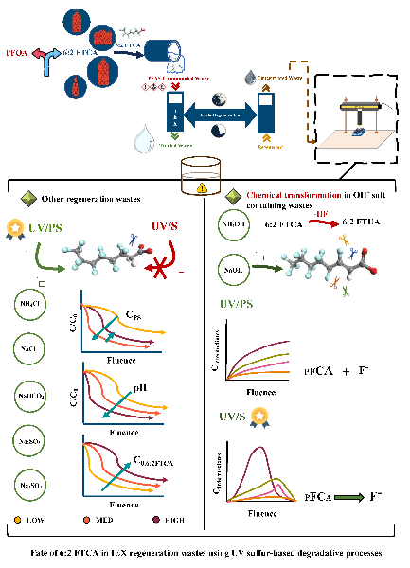 Graphical Abstract

(5×13 cm)