Experimental Evaluation of Microwave Systems for Minerals Dewatering

Milad Asgarpour Khansary, Amin Shadi, Parham Samea, and Seyed Ali Ghoreishi-Madiseh*

Norman B. Keevil Institute of Mining Engineering, University of British Columbia, Vancouver BC V6T1Z4, Canada

ali.madiseh@ubc.ca

**Abstract.** Drying is a critical step in the processing of minerals, with substantial energy demand, resource cost, and greenhouse gas emissions. In this work, the performance of microwave systems for drying minerals was experimentally investigated. Different materials with distinct chemical compositions and moisture contents ranging from 5% to 25% were chosen and their thermophysical and electromagnetic properties, including dielectric loss, thermal conductivity and heat capacity were characterized. Materials were incrementally heated in a 2.45 GHz microwave oven with subsequent measurements of mass loss and surface temperature until certain mass losses were attained. The dry materials showed minimal interaction with the applied electromagnetic field, but with discernible energy exchange in the presence of moisture which points to the potential of microwave systems in the drying of materials. Results showed a consistent drying rate up to a critical moisture content, followed by a falling rate regime. Conventional drying methods face challenges in reaching and surpassing the critical moisture content, often requiring prolonged residence times. These findings show that microwave heating is an excellent alternative for drying applications in mining with low net energy demands and greenhouse gas emissions.

**Keywords:** Microwave Drying Systems; Minerals; Dewatering; Zero Emission; Decarbonization.

1. Motivation

It is estimated that drying can account for up to 25% of a mining company's energy consumption [1]. The conventional technologies for drying minerals rely on fossil fuel, leading to greenhouse gases emission such as carbon dioxide. Therefore, mining companies seek sustainable and energy-efficient technologies to reduce carbon footprint, energy consumption, costs, and emission.

Microwave heating is an environment-friendly and efficient drying technique since it heats materials directly without requiring a heating medium [2]. This direct heating method can lead to significant energy savings [3]. Microwave heating is also a rapid and precise process, allowing for greater control over temperature and reduces processing times [4]. Additionally, microwave heating can be used for a wide range of materials, making it a versatile and effective heating method in various industries, including mining and mineral processing.

In this paper, the microwave heating is evaluated experimentally for drying mineral samples with initial moisture contents up to 25%. The thermophysical properties were thoroughly characterized and drying rates were measured. Our findings show that microwave heating is an excellent candidate for drying applications and can surpass the critical moisture contents without requiring prolonged residence time.

1. Methodology

Samples were procured from a partner industrial mining company and oven-dried at 75℃ overnight to determine moisture content. The heat capacity of samples was measured using differential scanning calorimetry method up to 120℃ degrees (due to presence of sulphur). The transient line heat source technique and cavity perturbation technique were employed to measure thermal conductivity and dielectric properties. For drying experiments, samples were incrementally heated in a 2.45 GHz microwave (MW) oven (Fig. 1) with subsequent measurements of mass loss and surface temperature using a benchtop scale and an infrared thermometer.

**Fig. 1.** Setup for drying experiments

1. Results and Discussion

The measured initial and final moisture contents are reported in Table 1 at two different energy dosages and corresponding drying curves are shown in Fig. 2. A wide constant falling rate region can be seen in all drying curves that is indicative of an evaporation-dominant mechanism. In all experiments, the final moisture content was below 1%. Achieving this level of drying through the conventional drying techniques is challenging and requires prolonged drying steps that is not desirable in continuous industrial practices since it may reduce productivity. In our experiments, the longest microwave drying test took around 5 minutes to complete.

**Table 1.** Moisture content of samples exposed to microwave drying

|  |  |  |  |  |
| --- | --- | --- | --- | --- |
| Material | Density  g/cm3 | Before MW drying | After MW drying at 15 kWh/t | After MW drying at 30 kWh/t |
| M1 | 1.243 | 5.47 | 0.07 | 0.01 |
| M2 | 1.206 | 26.32 | 1.15 | 0.23 |

a) 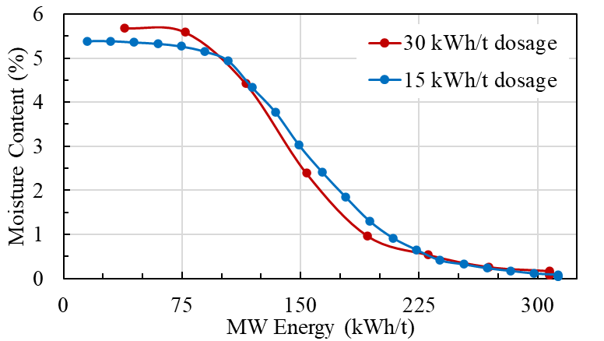

b) 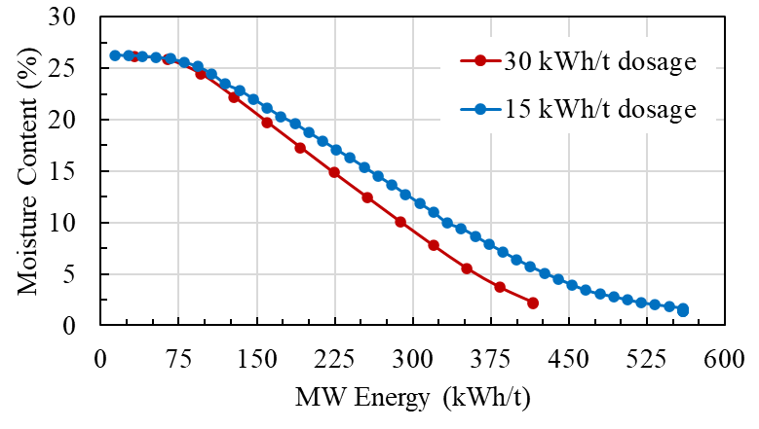

**Fig. 2.** Drying curves obtained for samples a) M1 and b) M2

The measured heat capacities and dielectrics are shown in Fig. 3. A drop in measured dielectric loss is observed as drying progresses (Fig. 3b) where the dried materials show minimal engagement with applied electromagnetic field. The higher dielectric losses in moist materials correspond to higher electromagnetic heating that agrees with the drying curves shown in Fig. 2.

a)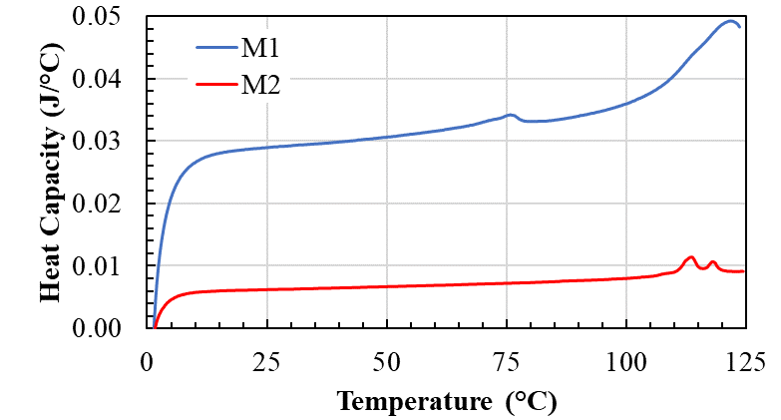

b)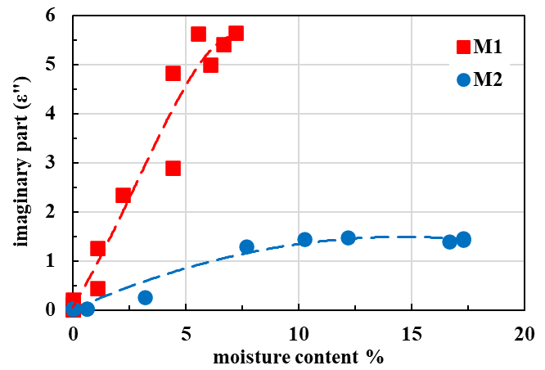

**Fig. 3.** Measured a) heat capacities and b) dielectrics

1. Concluding Remarks

It was shown that moisture contents as low as 1% is achievable within short exposure time of microwave heating. The drying measurements confirmed that the evaporation is the dominant mechanism in consuming microwave generated heat. These findings suggest that microwave heating is an excellent alternative for drying applications in mining with low net energy demands.

References

1. Mujumdar AS, Zhonghua W (2007) Thermal drying technologies-cost-effective innovation aided by mathematical modeling approach. Drying Tech 26:145-153. <https://doi.org/10.1080/07373930701812606>

2. D. El Khaled, Novas N, Gazquez JA, Manzano-Agugliaro F (2018) Microwave dielectric heating: applications on metals processing. Renew Sustain Energy Rev 82:2880-2892.

3. Falciglia PP, Roccaro P, Bonanno L, De Guidi G, Vagliasindi FGA, Romano S (2018) A review on the microwave heating as a sustainable technique for environmental remediation/detoxification applications. Renew Sustain Energy Rev 95:147-170. https://doi.org/10.1016/j.rser.2018.07.031

4. Lapshinov BA (2021) Temperature measurement methods in microwave heating technologies. Meas Tech 64:453-462. <https://doi.org/10.1007/s11018-021-01954-w>