Microwave Heating for Minerals Drying: Experimental and Numerical Study
M. Asgarpour Khansary, P. Samea, A. Shadi and S.A. Ghoreishi-Madiseh
The University of British Columbia, Vancouver, Canada
Keywords: Microwave Heating, Minerals Drying, Finite Element Analysis, Moisture Removal, Electrification.
INTRODUCTION
Transitioning from natural gas-burning kilns commonly used in minerals drying to electricity-driven technologies such as microwave heating powered by renewable energies, can cut dependence on fossil fuels [1]. The present paper evaluates the application of microwave systems for minerals drying through conducting laboratory experiments and numerical modeling. Drying tests were conducted in a commercial microwave oven, with samples exposed to energy dosages of up to 150 kWh/t aiming at reducing moisture content to below 1%. The tangent loss, heat capacity and thermal conductivity were evaluated at various temperatures and used to develop numerical models coupling electromagnetic and heat transfer. The drying rates and temperature profiles of samples were predicted using numerical model and compared to experimental measurements where strong agreement was found. It was found that providing a minimum of 15 kWh/t microwave energy dosage initiates evaporation. Evaporation remains the dominant mechanism in expensing microwave energy, removing water at approximate rate of 0.31 gram per kWhr/t of material until moisture content of approximately 2% is reached.
methOdoloGy
The thermal conductivity of wet and dry samples was measured using a KD2-Pro thermal properties analyzer. The heat capacity of the samples was measured only for fully dried samples using differential scanning calorimetry with Discovery 2500 from TA Instruments. The effect of latent heat was incorporated into models using an apparent heat capacity approach [2]. Samples were thoroughly analyzed for their electromagnetic properties using cavity perturbation technique at frequency of 2467 MHz across temperatures ranging from 25 °C to 120 °C, with incremental steps of 20 °C.
Drying experiments were conducted in a commercial microwave oven from Amana model RC30S2 (Figure 1(a)) with a nominal forward power of 3 kW, equipped with 3 magnetrons in separate rectangular TE10 waveguides, 3 stirrers, and 2 fans [3]. The actual forward power of microwave was measured following IEC 60705:2010 + A1:2014 standard [4] through energy absorption study on water.

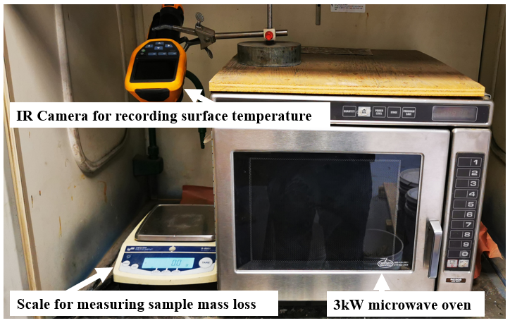
(a)
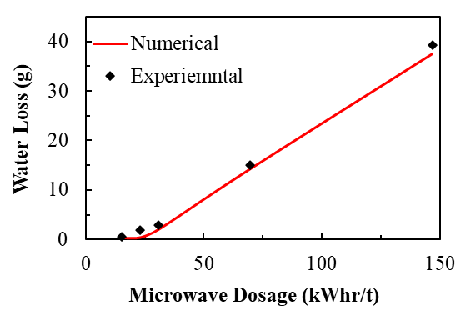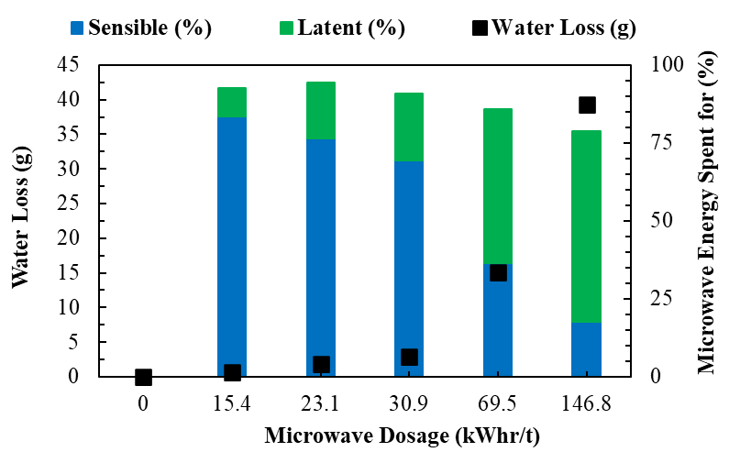
(b) (c)
Figure 1. The 3kW microwave oven together with IR camera and benchtop scale (a). The numerical mass loss is compared to experimental measurements (b), with respective contribution of sensible energy and latent energy energies in expensing microwave energy (c).

The generators’ ramp-up time and actual power draw from electrical grid were measured where changes in temperature, mass and electrical current were recorded using a thermometer, benchtop scale and power analyzer, respectively.
Samples weighing approximately 275 g with 25% initial moisture content were exposed to microwave energy for durations of 9, 12, 15, 30, and 60 s. Mass and temperature changes were measured and used to calculate the total thermal energy absorbed by the samples i.e. sum of sensible and latent energies.
A finite-element based numerical model was developed in COMSOL Multiphysics coupling electromagnetic physics with heat transfer bi-directionally. The transient revolution of stirrers was incrementally incorporated and the sequence of electromagnetic physics and heat transfer were solved iteratively. The electric field were solved in frequency domain at respective temperature profiles, and the corresponding resistive losses were used as heat source in solving heat transfer in time domain. Following a mesh dependency analysis taking into account the respective computational costs, meshes as small as 5 mm were given satisfying numerical errors below 1% in both calculated electromagnetic resistive losses and heat transfer power balance. The optimal mesh was used to perform numerical simulations to compute changes in temperature and mass of samples exposed to microwave radiation.
RESULTS AND DISCUSSION
The dielectric measurements at various moisture contents showed that decreasing the moisture content of samples decreases the tangent loss significantly. For instance, the dielectric loss of wet samples with 25% moisture content drops two orders of magnitudes upon drying, from 0.240 to 0.014 when moisture content dropped to 5%. Once fully dried, samples show minimal interaction with the applied electromagnetic field. This observation was further examined by preforming and comparing drying tests experimentally and numerically. An excellent agreement was found between measured and numerical moisture mass loss as shown in Figure 1(b). Once the material reaches the phase change threshold (at 100 °C), evaporation becomes the dominant mechanism in expensing microwave energy, as seen from the sharp change in mass loss trend as well as in latent energy contributions in Figure 1(c). Higher microwave dosages (longer exposures) result in higher moisture losses. At lower microwave dosages (shorter exposures), the microwave energy is mostly spent to rise and maintain materials volumetric temperature, leading to lower moisture losses. At low dosages, 0.04 gram of water can be removed per 1 kWhr/t energy dosage given to the material, and by increasing the energy dosage, up to 0.31 gram of water can be remove per 1 kWhr/t energy dosage given to material.
Conclusion
Through dielectric measurements over temperatures ranging from 25–120 °C, it was found that water has the dominant role in expensing electromagnetic energy of wet mineral samples, with wet samples showing dielectric loss factors two order of magnitude larger than those of dry samples. The mass and temperature changes from developed numerical model and experimental measurements were concordant. It was found that a minimum of 15 kWh/t microwave energy dosage must be provided to initiate evaporation. By retaining energy dosages above 30 kWhr/t of material, a consistent evaporation rate of 0.31 gram per kWhr/t of material can be sustained.
REFERENCES
- Heat Exchange: How today’s policy choices will drive or delay Canada’s transition to clean, reliable heat, The Canadian Climate Institute,13 June 2024.
- Y. Khattari, T. El Rhafiki, N. Choab, T. Kousksou, M. Alaphilippe, Y. Zeraouli, Apparent heat capacity method to investigate heat transfer in a composite phase change material, J. Energy Storage, vol. 28, pp. 101239, 2020.
- M. Asgarpour Khansary, A. Shadi, P. Samea, S.A. Ghoreishi-Madiseh, Experimental Evaluation of Microwave Systems for Minerals Dewatering, Proceedings of the 63rd Conference of Metallurgists, COM 2024, pp 961–964, 2024.
- Household microwave ovens - Methods for measuring performance, IEC 60705:2010+AMD1:2014 CSV, International Electrotechnical Committee, 30-06-2014.

