Computationally probing cavitation due to evaporation at the air-water interface in nanoconfinements

Abstract
The evaporation at air-water interface in nanoconfinements can induce a suction force within the liquid that is experienced in form of negative capillary pressure, leading to cavitation under certain conditions. Our current understanding of water thermodynamics suggests this observation should be associated with nanoconfinement (size and surface properties) and water composition (contaminations and entrapped bubbles). The effect of nanoconfinement surface homo/heterogeneity, roughness, uniformity, and size on the cavitation of water is thoroughly evaluated and discussed, followed by recommendations on properly probing this process via computational tools. This letter offers new insight on the cavitation within nanoconfinements of about several nanometers, where negative pressures emerge that stem from properties of nanoconfinement and water, and their interplay on phase behavior.
Keywords: nanoconfinement; cavitation; surface physics; thermophysical properties; nucleation.

Problem definition
Cavitation, by definition, involves bubble formation within a liquid. Bubble formation in a liquid, usually, can be induced by (1) changing temperature at a relatively constant pressure or (2) changing pressure at relatively constant temperature. The first is referred as boiling and the latter is vaporization and/or cavitation as illustrated in Fig. 1 (left). In both cases, the bubble formation requires a phase transition (liquid → gas/vapor), and therefore knowledge of equilibrium and coexistence boundaries or vapor pressure profile. Liquids establish different vapor pressures depending on their compositions and this in turn affects such a transition under system temperature and/or pressure.
Information about liquid → gas/vapor phase transition can be synthesized using a pressure – temperature phase diagram (in short: P–T diagram) which explains phase coexistence and transition boundaries. A P–T diagram (Fig. 1 (left)), however, does not offer any important information on the path that such transitions would follow, which has its roots in the use of Gibbs free energy. For instance, one can realize that vaporization at constant temperature can occur with a pressure dropdown but cannot conclude how vaporization at a phase transition would progress or why it sometimes is observed and sometimes not.
To synthesize an understanding of how vaporization progresses, one would need to study the pressure – volume relationship (in short: P–V diagram). The P–V diagram also shows the volume of each phase (liquid and vapor) once a phase transition occurs as indicated by the intersection of the isotherm and vapor pressure curve (Fig. 1 (right)). In thermodynamics, vaporization is a phase transition that involves performing work on the environment in form of volume change. Therefore, the environment (such as the container confining it) also plays a role on vaporization progress or the path it may follow. Helmholtz free energy is capable of tracking and explaining this phase transition while Gibbs free energy does not allow it (for further reading see ¹).
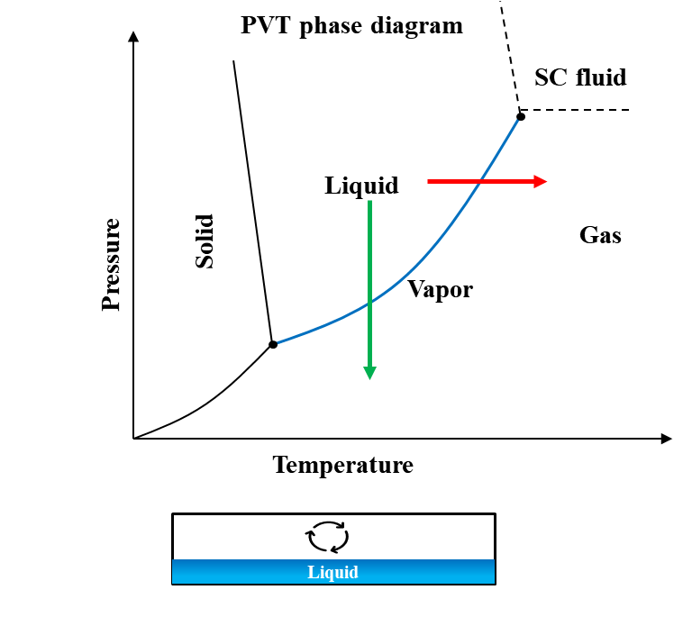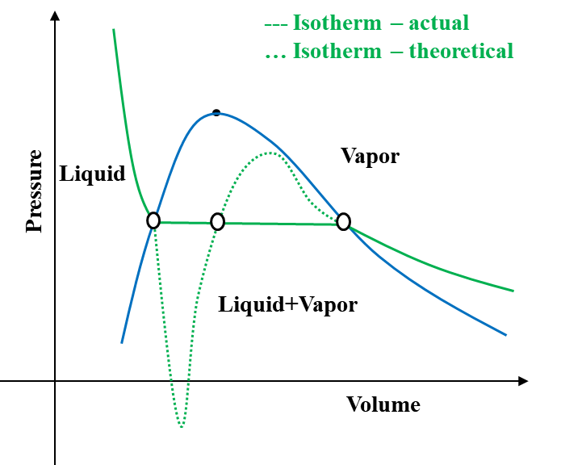
Fig. 1. The schematic phase diagram for liquids/water. Left: the phase boundaries and coexistence for solid, liquid and vapor sates of water in form of P–T diagram, blue solid line shows the liquid–vapor boundary (vapor pressure profile), red arrow shows the boiling process of liquid transition to vapor, red arrow shows vaporization liquid transition to gas. Right: the vaporization liquid transition to vapor in from of P–V diagram, blue line is liquid–vapor boundary (vapor pressure profile), green solid line is actual isotherm, green dashed line is theoretically expected isotherm, ovals show where the two types of isotherms meet each other.

The P–V diagram is given in more details in Fig. 2 to gain an understanding of vaporization path and progress and interplay of the surrounding’s constraints on it, especially the container that confining the liquid. If one connects the critical point of liquid–vapor boundary (binodal) to the critical points of theoretical isotherm, the curve that yields is called the spinodal boundary, which reflects on the thermodynamic stability of liquid and vapor phases in system ². A phase is unstable if it is enveloped within the spinodal boundary and therefore will always tend towards a phase transition to stabilize the system. The system, wherever it is in between the two binodal and spinodal boundaries, is metastable and will not experience a phase transition unless appropriate thermodynamic or kinetic triggers exist, such as nucleation sites of sufficient size, perturbation of the container, or sudden changes of system container constraints like pressure or volume changes ³⁻⁵.
The phase transition from liquid to vapor follows the actual isotherm (solid green line) if nucleation sites of sufficient size exist within the liquid. These nucleation sites, for example, can be the entrapped bubbles within the liquid itself, which for the case of water practically always exists. Other source of such nucleation sites is contaminations and impurities like ions and/or minerals. Also, the container surface roughness and properties can act as nucleation sites at irregular contact zones. If enough sufficient nucleation sites do not exist or nucleation growth is slow or delayed, then the liquid tends to follow the theoretical isotherm allowing itself to withstand more pressure dropdown than usual. This allows the liquid to enter a metastable equilibrium state to tolerate the lower pressures, even negative, while there is no chance of bubble formations (delayed or avoided), which is shown in red in Fig. 2. However, there is a lower negative pressure limit where the phase change from liquid to vapor (cavitation) will occur eventually by the spontaneous breaking of cohesion between water molecules, even in an absolutely pure liquid (marked by the black bullets on theoretical isotherm at negative side of pressure axis in Fig. 2). This is known as homogeneous cavitation and corresponds to the most negative pressure a liquid can ever sustain. For example, pure water can sustain a negative pressure of about -30 MPa at normal temperatures (between 5 and 35 °C) ⁶. In practice, however, one cannot expect liquid water to be pure, impurity-free, contamination-free, with no entrapped bubble. This triggers formation of bubbles well before the liquid would reach the lower negative pressure limit, and consequently cavitation may occur. This type of cavitation is known as heterogeneous cavitation. This concludes that the actual cavitation limit sits well above the theoretical limit, and it has been confirmed by many experiments, where liquid water would sustain pressures down to -25MPa ⁷. It is important to note that the corresponding vapor phase is within the spinodal boundary and therefore unstable, so if liquid → gas/vapor phase transition occurs, the bubbles must nucleate and grow.
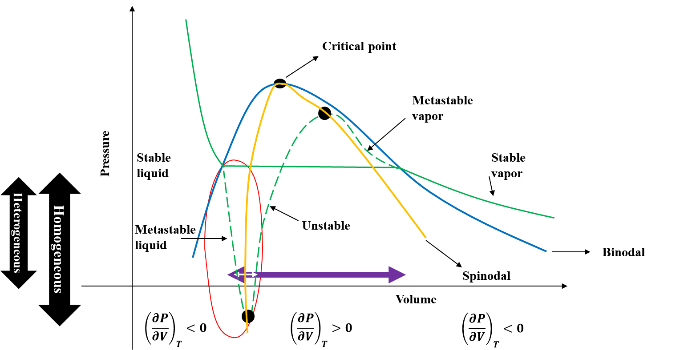
Fig. 2. A closer look at schematic P–V diagram, blue line is liquid–vapor boundary (vapor pressure profile), green solid line is actual isotherm, yellow solid line shows the spinodal boundary, green dashed line is theoretically expected isotherm, ovals show where the two type of isotherm meet each other, red oval shows the conditions reflecting confined liquid, cyan double arrow shows the volume change due to vaporization under normal conditions (no confinement) and white double arrow shows the volume change due to vaporization attainable (allowed) within a confinement.

For water, the ratio of density of vapor (0.804g/liter) to that of liquid (997g/liter) is in orders of magnitude of about 10⁴. In other words, the same amount (mass) of water requires and occupies a volume of 10⁴ times that of its liquid state (assuming gas incompressible to emphasize the magnitude of changes). This means that even if the thermodynamic dictates a liquid → gas/vapor phase transition, it may be suppressed/delayed due to the environmental constraints like the size/volume of container confining the system. For example, a nanoconfinement cannot accommodate such a large volume change, therefore it will push the liquid to follow the theoretical isotherm entering the metastable state rather than immediately following the actual isotherm forming bubbles.
This metastable state of water in a nanoconfinement (shown in red in Fig. 2) has been the subject of many studies to understand the occurrence of cavitation, especially where continuous water evaporation at the air–water interface occurs ^{8, 9}. A capillary pressure because of continuous water evaporation at the air–water interface exists that exerts a negative pressure within the liquid, leading to cavitation under certain conditions ⁹⁻¹¹⁹, associated with nanoconfinement (size and surface properties) and water composition (contaminations and entrapped bubbles) ^{12, 13}.

Interplay of confinement characteristics
A simple way to look at the surfaces is to assume an ideal surface similar to uniformly flat plane with the same texture and interaction tendency throughout its whole surficial area as shown in Fig. 3. However, such a surface does not exist, and for real surfaces neither their texture is flat/smooth, nor the curvature/form remains identical everywhere. Surfaces, because of possible functional groups and/or spatial orientation of atoms, may show different affinities toward the liquid. A surface can be hydrophobic (low surface–liquid affinity) or hydrophilic (high surface–liquid affinity) depending on their tendency to attract or repel water, respectively. If the affinity of the surface towards the liquid (chemical heterogeneities) or its texture (physical heterogeneities) remains the same everywhere on the surface, such a surface is referred to as homogeneous surface, otherwise it is referred to as heterogeneous surface. A heterogenous surface is the most realistic way of looking at surfaces.
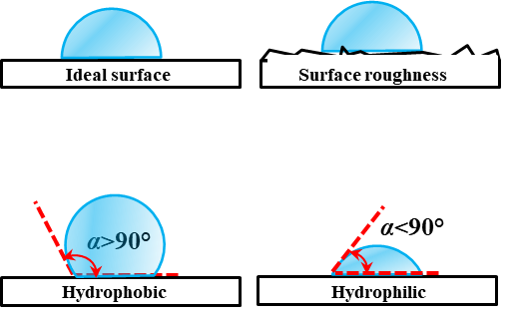
Fig. 3. Schematic representation of surface properties, α is the contact angle. An (unphysical) ideal surface is shown on the left with no surface roughness. The hydrophilic surface defined as when contact angle is smaller than 90° and hydrophobic when contact angle is larger than 90°.

The metastability of liquid confined within a heterogenous surface nanoconfinement can strongly be affected by the ratio of the highest surface–liquid affinity (hydrophilicity) to that of lowest (hydrophobicity) ^{14, 15} (Fig. 4). These chemical heterogeneities can influence the position and shape of initial bubbles, where nucleation will occur around the less hydrophilic regions. Furthermore, the affinity of the surface towards the liquid may cause layering of the liquid within a nanoconfinement. For example, a surface fully made of carbon (hydrophobic) would repel water molecules while a surface containing nitrogen (hydrophilic) attracts water molecules ¹⁵⁻¹⁸.
In a hydrophilic nanoconfinement, several layers are identified near the surface for monoatomic and polymeric fluids while the density profile at the center of the nanoconfinement remains smooth ¹⁹. In the case of water, the first water layer adjacent to the surface in the nanoconfinement is locked where each oxygen–surface bond is followed with a hydrogen–surface bond (known as flat ice). The affinity of the surface determines the thickness of this first layer. The remaining water molecules interact with this first layer and experience oscillations in velocity. The higher the affinity of the surface, the higher are the velocity oscillations. Such velocity oscillations can drastically increase if the size of the nanoconfinement is reduced to 15σ, where σ is the distance where the attractive and the repulsive forces of the surface equilibrate. These drastic velocity oscillations may expose water to high shear stresses and, if strong enough, can initiate bubble formation by breaking the cohesion between the water molecules. In fact, the more hydrophilic the surface, the greater is the energy barrier for bubble formation and nucleation. In contrast, in a hydrophobic nanoconfinement, bubble formation is almost inevitable. This is because a hydrophobic surface significantly reduces, or even eliminates, the energy required for bubble formation and nucleation ⁹.
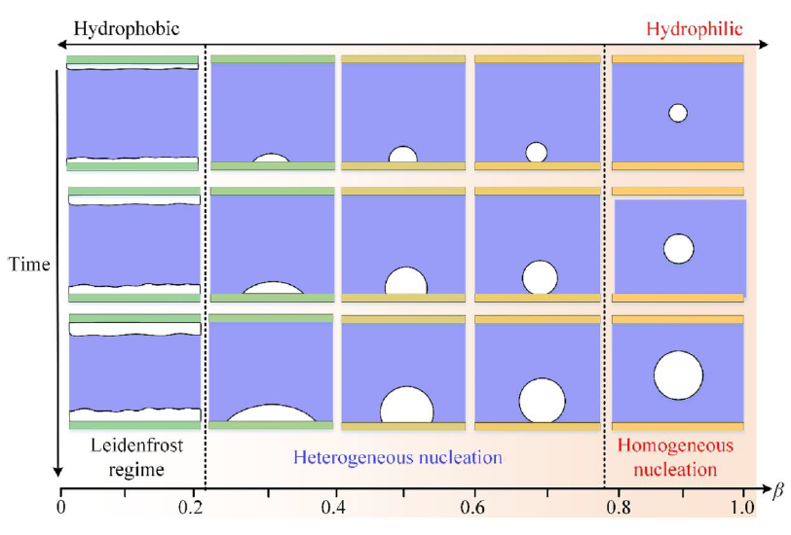 | 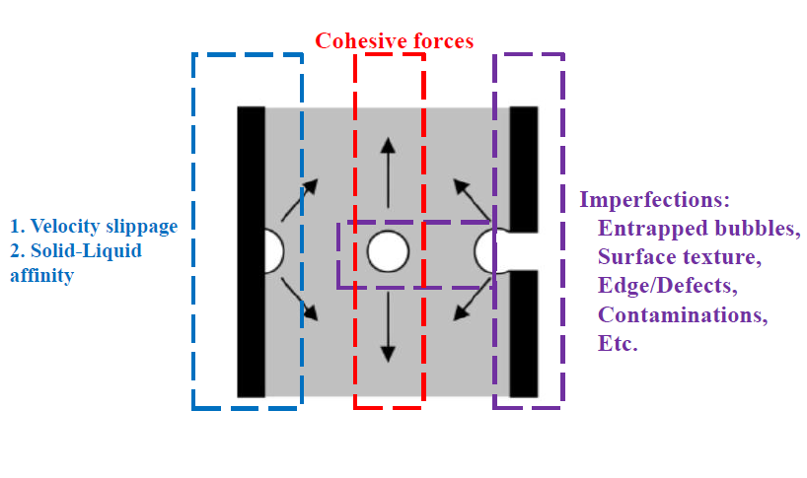
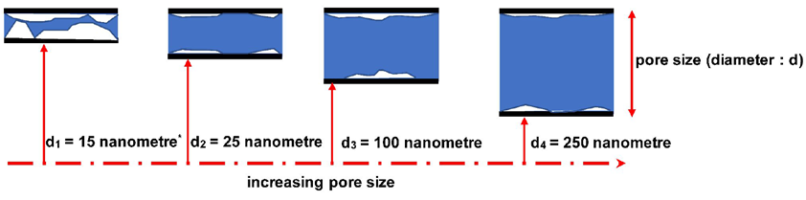
Fig. 4. Top-left: the effect of hydrophilicity (0≤β≤1) on the cavitation, the growth rate and regime of bubbles ²⁰ suggesting that the more hydrophilic a surface (β→0) the less probability of forming bubbles. A hydrophilic surface prohibits bubble formation until velocity fluctuations due to water–surface interactions become drastically large, where bubbles may form near the surface but merely transfer into the bulk. Top-right: the three main mechanisms sought for formation of bubbles near a surface ¹¹. The surface roughness creates small but sharp variations in interatomic potential deriving water–surface interactions and ultimately velocity fluctuations that may lead to bubble formation. A sudden drop of pressure at the interface of cavity and the air could create a uplifting force (toward the interface) that negatively affects the cohesion of water molecules and might lead to bubble formation. Bottom: the effect of nanoconfinement size and dimension on the probability of bubble formation near a hydrophilic surface where bubble formation is inevitable when velocity oscillations drastically increased due to nanoconfinement size (≤15σ).

In addition to the surface chemical heterogeneities in nanoconfinements, physical heterogeneities – which are comprised of change in the texture of the surface or the presence of contractions/expansions within the nanoconfinement – can also initiate bubble formation and nucleation ²¹⁻²³. Although it is very hard, nonetheless unphysical, to differentiate heterogeneities at nanoscale and atomic level, as chemical or physical. The nanoconfinement surface roughness can be defined as the ratio of minimum hydraulic radius to maximum hydraulic radius ¹⁴, and when roughness is larger than 6%, hydrophilic nanoconfinements may cause cavitation by increasing the possibility of bubble entrapment at physical heterogeneities as such irregularities resulting in different local liquid pressures. For irregularities in the form of corners, cavitation can occur due to the corner flow of liquid ²¹, especially when the equivalent radius of nanoconfinement is smaller than 115 nanometers. For irregularities in the form of expansion/contraction, bubble entrapment at the air–water interface at the nanoconfinement entrance can occur which then can move deep into the nanoconfinement in the direction of the contraction ²⁴⁻²⁷. It is worth to note that due to evaporation, a temperature difference alongside the nanochannel is formed from entrance being cooler than the center/middle of nanochannel. As surface tension varies with temperature, the pressure profile within nanochannel should vary too. Then, it might be expected that the interface at the entrance is much more stable than the one at the bubble boundary (higher temperature). However, this temperature difference is not big enough to establish a lower liquid pressure at the entrance.

Interplay of water characteristics
The purity of liquid, like presence of contaminations and entrapped bubbles, also play an important role in generating cavitation, such that, in certain circumstances ^{28, 29}, even a single dilute hydrophobic contamination can dry out the nanoconfinement completely.
Add stuff to here

Probing cavitation computationally
To probe cavitation computationally, the continuum and mesoscale approaches that rely on the Navier-Stokes theory cannot be considered since they fail when the geometry/size of system is less than 5.1 times the molecular diameter of liquid ³⁰⁻³². Among atomistic and molecular approaches, the molecular modeling is favored since it significantly saves time and resources to perfume computations. In molecular dynamics, the criteria to select a water model depends on the concerned physical phenomena, and for study of cavitation, that is how well the model replicates the air–water interfacial properties, most importantly the surface tension. The literature review ³³⁻³⁵ concludes that four-site transferable interaction potential (TIP4P/2005), with capability to reproduce long-range dipole-dipole interactions, is a reliable water model for purpose of investigating cavitation. The TIP4P/2005, also, provides satisfying agreement with the experimental pressure, volume, temperature (PVT) measurements ^{34, 35}.
To reflect hydrophobicity/hydrophilicity of surfaces, there are mainly two approaches to build a surface in simulations: (1) with atomistic resolution and explicit inclusion of atoms / particles, or (2) implicitly, meaning that the surface is represented as a boundary condition with effective interactions. The implicit approach significantly reduces the computational cost of the simulation, while explicit approach offers more detailed view of events occurring associated with cavitation particularly due to chemical heterogenicity of surface. In the implicit approach, one way to systemically generate a surface with different hydrophilic and hydrophobic affinities is introduced in literature ³⁶ that involves modifying the Leonard-Jones potential with a parameter, c, to tune the surface-liquid affinity, given as V(r_{ij}) = 4ε((σ/r_{ij})¹² - c(σ/r_{ij})⁶). Here V is the potential applied to a particle/atom at a distance r_{ij} from the surface, ε is the strength of potential, σ is the depth of potential, and c is the parameter to tune the surface-liquid affinity. The more positive the c value, the more hydrophilic is the surface, and the more negative the c value, the more hydrophobic is the surface. This modification also offers the opportunity to practically calibrate the value of c, by comparing surface angle measurements to that of computationally calculated ones.
To choose an ensemble, while statistically and theoretically all the ensembles would practically converge to similar final states, a good choice is using the microcanonical ensemble (NVE: constant number N, volume V, and energy E). Microcanonical ensemble corresponds to the Helmholtz free energy and finds minimized system entropy, which is more informative as discussed in introduction. The NVE ensemble essentially assumes the system is isolated with no energy exchange with the environment, so that the energy is conserved. For probing cavitation, the embedded isolated system assumption in NVE ensemble is a valid assumption and implementation because possible local thermal and pressure variations due to bubble formation are not that significant to results in an energy exchange with environment over system boundaries but only could create plausible local thermocapillary movements ²⁴. Furthermore, the timescale (duration) of such variations is at range of nanoseconds ³⁷ which is well below the threshold of thermal response in majority of materials forming nanoconfinements ³⁸⁻⁴¹. To ascertain the initial condition of simulated system matches the actual initial physical system of interest ⁴², isobaric−isothermal ensemble (NPT: constant number N, pressure P, and temperature T) can be used to relax initial configuration.
In order to initiate cavitation, a number of approaches can be found in literature ⁵, including (1) deleting random atoms / particles from the system from within the body of liquid or at the interface / boundary, (2) stretching system boundary, (3) applying a pulling force to atoms / particles at boundary and (4) manipulating the velocity of atoms / particles approaching boundary in a specific direction.
Deleting random atoms is physically inconsistent with the nature of cavitation since it creates fake nucleation sites and confuses results for the cause. Also, this approach causes improper description of the out-of-equilibrium and the mass transport phenomena ⁴³.
Stretching the boundary practically mimics a shear-induced cavitation where the cavitations found to occur at the liquid-surface interface, that is due to interaction of moving surface (boundary) ⁴⁴. It is obvious and critical to note that stretching is not mimicking pressure-drop driven cavitation. The extensive use of stretching in literature stem from such neglection when comparing these obtained simulation results with agreeing experimental observation, where often cavitation is seen on the surfaces.
Applying a force at boundary, while seems to be a sound approach, has its own challenges. In liquid, the pulling force is not uniformly felt by liquid molecules because of the weak cohesive forces between liquid molecules. So, the strength of pulling force, F(δ), gets weaker as deeper (δ, depth) one investigates its footprints within liquid body. At equilibrium conditions, particle dynamics will decay over a distance of a few mean free paths, where the mean free path in a liquid is about 0.13 nm. Water molecule has a diameter of 0.27 nm with an equilibrium distance of about 0.31 nm. This means that to make next adjacent molecules experiencing the force, solely through cohesive interactions, the force must be applied at least to a depth of 0.5 nm ³⁷. This is because previous studies ^{19, 45} suggesting the formation of several layers within nanoconfinements – the lowest being near the surface and the highest at the center. This force will be experienced by the next adjacent particles as fast as a shock wave traveling through the liquid. Given the speed of sound in water is 343 m/s (343 nm/ns), one would note that 0.31 nm takes 0.9 picoseconds. This concludes that to have statistically sound data to analysis, very long simulations would be needed.
It appears that manipulating velocity is a much softer approach than applying a force (changing acceleration) in terms of changing atom/particle coordinates ⁴⁶.

Computational details
We employ Molecular Dynamics simulations to probe cavitation and pressure dropdown due to the entrapped bubbles within both hydrophilic and hydrophobic nanoconfinements. The main reason to use Molecular Dynamics is that the continuum and mesoscale approaches which rely on the Navier-Stokes theory fail when the geometry of system is less than 5.1 times the molecular diameter of liquid,,. To reliability model water molecule and its interactions, we use the four-site transferable interaction potential (TIP4P/2005), capable of reproducing long-range dipole-dipole interactions. The TIP4P/2005 provides satisfying agreement with the experimental pressure, volume, temperature (PVT) measurements and computational studies ,,,,. In order to systemically generate surfaces with different hydrophilic and hydrophobic affinities, we employ a modified version of the Leonard-Jones potential given as V(r_{ij}) = 4ε((σ/r_{ij})¹² - c(σ/r_{ij})⁶), where V is the potential applied to a particle/atom at a distance r_{ij} from the surface, ε is the strength of potential, σ is the depth of potential, and c is the parameter to tune the surface – liquid affinity. The more positive the c value, the more hydrophilic is the surface, and the more negative the c value, the more hydrophobic is the surface. This modification also offers the opportunity to practically calibrate the value of c, by comparing surface angle measurements to that of computationally calculated ones. We use SHAKE algorithm is used to retain the molecular structure of water, with accuracy tolerance = 10⁻⁴ (1 part in 10000) and a maximum of 20 iterations, 1 bond type and 1 angle type (as given by TIP4P/2005 model). The long-range Coulombic interactions are computed in pppm (particle-particle particle-mesh) / TIP4P K-space where relative error in forces is 10⁻⁴. The seed number is 880713 for reproducibility. We consider a squared nanoconfinement as shown in Fig. 5. We induce the stretching and pressure dropdown within liquid body via moving system boundary (expanding) from its rightmost side. In order to bring the system to its equilibrium state, we perform dynamics under microcanonical ensemble (NVE: constant number N, volume V, and energy E) for 1ns. In order to retain the system at temperature of interest, T = 300 K, we employ a Berendsen thermostat applied at every 0.1 picoseconds and the Stoermer–Verlet time integration algorithm to calculate positions and velocities at every timestep (dt = 1 femtosecond). It worth to note that the microcanonical ensemble essentially assumes the system is isolated and no energy exchange with the environment may occur, so that the energy is conserved. This (isolated system) is a valid assumption and implementation for current study because possible local thermal and pressure variations due to bubble formation are not that significant to results in an energy exchange with environment over system boundaries but only could create plausible local thermocapillary movements. Furthermore, the timescale (duration) of such variations is at range of nanoseconds which is well below the threshold of thermal response in majority of materials forming nanoconfinements (thermal conductivity values in W/mK: cellulose = 0.040, silica = 1.31, soil = 0.2, ).
We perform two separate set of computational experiments following equilibrating the system.
Experiment A1 – entrapped bubble in absent of pressure dropdown: We insert a single bubble of radius R = 1, 2, 3, 5 Å centred at different locations x = α×L/2, y = β×W/2, z = γ×H/2, where L, W and H are the length, width, and heights of nanoconfinement, respectively as shown in Fig. 5. Parameters α, β, and γ, all can vary as +/- 0.25, +/-0.50, +/-0.75, and +/-1. We perform dynamics under microcanonical ensemble (NVE) for 1ns as mentioned before.
Experiment A2 – entrapped bubble in presence of pressure dropdown: We induce a pressure dropdown by expanding the system boundary on the rightmost side as shown in Fig. 5 (middle). We perform the expansion every 0.1 nanoseconds, where each time the system is expanded l Angstroms (Å), concluding an expansion rate of l m/s. We examine l = 0.01, 0.1, 0.5, 1, 2. We perform dynamics under microcanonical ensemble (NVE) for 1ns as mentioned before.
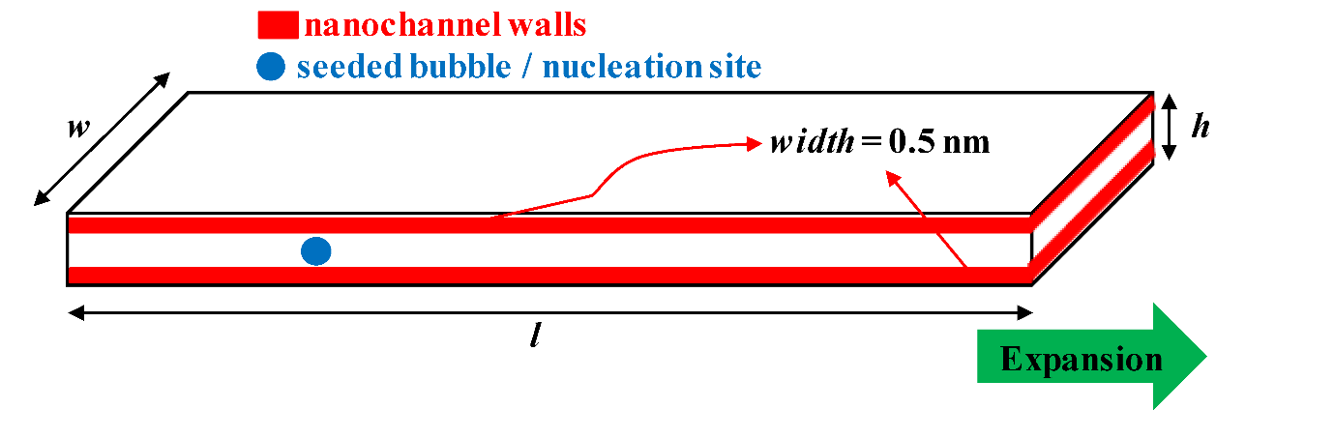

Fig. 5. Schematic of nanoconfinement (top) as well as entrapped bubble experiments. Bottom shows partitioning of nanoconfinement for data postprocessing

ξ
Curvature w₂(ξ)
local cross-sectional area
Curvature w₁(ξ)
w₁(ξ) = α₁ sin(α₃πξ/5) + α₂ sin(7πξ/5)
w₂(ξ) = r₀ + α₁ sin(α₃πξ/5) - α₂ sin(7πξ/5)
α₁=0, α₂=0.4, and α₃=1 | α₁=0.8, α₂=0.2, and α₃=1 | α₁=0.6, α₂=0, and α₃=2
Fig. 4. Schematic of nanoconfinement with irregular geometry (top) having a minimum equivalent radius of r₀ and local equivalent radius of r(ξ) =(w₂(ξ) - w₁(ξ))/2 at any position ξ, and three different examples (bottom)

Data analysis
For data analysis, we use a coarse-grained density field ……
We measure the density profile over a number of layers in nanoconfinement heights direction (z axis) and width direction (y axis), particularly because previous studies , suggest the formation of several layers within nanoconfinements – the lowest being near the surface and the highest at the centre. The radial distribution function, (or pair correlation function, g(r)) which reflects the molecular structure in terms of density is very useful, especially as it offers the possibility of comparison to experimental data extracted from X-ray scattering of molecular fluids and neutron diffraction experiments,.
We measure the average hydrogen bond lifetime as the time integral of the continuous hydrogen bond correlation function (S_{HB}(t)) given as S_{HB}(t) = ‹h(0)H(t)›/‹h(0)h(0)›, where H(t) = 1 if the initial hydrogen bonds at time t = 0 are remained unchanged until time t = t, otherwise, H(t) = 0. If there is hydrogen bond in a specific pair of water at time t = 0 and t = t, the h(0) = 1, otherwise it's h(0) = 0.

For the sake of data analysis and validation, a wide range of quantities are approached in literature, such as measuring the average hydrogen bond lifetime as the time integral of the continuous hydrogen bond correlation function that is given as S_{HB}(t) = ‹h(0)H(t)›/‹h(0)h(0)›, where H(t) = 1 is the initial hydrogen bonds at time t = 0 are remained unchanged until time t = t, otherwise, H(t) = 0. If there is hydrogen bond in a specific pair of water at time t = 0 and t = t, the h(0) = 1, otherwise it's h(0) = 0 ⁴⁷. However, it is recommended to consider the radial distribution function, (or pair correlation function, g(r)) for this purpose since it reflects the molecular structure in terms of density, that should be very useful as it offers the possibility of comparison to experimental data extracted from X-ray scattering of molecular fluids and neutron diffraction experiments ⁴⁸⁻⁵⁰.

References
(1) Smith, J. M. Introduction to chemical engineering thermodynamics. ACS Publications: 1950.
(2) Lienhard, J. H.; Shamsundar, N.; Biney, P. O. Spinodal lines and equations of state: A review. Nuclear Engineering and Design 1986, 95, 297-314. DOI: https://doi.org/10.1016/0029-5493(86)90056-7.
(3) Torabi, K.; Corti, D. S. Molecular simulation study of cavity-generated instabilities in the superheated Lennard-Jones liquid. The Journal of Chemical Physics 2010, 133 (13). DOI: 10.1063/1.3486086 (acccessed 7/28/2024).
(4) Lugli, F.; Höfinger, S.; Zerbetto, F. The Collapse of Nanobubbles in Water. Journal of the American Chemical Society 2005, 127 (22), 8020-8021. DOI: 10.1021/ja0505447.
(5) Wang, P.; Gao, W.; Wilkerson, J.; Liechti, K. M.; Huang, R. Cavitation of water by volume-controlled stretching. Extreme Mechanics Letters 2017, 11, 59-67. DOI: https://doi.org/10.1016/j.eml.2016.12.004.
(6) Briggs, L. J. Limiting Negative Pressure of Water. Journal of Applied Physics 1950, 21 (7), 721-722. DOI: 10.1063/1.1699741 (acccessed 7/28/2024).
(7) Herbert, E.; Balibar, S.; Caupin, F. Cavitation pressure in water. Physical Review E 2006, 74 (4), 041603. DOI: 10.1103/PhysRevE.74.041603.
(8) Wheeler, T. D.; Stroock, A. D. The transpiration of water at negative pressures in a synthetic tree. Nature 2008, 455 (7210), 208-212. DOI: 10.1038/nature07226.
(9) Luo, S.; Likos, W. J.; Lu, N. Cavitation of Water in Soil. Journal of Geotechnical and Geoenvironmental Engineering 2021, 147 (8), 04021079. DOI: doi:10.1061/(ASCE)GT.1943-5606.0002598.
(10) Venturas, M. D.; Sperry, J. S.; Hacke, U. G. Plant xylem hydraulics: What we understand, current research, and future challenges. Journal of Integrative Plant Biology 2017, 59 (6), 356-389. DOI: https://doi.org/10.1111/jipb.12534 (acccessed 2024/07/26).
(11) Cochard, H. Cavitation in trees. Comptes Rendus Physique 2006, 7 (9), 1018-1026. DOI: https://doi.org/10.1016/j.crhy.2006.10.012.
(12) Giacomello, A.; Roth, R. Bubble formation in nanopores: a matter of hydrophobicity, geometry, and size. Advances in Physics: X 2020, 5 (1), 1817780. DOI: 10.1080/23746149.2020.1817780.
(13) Karthika, S.; Radhakrishnan, T. K.; Kalaichelvi, P. A Review of Classical and Nonclassical Nucleation Theories. Crystal Growth & Design 2016, 16 (11), 6663-6681. DOI: 10.1021/acs.cgd.6b00794.
(14) Mehmani, A.; Kelly, S.; Torres-Verdín, C.; Balhoff, M. Capillary Trapping Following Imbibition in Porous Media: Microfluidic Quantification of the Impact of Pore-Scale Surface Roughness. Water Resources Research 2019, 55 (11), 9905-9925. DOI: https://doi.org/10.1029/2019WR025170.
(15) Xie, Q.; Alibakhshi, M. A.; Jiao, S.; Xu, Z.; Hempel, M.; Kong, J.; Park, H. G.; Duan, C. Fast water transport in graphene nanofluidic channels. Nature Nanotechnology 2018, 13 (3), 238-245. DOI: 10.1038/s41565-017-0031-9.
(16) Thiemann, F. L.; Schran, C.; Rowe, P.; Müller, E. A.; Michaelides, A. Water Flow in Single-Wall Nanotubes: Oxygen Makes It Slip, Hydrogen Makes It Stick. ACS Nano 2022, 16 (7), 10775-10782. DOI: 10.1021/acsnano.2c02784.
(17) Thomas, J. A.; McGaughey, A. J. H. Water Flow in Carbon Nanotubes: Transition to Subcontinuum Transport. Physical Review Letters 2009, 102 (18), 184502. DOI: 10.1103/PhysRevLett.102.184502.
(18) Markesteijn, A. P.; Hartkamp, R.; Luding, S.; Westerweel, J. A comparison of the value of viscosity for several water models using Poiseuille flow in a nano-channel. The Journal of Chemical Physics 2012, 136 (13). DOI: 10.1063/1.3697977 (acccessed 7/28/2024).
(19) Cieplak, M.; Koplik, J.; Banavar, J. R. Boundary Conditions at a Fluid-Solid Interface. Physical Review Letters 2001, 86 (5), 803-806. DOI: 10.1103/PhysRevLett.86.803.
(20) Zhang, L.; Xu, J.; Lei, J.; Liu, G. The connection between wall wettability, boiling regime and symmetry breaking for nanoscale boiling. International Journal of Thermal Sciences 2019, 145, 106033. DOI: https://doi.org/10.1016/j.ijthermalsci.2019.106033.
(21) Xie, Q.; Xiao, S.; Duan, C. Geometry-Dependent Drying in Dead-End Nanochannels. Langmuir 2017, 33 (34), 8395-8403. DOI: 10.1021/acs.langmuir.7b02027.
(22) Giacomello, A.; Chinappi, M.; Meloni, S.; Casciola, C. M. Geometry as a Catalyst: How Vapor Cavities Nucleate from Defects. Langmuir 2013, 29 (48), 14873-14884. DOI: 10.1021/la403733a.
(23) Amabili, M.; Lisi, E.; Giacomello, A.; Casciola, C. M. Wetting and cavitation pathways on nanodecorated surfaces. Soft Matter 2016, 12 (12), 3046-3055, 10.1039/C5SM02794B. DOI: 10.1039/C5SM02794B.
(24) Duan, C.; Karnik, R.; Lu, M.-C.; Majumdar, A. Evaporation-induced cavitation in nanofluidic channels. Proceedings of the National Academy of Sciences 2012, 109 (10), 3688-3693. DOI: doi:10.1073/pnas.1014075109.
(25) Nguyen, P. T. M.; Do, D. D.; Nicholson, D. On The Cavitation and Pore Blocking in Cylindrical Pores with Simple Connectivity. The Journal of Physical Chemistry B 2011, 115 (42), 12160-12172. DOI: 10.1021/jp2068304.
(26) Fan, C.; Do, D. D.; Nicholson, D. On the Cavitation and Pore Blocking in Slit-Shaped Ink-Bottle Pores. Langmuir 2011, 27 (7), 3511-3526. DOI: 10.1021/la104279v.
(27) Nguyen, P. T. M.; Fan, C.; Do, D. D.; Nicholson, D. On the Cavitation-Like Pore Blocking in Ink-Bottle Pore: Evolution of Hysteresis Loop with Neck Size. The Journal of Physical Chemistry C 2013, 117 (10), 5475-5484. DOI: 10.1021/jp4002912.
(28) Camisasca, G.; Tinti, A.; Giacomello, A. Gas-Induced Drying of Nanopores. The Journal of Physical Chemistry Letters 2020, 11 (21), 9171-9177. DOI: 10.1021/acs.jpclett.0c02600.
(29) Chauvet, F.; Geoffroy, S.; Hamoumi, A.; Prat, M.; Joseph, P. Roles of gas in capillary filling of nanoslits. Soft Matter 2012, 8 (41), 10738-10749, 10.1039/C2SM25982F. DOI: 10.1039/C2SM25982F.
(30) Travis, K. P.; Todd, B. D.; Evans, D. J. Departure from Navier-Stokes hydrodynamics in confined liquids. Physical Review E 1997, 55 (4), 4288-4295. DOI: 10.1103/PhysRevE.55.4288.
(31) Travis, K. P.; Gubbins, K. E. Poiseuille flow of Lennard-Jones fluids in narrow slit pores. The Journal of Chemical Physics 2000, 112 (4), 1984-1994. DOI: 10.1063/1.480758 (acccessed 7/26/2024).
(32) Travis, K. P.; Todd, B. D.; Evans, D. J. Poiseuille flow of molecular fluids. Physica A: Statistical Mechanics and its Applications 1997, 240 (1), 315-327. DOI: https://doi.org/10.1016/S0378-4371(97)00155-6.
(33) Kadaoluwa Pathirannahalage, S. P.; Meftahi, N.; Elbourne, A.; Weiss, A. C. G.; McConville, C. F.; Padua, A.; Winkler, D. A.; Costa Gomes, M.; Greaves, T. L.; Le, T. C.; et al. Systematic Comparison of the Structural and Dynamic Properties of Commonly Used Water Models for Molecular Dynamics Simulations. Journal of Chemical Information and Modeling 2021, 61 (9), 4521-4536. DOI: 10.1021/acs.jcim.1c00794.
(34) Conde, M. M.; Gonzalez, M. A.; Abascal, J. L. F.; Vega, C. Determining the phase diagram of water from direct coexistence simulations: The phase diagram of the TIP4P/2005 model revisited. The Journal of Chemical Physics 2013, 139 (15). DOI: 10.1063/1.4824627 (acccessed 7/26/2024).
(35) Conde, M. M.; Vega, C.; Tribello, G. A.; Slater, B. The phase diagram of water at negative pressures: Virtual ices. The Journal of Chemical Physics 2009, 131 (3). DOI: 10.1063/1.3182727 (acccessed 7/26/2024).
(36) Tinti, A.; Giacomello, A.; Grosu, Y.; Casciola, C. M. Intrusion and extrusion of water in hydrophobic nanopores. Proceedings of the National Academy of Sciences 2017, 114 (48), E10266-E10273. DOI: 10.1073/pnas.1714796114 (acccessed 2024/07/26).
(37) Bonn, M.; Nagata, Y.; Backus, E. H. G. Molecular Structure and Dynamics of Water at the Water–Air Interface Studied with Surface-Specific Vibrational Spectroscopy. Angewandte Chemie International Edition 2015, 54 (19), 5560-5576. DOI: https://doi.org/10.1002/anie.201411188 (acccessed 2024/07/26).
(38) 5 - Performance of the bio-based materials. In Performance of Bio-based Building Materials, Jones, D., Brischke, C. Eds.; Woodhead Publishing, 2017; pp 249-333.
(39) Zhu, W.; Zheng, G.; Cao, S.; He, H. Thermal conductivity of amorphous SiO2 thin film: A molecular dynamics study. Scientific Reports 2018, 8 (1), 10537. DOI: 10.1038/s41598-018-28925-6.
(40) Bristow, K. L.; Kluitenberg, G. J.; Goding, C. J.; Fitzgerald, T. S. A small multi-needle probe for measuring soil thermal properties, water content and electrical conductivity. Computers and Electronics in Agriculture 2001, 31 (3), 265-280. DOI: https://doi.org/10.1016/S0168-1699(00)00186-1.
(41) He, H.; Liu, L.; Dyck, M.; Si, B.; Lv, J. Modelling dry soil thermal conductivity. Soil and Tillage Research 2021, 213, 105093. DOI: https://doi.org/10.1016/j.still.2021.105093.
(42) Schmidt, J.; VandeVondele, J.; Kuo, I. F. W.; Sebastiani, D.; Siepmann, J. I.; Hutter, J.; Mundy, C. J. Isobaric−Isothermal Molecular Dynamics Simulations Utilizing Density Functional Theory: An Assessment of the Structure and Density of Water at Near-Ambient Conditions. The Journal of Physical Chemistry B 2009, 113 (35), 11959-11964. DOI: 10.1021/jp901990u.
(43) Puibasset, J. Cavitation in heterogeneous nanopores: The chemical ink-bottle. AIP Advances 2021, 11 (9). DOI: 10.1063/5.0065166 (acccessed 7/26/2024).
(44) Kurotani, Y.; Tanaka, H. A novel physical mechanism of liquid flow slippage on a solid surface. Science Advances 2020, 6 (13), eaaz0504. DOI: doi:10.1126/sciadv.aaz0504.
(45) Kapil, V.; Schran, C.; Zen, A.; Chen, J.; Pickard, C. J.; Michaelides, A. The first-principles phase diagram of monolayer nanoconfined water. Nature 2022, 609 (7927), 512-516. DOI: 10.1038/s41586-022-05036-x.
(46) To, Q. D.; Pham, T. T.; Lauriat, G.; Léonard, C. Molecular Dynamics Simulations of Pressure-Driven Flows and Comparison with Acceleration-Driven Flows. Advances in Mechanical Engineering 2012, 4, 580763. DOI: 10.1155/2012/580763.
(47) Pezzotti, S.; Serva, A.; Gaigeot, M.-P. 2D-HB-Network at the air-water interface: A structural and dynamical characterization by means of ab initio and classical molecular dynamics simulations. The Journal of Chemical Physics 2018, 148 (17). DOI: 10.1063/1.5018096 (acccessed 7/26/2024).
(48) Sorenson, J. M.; Hura, G.; Glaeser, R. M.; Head-Gordon, T. What can x-ray scattering tell us about the radial distribution functions of water? The Journal of Chemical Physics 2000, 113 (20), 9149-9161. DOI: 10.1063/1.1319615 (acccessed 7/26/2024).
(49) Hura, G.; Sorenson, J. M.; Glaeser, R. M.; Head-Gordon, T. A high-quality x-ray scattering experiment on liquid water at ambient conditions. The Journal of Chemical Physics 2000, 113 (20), 9140-9148. DOI: 10.1063/1.1319614 (acccessed 7/26/2024).
(50) Chen, M.; Ko, H.-Y.; Remsing, R. C.; Calegari Andrade, M. F.; Santra, B.; Sun, Z.; Selloni, A.; Car, R.; Klein, M. L.; Perdew, J. P.; et al. Ab initio theory and modeling of water. Proceedings of the National Academy of Sciences 2017, 114 (41), 10846-10851. DOI: doi:10.1073/pnas.1712499114.

Phys. Rev. E 55, 4288–4295 (1997).
J. Chem. Phys. 112, 1984–1994 (2000).
Physica A 240, 315–327 (1997).
J. Chem. Phys. 139, 154505 (2013).
J. Chem. Phys. 131, 034510 (2009).
J. Chem. Inf. Model. 2021, 61, 9, 4521–4536.
J. Chem. Phys. 139, 154505 (2013).
J. Chem. Phys. 131, 034510 (2009).
PNAS November 28, 2017, 114 (48) E10266-E10273.
PNAS November 28, 2017, 114 (48) E10266-E10273.
Acta Numerica, 2003, 12, 399-450.
PNAS, 2012, 109, 10, 3689.
Angew.Chem.Int.Ed.2015,54,5560–5576.
Performance of Bio-based Building Materials, 2017, 249-333.
Scientific Reports, 8, 10537 (2018).
Computers and Electronics in Agriculture, 31, 3, 2001, 265-280.
Soil and Tillage Research, 213, 2021, 105093.
Angew.Chem.Int.Ed.2015,54,5560–5576.
Phys. Rev. Lett. 86, 803, 2001.
J. Chem. Phys. 113, 9149 (2000).
PNAS, 114(41)10846-10851.
J. Chem. Phys. 148, 174701 (2018).

