Microwave Drying of Minerals with Moisture-Dependent Properties: Experimental and Numerical Analysis
Milad Asgarpour Khansary, Parham Samea, and Seyed Ali Ghoreishi-Madiseh*
Norman B. Keevil Institute of Mining Engineering, University of British Columbia, Vancouver BC V6T1Z4, Canada
*Correspondences: ali.madiseh@ubc.ca
Abstract
Drying of sulphur-bearing minerals using the conventional kiln dryers poses potential risks such as release of carbon emissions, toxic gases and loss of volatile substances due to sulphide phase transition. This has driven interest in alternative drying methods that enable selective moisture removal and precise temperature control. This study evaluates the effectiveness of microwave heating for drying sulphur-bearing minerals through experiments and numerical modelling. Material properties, including thermal conductivity, heat capacity, initial moisture content, bulk porosity, density and tangent loss, were thoroughly examined. A sequential finite element model of electromagnetic heating, incorporating moisture-dependent material properties, was developed and its results were compared against the experimental measurements. Results show that at an input microwave energy as low as 25 kW.hr/t, the moisture extraction can be at a rate of 0.05 grams per kW.hr/t. This increases progressively with input energy, reaching values of approximately 0.25 grams per kW.hr/t at input microwave energies larger than 100 kW.hr/t. Complete drying was attained a microwave energy dosage of 202.49 kW.hr/t, yielding drying efficiency of 72.05%. The findings suggest that for materials with an initial moisture content of 20%, microwave heating maintained the volume temperature below the safety maximum value of 110 °C.
Keywords: mineral drying; sulphur-bearing minerals; microwave drying; electromagnetic and heat transfer modelling; moisture-dependent material properties; drying of smelting feed.

Introduction
The imperative to achieve net-zero greenhouse gas (GHG) emissions has become a defining mandate in global climate policy frameworks. As one of the most energy-intensive industries, the mining sector ranks among the highest contributors to global GHG emissions, up to 15% [1, 2], primarily due to its reliance on fossil fuel-based technologies across various stages. A significant portion of these emissions originates from the drying of minerals and process materials, typically carried out in systems such as rotary kilns or fluidized bed dryers, which conventionally rely on fossil fuels, as the primary heat source [3]. These systems emit substantial quantities of greenhouse gases and hazardous air pollutants, including nitrogen oxides (NOₓ) and sulphur dioxide (SO₂) [1]. To illustrate the magnitude of emissions associated with such processes, consider the case of copper concentrate drying, where the thermodynamic requirement for removing one tonne of water is approximately 3150$MJ$ [4]. When this energy demand is provided though natural gas combustion in a rotary kiln with a thermal efficiency of 20 %, the process emits an estimated 884 $kg {CO}_{2}e$ per tonne of $H_{2}O$ (assuming an emission factor of 0.051 $kg {{CO}_{2}e}/{MJ}$ [5]). Given the substantial GHG emissions, transitioning to alternatives drying systems powered by renewable energy sources (e.g., hydroelectric power), offers a viable pathway in reducing the carbon/cost intensity of mineral processing operations, in support of broader decarbonization objectives of the mining industry [6-8].
Microwave heating presents a promising and environmentally-sustainable alternative to conventional drying technologies, offering higher energy conversion efficiency and reduced emissions [9, 10]. It delivers energy directly and selectively, with heating governed by the electromagnetic properties of the materials, which are strongly influenced by their chemical and mineralogical composition [11-13]. For instance, minerals rich in sulphides and arsenides exhibit high dielectric loss and absorb microwave radiation, leading to rapid temperature increase, while those containing silicates, carbonates and sulphates exhibit low microwave absorption and remain largely transparent to irradiation [12, 14]. Compared to water, most minerals are considered relatively transparent to microwave radiation, as water has a significantly higher dielectric loss and thus absorbs the microwave energy more readily [15-17]. This contrast in characteristics has made microwave heating particularly attractive for drying purposes and has been extensively investigated, both experimentally and numerically, for a variety of materials, such as coal [18, 19], chalcopyrite [20], clay/ kaolin [21], oxide-sulphide zinc ore [22], vanadium slag [23], manganese ore [24], zirconia [25].
In majority of prior studies, numerical models have primarily been served as a validation tool to support measured changes in mass and temperature of microwave irradiated samples. However, for thermally sensitive materials such as sulphur-bearing minerals, numerical modelling offers a far more critical role, by enabling the prediction of internal temperature distributions [26] that are otherwise experimentally inaccessible. Even in relatively soft and homogeneous materials, such as gels and liquids, measuring such temperature distributions remains highly challenging [27]. Despite considerable advancements in numerical modelling of microwave drying processes, a persistent limitation lies in the lack of experimentally measured transport parameters (e.g., permeability and diffusivity) and challenges in their characterization, which are crucial for realistic simulations. These parameters are often arbitrarily assigned or inferred indirectly via correlations. For example, Si et al. [28] implemented a coupled electromagnetic, heat and mass transfer model for drying of lignite, but were compelled to rely on trial-and-error estimations for the required transport parameters due to the absence of measured experimental data. Similarly, Huang et al. [29] developed a finite element-based model to simulate microwave drying of coal, which necessitated assumed values for parameters such as moisture conductivity and mass transfer coefficient to replicate experimental measurements. Kowalski et al. [30], in their study on Kaolin drying, built a three-phase system numerical model, but explicitly identified the accurate characterization of transport properties as the primary bottleneck, which required sophisticated experimental procedures to characterize those properties with sufficient precision.
Previous investigations have predominantly focused on samples with thickness on the order of only a few centimetre, for which thin-layer drying models have been demonstrated to adequately replicate measured drying rates [31]. For media of greater thickness, the use of fully coupled transport and momentum conservation formulations becomes essential to capture the governing physics. Nonetheless, existing numerical models often fail to reliably predict the transient evolution of temperature and moisture during microwave drying. The deficiency is primarily attributed to inadequate incorporation of moisture-dependent material properties. Numerous studies, including those by Hong et al. [32], Li et al. [33] and Montienthong et al. [34], have assumed key properties of the material, such as specific heat capacity, thermal conductivity, moisture diffusivity, mass transfer coefficients, and dielectric properties to remain constant throughout the drying process. Among these parameters, the tangent loss is particularly more prominent in reflecting on the thermal response of the material [12, 35].
In this study, a fully coupled electromagnetic-heat transfer model is developed with an explicit focus on the accurate incorporation of moisture-dependent materials properties. A representative sulphur-bearing smelting feed is selected as the target material, and its key thermophysical and electromagnetic properties are characterized. Microwave drying tests are conducted, and the results are benchmarked against the numerical predictions to evaluate its performance and reliability. Results suggest that microwave heating provide an effective and controllable drying method for such materials where temperature were maintained below the maximum temperature of 110 °C. The process achieved a drying efficiency of approximately 72% when moisture is fully removed.

Experimental Methods

Materials Characterization
The materials analysed in this study comprise feedstocks utilized in smelting process, evaluated in their as-received form prior to drying and injection into smelting shafts. These materials undergo thorough evaluation of their thermophysical and electromagnetic properties, encompassing measurements of density, bulk porosity, thermal conductivity, specific heat capacity, and dielectric response.
Initial moisture content was determined by drying the as-received materials at 105 °C for 24 hours in a laboratory oven. The initial moisture content, $M_{i}\left[=100×\frac{W_{i}-W_{f}}{W_{i}}\right]$, was calculated by measuring the initial $(W_{i})$ and final $(W_{f})$ weights of the prepared samples. The average initial moisture content was determined to be 20.1%, with a relative standard deviation of 0.25%.
The density was measured by applying Archimedes' principle where water was used as the immersion liquid for volume measurements. Solid (pore-free) phase was obtained by grinding the dried materials into fine powders to eliminate the effect of residual or bulk porosity. Based on laboratory measurements, the dry, moist (as-received material at $M=M_{i})$, and solid-phase densities were determined as $ρ_{d}=1419.18 {kg}/{m^{3}}$, $ρ_{m}=1803.54 {kg}/{m^{3}}$, and $ρ_{s}=2556.10 {kg}/{m^{3}}$, respectively.
Bulk porosity of the material, $φ$, was evaluated as it directly affects the drying kinetics within the medium. Bulk porosity was characterized based on bulk density measurements using the relation $φ=1-{ρ_{d}}/{ρ_{s}}$ [36]. These values correspond to a bulk porosity of $φ=44.48\%$. It should be noted that the effect of moisture content variations on the bulk porosity [37] is not taken into account in the present study.
The specific heat capacity [units of $J/{g.K}$] of the oven-dried materials was characterized up to 125 °C using differential scanning calorimetry (DSC) [38]. Measurements were conducted with a DSC Discovery 2500 system (with enthalpy accuracy of ±0.04%) under a continuous flow of nitrogen into the DSC chamber with a purge flow rate of 50 ${mL}/{min}$. Approximately 10 $mg$ of sample was sealed in an aluminium crucible, and heating was carried out from ambient temperature at a constant heating rate. The resulting specific heat capacity at different temperatures are presented in Fig. 1. The thermal response is characterized by the emergence of two peaks between 110 and 120 °C that are associated with thermal events, reflecting the absorption or release of energy. For this reason, the upper temperature limit in this study was deliberately restricted to 110 °C to preclude the influence of these thermal events.
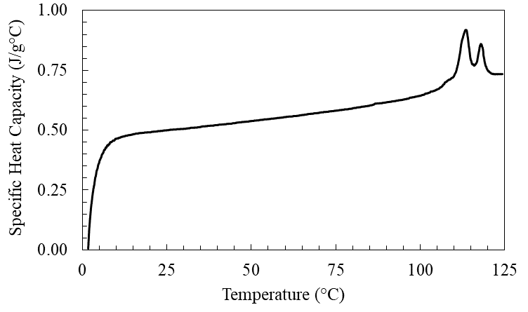
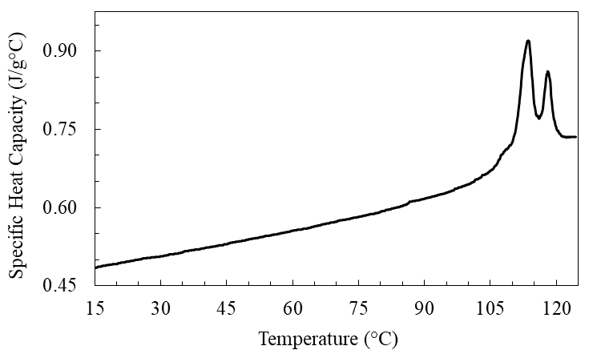
Fig. 1. The specific heat capacity of the material in dry state.
An apparent specific heat capacity $c_{p}^{'}$ (=$c_{p}+c_{L}$) approach was used to account for the effect of latent heat associated with phase change (evaporation) [39, 40]. Here $c_{p}\left[=\sum_{n=1}^{2}{C_{p,n}θ_{n}}\right]$ represents the equivalent heat capacity of the material mixture, where $c_{p,n}$ is the specific heat capacity of phase $n$ (i.e., wet or dry phases), and $θ_{n}$ is the corresponding mass fraction of that phase. The mass fraction of wet phase was set to linearly decrease from 1 to 0 over the prescribed phase change temperature interval $∆T=T_{2}-T_{1}$, starting from T₁ and ending at T₂. The term $c_{L}$ in Eq. (1) approximates the latent heat distribution associated with evaporation, applied incrementally over $∆T$.
$$c_{L}\left(T\right)=\left\{\begin{matrix}\begin{matrix}0 & & T<T_{1}\end{matrix} \\ \begin{matrix}\frac{2L_{v}}{T_{1→2}-T_{1}}∙\frac{T-T_{1}}{T_{2}-T_{1}} & & T_{1}≤T<T_{1→2}\end{matrix} \\ \begin{aligned}\begin{matrix}\frac{2L_{v}}{T_{2}-T_{1→2}}∙\frac{T_{2}-T}{T_{2}-T_{1}} & & T_{1→2}≤T≤T_{2}\end{matrix} \\ \begin{matrix}0 & & T>T_{2}\end{matrix}\end{aligned}\end{matrix}\right.$$ | (1)
In Eq. (1), $L_{v}$ is the latent heat of vaporization, and $T_{1→2}$ is the midpoint of phase change interval set at 100 °C. The sensitivity of numerical prediction of evaporation on the prescribed temperature interval [41] was evaluated and compared for values of 1 °C, 2.5 °C, 5 °C, and 10 °C as detailed in Section ‎4.
Thermal conductivity was measured for the oven-dried materials using the transient line heat source method [42] with a KD2-Pro Thermal Properties Analyser, resulting in a thermal conductivity value of $k_{d}=0.27W/{m.K}$. Calculating the variations in the nominal thermal conductivity of the material requires an appropriate choice of a mixture model [37, 43]. It has been demonstrated [44-46] that the geometric mean model provides reliable accuracy in estimating the thermal conductivity of minerals and therefore used in the present study. The geometric mean model is given as $k_{ }=\prod{k_{i}^{x_{i}}}$, where $k_{i}$ and $x_{i}$ are the thermal conductivity and volume fraction of phase $i$. The thermal conductivity of solid phase was calculated assuming the dry state as a binary mixture of solid phase and air ($k_{air}=0.025W/{m.K}$), yielding a nominal value of $k_{s}=1.79W/{m.K}$. The accuracy of thermal conductivity measurements was within ±10%, in accordance with the KD2-Pro Thermal Properties Analyser specifications. This corresponds to $k_{s,min}=1.51W/{m.K}$ at a +10% error margin and $k_{s,max}=2.16W/{m.K}$ at a -10% error margin. Accordingly, the nominal thermal conductivity of the material as a function of moisture content was determined and presented in Fig. 2. Thermal conductivity has a pronounced effect on the numerical prediction of evaporation [43], and this influence is further examined in detail in Section ‎4. Additionally, to further emphasize on the appropriate choice of mixture models, the performance of frequently used arithmetic mean model (i.e., $k_{ }=\sum{x_{i}k_{i}}$), on numerical mass loss prediction was evaluated and examined in detail in Section ‎4.
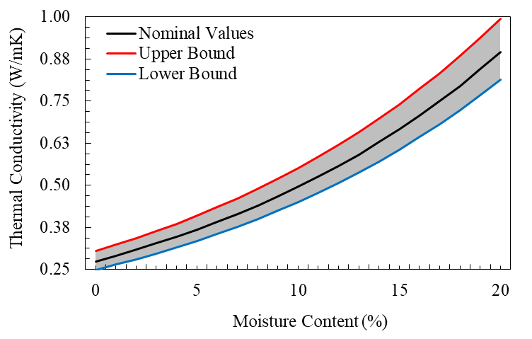
Fig. 2. Nominal thermal conductivity of the material, determined using the geometric mean model, including the uncertainty bounds based on the instrument measurement accuracy.
Dielectric responses of the moist material was measured using cavity perturbation technique [47, 48] at a frequency of 2.45 GHz, over a temperature range of 25 °C to 120 °C. Measurements were initiated at ambient temperature and conducted in 10 °C increments up to 120 °C. At the maximum temperature, the samples were held isothermally for 2 hours with moisture loss and dielectric [real ($ε^{'}$) and imaginary ($ε^{''}$) components of the complex permittivity] measurements taken every 15 minutes to monitor possible changes over time. The samples were subsequently cooled down to ambient temperature in 20 °C steps. To obtain weight and density, the sample holder was briefly removed from the cavity following each increment. Care was taken to preserve the internal structure, compaction and orientation of the material, ensuring that the specimen remained undisturbed within the sample holder. The evolution of the dielectric properties [tangent loss, $tanδ={ε^{''}}/{ε^{'}}$] obtained at different moisture contents is shown in Fig. 3. The results indicate that the measured tangent loss exhibits inconsiderable variation at moisture contents exceeding 6.5 %, stabilizing at an approximate value of 0.25. At lower moisture levels, the tangent loss progressively decreases, approaching a value of 0.015.
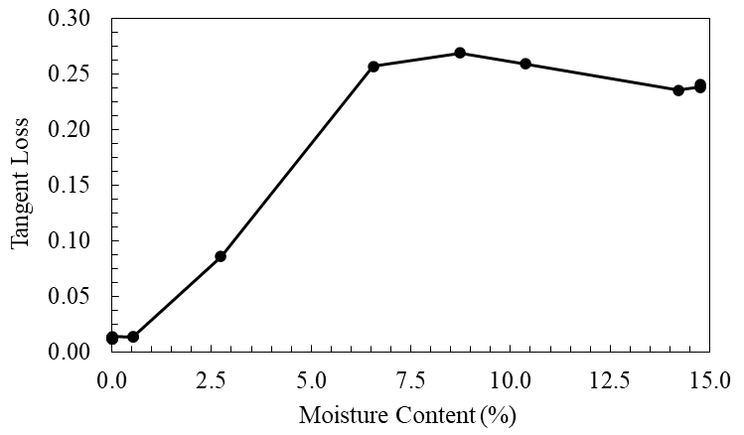
Fig. 3. Measured tangent loss versus moisture content at 2.45 GHz.

Microwave Drying Setup and Procedures
A 3-kW industrial microwave oven (Amana RC30S2) operating at a frequency of 2.45 GHz was used for the microwave heating experiments as shown in Fig. 4. The oven was equipped with three magnetron sources, each delivering microwave power through standard rectangular waveguides operating in TE₁₀ mode. A ceramic plate was installed at the base of the cavity to minimize the occurrence of thermal runaway [49]. Microwave energy was introduced into the cavity and was subsequently distributed by three rotating mode stirrers. These stirrers served to enhance field uniformity and thereby minimizing uneven drying that may otherwise occur due to the nonuniform power deposition [50, 51]. The stirrers were arranged with a phase shift of 90° from one another and rotated at an angular velocity of 1.795 rad/s.
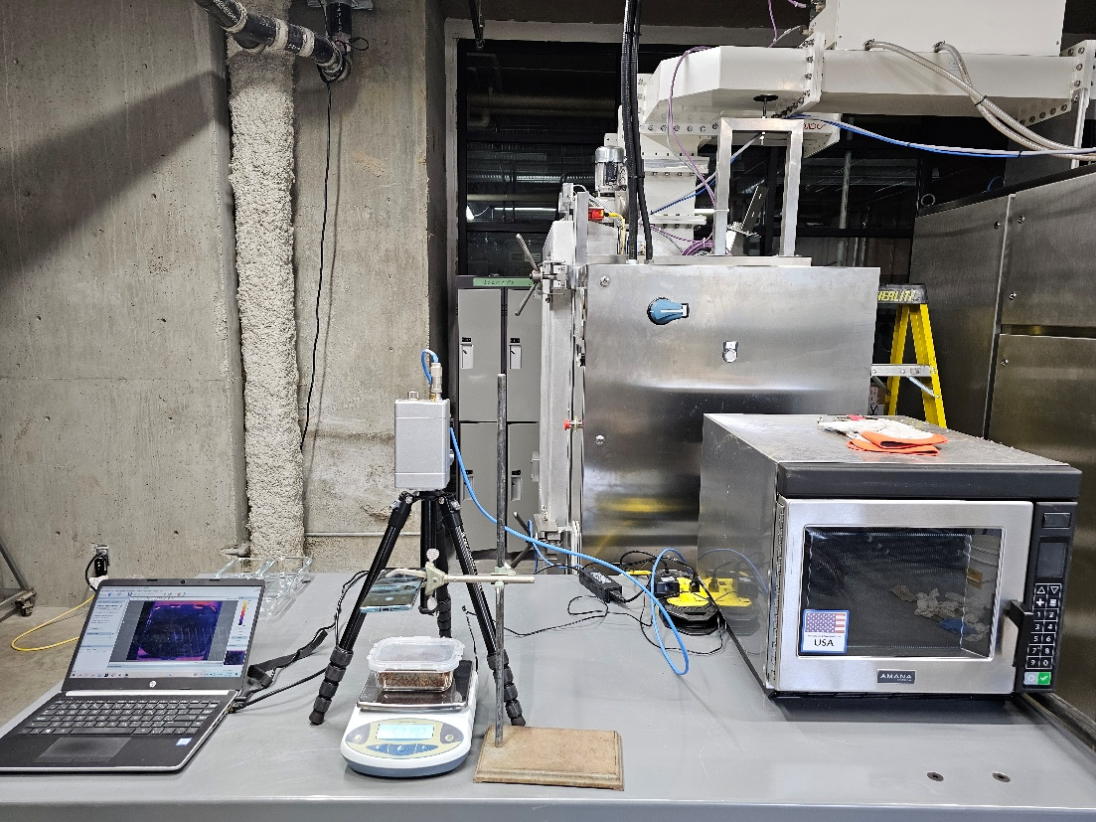
Fig. 4. Experimental setup showing a 3-kW microwave oven, benchtop scale, infrared (IR) thermal imaging camera, computer for data acquisition, and camera to record real-time mass changes during experiments
Air was directed into the microwave cavity through two rectangular openings/ducts to remove vapor and minimize plausible hygroscopicities [52]. This air flow enhanced convective heat exchange between the sample surface and the air inside the cavity [53]. Inflow air velocity was measured using an anemometer, and the average value of 4.65 m/s was concluded from these measurements and used in the developed heat transfer model to prescribe a forced convective boundary condition, as detailed in Section ‎3.2.
To characterize the magnetron ramp-up (i.e., the duration of time before stable power output [54]), two complementary measurements were conducted simultaneously: (i) measuring the power draw from electrical grid utilizing an Extech 382100 Power Analyzer/Datalogger, and (ii) assessing thermal energy absorbed by a water load [55]. A Pyrex glass container filled with 140 g of tap water was placed inside the microwave oven for time-in-ovens of 3, 4, 5, 6, 9 and 12 s. For each test, temperature rise, and mass loss were measured post-irradiation to estimate the absorbed energy, while the power draw was recorded by the Power Analyzer at every 2 s intervals. From power analyser data (Fig. 5), the magnetron ramp-up time was estimated to be approximately 4 s. Energy absorption results yielded a more precise estimate of 3.07 s (Fig. 5). These findings demonstrate that, although the microwave system is nominally rated at 3 kW, a fraction of the input energy is dissipated within the waveguide and associated components before reaching the cavity, resulting in a lower absorbed power by the sample.
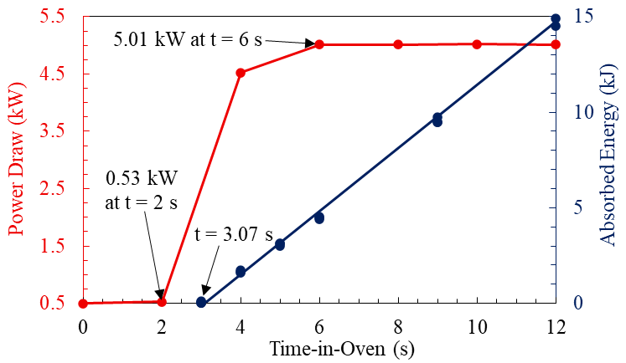
Fig. 5. Measuring ramp-up time using power analyser data, and thermal energy absorption. In power analyser data the baseline at 0.5 kW corresponds to power draw due to fans and other operating electrical units.

Drying Tests
A series of single-shot microwave drying experiments were conducted on samples with initial mass of 275 g, as listed in Table 1. The samples were positioned at the centre of the microwave cavity on the ceramic plate and exposed to microwave irradiation with overall time-in-oven of 12, 15, 30, 45, and 60 s. Immediately after exposure, the samples were removed, and the mass loss was measured with a benchtop balance with a resolution of ±0.01 g. Surface temperature distributions were subsequently recorded using an infrared thermal imaging camera. During the experiments, infrared thermal images were taken by rapidly removing the sample from the oven and placing it under the IR camera, where it rested on a scale until the image was captured. The total duration of this transition is recorded and referred to as the handling time (see Table 1).
Table 1. The details of experiment
Test | Time-in-Oven (s) | Energy Dosage ($kW.hr/t$) | Handling Time (s)
I | 12 | 25.89 | 10
II | 15 | 34.98 | 17
III | 30 | 80.44 | 11
IV | 45 | 125.89 | 11
V | 60 | 171.35 | 16

Numerical Modelling
The present model is formulated for the drying of thin material layers with thicknesses of only a few centimetres. At this scale, the moisture transport due to pressure and concentration gradients are neglected, and the drying kinetics are predominantly governed by energy supply. For thicker layers, where internal mass transport resistances become significant, a fully coupled heat and mass transfer framework would be required to accurately describe the drying process. The following subsections outline the governing equations describing the electromagnetic and heat transfer phenomena, followed by a description of the numerical implementation and a discussion of numerical stability considerations.

Governing Equations
In microwave heating, the coupling of electromagnetic wave propagation and heat transfer is essential for accurately realising power deposition and thermal response in a dielectric material [56]. The electric field propagates through the materials at nearly the speed of light and its magnitude and direction changes in nanosecond scale. This behaviour is well-represented by a time-harmonic formulation of electric field, $\vec{E}=E_{0}e^{iωt}$, where $ω$ is the angular frequency and related to frequency ($f$) as $ω=2πf$ [57]. This time-harmonic excitation enables application of Fourier transformation and solving Maxwell’s equations in frequency domain which makes computational tasks less costly. It is important to note, however, that solving in time-domain is strongly recommended when dealing with high permittivity materials ($ε^{ʹ}, ε^{ʺ}>10$), as they help to avoid numerical ill-conditioning and enable more efficient solutions of the constructed algebraic systems [58]. This is particularly critical in cases involving tightly coupled electromagnetic and heat transfer equations, where all governing equations are discretized and constructed simultaneously into one single matrix consisting all dependent variable [59]. In contrast, microwave heating of rocks and mineral ores typically involves low permittivity materials ($ε^{ʹ}, ε^{ʺ}<10$), for which frequency-domain schemes are more prevalent in the literature. In such cases, the response of the material to the generated thermal energy due to electromagnetic power loss is not spontaneous and the dissipation of the resulting thermal energy depends on the thermal diffusivity [60].
The Maxwell’s equation governs the distribution of electric field at any point and is given in Frequency domain as in Eq. (2) [61-63], where $\vec{E}$ is the intensity of the electric field [units of $V/m$], $ε_{r}$ is the relative permittivity, $μ_{r}$ is relative permeability, $σ=2πfε_{0}ε^{ʺ}$ is the electrical conductivity, $ε_{0}$ is the free space permittivity [8.854 × 10⁻¹² $F/m$], and $k_{0}\left(=ω/c\right)$ is the wave number/mode with $c$ being the speed of light [3 × 10⁸ $m/s$]. The relative permittivity is related to dielectric loss as $ε_{r}=\frac{ε}{ε_{0}}=ε^{ʹ}-ε^{ʺ}j$, with $ε^{ʹ}$ and $ε^{ʺ}$ being the relative dielectric constant (real part) and relative dielectric loss (imaginary part) of material, respectively.
$∇×\frac{1}{μ_{r}}\left(∇×\vec{E}\right)-k_{0}^{2}\left(ε_{r}-\frac{σ}{ωε_{0}}j\right)\vec{E}=0$ | (2)
In most microwave heating applications, magnetic losses are negligible compared to dielectric losses and dielectric loss remains the primary contributor to electromagnetic resistive power loss [64-71]. Therefore, the thermal power generated due to dielectric engagements [72], $Q$ [units of $W/{m^{3}}$], can be given as follows [73]:
$Q=2π{ε_{0}ε}^{ʺ}f{\left|\vec{E}\right|}^{2}$ | (3)
To describe the spatial distribution and dissipation of the generated power ($Q$) within the material, Eq. (4) is solved [74], in which $T$ is temperature [units of $K$], $k$ is thermal conductivity, $c_{p}^{'}$ is the apparent specific heat capacity, and $ρ$ is the density.
$\frac{∂T}{∂t}=\frac{k}{ρC_{p}^{'}}∇^{2}T+\frac{Q}{ρC_{p}^{'}}$ | (4)
To account for the effect of forced convective heat loss ($q$) from the lateral surfaces ($A$) of the samples exposed to airflow within the microwave cavity, a forced convection boundary condition was prescribed in the heat transfer model as in Eq. (5).
$q=UA\left(T_{air}-T\right)$ | (5)
Here, $T_{air}\left(=19.8 ℃\right)$ is the ambient air temperature inside the microwave cavity, and $T$ is the temperature at any point on the surface of material. The overall forced convection heat transfer coefficient, $U$ accounts for thermal resistance across the air-glass container interface and is calculated as in Eq. (6):
$U=\frac{1}{\left[\frac{1}{h_{air}}+\frac{δ_{glass}}{k_{glass}}\right]}$ | (6)
Here, $h_{air}$ is the convective heat transfer coefficient of air, and $δ_{glass}\left(=5 mm\right)$ and $k_{glass}\left(=1.14 W/m.K\right)$ are the thickness and thermal conductivity of the Pyrex glass container [75] used in the experiments, respectively. The value of $h_{air}$ was determined using the Nusselt’s number empirical correlations [Eq.(7)], where, $Re$ is the Reynold’s number and $Pr$ is the Prandtl’s numbers, respectively [74].
$Nu=0.037{Re}^{\frac{4}{5}}{Pr}^{\frac{1}{3}}$
$Re=\frac{ρ_{air}uL}{μ_{a}}$ | (7)
$Pr=\frac{μ_{air}C_{p,air}}{k_{air}}$
In Eq. (7), $ρ_{air}$ and $ν_{air}$ are the density and viscosity of air, $C_{p,air}$ and $k_{air}$ represent its specific heat capacity and thermal conductivity, $u$ is the measured velocity of the air inflow, and $L$ is the characteristic length.
The calculated values of $U$ are listed in Table 2 and show a good agreement with the findings of Halder and Datta [76] for a comparable case study, as well as with established empirical correlations [77]. In the numerical model, the corresponding post-exposure thermal response was simulated by applying a convective cooling over the handling time duration to all lateral surfaces, using a similar heat transfer coefficient $\left[U≤50W/{m^{2}.K}\right]$ under a free stream condition [76].
Table 2. The calculated values of forced convection coefficient applied to lateral surfaces of the sample
Surface | Dimensions $\left(m×m\right)$ | $Pr$¹ | $$Re$$ | $U$ $\left(W/m^{2}.K\right)$
Top surface² | 0.126 × 0.086 | 0.71 | 26513 | 34.1
Lateral short surfaces | 0.086 × 0.014 |  | 38845 | 34.1
Lateral long surfaces | 0.126 × 0.014 |  | 26513 | 31.6
¹ The following properties are considered for ambient air; temperature $=19.8 (°C)$, dynamic viscosity $=81.6×{10}^{-7} Pa.s$, specific heat capacity $=1005 J/{kg.K}$, and thermal conductivity $=0.0257 W/{m.k}$
² As the top surface is directly exposed to air, the term ${δ_{glass}}/{k_{glass}}$ is excluded from the calculation of $U$.

In the heat transfer model, thermal analysis was restricted to the sample domain only as neither the surrounding air nor the ceramic plate was assumed to exhibit significant dielectric losses. Accordingly, volumetric heat generation was applied exclusively within the material. The bottom surface of the sample was assumed an isothermal boundary with no energy exchange, while all other surfaces were subjected to convective heat transfer. In the electromagnetic model, all internal surfaces of the cavity and waveguide, along with the lateral surfaces of mode stirrers, were assumed as perfect electrical conductors.

Model Implementation
The developed model employed coupled electromagnetic and heat transfer interfaces in COMSOL Multiphysics [61]. A 3D numerical representation of the microwave oven was constructed based on the geometric and operational specifications provided by the manufacturer (Fig. 6). The Electromagnetic properties were defined as $ε_{r,air}=μ_{r,air}=1$ for air [78], and $ε_{r,ceramic}=38, { μ}_{r,ceramic}=1$ for ceramic [79]. The characterized dielectric properties, thermal conductivity, apparent specific heat capacity and density of the sample were incorporated as moisture content dependent functions [17]. A quadratic (10-node) and linear (4-node) discretization schemes with tetrahedral elements were used for solving the numerical solution of electromagnetic and temperature fields, respectively [61]. The electromagnetic study employed a Generalized Minimal Residual Method (GMRES) iterative solver, and the heat transfer utilized the Parallel Direct Solver (PARDISO) [61].
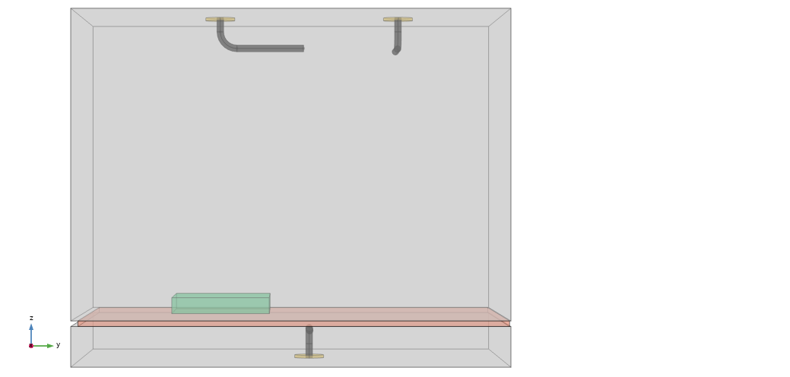 | 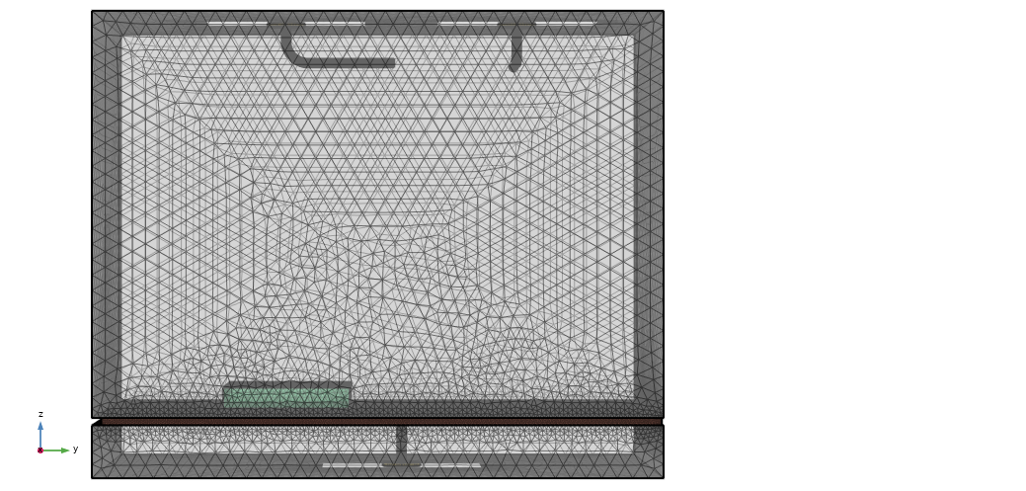
(a) | (b)
Fig. 6. A 2D schematic representation of the modelled microwave oven illustrating: (a) its components including mode stirrers (highlighted in yellow), the ceramic support plate (highlighted in red), and the sample (highlighted in green); and (b) the finite element mesh used for electromagnetic and heat transfer simulations.
To avoid the computational burden of simulating the fully transient (real-time) rotation of the mode stirrers, a quasi-transient approach was adopted. This approach involved discretizing one full revolution/cycle of the stirrers into incremental steps [80], thereby reducing the size of the model and its computational costs. In this loosely coupled sequential modelling scheme, the electromagnetic and temperature fields are still solved iteratively and bidirectionally [61]. To establish a reliable angular increment for mode stirrer repositioning, the electromagnetic field was solved for different angular increments over a complete revolution (equivalent to 3.5 s) at an initial temperature of 20 °C, to evaluate the corresponding variations in resistive power loss. Since the dielectric properties of the material remain effectively unchanged above moisture contents of 10% (see tangent loss profile in Fig. 3), any observed variations in resistive power loss in this scenario can be attributed solely to the angular increment of the stirrers. The resistive power loss averaged over a complete revolution for various angular increments are shown in Fig. 7. The results suggest that an angular increment as small as 45° adequately captures the variations in resistive power loss due to the stirrers’ rotation. Therefore, the incremental repositioning of stirrers was applied every 0.4375 $s$, based on angular velocity of 1.795 $rad.s^{-1}$ (as characterized in section ‎2.2).
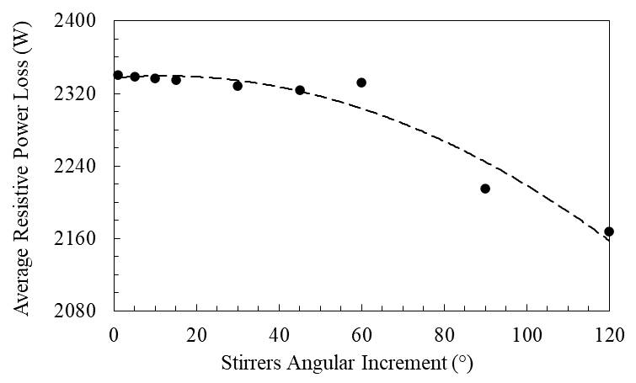
Fig. 7. Convergence of power loss averaged over discrete angular positions during a single revolution.

Numerical Stability Analysis
To assess numerical accuracy and ensure mesh independency in the electromagnetic and heat transfer models, the total resistive power loss in the volume and power balance over all boundaries were used as the primary convergence metrics, respectively. The total resistive power loss in the volume [units of $W$] is determined by integrating Eq. (3) over the volume of the material [i.e. $Q_{s}=\int{QdV}$]. The power balance ($E_{HT}$) in heat transfer module is defined in Eq. (8) [61].
$E_{HT}=\frac{\left|Q_{s}-\frac{d}{dt}\int{ρEdV}-\int{q_{s}dS}\right|}{Q_{s}}$ | (8)
In Eq. (8), the term $\int{q_{s}dS}$ corresponds to power exchange due to the convective cooling mechanism [i.e., $q_{s}=q/A$ (as in Eq. 5)], across the material boundaries, $S$. The term $\frac{d}{dt}\int{ρEdV}$ represents the rate of changes of the specific internal energy within the material accounting for both sensible and latent heat contributions, where $E$ is the specific internal energy [units of $J/{kg}$].
In the electromagnetics model, the mesh sizing was decided based on the Nyquist Criterion, which requires the maximum mesh/element size ($h_{max}$) be significantly smaller than half the wavelength ($λ$) within the respective medium, as defined in Eq. (9), to ensure numerical accuracy in solving the respective harmonic functions [81]. In this study, a discretization of at least six node per $h_{max}$ is adopted in accordance with the recommendations in the literature [82].
$h_{max}≪\frac{λ}{2}=\frac{1}{2}\frac{c}{f\sqrt{ε^{ʹ}μ^{ʹ}}}$ | (9)
In the heat transfer model, since an implicit approach with backward Euler scheme was used, the numerical method is always stable, and the Courant-Friedrichs-Levy (CFL) stability criteria does not apply [83] and no upper limit for the timestep holds [84]. However, the dependency of mass ($M$) and stiffness ($K$) matrices on thermal conductivity and apparent heat capacity – that are moisture dependent – may lead to the ill-conditioning of the linear systems [85, 86]. In COMSOL Multiphysics [61], to resolve such challenges, a pseudo time-stepping method is incorporated where timestep is measured based on the largest eigenvalue ($γ_{max}$) of the matrix $M^{-1}K$ formed from mass and stiffness matrixes and given as $dt≤\frac{2}{γ_{max}}$.
Element sizes as small as 5 mm were found to be numerically consistent, beyond which, no significant variations in the primary convergence metrics were observed [Fig. 8 (a)], i.e., the changes in resistive power loss were below 5 W and heat transfer power balance remained below 1%. Therefore, this element size was used in simulations.
The numerical error improvement with further mesh refinements was also measured based on h-convergence approach [87, 88] given as $ϵ=Ch^{r}$. Here, $ϵ$ is the normalized convergence metric at each mesh size with reference to its value at finest mesh size across different mesh sizes investigated [89], $r$ is the convergence rate, and $C$ is an arbitrary physics specific constant. As expected [87], the convergence rate was 0.98 (approximately 1), concordant with the linear elements used in the heat transfer model discretization. A similar result was concluded for electromagnetic model showing a convergence rate of 1.85 (approximately 2), concordant with the quadratic elements used in the electromagnetic model.
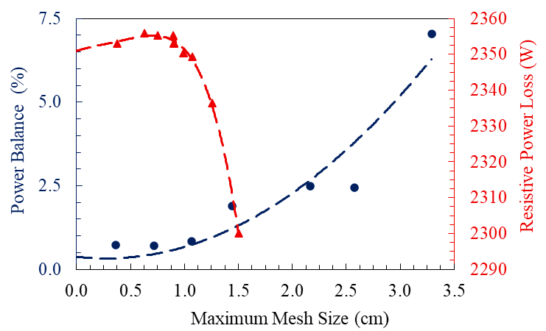
(a)
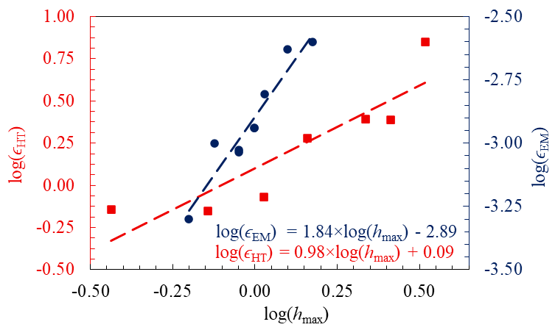
(b)
Fig. 8. (a) Mesh dependency analysis of electromagnetic resistive power loss and heat transfer power balance with dashed trendlines, and (b) h-convergence analysis for electromagnetic and heat transfer meshes, illustrating error reduction with mesh refinement.

Results and Discussion
Table 3 presents the variations in average surface temperature and water loss recorded at each microwave dosage, with exposure times ranging from 12-60 $s$ (Cases I-V). The total amount of evaporated water increased with extended microwave exposures and higher dosages. At the lower energy dosages, the supplied energy was insufficient to reach the evaporation, and thus was primarily consumed as sensible heat and increased the material temperature significantly. With further increase in energy input, the water extraction rate [17] increased and plateaued near 0.25 gram per $kW.hr/t$, suggesting that evaporation becomes the dominant mechanism of energy consumption at higher energy dosages. With gradual transition from sensible heating to latent heat absorption, the average surface temperature variations became less significant, reaching about 80 °C at the highest levels.
Table 3. Measured surface temperature and water removed at each microwave dosage.
Case | Time-in-Oven (s) | Energy Dosage  ($kW.hr/t$) | Temperature (°C) | Water Loss  (g) | Water Extraction Rate  ($g per kW.hr/t$)
I | 12 | 25.89 | 52.5 | 1.36 | 0.05
II | 15 | 34.98 | 62.8 | 2.71 | 0.08
III | 30 | 80.44 | 79.9 | 12.82 | 0.16
IV | 45 | 125.89 | 81.6 | 27.50 | 0.22
V | 60 | 171.35 | 84.3 | 40.08 | 0.23

The effect of the prescribed phase change interval ($∆T$) on the numerical prediction of evaporation was evaluated [41, 43, 90], and the results are listed in Table 4 for three Cases I, III and V. A broader phase change interval results in smaller mass loss predictions. This is due to a more gradual allocation of latent heat throughout the material domain, distributing the thermal energy over a larger volume and delaying the onset of predicted evaporation. Conversely, a narrower phase change interval causes the latent heat of evaporation to be released more. As the phase change interval decreases, the predicted mass losses exhibit asymptotic convergence. The sharper transitions introduce instability in the numerical solution process. To maintain numerical stability under such conditions, the solver requires significantly smaller time steps [91], which substantially increase the overall computational cost. While the smaller intervals are more consistent with actual evaporation process, the difference in predicted mass losses between $∆T≤$ 1 °C intervals and 2.5 °C interval is negligible. Therefore, a phase change interval of 2.5 °C is selected in this study as it provides a balance between numerical accuracy and computational efficiency.
Table 4. The effect of prescribed phase change interval on predicted mass loss.
 |  | Water Loss (g)
Energy Dosage ($kW.hr/t$) |  | 25.89 | 80.44 | 171.35
Case  $∆T$ (°C) |  | I | III | V
1 |  | 1.19 | 18.65 | 43.46
2.5 |  | 1.07 | 18.08 | 43.33
5 |  | 0.53 | 15.30 | 41.51
10 |  | 0.38 | 13.71 | 36.09

As mentions in Section ‎2.1, thermal conductivity of solid phase carries an experimental uncertainty of $±10\%$, contributing to an uncertainty in the estimated overall thermal conductivity, as shown in Fig. 2. The effect of the overall thermal conductivity on predictions of mass loss over various energy dosages is presented in Fig. 9. These results are compared with experimental measurements of mass loss, with the associated range of uncertainty accounting for potential errors related to mass loss quantification, including weighing precision and sample handling. The figure illustrates that higher (overestimated) thermal conductivity enhances the dissipation of thermal energy, resulting in a more uniform temperature distribution within the material and therefore, underestimates water loss predictions for the same input microwave energy. Conversely, lower (underestimated) thermal conductivity impedes heat diffusion, leading to localized temperature build-up and consequently higher evaporation predictions (overestimation).
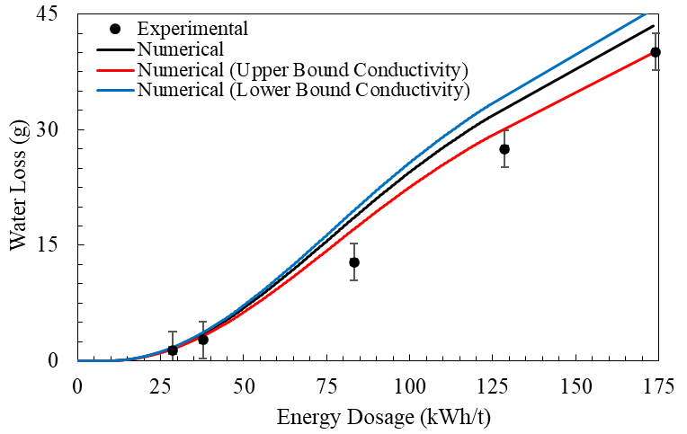
Fig. 9. Dependency of numerical results for evaporation on the adopted values of overall thermal conductivity (with phase change interval of ΔT = 2.5 °C). The experimental error bars accounted for mass measurement uncertainties including benchtop scale precision, and material handling.
The failure of arithmetic mean model of thermal conductivity in mass loss predictions is shown in Fig. 10. A large deviation between model predictions and the experimental data can be observed. The arithmetic mean model led to overestimation of mass loss, which has its roots in underestimation of thermal conductivity. Using this thermal conductivity model, the evaporation is predicted to occur much earlier than the experimental measurements. These results emphasize the important role of selecting an appropriate mixture model for thermal conductivity, as discussed in prior studies [37, 43-46].
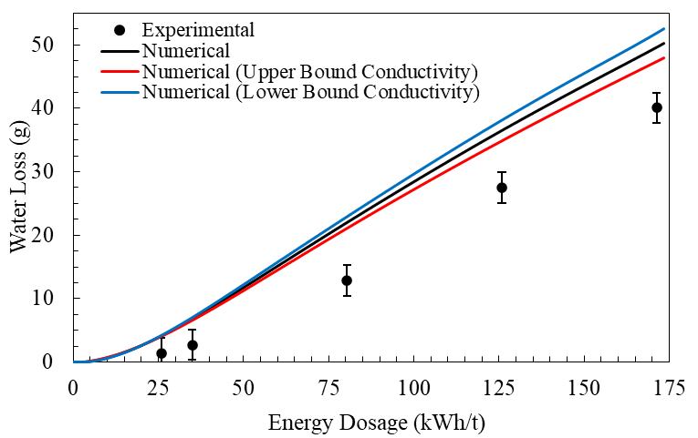
Fig. 10. Failure of arithmetic mean thermal conductivity model in numerical prediction of evaporation (with phase change interval of ΔT = 2.5 °C) due to underestimation of material overall thermal conductivity (with nominal value of $k_{s}=0.47W/{m.K}$, $k_{s,min}=0.43W/{m.K}$ at a +10% error margin and $k_{s,max}=0.53W/{m.K}$ at a -10% error margin).
The change in average surface temperatures captured using IR camera are compared with numerical model predictions in Fig. 11. The error bars indicate the associated range of uncertainty accounting for potential errors related to temperature quantification, including IR camera precision, image processing and post-exposure sample handling. The solid and dashed lines represent the exposure stage (microwave heating) and post-exposure stage (cooling during handling time), respectively, in the simulations. The results show excellent agreement between numerical model predictions and experimental measurements for single-shot microwave experiments. As discussed in section ‎3.1, a convective cooling over the handling time duration was applied to all lateral surfaces using a heat transfer coefficient $\left[U≤50W/{m^{2}.K}\right]$ under a free stream condition [76]. For high energy dosages (i.e., above 100 $kW.hr/t$), the application of an overall heat transfer coefficient of $U=50W/{m^{2}.K}$ yielded an absolute relative deviation (ARD), as defined in Eq. (10), of less than 10 % between the predicted surface temperatures ($T^{num}$) and the experimental measurements ($T^{exp}$).
$ARD(\%)=\frac{100×\left|T^{exp}-T^{num}\right|}{T^{exp}}$ | (10)

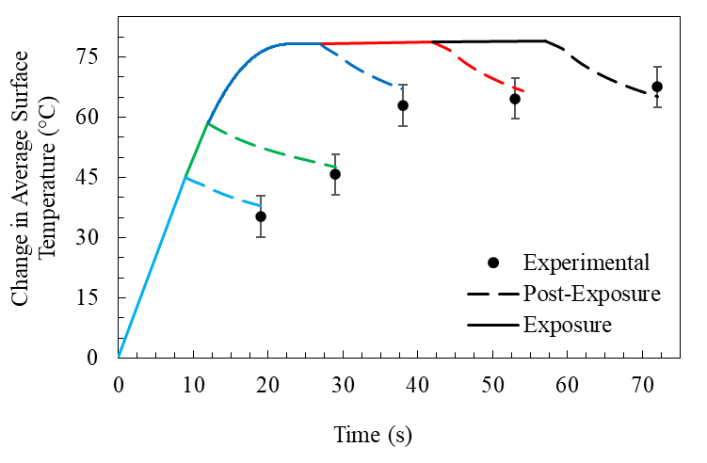
Fig. 11. Comparison of the average surface temperature recorded by an IR Camera with numerical model predictions for Cases I through V. Numerical results for phase change interval ΔT = 2.5 °C and solid phase thermal conductivity of $k_{s}=1.79W/{m.K}$.
Fig. 12 presents the uniformity index ($UI$) for Cases I through V. The Uniformity index is defined according to Eq. (11), where $σ$ and $μ$ denote the standard deviation and mean of the surface temperature, respectively, as defined in Eqs. (12) and (13) [92]. The experimental values of the UI remained above 80%, suggesting a high degree of temperature uniformity across the surface of the sample. This is attributed to the presence of stirrers [50, 51], which facilitates a more homogenous distribution of energy within the sample. As shown in Fig. 12, the uniformity index increases with energy dosage (exposure time), with this effect becoming more pronounced at higher energy dosages due to enhanced thermal diffusion throughout the material.
$UI=1-\frac{σ}{μ}$ | (11)
$σ=\sqrt{\frac{\sum{{\left[T_{i}-μ\right]}^{2}}}{N-1}}$ | (12)
$μ=\frac{\sum{T_{i}}}{N}$ | (13)

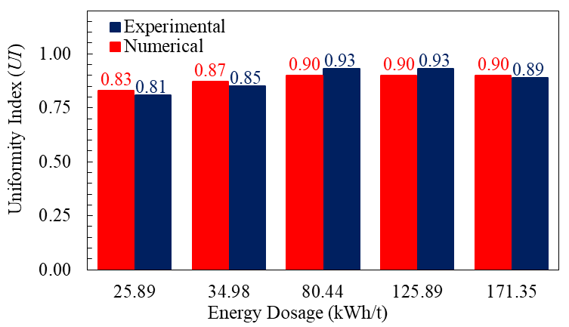
Fig. 12. Comparison of uniformity index for Cases I through V. Numerical results for phase change interval ΔT = 2.5 °C and solid phase thermal conductivity of $k_{s}=1.79W/{m.K}$.
The surface temperature profiles captured using IR imaging, alongside the respective predictions from the numerical model are shown in Fig. 13 for Cases I through III. Table 5 also presents a comparison of surface temperature field including extreme values, mean temperature, and standard deviation. A comparison between the experimental and numerical profiles reveals a strong overall agreement. When comparing the IR camera images with numerical surface temperature profiles, it is important to note that the numerical model does not incorporate the particulate or granular characteristics of the material, which are likely responsible for the localized hot and cold spots observed in the IR images. Incorporating such microstructural heterogeneities could enhance the ability of the model in capturing spatial temperature profiles more accurately [93]. Nevertheless, the present model demonstrates satisfactorily agreement.
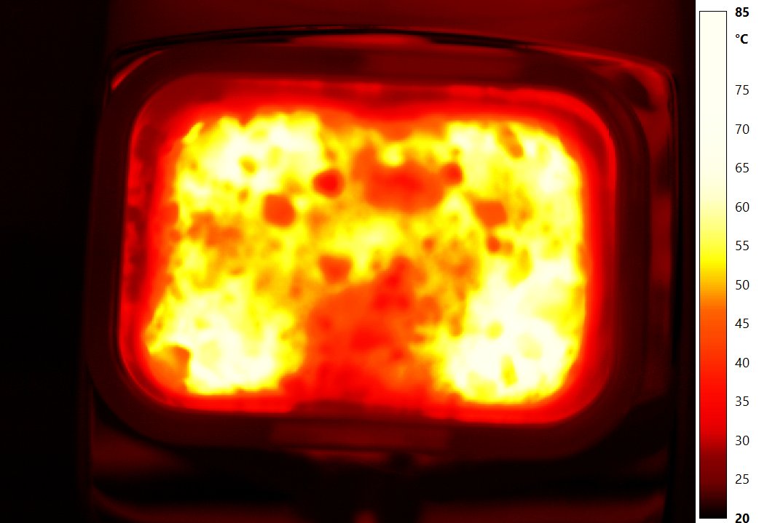 | 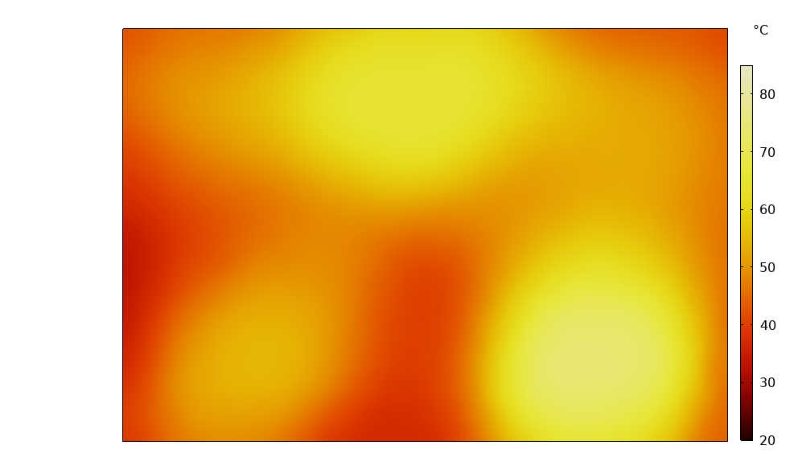
Case I
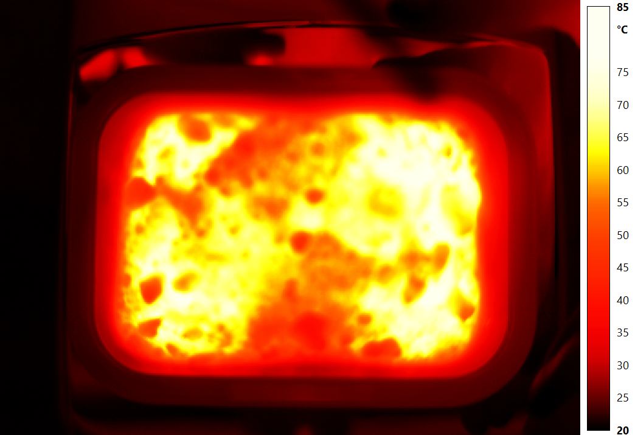 | 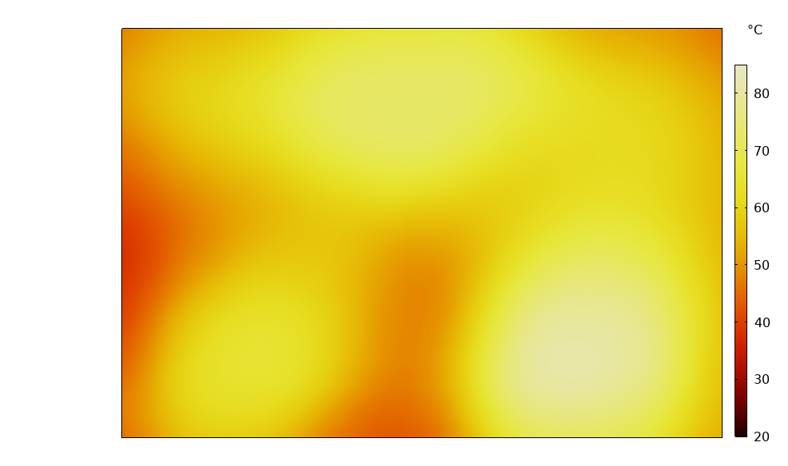
Case II
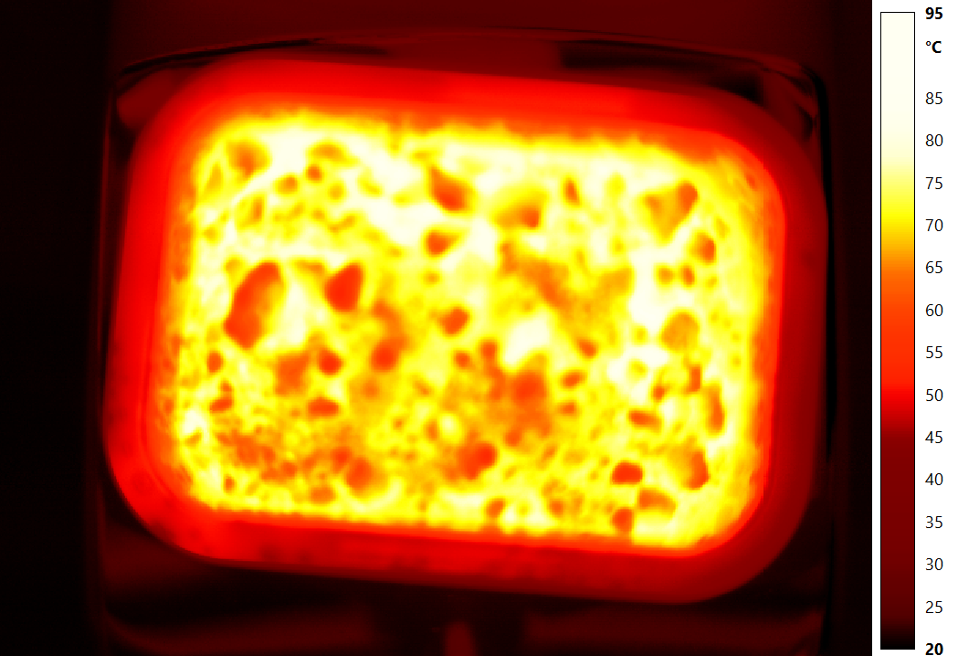 | 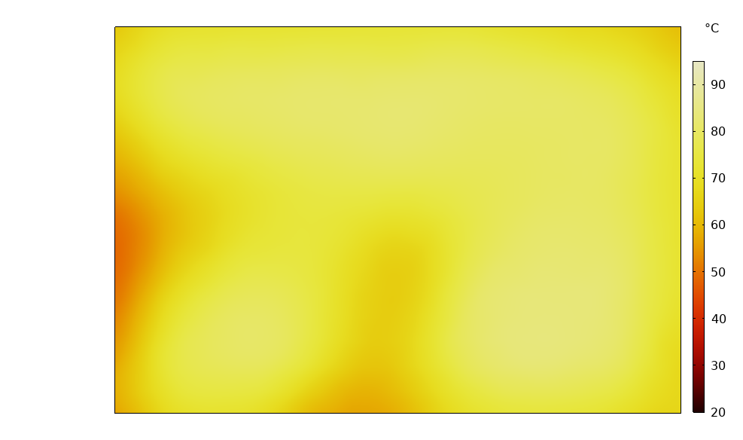
Case III
Fig. 13. Comparison of the surface temperature profiles captured by IR imaging (left) with numerical results (right) for Cases I through III.

Table 5. Surface temperature measured using IR camera thermal imaging, with corresponding numerical predictions (in parenthesis).
Case | Surface Temperature (°C) - Experimental (Numerical) |  |  | Standard Deviation (°C), $σ$ -  Experimental (Numerical)
 | Maximum | Minimum | Average
I | 85.0 (78.9) | 28.3 (31.6) | 52.5 (54.4) | 9.6 (9.1)
II | 84.4 (83.2) | 35.7 (39.2) | 62.8 (64.4) | 9.1 (8.2)
III | 97.0 (98.3) | 61.1 (65.7) | 79.9 (85.5) | 4.8 (8.1)
IV | 102.8 (98.6) | 62.2 (66.0) | 81.6 (85.6) | 4.9 (8.2)
V | 103.7 (98.8) | 62.7 (66.4) | 84.3 (86.1) | 5.8 (7.9)

The dependence of power loss on the angular positioning of the stirrers and moisture content, is shown in Fig. 14. For moisture contents above 10%, variations in power loss are primarily due to the angular movement of the stirrers, as the dielectric properties of the load remain nearly constant. With Prolonged microwave irradiation, power loss decreases with the reduction in moisture content. Owing to the strong dependence of the dielectric response on the moisture content (as shown in Fig. 3), the power loss decreases progressively as the moisture content drops. This trend becomes more pronounced after approximately 30 s of microwave exposure corresponding to 100 $kW.hr/t$ of energy dosages.
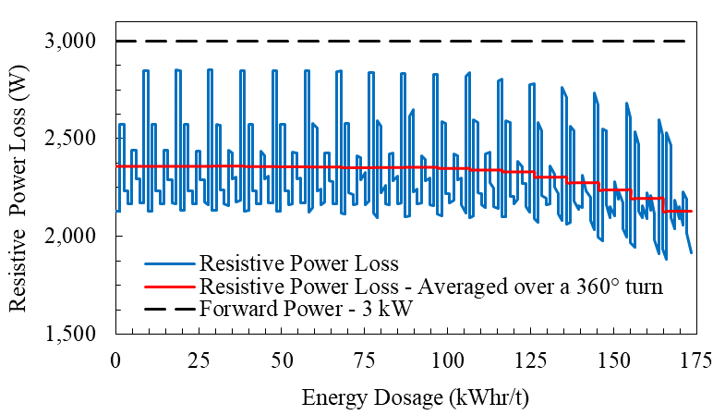
Fig. 14. The computed resistive power loss (Numerical results for phase change interval ΔT = 2.5 °C and $k_{s}=1.79W/{m.K}$).
The commonly used latent-only drying efficiency fails to account for energy expended on the heating up of the water content [94], which contributes to approximately 13% of absorbed energy expenditure. This can lead to misleading conclusions, particularly in drying of high moisture containing materials. Therefore, the drying efficiency ($η_{v}$) is defined as the ratio of the net energy expended for heating the removed mass of water ($m_{v}$) from its initial temperature ($T_{0}$) to onset of evaporation (100 $°C$), and its subsequent evaporation to the total forward microwave energy, as given in Eq. (14):
$η_{v}=\frac{m_{v}C_{p,w}\left(100\left[°C\right]-T_{0}\right)+m_{v}L_{v}}{P_{ }t}$ | (14)
Here, $P_{ }$ is the microwave forward power, and $t$ is the irradiation duration. The drying efficiency are shown in Fig. 15. The contribution of sensible energy to the drying efficiency was calculated as 1.8% for the lowest energy dosage investigated (25.89 $kW.hr/t$), increasing to 8.1% at the energy dosage of 171.35 $kW.hr/t$. Following the onset of evaporation, latent heat demand for phase change became the dominant mechanism in consuming the microwave energy. Fig. 15 shows that drying efficiency changes slightly above 100 $kW.hr/t$ of energy dosages, corresponding to the minimal variations in water extraction above this energy dosages as listed in Table 3. With aim of fully removing the moisture content of material, the numerical model predicted a drying efficiency of 72.05% by depositing an energy dosage of about 200 $kW.hr/t$, corresponding to irradiating material for a duration of 66.82 seconds. It worth noting that the resistive power loss decreases at higher energy dosages (as shown in Fig. 14), primarily due to its dependency on material’s moisture content. As the drying process advances, dried regions attain higher temperatures relative to the adjacent moist regions. This temperature gradient enables conductive heat transfer toward the moist region, resulting in a slightly higher drying efficiency values before the moisture is fully removed. It should be noted that no effort was made here to enhance efficiency by repositioning the load within the cavity, suggesting that higher values could be achieved with this setup.
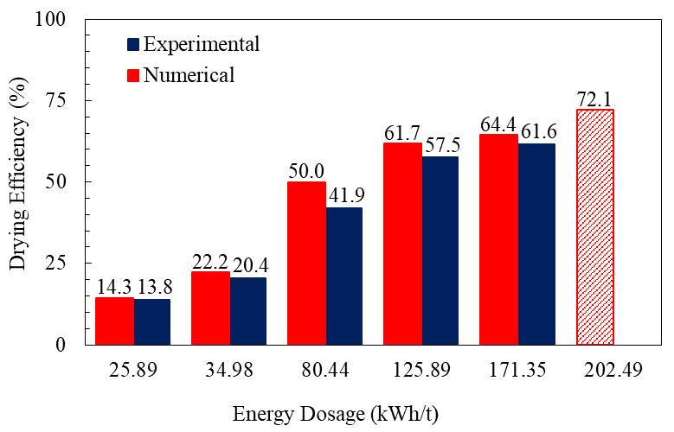
Fig. 15. Comparing the experimental and numerical drying efficiency. Numerical results for phase change interval ΔT = 2.5 °C and $k_{s}=1.79W/{m.K}$.
The heat over microwave efficiency (HOME) [95] is defined as the ratio of the microwave energy absorbed by the material (and expended on both overall sensible heat and latent energy) to the total forward microwave energy, and is given as in Eq. (15).
$HOME=\frac{Q_{s}-\int{q_{s}dS}}{P_{ }}$ | (15)
Variations in HOME are associated with (i) the dependency of power loss on moisture content and on the angular positioning of the stirrers (Fig. 14), as well as (ii) convective heat losses. Initially, the changes in HOME (Fig. 16) are primarily due to the angular movement of the stirrers. With prolonged microwave irradiation, the HOME drops with the reduction in moisture content, owing to the strong dependency of the power loss on the moisture content. With increased levels of water/moisture extraction rates after 30 s of microwave exposure, the decaying trend of HOME becomes more pronounced. Consequently, the HOME at longer exposure times showed an approximately 10% decline relative to the shorter exposure times. Additionally, at higher dosages, the surface temperatures are much higher than those at lower dosages (Fig. 13). Consequently, the convective energy exchange between surface of the sample and the ambient air in the cavity increases at higher dosages that may lead to higher thermal energy losses [53]. However, the effect of convective cooling on HOME is negligible, indicating that the microwave energy was predominantly expended on the sensible heat and latent energy.
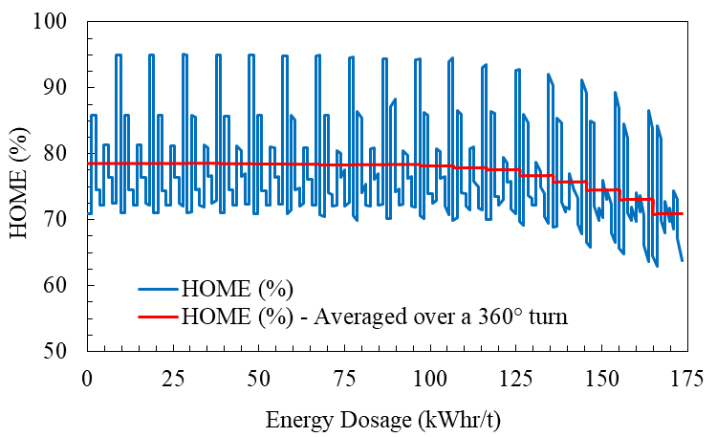
Fig. 16. The computed heat over microwave efficiency (Numerical results for phase change interval ΔT = 2.5 °C and $k_{s}=1.79W/{m.K}$).
The maximum temperatures within the material volume were determined numerically for different microwave energy dosages right after microwave irradiation, as shown in Fig. 17. The maximum temperature threshold (110 °C) is also indicated in the figure. For all applied microwave energy dosages, the predicted temperatures remained below this threshold, thereby ensuring that the heating conditions did not compromise the smelting efficiency of the material under investigation.
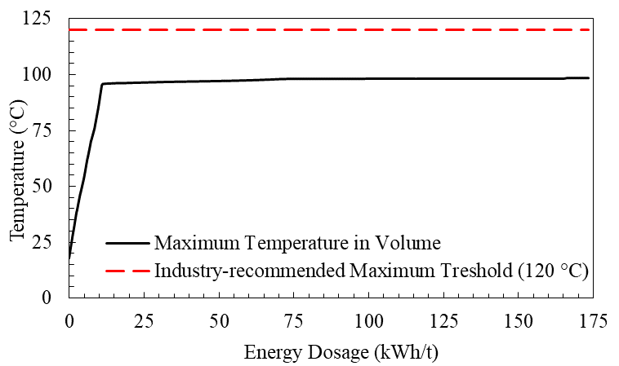
Fig. 17. Maximum volume temperatures for different microwave energy dosages. Numerical results for phase change interval ΔT = 2.5 °C and $k_{s}=1.79W/{m.K}$.

Conclusion
This study investigated microwave heating as a potential alternative to conventional dryers for sulphur-bearing materials. A series of experiments, in conjunction with numerical simulations, were carried out to assess its performance in moisture extraction. Comprehensive characterization of the material was conducted, such as thermal conductivity, specific heat capacity, initial moisture content, density, bulk porosity, and dielectric loss factors, were comprehensively examined. Before commencing the experiments, the oven underwent a detailed inspection to determine its ramp-up response and measure delivered forward power. Furthermore, a quasi-transient, loosely coupled, sequential finite element model was developed to simulate electromagnetic heating, and its predictions were evaluated against experimental measurements. Results demonstrated that increasing microwave energy dosages enhanced moisture extraction rates. In the evaporation-dominant zone, a consistent moisture extraction rate of 0.25 gram per $kW.hr/t$ was observed. Numerical simulations corroborated the experimental findings, indicating that, the average surface temperature remained below 100 °C. The model further predicted that maximum volume temperature remained below the maximum temperature threshold of 110 °C, thereby reducing the risk of sulphur-related phase transitions. The fidelity of numerical model in reproducing the experimental measurements was attributed to the accurate characterization and incorporation of moisture-dependent material properties. Overall, the combined insights from experimental observations and computational modelling highlight the feasibility of using microwave drying as a controlled and efficient technique for processing temperature-sensitive minerals. This method offers a promising solution to the inherent risks associated with conventional kiln-based drying techniques, ensuring both safety and efficiency in the mineral drying process.

Declaration of competing interest
Authors declare no conflict of interest.

Declaration of Generative AI and AI-Assisted Technologies in the Writing Process:
During the preparation of this work the authors used ChatGPT in order to refine the language and readability. After using this tool, the authors reviewed and edited the content as needed and take full responsibility for the content of the publication.

Author contributions:
MAK: Writing – original draft, Data curation, Formal analysis, Visualization, Validation, Conceptualization, Methodology. PS: Project administration, Supervision, Conceptualization, Methodology, Writing – review & editing. AGM: Project administration, Funding acquisition, Supervision, Resources, Conceptualization, Methodology, Writing – review & editing.

Acknowledgements
This research was supported by the Mitacs Accelerate Program and the CleanBC Industry Fund. The computations in this research were supported in part through the computational resources and services provided by Advanced Research Computing at the University of British Columbia as well as Digital Research Alliance of Canada (the Alliance). MAK gratefully acknowledges the invaluable support and contributions Dr. Amin Shadi and Dr. Hosein Kalantari offered, which were instrumental in shaping the outcomes presented in this work.

Data availability
Data will be made available on request.
References
1. Cox, B., et al., The mining industry as a net beneficiary of a global tax on carbon emissions. Communications Earth & Environment, 2022. 3(1): p. 17.
2. Zheng, X., et al., Greenhouse gas emissions from extractive industries in a globalized era. Journal of Environmental Management, 2023. 343: p. 118172.
3. Chaedir, B.A., et al., Advances in dewatering and drying in mineral processing. Drying Technology, 2021. 39(11): p. 1667-1684.
4. Salazar-Villalpando, M.D., et al., Energy technology 2012: carbon dioxide management and other technologies. 2012: Wiley.
5. Greenhouse gas equivalencies calculator - calculations and references. 2025, U.S. Environmental Protection Agency: Washington, DC.
6. Norgate, T. and N. Haque, Energy and greenhouse gas impacts of mining and mineral processing operations. Journal of Cleaner Production, 2010. 18(3): p. 266-274.
7. Durgut, E., Evaluation of the use of microwave energy on green floor/wall tile drying process. Drying Technology, 2025: p. 1-12.
8. Fragkos, P., et al., Energy system transitions and low-carbon pathways in Australia, Brazil, Canada, China, EU-28, India, Indonesia, Japan, Republic of Korea, Russia and the United States. Energy, 2021. 216: p. 119385.
9. Rattanadecho, P. and N. and Makul, Microwave-assisted drying: A review of the state-of-the-art. Drying Technology, 2016. 34(1): p. 1-38.
10. Amini, A., M. Latifi, and J. Chaouki, Electrification of materials processing via microwave irradiation: A review of mechanism and applications. Applied Thermal Engineering, 2021. 193: p. 117003.
11. Meloni, E., G. Iervolino, and V. Palma, Basics of microwave heating and recent advances, in Advances in Microwave-assisted Heterogeneous Catalysis, J. Hu and B.M. Reddy, Editors. 2023, Royal Society of Chemistry. p. 0.
12. Kingman, S.W., G.M. Corfield, and N.A. Rowson, Effects of microwave radiation upon the mineralogy and magnetic processing of a massive Norwegian ilmenite ore. Physical Separation in Science and Engineering, 1999. 9(3): p. 057075.
13. Galema, S.A., Microwave chemistry. Chemical Society Reviews, 1997. 26(3): p. 233-238.
14. Yu, V.B., K.I. Rybakov, and V.E. Semenov, High-temperature microwave processing of materials. Journal of Physics D: Applied Physics, 2001. 34(13): p. R55.
15. Chen, T.T., et al., The Relative Transparency of Minerals to Microwave Radiation. Canadian Metallurgical Quarterly, 1984. 23(3): p. 349-351.
16. Walkiewicz, J.W., G. Kazonich, and S.L. McGill, Microwave heating characteristics of selected minerals and compounds. Minerals & Metallurgical Processing, 1988. 5(1): p. 39-42.
17. Turner, I.W. and P.C. and Jolly, Combined microwave and convective drying of a porous material. Drying Technology, 1991. 9(5): p. 1209-1269.
18. Si, C., et al., Experimental study on three-stage microwave-assisted fluidized bed drying of Shengli lump lignite. Drying Technology, 2016. 34(6): p. 685-691.
19. Han, Y.-N., et al., Drying behavior and physicochemical properties of lignite under the coupling effect of microwaves and hot gases. Drying Technology, 2025: p. 1-20.
20. Sahyoun, C., S.W. Kingman, and N.A. Rowson, The Effect of Heat Treatment on Chalcopyrite. Physical Separation in Science and Engineering, 2003. 12(1): p. 360951.
21. Kowalski, S.J. and B. and Mielniczuk, Analysis of effectiveness and stress development during convective and microwave drying. Drying Technology, 2007. 26(1): p. 64-77.
22. Yang, K., et al., Microwave roasting and leaching of an oxide-sulphide zinc ore. Hydrometallurgy, 2016. 166: p. 243-251.
23. Li, K., et al., Investigations on the microwave absorption properties and thermal behavior of vanadium slag: Improvement in microwave oxidation roasting for recycling vanadium and chromium. Journal of Hazardous Materials, 2020. 395: p. 122698.
24. Li, K., et al., Microwave dielectric properties and thermochemical characteristics of the mixtures of walnut shell and manganese ore. Bioresource Technology, 2019. 286: p. 121381.
25. Ling, Y., et al., Drying kinetics and microstructure evolution of nano-zirconia under microwave pretreatment. Ceramics International, 2021. 47(16): p. 22530-22539.
26. Steger, H.F., E. Mark, and L.E. Desiardins, The drying of sulphide-bearing materials in a microwave oven: A caveat. Talanta, 1978. 25(3): p. 181-182.
27. Pitchai, K., et al., Coupled electromagnetic and heat transfer model for microwave heating in domestic ovens. Journal of Food Engineering, 2012. 112(1): p. 100-111.
28. Si, C., et al., Experimental and numerical simulation of drying of lignite in a microwave-assisted fluidized bed. Fuel, 2019. 242: p. 149-159.
29. Huang, J., et al., A coupled electromagnetic irradiation, heat and mass transfer model for microwave heating and its numerical simulation on coal. Fuel Processing Technology, 2018. 177: p. 237-245.
30. Kowalski, S.J., G. Musielak, and J. Banaszak, Heat and mass transfer during microwave-convective drying. AIChE Journal, 2010. 56(1): p. 24-35.
31. Kucuk, H., et al., A review on thin-layer drying-curve equations. Drying Technology, 2014. 32(7): p. 757-773.
32. Hong, Y.-d., et al., Three-dimensional simulation of microwave heating coal sample with varying parameters. Applied Thermal Engineering, 2016. 93: p. 1145-1154.
33. Li, H., et al., A fully coupled electromagnetic, heat transfer and multiphase porous media model for microwave heating of coal. Fuel Processing Technology, 2019. 189: p. 49-61.
34. Montienthong, P., P. Rattanadecho, and W. Klinbun, Effect of electromagnetic field on distribution of temperature, velocity and concentration during saturated flow in porous media based on Local Thermal Non-Equilibrium models (influent of input power and input velocity). International Journal of Heat and Mass Transfer, 2017. 106: p. 720-730.
35. Khansary, M.A., et al. Experimental evaluation of microwave systems for minerals dewatering. 2025. Springer Nature Switzerland.
36. Nakanishi, K., Porosity measurement, in Handbook of Sol-Gel Science and Technology: Processing, Characterization and Applications, L. Klein, M. Aparicio, and A. Jitianu, Editors. 2018, Springer International Publishing: Cham. p. 1399-1409.
37. Brigaud, F. and G. Vasseur, Mineralogy, porosity and fluid control on thermal conductivity of sedimentary rocks. Geophysical Journal International, 1989. 98(3): p. 525-542.
38. Höhne, G.W.H., W.F. Hemminger, and H.-J. Flammersheim, Types of differential scanning calorimeters and modes of operation, in Differential Scanning Calorimetry. 2003, Springer Berlin Heidelberg: Berlin, Heidelberg. p. 9-30.
39. Pena, F.J.C. and M.J.S. de Lemos, Unsteady heat conduction with phase change applied to a novel thermal plug and abandonment process. International Journal of Thermal Sciences, 2021. 170: p. 107155.
40. Prakash, S.A., et al., Review on numerical algorithms for melting and solidification studies and their implementation in general purpose computational fluid dynamic software. Journal of Energy Storage, 2021. 36: p. 102341.
41. Tubini, N., S. Gruber, and R. Rigon, A method for solving heat transfer with phase change in ice or soil that allows for large time steps while guaranteeing energy conservation. The Cryosphere, 2021. 15(6): p. 2541-2568.
42. Marovelli, R.L., K.F. Veith, and U.S.B.o. Mines, Thermal conductivity of rock: measurement by the transient line source method. 1965: U.S. Department of the Interior, Bureau of Mines.
43. Woodside, W. and J.H. Messmer, Thermal conductivity of porous media. I. unconsolidated sands. Journal of Applied Physics, 1961. 32(9): p. 1688-1699.
44. Abbasy, F., Thermal conductivity of mine backfill, in Building, Civil and Environmental Engineering. 2009, Concordia University.
45. Côté, J. and J.-M. Konrad, A generalized thermal conductivity model for soils and construction materials. Canadian Geotechnical Journal, 2005. 42(2): p. 443-458.
46. Zhang, M., et al., Evaluation of calculation models for the thermal conductivity of soils. International Communications in Heat and Mass Transfer, 2018. 94: p. 14-23.
47. Hutcheon, R., et al., A System for rapid measurements of RF and microwave properties up to 1400°C. Part 2: description of apparatus, data collection techniques and measurements on selected materials. Journal of Microwave Power and Electromagnetic Energy, 1992. 27(2): p. 93-102.
48. Carter, R.G., Accuracy of microwave cavity perturbation measurements. IEEE Transactions on Microwave Theory and Techniques, 2001. 49(5): p. 918-923.
49. Basak, T. and A. Meenakshi, Influence of ceramic supports on microwave heating for composite dielectric food slabs. AIChE Journal, 2006. 52(6): p. 1995-2007.
50. Li, Z.Y., W.R. F., and T. and Kudra, Uniformity issue in microwave drying. Drying Technology, 2011. 29(6): p. 652-660.
51. Idris, A., K. Khalid, and W. Omar, Drying of silica sludge using microwave heating. Applied Thermal Engineering, 2004. 24(5): p. 905-918.
52. Vasilakos, N.P. and F. and Magalhaes, Microwave drying of polymers. Journal of Microwave Power, 1984. 19(2): p. 135-144.
53. Liu, C.-l., et al., Numerical study on the temporal variations and physics of heat transfer coefficient on a flat plate with unsteady thermal boundary conditions. International Journal of Thermal Sciences, 2017. 113: p. 20-37.
54. Anilkumar, P., P. Dobbidi, and T. and Tiwari, Historical developments and recent advances in high-power magnetron: a review. IETE Technical Review, 2022. 39(6): p. 1309-1323.
55. Canada, S.C.o., Household microwave ovens - Methods for measuring performance. 2014.
56. Mishra, R.R. and A.K. Sharma, Microwave–material interaction phenomena: Heating mechanisms, challenges and opportunities in material processing. Composites Part A: Applied Science and Manufacturing, 2016. 81: p. 78-97.
57. Tretyakov, S., Analytical modeling in applied electromagnetics. 2003: Artech House.
58. Dibben, D.C. and N. Metaxas, Frequency domain vs. time domain finite element methods for calculation of fields in multimode cavities. IEEE Transactions on Magnetics, 1997. 33(2): p. 1468-1471.
59. Jin, J.M. and S. Yan, Multiphysics modeling in electromagnetics: technical challenges and potential solutions. IEEE Antennas and Propagation Magazine, 2019. 61(2): p. 14-26.
60. Sadeghi, G., Energy storage on demand: Thermal energy storage development, materials, design, and integration challenges. Energy Storage Materials, 2022. 46: p. 192-222.
61. COMSOL Multiphysics® v. 6.3 COMSOL AB: Stockholm, Sweden.
62. Birla, S.L. and K. Pitchai, Simulation of microwave processes, in The Microwave Processing of Foods (Second Edition), M. Regier, K. Knoerzer, and H. Schubert, Editors. 2017, Woodhead Publishing. p. 407-431.
63. Salvi, D., et al., Numerical modeling of continuous flow microwave heating: a critical comparison of COMSOL and ANSYS. Journal of Microwave Power and Electromagnetic Energy, 2010. 44(4): p. 187-197.
64. Raabe, G. and R.J. Sadus, Molecular dynamics simulation of the effect of bond flexibility on the transport properties of water. The Journal of Chemical Physics, 2012. 137(10): p. 104512.
65. Braun, D., S. Boresch, and O. Steinhauser, Transport and dielectric properties of water and the influence of coarse-graining: comparing BMW, SPC/E, and TIP3P models. The Journal of Chemical Physics, 2014. 140(6): p. 064107.
66. Purdue, M.J., et al., A comparative study of the properties of polar and nonpolar solvent/solute/polystyrene solutions in microwave fields via molecular dynamics. The Journal of Chemical Physics, 2006. 125(11): p. 114902.
67. Bur, A.J., Dielectric properties of polymers at microwave frequencies: a review. Polymer, 1985. 26(7): p. 963-977.
68. Forsh, P.A., et al., Mobility of charge carriers in porous silicon layers. Journal of Experimental and Theoretical Physics, 2009. 107(6): p. 1022-1026.
69. He, W., et al., Reconstructing charge-carrier dynamics in porous silicon membranes from time-resolved interferometric measurements. Scientific Reports, 2018. 8(1): p. 17172.
70. Hyun, G., et al., Three-dimensional, submicron porous electrode with a density gradient to enhance charge carrier transport. ACS Nano, 2022. 16(6): p. 9762-9771.
71. Zhang, H.T., T. Zhang, and X. Zhang, Perspective and prospects for ordered functional materials. Advanced Science, 2023. 10(13): p. e2300193.
72. Ayappa, K.G., et al., Microwave heating: an evaluation of power formulations. Chemical Engineering Science, 1991. 46(4): p. 1005-1016.
73. Sumnu, G. and S. Sahin, Recent developments in microwave heating, in Emerging Technologies for Food Processing, D.-W. Sun, Editor. 2005, Academic Press: London. p. 419-444.
74. Remsburg, R., Heat transfer with phase change, in Advanced Thermal Design of Electronic Equipment. 1998, Springer US: Boston, MA. p. 437-498.
75. Yang, G., A.D. Migone, and K.W. Johnson, Heat capacity and thermal diffusivity of a glass sample. Physical Review B, 1992. 45(1): p. 157-160.
76. Halder, A. and A.K. Datta, Surface heat and mass transfer coefficients for multiphase porous media transport models with rapid evaporation. Food and Bioproducts Processing, 2012. 90(3): p. 475-490.
77. Osczevski, R.J., The basis of wind chill. Arctic, 1995: p. 372-382.
78. Essen, L. and K.D. Froome, The Refractive Indices and Dielectric Constants of Air and its Principal Constituents at 24,000 Mc/s. Proceedings of the Physical Society. Section B, 1951. 64(10): p. 862.
79. Kui, J., Microwave dielectric ceramic materials and their industry development overview and future prospects. Journal of Physics: Conference Series, 2021. 1885(3): p. 032034.
80. Geedipalli, S.S.R., V. Rakesh, and A.K. Datta, Modeling the heating uniformity contributed by a rotating turntable in microwave ovens. Journal of Food Engineering, 2007. 82(3): p. 359-368.
81. Salvi, D., et al., COMSOL Multiphysics model for continuous flow microwave heating of liquids. Journal of Food Engineering, 2011. 104(3): p. 422-429.
82. Zhang, H., et al., Electromagnetics, heat transfer, and thermokinetics in microwave sterilization. AIChE Journal, 2001. 47(9): p. 1957-1968.
83. de Moura, C.A. and C.S. Kubrusly, The Courant–Friedrichs–Lewy (CFL) condition: 80 years after its discovery. 2012: Birkhäuser Boston.
84. Kelley, C.T. and D.E. Keyes, Convergence analysis of pseudo-transient continuation. SIAM Journal on Numerical Analysis, 1998. 35(2): p. 508-523.
85. Lobo, M. and A.F. and Emery, Use of the discrete maximum principle in finite-element analysis of combined conduction and radiation in nonpaticipating media. Numerical Heat Transfer, Part B: Fundamentals, 1995. 27(4): p. 447-465.
86. Fachinotti, V.D. and M. Bellet, Linear tetrahedral finite elements for thermal shock problems. International Journal of Numerical Methods for Heat & Fluid Flow, 2006. 16(5): p. 590-601.
87. Reddy, J.N., Preliminaries, in Introduction to the Finite Element Method, Third Edition. 2006, McGraw-Hill Education: New York.
88. Kittur, M.G. and R.L. Huston, Mesh refinement in finite element analysis by minimization of the stiffness matrix trace. 1989, Lewis Research Center, National Aeronautics and Space Administration (NASA).
89. Arballo, J.R., S.M. Goñi, and R.H. Mascheroni, Modeling of fluid dynamics and water vapor transport in microwave ovens. Food and Bioproducts Processing, 2020. 119: p. 75-87.
90. Khattari, Y., et al., Apparent heat capacity method to investigate heat transfer in a composite phase change material. Journal of Energy Storage, 2020. 28: p. 101239.
91. Vermeer, P.A. and A. Verruijt, An accuracy condition for consolidation by finite elements. International Journal for Numerical and Analytical Methods in Geomechanics, 1981. 5(1): p. 1-14.
92. King, A.P. and R.J. Eckersley, Descriptive statistics I: univariate statistics, in Statistics for Biomedical Engineers and Scientists, A.P. King and R.J. Eckersley, Editors. 2019, Academic Press. p. 1-21.
93. Fei, W., G.A. Narsilio, and M.M. Disfani, Impact of three-dimensional sphericity and roundness on heat transfer in granular materials. Powder Technology, 2019. 355: p. 770-781.
94. Kemp, I.C., Fundamentals of energy analysis of dryers, in Modern Drying Technology. 2011. p. 1-45.
95. Shadi, A., et al., Numerical and experimental analysis of fully coupled electromagnetic and thermal phenomena in microwave heating of rocks. Minerals Engineering, 2022. 178: p. 107406.
OF

