Chemophyically-Informed Population Balance Models of Cocrystalization
Abstract
This letter presents the development of a chemically and physically informed population balance model (PBM) for accurately simulating the cocrystallization process, with a focus on the binary mixture of ibuprofen and nicotinamide. By incorporating dynamics in particle interactions through the integration of dissipative particle dynamics (DPD), the model addresses a critical limitation in traditional PBMs, which often overlook the temporal and spatial variability of particle interactions. The model accounts for the formation and dissociation of homomers and heteromers, key processes in cocrystallization, and provides a comprehensive analysis of the associated birth and death events. Numerical simulations are conducted to investigate the behaviour of the system under varying conditions, with the results showing strong agreement with experimental data from Terahertz (THz) and infrared (IR) spectroscopy. The study demonstrates that the enhanced PBM framework not only improves the predictive accuracy of cocrystallization processes but also offers a scalable methodology applicable to other multi-component systems. This approach bridges the gap between molecular-scale interactions and macroscopic properties, paving the way for more reliable and detailed exploration of complex molecular processes. The findings highlight the potential of this methodology to advance the design and optimization of pharmaceutical cocrystals, with broader implications for material science and chemical engineering.
Keywords: Population Balance Modeling (PBM), Cocrystallization, Dissipative Particle Dynamics (DPD), Ibuprofen-Nicotinamide, Molecular Simulation.

Problem Statement
In population balance modelling methods, the change in population of each particle i (N_{i}) obeys the continuity law, ∂N_{i}/∂t + ∂N_{i}/∂x,y,z = B_{i} - D_{i} [1], where t is time and B_{i} and D_{i} are summation of all associated production (birth) and consumption (death) events under various mechanisms [2]. In order to include the birth and death events, a wide variety of highly sophisticated mathematical expressions, known as kernel functions, have been empirically developed, which however are applicable to a limited range of conditions and are not transferable [3]. In recent literature [4, 5], the utilization of first-principle data in building population balance models has been noted and implemented in LAMMPS, neglecting proper incorporation of dynamics in particle interactions. Such exclusion of dynamics on particle interactions, therefore, means that reacting/interacting particles are always at near neighbourhoods and reaction between particles is always granted, which is not physically consistent.
This letter, therefore, explores the dynamics-inclusive kinetics of particle interactions, and elaborate it for equimolar cocrystalization process of ibuprofen and nicotinamide via holt melt extrusion [6].

Model Development
In a binary mixture of ibuprofen (B) and nicotinamide (A), three main distinctive 2-body elementary molecular processes can be realized resulting in new molecular combinations (equivalent to birth events) [7]; (1) homomers of A–A, (2) homomers of B–B and (3) heteromers of A–B (see Fig. 1). All these elementary molecular processes are reversible, meaning that A–A, B–B and A–B can separate into (equivalent to death) mers of (A, A), mers of (B, B) and mers of (A, B) respectively [7, 8] (Fig. 1). The selected system in this letter has nine heteromers, nine homomers of A–A and three homomers of B–B.
 | + |  | ↔ |  | : | A | + | A | ↔ | A–A
 | + |  | ↔ |  | : | B | + | B | ↔ | B–B
 | + |  | ↔ |  | : | A | + | B | ↔ | A–B
Fig. 1. Elementary processes in a binary mixture of A and B.
Noting to mechanisms shown in Fig. 1, the birth and death terms for homomers of A–A are $b_{A-A}=k_{A-A}^{b}{N_{A}}^{2}$ and $d_{A-A}=k_{A-A}^{d}N_{A-A}$, respectively. For homomers of B–B, the birth and death terms are $b_{B-B}=k_{B-B}^{b}{N_{B}}^{2}$ and $d_{B-B}=k_{B-B}^{d}N_{B-B}$, respectively. For heteromers of A–B, the birth and death terms are $b_{A-B}=k_{A-B}^{b}N_{A}N_{B}$ and $d_{A-B}=k_{A-B}^{d}N_{A-B}$, respectively. Here N_{i} is the population of particle type i. The parameter k, is defined according to the transition state theory as $k=\left(\frac{k_{B}T}{N_{av}h}\right)\exp\left(-\frac{E}{RT}\right)$, where k_{B} is Boltzmann’s constant (1.38064852 × 10^{‒23} J.K^{‒1}), h is Planck’s constant (6.626069934 × 10^{‒34} J.s), R is the universal gas constant (8.3144598 J.K^{‒1}.mol^{‒1}), N_{Av} is Avogadro constant (6.02214076 × 10²³ mol^{‒1}), and T is the temperature in Kelvin [9-11]. $E$ corresponds to the barrier/resistance associated to each particle, as listed in Appendix A. Each of these birth/deaths is associated with either an energy release as indicated by negative sign of d^{e} and b^{e}, or energy uptake as indicated by positive sign of d^{e} and b^{e}. An energy release increases the total (thermal) energy of the system while an energy uptake consumes out of that total energy. Therefore, energy balance is also considered to include the energy exchange, i.e., $E_{t}=E_{0}-\sum{\left(b^{e}+d^{e}\right)}$ where $E_{t}$is total energy in system at time t and $E_{0}$ initial total energy in system.
These birth and death events may occur if particles are within an effective interaction range or cut-off distance of each other ($r_{rxt}$). Therefore, we allow particles to move according to Newton's equations of motion repulsively and interact dissipatedly through simpliﬁed force laws, using a dissipative particle dynamics formalism [12]. The newton’s laws of motion is $\frac{dr_{i}}{dt}=v_{i}$ and $\frac{m_{i}dv_{i}}{dt}=f_{i}$ where $r_{i}$ is particles’ position, $v_{i}$ is velocity and $m_{i}$ is mass of particle i [13] as listed in Appendix A. The total force acting on particle i, $f_{i}$ is defined as summation of (1) conservative force ($F_{ij}^{C}$), (2) dissipative force ($F_{ij}^{D}$) and (3) random intra-particle force exerted on the particle i by particle j ($F_{ij}^{R}$) i.e. $f_{i}=\sum_{j≠i}{\left(F_{ij}^{C}+F_{ij}^{D}+F_{ij}^{R}\right)}$ [14]. The conservative force is given as $F_{ij}^{C}=a_{ij}ω^{C}r_{ij}{\hat{r}}_{ij}$ in which $r_{ij}$ shows vector of direction (distance) of particle and ${\hat{r}}_{ij}$ is the unit vector in direction of $r_{ij}$, ${\hat{r}}_{ij}=\frac{r_{ij}}{\left|r_{ij}\right|}$. $ω^{C}$ is the weight function given as $ω^{C}=1-\frac{r_{ij}}{r_{C}}$ for $r_{ij}≤r_{C}$ and $ω^{C}=0$ for $r_{ij}>r_{C}$ where $r_{C}$ is effective interaction range or cut-off distance. $a_{ij}$ is the dissipative interaction parameter, or repulsive force parameter, that is used to address the strength of interactions between two particle of i and j which is correlated linearly to Flory–Huggins interaction parameter $χ_{ij}$ as $a_{ij}=α+βχ_{ij}$ [15]. Flory–Huggins interaction parameter can be calculated using methods as described elsewhere [16] and the calculated results for each two particles of i and j is listed in Appendix A. The dissipative force is defined as $F_{ij}^{D}=-ζω^{D}r_{ij}\left(v_{ij}.{\hat{r}}_{ij}\right){\hat{r}}_{ij}$ in which $ζ$ is dissipation coefﬁcient and $v_{ij}$ is relative velocity of particle i and j given as $v_{ij}=v_{i}-v_{j}$. The weight function $ω^{D}$ is related to $ω^{C}$ as $ω^{C}=\sqrt{ω^{D}}$. The random intra-particle force is given as $F_{ij}^{R}=\frac{σω^{R}r_{ij}ξ{\hat{r}}_{ij}}{\sqrt{Δt}}$ where is a randomly ﬂuctuating variable with stochastic properties and random force amplitude is controlled with $σ$ which is given as $σ=\sqrt{2k_{B}ξT}$ that k_{B} is Boltzmann constant, and $Δt$ shows time steps. The weight function $ω^{R}$ is the same as $ω^{C}$.

Numerical Experiments
A simulation box with periodic boundary condition on all boundaries is filled randomly with particle types A and B (10⁵ each). Each particle is assigned random initial positions and velocities. The cut-off range for reactions ($r_{rxt}$) is set as 5 Å – the distance between the lateral surface of particles –, within which the interaction between particles can be possible/activated [7, 8]. A dynamics cut-off ($r_{C}$) of 15 Å is used, beyond which particles exert no force on each other. The temperatures considered are 300, 325, 350, 375 and 400 K at a pressure of 1 atm. For the randomly ﬂuctuating variable $ξ_{ij}$, the dissipation coefﬁcient $ζ$, and the dissipative interaction (repulsive force) parameters $α$and $β$, a value of unity is used. Particles are initially equilibrated under an NPT ensemble at the specified temperature and pressure (keeping the reactions deactivated). The equilibrated system (with respect to energy and volume fluctuations) is then used under an NVE ensemble with a pressure fix to investigate the particle interactions and kinetics (allowing the reactions). In the Appendix B, the systems’ normalized energies, inclusive of zero-point vibrational energy (ZPVE), versus normalized time are shown, together with the normalized concentrations, that are in good agreement with temperature effect reported in Ref. [17].

Results and Discussion
The aggregation of particles is reported in Fig. 2 (top) in term of shrinkage; defined as the volume of system at time t divided by the initial relaxed volume, where the volume of voids is subtracted. This observation is in good agreement with results of Terahertz (THz) and infrared (IR) spectroscopy reported in Ref. [18] and voids volume corresponds to porosity measured in Ref. [19] with acceptable fitness. In Fig. 2 (bottom), we show that, following a logarithmic transformation of data, a Gaussian of the form y = A × exp (– ((x – α)/β)²/2) fits with an acceptable goodness (R²) of > 0.92, where α is the mean and β is the standard deviation. It can easily be shown (Fig. 3 and Error! Reference source not found.) that this aggregation is mainly due to cocrystalization of A and B (Forming AB) and is in accord with numerous reports in literature for this system.
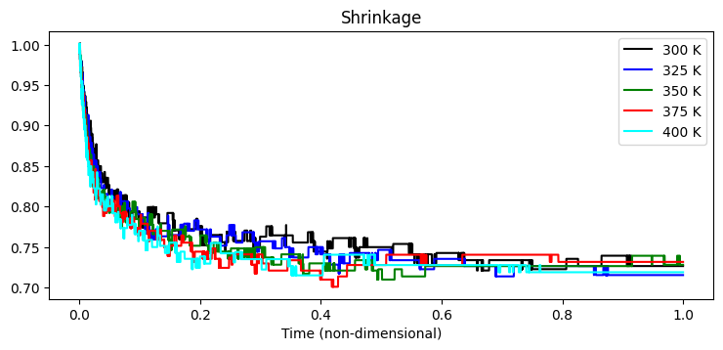
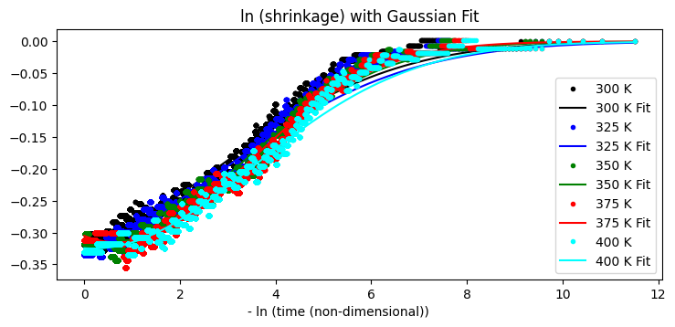
Fig. 2. System shrinkage versus normalized time (top) and the Gaussian fit to logarithmic transomed data (bottom).

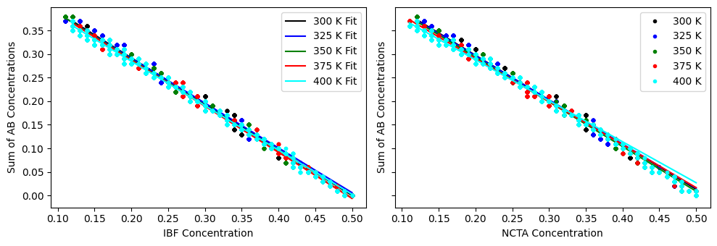
Fig. 3. Concentration of cocrystals versus IBF (left) and NCTA (right).

The integration of chemically and physically informed population balance models (PBMs) with dissipative particle dynamics (DPD) represents a significant advancement in the modeling of cocrystallization processes. By incorporating the dynamics of particle interactions, this study addresses a critical limitation of traditional PBMs, which often assume that particles are always in proximity, leading to oversimplified and less accurate models.
The case study of ibuprofen and nicotinamide cocrystallization demonstrates the effectiveness of this approach. The ability to simulate the formation of homomers and heteromers, along with the associated birth and death events, provides a more comprehensive understanding of the molecular processes involved. The study's results, which show good agreement with experimental data from Terahertz (THz) and infrared (IR) spectroscopy, underscore the reliability of the model.
The incorporation of dynamic interactions allows for a more accurate prediction of the cocrystallization process, which is crucial for the design and optimization of pharmaceutical formulations. This approach could significantly enhance the ability to predict the behaviour of multi-component systems, thereby improving the development of new cocrystals with desired properties.
While the current study focuses on ibuprofen and nicotinamide, the methodology is generalizable to other systems where cocrystallization or similar processes are of interest. The framework can be adapted to study a wide range of molecular interactions, making it a valuable tool for researchers in various fields, including pharmaceuticals, materials science, and chemical engineering.
The coupling of PBMs with DPD provides a bridge between molecular-scale interactions and macroscopic properties. This multiscale approach enables the extraction of macroscopic properties, such as concentration profiles and aggregation behaviour, from molecular-level simulations, thereby offering a more holistic understanding of the system under study.
While the study shows promising results, further experimental validation is necessary to confirm the model's predictions across different conditions and systems. Such validation would strengthen the credibility of the model and potentially lead to its broader adoption in industrial applications.
Future work could explore the extension of this approach to more complex multi-component systems, where interactions among multiple types of particles could lead to even more intricate cocrystallization behaviour. This would be particularly relevant in the design of advanced materials and pharmaceuticals, where multi-component systems are common. The current model uses specific parameters for the dissipative interaction and force parameters, which could be further refined to better match experimental observations. Ongoing research could focus on improving these parameters or developing new ones that better capture the nuances of particle interactions.
Beyond cocrystallization, this approach could be applied to other processes where particle dynamics play a critical role, such as nucleation, growth, and aggregation in crystallization processes, or even in biological systems where similar dynamics are at play.

Concluding remarks
The success of this approach in modeling the ibuprofen-nicotinamide cocrystallization process suggests that it could be a powerful tool for researchers and industry professionals alike. However, as with any model, continuous refinement and validation are essential to ensure its accuracy and applicability across various domains. The promising results open new avenues for research, with the potential to significantly impact the fields of pharmaceuticals, materials science, and beyond.

References
1. Bird, R.B., W.E. Stewart, and E.N. Lightfoot, Transport Phenomena. 2006: Wiley.
2. Shu, Y.D., et al., Considering nucleation, breakage and aggregation in morphological population balance models for crystallization processes. Computers & Chemical Engineering, 2020. 136: p. 106781.
3. Jeldres, R.I., P.D. Fawell, and B.J. Florio, Population balance modelling to describe the particle aggregation process: A review. Powder Technology, 2018. 326: p. 190-207.
4. Li, Z., et al., Transport dissipative particle dynamics model for mesoscopic advection-diffusion-reaction problems. The Journal of Chemical Physics, 2015. 143(1).
5. Lísal, M., et al., Dissipative particle dynamics with reactions: Application to RDX decomposition. The Journal of Chemical Physics, 2019. 151(11).
6. Asgarpour Khansary, M., S. Shirazian, and G. Walker, A molecularly enhanced proof of concept for targeting cocrystals at molecular scale in continuous pharmaceuticals cocrystallization. Proceedings of the National Academy of Sciences, 2022. 119(21): p. e2114277119.
7. Asgarpour Khansary, M., G. Walker, and S. Shirazian, Incomplete cocrystalization of ibuprofen and nicotinamide and its interplay with formation of ibuprofen dimer and/or nicotinamide dimer: A thermodynamic analysis based on DFT data. Int J Pharm, 2020. 591: p. 119992.
8. Asgarpour Khansary, M., S. Shirazian, and G. Walker, Molecular Engineering of Cocrystallization Process in Holt Melt Extrusion based on Kinetics of Elementary Molecular Processes. International Journal of Pharmaceutics, 2021.
9. Greene, S.M., X. Shan, and D.C. Clary, Rate constants of chemical reactions from semiclassical transition state theory in full and one dimension. The Journal of Chemical Physics, 2016. 144(24): p. 244116.
10. Laidler, K.J. and M.C. King, Development of transition-state theory. The Journal of Physical Chemistry, 1983. 87(15): p. 2657-2664.
11. Truhlar, D.G., Transition state theory for enzyme kinetics. Archives of Biochemistry and Biophysics, 2015. 582: p. 10-17.
12. Frenkel, D. and B. Smit, Chapter 17 - Dissipative Particle Dynamics, in Understanding Molecular Simulation (Second Edition). 2002, Academic Press: San Diego. p. 465-478.
13. Flekkøy, E.G. and P.V. Coveney, From Molecular Dynamics to Dissipative Particle Dynamics. Physical Review Letters, 1999. 83(9): p. 1775-1778.
14. Groot, R.D. and P.B. Warren, Dissipative particle dynamics: Bridging the gap between atomistic and mesoscopic simulation. The Journal of Chemical Physics, 1997. 107(11): p. 4423-4435.
15. Groot, R.D. and T.J. Madden, Dynamic simulation of diblock copolymer microphase separation. The Journal of Chemical Physics, 1998. 108(20): p. 8713-8724.
16. Schweizer, K.S. and J.G. Curro, Integral equation theory of the structure and thermodynamics of polymer blends. The Journal of Chemical Physics, 1989. 91(8): p. 5059-5081.
17. Ishihara, S., Y. Hattori, and M. Otsuka, MCR-ALS analysis of IR spectroscopy and XRD for the investigation of ibuprofen - nicotinamide cocrystal formation. Spectrochimica Acta Part A: Molecular and Biomolecular Spectroscopy, 2019. 221: p. 117142.
18. Ishihara, S., et al., Cocrystal Formation through Solid-State Reaction between Ibuprofen and Nicotinamide Revealed Using THz and IR Spectroscopy with Multivariate Analysis. Crystals, 2020. 10(9): p. 760.
19. Todaro, V. and A.M. Healy, Development and characterization of ibuprofen co-crystals granules prepared via fluidized bed granulation in a one-step process – a design of experiment approach. Drug Development and Industrial Pharmacy, 2021. 47(2): p. 292-301.

