Appendix A. Particles Data
Table 1. Properties of elementary birth and death events in generation of A–B heteromers [1].
ID | A–B-1 | A–B-2 | A–B-3 | A–B-4 | A–B-5 | A–B-6 | A–B-7 | A–B-8 | A–B-9
b^{b} | -18.932 | -5.355 | -3.170 | 1.068 | -6.192 | 1.776 | 0.408 | -4.765 | -3.997
b^{e} | -14.760 | -22.007 | -7.976 | -16.593 | -20.840 | 1.270 | -16.827 | -18.715 | -14.425
d^{b} | -4.172 | 16.652 | 4.806 | 17.661 | 14.648 | 0.506 | 17.235 | 13.95 | 10.428
d^{e} | 14.76 | 22.007 | 7.976 | 16.593 | 20.84 | -1.27 | 16.827 | 18.715 | 14.425
b^{b}: birth barrier/resistance, b^{e}: birth energy release, d^{b}: death barrier/resistance and d^{e}: death energy release. All energies are in kcal/mol.

Table 2. Properties of elementary birth and death events in generation of A–A homomers [1].
ID | A–A-1 | A–A-2 | A–A-3 | A–A-4 | A–A-5 | A–A-6 | A–A-7 | A–A-8 | A–A-9
b^{b} | 0.371 | -2.107 | -2.369 | -1.975 | 0.205 | 0.161 | 0.166 | 0.261 | -2.385
b^{e} | -11.810 | -8.447 | -10.789 | -2.930 | -3.627 | -15.878 | -11.738 | -12.011 | -2.267
d^{b} | 12.181 | 6.34 | 8.42 | 0.955 | 3.832 | 16.039 | 11.904 | 12.272 | -0.118
d^{e} | 11.81 | 8.447 | 10.789 | 2.93 | 3.627 | 15.878 | 11.738 | 12.011 | 2.267
b^{b}: birth barrier/resistance, b^{e}: birth energy release, d^{b}: death barrier/resistance and d^{e}: death energy release. All energies are in kcal/mol.

Table 3. Properties of elementary birth and death events in generation of B–B homomers [1].
ID | B–B-1 | B–B-2 | B–B-3
b^{b} | -5.051 | -5.038 | -4.933
b^{e} | -12.653 | -2.208 | -2.737
d^{b} | 7.602 | -2.83 | -2.196
d^{e} | 12.653 | 2.208 | 2.737
b^{b}: birth barrier/resistance, b^{e}: birth energy release, d^{b}: death barrier/resistance and d^{e}: death energy release. All energies are in kcal/mol.

Table 4. The details of particles defined in dynamics.
ID | Occupied Volume (Å³) | Effective Radius (Å) | Net Mass (gr/mol)
A–B-1 | 336.42 | 4.314505885 | 328.412
A–B-2 | 331.3 | 4.292506309 | 328.412
A–B-3 | 337.42 | 4.318776577 | 328.412
A–B-4 | 337.81 | 4.320439859 | 328.412
A–B-5 | 335.8 | 4.311853805 | 328.412
A–B-6 | 339.75 | 4.328694657 | 328.412
A–B-7 | 341.56 | 4.336368010 | 328.412
A–B-8 | 338.38 | 4.322868509 | 328.412
A–B-9 | 339.74 | 4.328652187 | 328.412
B–B-1 | 452.53 | 4.762696663 | 412.570
B–B-2 | 455.1 | 4.771695722 | 412.570
B–B-3 | 456.4 | 4.776234876 | 412.570
A–A-1 | 225.83 | 3.777730812 | 244.254
A–A-2 | 226.07 | 3.779068595 | 244.254
A–A-3 | 227.78 | 3.788572999 | 244.254
A–A-4 | 226.22 | 3.779904228 | 244.254
A–A-5 | 226.18 | 3.779681429 | 244.254
A–A-6 | 220.58 | 3.748226623 | 244.254
A–A-7 | 224.05 | 3.767779218 | 244.254
A–A-8 | 226.44 | 3.781129156 | 244.254
A–A-9 | 225.57 | 3.776280478 | 244.254
B | 223.3 | 3.763570346 | 206.285
A | 111.83 | 2.988752175 | 122.127

Table 5. The calculated Flory-Hugging’s interaction parameter.
 | A | B | A-A-1 | A-A-2 | A-A-3 | A-A-4 | A-A-5 | A-A-6 | A-A-7 | A-A-8 | A-A-9 | B-B-1 | B-B-2 | B-B-3 | A-B-1 | A-B-2 | A-B-3 | A-B-4 | A-B-5 | A-B-6 | A-B-7 | A-B-8 | A-B-9
A | 0.00 | 1.59 | 4.95 | 9.07 | 6.00 | 8.96 | 4.23 | 7.94 | 6.68 | 2.80 | 7.61 | 20.75 | 8.78 | 16.05 | 9.89 | 10.76 | 15.58 | 8.46 | 11.62 | 7.77 | 4.21 | 19.98 | 4.52
B | 1.55 | 0.00 | 4.82 | 12.38 | 6.12 | 9.55 | 3.98 | 8.62 | 10.13 | 4.16 | 7.05 | 17.25 | 3.27 | 7.30 | 5.55 | 6.74 | 10.81 | -1.59 | 7.65 | 4.47 | 2.53 | 15.69 | 2.73
A-A-1 | 4.94 | 5.23 | 0.00 | 5.20 | 3.84 | 4.25 | 0.67 | 0.60 | 1.54 | 2.20 | 4.04 | 16.50 | 10.01 | 14.53 | 3.79 | 6.10 | 13.81 | 8.01 | 12.42 | 0.01 | 2.01 | 18.84 | 4.31
A-A-2 | 9.16 | 12.38 | 5.05 | 0.00 | 2.82 | 1.16 | 2.34 | 1.35 | 1.62 | 5.90 | 3.90 | 20.60 | 19.69 | 23.91 | 14.16 | 12.59 | 20.25 | 17.86 | 16.09 | 3.10 | 2.77 | 26.37 | 12.55
A-A-3 | 6.16 | 6.22 | 3.68 | 2.87 | 0.00 | 2.65 | -1.70 | 2.41 | 1.75 | 1.87 | 3.62 | 17.12 | 12.38 | 14.95 | 8.40 | 6.25 | 15.10 | 7.06 | 12.28 | 3.78 | 0.79 | 18.46 | 7.51
A-A-4 | 9.03 | 9.59 | 4.55 | 1.57 | 1.97 | 0.00 | 2.92 | 1.90 | 3.51 | 5.87 | 2.38 | 21.84 | 15.70 | 18.35 | 13.42 | 12.88 | 17.85 | 14.22 | 15.01 | -0.11 | 1.50 | 20.73 | 10.41
A-A-5 | 4.19 | 3.98 | 0.14 | 2.43 | -1.81 | 2.47 | 0.00 | 2.68 | 2.81 | 0.34 | 2.44 | 16.77 | 6.20 | 10.53 | 7.69 | 5.74 | 9.74 | 7.05 | 6.17 | 2.10 | -0.65 | 11.58 | 2.84
A-A-6 | 8.01 | 8.58 | 0.19 | 1.37 | 2.14 | 1.83 | 2.70 | 0.00 | 2.83 | 5.85 | 3.36 | 20.72 | 12.02 | 15.29 | 10.53 | 10.39 | 14.71 | 12.10 | 9.75 | 5.99 | 1.41 | 17.45 | 7.41
A-A-7 | 6.63 | 10.28 | 1.15 | 1.26 | 1.64 | 3.84 | 2.45 | 2.67 | 0.00 | 3.48 | 4.65 | 21.19 | 16.05 | 19.18 | 11.82 | 10.03 | 17.88 | 14.69 | 13.54 | 3.34 | 3.21 | 22.83 | 8.75
A-A-8 | 2.83 | 3.99 | 2.00 | 5.76 | 1.70 | 5.76 | -0.04 | 5.78 | 3.38 | 0.00 | 4.94 | 16.55 | 7.68 | 12.53 | 7.07 | 6.80 | 12.81 | 6.53 | 11.67 | 4.15 | 2.16 | 18.62 | 4.22
A-A-9 | 7.83 | 7.08 | 4.27 | 4.62 | 3.92 | 2.22 | 2.35 | 3.40 | 4.69 | 4.56 | 0.00 | 19.73 | 12.35 | 17.23 | 11.38 | 12.12 | 16.88 | 13.00 | 14.07 | -3.68 | 2.88 | 21.14 | 7.85
B-B-1 | 20.93 | 13.30 | 22.28 | 22.82 | 18.99 | 24.52 | 16.55 | 20.59 | 18.12 | 16.12 | 15.54 | 0.00 | 9.33 | 16.44 | 17.93 | 16.78 | 8.75 | 13.90 | 18.01 | 14.47 | 13.43 | 29.34 | 9.63
B-B-2 | 8.51 | 4.02 | 9.63 | 19.74 | 12.56 | 15.24 | 7.50 | 12.25 | 15.98 | 7.63 | 13.12 | 6.65 | 0.00 | 2.58 | -5.07 | 4.66 | 4.27 | 2.11 | 7.03 | 5.03 | 4.12 | 14.54 | 2.26
B-B-3 | 17.94 | 6.02 | 13.12 | 26.10 | 14.56 | 19.06 | 10.19 | 18.30 | 18.70 | 12.58 | 18.68 | 14.09 | 2.36 | 0.00 | 4.34 | -0.03 | 5.73 | 4.07 | 2.39 | 11.04 | 4.17 | 5.71 | 5.79
A-B-1 | 9.18 | 5.09 | 3.57 | 15.67 | 9.29 | 13.45 | 8.25 | 10.55 | 12.51 | 6.95 | 11.40 | 18.59 | -6.36 | 8.14 | 0.00 | 6.70 | 12.49 | 3.55 | 5.36 | 6.65 | 4.95 | 13.01 | 3.66
A-B-2 | 10.35 | 6.03 | 5.89 | 12.18 | 6.21 | 12.84 | 5.41 | 10.10 | 10.50 | 6.78 | 12.05 | 16.10 | 3.37 | -2.62 | 6.77 | 0.00 | 2.53 | 2.46 | -0.01 | 9.93 | 3.80 | -3.06 | 5.80
A-B-3 | 15.72 | 14.35 | 18.77 | 22.63 | 15.62 | 19.20 | 13.16 | 20.76 | 21.31 | 14.68 | 19.18 | 11.92 | 4.84 | 5.44 | 13.03 | 6.86 | 0.00 | 8.75 | -0.44 | 16.72 | 8.81 | 17.79 | 11.79
A-B-4 | 8.31 | -2.09 | 7.69 | 17.45 | 6.83 | 14.47 | 6.62 | 11.64 | 14.62 | 6.48 | 13.00 | 16.24 | 0.81 | -0.84 | 4.20 | 1.79 | 5.54 | 0.00 | 0.13 | 6.95 | 1.94 | 5.29 | 0.17
A-B-5 | 11.57 | 6.72 | 12.60 | 14.23 | 13.31 | 14.10 | 5.77 | 9.31 | 13.44 | 11.73 | 14.07 | 15.93 | 3.38 | 0.55 | 4.33 | -1.39 | -0.93 | 0.47 | 0.00 | 9.36 | -1.09 | 3.97 | 6.86
A-B-6 | 7.93 | 4.36 | -0.42 | 3.41 | 3.91 | -1.08 | 2.21 | 6.26 | 3.72 | 4.47 | -2.99 | 16.88 | 5.34 | 9.97 | 6.26 | 9.85 | 13.17 | 7.62 | 8.89 | 0.00 | -1.44 | 15.53 | 3.06
A-B-7 | 4.29 | 2.55 | 2.30 | 3.06 | 1.23 | 1.84 | -0.66 | 1.55 | 3.52 | 2.34 | 2.99 | 12.43 | 3.28 | 4.39 | 4.39 | 3.85 | 7.11 | 1.51 | 0.12 | -1.32 | 0.00 | 13.19 | 1.18
A-B-8 | 20.84 | 14.03 | 19.20 | 30.46 | 15.93 | 20.57 | 10.38 | 18.28 | 21.98 | 18.32 | 20.38 | 28.02 | 12.10 | 12.15 | 11.50 | -4.51 | 13.78 | 1.68 | 3.02 | 12.53 | 13.91 | 0.00 | 11.15
A-B-9 | 3.94 | 2.74 | 3.64 | 12.24 | 7.31 | 10.15 | 2.92 | 7.50 | 9.09 | 5.17 | 7.99 | 11.84 | 0.20 | 5.59 | 3.37 | 5.03 | 10.70 | -0.07 | 6.79 | 2.75 | -1.40 | 16.24 | 0.00

Appendix B. System Energies and Concentration Profiles
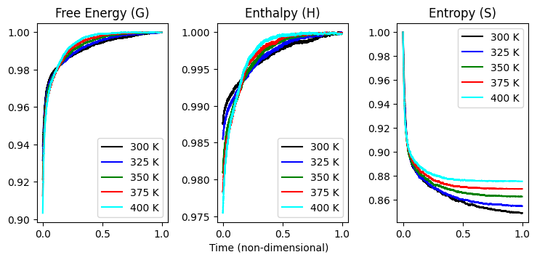
Fig. 4. Normalized energies (ZPVE included) of system in kcal/mol.

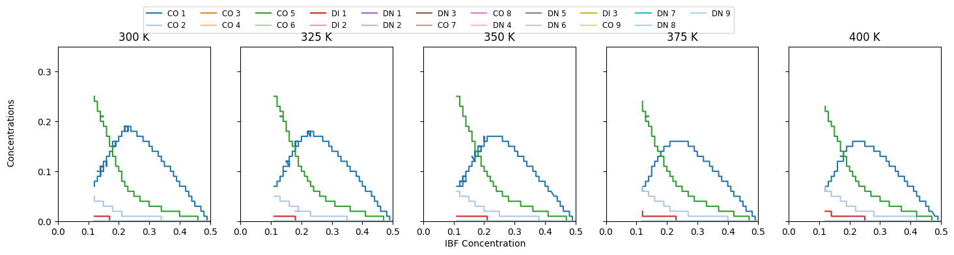
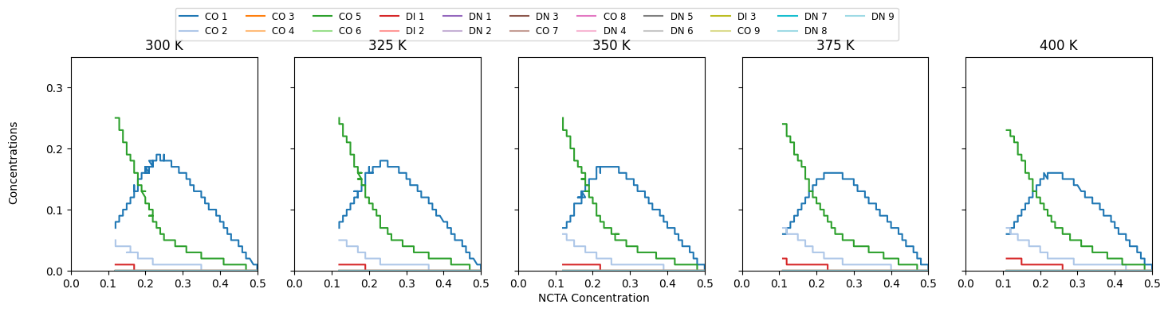
Fig. 5. Concentrations versus IBF (top) and NCTA (bottom)

References
1. Asgarpour Khansary, M., S. Shirazian, and G. Walker, Molecular Engineering of Cocrystallization Process in Holt Melt Extrusion based on Kinetics of Elementary Molecular Processes. International Journal of Pharmaceutics, 2021.

