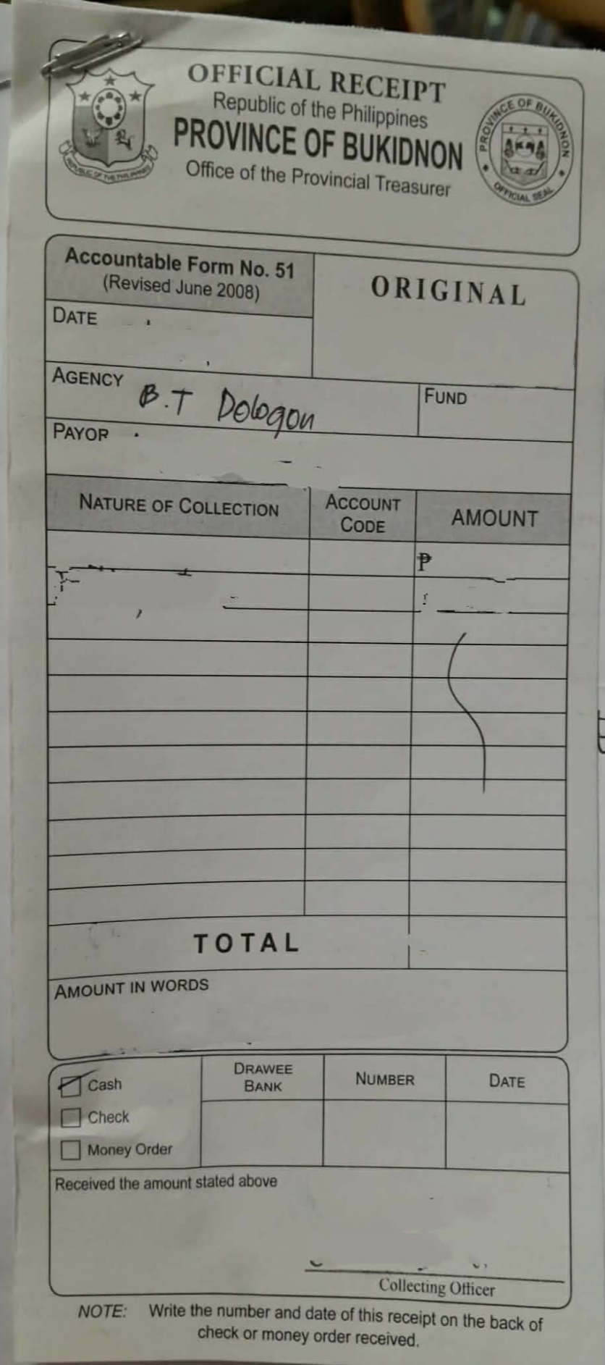
P130.00
P130.00
Barangay Clearance
Eric Pacatang
February 24 2026

