EASTERN VISAYAS STATE UNIVERSITY – ORMOC CAMPUS
COMPUTER STUDIES DEPARTMENT

DESIGN AND IMPLEMENTATION OF AN INVENTORY AND PURCHASER TRANSACTION TRACKING SYSTEM FOR IKEA CAKES AND SNACKS COMMISSARY

A Capstone Project Proposal
Submitted to the Computer Studies Department
In Partial Fulfillment of the Requirements
for the Degree
Bachelor of Science in Information Technology

By:
RANSMARK A. MORALES
LOREN C. CAPUYAN

Capstone Adviser:
Jude Alexes Ramas

DECEMBER 2025

ABSTRACT

ACKNOWLEDGEMENT

TABLE OF CONTENT
TABLE OF CONTENT 3
LIST OF TABLES 6
LIST OF FIGURES 7
INTRODUCTION 1
Background of the Study 1
Problem Statement 2
General Objective 3
Specific Objectives 3
Significance of the Study 4
Scope and Limitations 4
Definition of Terms 6
REVIEW OF RELATED LITERATURE 7
2.1 Introduction 7
2.1.1 Inventory Management in the Food Service Industry 7
2.1.2 Challenges in Manual Inventory Processes 7
2.1.3 Digital Solutions for SMEs and Commissary Operations 8
2.1.4 Purchase Tracking and Receipt Management 8
2.1.5 Usability and User-Centered System Design 9
2.2 Review of Related Studies 9
2.2.1 International Studies 9
2.2.2 Local / Philippine-Context Studies 10
2.2.3 Review of Related Systems 11
Feature Comparison Table 12
2.2.5 Synthesis and Research Gap 13
RESEARCH DESIGN AND METHODOLOGY 14
3.1 Research Design 14
3.2 Software Development Life Cycle (SDLC) Model Used 14
3.3 System Architecture 15
3.4 Tools and Technologies Used 17
3.5 Requirements Specification 17
3.6 Target Users and Respondents 19
3.7 Data Gathering Procedures 19
3.8 Evaluation Methods 21
NEEDS ASSESSMENT AND REQUIREMENT ANALYSIS 21
4.1 Database Design 22
4.2 User Interface (UI) Design 25
4.3 Module Description 30
4.4 System Features 33
4.5 Security Features 37
4.6 System Deployment 37
RESULTS AND DISCUSSION 39
5.1 System Implementation 39
5.2 Evaluation Results 42
5.3 Analysis of Results 43
5.4 Summary of Findings 43
SUMMARY, CONCLUSIONS, AND 44
RECOMMENDATIONS 44
6.1 Summary 44
6.2 Conclusions 44
6.3 Recommendations 44
REFERENCES 45

LIST OF TABLES

LIST OF FIGURES

INTRODUCTION

Background of the Study
The food service industry depends on efficient inventory management systems to maintain product quality and control costs and operational stability. The daily production requirements of retail branches depend on accurate raw material tracking because commissary-based operations function as their centralized production centers. Small and medium enterprises (SMEs) operating in the Philippines continue to use manual inventory management systems which include handwritten request forms and physical paper logs and separate spreadsheet records. Research indicates that human errors in inventory documentation result in substantial financial damage and operational delays and suboptimal business choices (Wynn, 2021). The operational inefficiencies in high-volume food production facilities result in double requests and overstocking which negatively impacts business profitability and sustainability.
The IKEA Cakes and Snacks Commissary based in Ormoc City demonstrates all the difficulties that exist in the industry. The central kitchen operates as the main supply point for two retail locations while handling diverse raw materials including perishable items and bulk supplies. The current process requires kitchen staff to create handwritten ingredient requests on paper slips which they must submit to the stock handler for verification. The stock handler provides the purchaser with an approved paper request and budget for purchasing new stock. The stock handler performs manual verification of physical receipts and inventory updates in Excel after the purchaser returns with their items.
The current process which depends on paper documents hinders real-time stock monitoring and delivery verification and makes it hard to detect any discrepancies. The system lacks an integrated audit trail which tracks user activities with timestamps because this feature enables organizations to monitor changes made to requests and purchases and stock records. The system's inability to track changes makes it possible for users to falsify reports and steal items and skip procedures which would harm operations at any size of business (Sharma & Saxena, 2021).

Multiple inventory management solutions exist but most systems fail to meet the requirements of small commissary operations which serve few outlets. The current process at IKEA Cakes and Snacks Commissary fails to link purchase tracking with inventory control and lacks an effective audit trail system which prevents complete expense and stock level and user action verification. The research proposes to create an IKEA Cakes and Snacks Commissary Inventory System with Built-in Purchaser Transaction Tracker which will focus on managing raw materials and ingredients. The system unifies paper-based operations through digitalization to achieve real-time reporting accuracy and prevent overstocking.

Problem Statement
The manual and paper-based handling of raw materials inventory at IKEA Cakes and Snacks Commissary, which supplies two retail branches, results in inefficiencies, gaps in accountability, and a lack of transaction traceability. Requests for ingredients are handwritten on paper forms and physically submitted, requiring the stock handler to verify them before preparation. For stock replenishment, the purchaser shops for supplies with an approved list and returns with physical receipts, which are reconciled against a separate, handwritten expense form. This fragmented, paper-reliant process lacks any real-time integration between purchasing and stock monitoring, and it has no audit trail to record who made changes to requests, stock counts, or purchase entries. As a result, double request, and unverified stock adjustments can occur without clear responsibility attribution.
The absence of an integrated, automated inventory tracking and purchase verification process has significant operational consequences. Stock discrepancies can go unnoticed, expense reports may be incomplete or delayed, and decision-making on restocking is often reactive rather than data-driven. These inefficiencies increase operational costs, compromise supply accuracy, and reduce transparency. Given the importance of accurate inventory and transaction records in commissary operations, this problem warrants a dedicated, technology-driven solution that can centralize tracking, strengthen accountability, and support evidence-based management.

General Objective
To design and develop a web-based commissary inventory management system with a built-in purchaser transaction tracker and audit trail that centralizes request handling, stock monitoring, purchase verification, and user activity logging for IKEA Cakes and Snacks Commissary’s raw materials and ingredients.

Specific Objectives
- To design a digital request and approval module that allows kitchen staff to submit ingredient requests and enables authorized personnel to verify and approve them in real time.
- To develop an automated stock monitoring module that updates inventory levels after verified transactions, issues low-stock alerts, and supports unit conversions for bulk-to-usable quantities.
- To implement a purchaser transaction tracker that logs all purchases, links receipts to corresponding inventory updates, and categorizes transactions by supplier and payment status.
- To integrate a delivery acknowledgment feature that records partial and full deliveries, with pending quantities remaining visible until fulfilled.
- To implement an audit trail module that logs all user actions with timestamps for accountability and traceability.
- To generate customizable reports summarizing requests, stock changes, deliveries, and supplier balances for improved decision-making.
- To implement security measures such as secure authentication, role-based access control, and regular data backups to protect sensitive inventory and transaction records.
- To provide a print and export feature for generating hard copies or digital files PDF of inventory, transactions, and supplier reports.
- To evaluate the system in terms of usability, efficiency, accuracy, and security through user acceptance testing, System Usability Scale, and performance analysis.

Significance of the Study
This capstone project will be most beneficial to the IKEA Cakes and Snacks Commissary staff and management. The proposed system will enable them to process ingredient requests digitally, monitor inventory in real time, track purchases with corresponding receipts, and review audit trail logs to see who performed specific actions and when. This ensures greater accountability and transparency.
Secondary beneficiaries include the commissary’s branch staff and customers, who will indirectly benefit from more reliable ingredient availability and fewer production delays. Accurate inventory tracking will help ensure consistent product quality and better cost control.
From a technological perspective, this project introduces an integrated system tailored for a small-scale commissary. By consolidating request approvals, stock monitoring, purchase logging, and an audit trail into a single platform, it supports the broader shift toward digital transformation in local food businesses. In a broader context, this study aligns with the ongoing push for SME digitalization in the Philippines, serving as a model for similar food service operations seeking to modernize their supply chain management.

Scope and Limitations
Scope
This study focuses on the design and development of a web-based commissary inventory management system with a built-in purchaser transaction tracker and audit trail for IKEA Cakes and Snacks Commissary. The system will manage the raw materials and ingredient inventory used in the commissary's operations for its two retail branches.
The system will include the following features:
- Digital Request and Approval Module: Kitchen staff can submit ingredient requests, and authorized personnel can verify and approve them in real time.
- Automated Stock Monitoring: Tracks stock-in and stock-out transactions, provides low-stock alerts, and supports unit conversions from bulk to usable quantities.
- Purchaser Transaction Tracker: Logs purchases with receipt uploads, categorizes by supplier, and records payment status.
- Delivery Acknowledgment Module: Records full and partial deliveries, with pending quantities visible until fulfilled.
- Audit Trail: Records all user actions with timestamps, ensuring accountability and traceability.
- Reporting Tools: Generates summaries on requests, deliveries, stock changes, and unpaid supplier balances.
- Printing and Exporting of Reports: Generates physical copies (via a printer) or digital PDF files of inventory summaries, purchase records, and supplier balances for documentation and auditing purposes.
The system will have role-based access for:
- Owner/Admin: Approve requests, manage inventory, monitor transactions, and access the complete audit trail.
- Manager: Approve requests in the absence of the owner.
- Stock Handler: Manage stock records, verify purchases, and prepare requested ingredients.
- Purchaser: Record purchases, upload receipts, and contact suppliers.
Limitations
- The system is limited to raw materials and ingredient inventory; it excludes finished product inventory for the two branches.
- The system is web-based and works on desktops, laptops, tablets, and mobile phones through a browser, but it is not a native mobile app.
- A stable internet connection is required for real-time updates; the system does not support offline operation.
- User acceptance testing will be limited to selected staff of IKEA Cakes and Snacks Commissary.
- The current version will not integrate with external accounting or point-of-sale (POS) systems.
- Automated forecasting of ingredient usage is excluded from the current scope.

Definition of Terms
- Audit Trail: A system feature that records all user actions within the application, including date, time, and user identity, to ensure accountability.
- Bulk-to-Usable Quantity Conversion: The process of recording bulk-purchased items in smaller units (e.g., converting a 50-kg sack of sugar into 50 1-kg units).
- Commissary: A centralized kitchen facility responsible for preparing and managing raw materials for multiple retail branches.
- Delivery Acknowledgment: The process of confirming and recording the receipt of purchased supplies.
- Digital Request and Approval Module: A system function that allows users to submit, verify, and approve ingredient requests electronically.
- Low-Stock Alert: A system-generated notification that warns when an ingredient’s quantity falls below a pre-defined threshold.
- Purchaser Transaction Tracker: A module that logs all purchases, links receipts to inventory updates, and records payment statuses.
- Raw Materials: Basic food items or ingredients used in production.
- Role-Based Access: A security feature that assigns different permissions to users based on their roles.
- Stock Handler: A staff member responsible for managing inventory records, verifying purchases, and preparing requested ingredients.
- Supplier: An external vendor from which the commissary purchases raw materials.
- SME: Small and medium enterprises.

REVIEW OF RELATED LITERATURE

2.1 Introduction
This section presents scholarly concepts, theories, and discussions relevant to the development of the proposed IKEA Cakes and Snacks Commissary Inventory Management System with Built-in Purchaser Transaction Tracker. The literature review is organized thematically, covering inventory management practices in the food service industry, challenges in manual inventory processes, digital solutions for small and medium enterprises (SMEs), purchase tracking and receipt management, and user-centered system design. These discussions establish the theoretical foundation and contextual relevance of the proposed system.

2.1.1 Inventory Management in the Food Service Industry
Effective inventory management plays a pivotal role in sustaining food quality, minimizing operational costs, and ensuring uninterrupted workflow in food service operations. Li (2025) emphasized that intelligent inventory systems utilizing automation and real-time tracking significantly improve stock accuracy and reduce food waste. According to Althaqafi (2020), strong inventory control correlates positively with SME profitability, as poor stock oversight results in unnecessary expenditures and inefficiencies.
In the Philippines, Cabungcal, De Jesus, and Dela Cruz (2023) highlighted that MSMEs with structured inventory practices achieved greater financial stability and operational efficiency. These findings underscore the importance of systematic inventory control in commissary-based operations such as IKEA Cakes and Snacks, where raw ingredients are distributed across multiple retail branches.

2.1.2 Challenges in Manual Inventory Processes
Manual inventory systems present substantial limitations in accuracy, efficiency, and reliability. Wynn (2021) found that handwritten records are prone to errors that may lead to financial losses. Sharma and Saxena (2021) reported that SMEs relying on manual processes commonly experience stock discrepancies, delayed replenishment, and redundant ordering. Li (2025) also observed that manual logs and spreadsheets increase the likelihood of oversight, especially in fast-paced food-related operations.
These challenges reflect the current workflow of IKEA Cakes and Snacks, where handwritten slips and manual spreadsheet updates make tracking difficult and introduce gaps in accountability.

2.1.3 Digital Solutions for SMEs and Commissary Operations
Digital inventory systems provide solutions to inefficiencies caused by manual processes. Lim Hui Qi, Rahmat, and Suban@Ani (2025) developed a digital inventory platform for SMEs that streamlined ordering, stock monitoring, and reporting, resulting in improved operational performance. Gill (2023) emphasized the importance of centralized systems that integrate purchase and inventory updates to minimize data fragmentation.
Opoku, Mensah, and Boateng (2021) likewise noted that structured digital platforms reduce financial risks by enabling continuous monitoring and timely intervention. These findings suggest that a digital system could address inefficiencies in commissary operations such as IKEA Cakes and Snacks.

2.1.4 Purchase Tracking and Receipt Management
Purchase tracking systems help organizations maintain transparency and reduce discrepancies between procurement and inventory records. Gill (2023) noted that centralized receipt management significantly lowers inconsistencies and operational costs. Li (2025) similarly discussed that misaligned purchasing and inventory practices contribute to food waste and budget mismanagement in food service businesses.
Integrating supplier details, digital receipts, and purchase logs into a unified system can help commissaries like IKEA Cakes and Snacks ensure accountability and streamline procurement tracking.

2.1.5 Usability and User-Centered System Design
User-centered design is essential in developing systems that cater to diverse users with varying levels of digital literacy. Baskerville and Myers (2023) argued that aligning system interfaces with user roles and workflows enhances usability and adoption. In commissary environments, where responsibilities range from administrative oversight to hands-on stock handling, intuitive and role-specific interfaces reduce training requirements and increase system acceptance.
This principle is highly relevant to IKEA Cakes and Snacks, where staff members include managers, stock handlers, purchasers, and operational personnel who may have different levels of computer experience.

2.2 Review of Related Studies
This section presents local and foreign studies relevant to inventory systems, commissary operations, and purchase tracking. Each study highlights methodologies, findings, and contributions that inform the proposed system.

2.2.1 International Studies
In the study entitled “Intelligent Inventory Management System: Innovation and Implementation of Restaurant Food Management” by Li (2025), the system was designed and tested specifically for restaurant operations. It incorporated automation and real-time tracking to enhance stock accuracy, reduce food waste, and improve ingredient shelf-life management. The study demonstrated that intelligent inventory systems could effectively align procurement with actual demand, reducing both overstock and shortages. The findings support the need for automated inventory management in food-service operations, highlighting the benefits of real-time monitoring for accuracy and efficiency. This is relevant to the current project as it emphasizes the importance of implementing a digital system to manage raw materials and reduce waste in commissary operations.
Gupta, Joshi, Jindal, and Singh (2025) conducted a study entitled “Optimizing Inventory Costs in Quick Service Restaurants: A Case Study Approach,” which applied supply-chain optimization and inventory control models, including adapted Economic Order Quantity (EOQ) and demand forecasting, to fast-food restaurants. Their results showed that optimized inventory planning significantly reduced food wastage and improved order fulfillment in dynamic, perishable-goods environments. The study also highlighted how data-driven inventory management contributes to operational efficiency and cost reduction. This supports the proposed system by demonstrating the need for predictive tracking and optimization of perishable raw materials in a commissary setting.
In the work “Design of an Inventory Management System for a Manabita Restaurant” by Zamora Saltos and Rodríguez Borges (2023), the authors proposed a restaurant-oriented inventory system capable of managing raw materials, preventing overstocking, and optimizing procurement timing. Their system reduced maintenance costs and improved stock control by providing timely alerts for replenishment needs. The study showed that integrating structured inventory processes in restaurant operations enhances operational stability and cost efficiency. This is relevant to the current project, as it underscores the benefits of a tailored inventory system for commissary operations distributing raw materials across multiple outlets.

2.2.2 Local / Philippine-Context Studies
In the study entitled “Inventory Management Practices of Small-Scale Pharmacies in Selected Towns in Cavite: A Marketing Perspective” by Soliveres, Herrera, and Cedillo (2024), the authors examined how small enterprises benefit from structured inventory control. Their findings indicated that businesses with systematic stock monitoring experienced fewer stockouts and lower holding costs. Although the study focused on pharmacies, the principles of structured inventory management can be applied to food-service SMEs. This supports the current project by showing that formal inventory systems contribute to better operational efficiency and reduced material loss, which is essential for managing a commissary’s raw materials.

Toroba, Gregori, Baraas, Impas, Martinez, and Cervantes (2025) conducted a study entitled “The Influence of Inventory Management Practices on Financial Performance Among Retail Businesses,” focusing on retail MSMEs in Davao Oriental. The study found a moderate but significant positive correlation between structured inventory practices and profitability, sales growth, and market expansion. It emphasized that disciplined stock management improves financial outcomes in small enterprises. This is relevant to the proposed system because it highlights the importance of maintaining accurate inventory records to support financial accountability and operational performance in a commissary business.
In the conference paper “Inventory Management System of Seasonal Raw Materials of Feeds at San Jose Batangas through Integer Linear Programming and VBA” by Napa (2023), the researcher developed a systematic inventory management approach for perishable feed materials. The system used demand forecasting and restocking planning to prevent overstock and shortages, thereby improving operational stability. The study demonstrated that even small-scale enterprises can achieve better efficiency through structured inventory planning. This is relevant to the current project as it justifies the need for a digital system to manage seasonal and perishable raw materials efficiently within IKEA Cakes and Snacks’ commissary operations.

2.2.3 Review of Related Systems
This section reviews existing inventory management systems currently used by SMEs or food‑service businesses. The goal is to examine their features, strengths, and limitations relative to the needs of a commissary business like IKEA Cakes and Snacks.
The first system, Zoho Inventory, is a cloud-based inventory management solution developed by Zoho Corporation. It provides features such as stock tracking, purchase order management, supplier management, real-time updates, and multi-warehouse support. Zoho Inventory’s strengths include its scalability, user-friendly interface, and ability to centralize inventory and procurement processes. However, it lacks built-in features for commissary-specific raw-material tracking, digital receipt storage, and a comprehensive audit trail. This limitation highlights the need for a system with specialized functionalities for small commissaries like IKEA Cakes and Snacks, particularly for tracking raw materials and purchase proof.
Upserve Inventory (now integrated with Lightspeed Restaurant) is designed specifically for the restaurant industry. Developed by Upserve / Lightspeed, it includes ingredient-level tracking, vendor ordering, cost analysis, recipe costing, and integration with menus for better procurement planning. Its main strengths are the restaurant-focused features that allow precise tracking of ingredients and help manage food costs effectively. However, the system is subscription-based, which may be expensive for small-scale commissaries, and it lacks native functionality for digital receipt uploads or multi-branch audit trails. This indicates the need for a more cost-effective, comprehensive solution for commissary operations.
Loyverse Back Office is an inventory and POS system developed for small retail and food-service businesses. It offers inventory control, stock adjustments, basic purchase order creation, and limited multi-store support in its paid version. Its strengths include a simple, easy-to-use interface and a free version suitable for small businesses. The weaknesses, however, include a weak purchase-tracking module, absence of digital receipt management, and limited audit logging, which may hinder accountability and oversight. This reinforces the need for a custom system tailored to commissary operations, combining inventory management with purchase tracking and audit features.

Feature Comparison Table
Table 2.1

Feature/Requirement | Zoho Inventory | Upserve Inventory | Loyverse Back Office | Proposed System
Inventory Monitoring / Stock Counts | ✅ | ✅ | ✅ | ✅
Ingredient-Level / Raw-Material Tracking | ❌ | ✅ | ❌ | ✅
Purchase Order / Supplier Management | ✅ | ✅ | ✅ | ✅
Purchase Receipt / Proof Upload (Images) | ❌ | ❌ | ❌ | ✅
Audit Trail / User-Level Logging | Limited | Same logging | Very limited | ✅
Commissary / Food Service Specific Design | ❌ | Restaurant-focused | General retail | ✅

2.2.5 Synthesis and Research Gap
The reviewed literature and studies emphasize the need for structured inventory management in small-to-medium enterprises (SMEs), consistently linking formalized practices, particularly digital systems, to improved stock accuracy, reduced waste, better cost control, and enhanced financial performance (Li, 2025; Gupta et al., 2025; Soliveres et al., 2024; Toroba et al., 2025). This research provides the theoretical justification for implementing a systematic solution within a local commissary context.
However, the evaluation of existing systems (as summarized in the table) reveals that commercial solutions either compromise on cost and complexity (e.g., restaurant-focused systems like Upserve) or feature completeness (e.g., general retail tools like Zoho, Loyverse). Specifically, existing systems lack the crucial combination of features required by the target commissary: raw-material tracking, and comprehensive purchase-to-stock traceability bolstered by digital receipt upload and robust audit logging.
The research gap is therefore identified as a lack of systems optimally tailored to small-to-micro-scale commissary operations, which handle perishable raw materials and distribution to multiple outlets while demanding high auditability and cost-effectiveness.
Thus, the current project the IKEA Cakes and Snacks Commissary Inventory Management System with Built-in Purchaser Transaction Tracker aims to fill this gap. Its unique contribution is providing a unified, cost-effective, and user-centered solution that integrates raw-material inventory management with purchaser transaction tracking (including receipt proof upload) and multi-outlet support, directly addressing the limitations and specific workflow needs identified in the local SME context.

RESEARCH DESIGN AND METHODOLOGY

3.1 Research Design
The developmental approach systematically integrated both qualitative and quantitative methods. The qualitative aspect was utilized during the initial phase to gather detailed user requirements and process insights through interviews and observations at the commissary. The quantitative component was employed in the later stages to analyze system evaluation metrics and user satisfaction surveys during the testing and acceptance phase. This blended methodology allowed for essential feedback-based iterations and ensured the developed system was both technically sound and practically aligned with the end-users' operational needs.

3.2 Software Development Life Cycle (SDLC) Model Used

The study adopted the Agile Software Development Life Cycle (SDLC) model. This model promotes iterative and incremental development, emphasizing adaptability, flexible responses to change, and frequent collaboration with stakeholders.
This model was chosen due to its suitability for developing a specialized system like the IKEA Cakes and Snacks Commissary Inventory Management System. Its inherent flexibility was crucial for handling specific and potentially evolving user requirements within the dynamic environment of a small commissary. The iterative nature of Agile allowed the team to incorporate continuous feedback from the commissary staff, ensuring the final product was highly practical and aligned with the end-users' specific workflow needs.
The project followed the key phases of the Agile process, applied as follows:
- Planning: The initial project scope and objectives were defined based on the findings from the literature review and the initial qualitative data gathered through interviews and observations at the IKEA Cakes and Snacks Commissary.
- Analysis: User needs and requirements were translated into detailed system requirements and functional specifications, which are documented in Chapter 4.
- Design: The system architecture, database schema (Entity-Relationship Diagram), and user interface mockups were created. These designs were reviewed with stakeholders before development began.
- Implementation: The system modules were developed incrementally in short cycles or sprints. Each sprint delivered a working piece of functionality, allowing for early demonstration and continuous evaluation.
- Testing: Comprehensive testing was conducted within and after each sprint, including unit testing (for individual code components), integration testing (for module cohesion), and formal User Acceptance Testing (UAT) with the commissary staff to validate functionality against real-world scenarios.
- Deployment: The fully tested system was deployed and implemented within the commissary's operational environment, making it live for daily use.
- Maintenance: The final phase involved applying necessary updates, patches, and fixes based on post-deployment monitoring and ongoing feedback from the end-users.

3.3 System Architecture
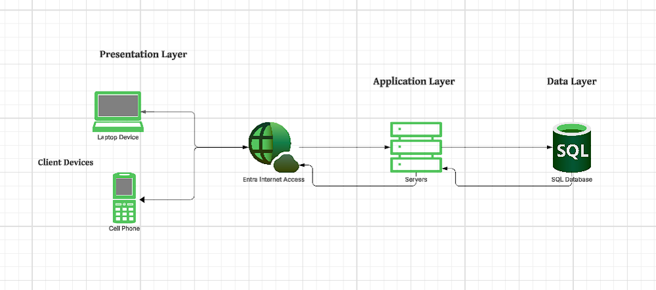
Figure 3.3.1

Presentation Layer (Client Devices)
Component: Web Browser
The user accesses the system through a web browser on a client device.
The browser displays the interface, sends user requests to the application server, and receives processed output for display.
Application Layer (Web Server Machine)
Components:
Web-Based Application
Module of IKEA - Portal
This layer processes all application logic. It receives requests from the client, performs validation, executes programmed functions, and interacts with the database layer when necessary. The web server returns processed results back to the client browser.
Data Layer (Database Server Machine)
Component: MySQL Database
This layer stores, manages, and retrieves system data. The application layer communicates with the MySQL database to run queries such as retrieving patient records, updating transactions, or saving new inputs.
Data Flow Explanation
- User Interaction:
The user sends a request through the web browser (e.g., viewing records or submitting a form).
- Request Processing:
The browser forwards the request through the internet to the web server.
- Application Logic Execution:
The web server processes the request using the web-based application and IKEA portal modules.
Database Communication:
If data is needed, the web server sends a query to the MySQL database.
- Data Retrieval or Update:
The database returns the required data or updates records.
- Response Delivery:
The processed output returns from the application server to the client’s browser for display.

3.4 Tools and Technologies Used
Programming Languages and Frameworks
- Frontend: HTML, Tailwind CSS, JavaScript
- Backend: PHP
- Database: MySQL
- Reporting: Chart.js for graphical reports
Development and Design Tools
- Figma – UI/UX design and wireframing
- Draw.io – System diagrams and workflows
- GitHub – Version control and collaborative coding

Testing Tools
- Browser Developer Tools – Debugging and performance checks
Hosting and Deployment
- Local Development Server: XAMPP
- Live Deployment: Hostinger

3.5 Requirements Specification
Functional Requirements (FR)
- FR-01: The system shall allow kitchen staff to submit ingredient requests with item name, quantity, and date needed.
- FR-02: The system shall allow authorized personnel (owner/manager) to approve or reject requests.
- FR-03: The system shall automatically update inventory levels after verified transactions.
- FR-04: The system shall generate low-stock alerts when reorder levels are reached.
- FR-05: The system shall support unit conversions from bulk purchases to smaller usable units.
- FR-06: The system shall allow purchasers to log purchases with item details, cost, and receipt image uploads.
- FR-07: The system shall record delivery acknowledgments, including partial deliveries.
- FR-08: The system shall generate customizable reports by date range, supplier, or item category.
- FR-09: The system shall maintain an audit trail of all user actions.
- FR-10: The system shall allow users to print or export reports in PDF format.
Non-Functional Requirements (NFR)
- NFR-01: The system shall be accessible via web browsers on desktop, laptop, and mobile devices.
- NFR-02: The system shall respond to user actions within 3 seconds under normal load.
- NFR-03: The system shall implement secure authentication with strong password policies and role-based access control.
- NFR-04: All user inputs shall be validated on the server-side to prevent common vulnerabilities such as SQL injection and Cross-Site Scripting (XSS).
- NFR-05: The system shall store all transactions with timestamps and maintain an unalterable audit trail.
- NFR-06: The system shall ensure automated daily data backups are performed to prevent data loss.
- NFR-07: The system shall encrypt sensitive data such as user credentials to ensure confidentiality.
- NFR-08: The system shall be usable by staff with only basic computer literacy.
User Requirements (UR)
- UR-01: Owner: Can approve/reject requests, manage stock, view audit trails, and view all reports.
- UR-02: Stock Handler: Can verify requests, update inventory, and record deliveries.
- UR-03: Purchaser: Can log purchases, upload receipts, and categorize supplier details.
- UR-04: Kitchen Staff: Can submit ingredient requests and confirm received items.

3.6 Target Users and Respondents
The participants in this study, who also served as the primary system users and evaluation respondents, were composed of five (5) key staff members from the IKEA Cakes and Snacks Commissary.
- Owner: Provides strategic oversight and financial approval.
- Stock Handler: Responsible for receiving, storing, and issuing raw materials.
- Purchaser: Manages supplier data and logs all purchase transactions.
- Kitchen Staff Representative: Initiates requests for raw material issuance from the Stock Handler for production use.
The respondents were selected using a purposive sampling method. This method was applied to ensure that the chosen individuals were directly and actively involved in the commissary’s daily inventory operations, purchasing processes, and stock movements. This selection criterion was critical to gathering the most relevant and accurate information during the requirements elicitation phase and obtaining reliable feedback during the system testing and evaluation phase.

3.7 Data Gathering Procedures
Data were collected using a mixed-methods approach, combining qualitative and quantitative instruments to inform the system design and validate its performance.

Qualitative Data Collection:
- Semi-Structured Interviews were conducted with the five key participants (Owner, Manager, Stock Handler, Purchaser, and Kitchen Staff Representative) to gather initial requirements and process insights.
- Observation Checklists were employed during on-site visits to document the physical inventory movements, stock handling procedures, and existing manual documentation processes, which provided workflow validation for system design.
Quantitative Data Collection:
- Survey Questionnaires were distributed to the five key staff members during the testing phase to collect feedback regarding system usability and performance.
- For the usability assessment, the System Usability Scale (SUS), a standardized 10-item questionnaire, was administered. The SUS was chosen because it is a validated and highly reliable instrument for measuring usability across various IT systems; therefore, no further content validation by faculty was required for this specific tool. Other custom questionnaires were administered to measure specific functional and performance metrics.

Data Processing and Analysis
- Qualitative Data Analysis: The interview transcripts and observation notes were subjected to thematic analysis. This process involved transcribing, coding, and grouping the data to identify recurring issues, core user needs, and essential feature requirements. This analysis was critical in prioritizing and finalizing the system features documented in Chapter 4.
- Quantitative Data Analysis: The responses collected from the SUS and other questionnaires were analyzed using descriptive statistics. The data processing included calculating percentages and mean scores (specifically, the final SUS score) to objectively evaluate user satisfaction and the system's overall performance.
- Synthesis: The findings from both the qualitative (identifying the what and why of needs) and quantitative (measuring the how well the system met those needs) analyses were synthesized to formally validate the developed system's functionality and performance against the study's initial objectives.

3.8 Evaluation Methods
The system's performance was comprehensively assessed using a multi-faceted approach during the User Acceptance Testing (UAT) phase, focusing on key metrics derived from both industry standards and project objectives.
- Usability: Will be quantitatively measured using the System Usability Scale (SUS), a standardized 10-item questionnaire administered to all testers to generate a reliable usability score. Qualitative feedback will also be gathered through post-testing interviews to identify specific usability challenges.
- Efficiency: Will be evaluated by measuring the time taken for users to complete key tasks (e.g., submitting an ingredient request, logging a new purchase) and comparing this to the time required for the equivalent manual process.
- Accuracy: Will be assessed by performing a physical stock count and comparing the results against the system's inventory records after a one-week testing period to calculate the discrepancy rate.
- Security: Will be evaluated by verifying the proper implementation of role-based access controls (i.e., ensuring users can only access their designated modules) and conducting basic vulnerability checks on data entry forms to test for common threats like SQL injection.

NEEDS ASSESSMENT AND REQUIREMENT ANALYSIS

4.1 Database Design

The system's data structure is typically implemented using a Relational Database Management System (RDBMS), such as MySQL or PostgreSQL. This model is chosen because it effectively manages and links diverse, structured data through tables and defined relationships. The provided diagram is the Entity-Relationship Diagram (ERD), which visually represents the database schema.
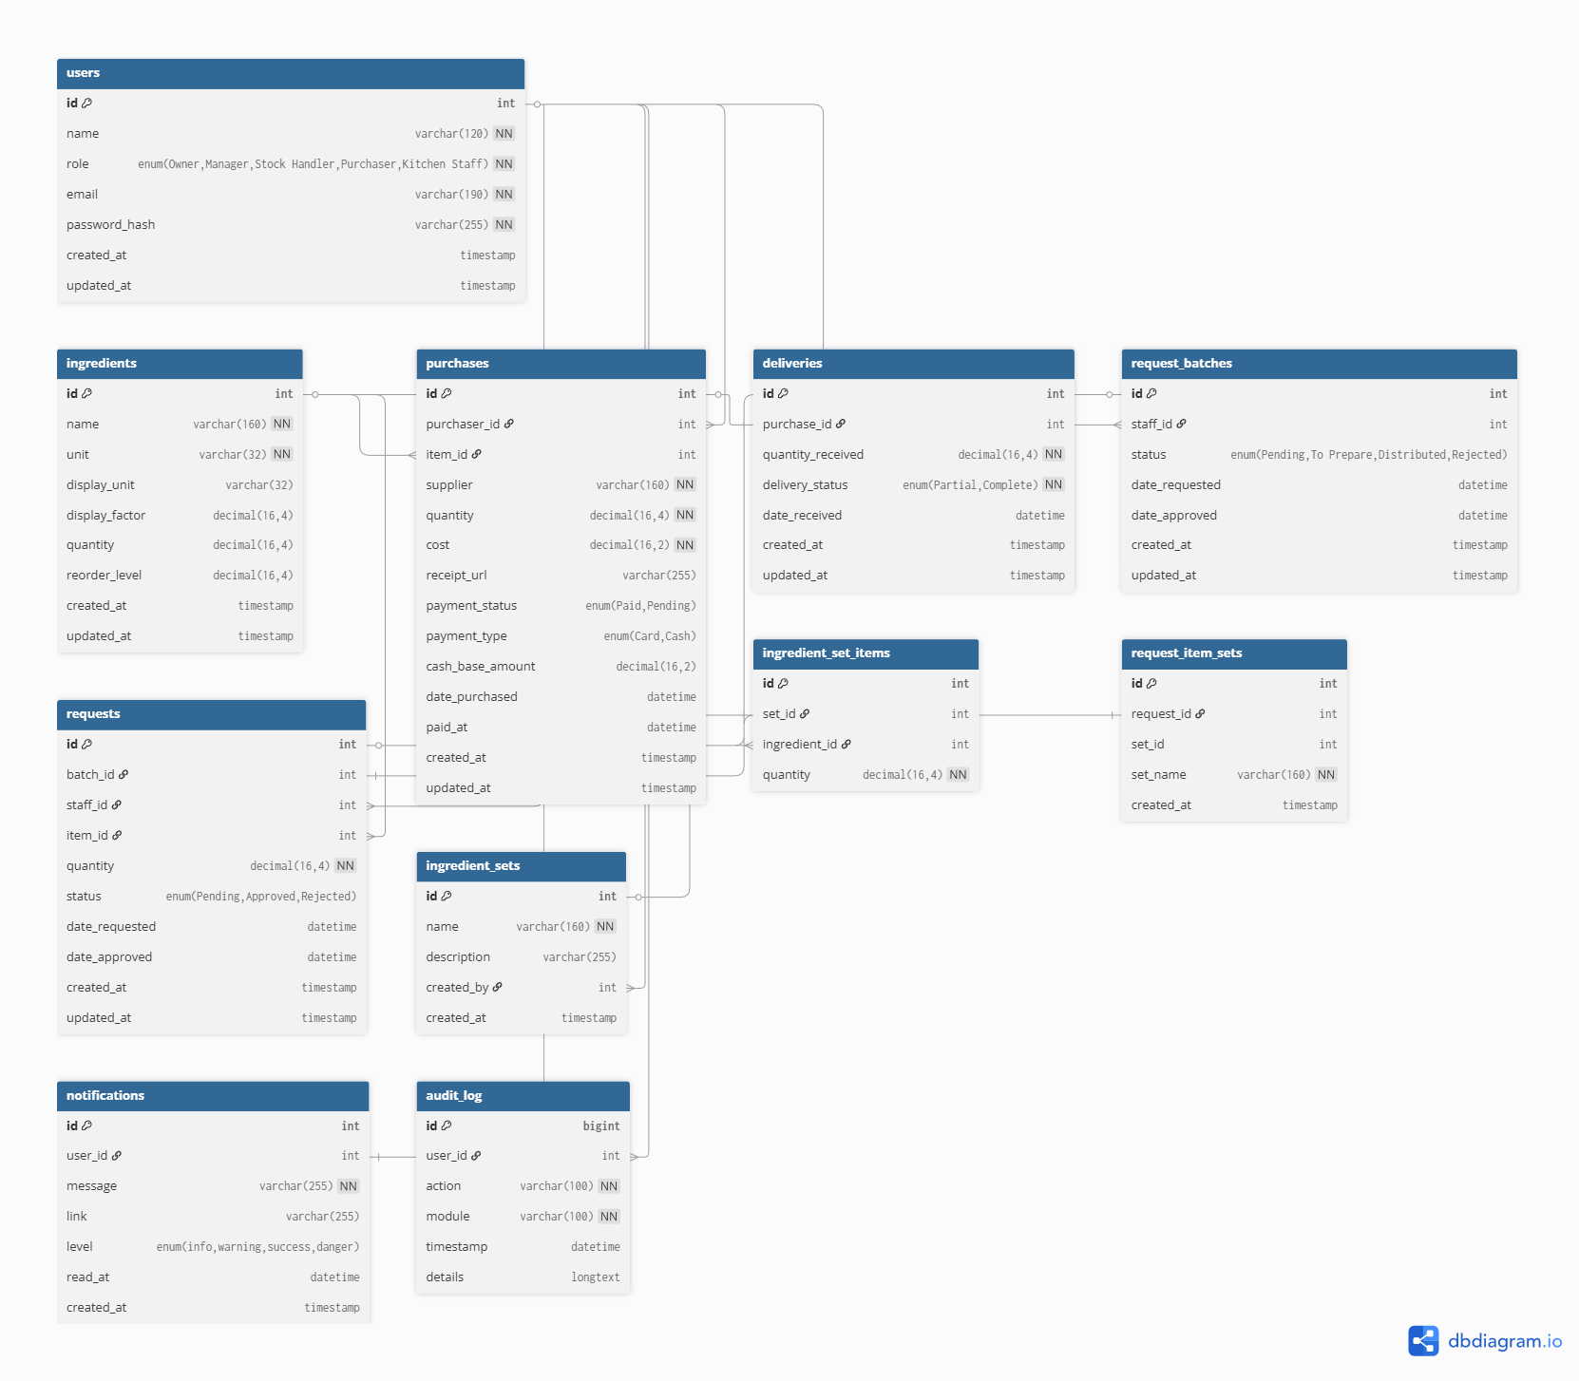

Figure 4.1

Table Name | Key(s) | Key Attributes | Data Types of Key Attributes
users | Primary Key  (PK) | id | Int
ingredients | PK | id | Int
purchases | PK | id | Int
deliveries | PK | id | Int
requests | PK  Foreign Key (FK) | id  Batch_id, item_id  staff_id | Int
notifications | PK  FK | id  user_id | Int
audit_log | PK | id | BigInt
request_batches | PK  FK | id  staff_id | Int
request_item_sets | PK  FK | id  request_id | Int
ingredient_sets | PK | id | Int
ingredient_set_items | Composite PK  FK | ingredients_set_id,  ingredient_id  ingredients_set_id,  ingredient_id | Int
Table 4.1

- users: Stores information about system users, including their role (e.g., Owner, Staff) and credentials.
- ingredients: Holds details on all raw materials, including unit, display_unit, and inventory management attributes like reorder_level.
- purchases: Records every purchase transaction with details like supplier, cost, and payment status/type.
- deliveries: Tracks incoming ingredients, linking back to a purchase_id and recording the quantity_received.
- requests: Represents internal requests for items, likely submitted by staff (staff_id) and linked to a request_batches and an item_id.

Relationships
Relationships ensure the coherence of the data by linking tables based on shared key columns.
- One-to-Many (1:N):
  - A single user can be associated with multiple notifications.
  - A single purchase can result in multiple deliveries.
  - An ingredient_sets can contain multiple ingredient_set_items.
  - A user (likely a staff member) can be linked to multiple request_batches.
- Many-to-Many (M:N) via Junction/Bridge Tables:
  - request_batches and request_item_sets are linked to requests.
  - ingredient_sets and ingredients are linked by the junction table ingredient_set_items. This table allows a single ingredient set to contain multiple ingredients, and a single ingredient can belong to multiple sets.
Data Integrity and Normalization
The design adheres to principles of data integrity and normalization (appearing to be at least Third Normal Form - 3NF):
- Primary and Foreign Keys: The use of Primary Keys (PKs) (unique identifiers like id) and Foreign Keys (FKs) (linking columns like purchase_id in deliveries) ensures Referential Integrity. This means a record in a "child" table (e.g., deliveries) must always refer to an existing record in the "parent" table (e.g., purchases), preventing orphaned data.
- No Redundancy: By splitting data into separate, thematic tables (e.g., separating user info from purchase details), data redundancy is minimized. For instance, an ingredient's name and unit are stored only once in the ingredients table, even if it appears in many deliveries.
- Data Consistency: ENUM data types are used in columns like users.role, purchases.payment_status, and requests.status. This restricts the allowed values for these fields, ensuring data consistency and preventing incorrect entries.
Overall, this structure is robust, minimizing storage waste and ensuring the accuracy and reliability of the data for effective system operation.

4.2 User Interface (UI) Design
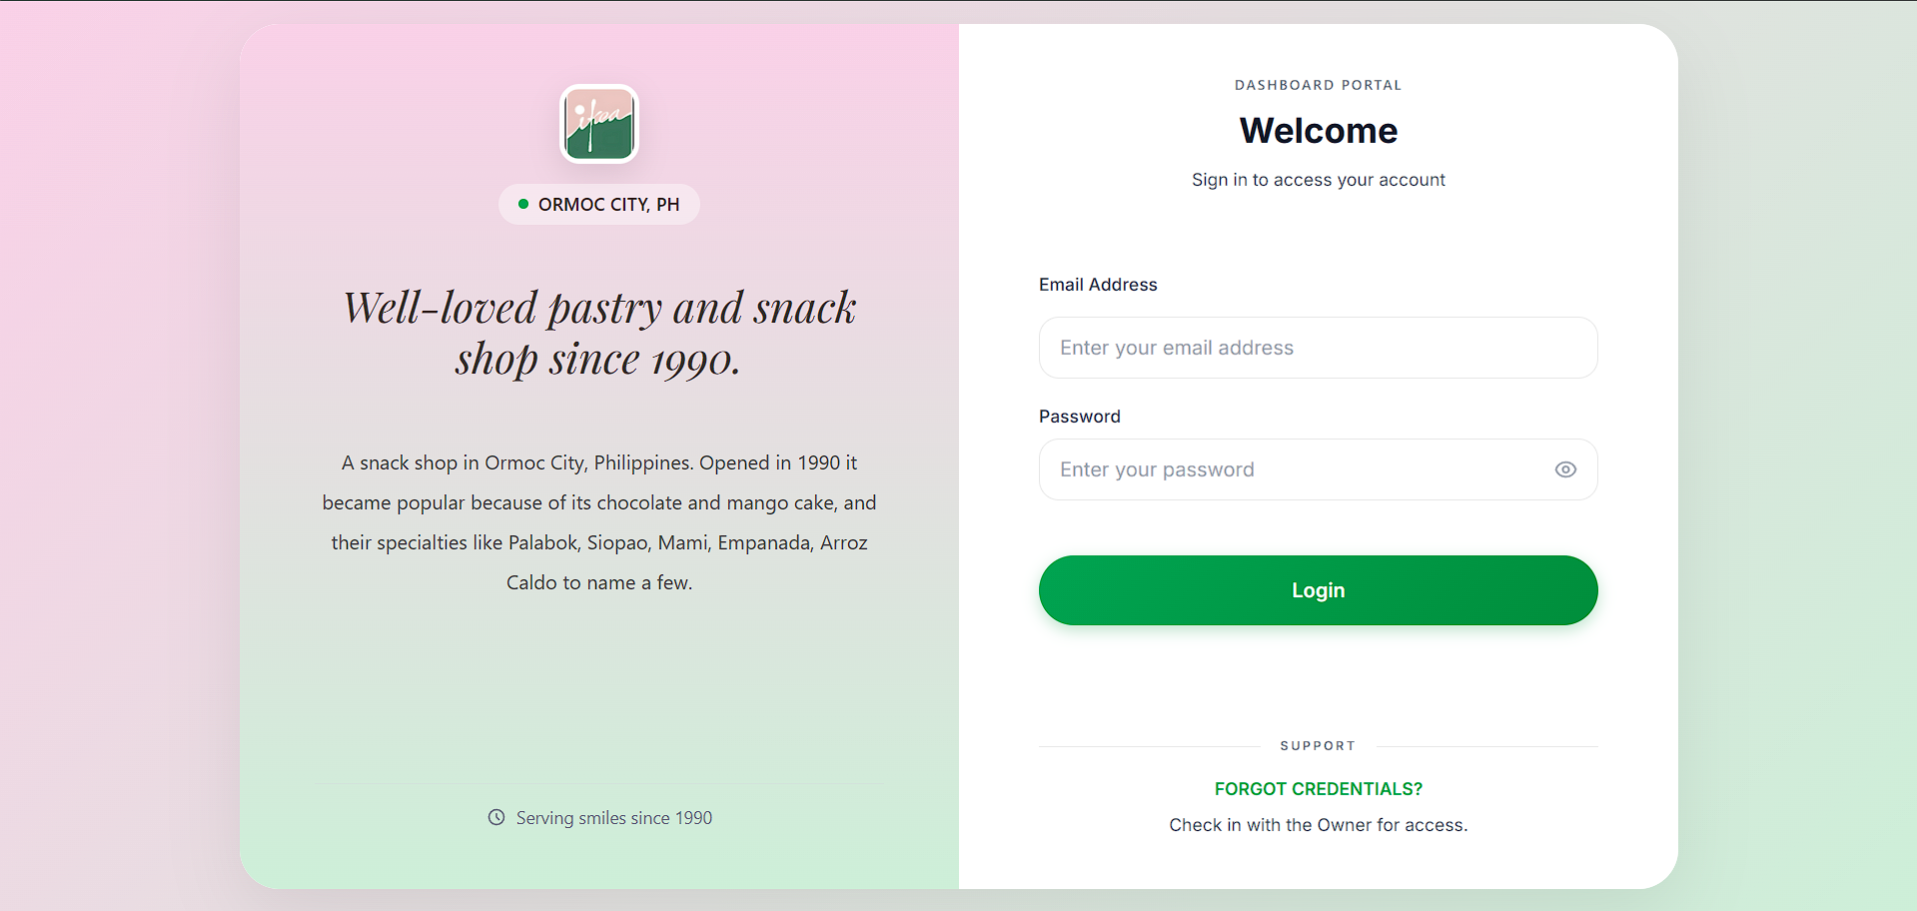
Figure 4.2
The login page acts as the system's entrance point and provides real-time feedback for invalid credentials, guaranteeing that only those with permission can access it. The layout enhances readability and usability with its simple, contemporary, and minimalistic design. Before allowing users access to the dashboard and other system modules, the login page serves to authenticate them.
Functionality
- It contains two primary input fields:
  - Email Address – allows users to enter their registered email.
  - Password – masks input to protect password visibility, with an eye icon to toggle view.
- A Login button submits the credentials for validation.
- A Support section provides a “Forgot Credentials?” prompt, guiding users to contact the system owner for account recovery.
User Experience Considerations
- The interface uses a two-panel layout:
  - The left panel presents branding, history, and store identity.
  - The right panel focuses on the login form.
- Ample spacing and clear hierarchy make the page easy to read and navigate.
- Typography is consistent, with readable font sizes and clear contrast.
- The green gradient and soft colors provide a calm, welcoming visual experience.
- The system maintains accessibility by:
  - Using high-contrast input boxes
  - Providing descriptive placeholder texts
  - Ensuring large button sizes for easy clicking
- The design adapts well to different screen sizes, supporting mobile responsiveness.
Consistency and Intuitiveness
- The visual style aligns with the brand’s identity—soft gradients, rounded corners, and minimal icons.
- Input fields and buttons follow a consistent shape, spacing, and alignment across the interface.
- Icons and labels are intuitive, helping users understand each component without difficulty.
- The login form is positioned where users naturally expect it—center-right of the screen—making access straightforward.
Annotated UI Elements (Login Page)
Left Panel
- Brand Logo — reinforces identity.
- Location Tag (ORMOC CITY, PH) — indicates service area.
- Tagline (“Well-loved pastry and snack shop since 1990”) — adds context and builds trust.
- Short Description — summarizes the business history and specialties.
- Footer Note (“Serving smiles since 1990”) — enhances brand storytelling.
Right Panel
- Heading: “Welcome” — greets the user and indicates purpose.
- Subtext: “Sign in to access your account” — clarifies action.
- Email Address Field — main authentication input.
- Password Field — includes password visibility toggle.
- Login Button — primary action button.
- Support Section — provides guidance for locked-out users.
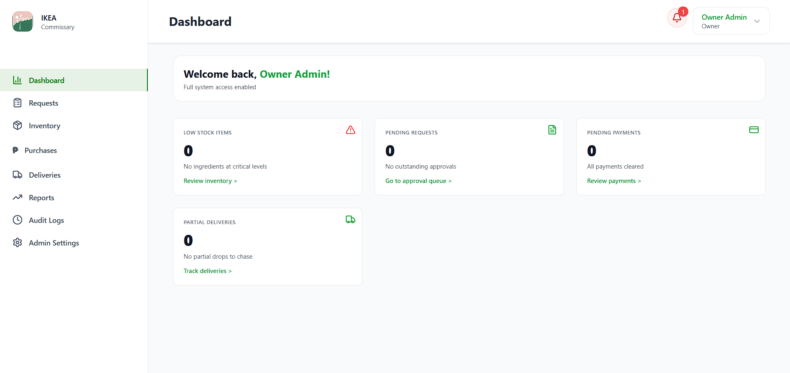
The dashboard functions as the system's primary control center. This interface allows authorized users to quickly access system status, pending tasks, and decision-supporting summary data after logging in. The dashboard's goal is to give users a real-time overview of system events, including deliveries, payments, pending requests, and inventory levels. Important information is centralized so users may act right away.
Functionality
1. Sidebar Navigation
The left panel contains the main navigation menu, allowing users to move between different modules:
- Dashboard
- Requests
- Inventory
- Purchases
- Deliveries
- Reports
- Audit Logs
- Admin Settings
Each item includes an icon for easy visual recognition.
2. Greeting and User Status
The top section displays a welcome message:
- Shows the logged-in role (e.g., Owner Admin).
- Confirms the user’s level of access.
3. Summary Cards
The dashboard displays four main summary widgets:
a. Low Stock Items
- Shows the number of ingredients at critical stock levels.
- Provides a link to "Review inventory" for immediate action.
b. Pending Requests
- Displays the number of approval requests waiting for review.
- Provides a shortcut to the approval queue.
c. Pending Payments
- Shows outstanding payment transactions.
- Includes a link to the payments module.
d. Partial Deliveries
- Shows the number of incomplete deliveries.
- Includes a link to track ongoing deliveries.
Each card uses visual cues (icons, colors) to differentiate types of alerts.
4. Notification Panel
- A bell icon at the top-right corner indicates system notifications.
- A red badge appears when unread notifications are present.
5. User Profile Menu
The user profile dropdown on the top-right:
- Shows account name and role.
- Provides access to account settings or logout options.
User Experience Considerations
- Clean and Balanced Layout: The dashboard uses a spacious, grid-based layout that avoids clutter and presents information clearly.
- Color Coding for Priority:
  - Red icons signal potential issues (e.g., low stock).
  - Green elements emphasize available actions or successful states.
- Readable Typography: Consistent and modern fonts improve readability, especially for quick scanning of numbers and labels.
- Quick Access: Summary cards include action links so users can reach detailed pages in one click.
- Accessibility:
  - Icons are recognizable and complemented with clear labels.
  - Buttons and links are sufficiently spaced for easier clicking.
- Mobile Responsiveness: The layout adapts to smaller screens by collapsing the sidebar and stacking the cards vertically.
Consistency and Intuitiveness
- Icons, spacing, and border styles remain consistent across all modules.
- The sidebar maintains the same structure throughout the system, helping users recognize navigation patterns.
- Card components follow a unified design—rounded corners, shadows, and typographic hierarchy.
- Visual grouping (cards arranged in rows) makes status information easy to digest.
- The interface behaves predictably: clicking any summary card always leads to the related module.

4.3 Module Description
This section describes the major functional modules of the system, including their inputs, internal processes, outputs, and the user roles assigned to each. Each module contributes to the overall goal of managing ingredient requests, inventory tracking, purchasing workflows, deliveries, and administrative control.
Module: Ingredient Requests
Input: Batch request details such as requested name, requested ingredients, date needed.
Process: The request is recorded, validated, and placed in the batch request history. The system sorts each request by status (Preparing, Approved, Rejected, Done) and moves approved batches to the “To Prepare” section.
Output: An updated list of request records with real-time statuses and a detailed request view.
User Role: Kitchen Staff, Owner.

Module: Inventory Management
Input: Ingredient details such as ingredient name, category, base unit, display unit, and reorder level.
Process: The inventory information is stored in the system and displayed as reference data for monitoring ingredient availability. The module serves as a placeholder for viewing current stock values, which are updated manually or through other modules when necessary. Items that fall below their reorder level are identified and highlighted to prompt replenishment actions. Users are allowed to search and filter ingredients by name, category, status, or alphabetical order to quickly locate specific items.
Output: Current inventory table showing Current Stock, Reorder Level, and Status (In Stock, Low Stock); visual indicators for low stock items; summary counts for Total Ingredients, Low Stock Items, and In Stock Items; a printable Purchase List.
User Role: Stock Handler, Owner.
Module: Purchase Item Entry
Input: The user input order details such as Ingredient name, quantity, unit, cost.
Process: The system validates that all fields are filled. Upon clicking "Add to Purchase List", the individual item's details (Ingredient, Qty, Unit, Cost) are transferred from the form to the Items list below.
Output: A populated row is added to the Items table; the input fields are cleared, ready for the next item.
User Role: Purchaser, Owner
Module: Purchase Batch Aggregation
Input: System: Individual items transferred from the Purchase Item Details Form; User: Actions to delete existing items in the list.
Process: Items are stored temporarily in a list/table. Actions are provided to allow the user to remove an item before the batch is finalized. Once the user clicks "Record Purchase Batch", the entire list of items is processed.
Output: A new transaction entry appearing in the Recent Purchases log, providing an immediate overview of the procurement activity. This entry contains crucial details that summarize the transaction: the Purchaser, Supplier, Payment status, Delivery status, and action buttons.
User Role: Purchaser, Owner
Module: Record New Delivery
Input: User/System: A specific, existing Purchase Batch is selected by searching or choosing from a dropdown menu based on the supplier, purchaser, or batch ID.
Process: 1. The module retrieves the details of the selected Purchase Batch (the items ordered and their quantities). 2. The user is prompted to enter the actual quantity Received for each ordered item. 3. The system compares the received quantity against the ordered quantity. 4. Upon clicking "Record Delivery," the system validates the input and updates the stock.
Output: 1. The Current Stock levels in the Inventory Module are increased by the quantity recorded as received. 2. The Delivery Status for the original Purchase Batch in the Recent Purchases log is updated (e.g., from Partial to Complete or remains Partial if not fully received).
User Role: Stock Handler, Owner
Module: Recent Deliveries Log
Input: System: Every successfully recorded delivery transaction.
Process: Each completed delivery is timestamped and logged with a unique Delivery ID. The log displays a summary of the received items, providing a historical record of all fulfilled orders.
Output: A table of recent deliveries showing the following fields: Delivery ID, Batch, Item, Quantity Received, Status, Date Received.
User Role: Stock Handler, Owner
Module: Purchase Filters & Details
Input: User: Date Range (From Date, To Date); Filters for Supplier, Item, Category, and Payment Status.
Process: The system retrieves purchase transactions that match the defined filters. The data is compiled into a detailed table and is available for export.
Output: A table of Purchase Details showing the Date, Item, Supplier, Quantity for each transaction.
User Role: Stock Handler, Owner
Module: Consumption Filters & Report
Input: User: Date Range (From Date, To Date); Filters for Category and Usage Status.
Process: The system consolidates all consumed or distributed batches within the selected date range. All consumption values are automatically converted and presented in the ingredient's defined Base Unit.
Output: A table of Ingredient Consumption showing the Ingredient, Category, and Total Used (Base Unit).
User Role: Stock Handler, Owner
Module: Audit Filters
Input: User: Filters for User, Module, Date Range (From Date, To Date), Keyword, and Show entries (number of entries per page).
Process: The system queries the master log database using the specified criteria and retrieves matching activities. It also allows for Clear Logs functionality, though this action is restricted to Owner.
Output: A filtered and updated Audit Logs table showing only the relevant activities and their associated details.
User Role: Owner.
Module: Audit Logs Table
Input: System: Every transaction or action successfully logged by the system (e.g., logins, request ingredients, approve request).
Process: Displays the filtered data, summarizing the event, the user responsible, and the time it occurred. The system tracks the total entries and activity for the current day.
Output: A detailed log showing: Activity, User, Time.
User Role: Owner.

4.4 System Features
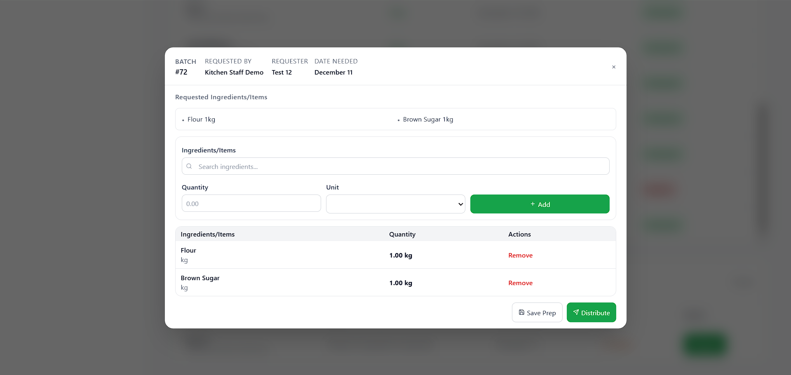

Figure 4.4.1

Based on the 4.4.1 screenshot, Once the stock handler finalizes the list of ingredients or items and clicks the Distribute button, the system automatically deducts the corresponding quantities from the inventory in real time. This automated feature replaces the commissary’s current manual deduction process, eliminating common errors such as incorrect encoding, delayed updates, and inconsistent inventory records. By integrating process automation, real-time data tracking, and system-controlled calculations, the feature ensures accurate stock levels, improves operational efficiency, and strengthens accountability. Additionally, the automated deduction supports better decision-making by providing up-to-date inventory status and can trigger low-stock notifications, enabling timely reordering and preventing production delays (Based on figure 4.4.2).

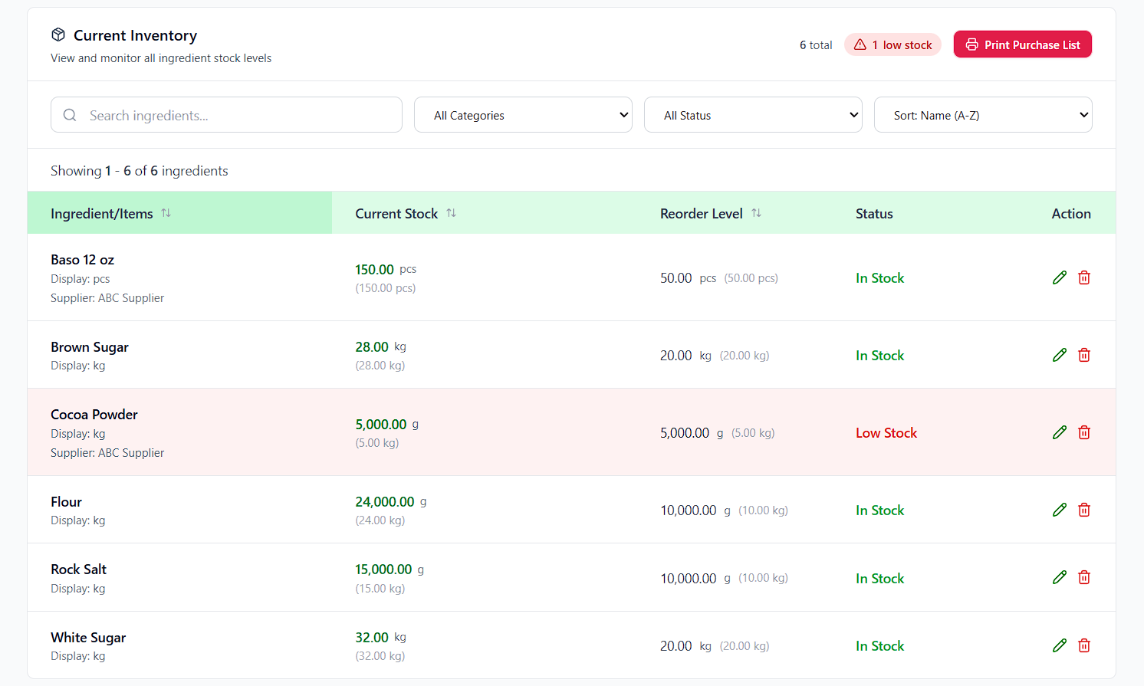
Figure 4.4.2

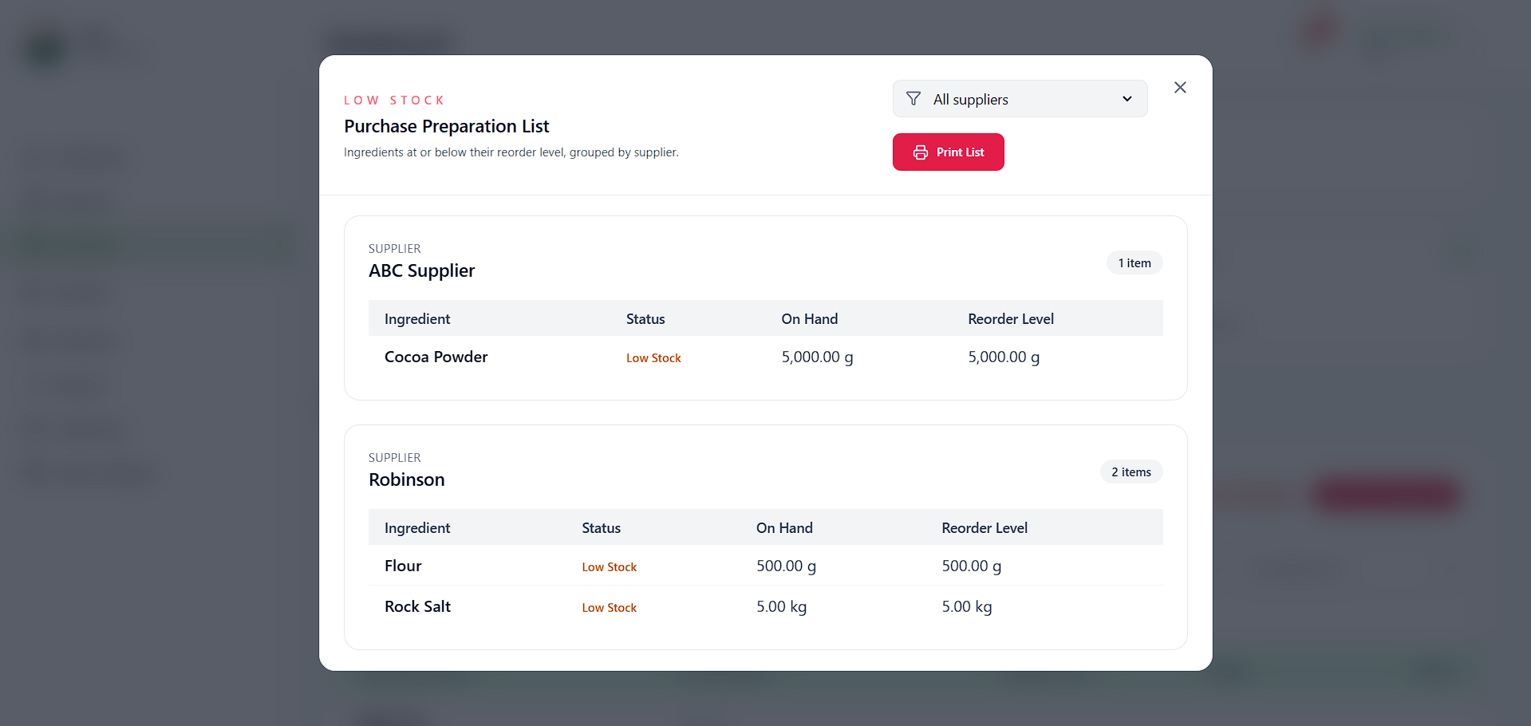
Figure 4.4.3

Based on the Figure 4.4.3 screenshot, the system includes a Low Stock Alert feature that automatically highlights ingredients or items once their current quantity reaches the designated reorder level. In addition, the system can automatically generate and print a list of low-stock items, which can also be filtered by supplier for easier monitoring and procurement. This automated functionality enables both the stock handler and the owner to quickly identify which items require replenishment, ensuring timely restocking and preventing production delays. Overall, this feature significantly improves efficiency and accuracy compared to the manual process of checking and identifying low-stock ingredients or items.

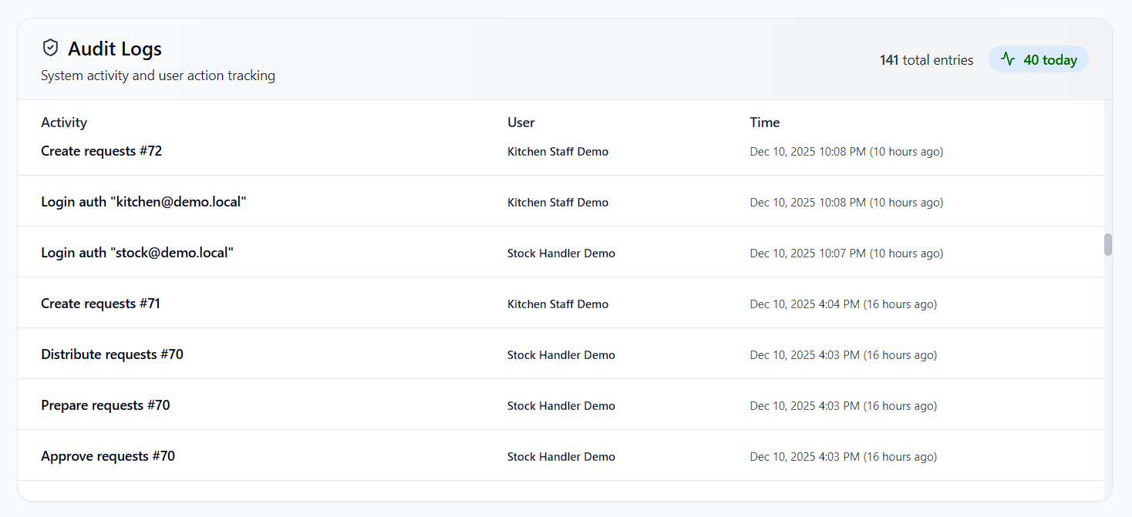
Figure 4.4.4
Based on the Figure 4.4.4 screenshot, the system includes a comprehensive Audit Log feature that records all user activities, including login attempts, request creation, preparation, approval, purchasing, and other key transactions. This centralized log enhances accountability and transparency by ensuring that every action is accurately documented and traceable. The audit module also provides multiple filtering options—such as by user, module, and date range—along with adjustable table entries and a search function, enabling users to locate specific records quickly and efficiently. Overall, this feature strengthens system security, supports performance monitoring, and reinforces responsible system usage by keeping a clear and organized record of all user interactions.

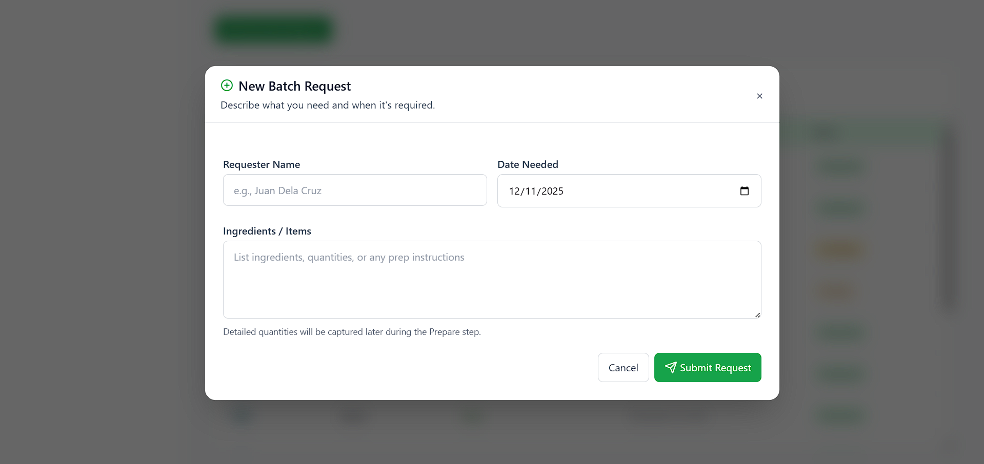
Figure 4.4.5
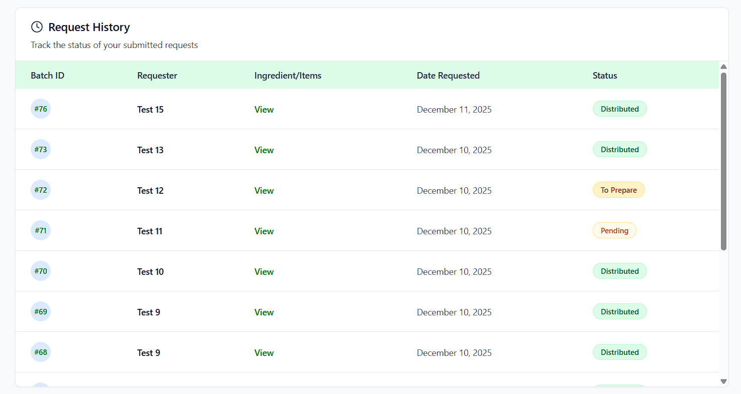
Figure 4.4.6

Based on the Figure 4.4.6 screenshot, the system provides a dedicated Ingredient Request feature for kitchen staff, allowing them to submit requests for needed ingredients or items by specifying their name and the required date, with all entries automatically recorded in the system. This digital process eliminates the current paper-based method, making requests more secure, organized, and less prone to loss or miscommunication. The module also includes a Request History table that displays all submitted requests along with their corresponding statuses such as distributed, to prepare, pending, or rejected (in cases where items are out of stock). This ensures full transparency, allows staff to monitor the progress of their requests, and streamlines coordination between the kitchen staff and the stock handler.

4.5 Security Features
The system enforces distinct authorization levels to restrict access to sensitive functions, thus preserving system integrity. Access is strictly governed by four defined user roles, each assigned specific permissions: Owner full administrative and financial oversight of the entire system, Stock Handler access to inventory levels and stock movement records, Purchaser authorized to initiate purchasing orders for supplies, Kitchen Staff limited to functions related to request ingredients or items. Password security is ensured through the utilization of the bcrypt hashing algorithm for hashing credentials. This mechanism employs an adaptive cost factor to significantly impede brute-force attacks, thereby protecting user confidentiality. All user input is rigorously validated and sanitized prior to processing. Data types, formats, and acceptable ranges are verified to ensure that only expected and safe information is processed by the system.

4.6 System Deployment

The system was deployed using the Hostinger web hosting platform, where a dedicated domain was availed to make the application publicly accessible. The deployed system supports multiple device types, including desktop computers, iPads, and mobile devices, ensuring consistent usability across various screen sizes.
During development, XAMPP served as the local server stack, providing the Apache server, PHP environment, and MySQL database required for system testing. After completion, the system was transferred from the local environment to the live hosting platform through the following procedures:
The project files were uploaded to the (public_html/IKEA) directory using Hostinger’s File Manager. File organization and directory placement were verified to ensure correct routing, asset loading, and system functionality.
A MySQL database was created and configured through Hostinger’s hPanel. The project’s local database was exported from XAMPP and imported into the newly created MySQL database in Hostinger. Necessary connection adjustments were applied in the configuration files to link the live server to the hosted database.
The live and fully deployed system can be accessed through the following URL: https://ikea-cakes-n-snacks.shop/.

RESULTS AND DISCUSSION

5.1 System Implementation
The system was successfully implemented and made operational on the Hostinger web hosting platform after initial development and testing in a local XAMPP environment. Throughout the implementation phase, key modules and features were deployed, configured, and tested to ensure that the system functioned as intended.
A step-by-step walkthrough of the implementation process was conducted. The source code was transferred to the live server, and the database was migrated to Hostinger’s MySQL service. After deployment, all modules including user authentication, dashboard monitoring, inventory management, request, purchase and reporting were thoroughly tested to verify their accuracy, responsiveness, and stability across desktop, iPad, and mobile devices.
The system was designed with four user roles: Owner, Stock Handler, Kitchen Staff, and Purchaser. Each role was assigned specific authorization levels to ensure secure and role-appropriate access to the system’s functionalities. A total of eight system sections were implemented, namely: Dashboard, Request, Inventory, Purchase, Deliveries, Reports, Audit Logs, and Admin Settings.
Access permissions were configured based on user type. The Owner was granted full access to all system sections. The Stock Handler was permitted to access the Dashboard, Request, Inventory, Purchase, Deliveries, and Reports modules. The Purchaser was allowed to access the Dashboard and Purchase modules, while the Kitchen Staff was limited to the Dashboard and Request sections. All access levels and role-based permissions were thoroughly tested to confirm that each account type could only navigate and use the sections assigned to them.
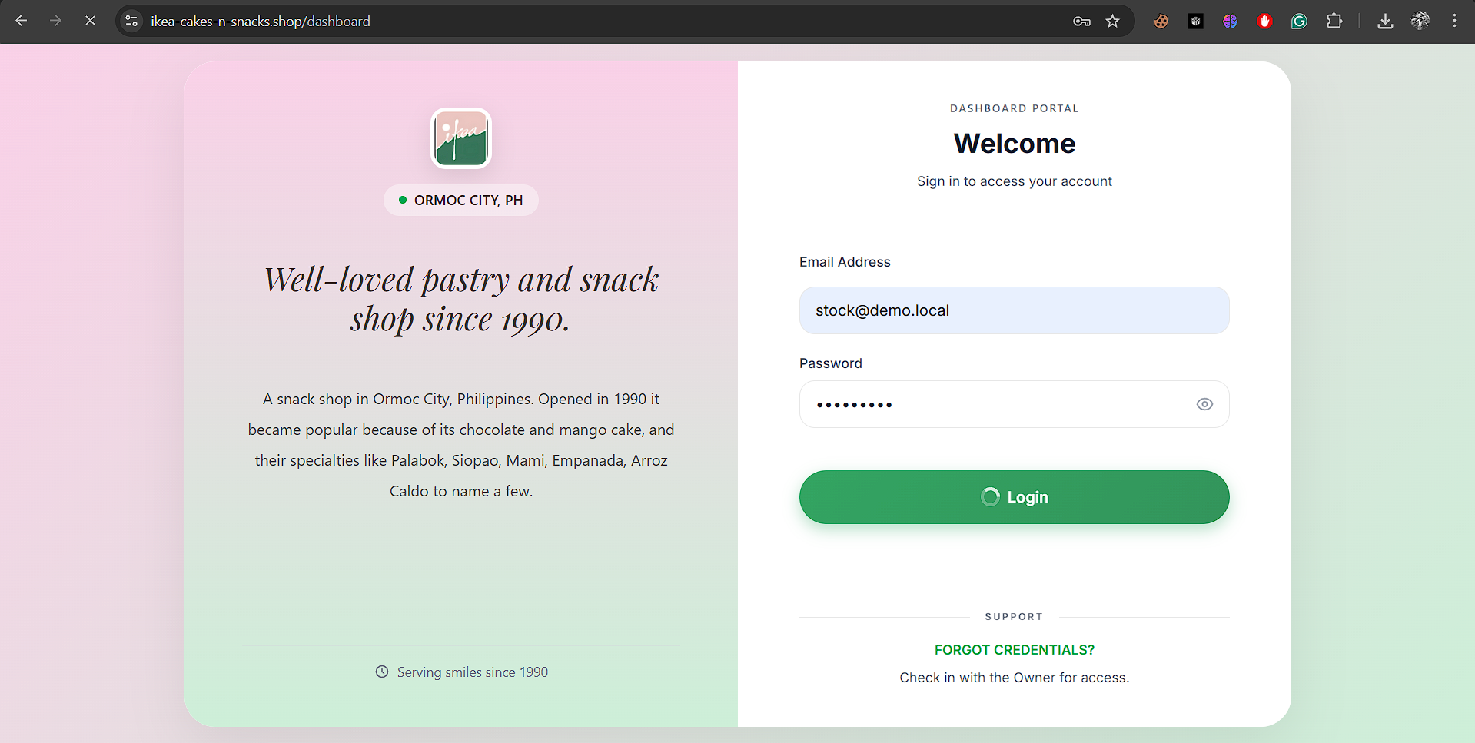
Figure 5.1.1
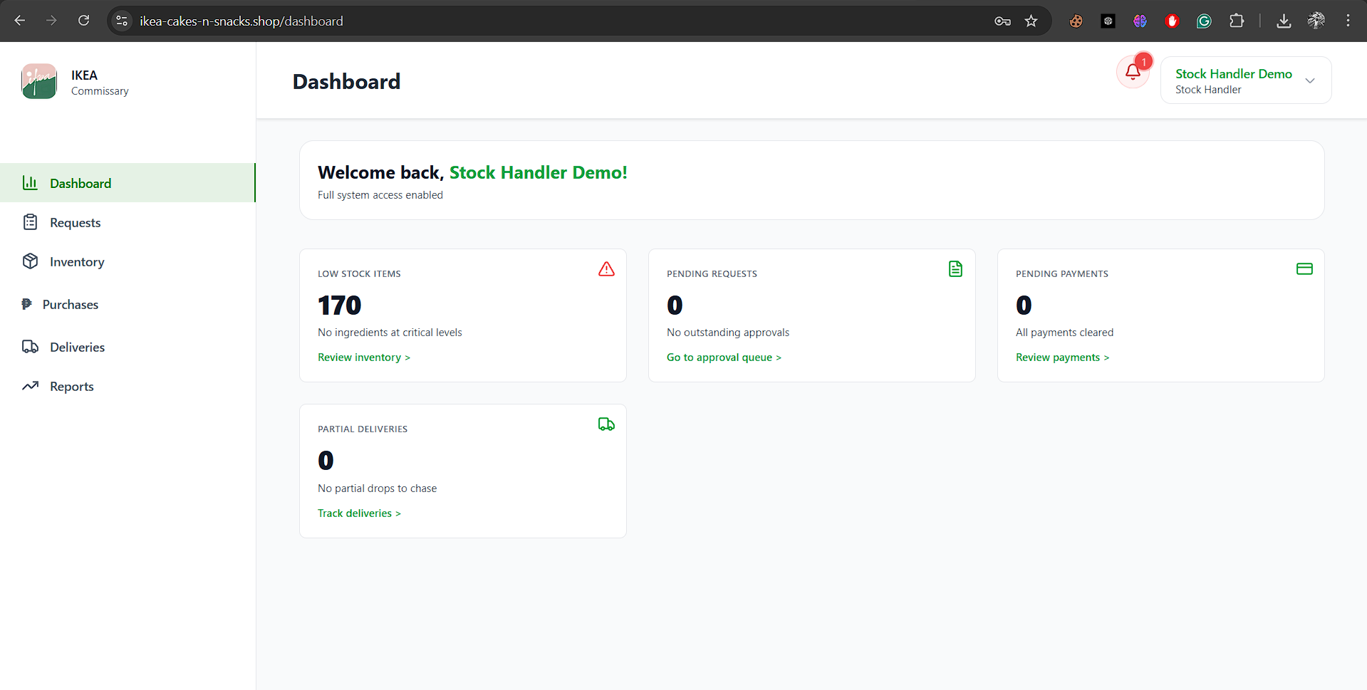
Figure 5.1.2
Figure 5.1.1 presents the Login Page, showing the interface where users entered their credentials to access the system. This screenshot demonstrates the authentication process and verifies that the login functionality was operating correctly. Figure 5.1.2 displays the Dashboard interface after a successful login. This confirms that authorized users were able to access the system and were correctly redirected to the main dashboard upon authentication.

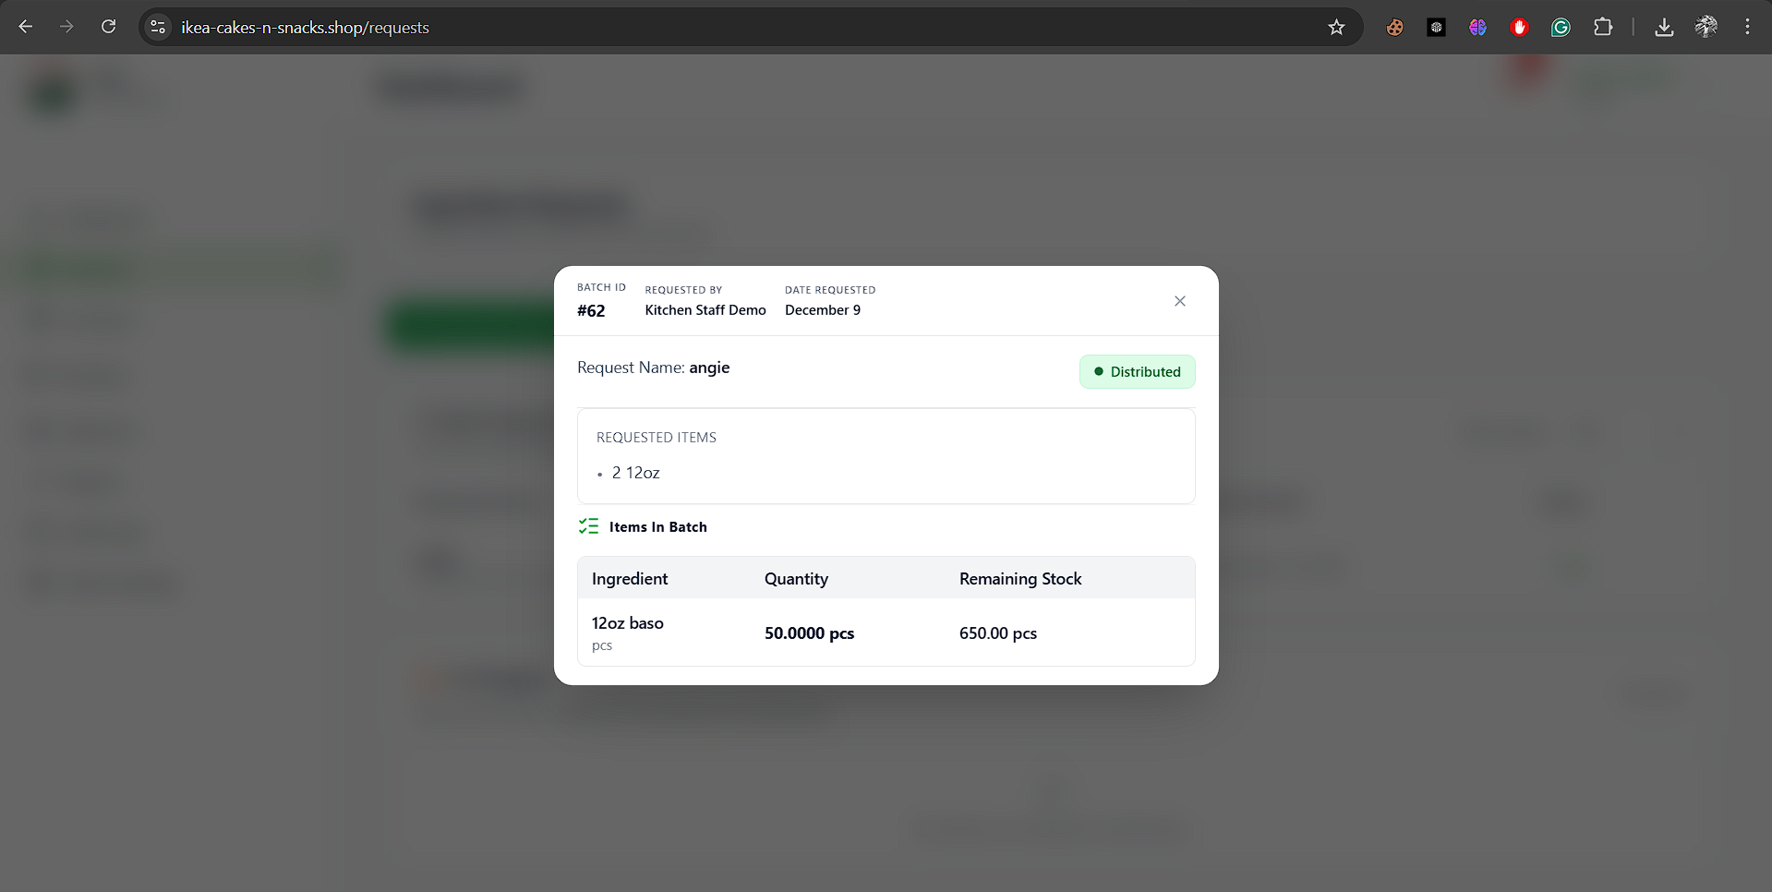
Figure 5.1.3
Figure 5.1.3 shows the successful submission of an ingredient or item request in the Request Section. The screenshot also demonstrates that the request was properly transmitted and made available to the Stock Handler for processing.
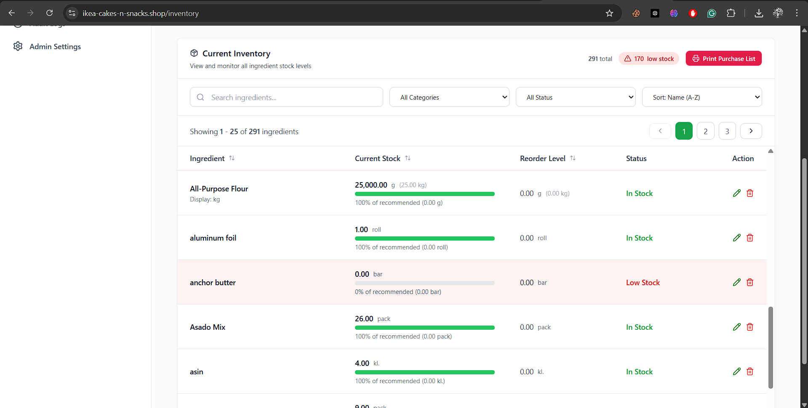
Figure 5.1.4
Figure 5.1.4 displays the current Inventory Table, where all ingredient and item entries are shown along with their corresponding remaining stock levels. The screenshot also highlights items that are marked as low in stock, demonstrating that the inventory monitoring feature is functioning accurately and effectively.
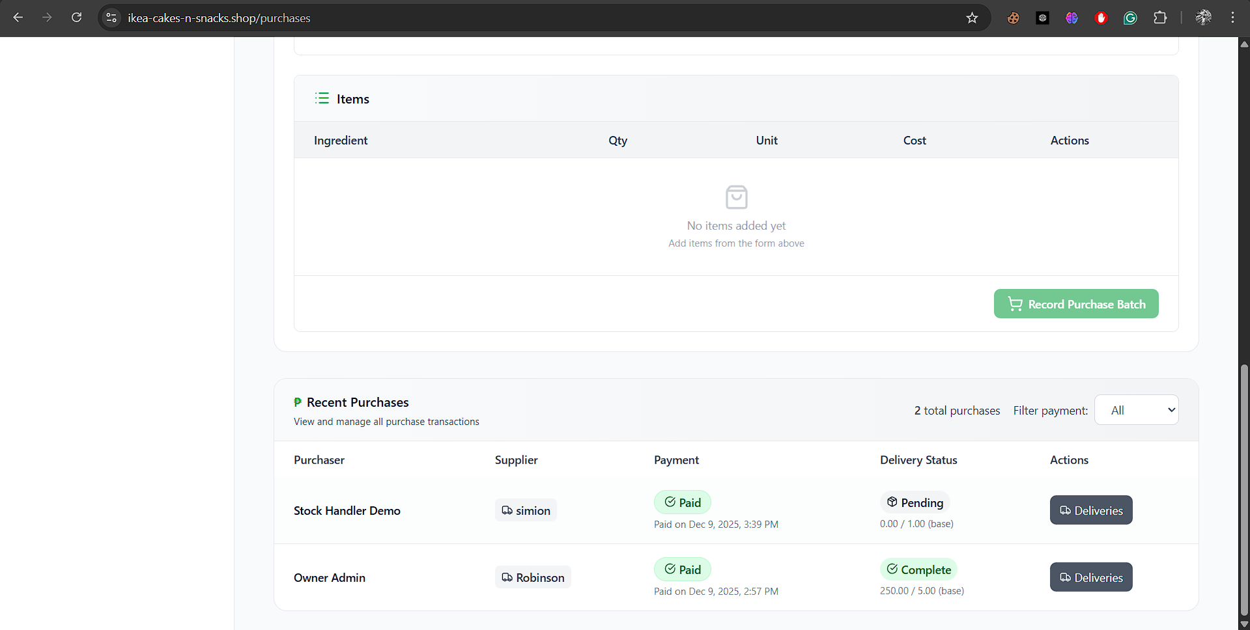
Figure 5.1.5
Figure 5.1.5 presents the Recent Purchase table, which displays the successful purchase transactions recorded by the Purchaser. The screenshot confirms that purchase entries were properly saved, reflected in the system, and included in the transaction history. This demonstrates that the purchasing workflow was functioning correctly and that the system accurately tracks and logs all purchase activities.
The current version of the system was implemented under a beta deployment status, allowing continued monitoring, refinement, and debugging based on user feedback gathered from real-time usage.

5.2 Evaluation Results

5.3 Analysis of Results

5.4 Summary of Findings

SUMMARY, CONCLUSIONS, AND

RECOMMENDATIONS

6.1 Summary

6.2 Conclusions

6.3 Recommendations

REFERENCES
Gill, A. (2023). Developing a centralized receipt service to streamline restaurant operations and reduce costs. Journal of Engineering and Applied Sciences Technology, 5(6), 1–12. http://dx.doi.org/10.47363/JEAST/2023(5)E130
Li, D. (2025). Intelligent inventory management system: Innovation and implementation of restaurant food management. Economics and Management Innovation, 2(1), 1–12. https://doi.org/10.71222/64cdzw06
Lim Hui Qi, Rahmat, A. R., & Suban@Ani, S. (2025). An inventory management system for small businesses. Journal of Digital System Development, 3(1), 29–44. https://doi.org/10.32890/jdsd2025.3.1.3
Sharma, P., & Saxena, A. (2021). Challenges and solutions for inventory management in small and medium enterprises (SMEs): A systematic literature review. Journal of Business Studies, 9(2), 45–60.
Wynn, S. (2021). The financial impact of manual inventory record errors [Doctoral dissertation, Liberty University]. https://digitalcommons.liberty.edu/doctoral/3208
Althaqafi, S. S. (2020). The relationship between inventory management and financial performance of small and medium enterprises. Journal of Accounting and Finance Research, 2(1), 10-25. https://www.eajournals.org/wp-content/uploads/Effect-of-Inventory-Management-on-Financial-Performance.pdf
Baskerville, R., & Myers, M. D. (2023). A user-centered design approach to information systems. MIS Quarterly, 47(3), 89-105.
Cabungcal, E. C., De Jesus, L. A., & Dela Cruz, M. R. (2023). The impact of inventory management on the financial performance of MSMEs in Santiago City. Philippine Business Review, 15(2), 45-60. https://www.researchgate.net/publication/373385793_Impact_of_Inventory_Management_on_Financial_Performance_of_MSMEs_in_Santiago_City
Gill, J. (2023). The evolution of receipt management: From paper to digital solutions. Journal of Digital Business, 11(4), 201-215. https://www.researchgate.net/publication/388194718_Developing_a_Centralized_Receipt_Service_to_Streamline_Restaurant_Operations_and_Reduce_Costs
Iyer, V. (2025). The role of data-driven decision-making in modern organizations. Journal of Business Strategy, 46(1), 78-92. https://doi.org/10.47191/rajar/v11i3.06
Li, A. (2025). The impact of manual records on food waste and operational costs in the food industry. International Journal of Food Science and Technology, 60(2), 112-125. https://www.fsis.usda.gov/news-events/news-press-releases/constituent-update-january-3-2025
Lim, S., Rahmat, M., & Suban@Ani, N. (2025). EzStock: A web-based inventory management system for small businesses. Journal of Information Technology and Systems Management, 20(1), 30-45. https://e-journal.uum.edu.my/index.php/jdsd/article/view/26384
Opoku, A., Mensah, F., & Boateng, K. (2021). The financial risks of improper inventory management: A case study approach. Journal of Financial Management, 8(3), 55-70. http://doi.org/10.17270/J.LOG.2021.557
Raji, A., Ijomah, C., & Eyieyien, B. (2024). Data-Driven decision making in agriculture and business: The role of advanced analytics. Computer Science & IT Research Journal, 5(7), 1565-1575. https://fepbl.com/index.php/csitrj/article/view/1275
Ravalji, S., & Singh, R. (2025). Responsive web design: A critical methodology for optimal user experience. Journal of Web Engineering, 24(1), 5-18. https://www.researchgate.net/publication/391994214_User-Centric_Design_for_Real_Estate_Web_Applications

