Kiffi Arts Print Shop

Shirt Order Transactions Management System

A Capstone Project submitted to the

Computer Science Department

as partial fulfillment of the requirements for the degree of

Bachelor of Science in Information Technology major Web Development

Garcia, Mark Louis M.

Mamon, Jyszzle M.

TABLE OF CONTENTS

Chapter Page

1 Introduction 1

1.1 Project Context 1

1.1.1 The Organization 2

1.1.2 The Ordering Process 2

1.1.3 The Opportunity 5

1.2 Purpose and Description 6

1.3 Objectives 7

1.3.1 General 7

1.3.2 Specific 7

1.4 Scope and Limitation 8

2 Review of Related Literature 11

3 Architectural Design 18

3.1 User’s Interface 20

3.2 Administrator’s Interface 22

3.3 Languages Used 22

3.4 Database Layer 24

4 Methodology 26

4.1 Requirements Specification 26

4.2 Analysis 33

4.2.1 Process Models 33

4.2.2 Data Models 38

4.3 Design 39

4.4 Development and Testing 48

4.4.1 User’s Module Evaluation 49

4.4.2 Developer’s Evaluation 49

References 51

CHAPTER 1

INTRODUCTION

* 1. Project Context

Everything in this world has been evolving. The innovation of our technology advances by decades and is still changing. Many organizations, industries, and businesses have their method for managing and processing the task conveniently. Computers are vital to each field of work. It is a great help since it efficiently manages time to each office works and can be processed at the same time. Likewise, it helps us to organize, control and monitor each work. One of the systems that are utilized today is the ordering system. It is utilized to view and manage records in a computer easier and faster.

The era of custom t-shirts began in the early 1950s, when several companies in Miami, Florida started decorating t-shirts with the names of local resorts and other tourist attractions. Since then, printed t-shirts are almost seen everywhere: university or organizational shirts, political advertisements printed on t-shirts, title of an event, different superhero characters, statement t-shirts and a lot more things printed on t-shirts. It is used as a method of personal expression through which individuals can express their political and social views, advocate for causes, or simply amuse onlookers.

This study focuses on t-shirt printing services and transactional management of orders. The Kiffi Arts Print Shop Shirt Order Transactions Management System is a system that would allow users to do shirt transactions, where they can design and order shirts anytime and anywhere. The system will give Kiffi Arts Print Shop’s clients a new and more convenient ordering process.

1.1.1 The Organization

Kiffi Arts Print Shop is a sought-after printing shop in Zamboanga City. Well-known for its great print quality and providing fast and reliable service which has been attracting more customers since 2008 by Mr. Kiffi Lakibul. It has two branches serving its customers: the main branch is located at Suterville, and the other branch at San Jose Gusu, both in Zamboanga City. Its products include car and motor stickers, t-shirt, photo-papers, badges, etc. Its services include but not limited to: piso text document printing, photo printing, editing, scanning, lay-outs, and CD/DVD burning.

1.1.2 The Ordering Process

The ordering process needs to be done in-store. Having an order of one to six shirts should be made three days or more before pick-up. For bulk orders, they recommend that ordering should be made at least two weeks before pick-up or delivery since materials are ordered in Manila.

The current procedure for ordering at Kiffi Arts Print Shop could only be done in-store. All of the customers should visit any of the branches and personally make their orders with the help of the staff. Customers need to have a soft copy or a hard copy of the text or image that they want to be printed on the shirt. Otherwise, they have to consult with the store’s layout designer. After providing the soft copy or consulting with the layout designer, the staff will decide if the design is doable or not depending on the type of shirt printing and kind of shirt that will be used. There are four types of shirt printing: Textile Paint, Rubber Vinyl, Sublimation and Transfer Paper. However, these types of shirt printing are not applicable to all kinds of shirts. Kiffi Arts Print Shop only does printing on Election Shirts and Cotton Shirts. For election shirts, only Textile Paint printing is used. For cotton shirts, all types of printing can be used. But for sublimation, it is intended for light colored shirts only. These will be explained to the customer by the staff and this time-consuming process taxes both ends. Most of the time, the hard copies of the text or image done by the customer get lost or misplaced. They also have a record book where they manually list the order details and staple the hard copies and these entries are sorted in no particular order. For changes to the order, the customer must go back to the print shop, and then browsing the record book would take time to find the customer’s records. There are times when several customers with different orders visit the print shop at the same time. Staff would need to accommodate their questions and orders; this is usually not a problem but when then are more customers at the same time, considering the fact that they only have few (1-2) staff to accommodate the rise in customer numbers.

Ordering consumes a lot of time both for the customer and the staff. There are factors that affect the inefficiency of ordering shirts. Some customers would ask numerous questions related to their orders. Some of the staffs aren’t familiar with all the questions given so it would take time for them to browse the information needed for the customer. Each and every problem must be addressed with the least amount of time and energy.

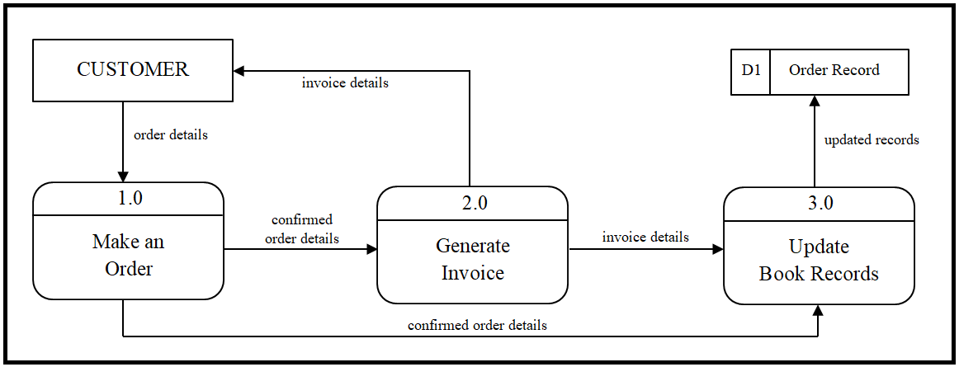**Figure 1.0** *Data Flow Diagram of the Present Ordering System*

The customer should visit a Kiffi Arts Print Shop branch to place an order. The usual time for accommodating a customer’s order is about thirty minutes or more. The customer should present the soft copy or hard copy of the text or image they want to be printed on the shirt or if they have no prepared image, they can instead consult with the shop’s layout artist and provide all the necessary details to be included in the text or image. During this process, the customers will ask a lot of questions and/or provide different ideas for the theme that they want. In this case, it will consume a lot of time for the Kiffi Arts Print Shop layout designer. After evaluating the image and the staff decides that it is doable, the customer then needs to proceed to the cashier personnel. For the order to be started printing, a fifty percent down payment of the total price should be made. This payment will cover the expenses for the printing of the shirts. After payment verification, the order and invoice details will be listed and stored in the book records of the shop. But sometimes, the order details and image get lost or misplaced especially when the order is not made in the main branch.

Thus, the creation of the order transactions management system is proposed to address such problem. The order transactions management system will be a creative platform powered by the internet that makes good use of design to boost sales and provide a venue for seller and customers to interact.

1.1.3 The Opportunity

Technologies today have progressed toward becoming part of life for getting any sort of data and information. Our proposed system is an open door for the Kiffi Arts Print Shop to keep up the great association with their clients by giving quality items and services. By ordering online, this will offer comfort in ordering of shirts instead of waiting for the shop’s availability and accommodation for its clients. It will also save their time and help them concentrate in processing the pick-up and walk-in orders. The system will give the clients the opportunity to place an order at their convenience. On the hand, the system will provide the print shop a more organized management of order transactions.

Our proposed system will be having several modules for its clients. The system will contain links for the profile information of registered clients and the list of their previous orders and transactions made in the website. A link for the designing of shirts will also be provided. For this, a canvas will be provided where the customers can create their own designs from scratch. The system will also provide a module for the user-to-site interaction in a form of chat. Processing of orders will only be made available for the registered clients of the website. The system will handle online payments. Clients can likewise order anywhere they are and whenever they need or feel like it. This will help save their time as opposed to waiting for the shop’s accommodation and availability.

The ordering process will be carefully monitored each step of the way to be able to manage and handle orders properly. Inventory management will be provided for the print shop to strike a balance between fulfilling the demands of the customers and maintaining adequate supply of materials. The system will also be able to update the status of an order, be able to calculate the order price depending on the type and quantity of orders, be able to manage order cancellation/returns depending on its policies, and be able to provide options for customers on the payment and delivery method.

* 1. Purpose and Description

One of the purposes of the Kiffi Arts Print Shop Shirt Order Transactions Management System is to address the necessity for a quick and queue-free ordering system. This gives opportunity to clients by letting them order online and save time, as opposed to having to answer landline/phone calls, and personally visiting the shop’s office, waiting for the shop’s availability and accommodation to design a shirt for them. This system can offer clients with fast and reliable way of ordering shirts to Kiffi Arts Print Shop. The easy and accessible feature of the system would also help them order anytime and anywhere because it is open 24 hours. It can likewise function as a medium from which the organization can stay in contact and stay receptive to clients' decisions and choices.

The Kiffi Arts Print Shop Shirt Order Transactions Management System is a web-based system that allows customers to order shirts online, without having to personally go in their shop. It simplifies the ordering procedure between the print shop and the clients. This system would be able to help monitor, identify and prioritize orders depending on the date ordered or from the request of the clients. Through this, the manual listing and recording of orders in the Kiffi Arts Print Shop is eliminated. It secures the records consistently and can easily track different orders. By having the proper handling and management system of orders, it will help them avoid losing possible customers and keep present customers because one reason why organizations lose its customer is because of orders that were not given immediate attention.

* 1. Objectives

1.3.1 General Objective

To develop a web-based management system for Kiffi Arts Print Shop’s shirt order transactions.

1.3.2 Specific Objectives

* + - To develop a website where customers can place their orders
    - To develop a module to manage clients’ order and delivery records
    - To develop a canvas that allows clients to upload their own shirt designs and incorporate it to their choice of shirt
    - To develop a module that calculate discounts and generates the total price of an order
    - To create a module that will allow customers to save their order as draft and access it at a later time
    - To create a module that will allow clients to receive status of their order through SMS and web portal
    - To develop a module that monitors the due date and delivery status of orders as well as a module that monitors the percent completed of printing
  1. Scope and Limitation

The order transactions management system is only exclusive for the shop’s shirt printing service. Other ready-made products are sold in their branches. The system allows only registered customers to access the shirt designing page provided by the Kiffi Arts Print Shop. The shirt designing allowed in the system is minimal and is limited to the print shop’s capacity to have the printing done based on the image provided by the customer. The customer can only add texts, change font colors and upload multiple images or logos in designing the shirt. Design library will be available in the system, where ready-made shirt designs are stored and can be utilize by the customer for their transactions.

The price displayed in the system is auto calculated and tentative. A Kiffi Arts Print Shop staff is assigned for the evaluation of prices and will inform the reasonable changes about the price to the customers during the confirmation method through call and could explain further during the approval method once the customer will pay for a down payment. Discounts are auto-calculated once the total price is greater than five thousand pesos. The discount will start at five percent.

<insert discount table here>

The system does not limit the number of customers that may order on a same date. The system will show the available dates for pick-up or delivery based on all the orders that has been made. Once the customer is done designing and the request is sent to the shop, the order is verified by the staff via phone call.

The customers will have a choice whether to design a shirt from scratch or modify a design from their previous orders that has not yet printed by the shop. Both options have a few policies or reminders that the customers must take note before proceeding. First: for bulk orders, the order should be made at least two weeks before pick-up or delivery. As for orders with one to six shirts only, the order should be made at least three days before pick-up. Delivery service is only available for bulk orders. Second: an order status is shown in the order details from the customer’s list of details. These statuses are: Pending, the order has not been viewed by the shop’s staff; Approved, the order has been reviewed, evaluated and approved by the shop’s staff; Confirmed, the shop’s staff will verify through phone call and a down payment has been made; Cancelled, the order has been cancelled by the customer or the shop’s staff; Printing, on the process of printing the shirt; and Delivered, when the order has been picked up by or delivered to the customer. Only when the status is ‘Pending’ the customer is allowed to make some changes to the order details or modify the image design. Once the status is ‘Printing’, changes and modifications are no longer allowed by the system.

Available shirt colors will be displayed in color swatches. Choosing dark colored shirts will disable the sublimation type of shirt printing. Rubber Vinyl has other types other than the ordinary one, which are: Reflectorized, Glow-in-the-Dark, and Gamuza. For sublimation, preferably A4 size.

For the Shirt Quantity, the minimum is one order for cotton shirts. On the other hand, the system will only allow the number of quantity that will have a total price of at least five thousand pesos. If the customer wishes to pick-up the order, the system will ask for the date of pick-up, time, and branch. Otherwise, the system will ask for the date of delivery, time, and location.

Once the customer is done designing a shirt and submits the order, the Kiffi Arts Print Shop staff will be notified. Once the order has been reviewed, evaluated and approved, the staff will call the customer for confirmation and will be asked to go to any of the two branches for down payment. In case of some changes due to renovation or relocation of branches, the staff will notify the customer ahead of time via phone call to inform the customer about the change of pick-up venue. Changes to customer’s order details will also be made.

The developers chose to make the proposed system as web-based. Allowing the customers to design or order a shirt online will benefit them in many ways. They are not limited to the time that they can order a shirt. Customers can order even when the print shop is closed: at dawn, on Sundays, or even on holidays; the system will automatically save their order details. Creating an avenue for customers to create, order and access information about the products of the print shop via our online system is not just a way to get more loyal customers but to also ensure a steady flow of orders that is recorded and organized. The customer trends will also serve as information from which the print shop can learn more to be able to better serve and sell their products.

CHAPTER 2

REVIEW OF RELATED WORKS

The literature presented here shows a review of a system related to this project focusing on the steps the customer takes when they make use of an online shirt ordering system. By getting ideas on these reading materials that are related to the online system, it will guide the researchers to achieve their target objectives and make improvements as possible. The developing team will draw inspiration from these related systems in creating the Kiffi Arts Print Shop Shirt Order Transactions Management System. The team will replicate its function of choosing shirt product, and add text or upload own image, and providing pick-up or delivery details. This will help in organizing and managing the ordering process of Kiffi Arts Print Shop. This will also be a great opportunity for them in upgrading their service to their customers. The proposed system will be help in saving time and giving a lot of convenience to both users. Kiffi Arts Print Shop Order Management System includes technology and solutions that would make the ordering process more efficient. These technology and solutions include: customer’s profile, order list, and order notification and print shop’s order monitoring. With these technologies and solutions, we believe that the system would be more reliable and will save more time for both the customers and the Kiffi Arts Print Shop staff.

2.1 Order Management Systems

The system involves looking at the functionality of these systems that include an order management. According to Haselden (2015), every seller starts out small. The seller could get by doing the entire order process by hand. But when the store experiences rapid growth and with the influx of orders, the seller will feel the pain of the manual processes that are prone to error. This is why a seller needs an order management system. This will help the seller organize and fulfill the orders efficiently. Thus, he compiled a top five list of order management systems. The order management systems he looked at are: Ordoro, CrazyVendor, TradeGecko, Newgistics, and Freestyle Solutions.

Accordingly, the areas a seller should pay attention to when choosing an order management system includes: Price, the lowest tier pricing plan available; Order Amount, the amount of orders a seller can process a month; Users, the number of users you can have on the system; Support, the support plan for customer’s concerns; Shipping, whether or not the system has a shipping solution; and Inventory, whether or not the system has an inventory management solution.

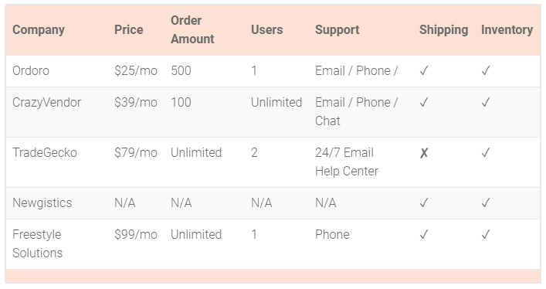Comparison of the top five order management systems:

All of these order management systems are not perfect based on the areas that a seller should to pay attention to when choosing one. The researchers will incorporate the best options per area in one system. For the price, it is as low as ₱1000 annually for web-hosting; order amount is unlimited since there is no limit to the number of customers that may order on a same date; users are unlimited since there is a module to track which administrator alters or manages the system for the time being; support is by e-mail, phone or chat, to provide customers different support choices; shipping and inventory management solutions will also be available.

2.2 Online Shirt Designing

The system also involves looking at the functionality of systems that include online shirt designing. There are multiple shirt designing features available online. Three of which that are chosen in the development of the Kiffi Arts Print Shop Shirt Order Transactions Management System are Norwest Graphics (www.norwestgraphics.com), Rush Order Tees (www.rushordertees.com) and Uber Prints (www.uberprints.com).

Norwest Graphics has specialized in custom products, custom apparel, and business forms for over 30 years, and its website is a shirt ordering website for customized shirts. Its feature includes choosing a shirt product from different categories, product color, quantity and sizes, adding of text and editing its style, adding of art from its art library with different categories, or adding a name and number with an option to choose a standard or customized position, and choosing a shipping option.

The pricing is based on the shirt product chosen, text and/or art added. The user can access Quick Quote from the navigation menu to have an idea how much the order will cost, or go directly to the Design Lab which is also accessible from the navigation menu and immediately customize a shirt and the amount will be computed upon providing the quantity and sizes.

The second system is a website called Rush Order Tees (www.rushordertees.com). The company is founded in 2002. It did not have any intent on becoming what it is today, but the online service was built with the customer in mind so that their ordering experience would be as easy and effortless as possible. The system is also a shirt ordering website. Its shirt customization feature includes choosing a shirt product from various categories, product color, quantity and sizes, adding and editing of text, adding cliparts from its clipart library with different categories, uploading own image, or adding a personalized text, providing the shipping details. Prices may vary depending on the shirt chosen, text and/or art added and prices are shown once the customer is done customizing. The above mentioned are the same as Norwest Graphics key elements. The difference is that, Rush Order Tees has no Quick Quote module where the customer will have an idea how much the order will cost.

Uber Prints (www.uberprints.com), is a direct-to-website shirt printing company since 2005. The company’s goal was to make it easier, faster and more convenient than ever to get quality custom apparel printed and delivered directly to its customers. Its feature includes choosing a shirt product, quantity and sizes, and shirt color; adding of images such as choosing cliparts from its clipart library, or uploading one’s own image; adding of text and editing its style; editing product, like swapping of colors; and choosing of decoration methods, which include screen print or digital print.

There are three key elements in the Kiffi Arts Print Shop system that these systems do not have: First, these websites do not have registration modules. They do not allow customers to create their own accounts. Second, prices are not shown automatically for every required detail that is added. Third, the decoration method or types of shirt printing is not only limited to two but four which includes Textile Paint, Rubber Vinyl, Sublimation and Transfer Paper. There are also four kinds of rubber vinyl: Ordinary, Reflectorized, Glow-in-the-Dark, and Gamuza.

2.3 Report Generator

Chart.js is a library that helps developers visualizes data from database to the website (Rometty, 06 September 2016). It is commonly used by many developers because it is easy to use and its ability to customize different charts. It will get the data from the database and use it to determine the position of the graph’s figures and labels. This graphing library has the same function as the report generator of the proposed system. All the data from the database will be fetched and will be used to visualize a graph that will help the Kiffi Arts’ staff in determining statistical report of the produced shirts.

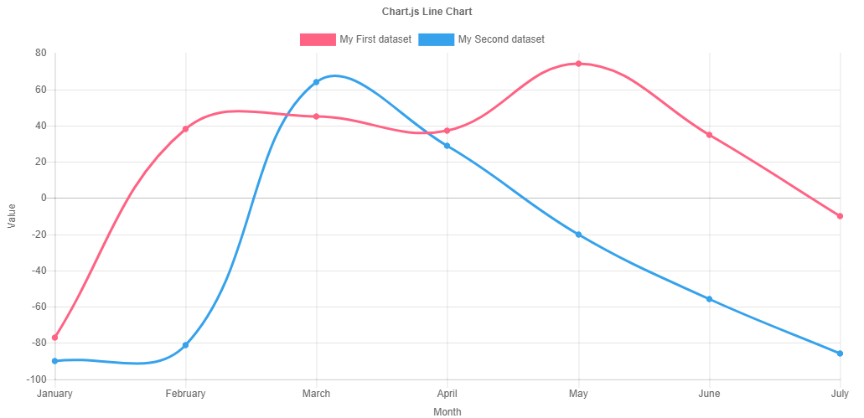

**Figure 2.0** *Example Chart.js line Graph*

Report Generation System enable user to create scheduling reports ([www.icom-software.com](http://www.icom-software.com)). The same as the previous related system, this system will fetch all the data and the produce the report. However, there is a slight difference in the final output. This system gathers all the data from a specific system, generates all the reports and then export it to an MS excel worksheets. The user of Report Generation system can access different version of reports using the default and other provided options in system. The same as the proposed system, Kiffi Arts’ Staff can access all the reports using the default menu provided in the system. Furthermore, they can still access previous reports.

2.4 Design Gallery

Custom Ink is an online shirt shop; they offer a collection of international and local brands of shirts ([www.customink.com](http://www.customink.com)). Aside from selling different brands in their own in-house labels for apparels, they also allow their user to design the shirts. (see figure 2.1). They also provide the pricing and delivery details.

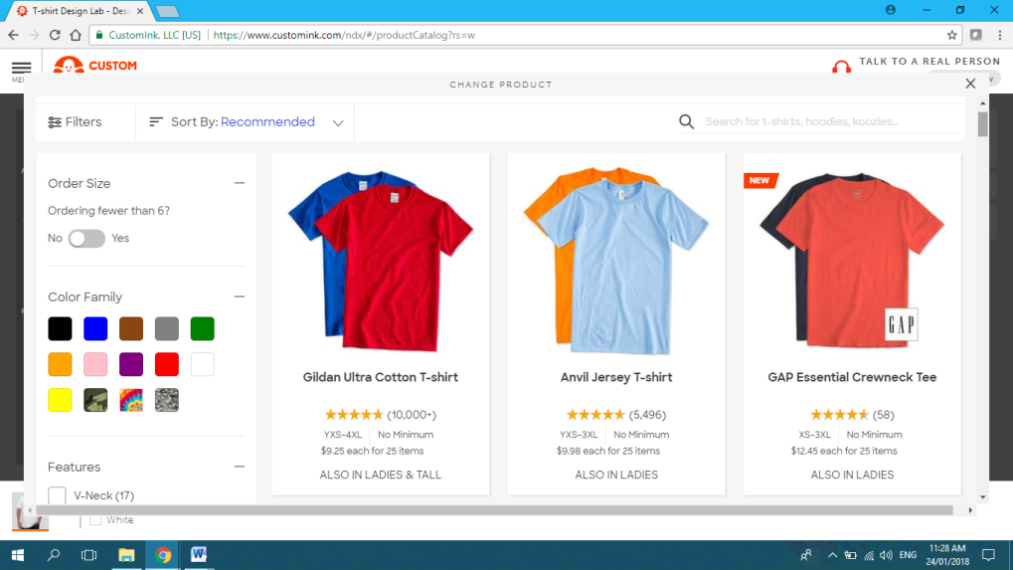

**Figure 2.1** *Example Custom Ink’s in-house designs*

They create and showcase their own design and it has been selling. The design Library feature of the Kiffi Arts Printing Shop Order Management System is like how Custom Ink features their designs. The ready-made designs of Kiffi Arts will be uploaded by the staff in this section and can be accessed by customers in ordering.

Crossfit Mayhem is a fitness program in Cookeville. They offer different courses for different clients ([www.crossfitmayhem.com](http://www.crossfitmayhem.com)). Moreover because of continuous growth of their business they have launched their online store for different kinds of apparels for all kinds of gender and age. They post all their designs in their online store that allows customers to order and pay online (see figure 2.2). just like the online store of Crossfit Mayhem, this is how the design library of Kiffi Arts Printing Shop order Management system works. All their designs will be uploaded in this library and then the customer can use in ordering.

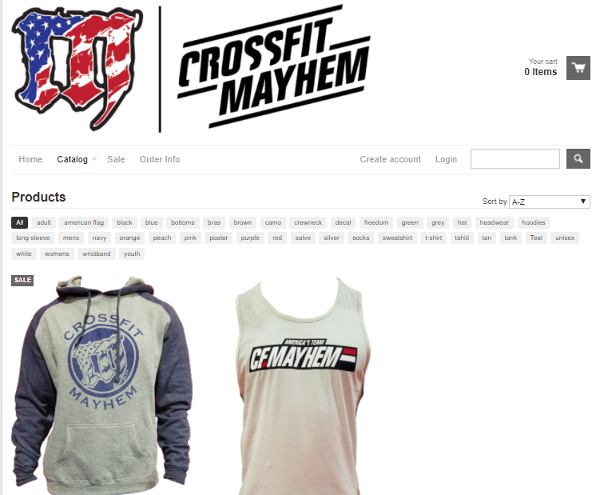

**Figure 2.2** *Crossfit Mayhem Online Store*

CHAPTER 3

ARCHITECTURAL DESIGN

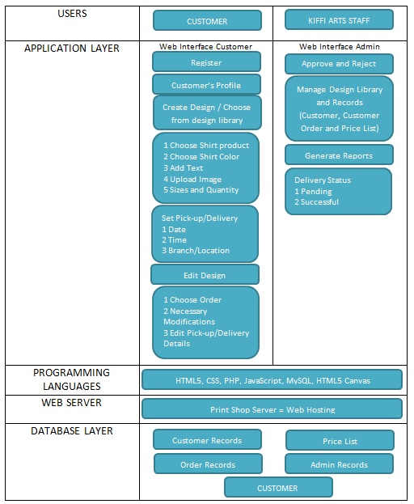 This architectural design is a baseline which typically consists of the list of modules and briefly shows the functionalities for each user (customer and Kiffi Arts Print Shop’s staff). It will also show their interface relationships, dependencies, database tables and technical details.

**Figure 3.0** *Layered Architectural Design*

In figure 3.0, there are two users who have different access privileges in the system, the customer and the Kiffi Arts Print Shop staff. It is assumed that the customer has internet access and is computer literate. There are three customer interfaces namely: registration, customer’s profile, and customization template for the shirt. The privileges of the customer include: registration, update profile, create own design or modify design from previous orders, and set pick-up branch or delivery location.

Customer privileges:

* Registration: this is where the customer inputs their personal information. The information taken are name, address, contact number, etc.
* Customer’s Profile: this page displays the information that the customer registered during the registration process. The customer can access this page to edit his/her profile if there will be any personal information changes.
* Create Design/Choose design form Design Library: this is where the customer can create a shirt design from scratch by choosing the type and color of the shirt. The customer may add text and customize its font style and size. Ready-made designs from the owner of the shop are also provided in the Design library where the customers can access and choose designs from.
* Set Pick-up Branch/Delivery Location: the customer can choose a branch where they want to pick up their orders, or choose a delivery location where they want the bulk orders to be delivered.

There are also four interfaces for the administrator, which are: pending orders, inventory, orders list and reports.

Administrator privileges:

* Pending Orders: the administrator can approve an order if the design for printing is feasible, otherwise reject it.
* Orders List: should there be any changes, the administrator can view and edit the details of a customer’s orders.
* Design Library: this is where ready-made designs of Kiffi Arts are uploaded by the staff.
* Reports: a list of daily and monthly reports for successful and unsuccessful deliveries. Generation of sales reports is also included here.

3.1 User’s Interface

The registration module will ask basic information from the customers, such as: e-mail address as username and password. After a successful registration, the information gathered is stored in the database, and the customer will be directed to the login module where it will allow the customer to log in to their account. Once logged in, the page will redirect to the homepage of the Kiffi Arts Print Shop website with customer’s profile and logout buttons enabled. In the customer’s profile page, the user can edit information such as name, address, and contact number for future transactions purposes.

The homepage will include a “Start Designing” button but it will notify that the customer will need to login to be able to access the online designer tool. An “About Us” section is also included where a brief information about Kiffi Art Print Shop is included. Beside the “About Us” section is the “Ready-Made Designs”, it is a preview of some of the ready-made designs of the print shop. “Discount Chart” shows the percentage discount for every price range. “Location” is the list of the print shop’s branches, that when clicked it will display the location of these branches where the use of Google Maps will show. This page also provides social media buttons which can redirect the customer to pages Kiffi Arts Print Shop is engaged in.

Customer’s Profile displays the information of the customer; they can also edit the details of their profile. On the customer’s profile page, it shows the customers their orders list. It shows table where it lists the orders that the customer have created. The table has the following details: date created, shirt product, shirt color, image designs, tentative price, and order status. Date created is the date when the customer submitted the order. Shirt product shows whether the customer chose election shirt or cotton shirt. Shirt color shows the color of the shirt that the customer picked. Image designs are the images in jpeg file type, these images are based on the location on the shirt of the design, which are: front, back, left sleeve, or right sleeve. The tentative price shows the undiscounted price. And order status, it enables the customer to know if the order is pending, approved, confirmed, cancelled, printing, or delivered.

The start designing functionality is the module for creating a shirt design from scratch or for customizing a shirt design from the design library. The steps in creating a shirt design from scratch are: choose a shirt product, choose a shirt color, insert text or image, input quantity and sizes, and include pick-up or delivery details. There is only a slight difference in the steps when modifying a shirt design from the design library. Both have the same steps but when modifying, the customer will have to choose a design from the design library first and then insert additional text or image.

3.2 Administrator’s Interface

The administrator’s modules have the comprehensive privileges of managing and maintaining customer’s records, order records and design library designs. The first module is the login page, this is to track who accommodates orders during the time period. Once logged, the page will redirect to the dashboard page where it shows the notification of all orders. There are two notification widgets for the Kiffi Arts Print Shop staff. The navigation panel is displayed on the left side of the interface.

3.3 Languages Used

All modules that are used in the system use different types of programming languages such as HTML, CSS, and scripts; each module performs an important role in the development of the system.

HTML (Hypertext Markup Language) is one of the core technologies for building webpages and also the language for describing the structure of webpages. It publishes online archives with headings, text, tables, lists, photos, and retrieves online data by means of hypertext links. HTML has the way to design forms for directing transactions with remote services, for data searching, making reservations, ordering products, etc.

CSS (Cascading Style Sheet), on the other hand, is also one of the core technologies for building webpages. It is the language for describing the presentation of webpages, and provides the visual and aural format including colors, layout, and fonts. CSS allows one to adapt the presentation to a variation of devices and screen sizes such as large screens, small screens, or printers. Alongside designs and scripting, HTML and CSS are the premise of building webpages and web applications.

A client-side script is a scripting language that is embedded within and interacts with the HTML of a website, selecting elements of it, and then handling those elements to give an interactive experience. Scripts interact with a CSS file that styles the way the page looks. It directs what work the server-side code will need to achieve, where ought to be worked around front-end functions, and returns information that is taken from the website in a way that is readable by the browser. JavaScript is client-side scripting. The most commonly used client-side script where nearly every site’s front end is a combination of JavaScript, HTML, and CSS. JavaScript is run by an array of excellent frameworks that simplifies it and gives it more agility. The HTML5 canvas element is utilized to draw graphics, by means of using JavaScript. The canvas element is only a container for graphics. It must use JavaScript to actually draw the graphics. Canvas has a number of ways for drawing paths, boxes, circles, text, and adding images. Through the canvas, it will enable users to customize shirts.

MySQL and PHP are codes that associate the interface to the database, and vice versa. Like all other database systems available, MySQL is a relational database system and a client/server system. There is a database server and arbitrarily numerous clients (application programs), which connect with the server, that is, they query, save changes, etc. The clients can run on the same computer as the server or on another computer (communication via a local network or the Internet). PHP, on the other hand, is a server scripting language, and a powerful tool for making dynamic and interactive webpages that is especially suited for web development and can be embedded into HTML. PHP was designed strictly for the web and remains one of the most widely used languages.

3.4 Database Layer

The database layer has five parts: the customer records is where all the information of the registered users (such as name, address, phone number, e-mail address, username and password) are stored. The customers can update their profile information when needed, and the administrator can do some changes as well but is only limited to deactivating an account as per customer’s request.

The order records layer is where all the order details are stored regardless what the order status is. These details are: customer name, order date, shirt product, shirt color, design image (customized from scratch, modified from the design library, or uploaded an image), sizes and quantity, pick-up or delivery details (pick-up date, delivery date, time, pick-up branch, delivery location). Pending orders are orders that have not been reviewed, evaluated and approved, or orders that are approved but down payment has not yet been made. Completed orders are successful transactions that are fully paid and have successful pick-up or delivery statuses. Details of cancelled orders are also stored here.

Ready-made designs from Kiffi Arts are stored in the Design Library. Every item added during the customization process has a corresponding price. These prices are retrieved from the price list layer where they are stored. This will serve as the basis for computing the tentative amount of the order. Lastly, the administrator records. This is where all the necessary records for reviewal (such as weekly, monthly, or annual sales performance) are stored.

CHAPTER 4

METHODOLOGY

* 1. Requirements Specification

An analysis and design of the system were made through the Data Flow Diagram (DFD) in order to specify the requirements of the system. The DFD will identify the flow of data and information as it enters and leaves the system. It is a representation of the system to get the technical requirements from the needs of the business. It also identifies all the elements and modules that are considered by the entire system. It shows the methodology for improving the quality of software and the overall development process, and what data are gathered. The diagram will be helpful and be efficient in identifying the scope and functionalities of the system, the types of users and their respective roles, technical requirements, physical design, assumptions, and the dependencies of the system.

4.1.1 Functional Requirements

* Software Functionality

Kiffi Arts Print Shop Shirt Order Transactions Management System allows customers to make orders online as well as allow Kiffi Arts Print Shop’s Staff manage customers’ orders. Below are the major functionalities of the system:

* Customer create order/s:
  + - The customer will choose the type of shirt that will be used; Election shirt, Cotton Shirt or Shirt provided by the customer.
    - The customer will choose the color of the shirt.
    - The customer can insert text and then customize its font size and style.
    - The customer can also upload their own designs or logos.
    - The customer can order shirts from the design library.
    - The customer will set the quantity of shirt to be printed.
    - The customer will set the pick-up/delivery details; Date Needed, Time, Venue and Branch.
    - The customer will be able to view the receipt of their orders where computations of discounts are included.
* Kiffi Art Staff manage orders:
  + - Approve or reject an order depending on the feasibility of the design for printing.
    - View and edit the details of a customer’s order.
    - Upload and manage ready-made designs in design library.
    - View daily, weekly and monthly reports for deliveries as well as sales reports.
* Ordering Policy
* For bulk orders, the order should be made at least two weeks before pick-up or delivery.
* For orders with one to six shirts only, the order should be made at least three days before pick-up.
* In one day, the print shop can only print one hundred and fifty (150) shirts at most, but the system does not limit the number of customers that may order on a same date.
* Order Statuses
* PENDING - the order has not been viewed by the shop’s staff. Customer is allowed to make some changes to the order details or modify the image design.
* APPROVED - the order has been reviewed, evaluated and approved by the shop’s staff.
* CONFIRMED – the print shop’s staff will verify through phone call and a down payment has been made personally at the print shop.
* CANCELLED - the order has been cancelled by the customer, or has been rejected by the administrator. Once the status is ‘Confirmed’, the customer can no longer cancel their order.
* PRINTING - on the process of printing the shirt. Changes and modifications are no longer allowed by the system.
* READY FOR PICK-UP/DELIVERY – the order has finished printing and is ready for pick-up or delivery.
* PICKED-UP/DELIVERED - when the order has been picked up by or delivered to the customer.
* Return Policy

An order can only be returned only if the printing or the shirt itself is damaged or was printed incorrectly. The customer must provide the order/transaction number. For bulk orders, it should be returned within 14 days and it will only be re-printed. For non-bulk orders, it should be returned within 7 days.

* Pick-up/Delivery

If the customer wishes to pick-up the order, the system will ask for the date of pick-up, time, and branch. Otherwise, the system will ask for the date of delivery, time, and location. Delivery service is only available for bulk orders. The customer can choose a branch where they want to pick up their orders, or choose a delivery location where they want the bulk orders to be delivered. The system will show the available dates for pick-up or delivery.

* Notification

A notification will be available thru SMS and web portal. A notification will only be sent only if the order is ready for pick-up or delivery. No other status of orders will be sent.

* Chat

The chat module is only available for registered customers. This is where concerns to the print shop are made.

* Users and Characteristics

The users of Kiffi Arts Print Shop Shirt Order Transactions Management System are:

* Customer- The customers are the ones who orders shirt from Kiffi Arts Print Shop. They are basically the front-end users of the system. They initiate the transaction and create the order. They register for an account of their own where they generate and save their own designs. The system will not require them high level of knowledge technically because their work focuses only on simple navigation of the system.
* Administrator- The administrator is the Kiffi arts staff. The administrator is the ones who manage the system in processing the orders, deliveries and report. They are the ones who receive all the inputs from the customers. Then from that inputs they provide outputs. For example if the customer creates his own design, the administrator will respond if the design is feasible for printing or not by accepting/ rejecting the order. Just like the customer, the system will not require administrator to have high level of technical knowledge because their work focuses only on simple navigation of the system.

4.1.2 Nonfunctional Requirements

* Technical Requirements

For the system to work, one must have an internet connection and computer. The customer needs to have an internet connection to be able to design or order a shirt and for the administrator to be able to access the management system. These days, accessing to an internet connection is no longer difficult because most of the people are subscribed to internet plans at home, some of the establishments offer free Wi-Fi, or one can subscribe to a mobile data plan at a reasonable price. To be able to use the system, a computer or mobile phone is needed. By typing the web address of the system, it will direct the customer to the homepage of the website.

* Performance Requirements

Enumerated in this section are the performance requirements of each feature of the system:

1. Registration
   1. Allow user to register his/her personal information; Name, address and contact number.
2. Customer profile
   1. Allow user to login to profile
   2. Allow user to edit profile
   3. Allow user to create new designs or access previous designs.
   4. Allow user to view and choose designs from the design library
   5. Allow user to set Pick-up Branch or Delivery Details
3. Administrator profile
   1. Allow user to approve or Reject Orders
   2. Allow user View and the details of customer’s orders
   3. Allow user to upload designs in design library
   4. Generate list of daily, weekly and monthly delivery reports and sales reports

* Assumptions and Dependencies

The system is dependent to the internet. So it is assumed that in order to use the system, and to prevent failure of updating the database, an internet connection is necessary. It is assumed that both users will be knowledgeable simple navigation of the web to be able to use the system in transacting and processing orders. The organization must be strictly mindful of privacy and confidentiality of information stored in the system to prevent leakage of information and for better security. The developers of the system will assume that users will be able to use the website successfully and able to make transactions in the website without any problems. The customers can access the website anytime to check their orders, be mindful of the order’s status, and to specify the date and location for pick up/delivery.

* Security Requirements

Some measures should be done to secure all data and information that comes in and out of the system. These measures will also help avoid losing data. Any user that is not registered will not be able to use the functionalities of the system. Therefore, Registering for an account is required. Username and password will be used to identify the user and secure the account. The password will be encrypted in the database. Once the user forgets his password he will not be able to retrieve it, instead, the system will first identify the user and then a new password will be asked from him. The user should log in to the system to be able to access the functionalities of the system. In terms of the confidentiality of the data, the user is the only one with high privileged aside from the developers to view their own information and saved data.

* 1. Analysis

In this section, a diagram is provided to further explain the design of the project. Context Diagram, Data Flow Diagram (DFD), and Entity Relationship Diagram (ERD) will be shown. The requirement of the system will be based on the objectives of developing the system. The computer must have a web browser installed and internet connection to access the website.

* + 1. Process Models

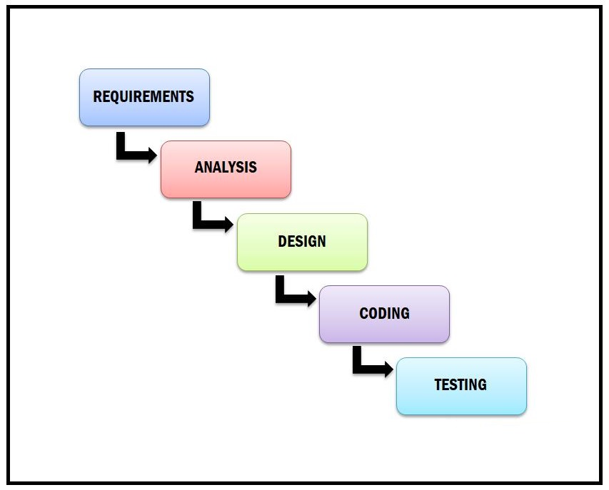

**Figure 4.0** *SDLC Waterfall Model*

Figure 4.0 demonstrates the Waterfall Model in which it shows the software development process in a linear sequential flow. In a waterfall model, each phase must be finished before the following phase can start and there is no overlapping in the phases. As a result of this nature, each phase of waterfall model is quite precise and well defined, since the phase’s falls from higher level to lower level. Waterfall model is utilized in the development of the system because the requirements for the system are defined by the users. The business rules and policies of the shop were analyzed thoroughly so that the system will meet the needs of their customers as well as the business’ needs.

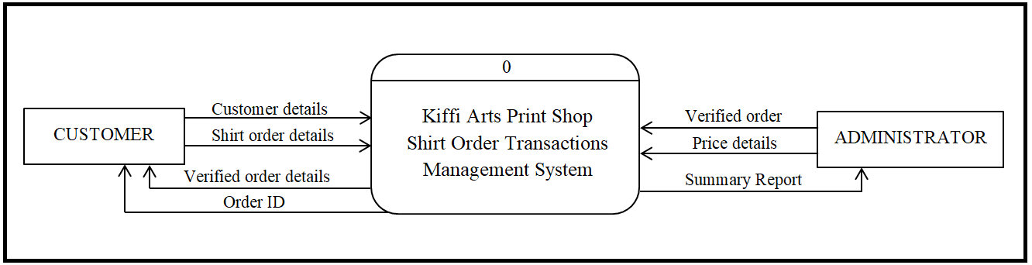**Figure 4.1** *Context Diagram of the Proposed System*

Figure 4.1 illustrates the context diagram of our proposed system. It contains one process, which generalizes the function of the entire system in relationship to external entities. The customer details will contain all the basic information needed from the customer, along with a username and password upon logging in. After the login process, the shirt order details will be asked from the customer for the creation of the shirt design. After entering the order details, the customer will be redirected to a summary page of his/her order details along with an ID number provided for each order. The administrator is also required to login to the system to be able to access its full functionalities. After processing of orders, the system will generate a summary report of the list of orders.

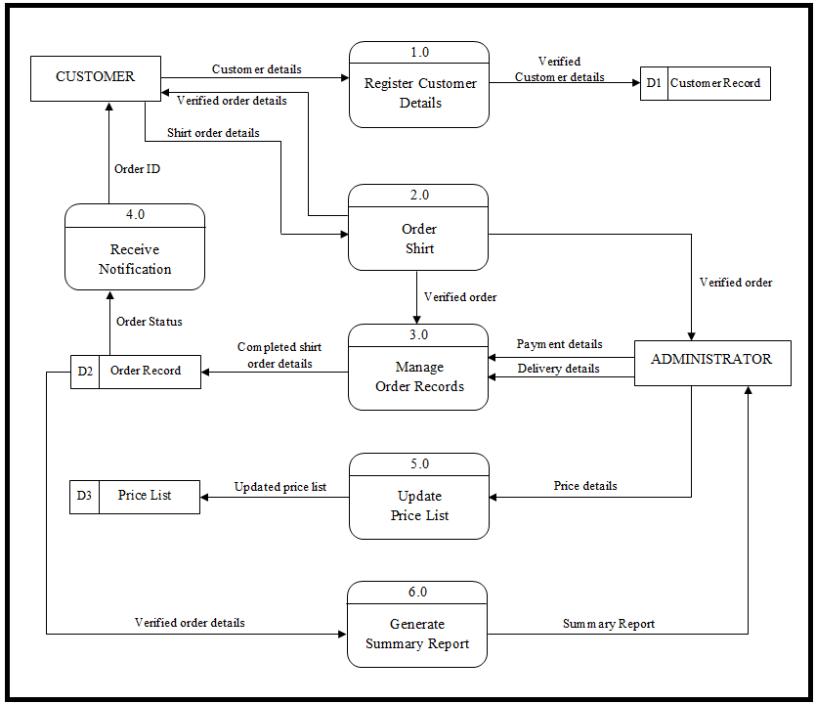**Figure 4.2** *Data Flow Diagram (DFD) Level 0*

*of the Proposed System*

Figure 4.2 illustrates the Level 0 DFD of the proposed system. In order for the system to process an order, first, a customer must be a registered member of the website. Basic information that is needed for the completion of order will be asked from the customer: Customer’s full name, contact number, address, e-mail, and a username and password. After the registration process, the customer will be directed to the login page and will key in their username and password. Once the login details are confirmed, the customer will be directed to the homepage of the system and can proceed to ordering. When the administrator has viewed and verified the order, a down payment must be made for it to be processed. After all these process, the admin will manage the verified orders.

The customer will receive a notification through SMS or through the web portal when their order has been completed and is ready for pick-up/delivery. The admin can also manage the price list of each shirt and print types, but won’t affect verified orders that were made beforehand. The system will also generate a summary report of verified orders depending on the date specified by the admin.

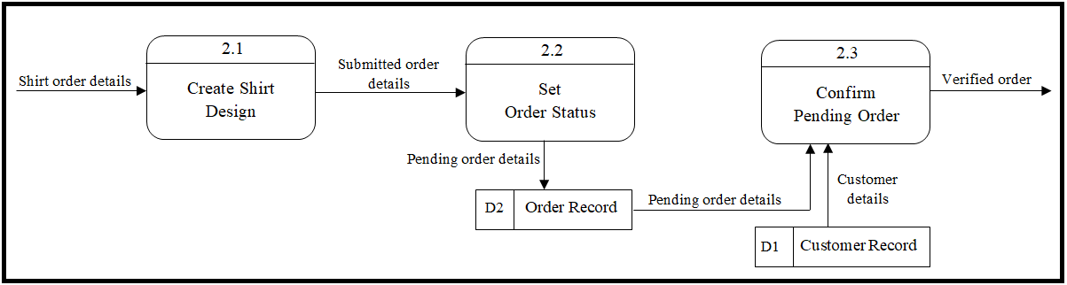**Figure 4.3** *Data Flow Diagram Level-1 of Process 2.0*

Figure 4.3 illustrates the Level 1 DFD for second process of the proposed system. In ordering a shirt, the customer must create a shirt design from scratch. The customer can either upload their own design, or choose from the available designs and texts in the website. Each shirt and print type has a corresponding price that the customer can choose from, and after creating the shirt design a tentative amount will be automatically calculated by the system. When the order is submitted by the customer, the order’s status will be set to its default which is ‘Pending’. Once the administrator has viewed and verified the order details, they can already change the order status to ‘Confirm’. This is to let the customer know that their order has been verified.

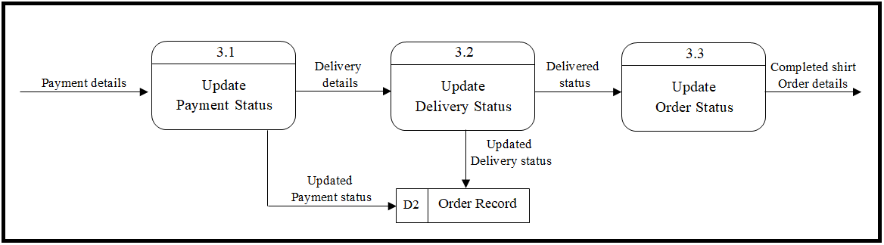

**Figure 4.4** *Data Flow Diagram Level-1 of Process 3.0*

In figure 4.4, the verified order will be sent to the next process, which is to Manage Order Records. The administrator will be responsible in monitoring and updating the payment, delivery, and order details status made in the website, depending on the current process of an order. The administrator will have an option to choose between three choices for the payment status, namely, ‘Unpaid’, ‘With down payment’, and ‘Fully paid’. Unpaid will be the default payment status. A down payment must be maid personally at Kiffi Arts Print Shop for the order to be processed and for the order status to be changed into ‘Printing’. Next, the administrator will update the pick-up/delivery status after the order has been completed. It could be ‘Ready for pick-up/delivery’ or ‘Successful’ which means the order was successfully picked-up/delivered. There are times that the pick up or delivery location is changed by the customers, thus the delivery details can be updated. Lastly, an order status could be the following: ‘Pending’, ‘Confirmed’, ‘Cancelled’, ‘Printing’, or ‘Delivered’. For the ‘Cancelled’ status, a customer, or the administrator can only cancel an order, only if the print shop has not yet started the printing process. When the order has been completed and has been delivered/picked-up successfully, the admin can change and update the order status to ‘Delivered’.

* + 1. 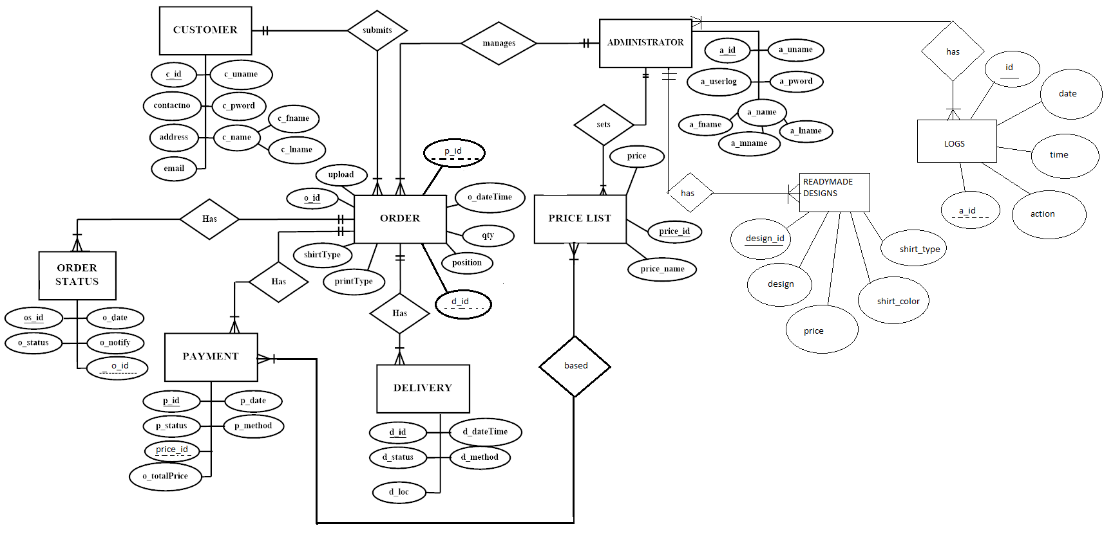Data Models

**Figure 4.2.2.0** *Entity Relationship Diagram (ERD) of the Proposed System*

Figure 4.5 illustrates the ERD for the proposed system. In creating an order, it will be provided by the relationship between CUSTOMER and ORDER. The administrator will be responsible for managing and handling of shirt orders from the customer, as well as manage inventories available in the print shop. The admin, at the same time, can set the price list on the choices of shirt type and designs. The ORDER STATUS, PAYMENT, and DELIVERY entities will contain all details needed for the monitoring of orders.

* 1. Design
     1. Database Design

In this section is the relational database deisign. This is based from the Entity Relationship diagram that was illustrated in figure 4.2.2.0. There are 7 entities; Customer, Price list, Payment, Delivery, Order, Order status and Administrator.

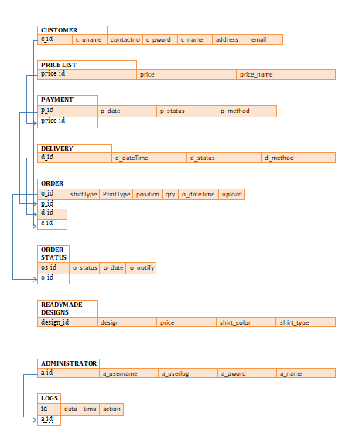

**Figure 4.3.1.0** *Relational Database Diagram of the Proposed System*

* + 1. User Interface Design

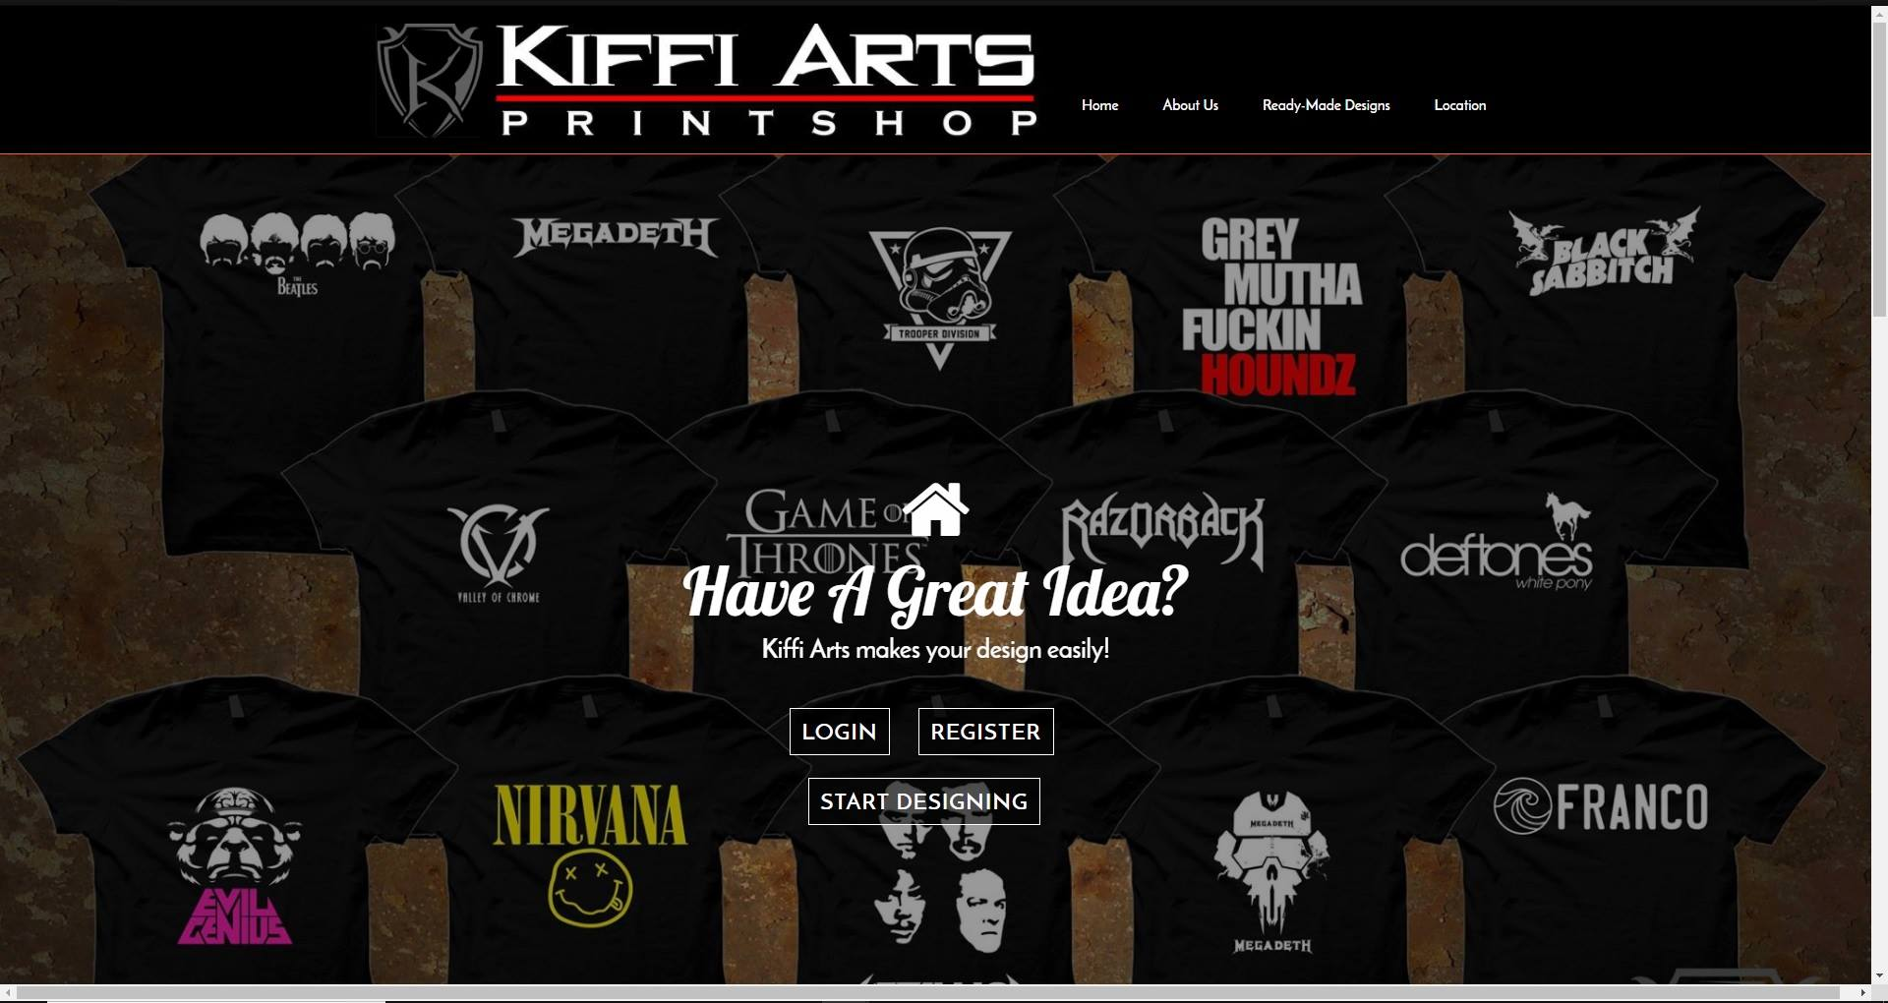The system will have several interfaces: an interface for the guest users, registered users and a backend interface for the administrator. Each interface has its own different functions that the system allows.

**Figure 4.3.2.0** *Home Page of Guest Customers*

In figure 4.3.2.0, the home page for the guests is also the home page for the registered customers, which includes four navigations: Home, About Us, Ready-Made Designs, and Location. There are two links at the bottom of the page, Login, Register and Start Designing button. Home redirects the user to the home page.

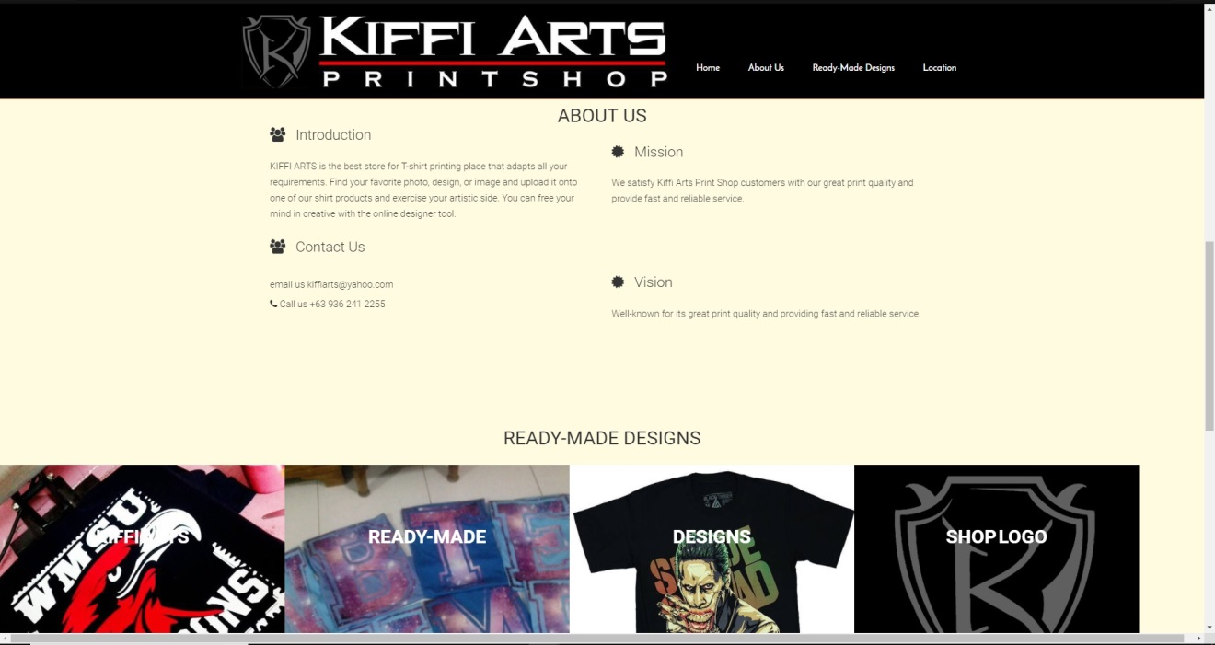

**Figure 4.3.2.1** *About Us Page*

Shown in Figure 4.3.2.1, About Us is brief information about Kiffi Arts Print Shop. Contact Us shows the contact information of the print shop. These are the only functions that the guest customers can access.

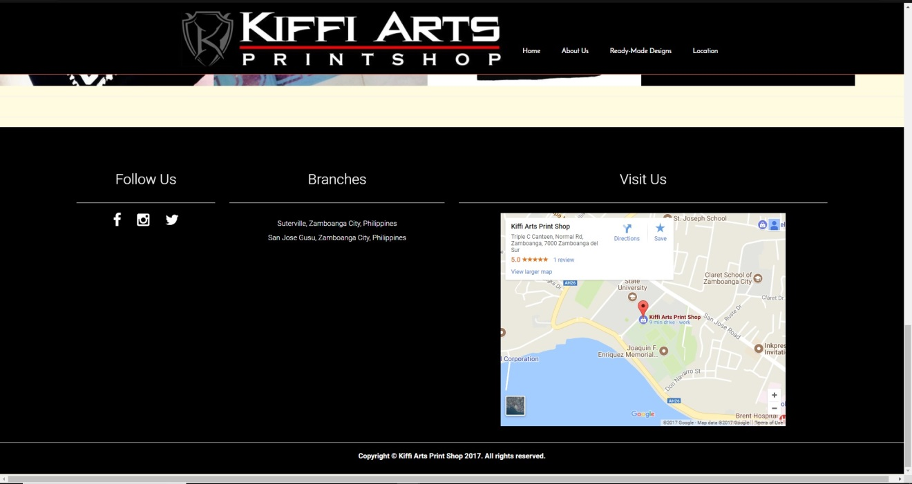

**Figure 4.3.2.2** *Location Page*

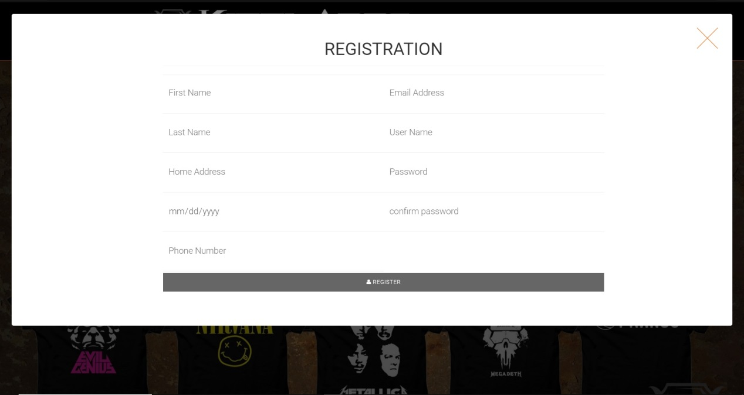 Location shows the list of the print shop’s branches, with a map of each branch, as shown in Figure 4.3.2.2.

**Figure 4.3.2.3** *Register for Guest Customers*

From the home page, once the Register button above the navigation bar or the Start Designing button at the bottom of the page is clicked, the user will be redirected to the register page.

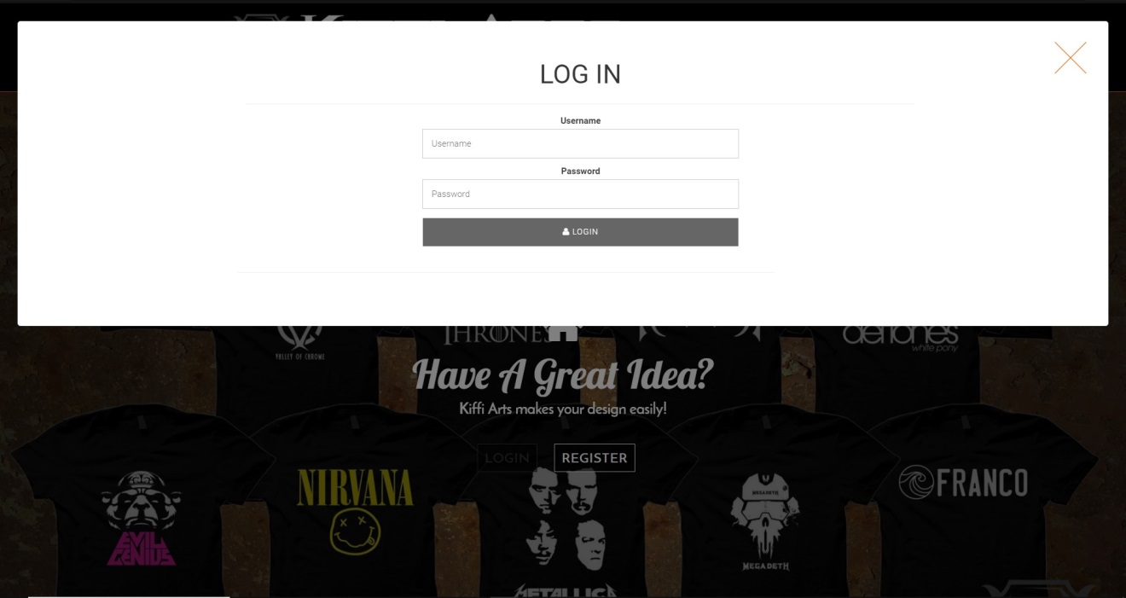**Figure 4.3.2.4** *Login for Registered Customers*

When logging in, the user only needs to provide their username and password, as shown in Figure 4.3.2.4.

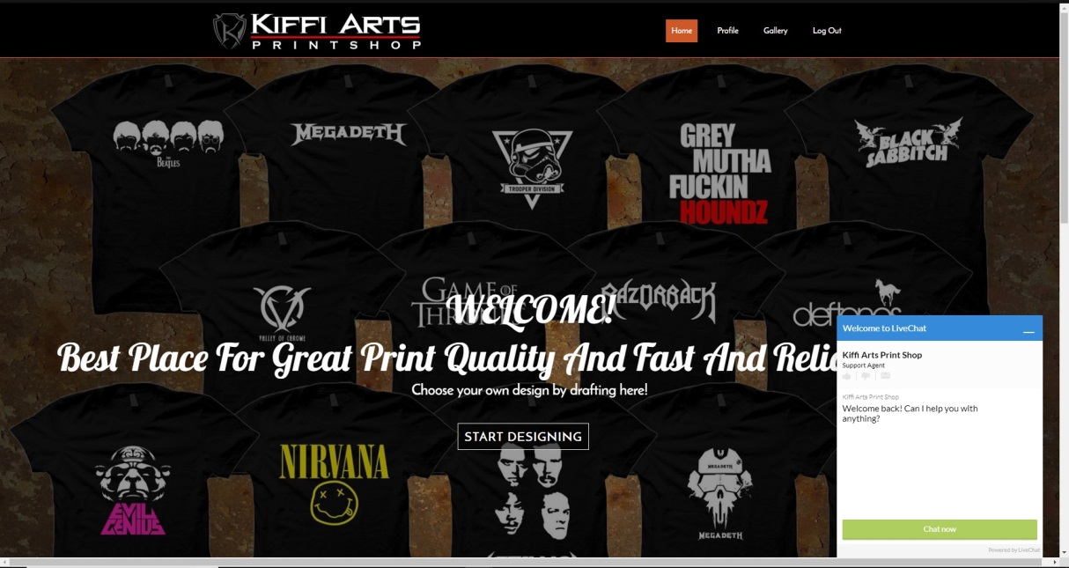

**Figure 4.3.2.5** *Homepage for Registered Customers*

When the customer’s login is successful, they will be redirected to the Homepage. A live chat box will now be available for any concerns, as shown in Figure 4.3.2.5.

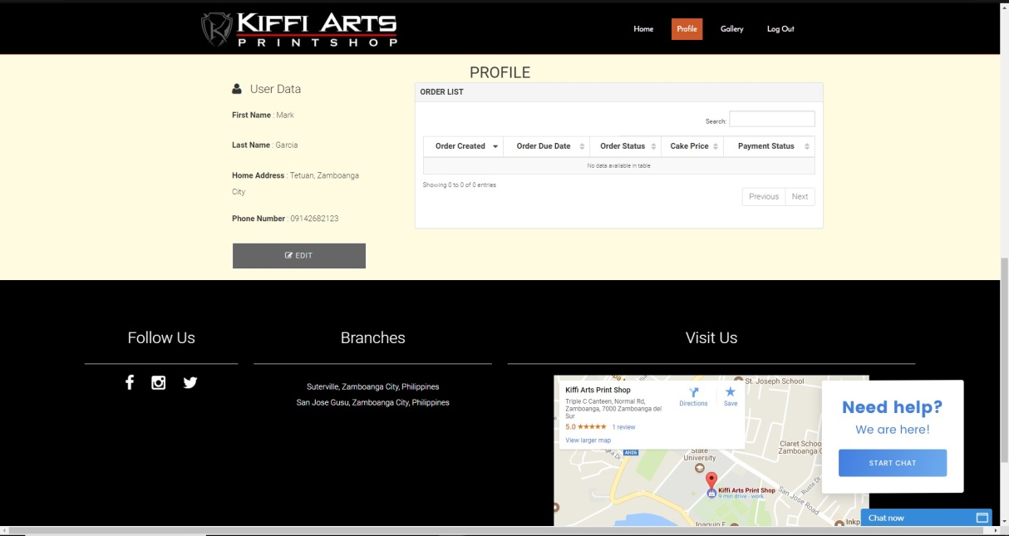

**Figure 4.3.2.6** *Customer Profile*

In Figure 4.3.2.6 shows the customer’s dashboard page which will show a list of their orders that are not completed. In this dashboard pages, information that will be provided are User Data and their Order List.

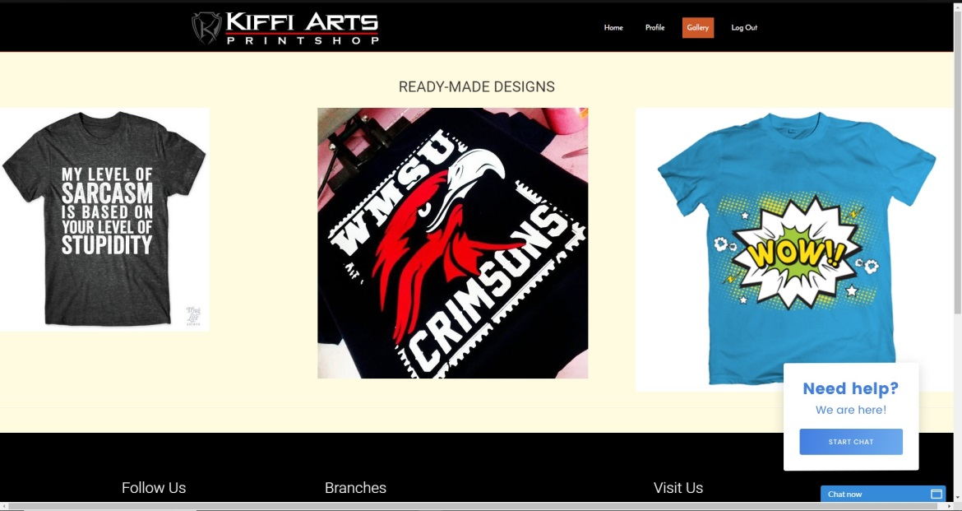

**Figure 4.3.2.7** *Gallery Page*

Figure 4.3.2.7 shows the gallery of ready-made designs where the customers can choose to order.

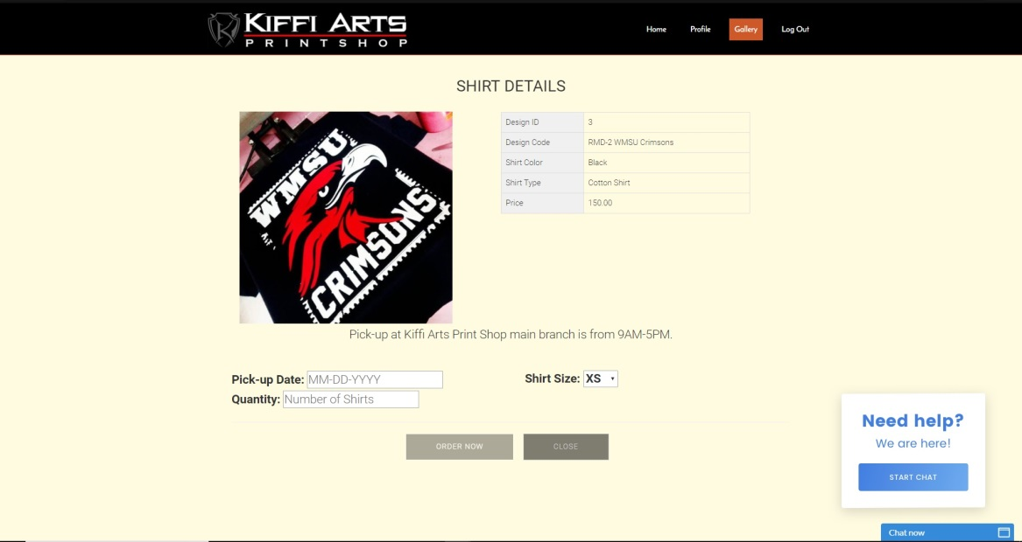

**Figure 4.3.2.8** *Ready-made Design Details*

Figure 4.3.2.8 illustrates the details of a ready-made shirt. It is where the customer will provide the details needed if he/she wants to order shirts from the design library.

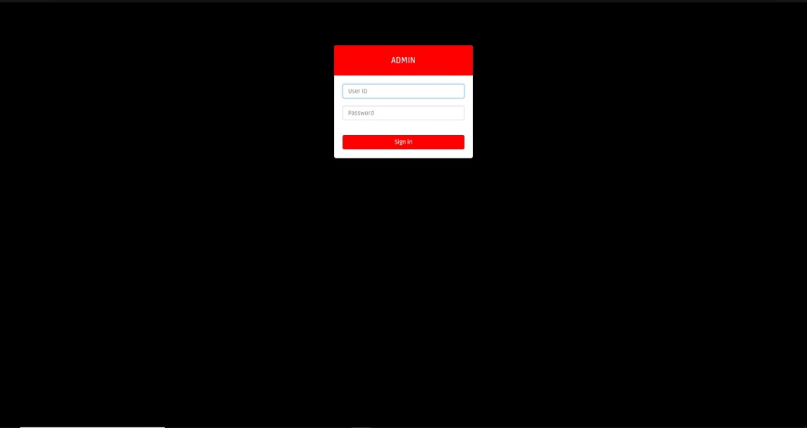

**Figure 4.3.2.9** *Administrator Login Page*

Figure 4.3.2.9 shows the login page of the administrator. A user ID and a password will be required.

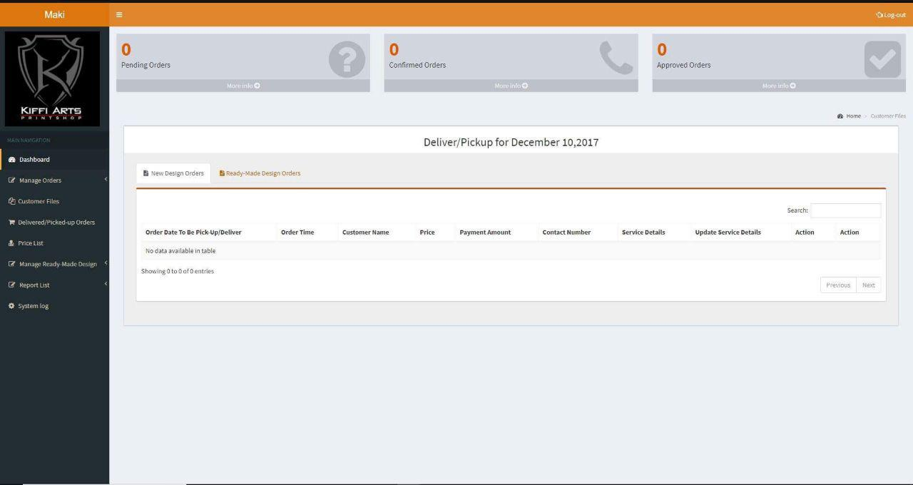

**Figure 4.3.2.10** *Administrator Dashboard*

When the administrator’s login is successful, they will be directed to the dashboard page where it shows the notification of new orders and orders that are on the process of printing. The navigation panel is displayed on the left side of the interface.

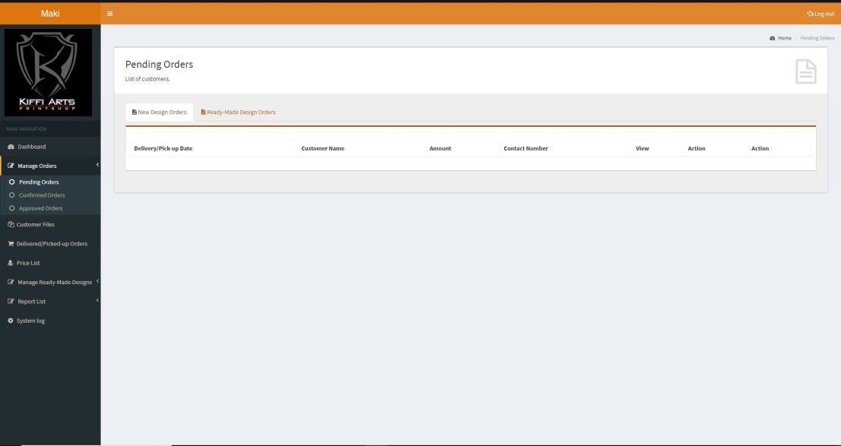

**Figure 4.3.2.11** *Manage Pending Orders*

The pending order page shown in figure 4.3.2.11, are the list of customer’s order that are pending and ready to confirm, view or delete.

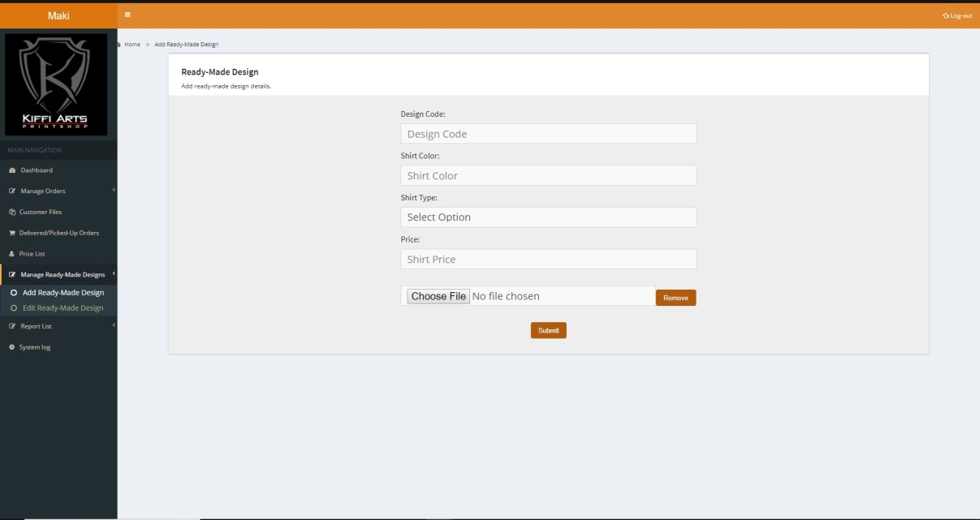

**Figure 4.3.2.12** *Manage Ready-Made Designs*

The Manage Ready-Made Designs, shown in Figure 4.3.2.12, the admin can add a new shirt design provided with the details needed. Once submitted, the design will be displayed in the Gallery of the Customer’s Profile.

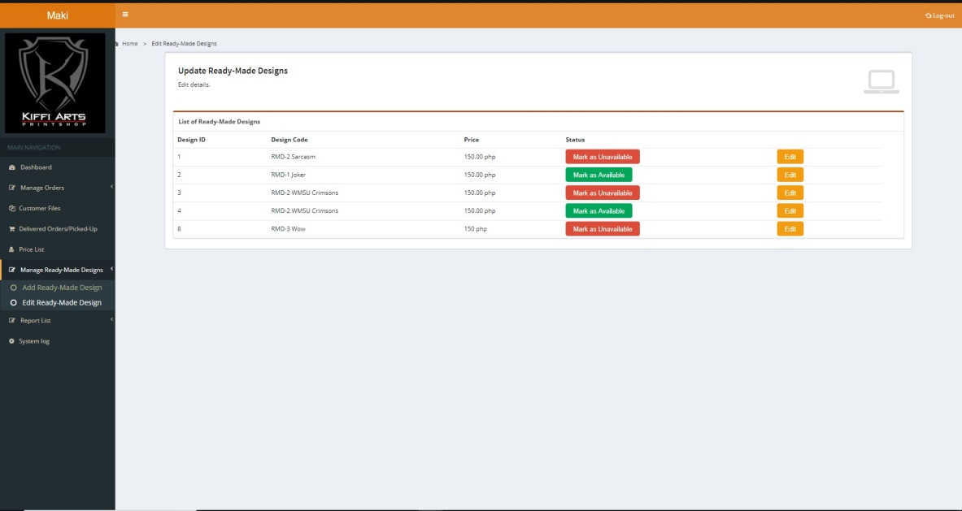

**Figure 4.3.2.13** *Edit Ready-Made Designs*

Figure 4.3.2.13 is the page for editing ready-made designs. It allows the system to mark it as “available” or “unavailable”. Once it is marked “unavailable”, the product will no longer be available in the gallery page.

* + 1. Integrity Controls
       - Input Integrity Controls

Data that will be inputted should be precise. To help in assuring the data is precise is to make sure the forms are designed in such a way that the clients should input data that is based from Kiffi Arts’ business rules because these data will be crucial in processing their client’s orders. For example, if contact numbers are asked from clients, the form of the system will make sure that the user inputted a valid contact number. Thus, data types are all identified to make sure data are accurate. The sizes of each data are also identified to maximize the space in the database.

* + - * Database Integrity Controls

To assure the Integrity of all the data in the database, the system will maintain a security measure that will secure that the data inputted is correct and the information that will be drawn from the database is accurate. For example, the encrypting of password to secure all the data of the user and their orders.

* + - * Output Integrity Controls

The system will have notifications sections in the system. This is to inform the user that new data is drawn from the database. For example for the Kiffi Arts’ account, there will be a notification section that will show all new and pending orders. Successful or error message will be also displayed after every submission of forms. These will help inform the user if the form was successfully submitted or not.

* + 1. Security Controls

All the data that will evolve around the system will be secured by limiting one account per user. The account for kiffi Arts staff will also be limited to secure their client’s information and the information of their client’s orders. The users will have the privileged provide their own username and password they will used to log-in to their respective accounts. The Log-in will secure that the account is being accessed by its real user.

* 1. Development and Testing

The technologies that were used in testing are computer devices, which will likewise be tried in various web browsers and with various operating systems. Localhost was used in testing whether the modules of the designs and functions are working. XAMPP Server software was the medium associated with the development of the proposed system. The programming languages that were utilized as a part of building up the system and the database are the following: HTML, CSS, PHP, JavaScript, MySQL, and HTML5 Canvas. A graph API was used for the sales performance graph. A SMS API was also used to send SMS Notifications. The system will be tested by the developers, the organization, and some sample users. Every module will be tested to provide further improvements and fix some found bugs. In the testing, there will be two evaluation tools to be used, namely, the user’s module evaluation and the developer’s evaluation.

4.4.1 User’s Module Evaluation

The user’s module evaluation is responsible to find out the sample user’s assessment to the system. The system design and functionalities are being tested whether there are errors, malfunctions or other improvements. Each module will be tested: First, the sample users will test if they can only view limited features of the system. After the registration process, they will test if the designing for the shirt is functioning well; test whether the availability of shirt type and print type will be available or be disabled depending on its specific requirements; test if price will be added for each added shirt design; test if the system can successfully generate the total price of the order and if the system will generate a discount if the total price of the order has reached more than 5000 pesos; test if they can choose from the list of payment and delivery methods; test if the system will generate a receipt when the user chooses to pay online; if they can view their complete order details; test if they can edit their profile; test if they can successfully send a message using the chat module; and if they can logout successfully.

4.4.2 Developer’s Evaluation

The developers will test the major functionalities of the system for the administrator. They will use a pre-defined username and password to login to the system. If the login details are successful, the system will be redirected to the list of orders made by the sample users (as the customer). Each module will be tested: View List of Orders (new and on-the-process), Set Order Status (Pending, Confirmed, Cancelled, Printing, and Delivered), Search Order using its ID number, Update Payment and Pick-up/Delivery Status, Send Notification through SMS and web portal for every change of status and percent of printing completed and when order has been completed, make necessary changes in the price list, View and/or Delete Customer’s Profile, Add Items and Calculate Costs in the inventory, and auto addition of price to the actual sales in the graph. Upon testing each module, the developers will check if every modification in an order detail, the corresponding detail in the database will also be successfully modified. Details for the user logs will also be checked for every login and logout of the user/customer. Lastly, the developer will test if the system can successfully generate summary reports in a specified period of date.

REFERENCES

Sharprint Associated Press. (2012, April 03). THE HISTORY OF T-SHIRT PRINTING.

Retrieved August 31, 2017, from http://www.sharprint.com/blog/bid/80650/The-History-of-T-Shirt-Printing

Live & Let Live. (2008-2009). Feasibility Study (Shirt Printing). Far Eastern University.  
Haselden, J. (2014, September 4). Top 5 Order Management Systems.

Retrieved September 26, 2017, from <https://www.nchannel.com/blog/top-5-order->management-systems/

Norwest Graphics. (n.d.). About Us. Retrieved August 31, 2017, from

https://www.norwestgraphics.com/page/22-ABOUT-US

Rush Order Tees. (n.d.). Our Story. Retrieved August 31, 2017, from

https://www.rushordertees.com/about/our-story/

Custom Ink. (n.d.). About. Retrieved from https://www.customink.com/about

Uber Prints. (n.d.). A Little Bit About Us. Retrieved August 31, 2017, from

http://www.uberprints.com/company

Alam-alam, R. D., & Quilaton, C. M. (2016-2017). Myrna's Bake House Online

Customization and Ordering Cake System. Ateneo de Zamboanga University.

StudyMode Research. (2013, January 18). Online Ordering System. Retrieved from

http://www.studymode.com/essays/Online-Ordering-System-1366934.html

W3C. (2016). HTML & CSS. Retrieved from https://www.w3.org/standards/

webdesign/htmlcss

Wodehouse, C. (2015, May 5). Front-End Web Development: Client-Side Scripting &

User Experience. Retrieved from https://www.upwork.com/hiring/

development/how-scripting-languages-work/

W3Schools. (n.d.). HTML5 Canvas. Retrieved from https://www.w3schools.com/html/

html5_canvas.asp

Kofler, M. (January 2007). What are the top MySQL features? What is MySQL? \

Retrieved from http://searchitchannel.techtarget.com/feature/What-are-the-top-

MySQL-features-What-is-MySQL

PHP. (n.d.). What is PHP? Retrieved from http://php.net/manual/en/intro-whatis.php

Wodehouse, C. (2015, May 5). Server-Side Scripting: Back-End Web Development

Technology. Retrieved from https://www.upwork.com/hiring/development/server-

side-scripting-back-end-web-development-technology/

Thakral, A. (2011, March 19). What is XAMPP? Retrived from

https://www.targetintegration.com/uncategorized/what-is-xampp

Techopedia. (n.d.). Password Protection. Retrieved from https://www.techopedia.com/

definition/8797/password-protection

Icom. (n.d.). RGS: Report Generation System Retrived from

http://www.icom-software.com/pages/Products%20-%20RGS.htm

Tutorialspoint. (n.d.). SDLC - Waterfall Model. Retrived from

https://www.tutorialspoint.com/sdlc/sdlc_waterfall_model.htm

Software Testing Help. (n.d.). What is SDLC Waterfall Model? Retrieved from

http://www.softwaretestinghelp.com/what-is-sdlc-waterfall-model/

SmartDraw. (n.d.). Data Flow Diagram. Retrieved from https://www.smartdraw.com/

data-flow-diagram/

WikiHow to Integrate a Payment Gateway Into a Website. (n.d.). Retrieved from

<http://www.wikihow.com/Integrate-a-Payment-Gateway-Into-a-Website>

Rometty, J. (06 September 2016). An Introduction to Chart.js 2.0-Six Simple Examples

Retrieved from https://www.sitepoint.com/introduction-chart-js-2-0-six-examples/