GROUP 14: Air Compressor

MECH 203 Project Report



Mert Ayhan Tandoğdu

Hikmet Batuhan Balkı

Erkin Püren

Ahmet Mete Coşkun

Emir Kaan Sonay

TA: Berkay Demiryülek

Responsible TA: TA Name



**Introduction**

-What is your project?

Air compressor.

-What is it used for?

Air compressors are machines that store the outside air in the tank chamber and allow the formation of compressed air. from small businesses to large industrial plants. Compressed air is used in many areas such as tire inflation, gas compression in the oil field, mold processing in the automotive and press benches. Compressors are used in the production of many products that we use in our daily lives.

-How does it operate?

The motor that is located outside the main mechanism creates circular motion by turning the wheel outside the compressor and that circular motion creates linear motion of the pistons with the help of the crank shaft. When pistons move upwards and downwards they create air pressure.

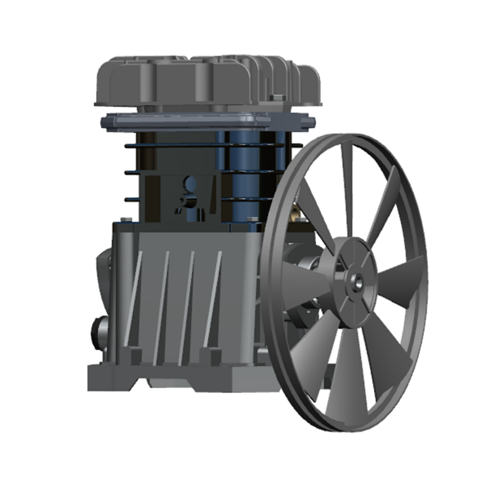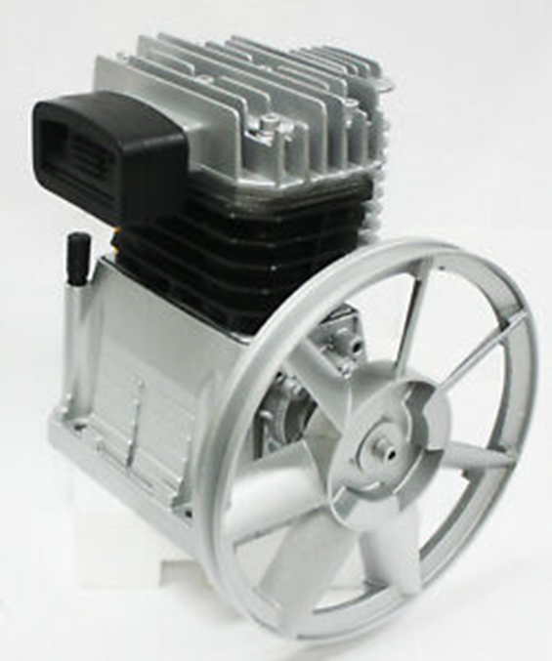

**Disassembly**

How did you measure the dimensions of your part? Did you face any challenges during the disassembly or measuring the dimensions? How did you solve those problems?

For disassembling, we faced the most difficulty seperating the wheel from the shaft because it required a special tool that is just responsible for the separating it also the inside of the compressor was stuck so we forcing the wheel with the tool probably resulted in breaking of one of the pistons.

When we were measuring our components most of the time we used calipers but sometimes the parts were to big in size so we instead used rulers, so we solved this problem by using a different measurement tool. Another problem that we faced was to measure tight places that are too small for calipers or rulers, in order to solve that we measured other places and did basic calculations to come up with the measurements.

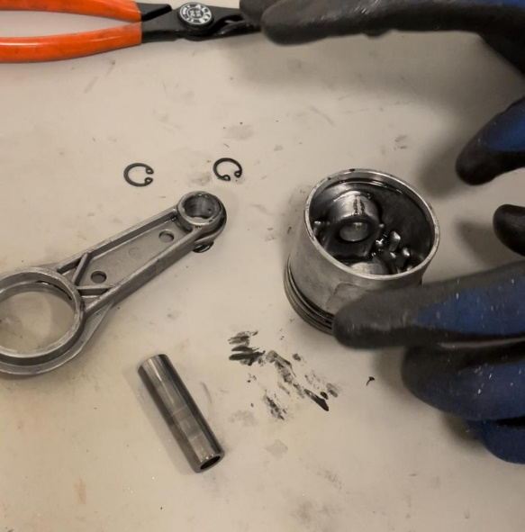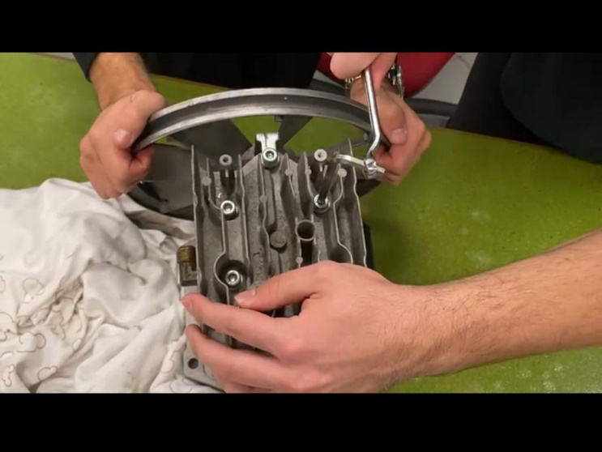

**Exploded View**

How many separate parts does your object contain? How many parts did you assemble in the assembly file?

The part contains 46 parts and 21 unique parts. Assembly file contains 19 parts.

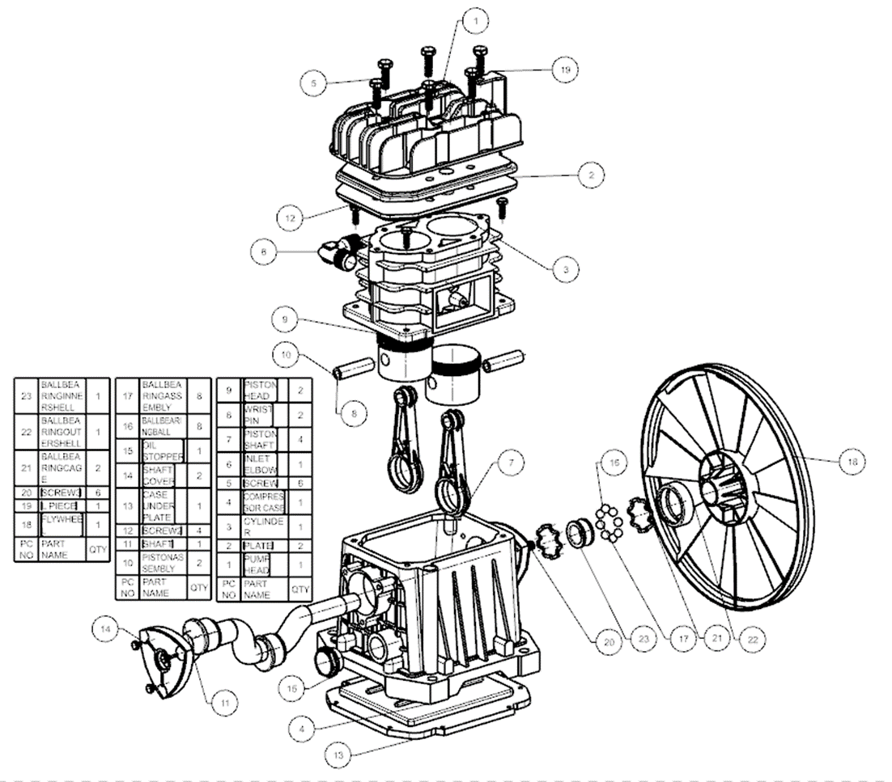

**Part Comparisons and NX Commands**

* **Revolve**
* **edge blend extrude**
* **copy sketch**
* **MIrror**
* **Hollow**
* **SectIon surface**
* **Boss**
* **Pattern feature**
* **Hole**

**Drafting and Tolerances**

Talk about why the drafting for your chosen part is important. What surface and dimensional tolerances have you assigned and why?

We chose this piston because it is the integral part of our system.

**Finite Element Analysis**

FOR Finite element analysis ı used structural analysis where I have introduced our material as aluminum alloy. our compressor normally sits on a surface that is connected to the tank, so, our goal was to observe the possible deformation on where it may occur in compressor case.

In thıs part, we meshed our geometry wıth mesh sıze 0,007 m. We fıxed the geometry on the bottom ends (-y dırectıon) by ıntroducıng parametrıcal forces. (We used the weıght of the structure to get thıs gravıtatıonal force.) Later, wıth these forces, we ıncluded equıvalent stress (von-mıses) to observe where the stress wıll be hıgher. The hıgher stress poınts represents where our geometry can break.

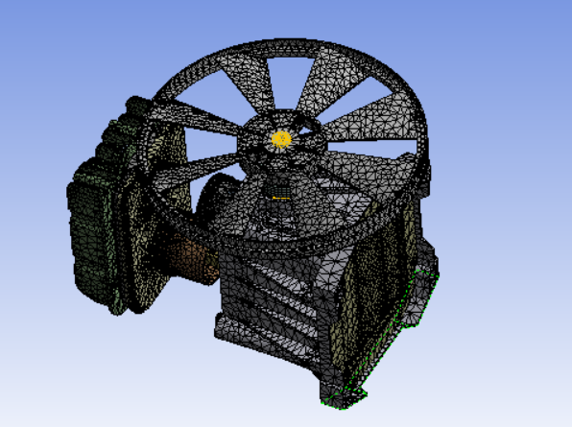

In the figure above, color map represents the equivalent stress points, We have understood where our geometry may break – not due to the motıon but due to the surface where ıt sıts. It gets to 2 kpa where the bıggest stress factor occurs whıch ıs acceptable.

Some errors we faced were:

* Somehow ıt dıdn’t mesh geometry of the shaft ınsıde.
* I always ended up gettıng under constraıned error whıch ı have solved wıth enablıng weak sprıng optıons on. Thıs error was because of ınsuffıcıent constraınt.

In the video above, there is the final structural analysis of our aluminum alloy geometry, where it shows us the equivalent stress ranging from 2 KPa to minimum.

**Conclusion**

As a result of this project, we have seen how complex a tool that looks simple from the outside can be. We also had the chance to reinforce and develop our drawing skills that we learned in this course. Since this project is a group project, we improved our communication and teamwork skills. It was a project that developed us in every sense and that we enjoyed very much.