**Externally Driven Inflow Effect on Current Sheet Dynamics**

**in TS-6 Tokamak Merging Experiment**

Y. Doke1, K. Doi1 and M. Akimitu2, and Y. Ono1

1 The University of Tokyo,

2 National Institutes for Quantum Science and Technology (QST)

e-mail (speaker): dokeyuka@g.ecc.u-tokyo.ac.jp

We have found the current sheet structure, especially its blob structure, depends on the flow condition of externally driven plasma. As shown in Fig. 1, we used a pair of poloidal field (PF) coils to form two tokamak plasmas and to compress them together in TS-6, the tokamak plasma merging device. Setting three positions of PF coils, we varied the inflow speed/sheet compression to study its effect on the current sheet structure. We measured the detailed 2D structure of the current sheet: contours of poloidal flux, the current sheet density, and effective resistivity at X point using the newly developed printed-circuit board (PCB) type magnetic probe array whose spatial resolution is as high as 5 mm. Our 2D magnetic probe measurements reveal the current sheet structure is determined by the following three effects:

(a) anomalous resistivity when the current sheet is compressed to the order of ion gyro radius ,[1], [2]

(b) plasmoid generation and diffusion area expansion, [2]

(c) plasma blobs ejection. [3]

Under the low external inflow condition with coil separation length L=700mm, the sheet transforms into a large single plasmoid, and the reconnection speed increases, probably due to the expansion of the diffusion area. Under the medium inflow condition with L=600mm, the reconnection speed/electric field increases right after the current sheet splits into several blobs. And then the number of blobs decreases when the effective resistivity rises as the current sheet is compressed to $ρ_{i}$ as shown in Fig. 2. Under the high inflow condition with L=427mm, the effective resistivity becomes larger in the early stage of the reconnection by compressing the sheet to $ρ_{i}$, increasing reconnection speed without forming a plasma blob. We also found the further increase in external inflow causes the current sheet to split and eject, accelerating the reconnection due to the effective mass ejection from the X-point area.

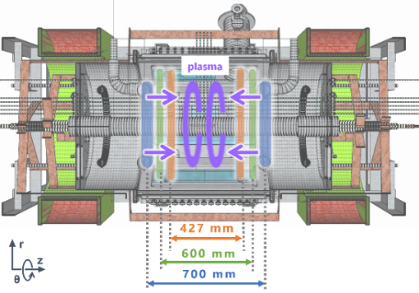

Fig.1 Vertical cross-section of TS-6 tokamak plasma merging device with three PF coil positions

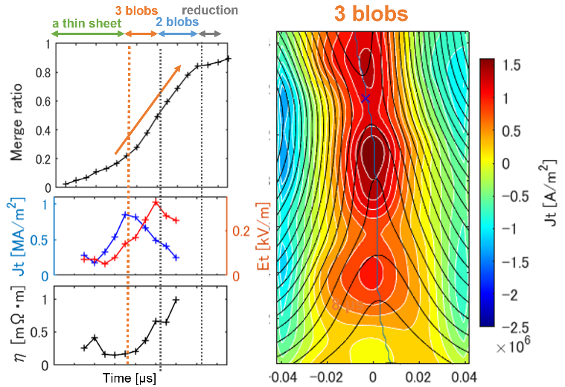

Fig.2 The time evolution of the merging ratio of two tokamak plasmas (upper left), toroidal current density (middle left), effective resistivity (lower left) at the X point, and 2D profiles of the poloidal flux (black line) and current density (color contour) (right) under medium inflow

References

[1] Y. Ono et al., Physics of Plasmas, Vol. 4, No. 5, pp. 1953–1963, 1997.

[2] M. Yamada et al., Physics of Plasmas, Vol. 13, No. 5, p. 052119, 2006.

[3] S.　Takasao et al., The Astrophysical Journal Letters, Vol. 745, No. 1, p. L6, 2011.

[4] M. Akimitsu et al., Plasma Fusion Res. 13, 1202108 (2018).