Map Icons « Loir & Cher 2020 »

Aha-Soft :
- Victor Ivlichev ahasoft.ivp@gmail.com

Developpers :
- Mathieu Leplatre mathieu.leplatre@makina-corpus.com
- Sylvain Beorchia sylvain.beorchia@makina-corpus.com

Managers (in charge of payment) :
- Jean Pierre Oliva jeanpierre.oliva@makina-corpus.com

Context of use
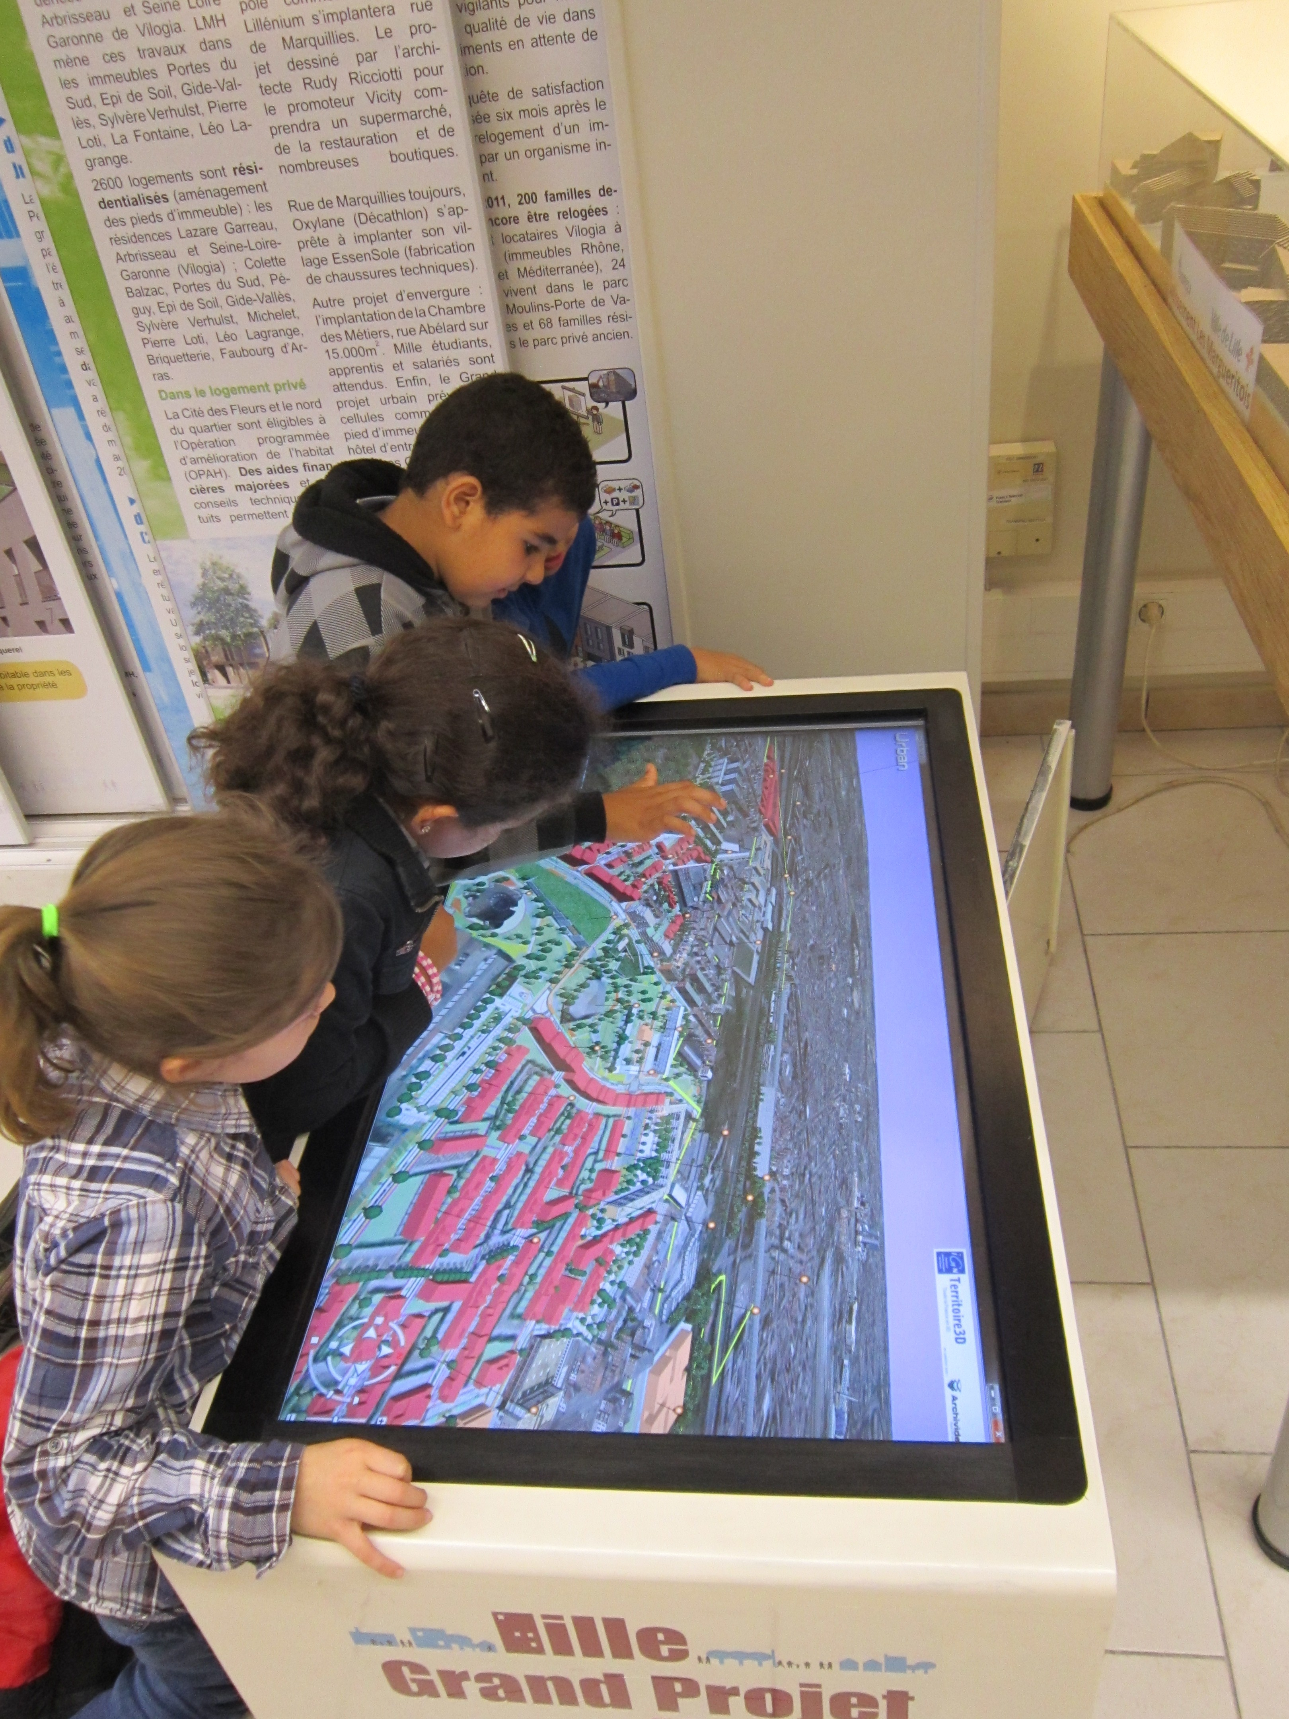
The icons are to be shown on an interactive map, on a giant touch screen, in a public exhibition.

The exhibition shows the future projects in the region between 2013 and 2020.

The idea is to mimic the Sim City 3D isometric style.

Each icon represents a category of several projects.

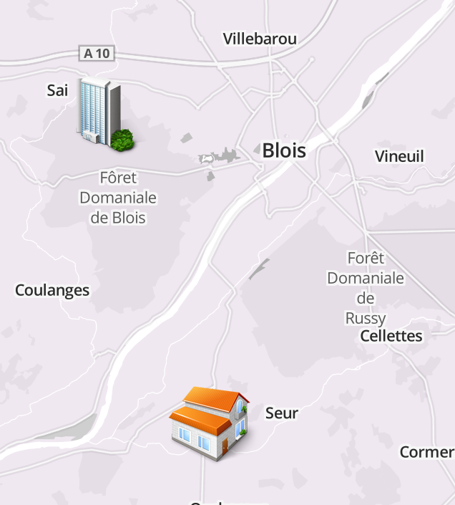

About the region « Loir et Cher »
The region has a few graphical details to take into consideration :

- House roofs are black (slate)
- The land is flat
- It's a region of agriculture (mainly cereals)
- Forests are dense and very green
- It's the region with many king castles

Road projects
Description | Road & transportation
Examples | - Road deviation  - Footbridge
Details | A modern car  Safety barriers  Modern lights on the sides
Sketch | 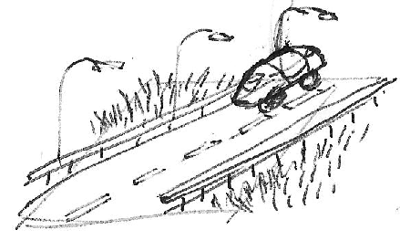

Rail projects (« TGV »)
Description | High Speed & Station
Examples | - New rail link between cities  - Renovation of train station
Details | French High Speed train (TGV)
Sketch | 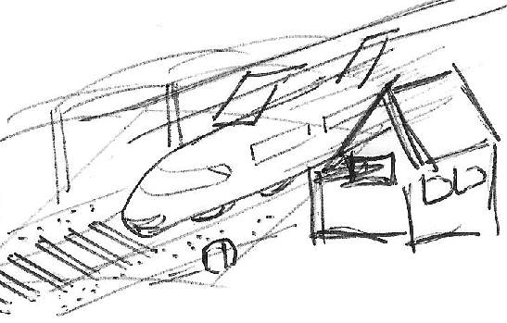

(old station)
http://www.railteam.eu/en/files/2011/11/TGV-Duplex1.jpg

Airdrome project
Description | The airdrome (aerodrome) in Le Breuil
Examples | This is not a category but a single project
Details | See architect images below..  Modern small plane (2020)  Helicopter or microlight on the ground
Sketch | 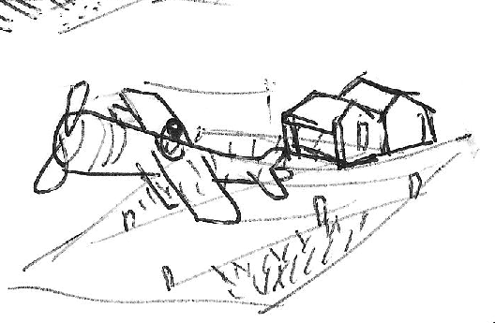

Agriculture & Environment projects
Description | The airdrome (aerodrome) in Le Breuil
Examples | Wood industry  Agriculture (cereals)  Recycling and environment
Details | Corn or Weat field  Big green tree with birds  A heap of wood with « recycle » sign
Sketch | 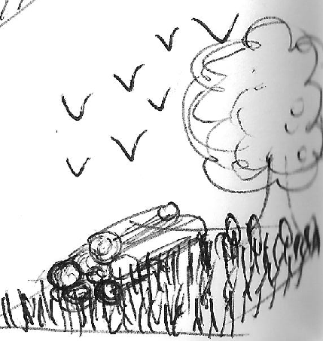

Engineering School Building
Description | ENIVL School building
Examples | N/A
Details | The building like on the picture  Students going out  No square for the ground  A transparent shadow of the building
Sketch | 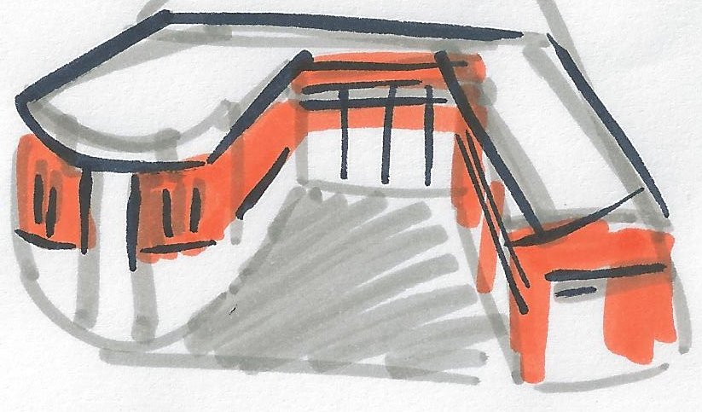

Google Street View : http://goo.gl/maps/rZFVM

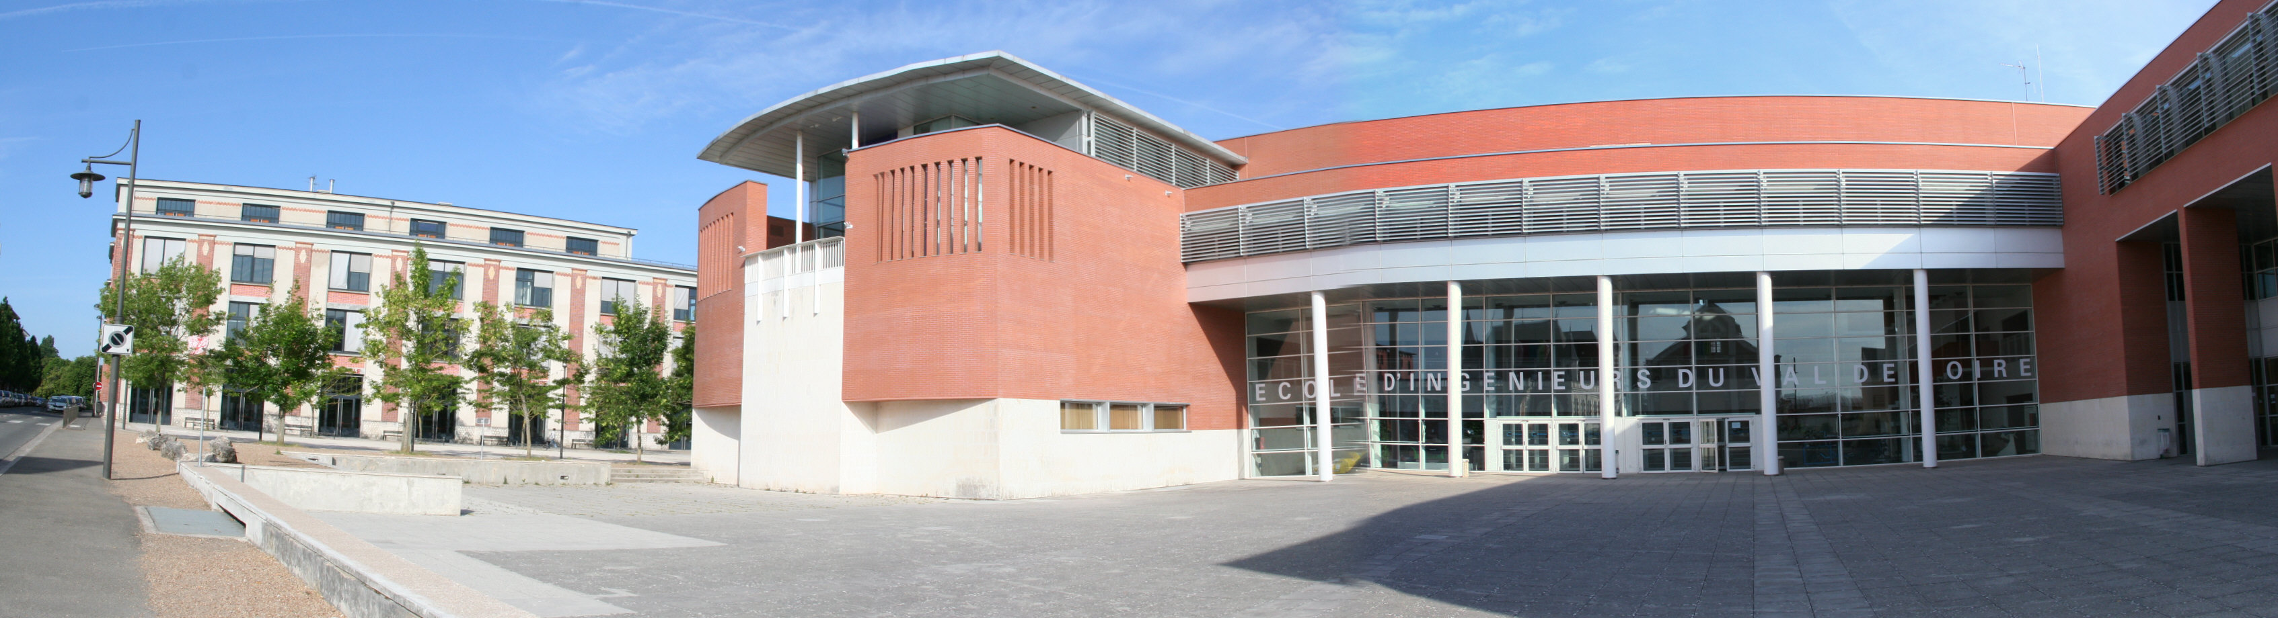
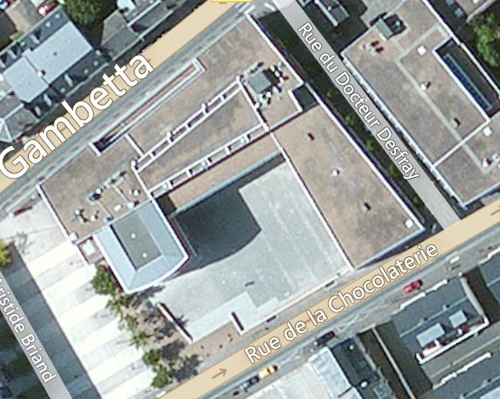

Modern Hospital
Description | Construction of new hospitals
Examples
Details | « H » letter  Emergency car  Trees  Parking lot  Lots of windows
Sketch | 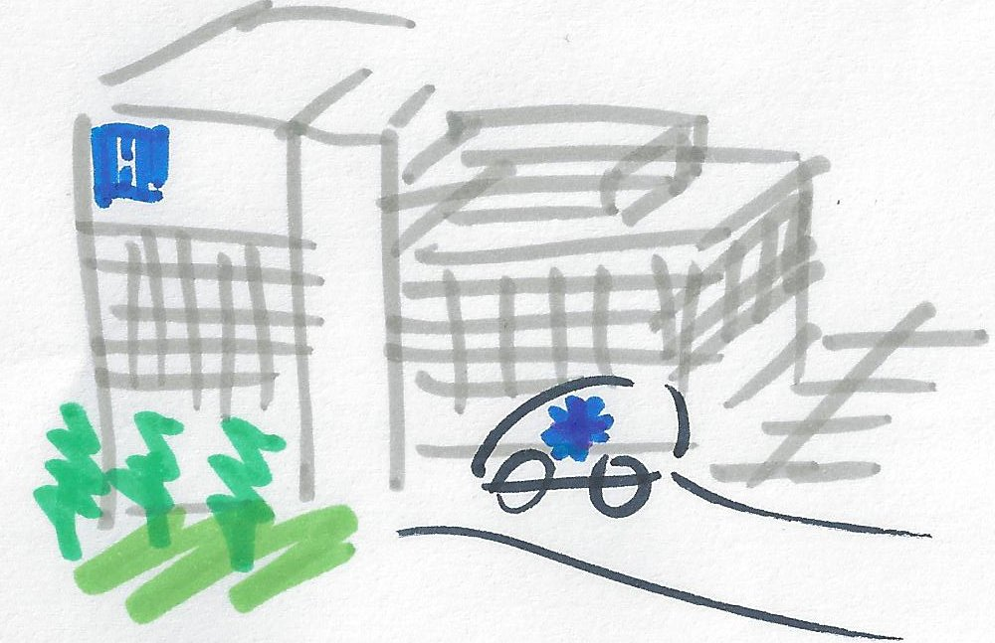

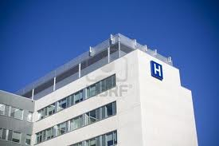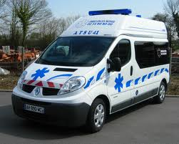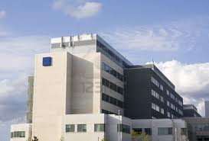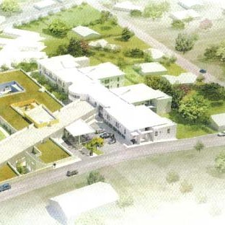

Castles by bike
Description | A family cycling along a river with castle in background
Examples
Details | Castle (see pictures in the first pages of the document)
Sketch | 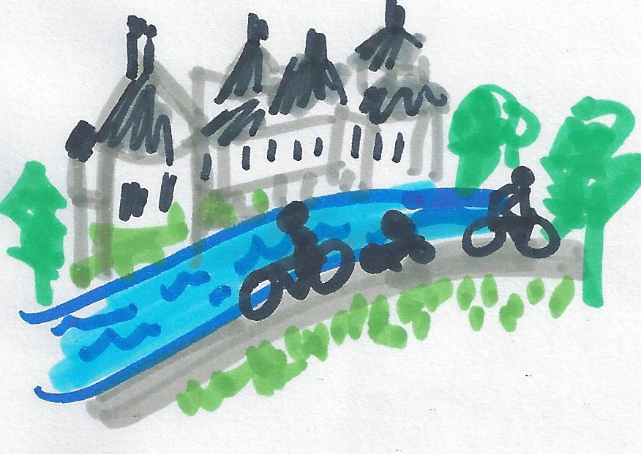

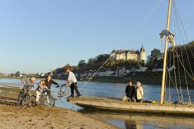
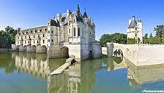
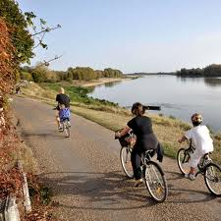
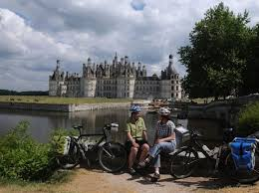

Outdoor Sports
Description | Represent multiple outdoor sports
Examples projects | Golf extension  Equestrian center  Construction of swimming pool
Details (ideas) | Golf hole in background  Horse jumping in foreground  ...rackets, balls, bow, water ...
Sketch | Victor's imagination

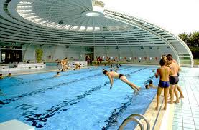
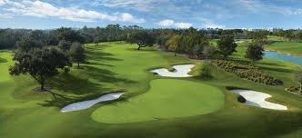
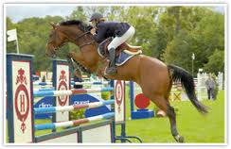
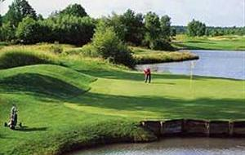

Civil works
Description | A crate working on new modern houses
Examples projects | New neighbourhood  Old building renovation  New houses  Residential parc
Details (ideas) | Crate  Trees  Modern houses  « Ecology »
Sketch | 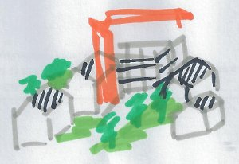
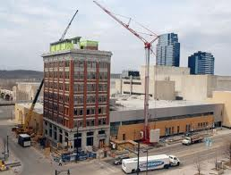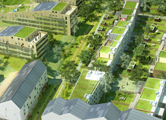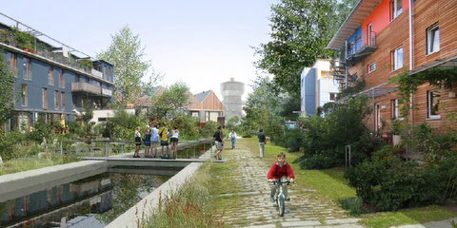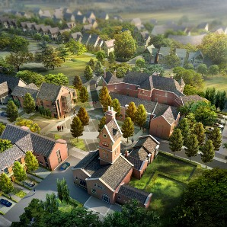
More pictures

Industrial site
Description | A modern commercial center or clean industrial site
Examples projects | Commercial center  Activity areas (shops and companies)  Modernization of old industrial sites
Details (ideas) | Parking lot  Trees  Small square buildings
Sketch

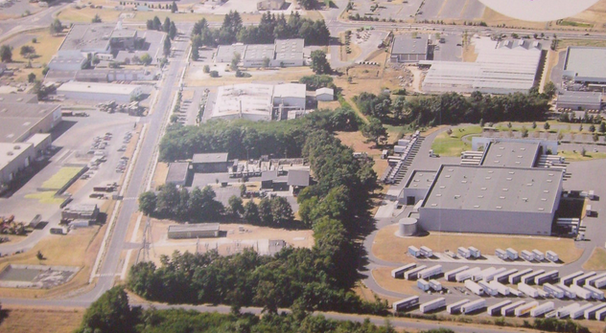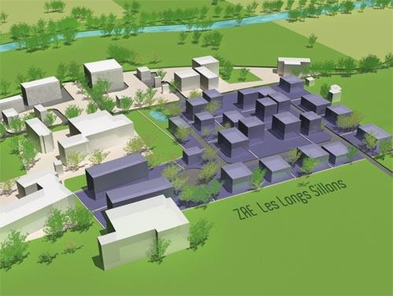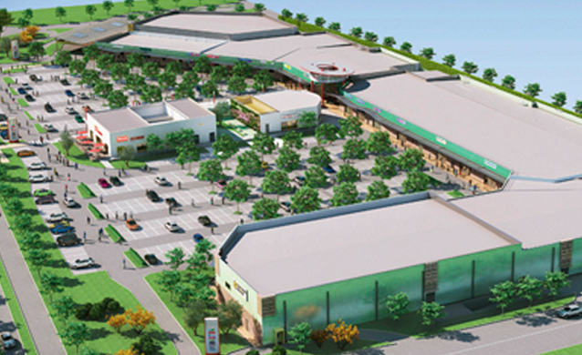


Culture
Description | Creation of cultural centers
Examples projects | Multimedia library  Theater  Cultural center
Details (ideas) | People queuing  Transparent windows  Chairs and books shelves inside
Sketch | 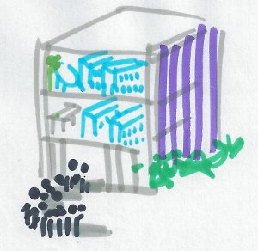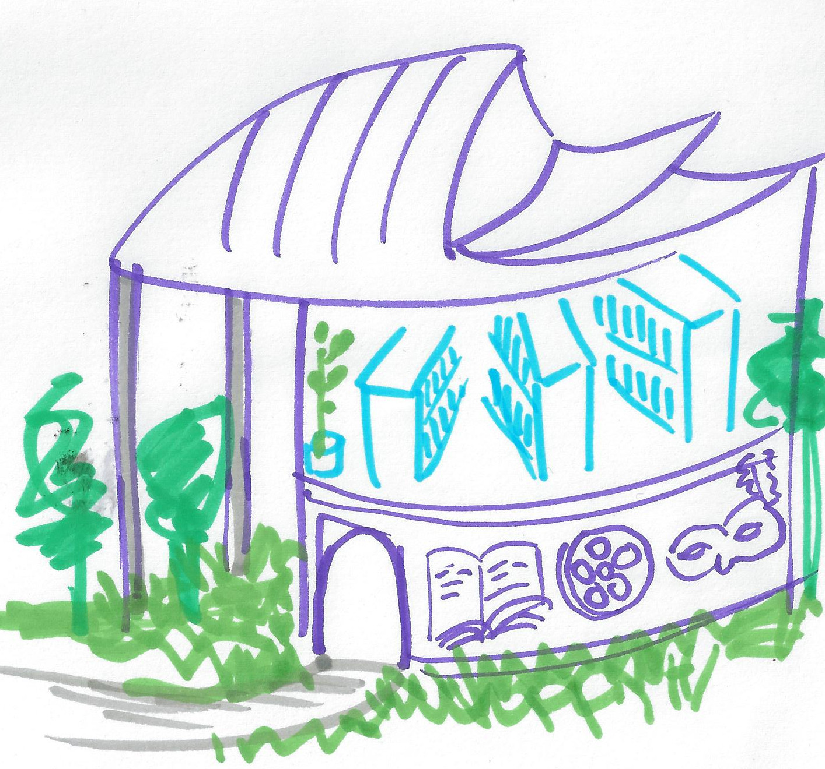  You can invent something :)  - modern building  - shelves  - cultural icons  (book,cinema,theather)
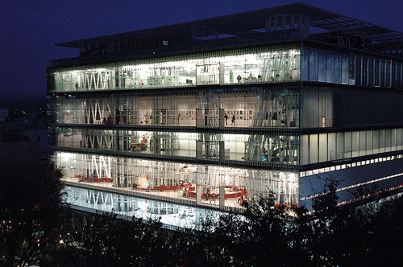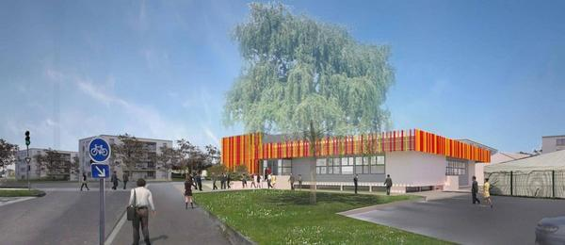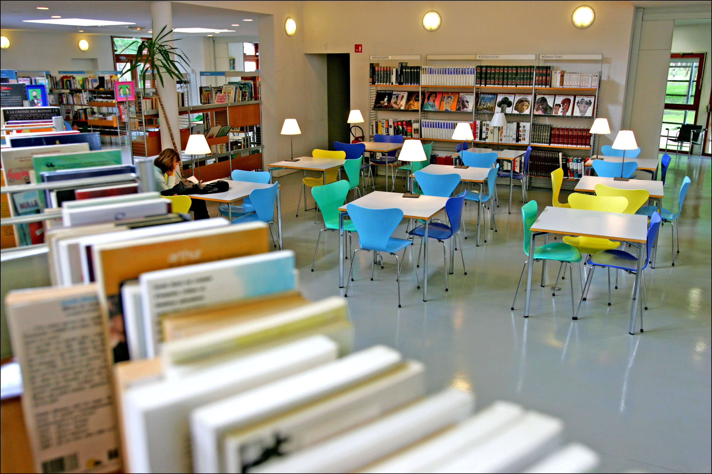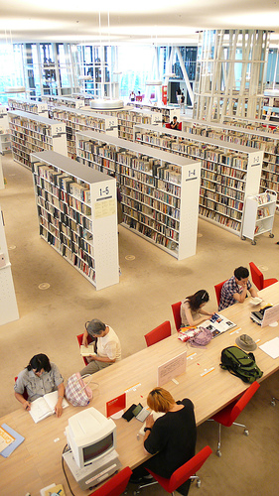

Holidays
Description | An holiday hotel with swimming pool
Examples projects | New hotels  Sport tourism center
Details (ideas) | Flowers  Umbrellas  Long chairs  Swimming pool
Sketch | 

