The same manual applies for Linux, Windows and Mac users. Depending of your setup, you will need to run the python code directly, or you can use the lazy compiled version for windows. Once opened the program, you will see the following screen:

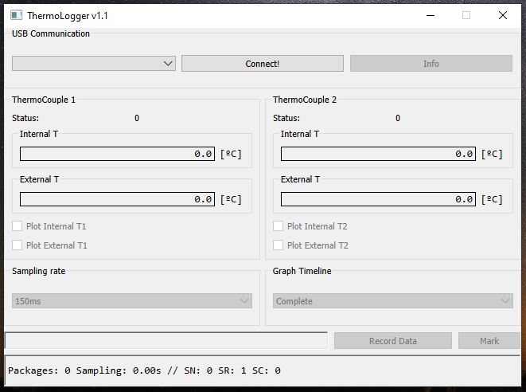

**Figure 1:** ThermoLogger v1.1 software main windows.

In the upper part of the windows, you will see a blank combobox under “USB Communication”. Now you can connect the board to the USB of your computer. No extra drivers are needed. Then the COMPORT will should appear as shown in next picture:

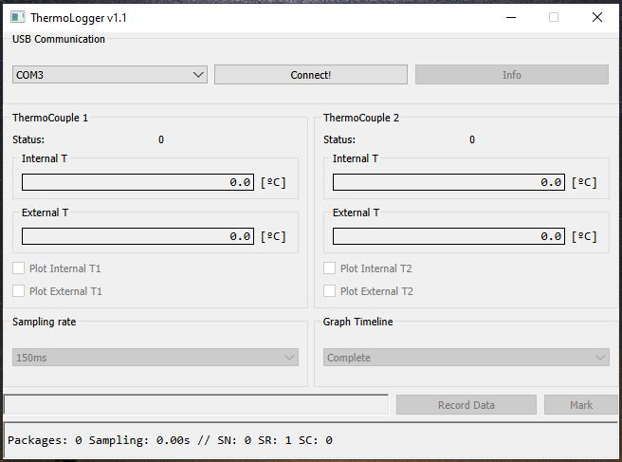

**Figure 2:** A board is detected at COM3.

Once you clicked “Connect!”, all the options will enable for you to use:

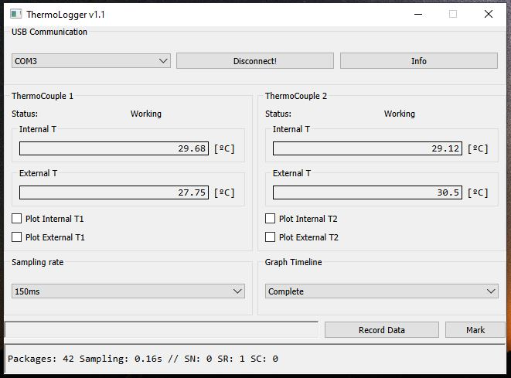

5

4

3

2

1

**Figure 3:** Sections of the software.

1. The values from the thermocouple and the status of each one. It can detect any short between wires, to ground, or if the thermocouple is disconnected. The “internal T” is the temperature of the ADC over the board, so it is not relevant for measurements.
2. You can tick or untick those boxes to add the curve to the graph:

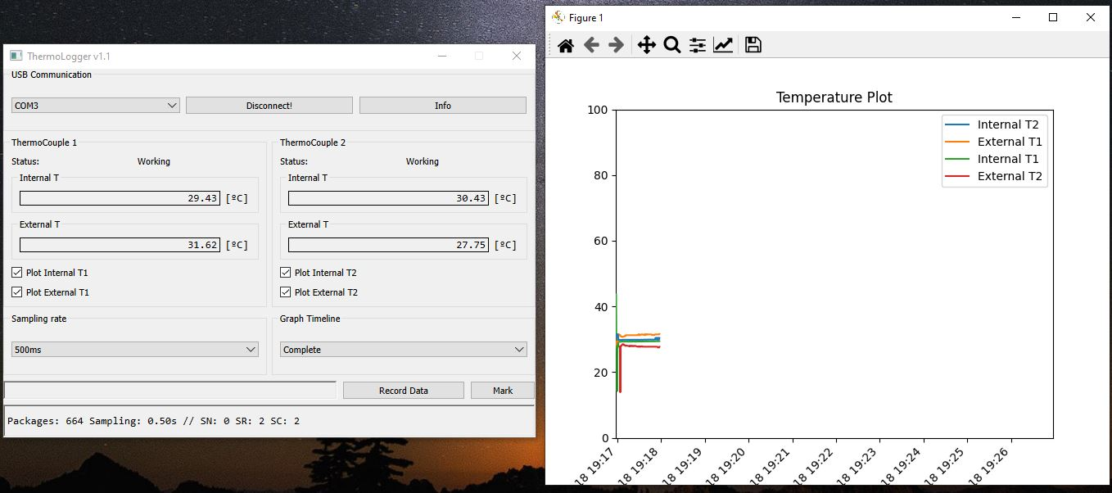

**Figure 4:** The graph window will pop-up as soon as any box is ticked

You can change the plot in real time. In addition, you can modify the view, Y and X axis, colors and curves colors in the graph windows. Furthermore, you can export the graph as picture or vector using the options of the same windows.

1. You can select the sampling rate, but it has a trick: Only 150ms or 250ms are functional. Any value above this values will sample every 250ms and make an average data until the sampling rate required is achieved, acting as a Low Pass Filter.

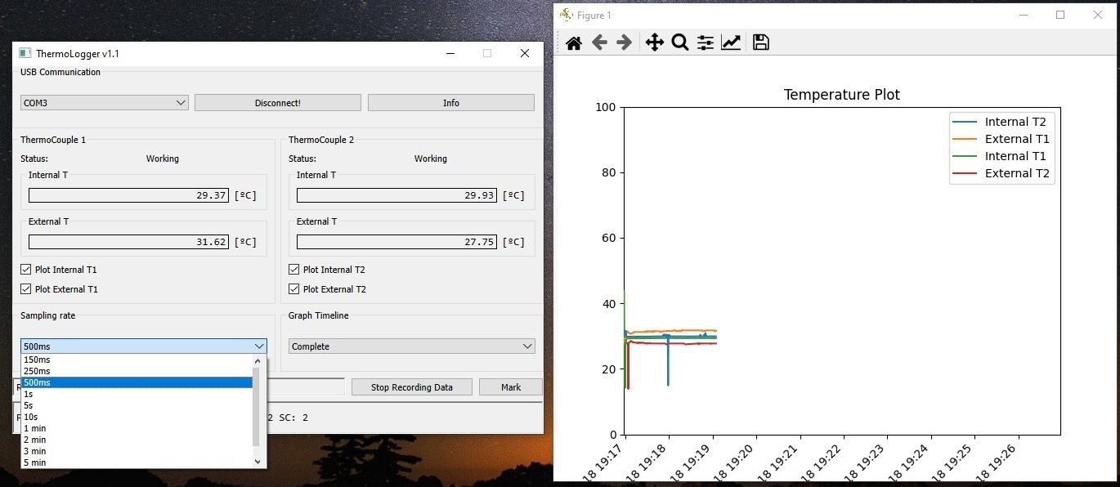

**Figure 5:** Sampling rate selection.

1. Graph timeline: This will help you change the X-axis of the graph manually. You can select from different timelines, but we recommend to leave it as “Complete”, so the X-axis will include all the temperature curves.

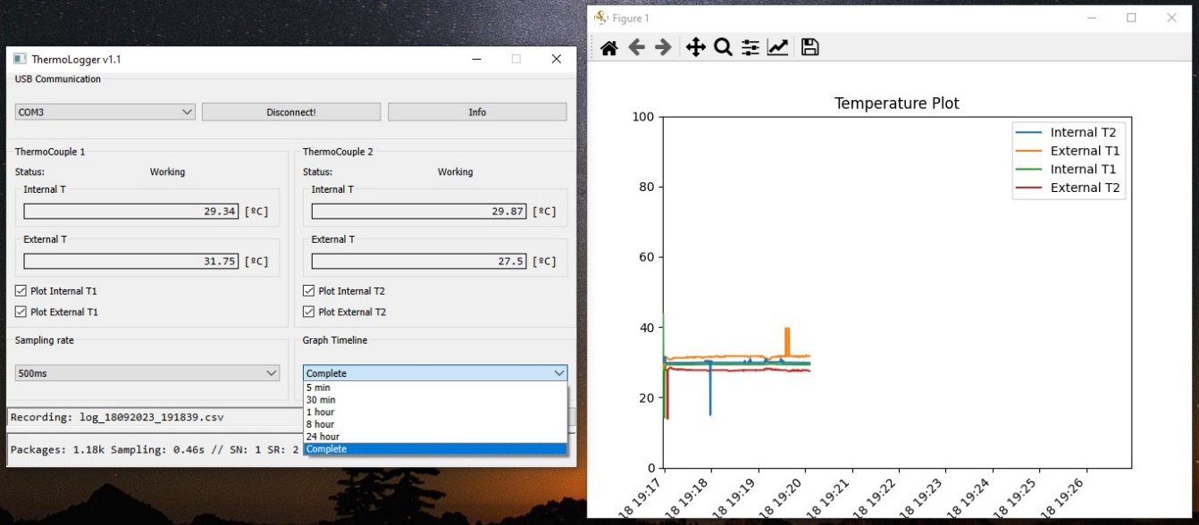

**Figure 6:** Graph timeline menu selection.

1. In the fifth selection we have the recording data section. By clicking “record data” we start to record all the data in a .csv file inside “Data” folder:

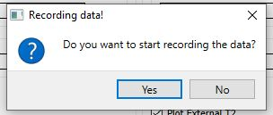

**Figure 6:** The user is asked to start recording the data.

As soon as we click Yes in the pop-up, a .csv file with the date will be created. The “Mark” button will create a Mark in the file, so you can keep track of the time you change anything during the test. (Example: You can mark whenever you change the temperature of the oven you are measuring, so later on when reviewing the .csv file, you will see the mark). You can make as many mark as you want.

Finally, the bottom bar is for debugging, as it includes the following data:

***Number of packages:*** The number of packages received from the board.

***Sampling:*** The time (in seconds) of the last data printed in graph and screen. Should coincide with the Sampling Rate selected on the GUI.

***SN:*** Sample Number inside the average loop

***SR:*** Number of samples we are averaging for every printed sampled.

***SC:*** Sampling Choice (Position of the comboBox).

To end, if you click on the “Info” button, you will extract the info of the FW and HW board you have:

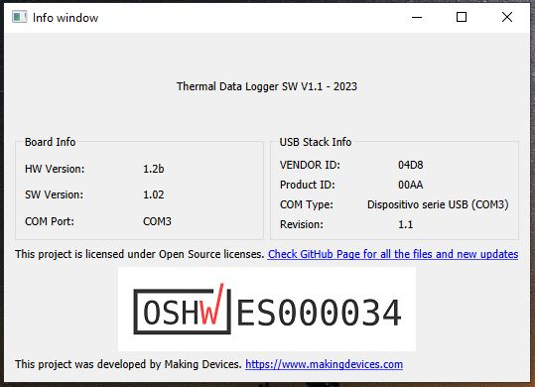

**Figure 7:** Info window.

For any requested feature or problem with the software or the board, please contact using the form of https://www.makingdevices.com