Setting up to use Framer with the FramerCompanion (WIN)
Andrea Bianchi
alsoplantsfly.com

1) Download the NodeJS (LTS) from https://nodejs.org/en/.
Install it.

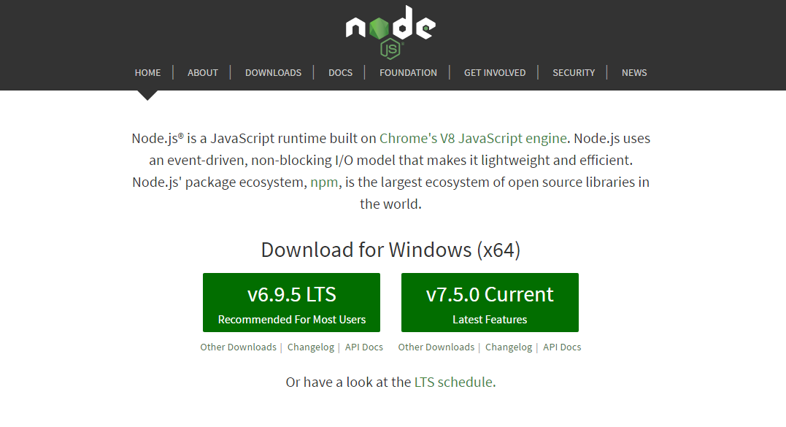

2) Download Atom editor from https://atom.io/.
Install it.
Then, go to File -> Settings

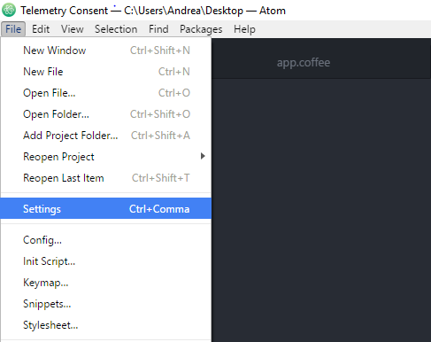

3) Select install and search and install the following packages: coffee-compile, color-picker, file-icons, atom-beautify, atom-html-preview, atom-terminal. Optional: auto-detect-indentation, autocomplete-modules.

4) In settings, go to Package and then select color-picker.
Choose as trigger the letter E

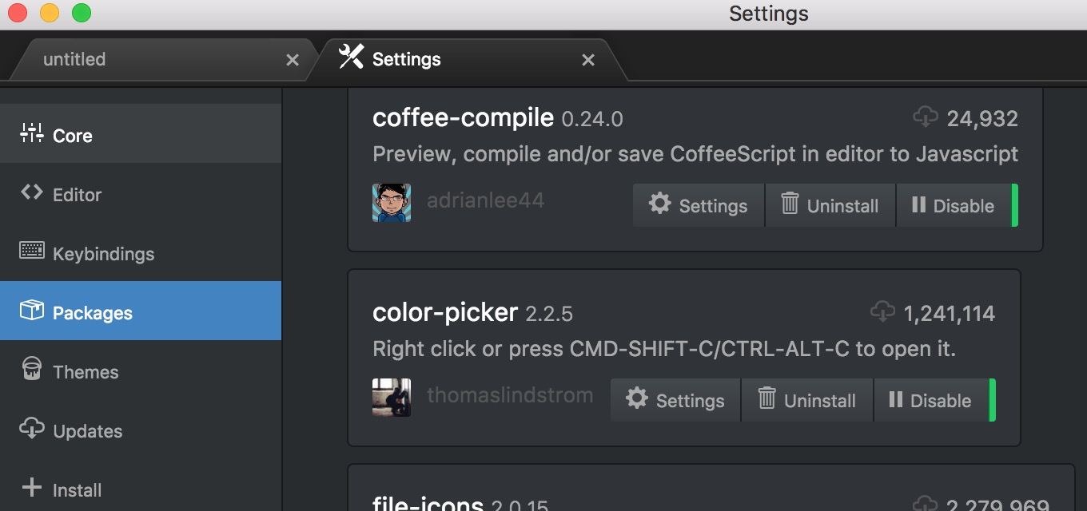

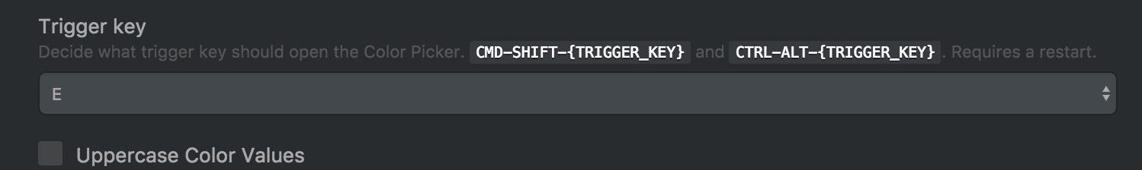

Now color picker will be active by pressing Cmd+Shift+E

5) Copy the snippets file at https://github.com/makinteract/FramerTools/blob/master/editors/atom/snippets.cson.
The click on the menu File -> Snippets and paste the snippets in there.

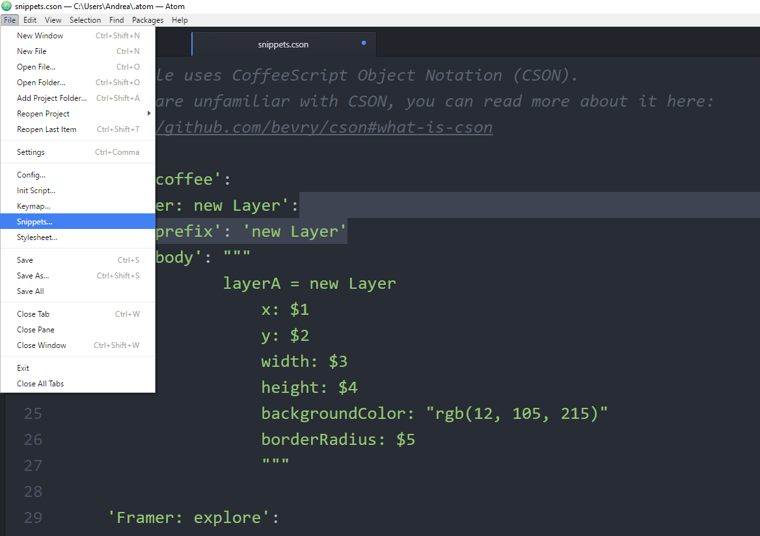

6) Go to the Github FramerTools page https://github.com/makinteract/FramerTools and download the binary files for windows.

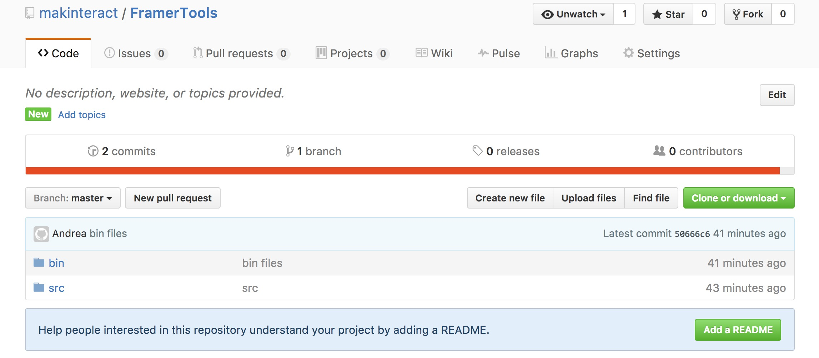
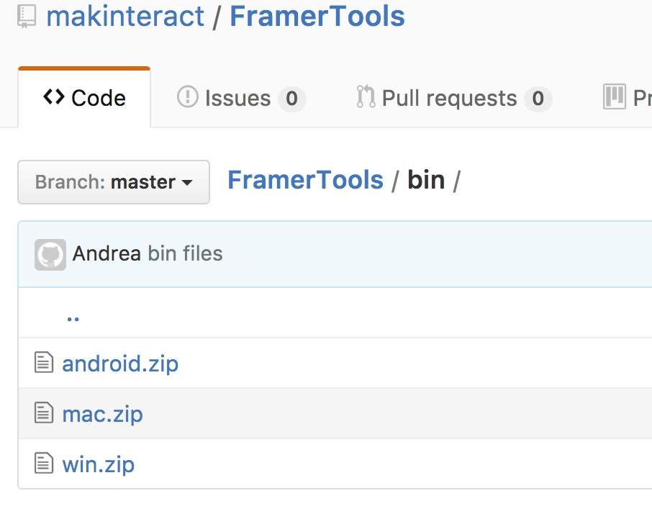

7) Unzip the mac.zip file. You should have the following apps.

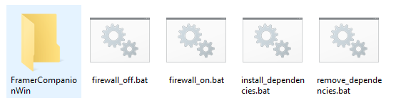

8) Install the dependencies (to uninstall them, use remove_dependencies.app).

9) Open the FramerCompanion.exe in the FramerCompanionWin folder. It requires Java 8. If java is not installed, a prompt will ask you to download Java JRE (runtime environment) from here: http://www.oracle.com/technetwork/java/javase/downloads/jre8-downloads-2133155.html

10) In the New From Template panel, fill up the details of your app, then initialize it to create it.
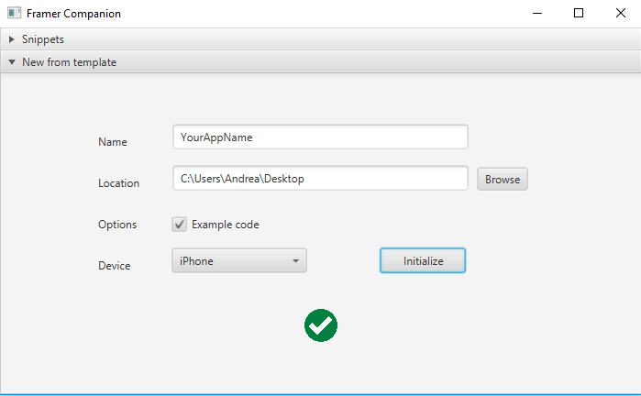

11) Open the folder in Atom by dragging it on the Atom icon. Code the app.coffee file. You can use the Snippet panel to drag snippets in your code. Alternatively, you can right click on the snippet you want to save it on a clipboard.

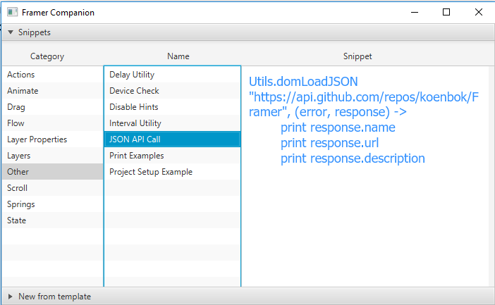

12) To see a result, select the index.html file, then from the menu select Packages -> Preview HTML -> Enable Preview. Go back to your coffee file, code and enjoy :)

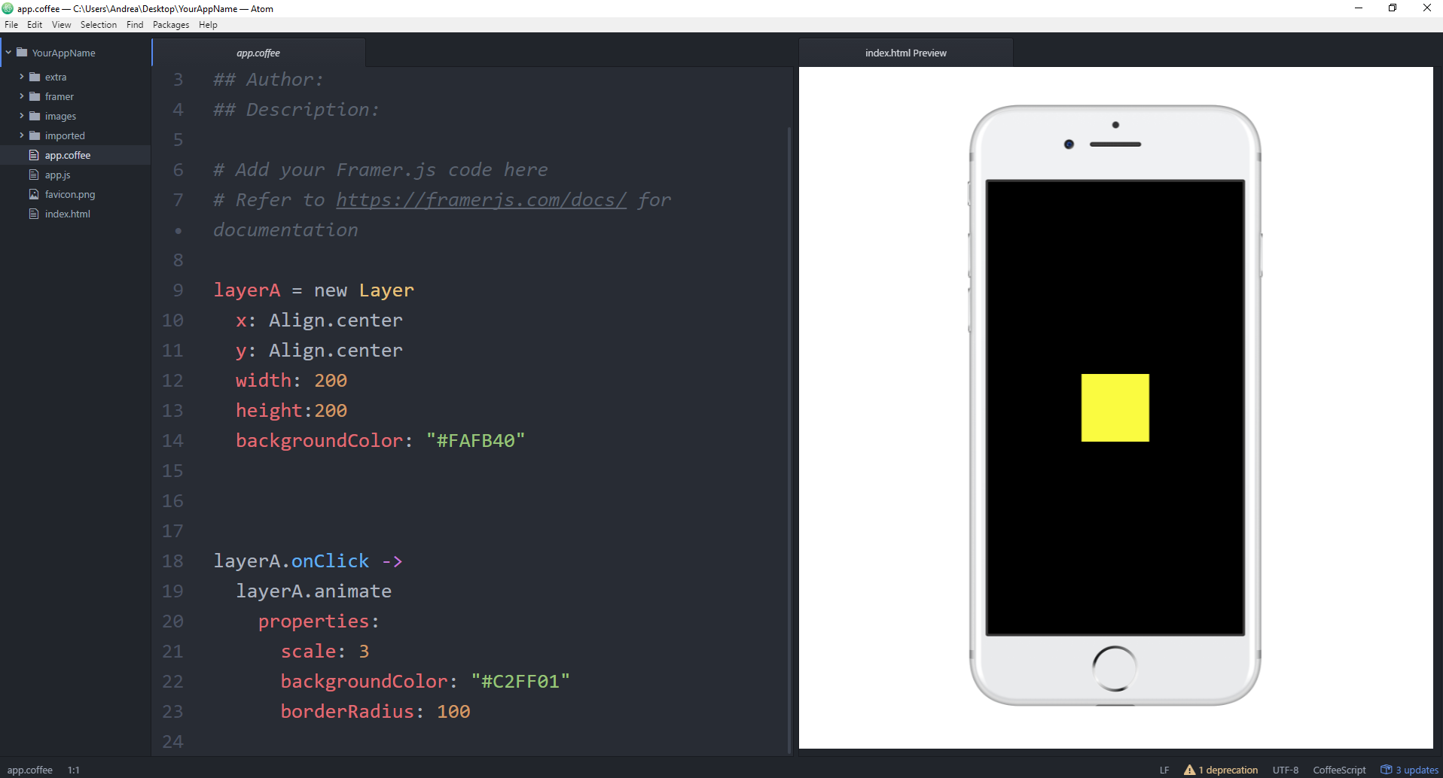

Preview on Android phone:

1) Go inside your project folder -> extra and click on the file browser-sync.bat

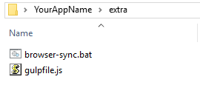

2) The browser will be launched with synchronized content and a command window will display an External IP address and port number. For example in the picture the IP address is 169.254.80.80 and the port number is 3000.
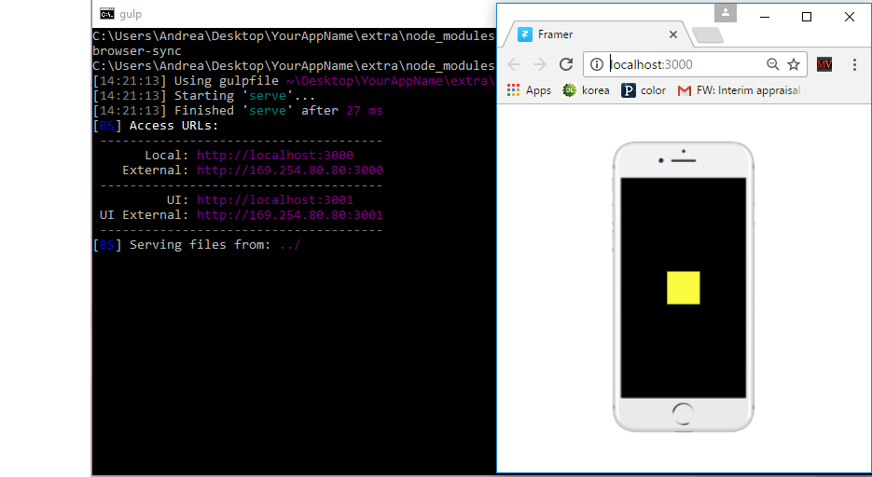

3) Download the Android APK for the FramerPlayer app from Github or from here using your Android phone: https://dl.dropboxusercontent.com/u/6787624/classes/InterfaceDesign/software/FramerPlayer.apk

4) Install the app FramerPlayer on your phone. Open it and insert the IP address and the port number in the proper fields. Then click START. Tip: make sure that both your computer and your phone are connected to the same network.

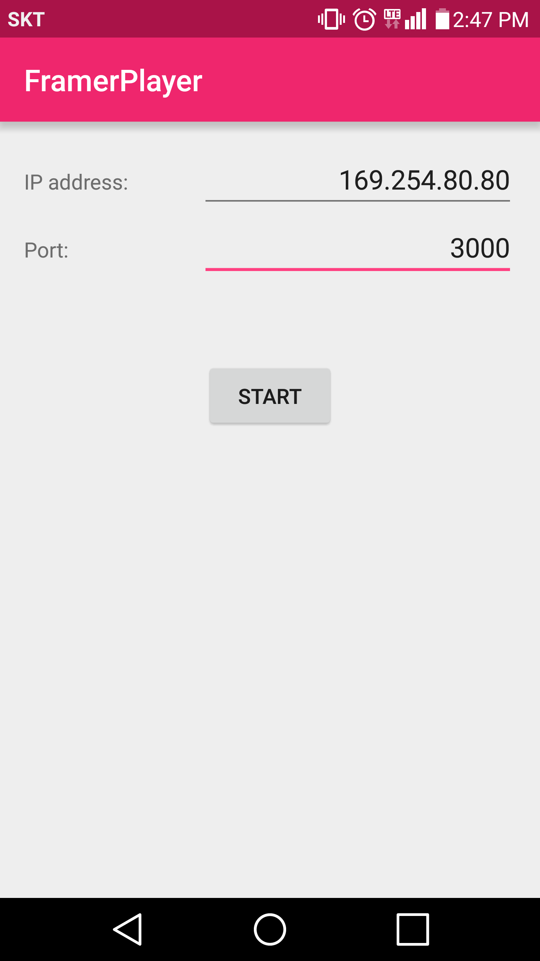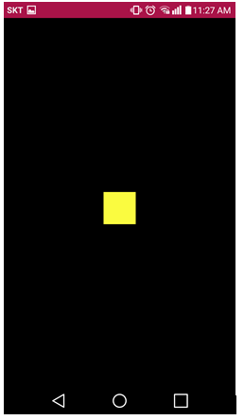

Enjoy. For questions see here: http://alsoplantsfly.com

