Setting up to use Framer with the FramerCompanion (MAC)
Andrea Bianchi
alsoplantsfly.com

1) Download the NodeJS (LTS) from https://nodejs.org/en/.
Install it.

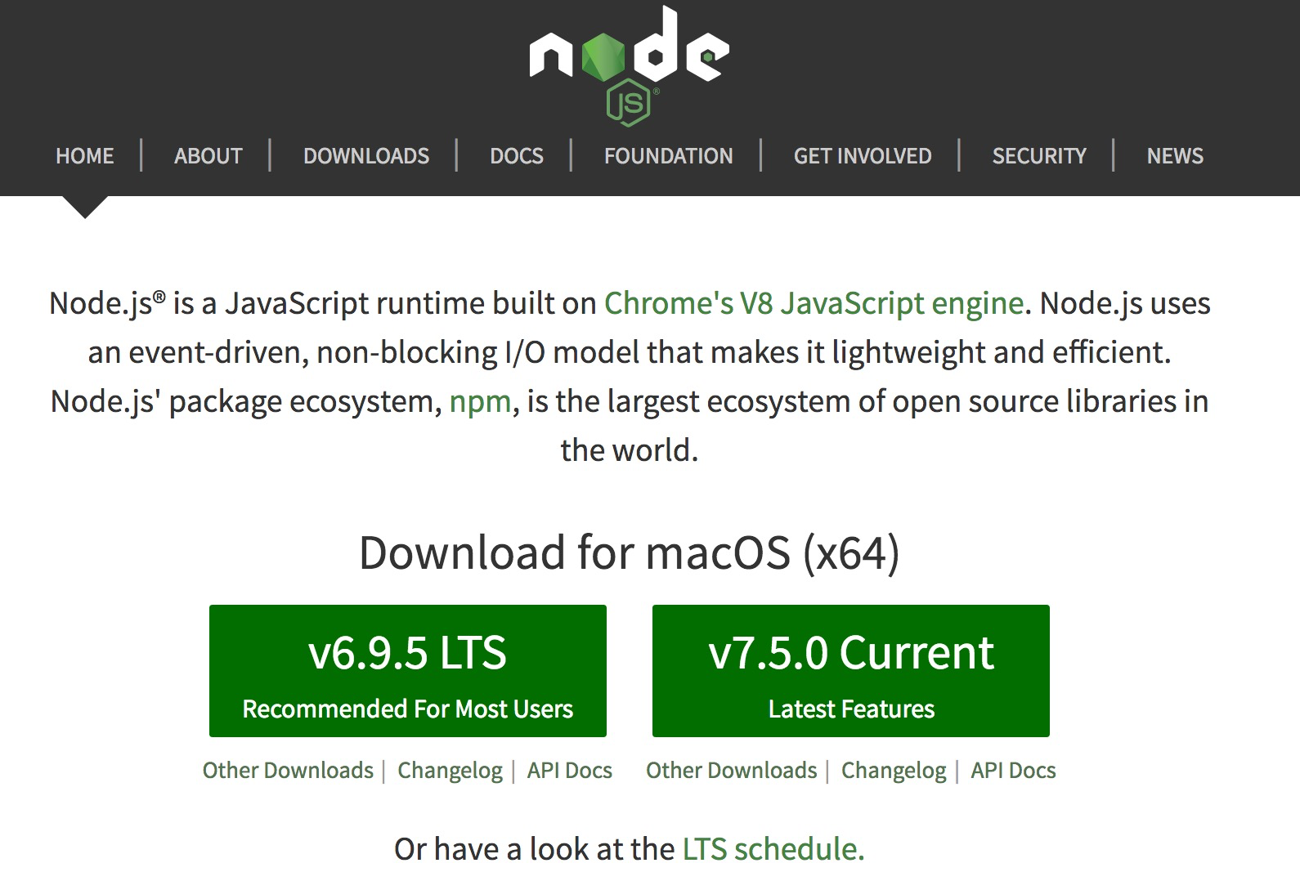

2) Download Atom editor from https://atom.io/.
Install it.
Then, go to Atom -> Preferences

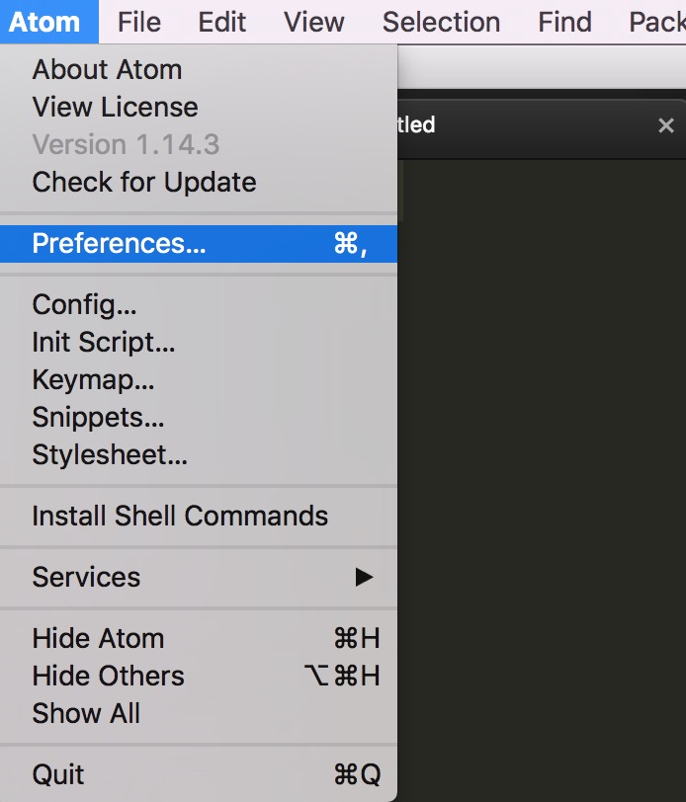

3) Select install and search and install the following packages: coffee-compile, color-picker, file-icons, atom-beautify, atom-html-preview, atom-terminal. Optional: auto-detect-indentation, autocomplete-modules.

4) In settings, go to Package and then select color-picker.
Choose as trigger the letter E

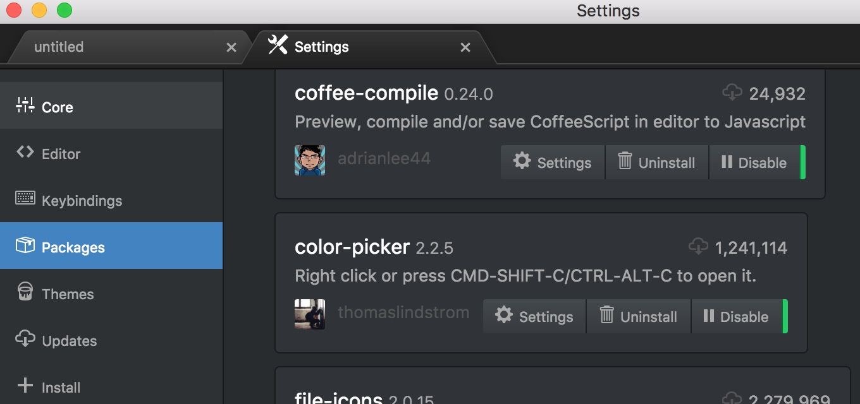

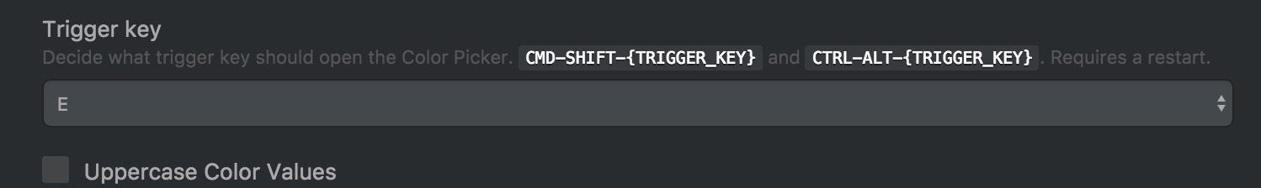

Now color picker will be active by pressing Cmd+Shift+E

5) Copy the snippets file at https://github.com/makinteract/FramerTools/blob/master/editors/atom/snippets.cson.
The click on the menu Atom -> Snippets and paste the snippets in there.

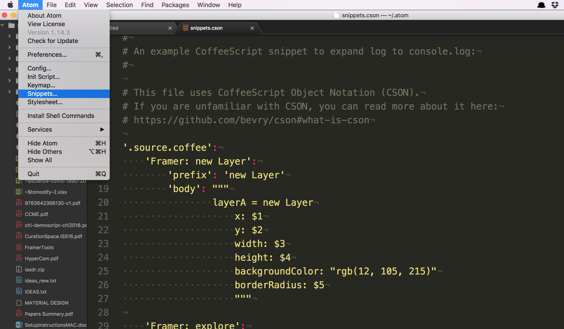

6) Go to the Github FramerTools page https://github.com/makinteract/FramerTools and download the binary files for mac.

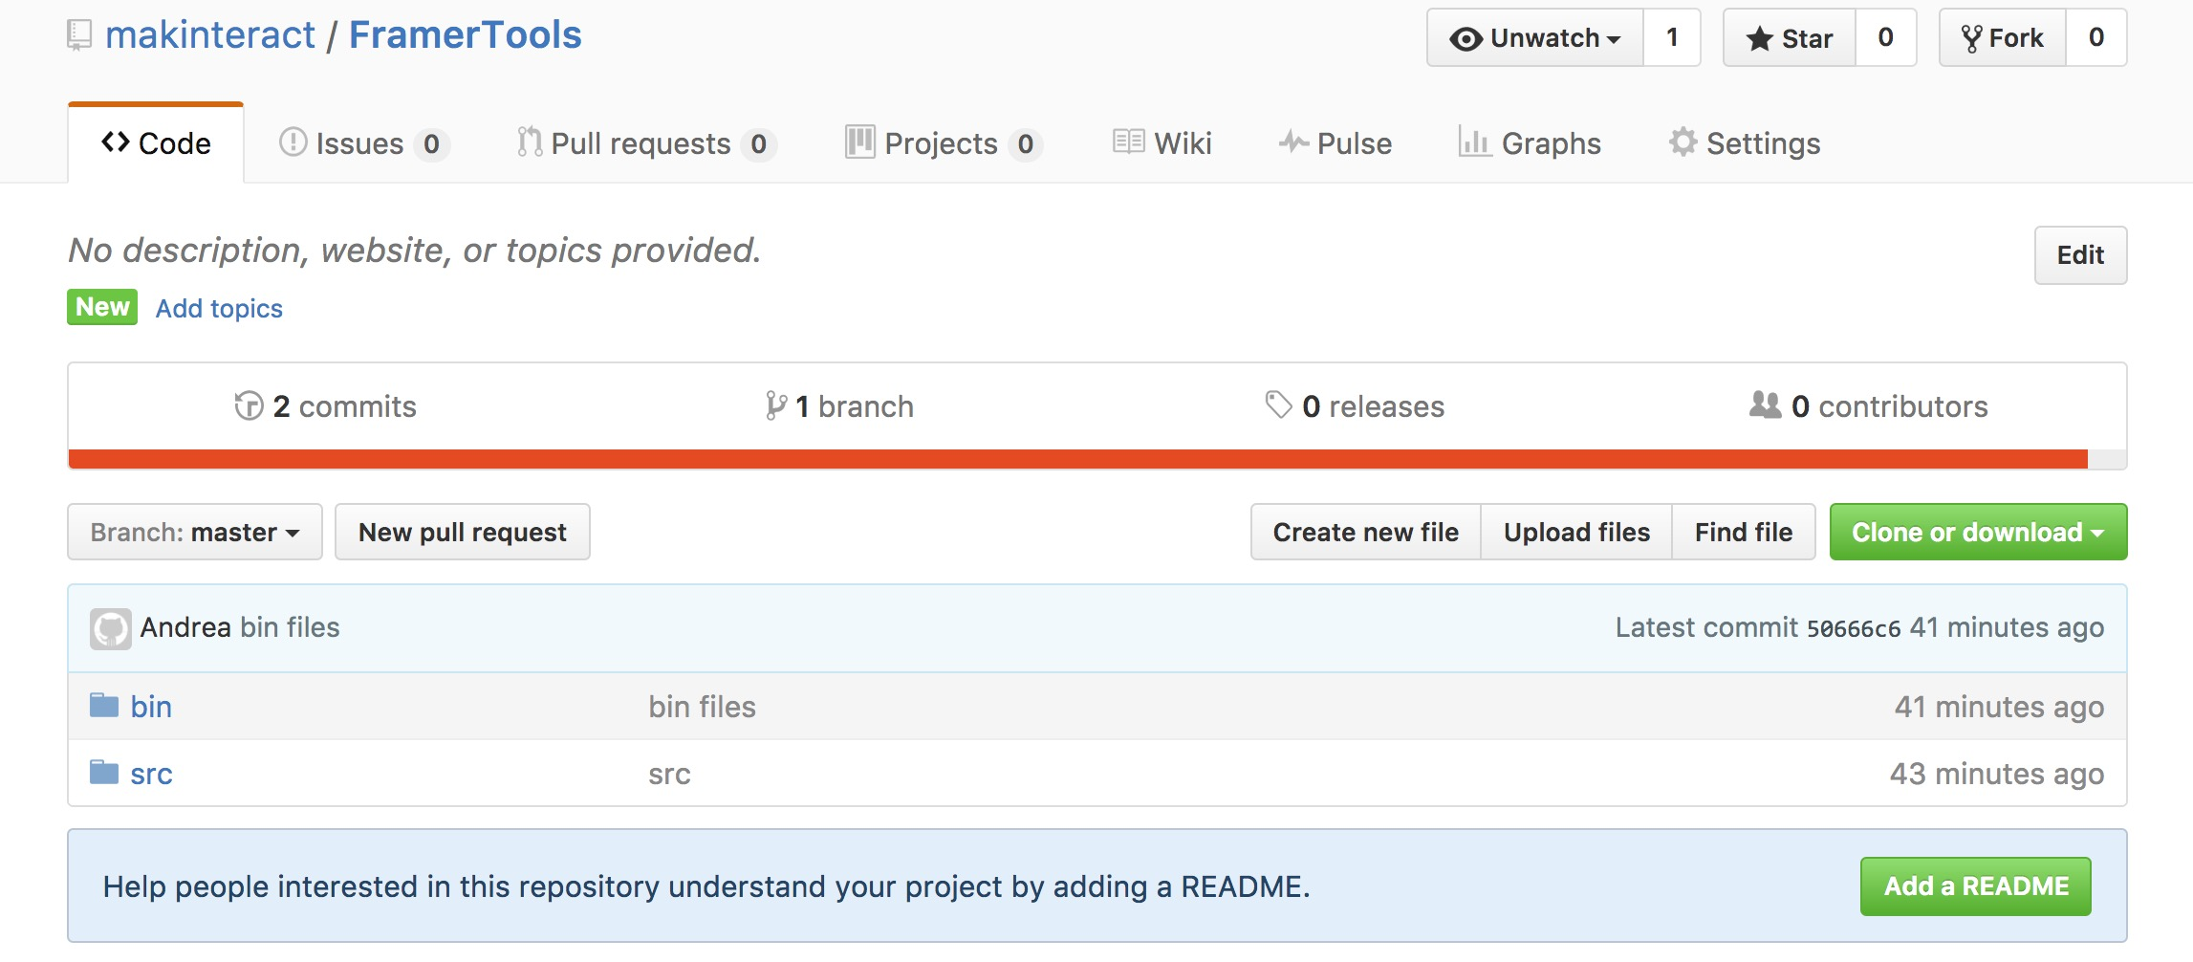
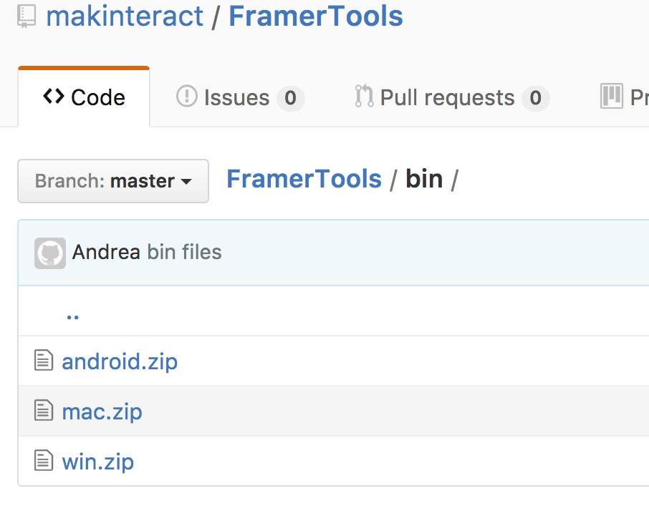

7) Unzip the mac.zip file. You should have the following apps.

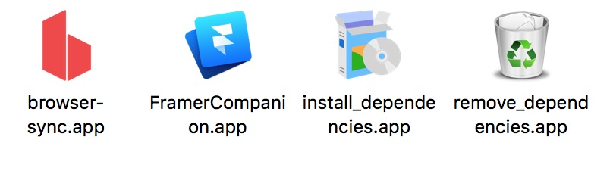

8) Install the dependencies (to uninstall them, use remove_dependencies.app).

9) Open the FramerCompanion. It requires Java 8. If java is not installed, a prompt will ask you to download Java JRE (runtime environment) from here: http://www.oracle.com/technetwork/java/javase/downloads/jre8-downloads-2133155.html

10) In the New From Template panel, fill up the details of your app, then initialize it to create it.
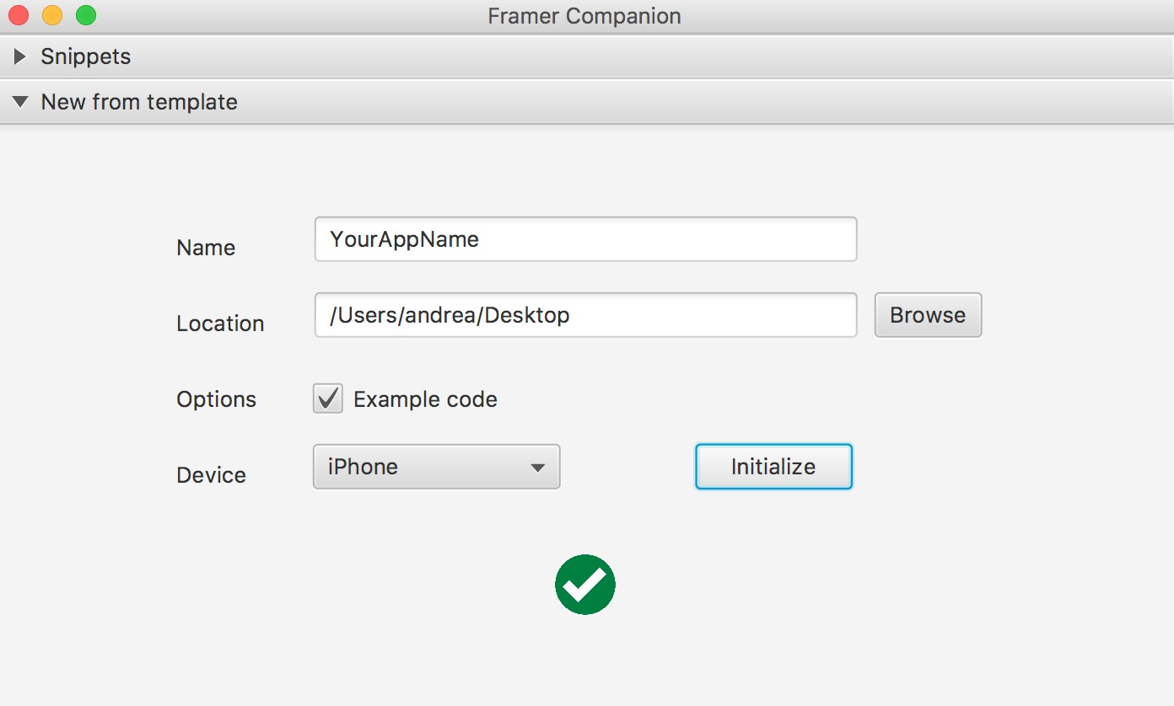

11) Open the folder in Atom by dragging it on the Atom icon. Code the app.coffee file. You can use the Snippet panel to drag snippets in your code. Alternatively, you can right click on the snippet you want to save it on a clipboard.

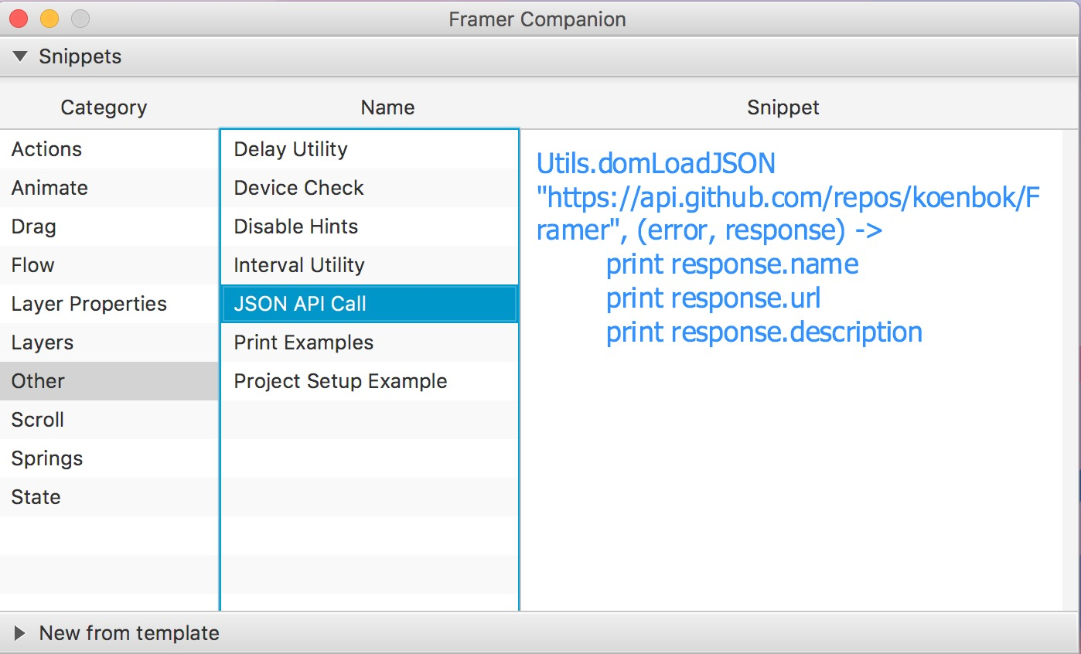

12) To see a result, select the index.html file, then from the menu select Packages -> Preview HTML -> Enable Preview. Go back to your coffee file, code and enjoy :)

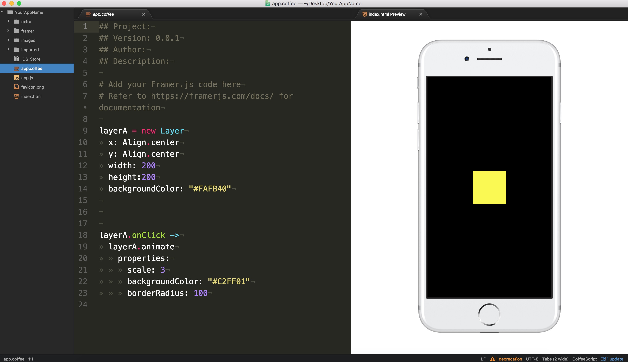

Preview on Android phone:

1) Open browser-sync from the mac folder with the FramerTools. It will prompt to choose a folder. Select your project folder.
Click choose and your browser will open with synchronized content.

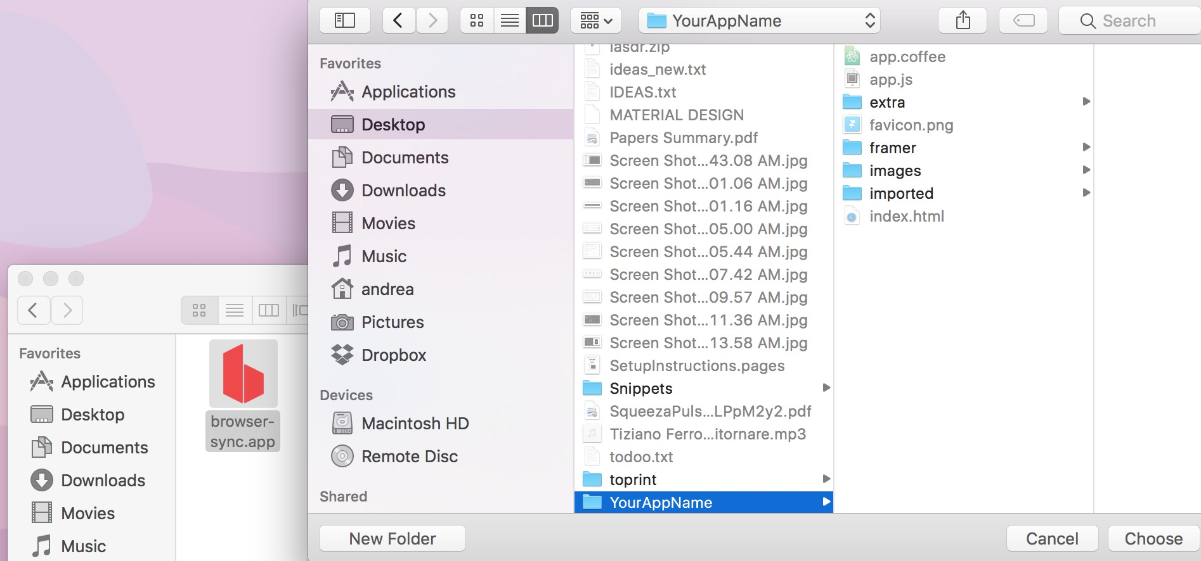

2) Look at your computer ip address from the Network preferences and look at the port number your browser is connected to in the URL bar of the browser

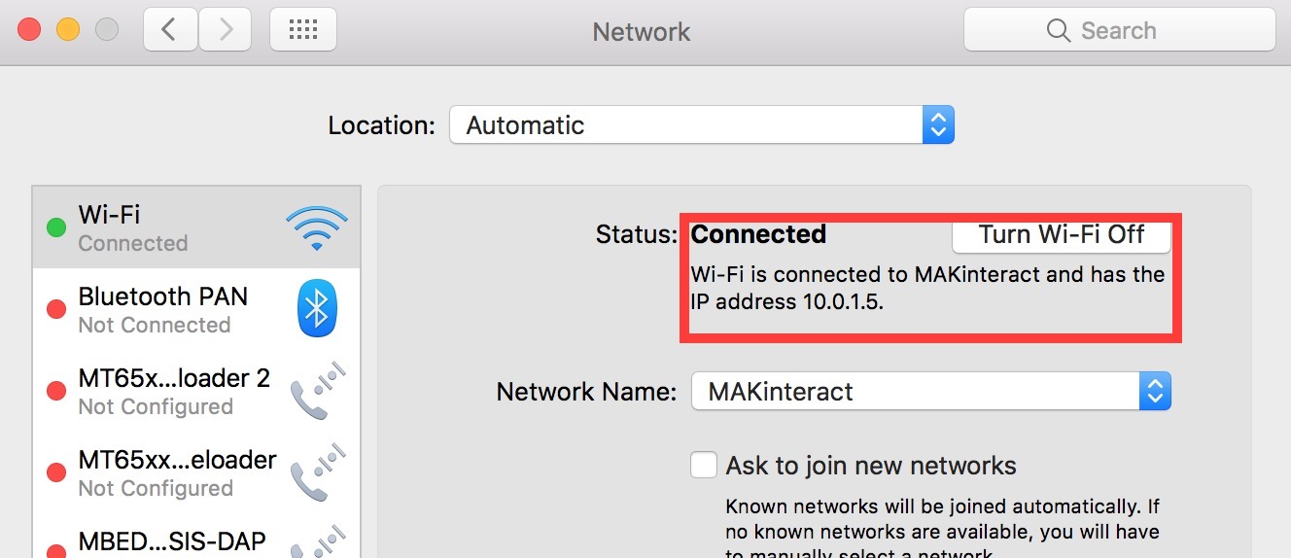

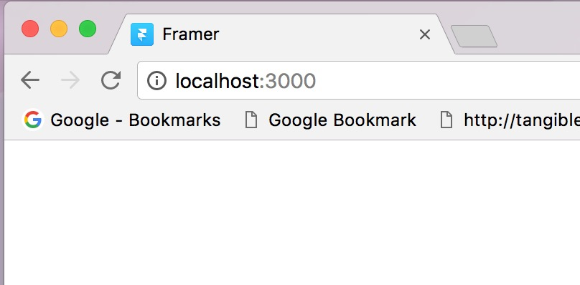

3) Download the Android APK for the FramerPlayer app from Github or from here using your Android phone: https://dl.dropboxusercontent.com/u/6787624/classes/InterfaceDesign/software/FramerPlayer.apk

4) Install the app FramerPlayer on your phone. Open it and insert the IP address and the port number in the proper fields. Then click START. Tip: make sure that both your computer and your phone are connected to the same network.

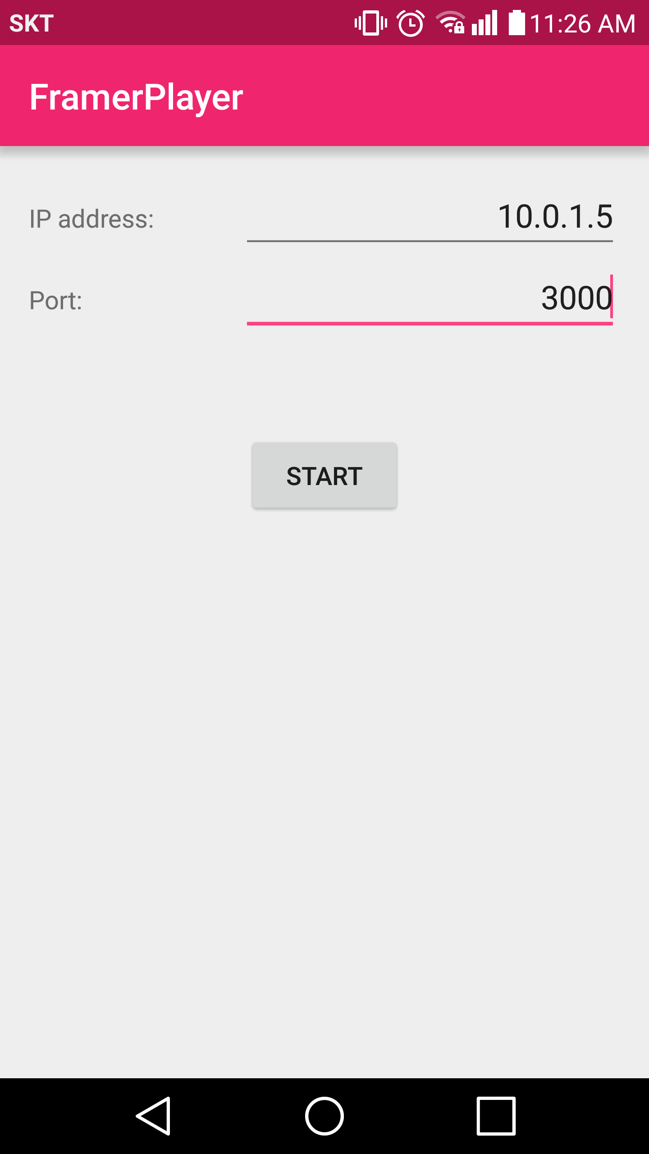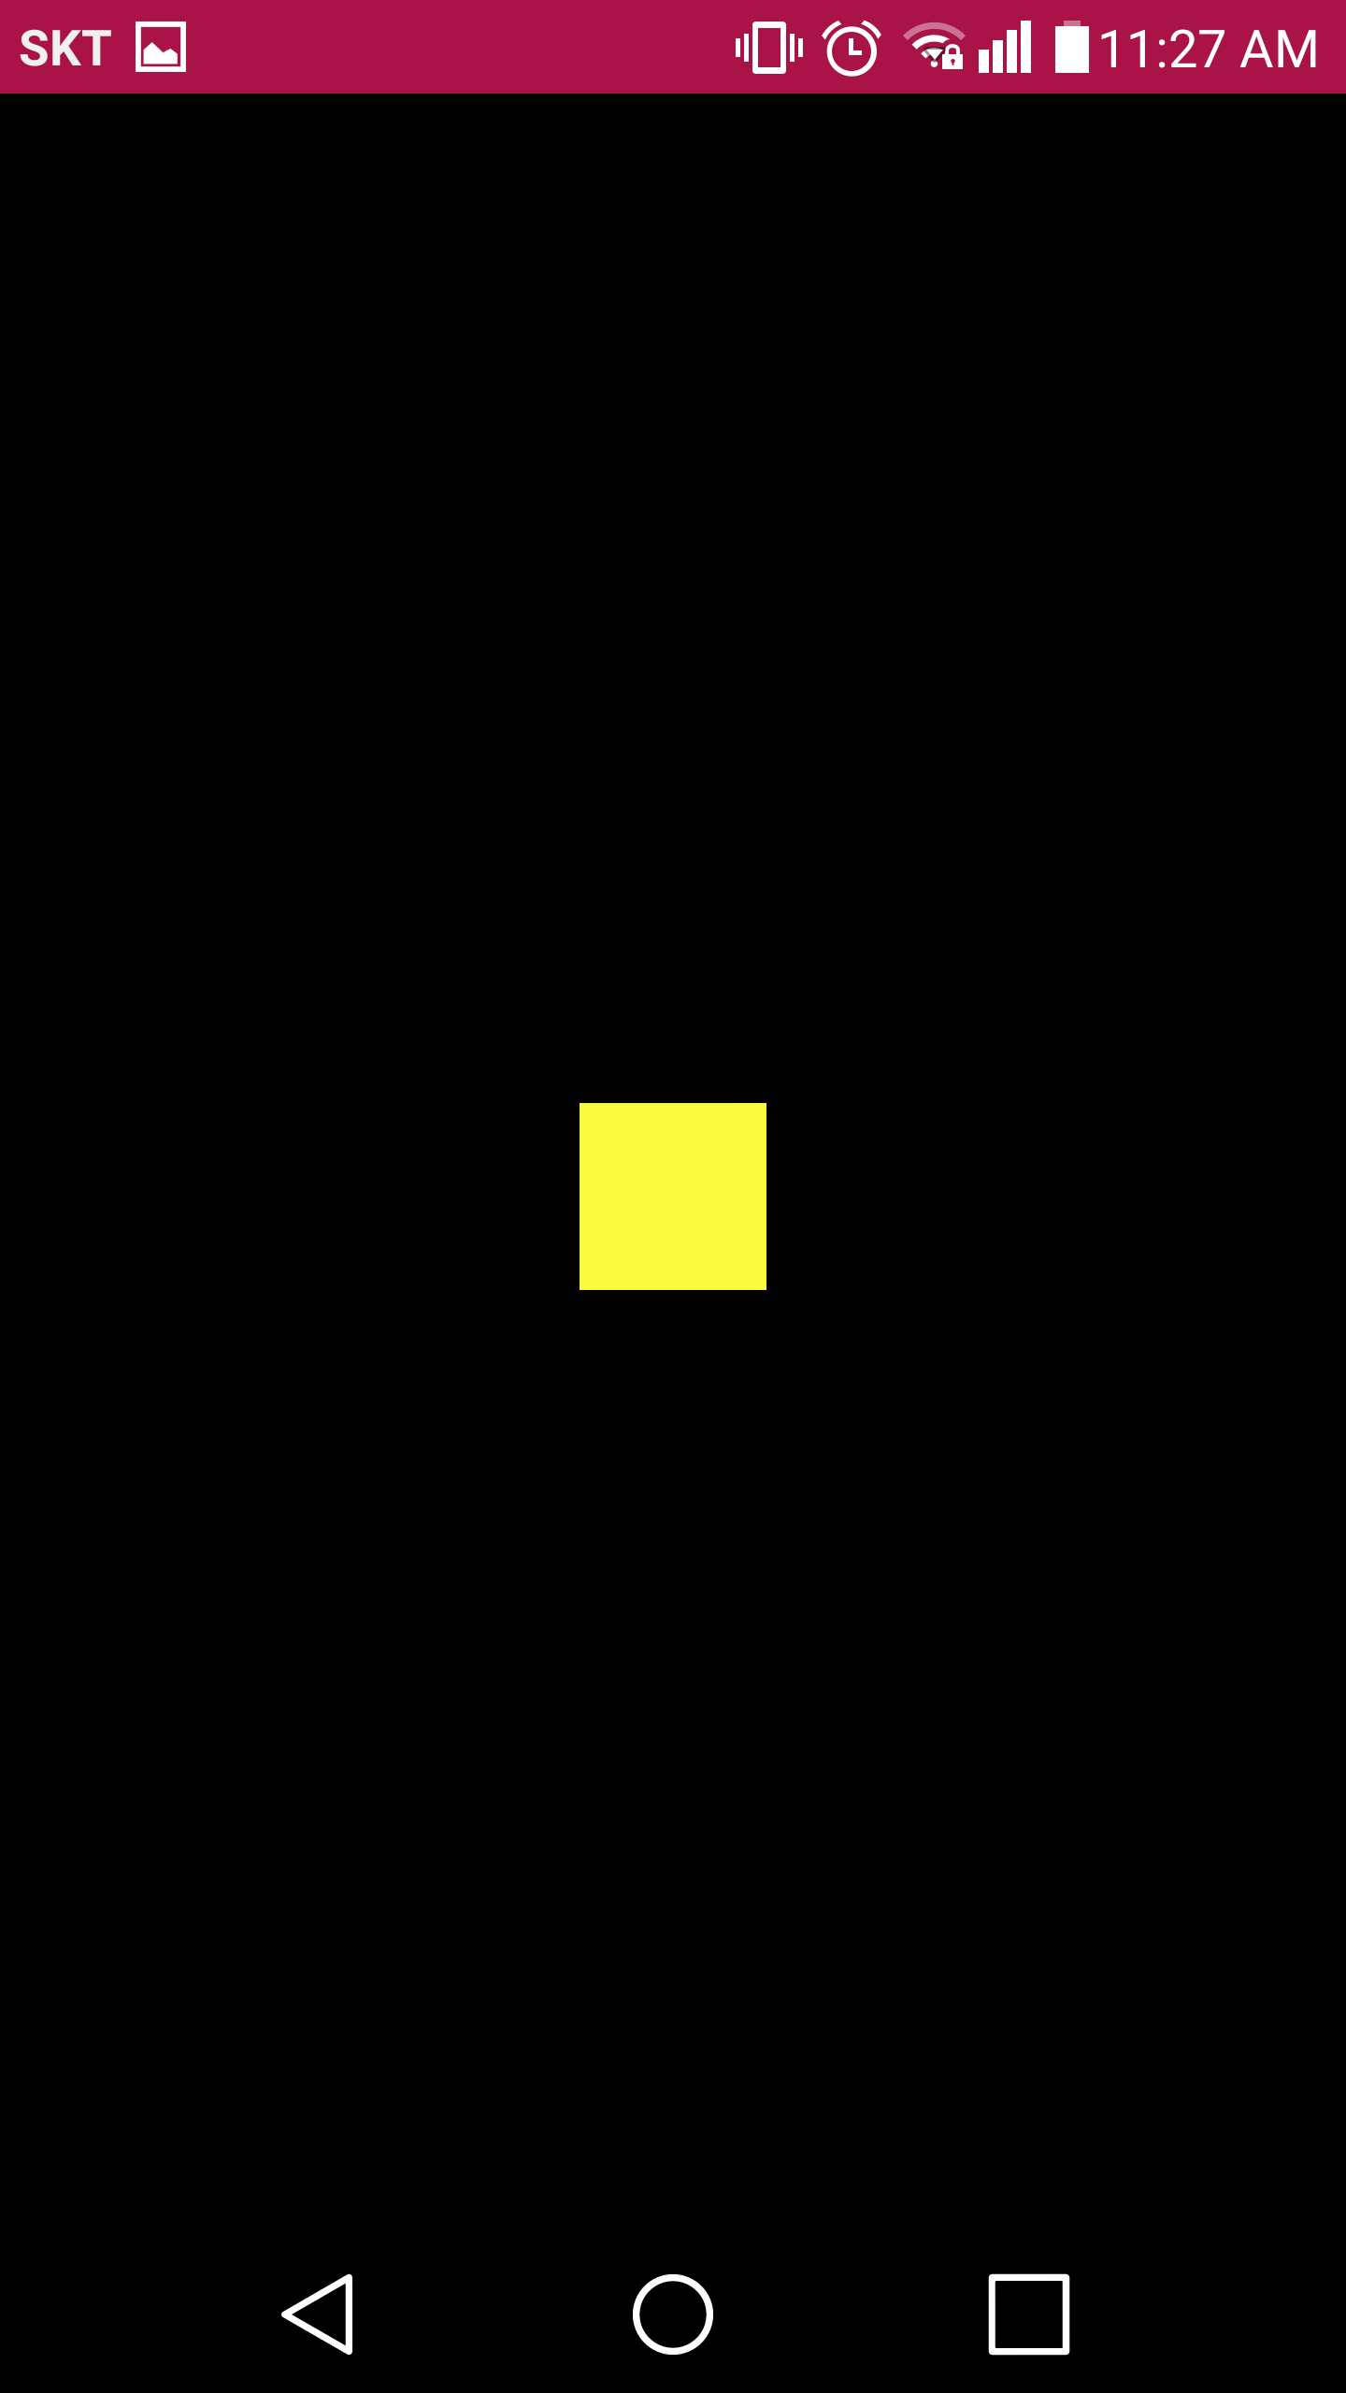

Enjoy. For questions see here: http://alsoplantsfly.com

