Maksims Kazijevs

COMP6200

03/26/2022

**Project 2**

**SOURCE CODE**

**RESULTS**

Best number of clusters: 3

Number of samples in cluster 1 is: 70

Number of samples in cluster 3 is: 38

Number of samples in cluster 2 is: 9

Other clusters:

K = 1

Number of samples in cluster 1 is: 117

K = 2

Number of samples in cluster 1 is: 99

Number of samples in cluster 2 is: 18

K = 4

Number of samples in cluster 1 is: 52

Number of samples in cluster 4 is: 45

Number of samples in cluster 2 is: 14

Number of samples in cluster 3 is: 6

K = 5

Number of samples in cluster 5 is: 36

Number of samples in cluster 1 is: 34

Number of samples in cluster 4 is: 27

Number of samples in cluster 2 is: 14

Number of samples in cluster 3 is: 6

K = 6

Number of samples in cluster 5 is: 36

Number of samples in cluster 3 is: 34

Number of samples in cluster 1 is: 27

Number of samples in cluster 4 is: 11

Number of samples in cluster 6 is: 5

Number of samples in cluster 2 is: 4

K = 7

Number of samples in cluster 1 is: 31

Number of samples in cluster 7 is: 30

Number of samples in cluster 5 is: 21

Number of samples in cluster 4 is: 15

Number of samples in cluster 6 is: 11

Number of samples in cluster 2 is: 5

Number of samples in cluster 3 is: 4

**PCA RESULTS**

Best number of clusters: 4

Number of samples in cluster 4 is: 51

Number of samples in cluster 2 is: 40

Number of samples in cluster 1 is: 18

Number of samples in cluster 3 is: 8

Other clusters:

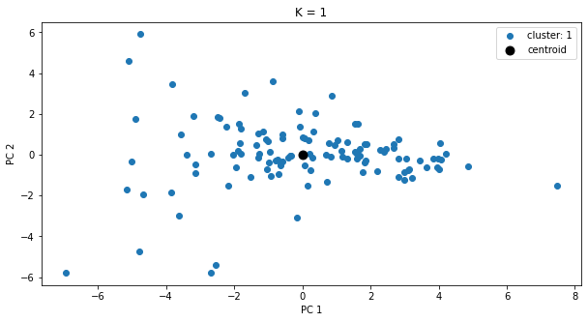

K = 1

Number of samples in cluster 1 is: 117

K = 2

Number of samples in cluster 2 is: 61

Number of samples in cluster 1 is: 56

K = 3

Number of samples in cluster 1 is: 57

Number of samples in cluster 2 is: 51

Number of samples in cluster 3 is: 9

K = 5

Number of samples in cluster 1 is: 36

Number of samples in cluster 3 is: 34

Number of samples in cluster 2 is: 26

Number of samples in cluster 5 is: 12

Number of samples in cluster 4 is: 9

K = 6

Number of samples in cluster 3 is: 35

Number of samples in cluster 5 is: 34

Number of samples in cluster 2 is: 26

Number of samples in cluster 1 is: 10

Number of samples in cluster 6 is: 8

Number of samples in cluster 4 is: 4

K = 7

Number of samples in cluster 4 is: 28

Number of samples in cluster 6 is: 27

Number of samples in cluster 5 is: 23

Number of samples in cluster 2 is: 19

Number of samples in cluster 1 is: 11

Number of samples in cluster 3 is: 5

Number of samples in cluster 7 is: 4

