S.A.M.U.D.R.A
PERFORMANCE.Intelligence
SAMUDRA⁷.Jobfit
Report: SAMUDRA.Jobfit ID: {report_ref} Date: {report_date}


@2025 GESTALT PSYCHO.GRAPHOLOGY INTELLIGENCE SYSTEM
Distributed by: Samudra7axis II graphoworldproject@gmail.com II www.graphoworld.com II +91 9095215551 ; +91 9994662290

Powered by GPS7 | S.A.M.U.D.R.A  PERFORMANCE.Intelligence
SAMUDRA⁷. Jobfit
 | Date: {report_date_short}  Name: {candidate_name}  Education: {education}  Job Applied/Desired: {job_applied} | Assessment Input: {assessment_input}  Report Code: {report_code}  Mobile: {mobile}  Email Id: {email}
Powered by GPS7
This report is powered by GPS7 – a proprietary Gestalt Grapho-Psychology Intelligence System and one of its kind in the world, designed to interpret handwriting and signatures as visible expressions of subconscious behavioural patterns. Using an integrated Gestalt Psycho.Graphology approach, the system evaluates rhythm, pressure, spacing, movement, form, and signature structure to create a unified psychological perspective rather than isolated trait readings. The framework draws upon established psychological research recognizing handwriting as a reflection of underlying cognitive and subconscious processes.
The Seven Core Performance Traits
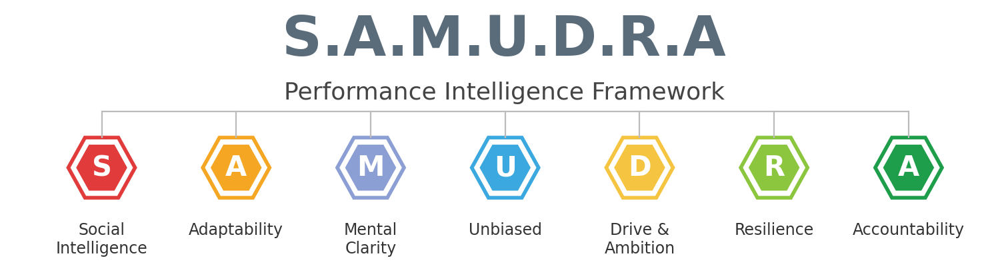

Stability – emotional balance, consistency, and dependability conditions.
Adaptability – flexibility, openness to change, and the ability to adjust.
Motivation – measures drive, initiative, ambition, and goal-orientation energy.
Unbiased – objectivity, balanced judgment, balanced excessive emotional influence.
Decisioning – clarity of thought, planning ability, and execution orientation.
Resilience – recovery ability, stress tolerance, response to pressure or setbacks.
Assertiveness – confidence, communication strength, and ability to take initiative.

Powered by GPS7 | S.A.M.U.D.R.A  PERFORMANCE.Intelligence
SAMUDRA⁷. Jobfit
Behavioral Profile
{%radarChart}
S – Social Intelligence ({t_s_score})
{t_s_text}
A – Adaptability ({t_a_score})
{t_a_text}
M – Mental Clarity ({t_m_score})
{t_m_text}
U – Unbiased ({t_u_score})
{t_u_text}

Powered by GPS7 | S.A.M.U.D.R.A  PERFORMANCE.Intelligence
SAMUDRA⁷. Jobfit
Behavioral Profile
SAMUDRA FIT SCORE  {samudra_fit_score}  Strong Alignment | STRONGEST TRAIT  {strongest_trait}  {strongest_trait_score} | FOCUS TRAIT  {focus_trait}  {focus_trait_score}
Scale: 0 (Lowest) to 100 (Highest)
D – Drive & Ambition ({t_d_score})
{t_d_text}
R – Resilience ({t_r_score})
{t_r_text}
A – Accountability ({t_ac_score})
{t_ac_text}

Powered by GPS7 | S.A.M.U.D.R.A  PERFORMANCE.Intelligence
SAMUDRA⁷. Jobfit
Jobfit.Evaluation
{%gaugeChart}
The overall Job Fit score of {jobfit_score}% {jobfit_box_text}
■ 0% – 25% Low Fit ■ 25% – 75% Moderate to High Fit ■ 75% – 100% Very High Fit

Jobfit.Summary
{jobfit_summary_p1}
{jobfit_summary_p2}

Powered by GPS7 | S.A.M.U.D.R.A  PERFORMANCE.Intelligence
SAMUDRA⁷. Jobfit
Industry Mapping
Industry | Fit % | Fit Level
{#industries}{name} | {fitPct}% {fitBar} | {fitLevel}{/industries}

Industry Fit
{industry_fit_strong}
{industry_fit_moderate}
{industry_fit_development}
{industry_fit_overall}

Powered by GPS7 | S.A.M.U.D.R.A  PERFORMANCE.Intelligence
SAMUDRA⁷. Jobfit
Strength Zone
{s1_title} | {s2_title} | {s3_title} | {s4_title}
{s1_text} | {s2_text} | {s3_text} | {s4_text}

{strength_zone_summary}
Variability Zone
{v1_title} | {v2_title} | {v3_title}
{v1_text} | {v2_text} | {v3_text}

{variability_zone_summary}

{#hasOverlays}
Applied Overlays
{#overlays}
{code} – {title}
{body}
{/overlays}

{/hasOverlays}
Powered by GPS7 | S.A.M.U.D.R.A  PERFORMANCE.Intelligence
SAMUDRA⁷. Jobfit
Executive Summary
Job Fit | Top Strength | Key Variability | Best Industries
{jobfit_score}% | {top_strength} | {key_variability} | {best_industries}

{exec_summary_p1}
{exec_summary_p2}
{exec_summary_p3}
Disclaimer
This report has been generated with the knowledge and consent of the applicant and is based on the analysis of provided handwriting and signature samples. The interpretation reflects behavioral tendencies derived through the GPS7 Gestalt Grapho.Psychology framework and is intended to support career awareness and guidance. It should be used as an indicative tool alongside other evaluation methods and not as the sole basis for decision-making.
@2025 GESTALT PSYCHO.GRAPHOLOGY INTELLIGENCE SYSTEM
Distributed by: Samudra7axis II graphoworldproject@gmail.com II www.graphoworld.com II +91 9095215551 ; +91 9994662290 II END OF THE REPORT

